Supplementary material: Cell-free DNA release following psychosocial and physical stress in women and men

Supplementary table

Target Name | Binding Site Position | Sequence (5´- 3´)
Line forward (300nM) | % | AATGCCGCAATAAACATAC
Line reverse (300nM) | % | GAACTAGAGATACCATTTGACC
FAM-LINE-MGBEQ Probe (250nM) | % | [FAM] TGC ATG TGT CTT TAT AGC AGC ATG A [MGBEQ]
mtDNA forward (300nM) | mt 16 528 - 16 548 | CTAAATAGCCCACACGTTCCC
mtDNA reverse (300nM) | mt 23 - 42 | AGAGCTCCCGTGAGTGGTTA
HEX-mtDNA-BHQ1 Probe (250nM) | mt 16 560 - 16 510 | [HEX]CAT[+C]AC[+G]AT[+G][+G]A[+T]CA[+C]AGGT[BHQ1]
Lambda forward (300nM) | 13 436- 13 455 | ATATCCGGCAGGAAACACTG
Lambda reverse (300nM) | 13 535- 13 516 | TAACGTTCTCCACCGACCTC
Cy5-Lambda-BHQ3 Probe (250nM) | 13 457- 13 476 | [Cy5]ATGAATGCACCCGTGCGGAG[BHQ3]
Supplementary table 1 Probes and Primers. Depicted are sequences of the primers (300nM) and probes (250nM) of the cfDNA qPCR for the three targets LINE (cf-nDNA), mtDNA (cf-mtDNA) and Lambda (spike-in). The cf-nDNA target LINE targets the L1PA2 elements. Because of their viral origin of these transposition elements, the DNA sequence occurs approximately 2374 times using the depicted primers and probe. BHQ = black hole quencher®; [+] = locked nucleic acids (LNA); MGBEQ = minor groove binder eclipse quencher

Supplementary figures
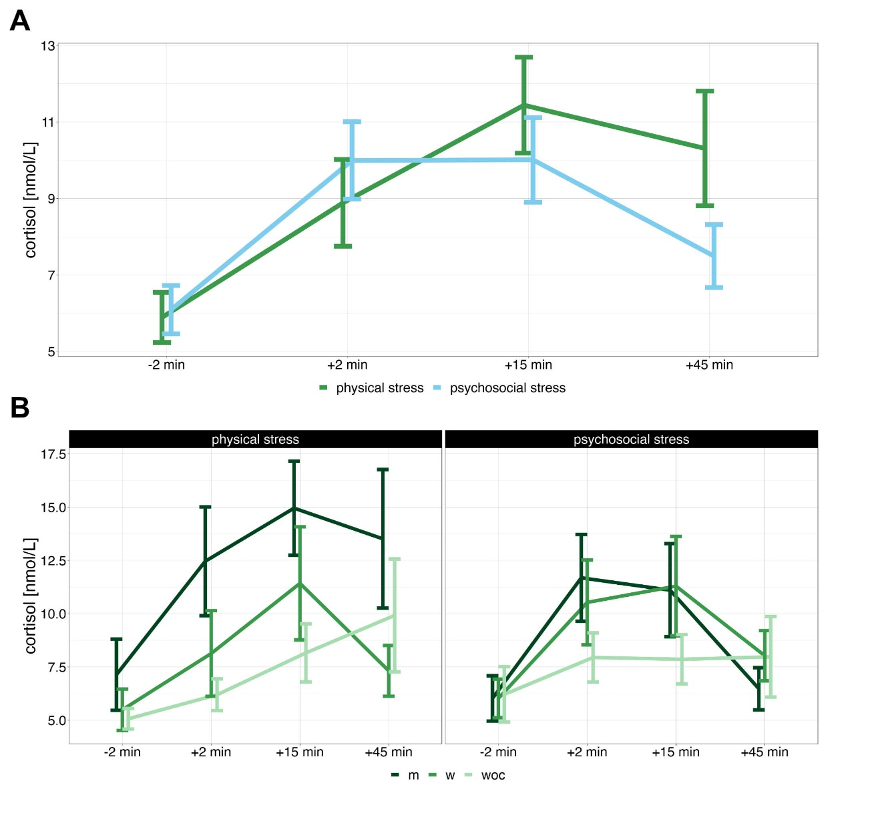
Supplementary figure 1 Cortisolconcentration. Cortisolconcentration before and after acute physical and psychosocial stress for all participants (A) as well as for the three groups (B; m = men, w = women, woc = women with hormonal contraception). The Cortisolconcentration was plotted in nmol/l over time. Error bars show standard error of the mean.
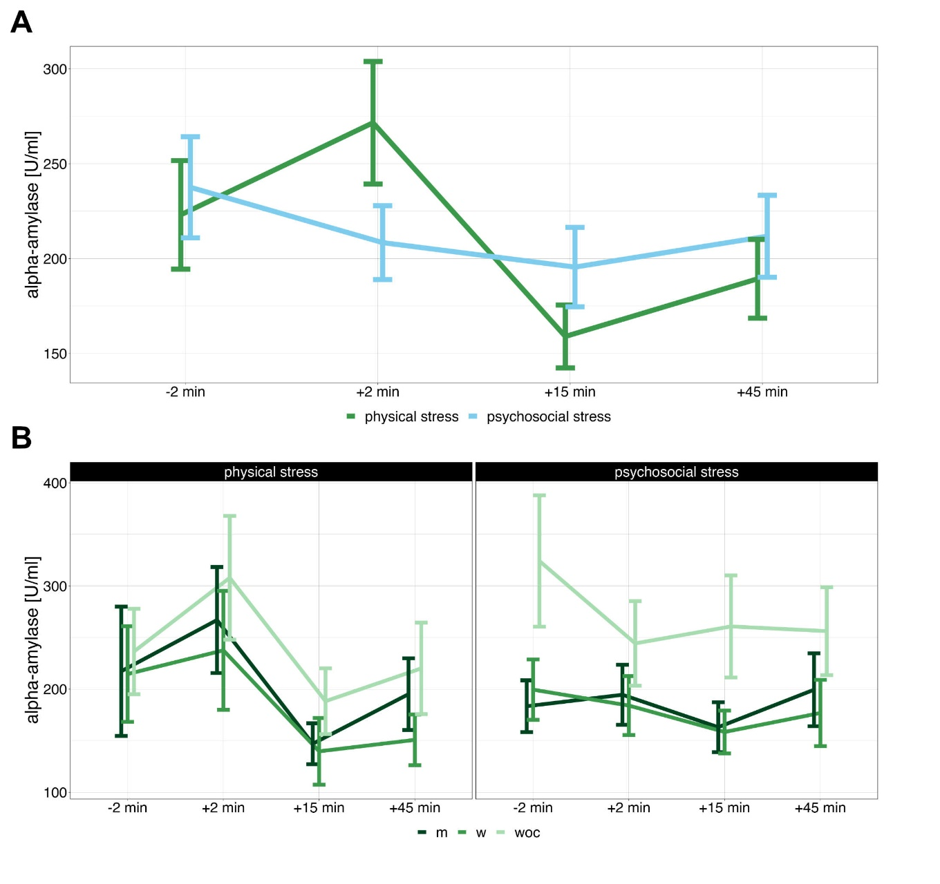
Supplementary figure 2 α-amylase activity. Α-amylase activity before and after acute physical and psychosocial stress for all participants (A) and for the three different groups (B; m = men, w = women, woc = women with hormonal contraception). Α-amylase activity is plotted in U/ml over time. Error bars display standard error of the mean.
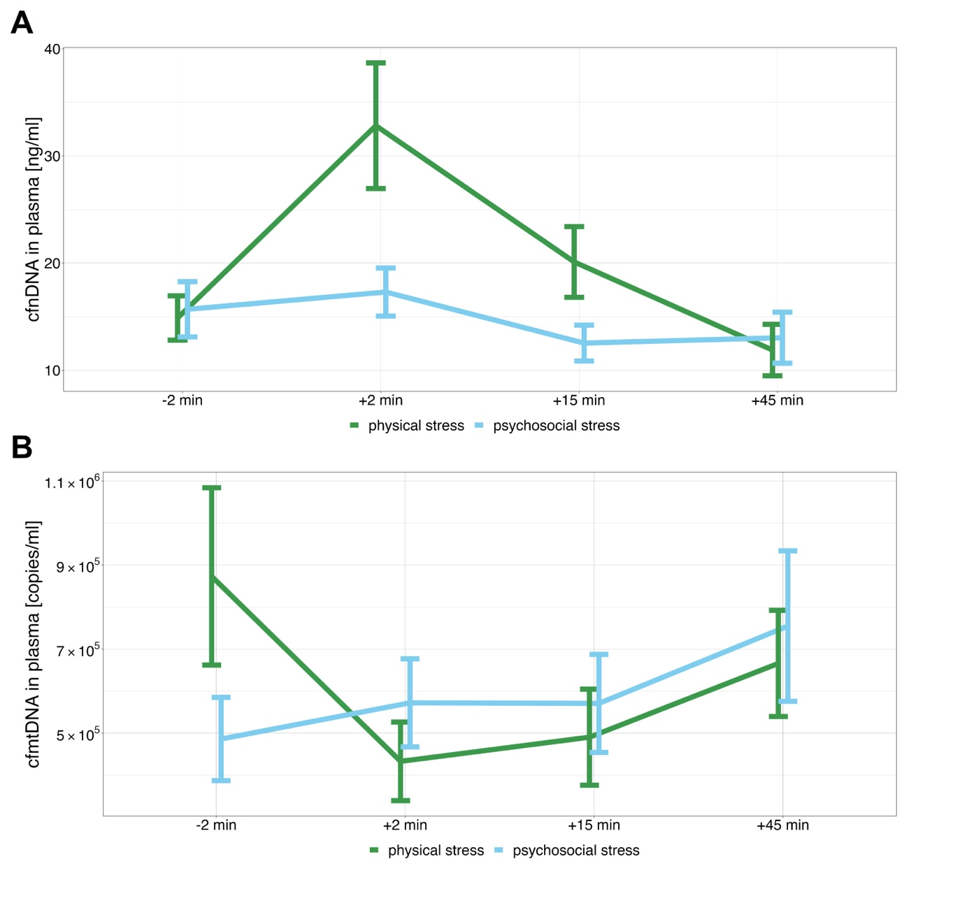
Supplementary figure 3 cf-nDNA and cf-mtDNA in plasma. A) cf-nDNA concentration in plasma before and after physical and psychosocial stress B) cf-mtDNA concentration in plasma before and after physical and psychosocial stress. Plasma cf-nDNA is plotted in ng/ml over time, while cf-mtDNA is plotted in copies/ml over time. Error bars display standard error of the mean.
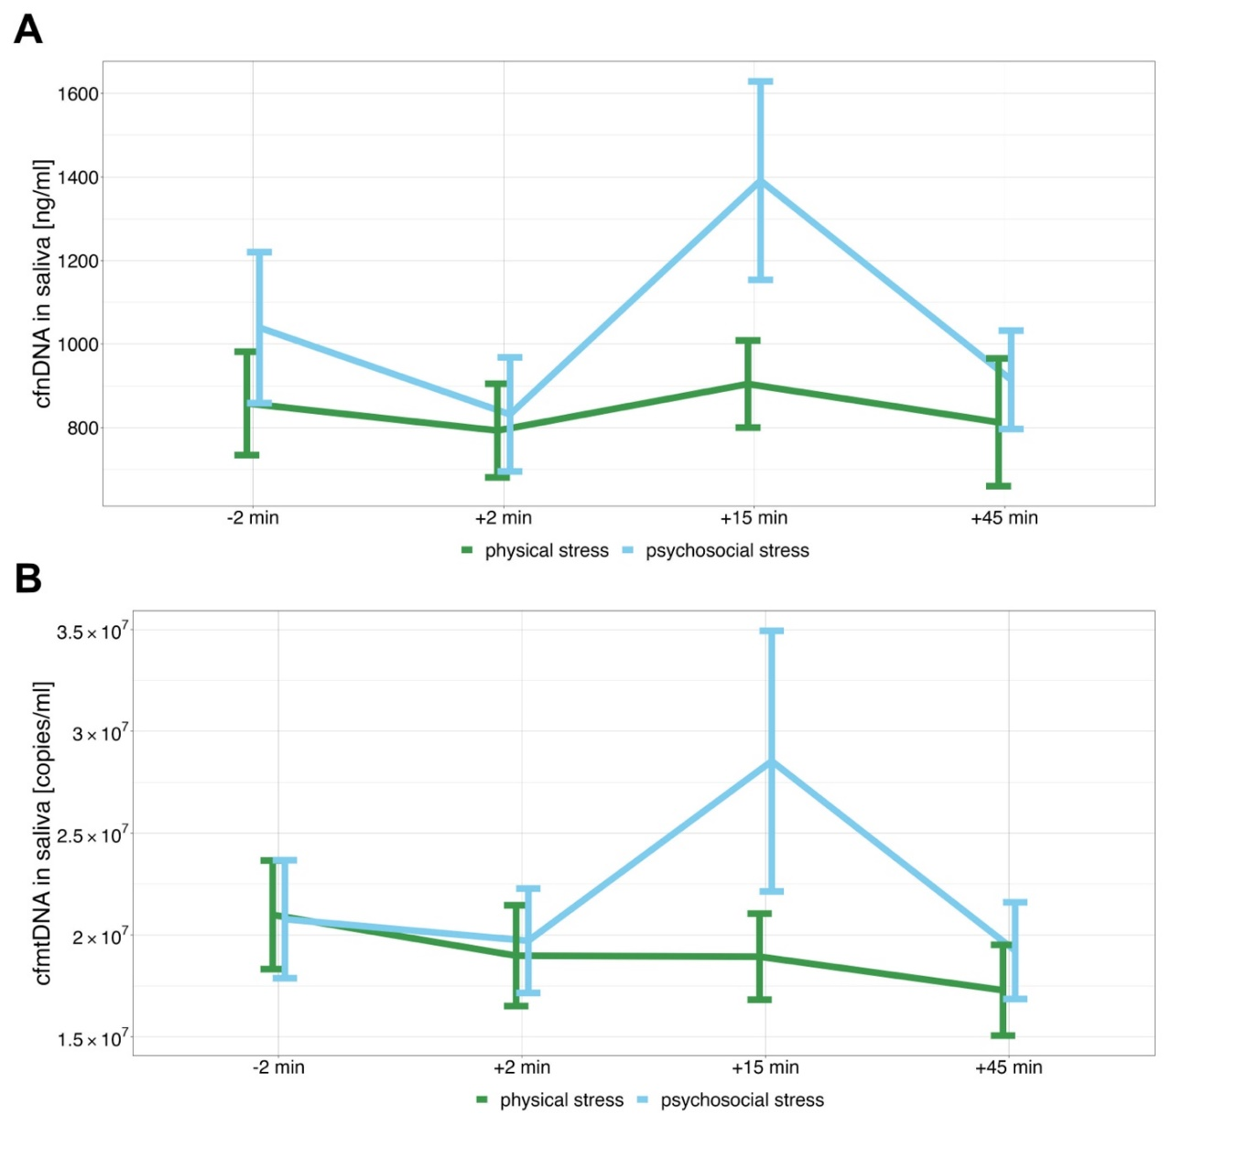
Supplementary figure 4 cf-nDNA and cf-mtDNA in saliva. A) cf-nDNA concentration and B) cf-mtDNA concentration in saliva before and after physical and psychosocial stress. Saliva cf-nDNA is plotted in ng/ml over time. Saliva cf-mtDNA is represented in copies/ml over time. Error bars display standard error of the mean

Supplementary Results

Changes in subjective stress perception
For the investigation of changes in the subjective stress perception the data of 43 of the 46 participants was included into the analysis (13 m, 14 w, 16 woc).
Descriptive Analysis of the data revealed that “tense arousal” and “self-directed emotions” increased during both stress conditions. Moreover, both dimensions also showed a peak at T2, followed by a decline in both dimensions. Contrary the third investigated dimension “anxiety” showed a rather shallow progression over time without a distinct peak after the stressor (supplementary figure 5).

Tense arousal
The ANOVA for “tense arousal” revealed a main effect for the measuring timepoint (F(2,42,96,61) = 50.52, p < .001, η2p = .56) as well as an interaction between measuring timepoint and type of stressor (F(2,15,85,81) = 5.87, p = .003, η2p = .13). All other effects were not significant. The ANOVA was followed by post hoc tests, which revealed a two-fold interaction effect within the types of stress with significant differences in the information on tense arousal between the measuring timepoints for the physical (F(2,42,102) = 27.0, p < .001, η2p = .13) and the psychosocial stressor (F(2,16,90,6) = 35.7, p < .001, η2p = .46). Additional pairwise comparisons (see supplemental figure 6) showed that for the physical stressor at T1 the arousal was significantly elevated after the stressor at T2 (t(42) = -2.84, p = .02). Moreover, at T4, arousal was significantly lower in contrast to baseline levels (t(42) = 5.72, p < .001). T3 arousal levels did not differ significantly from baseline. For the psychosocial stressor the reported tense arousal was significantly higher at T1 than T3 (t(42) = 4.4, p < .001) and T4 (t(42) = 7.35, p < .001). Correspondingly there was a significantly lower tense arousal at T1 than at T2 (t(42) = -3.1, p = .003).

Anxiety and self-directed emotions
Data of the anxiety and self-directed emotions scale were not evaluated statistically due to major violations of the assumption of normality.
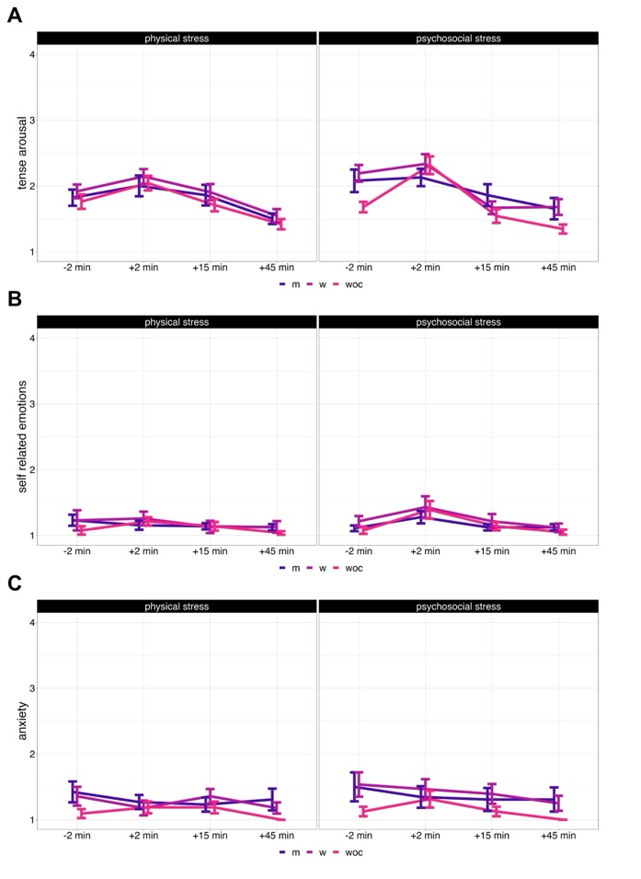
Supplementary figure 4Supplementary figure 5 SERS questionnaire responses. Trend of A) tense arousal B) self-related emotions and C) anxiety responses of the three groups (m = men, w = women, woc = women with hormonal contraception)) before and after physical and psychosocial

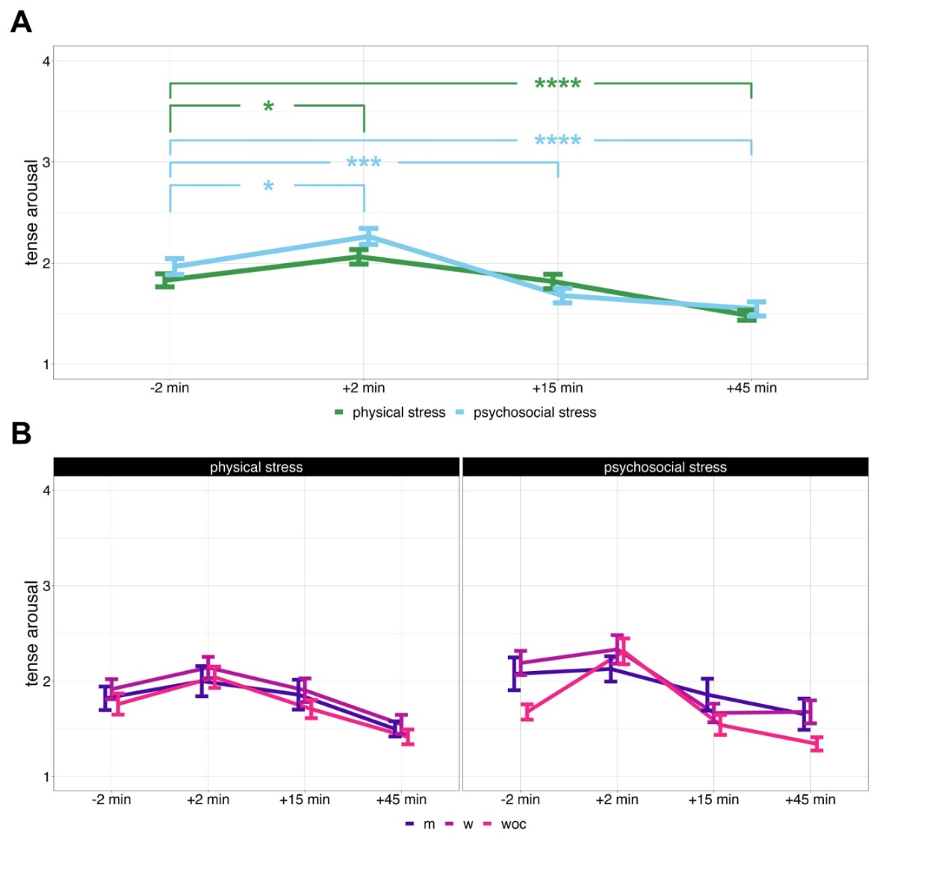
Supplementary figure 6 SERS tense arousal responses. Trend of tense arousal after acute physical and psychosocial stress for all participants (A) and for the three different groups (B; m = men, w = women, woc = women with hormonal contraception). Error bars display standard error of the mean. * p < .05, ** p < .01, *** p < .001, **** p < .0001

