Supplemental Table 1 OTU numbers of tomato endophyte samples
BMK_ID | OUT Num | Seqs Num
T1ORGR | 487 | 139910
T2CONR | 503 | 267257
T2CONS | 452 | 214359
T2ORGR | 464 | 154828
T2ORGS | 516 | 168367
T3CONR | 577 | 206517
T3CONS | 402 | 40983
T3ORGR | 506 | 189908
T3ORGS | 338 | 20010
T4CONR | 492 | 32275
T4CONS | 498 | 58841
T4ORGR | 519 | 52344
T4ORGS | 420 | 58173
TICONR | 517 | 332457
TICONS | 375 | 48061
TIORGS | 274 | 30702
Total | 648 | 2014992

TIORGR：organic system root endophyte in the seeding stage, T2ORGR: organic system root endophyte in the flowering stage, T3 ORGR: organic system root endophyte in the fruiting stage, T4ORGR: organic system root endophyte in the harvesting stage. TICONR: conventional system root endophyte in the seeding stage, T2CONR: organic system root endophyte in the flowering stage, T3 CONR: organic system root endophyte in the fruiting stage, T4CONR: organic system root endophyte in the harvesting stage. TIORGS: organic system stem endophyte in the seeding stage, T2ORGS: organic system stem endophyte in the flowering stage, T3 ORGS: organic system stem endophyte in the fruiting stage, T4ORGS: organic system stem endophyte in the harvesting stage. TICONS: conventional system stem endophyte in the seeding stage, T2CONS: conventional system stem endophyte in the flowering stage, T3 CONS: conventional system stem endophyte in the fruiting stage, T4CONS: organic system stem endophyte in the harvesting stage.
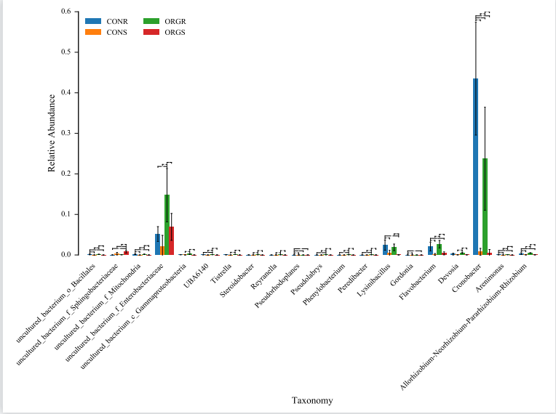
Supplemental Fig. 1Discrepancy taxonomy of endophyte communities between organic and conventional agricultural practices (class level) CONR: conventional system root endophyte, CONS: conventional system stem endophyte, ORGR: organic system root endophyte, ORGS: organic system stem endophyte. (* denote significant, p <0.05; ** denote extremely significant, p< 0.01).

