Supplementary information for
Ontogeny of predatory capacity and prey choice during early life history of the holobenthic octopus Amphioctopus fangsiao (d’Orbigny, 1841): switching prey-choice strategy

Nozomi Awaª, Shigeki Dan^{a*}, Kota Nagatsukaª, Yumiko Sekiguchiª, Ayako Shimbaª, Yuji Anaguchi^{b}, Yoshinori Kamei^{c}, Katsuyuki Hamasakiª

ª Department of Marine Biosciences, Tokyo University of Marine Science and Technology, Konan, Minato, Tokyo 108-8477, Japan
^{b} Ocean Construction Co., Ltd., Kurashiki, Okayama 711-0924, Japan
^{c} Research Institute for Fisheries Science, Okayama Prefectural Technology Center for Agriculture, Forestry, and Fisheries, Setouchi, Okayama 701-4303, Japan

* Corresponding author.
E-mail address: sdan@kaiyodai.ac.jp (S. Dan).
Table S1 Contents of nutrients and energy of bivalve Ruditapes philippinarum, gastropod Littorina brevicula, and mysid Neomysis awatschensis used as prey organisms for Amphioctopus fangsiao
Content (dry matter basis) | Clam | Gastropod | Mysid
Crude protein (g 100g⁻¹) | 72.2 | 48.7 | 80.4
Total lipid (g 100g⁻¹) | 7.6 | 5.1 | 7.1
Carbohydrate (g 100g⁻¹) | 0 | 19.0 | 0
Ash (g 100g⁻¹) | 20.3 | 27.1 | 12.5
Energy (kJ g⁻¹) | 14.829 | 13.334 | 16.437

Table S2 Coefficient estimates with standard error (SE) for the linear model (LM) to estimate the relationship between prey size (SH or SL in mm) and force (N) required for an octopus (Amphioctopus fangsiao) to open the valves of a bivalve (Ruditapes philippinarum) or to detach a gastropod (Littorina brevicula); and for the generalized linear model (GLM) to estimate the relationship between octopus WW (g) and the proportion of successful attacks on mysid (Neomysis awatschensis)
Response variable | Explanatory variable | Coefficient | SE | t, z | P
Force (N) required to open bivalve valves | Intercept | -3.349 | 0.273 | -12.3 | < 0.0001
Force (N) required to open bivalve valves | SL | 1.597 | 0.137 | 11.7 | < 0.0001
Force (N) required to detach a gastropod | Intercept | -2.980 | 1.140 | -2.62 | 0.0149
Force (N) required to detach a gastropod | SH | 0.374 | 0.594 | 0.629 | 0.5354
Proportion of successful attacks on mysids | Intercept | -2.469 | 0.085 | -29.1 | < 0.0001
Proportion of successful attacks on mysids | Octopus WW | 0.965 | 0.085 | 11.4 | < 0.0001
SL, shell length; SH, shell height; WW, wet weight. Log-transformed N, SL, SH, and WW were used in the LMs and GLM. Bold letters indicate statistical significance of explanatory variables
Table S3 Coefficient estimates with standard error (SE) test statistics generated by the F test based on the LMM estimating the relationship between wet weight (g) of octopuses Amphioctopus fangsiao and size (SL or SH in mm) of bivalves Ruditapes philippinarum and gastropods Littorina brevicula consumed by the octopus
Response  variable | Explanatory  variable | Estimated |  |  |  | F test
Response  variable | Explanatory  variable | Coefficient | SE | t |  | F | DF | P
Maximum SL of bivalve  consumed | Intercept | 2.048 | 0.023 | 87.8
Maximum SL of bivalve  consumed | Octopus WW | 0.246 | 0.021 | 11.5 |  | 128.7 | 1, 27.9 | < 0.0001
Mean SL of bivalve  consumed | Intercept | 1.809 | 0.039 | 46.5
Mean SL of bivalve  consumed | Octopus WW | 0.186 | 0.022 | 8.45 |  | 70.57 | 1, 31.4 | < 0.0001
Maximum SH of gastropod  consumed | Intercept | 1.945 | 0.022 | 90.3
Maximum SH of gastropod  consumed | Octopus WW | 0.078 | 0.018 | 4.33 |  | 17.6 | 1, 24.1 | 0.0003
Mean SH of gastropod  consumed | Intercept | 1.837 | 0.018 | 100.8
Mean SH of gastropod  consumed | Octopus WW | 0.074 | 0.015 | 5.09 |  | 24.2 | 1, 32.8 | < 0.0001
SL, shell length; SH, shell height. Bold letters indicate statistically significant explanatory variables. Log-transformed SH, SL, and WW were used in the LMMs (linear mixed-effects models)
Table S4 Coefficient estimates with standard error (SE) for the GLMM to evaluate the effects of octopus growth on accumulated handling time and energy intake in 24 h by Amphioctopus fangsiao
Response variable | Explanatory variable | Coefficient | SE | t | P
Accumulated handling time for 24 h  (H_{t}) | Intercept | 5.264 | 0.099 | 53.3 | < 0.0001
Accumulated handling time for 24 h  (H_{t}) | Octopus WW | -0.035 | 0.072 | -0.48 | 0.6310
Accumulated energy intake for 24 h  (E_{t}) | Intercept | 5.605 | 0.058 | 101 | < 0.0001
Accumulated energy intake for 24 h  (E_{t}) | Octopus WW | 0.565 | 0.055 | 10.3 | < 0.0001
WW, wet weight. Bold letters indicate statistically significant explanatory variables. Log-transformed WW was used in the GLMMs (generalized linear mixed-effect models)

Table S5 Coefficient estimates with standard error (SE) for the GLMM to test the effect of wet weight (g) of Amphioctopus fangsiao and prey size (mm) on the handling time required to consume individual prey
Response variable | Explanatory variable | Coefficient | SE | t | P
Handling time required to consume a bivalve  (H_{b}) | Intercept | 2.728 | 0.643 | 4.24 | < 0.0001
Handling time required to consume a bivalve  (H_{b}) | Octopus WW | -0.988 | 0.108 | -8.84 | < 0.0001
Handling time required to consume a bivalve  (H_{b}) | Bivalve SL | 2.083 | 0.351 | 5.94 | < 0.0001
Handling time required to consume a gastropod  (H_{g}) | Intercept | 8.452 | 0.700 | 12.1 | < 0.0001
Handling time required to consume a gastropod  (H_{g}) | Octopus WW | -0.198 | 0.054 | -3.68 | 0.0002
Handling time required to consume a gastropod  (H_{g}) | Gastropod SH | -0.312 | 0.385 | -0.81 | 0.4171
Handling time required to consume a mysid  (H_{m}) | Intercept | 5.629 | 0.099 | 56.6 | < 0.0001
Handling time required to consume a mysid  (H_{m}) | Octopus WW | -0.435 | 0.071 | -6.09 | < 0.0001
SH, shell height; SL, shell length; WW, wet weight. Bold letters indicate statistically significant explanatory variables. Log-transformed SH , SL and WW were used in the GLMMs (generalized linear mixed-effect models)

Table S6 Coefficient estimates with standard error (SE) for the GLMM to test the effect of wet weight (g) of Amphioctopus fangsiao on the rate of energy (J) intake per unit time to consume individual prey
Response variable | Explanatory variable | Coefficient | SE | t | P
Rate of energy intake per unit time for a bivalve  (E_{b}/H_{b}) | Intercept | -2.417 | 0.164 | -14.7 | < 0.0001
 | Octopus WW | 1.126 | 0.082 | 13.7 | < 0.0001
Rate of energy intake per unit time for a gastropod  (E_{g}/H_{g}) | Intercept | -3.133 | 0.093 | -33.6 | < 0.0001
 | Octopus WW | 0.518 | 0.075 | 6.93 | < 0.0001
Rate of energy intake per unit time for all prey consumed for 24 h  (E_{t}/H_{t}) | Intercept | -3.257 | 0.067 | -48.4 | < 0.0001
 | Octopus WW | 0.682 | 0.062 | 11.1 | < 0.0001
WW, wet weight. Bold letters indicate statistically significant explanatory variables. Log-transformed WW was used in the GLMMs (generalized linear mixed-effect model)

Table S7 Analysis of deviance for the Type II Wald χ² test to assess the effects of explanatory variables on choice of prey species, handling time, H, and energy content, E, of different prey species by Amphioctopus fangsiao in GLMMs
Response variable | Explanatory variable | χ² | df | P
Proportion of a certain prey species among the total number of prey consumed  (N_{b}/N_{t}, N_{g}/N_{t}, and N_{m}/N_{t}) | Octopus WW | 0.011 | 1 | 0.9155
 | Prey species | 16.76 | 2 | 0.0002
 | Interaction of WW  and prey species | 11.79 | 2 | 0.0028
Proportion of handling time, H, spent to consume a certain prey species among the total handling time to consume all prey  (H_{b}/H_{t}, H_{g}/H_{t}, and H_{m}/H_{t}) | Octopus WW | 0.004 | 1 | 0.9480
 | Prey species | 408970 | 2 | < 0.0001
 | Interaction of WW  and prey species | 858.4 | 2 | < 0.0001
Proportion of energy, E, obtained from a certain prey species among the total energy intake for all prey  (E_{b}/E_{t}, E_{g}/E_{t}, and E_{m}/E_{t}) | Octopus WW | 30.08 | 1 | < 0.0001
 | Prey species | 7300 | 2 | < 0.0001
 | Interaction of WW  and prey species | 2960 | 2 | < 0.0001
WW, wet weight. Bold letters indicate statistically significant explanatory variables. Log-transformed WW was used in the GLMMs (generalized linear mixed-effects models)

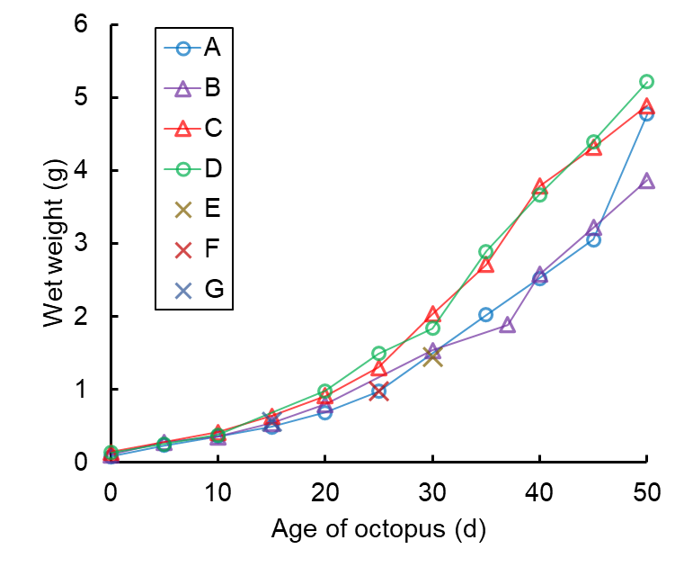
Fig. S1 Changes in wet weight of juveniles of Amphioctopus fangsiao reared for 50 d after hatching. Juveniles A−D were used for experiments once every 5 d. (Juveniles E-G were used as occasional substitutes; see Materials and Methods)

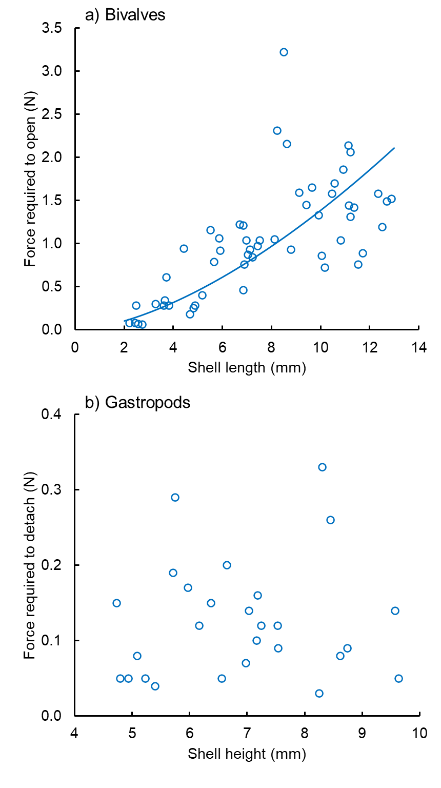
Fig. S2 Relationships between (a) bivalve shell length and force required to open the two shell valves, and (b) gastropod shell height and force required to detach it from the surface of the arena. Solid line represents the statistically significant coefficient P < 0.05, estimated using a linear model

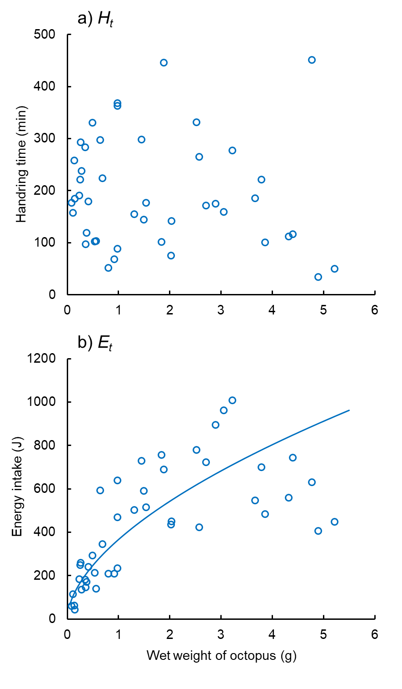
Fig. S3 Changes in (a) accumulated time H_{t} spent to handle and consume prey organisms, and (b) energy E_{t} obtained during the 24 h experimental period by a juvenile Amphioctopus fangsiao. Solid line represents statistically significant coefficients at P < 0.05, estimated using a GLMM (generalized linear mixed-effect model)

