Supplement information
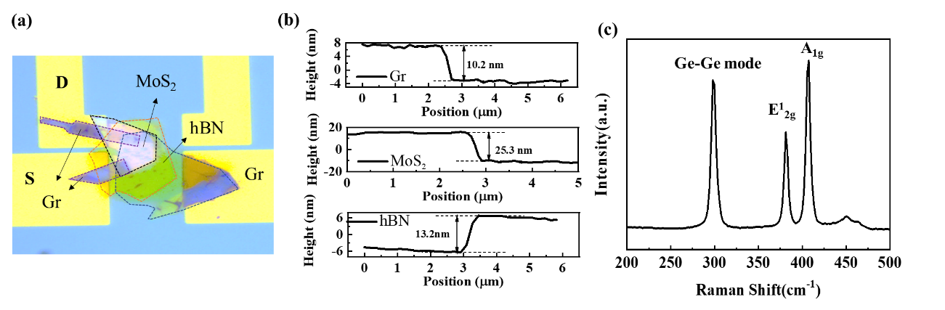
Figure S1 a) Optical image of the FG-PT. b) Measured thicknesses of Gr, MoS₂ and hBN flakes from the AFM results. c) Raman spectra of Ge and MoS₂ flakes in the dual-gate phototransistor.

Figure S2 illustrates the electrical reconfigurability effect of the device. The device is in the normally off state under the programming voltage of 10V(1ms), and when the programming voltage is 7.5V(1ms), the device is in the conventional MOS operating mode, with a switching ratio of 10⁵, and when the device is in the erased state, it appears in the normally on state. The current level is 10⁶. No matter which programming state the device is in, it shows an obvious positive response under 532 nm light and an obvious negative response under 1550nm light. The positive infrared response in the programming state mainly comes from the transfer curve shift effect caused by the photogating effect, which once again verifies the source of the infrared light response.
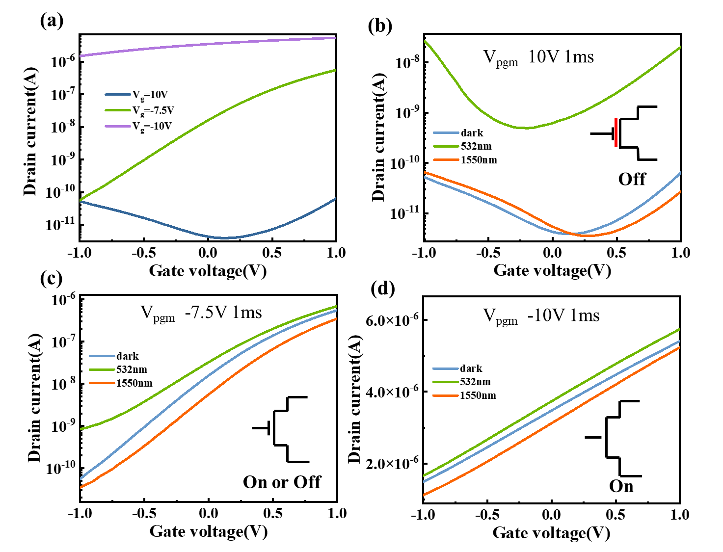
Figure S2 a) Transfer curves of the device in different programming states. b) The transfer curve of the device under programming state (10V 1ms) and the transfer curve under 532nm and1550nm illumination. c) The transfer curve of the device under programming state (-7.5V 1ms) and the transfer curve under 532nm and1550nm illumination. d) The transfer curve of the device under erase state (-10V 1ms) and the transfer curve under 532nm and1550nm illumination.

Figures S3 show the simulation results of the device using TCAD software. Figure S3a and 3b shows the electron distribution diagram of the channel under different floating gate charges. It can be clearly seen that when there are more electrons in the floating gate, the channel can be effectively depleted. The electrons in the channel concentration decreased.
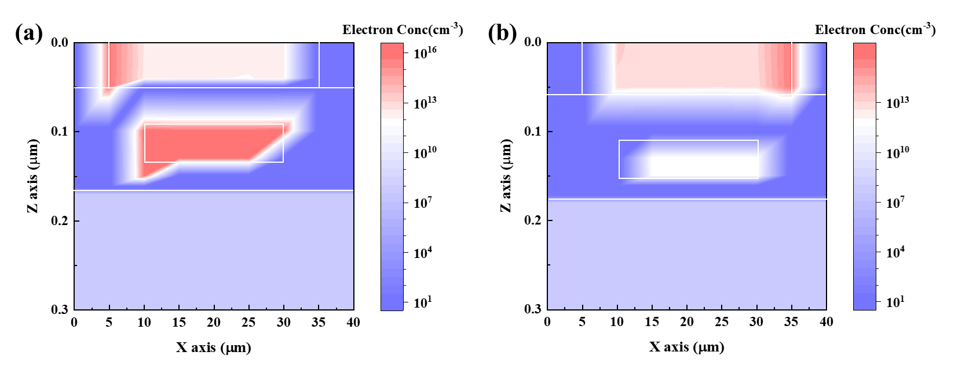
Figure S3 Simulation results of the device by TCAD. The electron distribution diagram under different floating gate charges: a) The floating gate charge is 1e¹⁶. b) The floating gate charge is 1e¹².

In order to further determine the source of the photogating effect, we built MOSFET structural devices with different substrate types, and the channel materials were all MoS₂. As shown in Figures d-f, under infrared illumination, only the P-type substrate shows a negative photoresponse, while both the I-type and n-type substrates show a positive photoresponse. We think this is mainly related to the energy band structure. Since the work function of P-type Ge is greater than the work function of MoS₂ (Figure S5b), the Ge energy band bends downward, resulting in electron accumulation. Under 1550 nm light, Ge absorbs infrared light to generate a large number of photogenerated carriers. As shown in Figure S5c, the generated holes moved to the bulk of the Ge, the generated electrons accumulated at the SiO₂/Ge interface. The accumulated electrons will further deplete the MoS₂ channel and pull up the energy band of the MoS₂. The carrier concentration in the channel is effectively reduced. Therefore, a small channel current is observed under 1550 nm illumination, showing an obvious negative photoresponse. In addition, we also tested the photocurrent variation curves of three devices under different optical powers (Figure S5a). The photocurrent increases almost linearly (α= 0.16, 0.38 0.6) with power density. Since the coefficients are all much less than 1, this indicates that photogating effect becomes the dominant photodetection mechanism in the three devices.
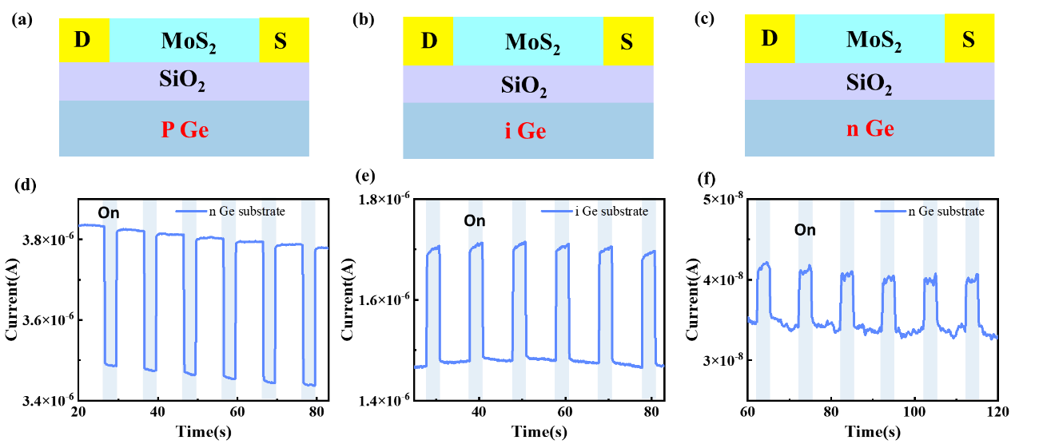
Figure S4 The optical microscope pictures (a-c), device structure diagrams(d-f), and infrared light response(g-i) of devices on p-type substrates, i-type substrates and n-type Ge substrates.

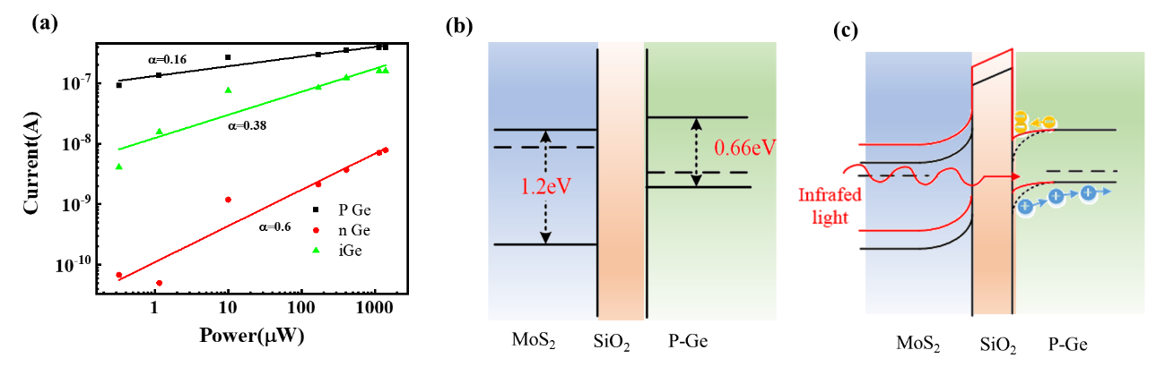
Figure S5 a) Device photocurrent changes curve with optical power. Energy band diagram of the device in the vertical direction b) Before Fermi level equilibrium, b) with infrared light (1550 nm) using a Ge gate.

After the device is connected in series with a fixed resistor, the effect of the light response of the device on the output voltage under different illumination and the change in the proportional relationship between the device and resister can be derived from the following formula.
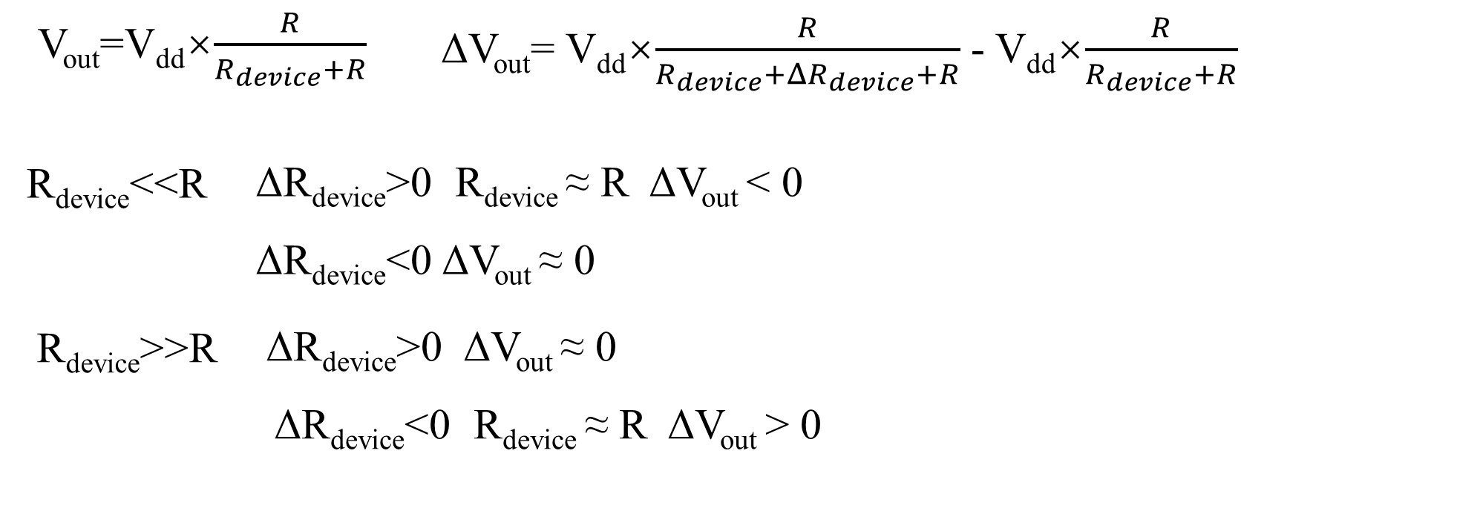
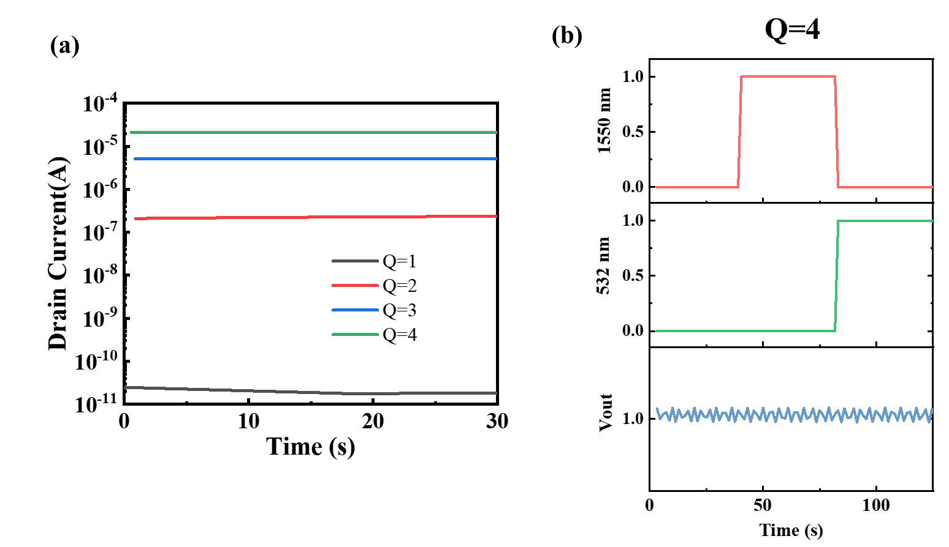

Figure S6 a) Modulate the device into different current states by applying different voltage pulses. b) Output voltage and visible-infrared light response under Q=4 states.

Figures S7 show the electron current distribution diagrams under different floating gate charges and under different lighting conditions. When the device is in the Q=1 state, the channel current is small. Under 532 nm illumination, the device current density increases significantly. However, under 1550 nm illumination, the device shows a negative response. Since the channel current itself has a small current density, the channel current density increases significantly. The current density does not change much. When the device is in the Q=3 state, the channel current is large. Under 532nm illumination, the device shows a positive response. However, because the current density of the device is large, the current density does not change significantly. Under 1550 nm illumination, an obvious depletion zone appears in the channel.

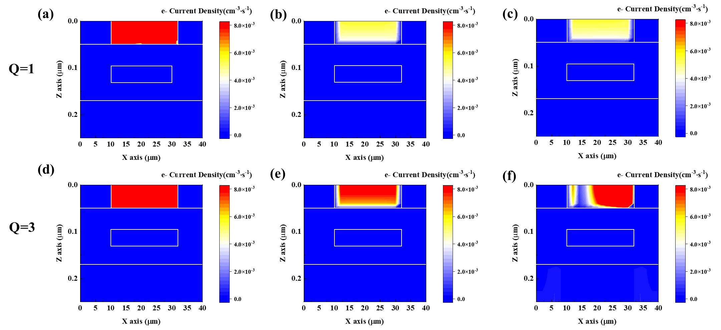
Figure S7 a-c: show the electron current distribution under different lighting conditions when the floating gate charge is larger (Q=1). a) under 532 nm light, b) is under dark conditions, and c) is under 1550nm light. d-f: show the electron current distribution under different lighting conditions when the floating gate charge is small (Q=3). d) under 532 nm light, e) is under dark conditions, and f) is under 1550nm light.

Figure S8 shows the imaging effect of the device in encryption and decryption scenarios. In addition to improving the recognition rate, the wavelength extraction function can also be used as an encryption imaging tool. When the encrypted information is encoded as visible infrared cross-visible, and when the device is used for decoding, the device state becomes password. The complete effect can only be presented when Q=2. Under Q=1 and Q=3 states, both password error effect.

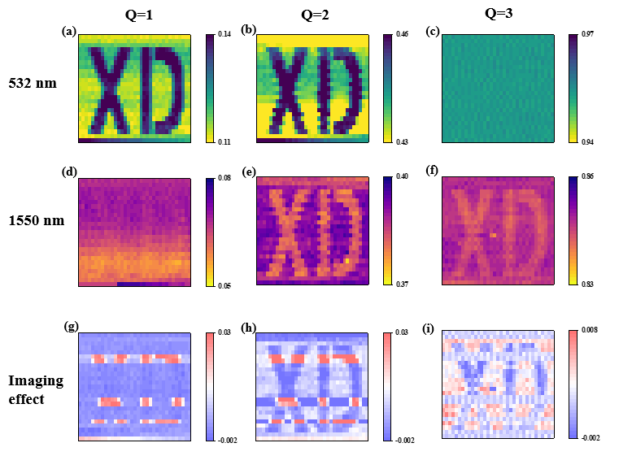
Figure S8 The imaging effect of the words ‘XD’ at different device conditions.

Since the device has a positive response under visible light and a negative response under infrared light, simultaneous illumination of two beams of light will inevitably lead to the problem of mutual cancellation of the light responses. Figures S9 describe the device’s imaging effect with consistent light intensity under visible infrared illumination. When the device is in the Q=1 state, the device resistance is large and V_{out} is around 0.006. At this time, the visible light response is very obvious and the infrared light response is small. The visible light response is 1.83 times that of the infrared light response, so the device can achieve effective visible light extraction function. When the device is at Q=2, V_{out} is around 0.4V, and the visible light response is equivalent to the infrared light response. When the device is at Q=3, V_{out} is around 0.977. At this time, the visible light response is much smaller than the infrared light response, and the visible light response is about 0.4 times the infrared light response. Therefore, the infrared light signal extraction function is realized in this state. Therefore, the device can also realize the single-wavelength signal extraction function of visible light/infrared light when irradiated with visible infrared light at the same time.
In conventional imaging systems, when a single-band imaging effect is required, whether it is a wide-spectrum detector or a visible-infrared combination detector, a filter or grating component needs to be added to filter out excess light sources to achieve a single-band light source (Figure 9c). In this system, because the wavelength extraction is implemented at the device side, complex optical designs such as optical paths and optical components are eliminated, which effectively improves system integration and greatly reduces complexity, as shown in Figure 9d.
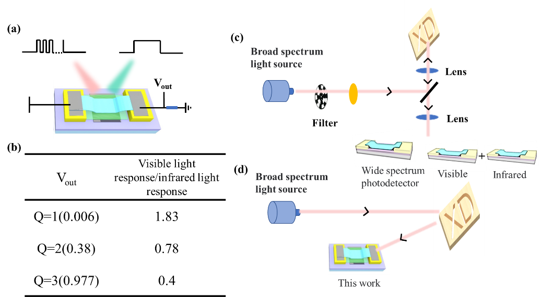
Figure S9 a) Schematic diagram of the device structure under different frequencies of visible infrared light. b) Schematic diagram of the visible infrared light response of the device in different states. Schematic diagram of single-spectrum imaging under wide-spectrum light source: c) traditional mode and d) this device mode.

S10:
The results in Figure 7 are mainly obtained through the quantitative spectral image calculation method based on the ray tracing algorithm. The specific process is as follows:
(1) Segmenting ground object materials for visible light remote sensing images. The ground object materials are divided into four major categories: roads, water bodies, woodlands, and urban areas.
(2) Assign the spectral reflectance of each type of material based on public information. At the same time, given the average temperature distribution of various objects, the details of each major area use the color of visible light as the modulation factor to generate a random fluctuation distribution of temperature, with a variance of 5 degrees.
(3) Query the public DEM terrain data based on the longitude and latitude of the remote sensing image, and generate a three-dimensional terrain geometry network of the terrain area.
(4) Under typical meteorological conditions, establish a ray tracing equation and use the Monte Carlo algorithm to solve the radiation field distribution reaching the entrance pupil of the imaging system.
(5) Use the digital model of the imaging system to optically modulate and spatially sample the radiation field to generate the irradiance distribution reaching the detector surface.
(6) According to the detector response model, the irradiance is photoelectrically converted to generate a digital signal, which is stored as an 8-bit grayscale image.
In Figure 7, the device input data is the wide-spectrum imaging data of the device in the Q=1 and Q=3 states. The visible light band is 500 ‒ 600 nm and the infrared light band is 1000 ‒1600 nm.

