Supplementary information for:
Accumulation, contamination, Health and ecological risk assessment of heavy metals in landfill soil: case study of Shiraz city in the Middle East
Ali Ghandeharizadeh ª, Mansooreh Dehghani ^{b*}, Abolfazl Azhdarpoor ^{b}, Hassan Hashemi ^{b} Azadeh Binai Haghighi ^{b}, narges shamsedini ª

ª Department of Environmental Health Engineering, School of Health, Student Research Committee, Shiraz University of Medical Sciences, Shiraz, Iran
b Department of Environmental Health Engineering, School of Health, Shiraz University of Medical Sciences, Shiraz, Iran
Corresponding author: Mansooreh Dehghani
E-mail:mandehghani@yahoo.com

List of Figures:
Fig S1. The average heavy metal concentrations in the soil from the Shiraz landfill
Fig S2. The average heavy metal concentrations in the area surrounding the Shiraz landfill
Fig S3. GRAPH/HISTOGRAM(NORMAL)=cd.
Fig S4. Organic carbon values at different sampling points

List of Tables:
Table S1. The results for the Independent Samples Test
Table S2. The results for the Mann-Whitney U test in two seasons
Table S3. The daily exposure for non-carcinogenic risk of heavy metals in the soil and surroundings of the Shiraz landfill
Table S4. The non-carcinogenic risk index of heavy metals in the soil and surroundings of the Shiraz landfill
Table S5. The daily exposure for carcinogenic risk of heavy metals in the soil from the Shiraz landfill
Table S6. The daily exposure for carcinogenic risk of heavy metals in the area surrounding the Shiraz landfill

Fig S1. The average heavy metal concentrations in the soil from the Shiraz landfill
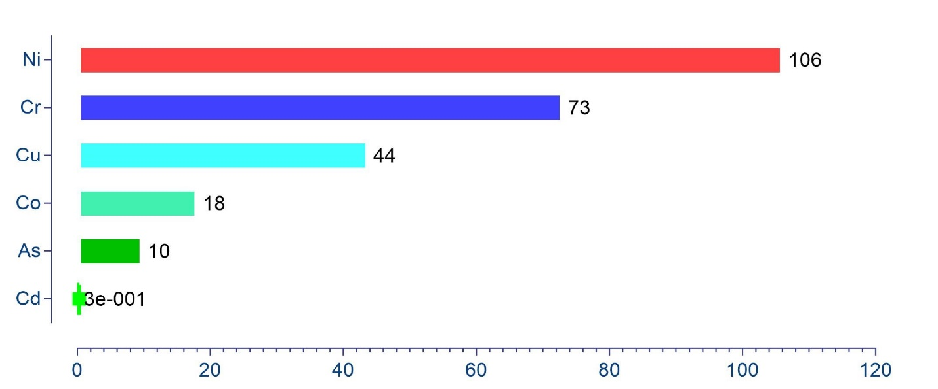

Fig S2. The average heavy metal concentrations in the area surrounding the Shiraz landfill
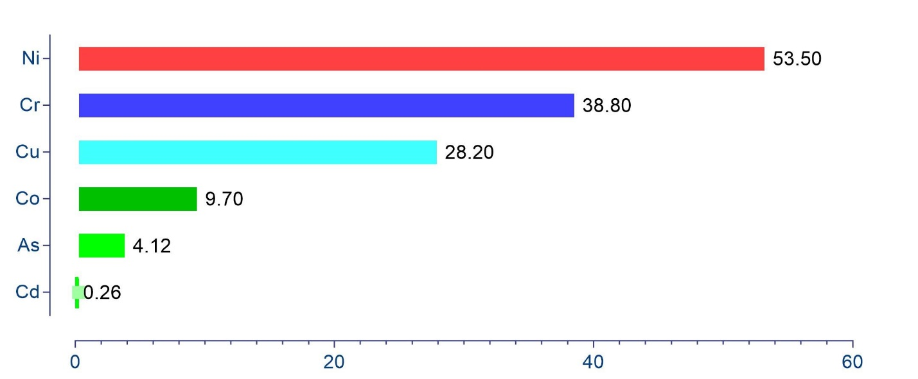

Fig S3- GRAPH/HISTOGRAM(NORMAL)=cd.
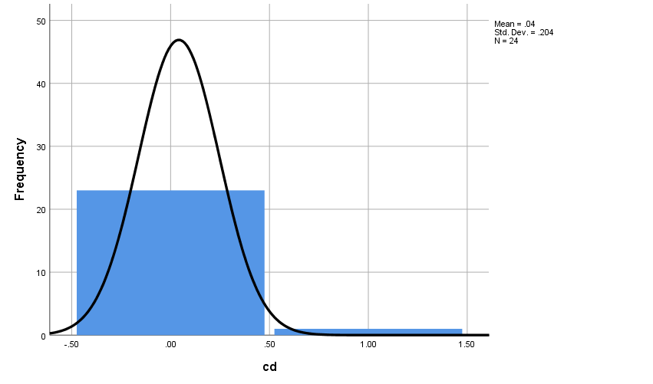

Fig S4. Organic carbon values at different sampling points
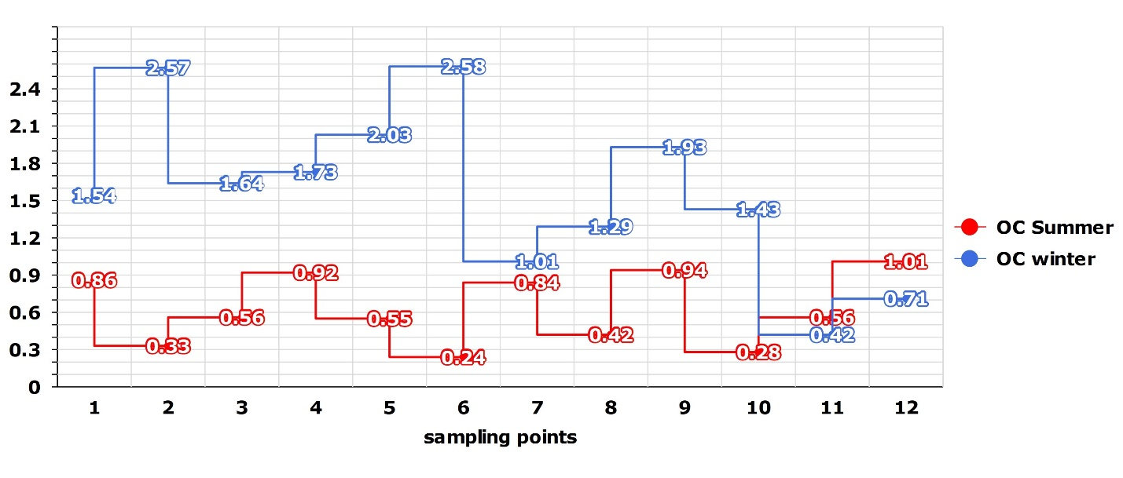

Table S1. The results for the Mann-Whitney U test in two seasons
 | Cr | Cu | Ni | Co | As | cd
Mann-Whitney U | 59.500 | 44.500 | 59.500 | 67.000 | 27.000 | 55.500
Wilcoxon W | 137.500 | 122.500 | 137.500 | 145.000 | 105.000 | 133.500
Z | -.723 | -1.593 | -.724 | -.294 | -2.601 | -.958
Asymp. Sig. (2-tailed) | .470 | .111 | .469 | .769 | .009 | .338
Exact Sig. [2*(1-tailed Sig.)] | .478 | .114 | .478 | .799 | .008 | .347
a. Grouping Variable: fasl

Table S2 Independent Samples Test
 |  | Levene's Test for Equality of Variances |  | t-test for Equality of Means
 |  | F | Sig. | t | df | Sig. (2-tailed) | Mean Difference | Std. Error Difference | 95% Confidence Interval of the Difference
 |  |  |  |  |  |  |  |  | Lower | Upper
Cd | Equal variances assumed | 3.832 | .063 | -.806 | 22 | .429 | -.07667 | .09515 | -.27400 | .12067
Cd | Equal variances not assumed |  |  | -.806 | 11.197 | .437 | -.07667 | .09515 | -.28565 | .13231

Table S3. The daily exposure for non-carcinogenic risk of heavy metals in the soil and surroundings of the Shiraz landfill
 | CDI _{Ingest} |  | CDI _{Inhale} |  | CDI _{Dermal} |  | CDI _{Total}
 | Adults | Children | Adults | Children | Adults | Children | Adults | Children
As | 1.26E-05 | 9.05E-05 | 1.86E-09 | 2.54E-09 | 9.50E-08 | 2.53E-07 | 1.26E-05 | 9.07E-05
Cd | 5.06E-07 | 3.61 E-06 | 7.44E-11 | 1.01E-10 | 3.79E-09 | 1.01E-08 | 5.09E-07 | 3.62E-06
Cu | 6.30E-05 | 45E-05 | 9.26E-09 | 1.26E-08 | 4.72E-07 | 1.25E-06 | 6.34E-05 | 45E-05
Ni | 14E-05 | 10E-04 | 2.09E-08 | 2.85E-08 | 1.06E-06 | 2.84E-06 | 14E-05 | 10E-04
Cr | 9.93E-05 | 7.09E-04 | 1.46E-08 | 1.99E-08 | 7.44E-07 | 1.98E-06 | 1E-04 | 7.10E-04

Table S4. The non-carcinogenic risk index of heavy metals in the soil and surroundings of the Shiraz landfill
 | HQ _{Ingest} |  | HQ _{Inhale} |  | HQ _{Dermal} |  | HQ
 | Adults | Children | Adults | Children | Adults | Children | Adults | Children
As | 42E-03 | 30E-02 | 6.2E-09 | 8.46E-09 | 77E-05 | 20E-04 | 4.2E-02 | 3.02E-01
Cd | 5.06E-04 | 3.61E-03 | 7.44E-08 | 1.01E-10 | 3.79E-04 | 1.01E-03 | 8.85E-04 | 4.62E-03
Cu | 1.57E-03 | 1.12E-02 | 2.31E-07 | 3.15E-07 | 3.93E-05 | 1.04E-04 | 1.60E-03 | 1.13E-02
Ni | 7E-03 | 5E-02 | 1.01E-06 | 1.38E-06 | 1.96E-04 | 5.25E-04 | 7.19E-03 | 5.05E-02
Cr | 3.31E-02 | 2.36E-01 | 5.10E-04 | 6.97E-04 | 2.48E-04 | 6.61E-04 | 3.38E-02 | 2.49E-02
HI
Adults | children
0.0854 | 0.3933

Table S5. The daily exposure for carcinogenic risk of heavy metals in the soil from the Shiraz landfill
 | CDI _{Ingest} |  | CDI _{Inhale} |  | CDI _{Dermal} |  | CDI _{Total}
 | Adults | Children | Adults | Children | Adults | Children | Adults | Children
As | 5.74E-06 | 1.02E-05 | 8.45E-10 | 2.88E-10 | 4.30E-08 | 2.86E-08 | 5.78E-06 | 1.02E-05
Cd | 1.85E-07 | 3.30 E-07 | 2.72E-11 | 9.30E-12 | - | - | 1.85E-07 | 3.30E-07
Cr | 4.23E-05 | 7.56E-05 | 6.22E-09 | 2.12E-09 | 3.17E-07 | 2.11E-07 | 4.26E-05 | 7.58E-05
Ni | 6.14E-05 | 1.09E-04 | 9.04E-09 | 3.08E-09 | 4.6E-07 | 3.06E-07 | 6.18E-05 | 1.09E-04

Table S6. The daily exposure for carcinogenic risk of heavy metals in the area surrounding the Shiraz landfill
 | CDI _{Ingest} |  | CDI _{Inhale} |  | CDI _{Dermal} |  | CDI _{Total}
 | Adults | Children | Adults | Children | Adults | Children | Adults | Children
As | 2.38E-06 | 4.25E-06 | 3.50E-10 | 1.19E-10 | 1.78E-08 | 1.19E-08 | 2.39E-06 | 4.26E-06
Cd | 1.51E-07 | 2.30E-11 | 2.70E-07 | 7.61E-12 | - | - | 4.21E-07 | 3.06E-11
Cr | 2.24E-05 | 4.01E-05 | 3.30E-09 | 1.12E-09 | 1.68E-07 | 1.12E-07 | 2.25E-05 | 4.02E-05
Ni | 3.09E-05 | 5.53E-05 | 4.55E-09 | 1.55E-09 | 4.73E-07 | 1.54E-07 | 3.13E-05 | 5.54E-05

