Supplementary Information

ANTIMALARIAL POTENTIAL OF A MARINE SPONGE Tedania ignis AGAINST Plasmodium falciparum
Caio S. Moura^{1#}, Yasmin Annunciato^{1#}, Thais B. V. Dantas², Wéldion Gonçalves Mesquita Júnior², Larissa R. G. da Silva^{3,4}, Erica P. M. L. Peres¹, Larissa A. Bafoni¹, Renata Neves Granito¹, Ana Cláudia Muniz Renno¹, Marcos Gazarini Dutra¹, Quezia B. Cass³, Lorena R. Freitas de Sousa^{2*}, Anna C. C. Aguiar¹,^{5*}.
¹Federal University of São Paulo (UNIFESP), CEP 11015-020, Santos, São Paulo, Brazil
²Federal University of Catalão (UFCAT), CEP 75704-020, Catalão, Goiás, Brazil
³Federal University of São Carlos (UFSCar), CEP 13565-905, São Carlos, São Paulo, Brazil
⁴Federal University of Fluminense, CEP 24020-007, Niterói, Rio de Janeiro, Brazil
⁵São Carlos Institute of Physics, University of São Paulo (USP), CEP 13566-590, São Carlos, São Paulo, Brazil
#CSM and YA, contributed equal for this work.
*LRF was responsible for the LC-HRMS analyses and ACCA for biological data.
Table S1 Metabolites identified by LC-HRMS experiments from TiE. The exact mass of compounds was assigned based on MS experimental data.
Cpd | Formula | Experimental m/z,  [M + H]⁺ | Theoretical m/z,  [M + H]⁺ | Error (ppm) | products ions in MS² spectra | Cluster Index | Annotated compound
1a | C₁₈H₃₅NO | 282.2780 | 282.2791 | 4.0 | 149.1322; 135.11166; 121.1010; 114.0911; 111.1164; 100.0752; 97.1009; 95.0852; 93.0693; 83,0853; 71.0848; 69.0696; 57.0696; 55.0541 | 3333 | octadecenamide
1b | C₁₈H₃₇NO | 284.2949 | 284.2948 | -0.4 | 228.2315; 116.9715; 102.0912; 88.0752; 57.0696 | 3354 | octadecanamide
2a | C₂₇H₄₄O₂ | 401.3431 | 401.3414 | -4.2 | 385.3065, 383.3523; 367.8469; 365.3351; 311.2946; 175.1140; 124.0867; 95.0840 | 4087 | ketocholesterol
2b | C₂₄H₃₀O₆ | 415.2116 | 415.2115 | -0.1 | 147.0650; 135.0799; 119.0852; 107.0858 | 4104 | austinoneol
3a | C₁₁H₁₆N₅O₅ | 298.1139 | 298.1146 | 2.3 | 167.0746; 166.0722; 149.0461; 134.0522 | 3431 | methylguanosine
3b | C₅H₆N₂O₂ | 127.0502 | 127.0501 | -0.1 | 110.0234; 109.0395; 84.0448; 56.0503; 54.0340 | 744 | thymine
4a | C₇H₇NO₂ | 138.0551 | 138.0550 | -1.1 | 120.0445; 110.0600; 94.0649; 79.0214; 65.0384 | 1053 | trigonelline
5a | C₁₆H₂₂O₄ | 279.1592 | 279.1591 | -0.4 | 167.0335; 150.0266; 149.0234; 121.0285 | 3305 | dibutyl phthalate
Compounds were annotated by GNPS platform. Error and ion fragments were predicted by DataAnalysis 4 with manual data curation.
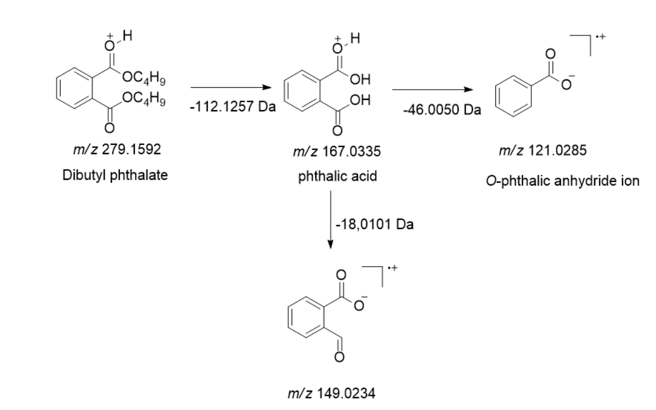
Figure S1. Fragmentation pattern of Dibutyl phthalate (5a).
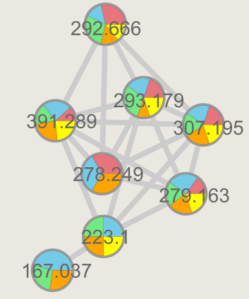
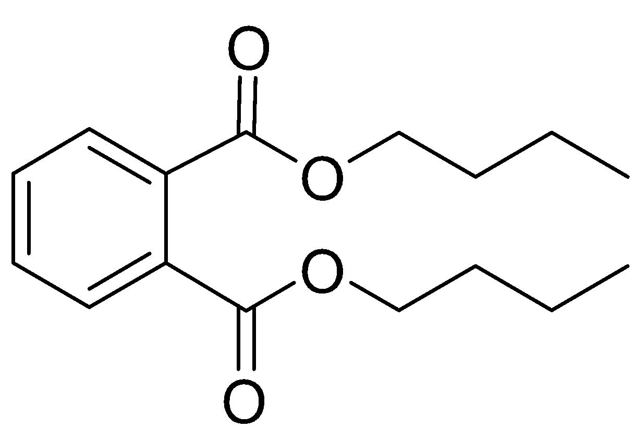

dibutyl phthalate

Figure S2. Networking (GNPS) cluster B with eight nodes where dibutyl phthalate were annotated.

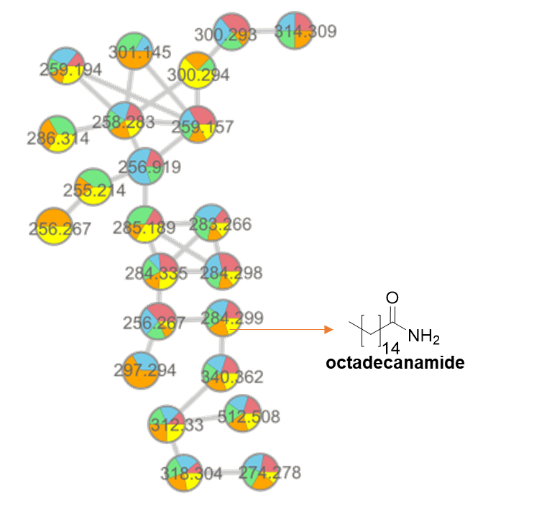
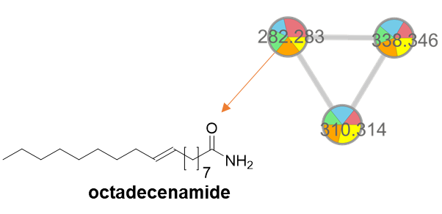

Figure S3. Networking (GNPS) clusters A and C of alkamides with twenty-three and three nodes, respectively.
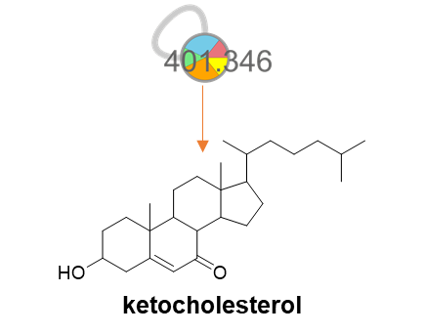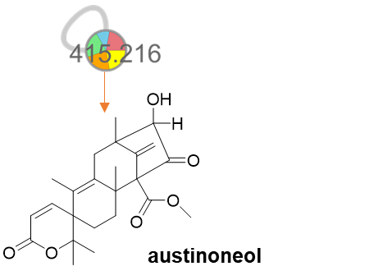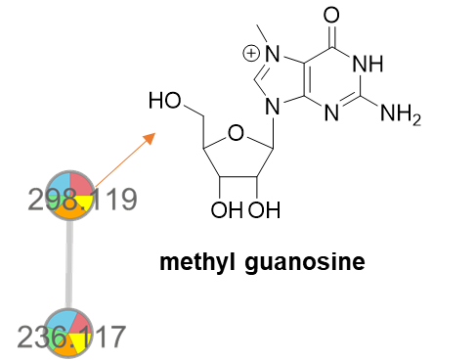
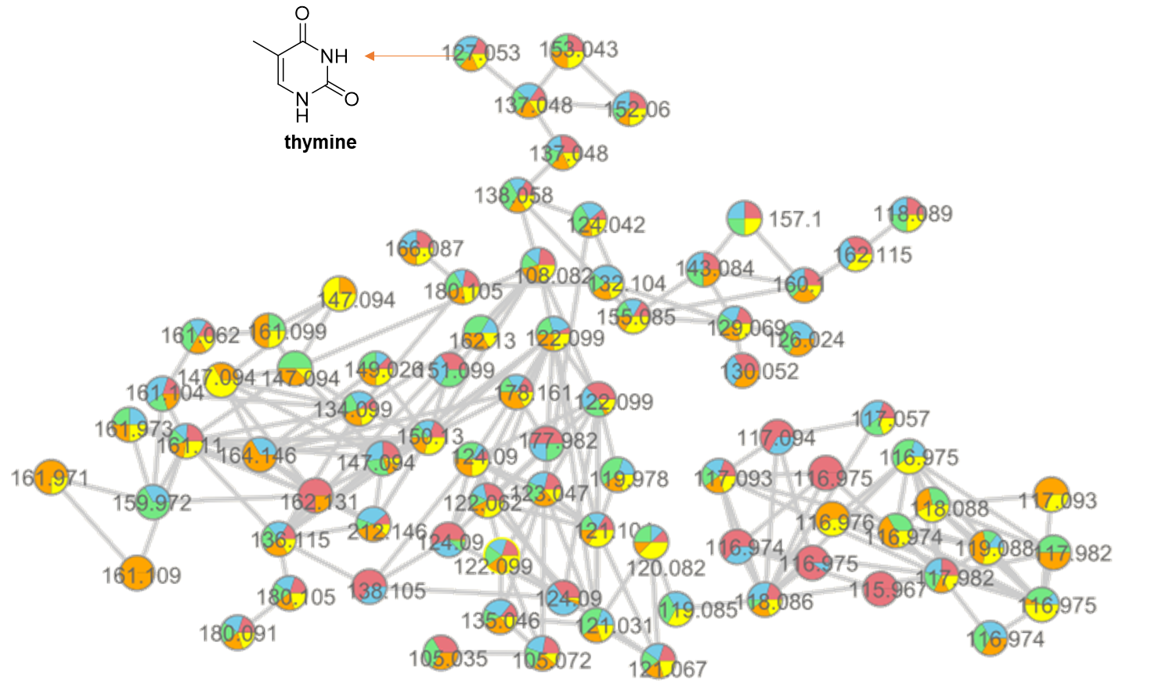
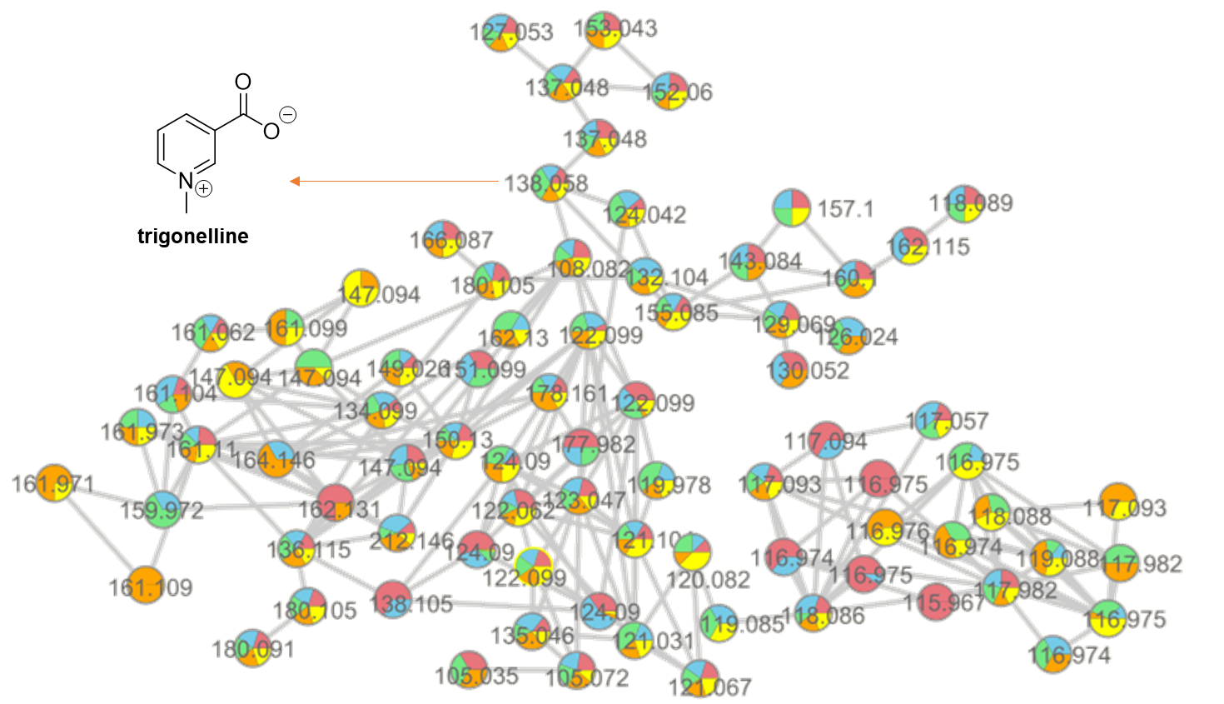
Figure S4. Networking (GNPS) clusters which terpenes, nucleobases and an alkaloid where annotated.

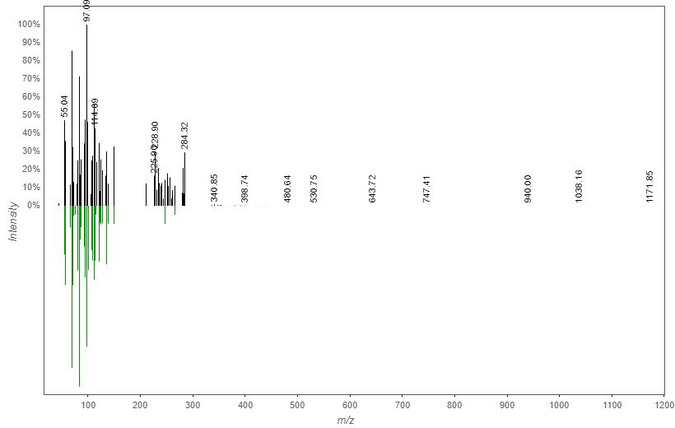
Figure S5. MS/MS match for octadecenamide (1a) between GNPS database (green) and T. ignis extract (black).

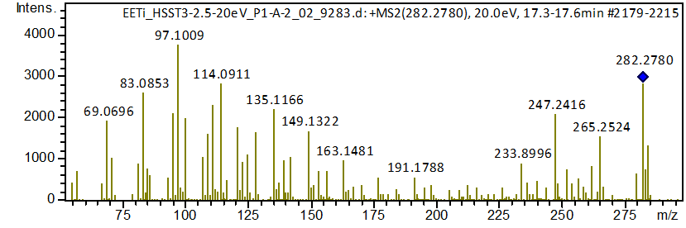
Figure S6. MS/MS spectra of octadecenamide (1a) obtained using DataAnalysis 4.
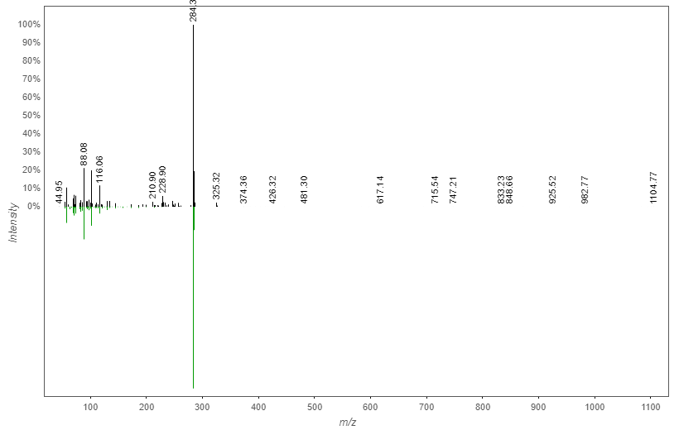
Figure S7. MS/MS match for octadecanamide (1b) between GNPS database (green) and T. ignis extract (black).
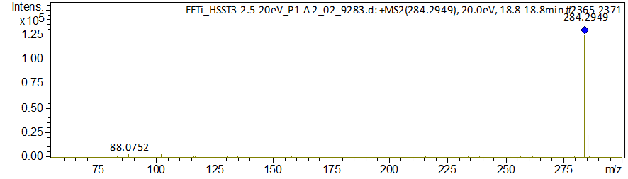
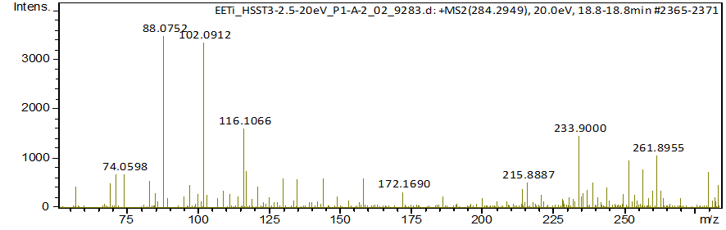
Figure S8. MS/MS spectra of octadecanamide (1b) obtained using DataAnalysis 4.
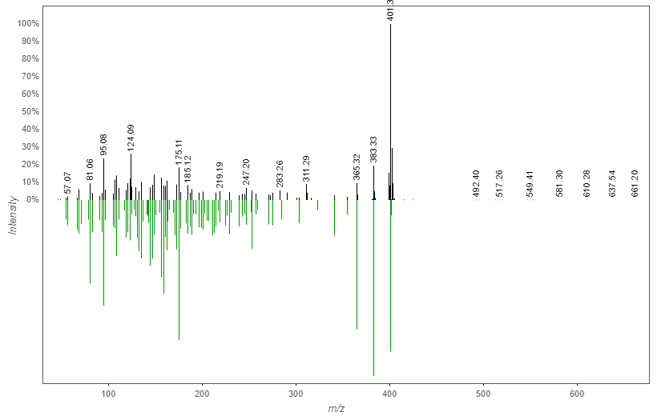
Figure S9. MS/MS match for ketocholesterol (2a) between GNPS database (green) and T. ignis extract (black).
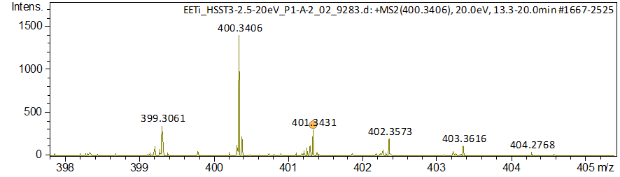
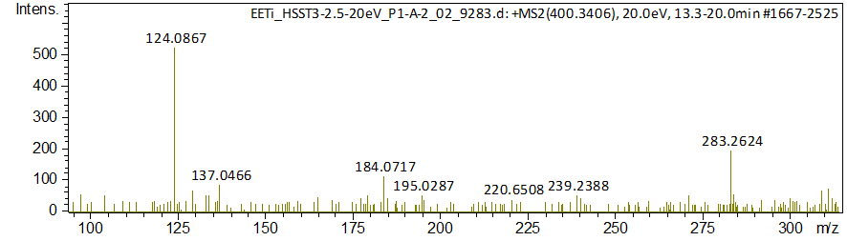
Figure S10. MS/MS spectra of ketocholesterol (2a) obtained using DataAnalysis 4.
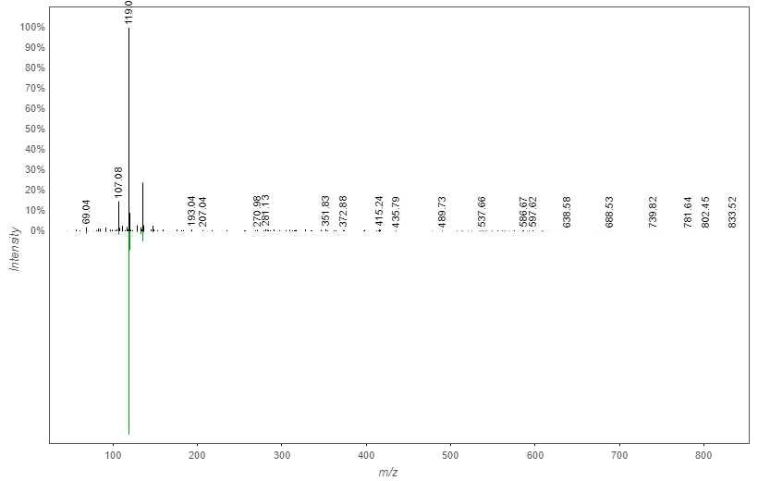
Figure S11. MS/MS match for austinoneol (2b) between GNPS database (green) and T. ignis extract (black).
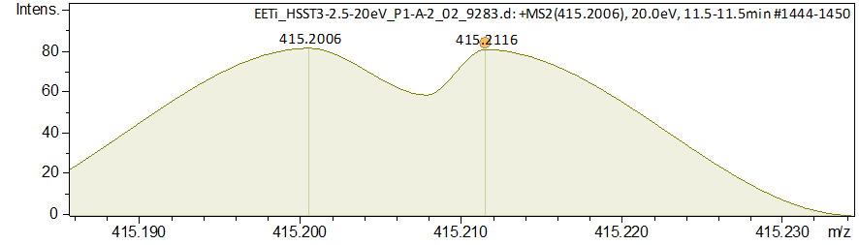
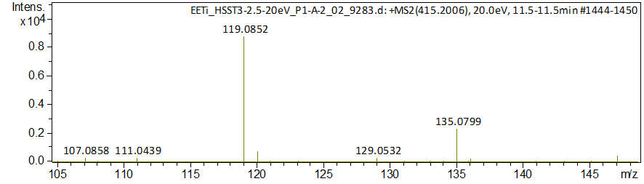
Figure S12. MS/MS spectra of austinoneol (2b) obtained using DataAnalysis 4.

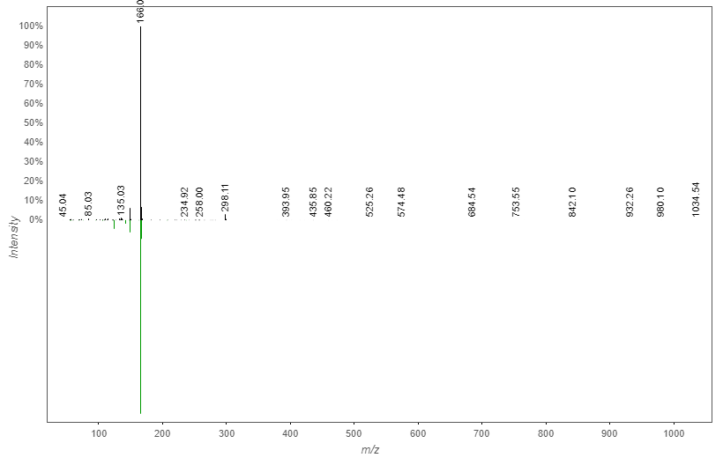
Figure S13. MS/MS match for methylguanosine (3a) between GNPS database (green) and T. ignis extract (black).
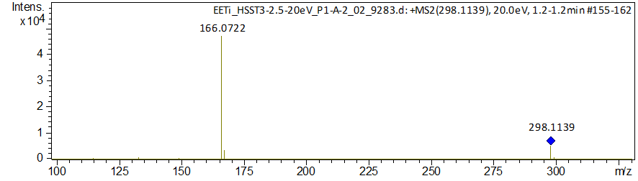
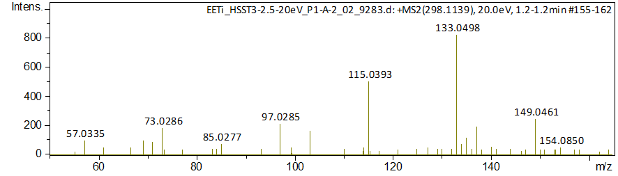
Figure S14. MS/MS spectra of methylguanosine (3a) obtained using DataAnalysis 4.
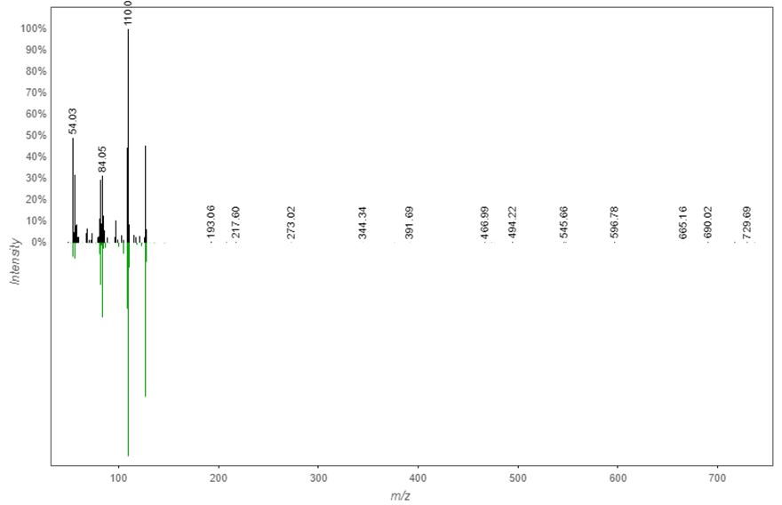
Figure S15. MS/MS match for thymine (3b) between GNPS database (green) and T. ignis extract (black).
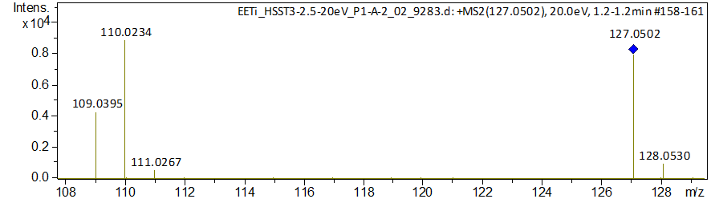
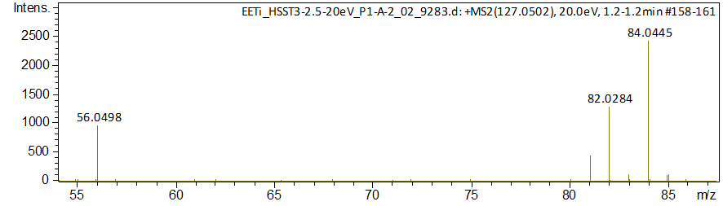
Figure S16. MS/MS spectra of thymine (3b) obtained using DataAnalysis.
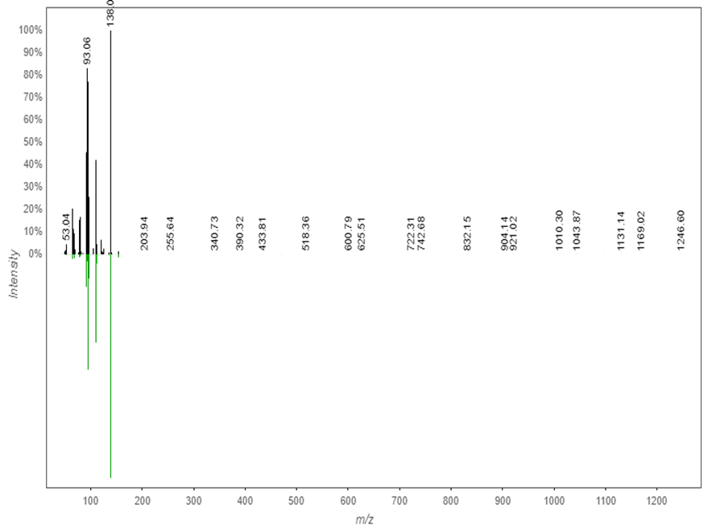
Figure S17. MS/MS match for trigonelline (4a) between GNPS database (green) and T. ignis extract (black).

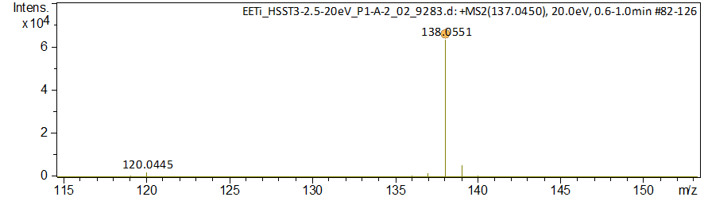
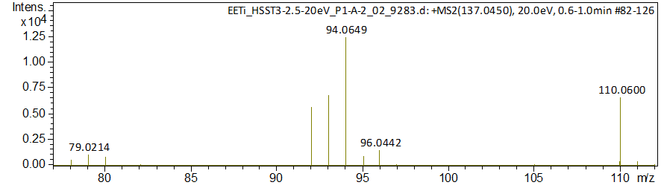
Figure S18. MS/MS spectra of trigonelline (4a) obtained using DataAnalysis 4.
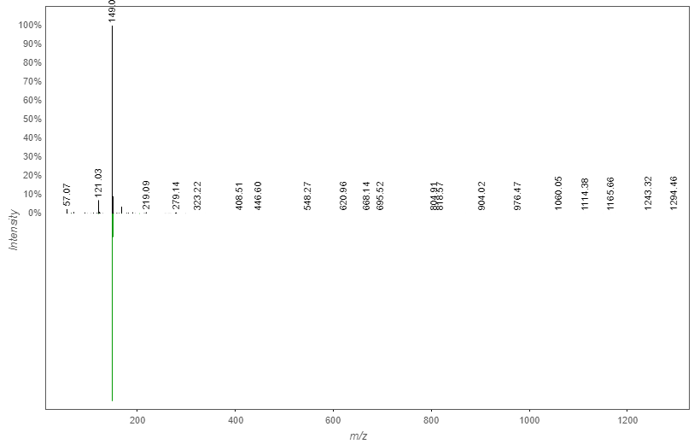
Figure S19. MS/MS match for dibutyl phthalate (5a) between GNPS database (green) and T. ignis extract (black).
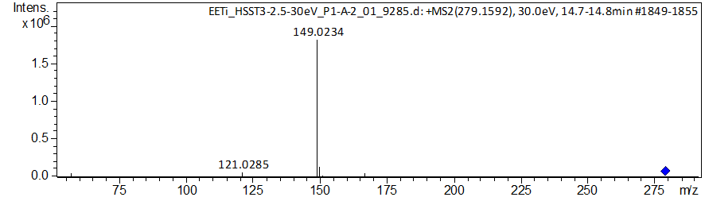
Figure S20. MS/MS spectra of dibutyl phthalate (5a) obtained using DataAnalysis 4.

