Appendix A Table for River channel Length, Area and Sinuosity

Date | Length(Km) | Area(Sq. Km.) | Sinuosity
1990 | 53.67 | 7.14 | 1.18
1995 | 53.74 | 4.09 | 1.22
2000 | 52.84 | 5.62 | 1.20
2005 | 53.97 | 6.83 | 1.17
2010 | 54.23 | 8.71 | 1.17
2015 | 54.79 | 5.49 | 1.22
2020 | 52.04 | 6.65 | 1.17
2023 | 52.82 | 7.17 | 1.12

Appendix B Photo plates

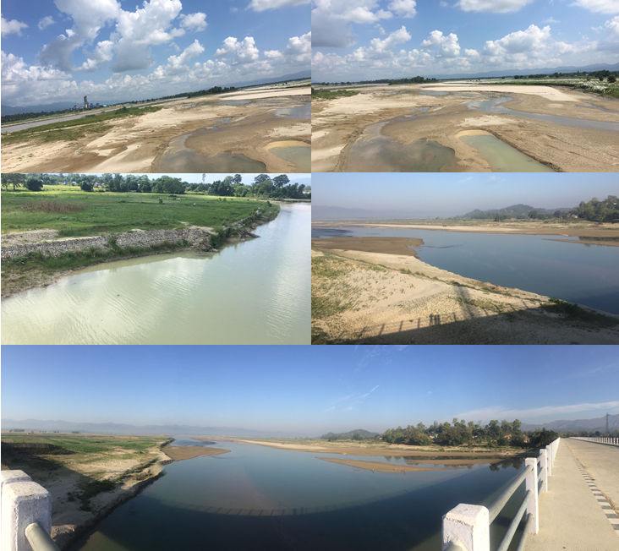
Photo 1: These photos represents the sediment deposits and situation of waterbody presence and the riverbed along with the bank protection measures applied within the West Rapti River Area.

