Supplementary data

Virulence analysis of wheat stem rust pathogen (Puccinia graminis f. sp. tritici) using differential lines
Fatemeh Khanboluki¹, Mahmoud Nasrollahi² and Mansoor Karimi-Jashni^{*1}
1- Department of Plant Pathology, Faculty of Agriculture, Tarbiat Modares University, Tehran, Iran;
2- Department of Plant Protection, Agricultural and Natural Resources Research Centre of Lorestan, Iran

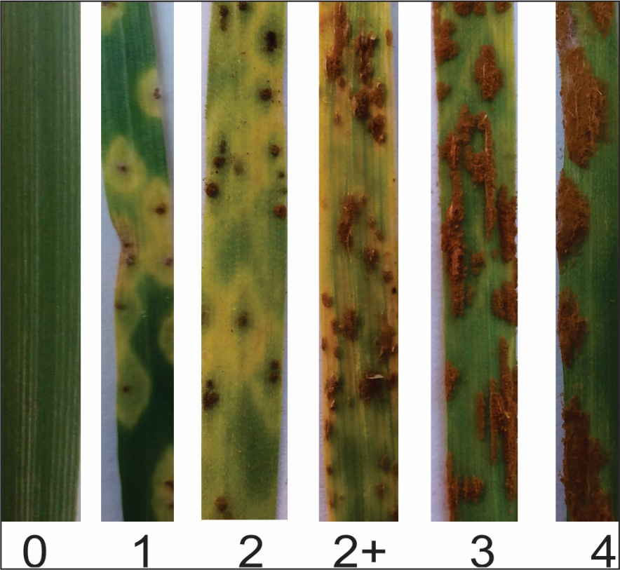
Fig. S1 Infection types of Pgt and host response used for this study (Provided by authors based on standard scale used by Stockman, et al.1962) .

Table S1 Date and geographical location of collected Pgt isolates. Samples were collected at 2020. Geographical location of samples was indicated in three separate columns.
Isolate | Year | location | Latitude | Longitude
Pgt99-1 | 2020 | Mazandaran | 36.61961787 | 53.24757337
Pgt99-2 | 2020 | Mazandaran | 36.69047455 | 53.45640099
Pgt99-3 | 2020 | Mazandaran | 36.71806725 | 53.71491677
Pgt99-4 | 2020 | Golestan | 36.7747739 | 54.02812366
Pgt99-5 | 2020 | Golestan | 36.81113697 | 54.16549373
Pgt99-6 | 2020 | Golestan | 36.82573499 | 54.26306802
Pgt99-7 | 2020 | Golestan | 36.85204065 | 54.52057592
Pgt99-8 | 2020 | Lorestan | 33.43210552 | 49.45595012
Pgt99-9 | 2020 | Hamedan | 34.87909749 | 48.53954011
Pgt99-10 | 2020 | Hamedan | 34.94205744 | 48.55843577
Pgt99-11 | 2020 | Hamedan | 35.02636871 | 48.53498161
Pgt99-12 | 2020 | Hamedan | 35.07787146 | 48.63222511
Pgt99-13 | 2020 | Hamedan | 35.07667791 | 48.67855379
Pgt99-14 | 2020 | Hamedan | 37.26606827 | 47.23983118
Pgt99-15 | 2020 | Hamedan | 37.95542517 | 47.05119621
Pgt99-16 | 2020 | Hamedan | 37.94872449 | 47.10035873
Pgt99-17 | 2020 | East Azarbayjan | 38.27170775 | 48.31434639
Pgt99-18 | 2020 | East Azarbayjan | 38.2768584 | 48.31909921
Pgt99-19 | 2020 | Ardebil | 38.28763139 | 48.33046234
Pgt99-20 | 2020 | Ardebil | 38.33218891 | 48.54746261
Pgt99-21 | 2020 | Ardebil | 38.31984629 | 48.55272856
Pgt99-22 | 2020 | Ardebil | 38.24736766 | 48.39154022
Pgt99-23 | 2020 | Ardebil | 38.25937017 | 48.47955935
Pgt99-24 | 2020 | Ardebil | 38.21556932 | 48.3287213
Pgt99-25 | 2020 | Golestan | 37.08610204 | 55.21903664
Pgt99-26 | 2020 | Golestan | 37.08132025 | 55.25344232
Pgt99-27 | 2020 | Golestan | 37.08132025 | 55.25344223
Pgt00-28 | 2021 | Hamedan | 34.45825162 | 48.26710057
Pgt00-29 | 2021 | Ardebil | 38.09901711 | 48.12819977
Pgt00-30 | 2021 | Ardebil | 38.10400223 | 48.13441454
Pgt00-31 | 2021 | Ardebil | 38.30882643 | 48.26893577
Pgt00-32 | 2021 | Ardebil | 38.31190455 | 48.26664954
Pgt00-33 | 2021 | Ardebil | 38.24980399 | 48.40759378
Pgt00-34 | 2021 | Ardebil | 38.24821243 | 48.39865867
Pgt00-35 | 2021 | Lorestan | 33.82729198 | 48.78855754
Pgt01-36 | 2022 | Ardebil | 38.18358898 | 48.39660911
Pgt01-37 | 2022 | Ardebil | 38.18360323 | 48.39664577
Pgt01-38 | 2022 | Ardebil | 38.19925144 | 48.43803966
Pgt01-39 | 2022 | Ardebil | 38.24910498 | 48.40327845
Pgt01-40 | 2022 | Lorestan | 33.82772592 | 48.78989864
Pgt01-41 | 2022 | Lorestan | 33.82772592 | 48.78989864
Pgt01-42 | 2022 | Lorestan | 33.82772592 | 48.78989864
Pgt01-43 | 2022 | Lorestan | 33.82772592 | 48.78989864

Table S2: North American Stem Rust Nomenclature Code Sheet