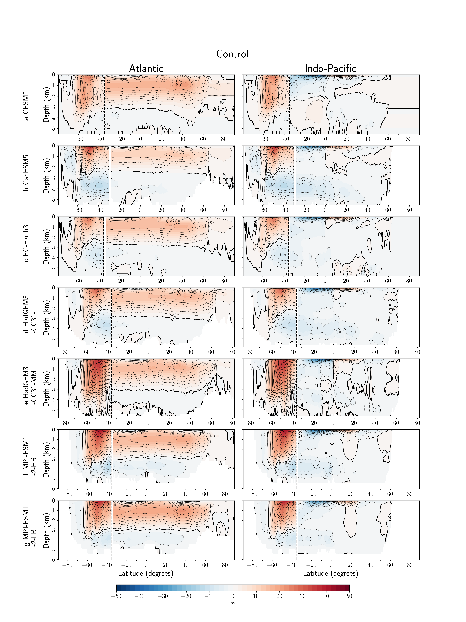Extended Data Fig. 1: Overturning circulation in the pre-industrial control simulation. Overturning streamfunction (Sverdrups (Sv); 2 Sv contour interval) in depth space averaged over the initial 50 years of the pre-industrial control experiment in the u03_hos subset of models, for the (left) Atlantic, and (right) Indo-Pacific Ocean north of 34.5°S (indicated by vertical dashed lines) and globally within the Southern Ocean (“S.O.”). The zero-streamline contour is defined by the solid black line.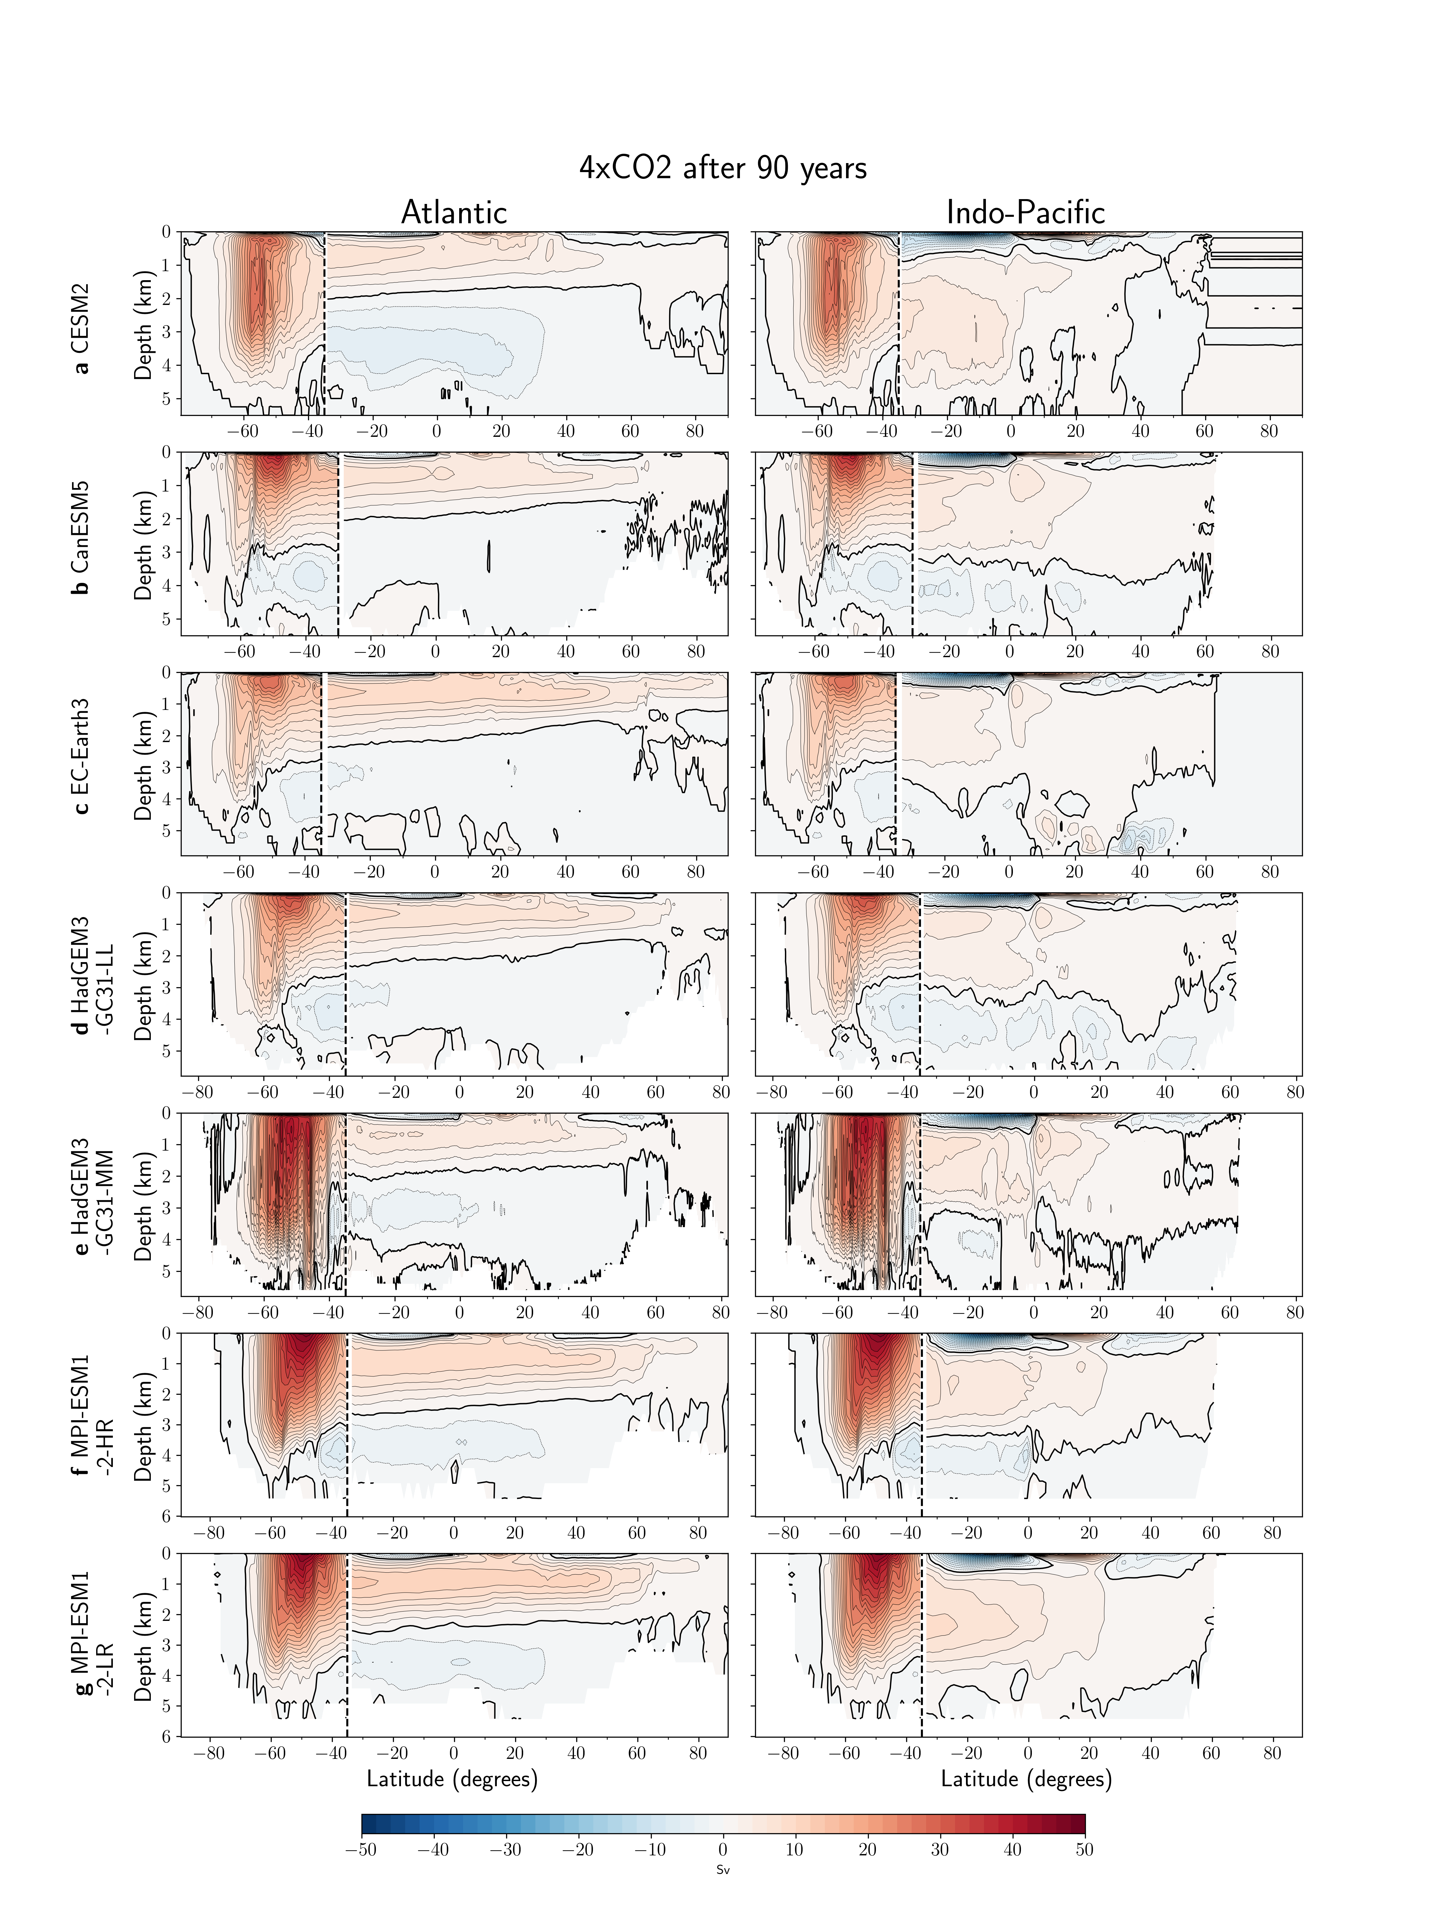Extended Data Fig. 2: Overturning circulation in the future state of the 4xCO2 experiment. As in Extended Data Fig. 1, but averaged over the 20-year period centred on year 90 after the 4xCO2 experiment is initialised.
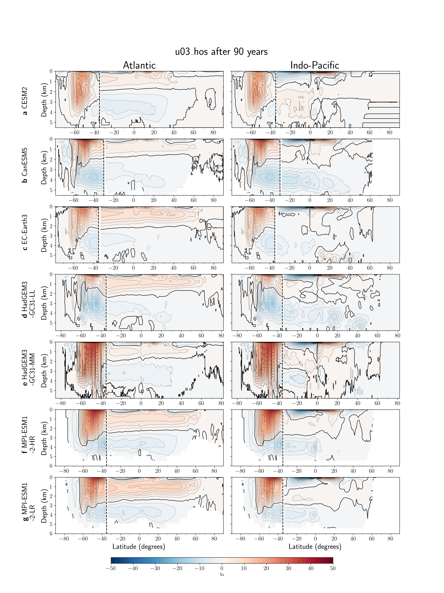
Extended Data Fig. 3: Overturning circulation in the future state of the North Atlantic freshwater forcing experiment. As in Extended Data Fig. 1, but averaged over the 20-year period centred on year 90 after the u03_hos experiment is initialised.
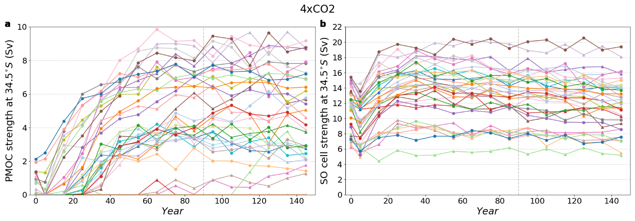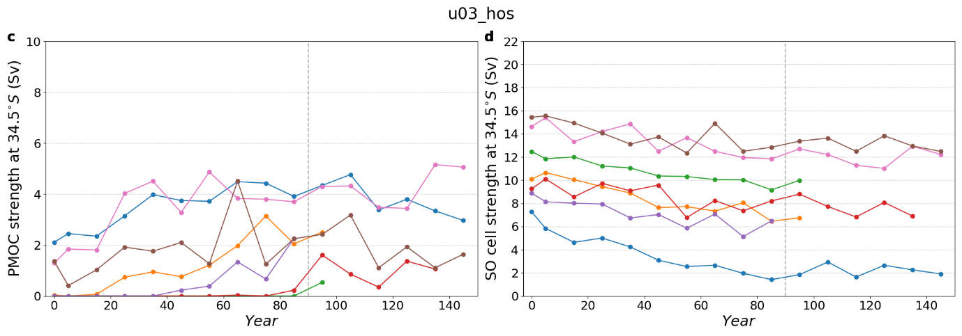
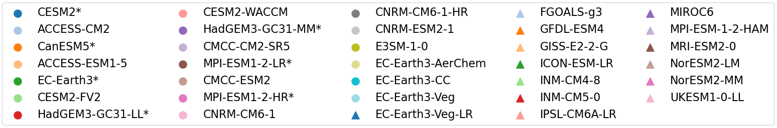
Extended Data Fig. 4: Decadal-mean evolution of PMOC and Southern Ocean overturning under extreme forcing. a-b Abrupt quadrupling of CO₂ (“4xCO2”) and c-d North Atlantic freshwater hosing (“u03_hos”) forcing scenarios. Variables plotted are (a,c) PMOC strength at 34.5°S, and (b,d) SO upper cell strength at 34.5°S. Models used in both the 4xCO2 and u03_hos scenario are labelled *.

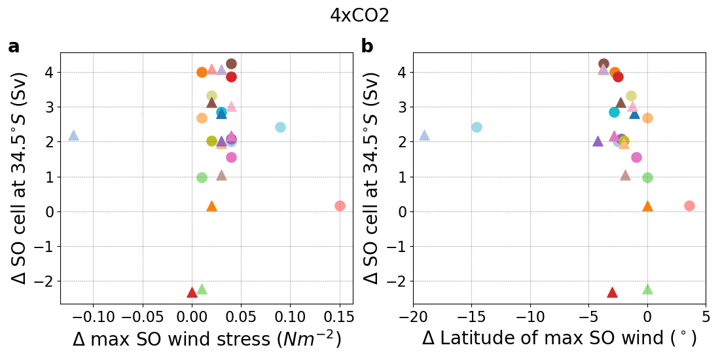
Extended Data Fig. 5. Impact of Southern Ocean wind changes on Southern Ocean overturning under extreme GHG forcing. Change in (a) the magnitude and (b) the latitude of the maximum SO wind stress, against the change in SO upper cell strength at 34.5°S (future state minus control) in the 4xCO2 experiment.
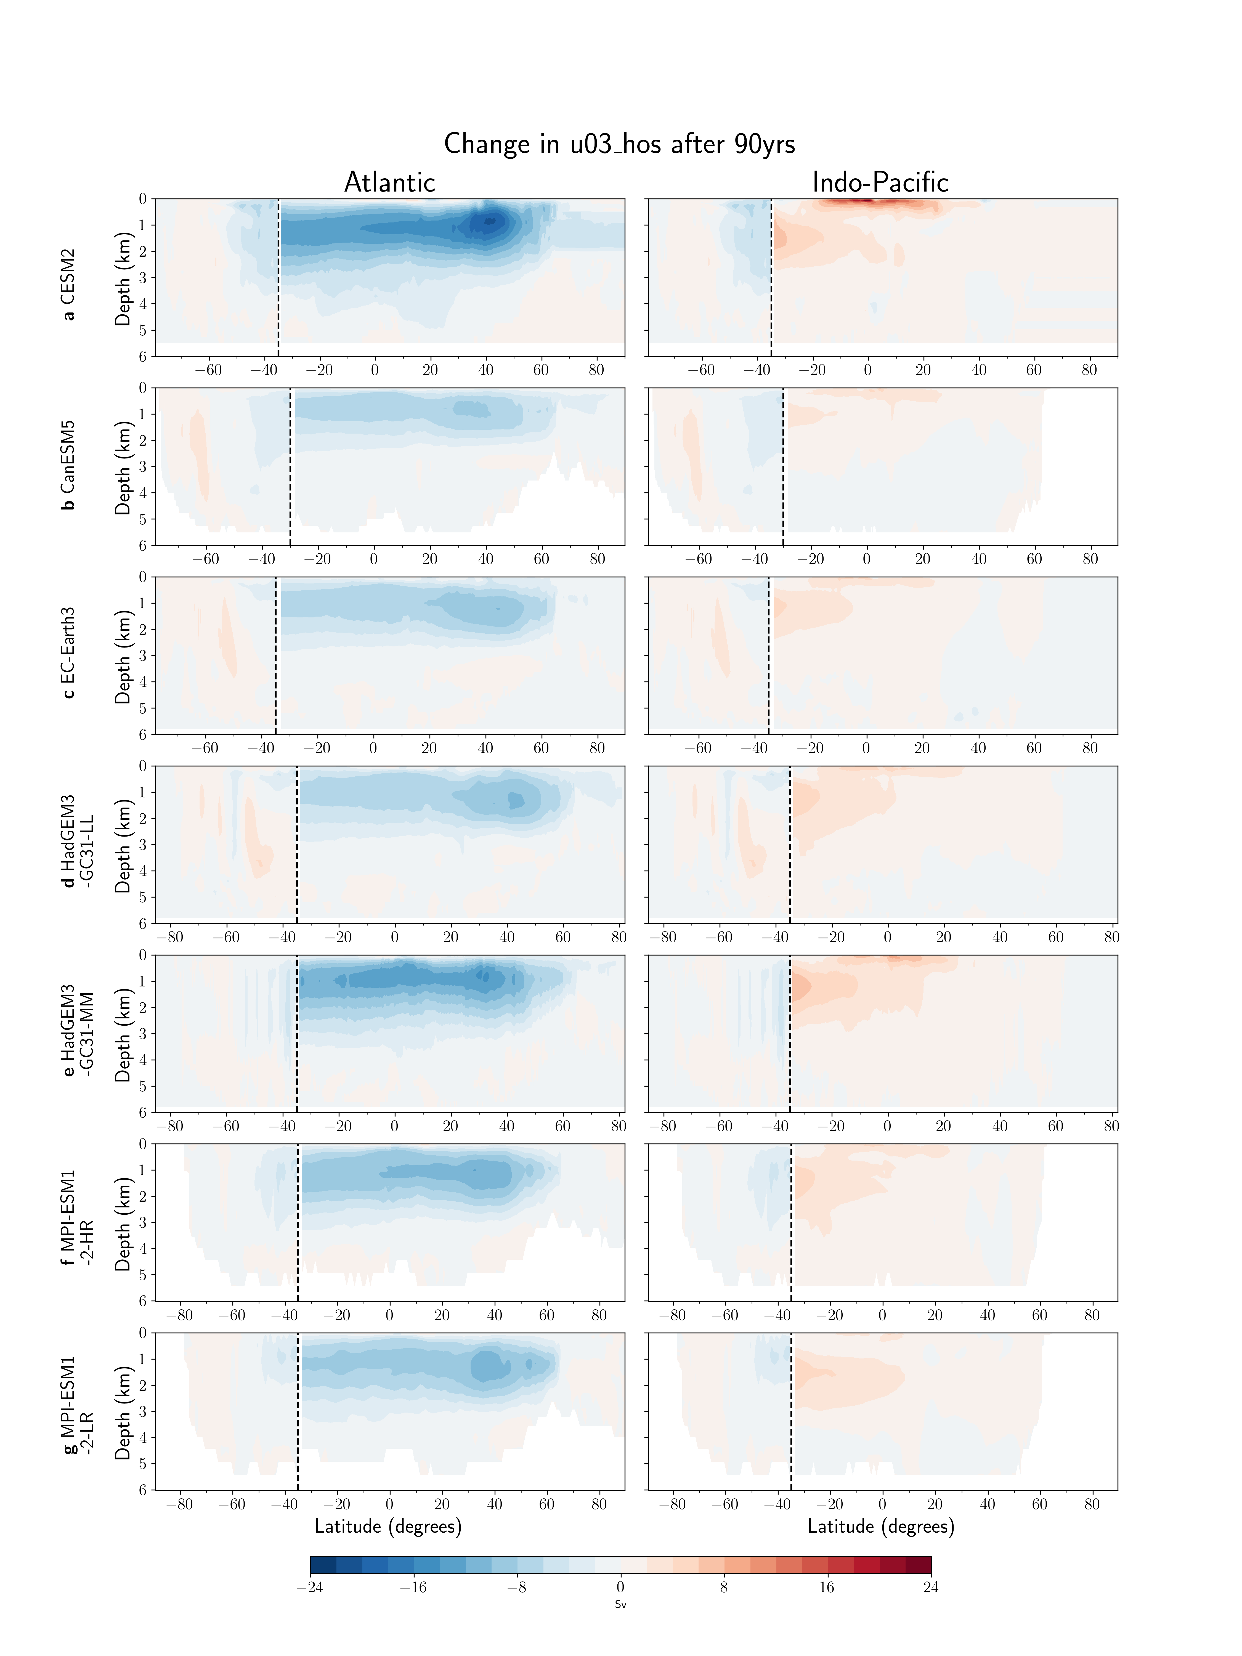Extended Data Fig. 6. Changes in overturning circulation after 90 years of North Atlantic freshwater forcing. Differences (2 Sv contour interval) are between the future state (average over the 20-year period centred on year 90) of u03_hos, and the pre-industrial control experiment. Details are described in Extended Data Fig. 1.

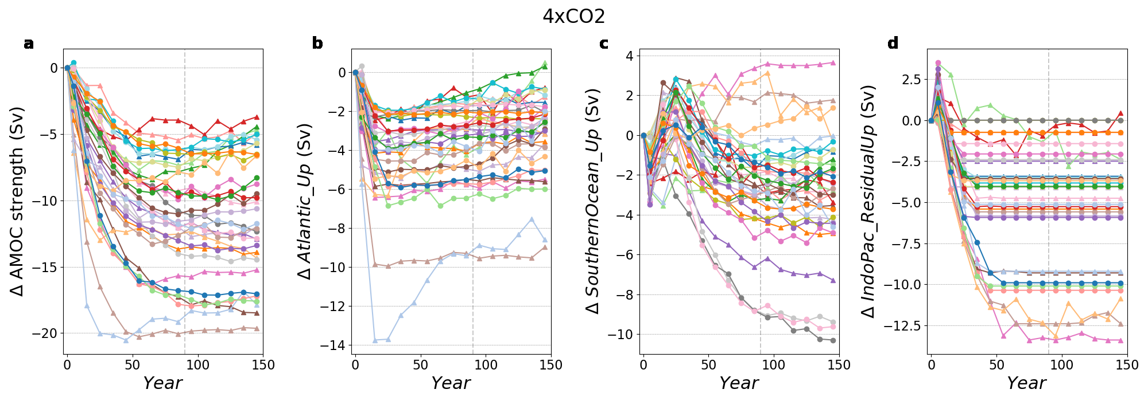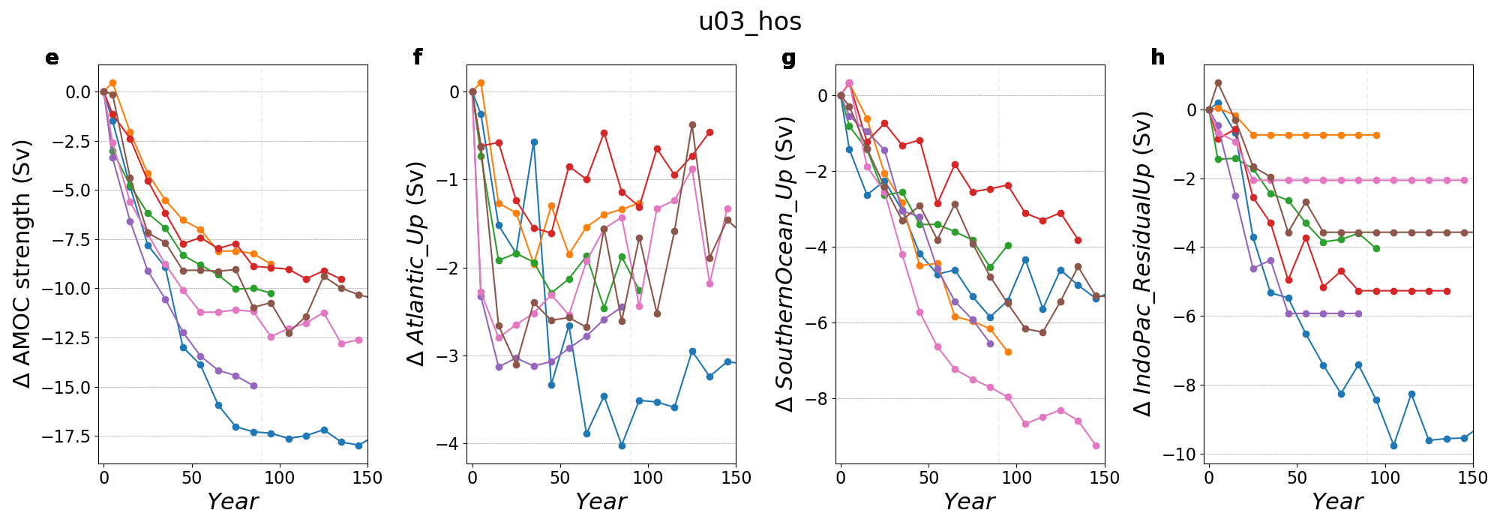
“Future” state
Extended Data Fig. 7 Decadal-mean change in AMOC strength and upwelling pathways under extreme forcing relative to the control a-d Abrupt quadrupling of CO₂ (“4xCO2”) and e-h North Atlantic freshwater hosing (“u03_hos”) forcing scenarios. Variables plotted are (a,e) AMOC strength, and (b,f) Atlantic, (c,g) Southern Ocean, and (d,h) Indo-Pacific residual upwelling pathways of the AMOC. Models used in both the 4xCO2 and u03_hos scenario are labelled *.
Extended Data Fig. 8: Localised South Atlantic overturning circulation (a,b) Meridional overturning streamfunction (Sverdrups (Sv); 2 Sv contour interval) from the GISS-E2-2-G pre-industrial control simulation, illustrating the method used to separate the AMOC’s upwelling pathways when the AMOC has a localised South Atlantic circulation that is isolated from the North Atlantic. Streamfunctions are shown for the Atlantic (a) and Indo-Pacific (b) Oceans north of 34.5°S (indicated by vertical dashed lines) and globally within the Southern Ocean (“S.O.”). The 0-Sv streamline is marked by a solid black line. Colored circles highlight the MOC strength at the highlighted location.
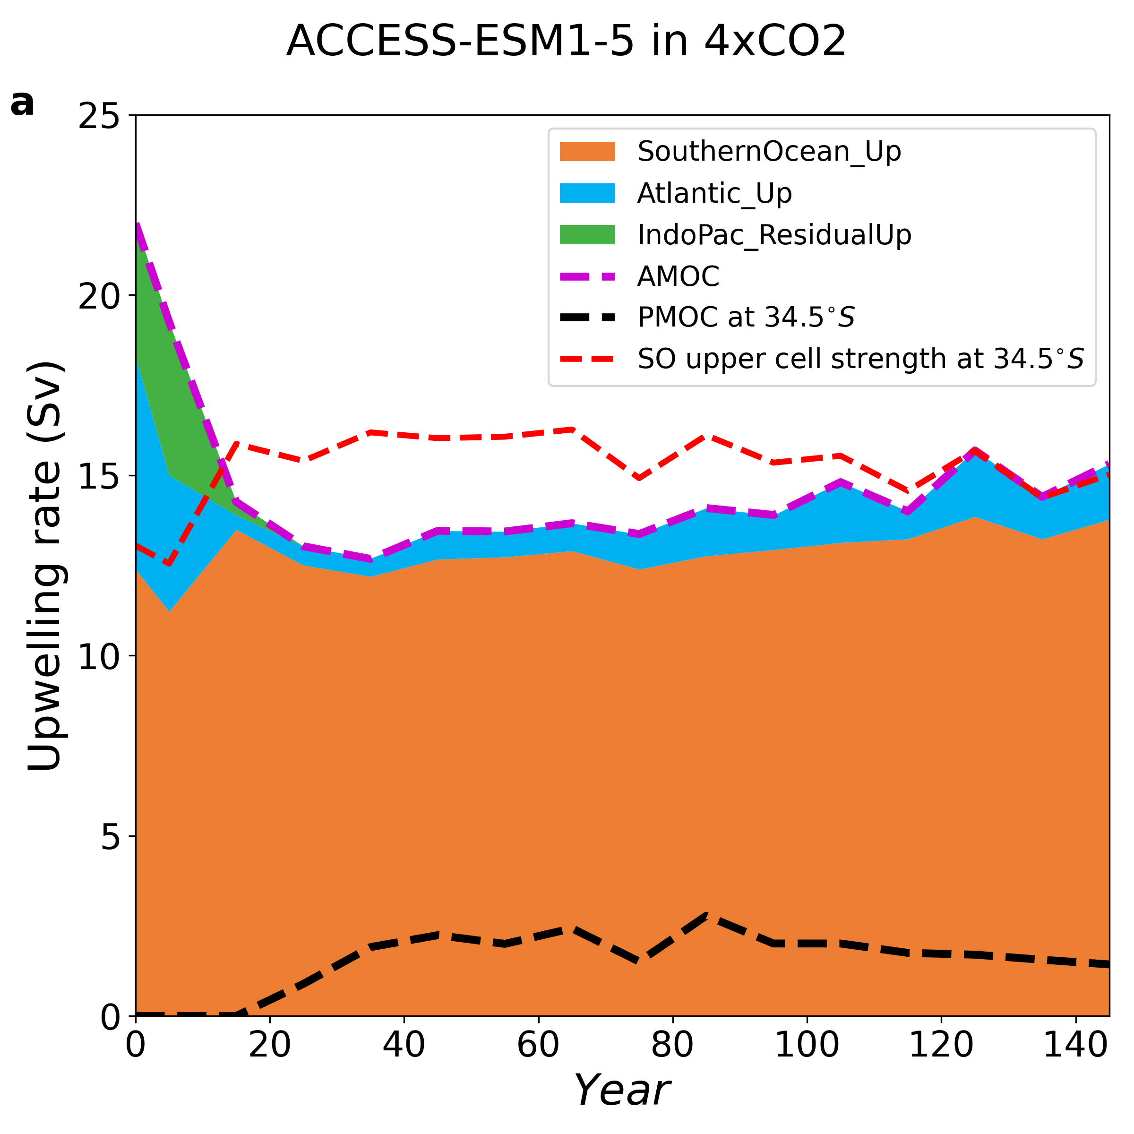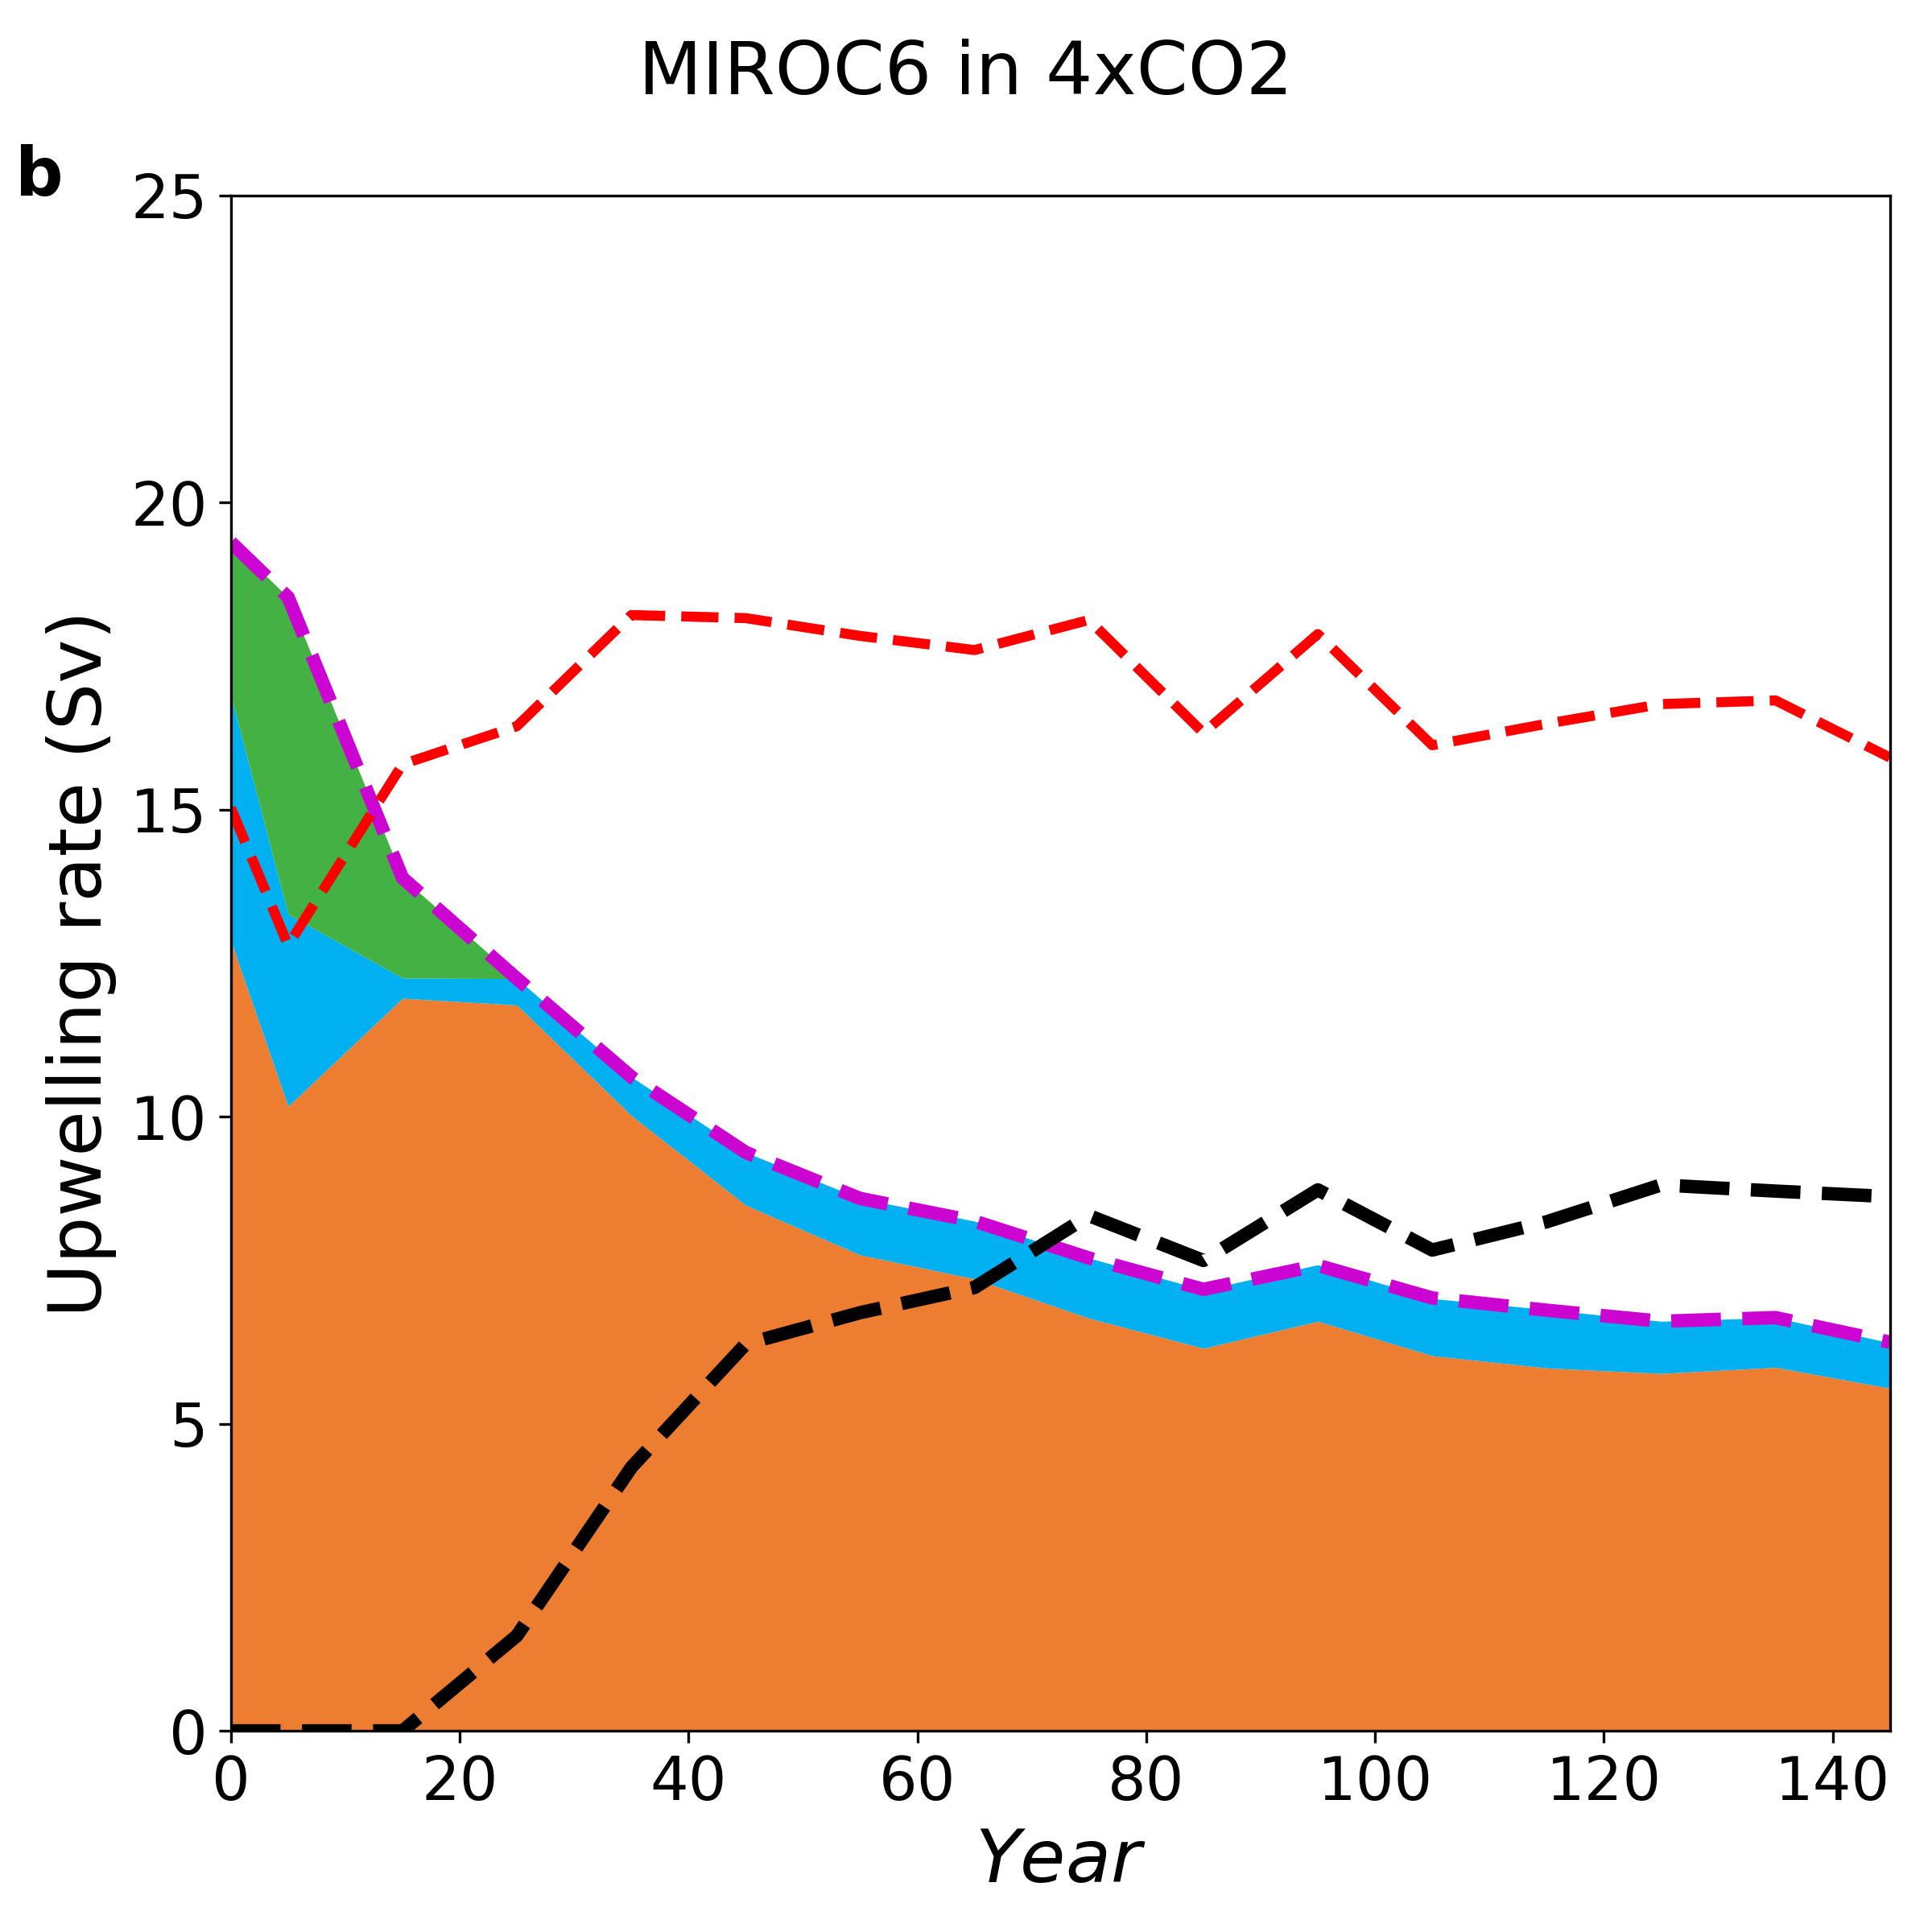Extended Data Fig. 9: Aggregated AMOC upwelling pathways under 4xCO2 forcing (a,b) Contribution of each AMOC upwelling pathway - SouthernOcean_Up (orange), Atlantic_Up (blue), and IndoPac_ResidualUp (green) - to the AMOC strength (purple line) for a model that develops a weak (a) and strong (b) PMOC at 34.5°S (black line). The SO upper cell strength at 34.5°S (red line) is also shown.

Extended Data Table 1. Climate models and their ensemble members.
Model | Modeling Center | Ensemble member
ACCESS-CM2 | CSIRO-ARCCSS | r1i1p1f1
ACCESS-ESM1-5 | CSIRO | r1i1p1f1
CESM2* | NCAR | r1i1p1f1
CESM2-FV2 | NCAR | r1i1p1f1
CESM2-WACCM | NCAR | r1i1p1f1
CMCC-CM2-SR5 | CMCC | r1i1p1f1
CMCC-ESM2 | CMCC | r1i1p1f1
CNRM-CM6-1 | CNRM-CERFACS | r1i1p1f2
CNRM-CM6-1-HR | CNRM-CERFACS | r1i1p1f2
CNRM-ESM2-1 | CNRM-CERFACS | r1i1p1f2
CanESM5* | CCCma | r1i1p1f1
E3SM-1-0 | E3SM Project | r1i1p1f1
EC-Earth3* | EC-Earth Consortium | r1i1p1f1
EC-Earth3-AerChem | EC-Earth Consortium | r1i1p1f1
EC-Earth3-CC | EC-Earth Consortium | r1i1p1f1
EC-Earth3-Veg | EC-Earth Consortium | r1i1p1f1
EC-Earth3-Veg-LR | EC-Earth Consortium | r1i1p1f1
FGOALS-g3 | CAS | r1i1p1f1
GFDL-ESM4 | NOAA | r1i1p1f1
GISS-E2-2-G | NASA-GISS | r1i1p1f1
HadGEM3-GC31-LL* | MOHC | r1i1p1f1
HadGEM3-GC31-MM* | MOHC | r1i1p1f1
ICON-ESM-LR | MPI | r1i1p1f1
INM-CM4-8 | INM | r1i1p1f1
INM-CM5-0 | INM | r1i1p1f1
IPSL-CM6A-LR | IPSL | r1i1p1f1
MIROC6 | JAMSTEC, NIES, AORI, University of Tokyo | r1i1p1f1
MPI-ESM-1-2-LR | MPI | r1i1p1f1
MPI-ESM-1-2-HR | MPI | r1i1p1f1
MPI-ESM-1-2-HAM | MPI | r1i1p1f1
MRI-ESM2-0 | MRI | r1i1p1f1
NorESM2-LM | NCC | r1i1p1f1
NorESM2-MM | NCC | r1i1p1f1
UKESM1-0-LL | MOHC | r1i1p1f2
The 34 CMIP6 models from the pre-industrial control and abrupt-4xCO2 experiments used in this study (Methods). Models with * are also used in the NAHosMIP experiments⁵³.

