Supplementary Materials
for

Self-assembled Aldehyde Dehydrogenase-Activatable Nano-prodrug for Cancer Stem Cell-Enriched Tumor Detection and Treatment

Bowen Li¹, Jianwu Tian¹, Fu Zhang², Chongzhi Wu², Zhiyao Li¹, Dandan Wang¹, Jiahao Zhuang¹, Siqin Chen¹, Wentao Song¹, Yufu Tang¹, Yuan Ping^{2*}, Bin Liu^{2*}

¹Department of Chemical and Biomolecular Engineering, National University of Singapore, 4 Engineering Drive 1, Singapore, 117585 (Singapore)
²College of Pharmaceutical Sciences, Zhejiang University, Hangzhou 310058, China

These authors contributed equally: Bowen Li, Jianwu Tian.

*Corresponding emails: cheliub@nus.edu.sg (Bin Liu); pingy@zju.edu.cn (Yuan Ping).

Materials
All-trans retinoic acid (ATRA) was purchased from Bide Pharmatech Lt, 4-Chlororesorcinol, NaBH_{4,} I₂, Na₂S₂O₃·5H₂O, 4-Formylbenzoic acid hexamethylenetetramine, 2-(3-cyano-4,5,5-trimethylfuran-2(5H)-ylidene) malononitrile, 2,2'-disulfanediylbis(ethan-1-ol), trifluoroacetic acid was obtained from Sigma Aldrich Co., Ltd. Dess-Martin reagent and N,N'-dicyclohexylcarbodiimide was obtained from Tokyo Chemical Industry Co. Ltd. 4-dimethylaminopyridine (DMAP) were obtained from Shanghai Macklin Biochemical Co., Lt. DSPE-PEG2000-HA_{5K} was purchased from xi’an ruixi Biological Technology Co., Ltd. RPMI1640 media, Dulbecco’s modified eagle medium (DMEM), fetal bovine serum (FBS), penicillin and streptomycin were obtained from Hyclone (Logan, UT, USA). A cell counting kit-8 was purchased from MedChemExpress (Trenton, NJ, USA). Annexin V-FITC/PI apoptosis detection kit and Mito-Tracker Green were provided by Beyotime (Shanghai, China). ALDH and the primary antibody of HIF-1α were purchased from Sigma Aldrich Co., Ltd.. ALDEFLUOR kit was purchased from STEMCELL Technologies (Vancouver, BC, Canada). Calcein-AM/PI cell viability assay kit was purchased from Shenzhen Bio-Wonderful Technology Co., Ltd. Dulbecco’s modified Eagle’s medium (DMEM)/F12, B-27 supplement, N2 supplement, epidermal growth factor (EGF), and fibroblast growth factor-basic (FGF) was purchased from Zhong Qiao Xin Zhou Biotechnology (Shanghai, China). 12-well ultralow attachment plates and 96-well ultralow attachment U-shaped plates were purchased from Qingdao AMA Co., Ltd.

Instruments
The ¹H nuclear magnetic resonance (¹H NMR) spectra were recorded on Bruker Avance 400 with TMS as the internal reference. The high-resolution mass spectrometric data were determined with an AmaZon X LC-MS for electrospray ionization. The high-resolution mass spectra were measured by Agilent 6546 LC/Q-TOF LC/MS system. The hydrodynamic sizes and zeta potentials of the nanoparticles were measured by a Malvern zetasizer pro zsu3200 instrument. The confocal imaging of cells was realized using confocal microscope Leica TCS SP8. The in vivo and ex vivo fluorescence images were obtained by an IVIS Spectrum imaging system.

Synthesis of PS-CHO and PS-COOH
Synthesis of compound 1 and PS-COOH
The synthesis of compounds 1 and PS-COOH followed methodologies described in previous literature^{1, 2}. PS-COOH: ¹H NMR (400 MHz, DMSO-d₆) δ 11.64 (s, 1H), 10.23 (s, 1H), 9.05 (d, J = 11.7 Hz, 2H), 8.21 (d, J = 6.5 Hz, 2H), 8.04 (d, J = 6.5 Hz, 2H), 7.58 (d, J = 11.7 Hz, 2H), 7.04 (s, 2H), 1.69 (s, 12H). HRMS (m/z): [M-H]⁻, found, 817.1015; calcd. for C₄₄H₂₃Cl₂N₆O₇, 817.1005.

Synthesis of compound 2
In this experiment, compound 1 (0.403 g, 1.0 mmol) was dissolved in tetrahydrofuran (THF, 4 mL) under stirring conditions. Subsequently, sodium borohydride (NaBH₄, 0.227 g, 6.0 mmol) was incrementally added until gas evolution ceased. Iodine (I₂, 0.762 g, 3.0 mmol) was then introduced gradually, followed by an increase in reaction temperature to 60 °C. The mixture was allowed to react for 48 hours before being cooled to ambient temperature. Sodium thiosulfate pentahydrate (Na₂S₂O₃·5H₂O, equimolar to I₂) and then followed by a slow addition of saturated sodium bicarbonate (NaHCO₃) solution. The pH was adjusted to 5 using 2 M acetic acid (AcOH). The aqueous layer was extracted using ethyl acetate (EtOAc, 4×30 mL). The combined organic phases were washed with saturated sodium chloride (NaCl), dried over anhydrous sodium sulfate (Na₂SO₄), and the organic layer was collected and concentrated under reduced pressure. Purification was achieved through column chromatography, utilizing a methanol/dichloromethane (MeOH/DCM) gradient as the eluent. Compound 2 was isolated as a pale-yellow powder (0.355 g, yield: 91.2%).¹H NMR (400 MHz, DMSO-d₆) δ 8.50(s, 2H), 7.29 (d, J = 6.1 Hz, 2H), 7.19 (s, 2H), 7.02-6.81 (d, J = 8 Hz, 2H), 6.72 (s, 2H), 5.50 (s, 1H), 5.37(s,1H), 4.73-4.44 (m, 2H). HRMS (m/z): [M+H]⁺, found, 389.0342; calcd. for C₂₀H₁₅Cl₂O₄, 389.0347.

Synthesis of compound 3
In the synthesis of compound 3, compound 2 (400 mg, 1.0 mmol) and hexamethylenetetramine (1.0 g, 5.0 mmol) were co-dissolved in trifluoroacetic acid (15 mL) under ice bath. This mixture was subjected to magnetic stirring at 90 °C for an overnight reaction. Upon completion, the reaction was allowed to cool to ambient temperature. The reaction was further processed by gradual addition of 2 N hydrochloric acid under stirring, continued until the cessation of orange precipitate formation. The resulting solid was extensively washed with deionized water until the filtrate appeared colorless. The dried crude product, compound 3, weighed 429.2 mg and was utilized in further reactions without additional purification steps.

Synthesis of compound 4
In the preparation of compound 4, compound 3 (227 mg, 0.5 mmol) was dissolved in methanol (25 mL). To this solution, 2-(3-cyano-4,5,5-trimethylfuran-2(5H)-ylidene) malononitrile (251 mg, 1.25 mmol) was added. The mixture underwent magnetic stirring at 60 °C for an overnight reaction. After the reaction completed, the mixture was cooled to room temperature. Then, the solvent was removed under vacuum conditions. The resultant crude product underwent purification using column chromatography, employing a gradient elution of methanol and dichloromethane in varying ratios (from 1:100 to 1:8, v/v). Compound 4 was obtained as a black, brown solid (100 mg, 24.4% yield). ¹H NMR (400 MHz, DMSO-d₆) δ 9.17 (s, 2H), 8.74 (d, J = 11.7 Hz, 2H), 8.06 (t, J = 6.0 Hz, 2H), 7.80 (d, J = 11.7 Hz, 2H), 7.24 (d, J = 6.1 Hz, 2H), 6.74 (s, 2H), 5.64 (s, 1H), 5.35 (s, 1H), 4.74 (d, J = 4.5 Hz, 2H), 1.59 (s, 12H); HRMS (m/z): [M-H]⁻ , found, 805.1355; calcd. for C₄₄H₂₅Cl₂N₆O₆, 805.1369.

Synthesis of compound 5
For the synthesis of compound 5, compound 4 (43 mg, 0.05 mmol) was dissolved in dry dichloromethane (CH₂Cl₂, 15 mL). To this solution, Dess-Martin reagent (1.3 g, 0.125 mmol) was added. The reaction mixture was stirred at room temperature for 2 hours, leading to the completion of the oxidation process. Subsequently, the mixture was diluted with ethyl acetate (EtOAc, 60 mL) and washed successively with saturated sodium thiosulfate (Na₂S₂O₃, 10 M), saturated sodium bicarbonate (NaHCO₃, 10 mL) solution, and brine. The organic layer was then combined and dried over anhydrous sodium sulfate (Na₂SO₄) and concentrated under reduced pressure. The crude product underwent purification via silica gel column chromatography using a gradient of methanol and dichloromethane (from 1:100 to 1:8, v/v) as the eluent and yielded compound 5 (PS-CHO) as a black-brown solid (36 mg, 83.7% yield).¹H NMR (400 MHz, DMSO-d₆) δ 9.80 (s, 1H), 8.93 (dd, J = 17.9, 2.9 Hz, 2H), 8.24-8.07 (m, 2H), 7.87 (d, J = 1.6 Hz, 2H), 7.55 (dd, J = 5.3, 1.6 Hz, 2H), 7.03 (s,2H), 1.68 (s, 12H). HRMS (m/z): [M-H]⁻, found, 801.1055; calcd. for C₄₄H₂₅Cl₂N₆O₆, 801.1056.

Synthesis of compound 6
In the synthesis of compound 6, a 250 mL round-bottom flask was added with all-trans retinoic acid (ATRA, 601 mg, 2 mmol), 2,2'-disulfanediylbis(ethan-1-ol) (123.2 mg, 0.8 mmol), and 4-dimethylaminopyridine (DMAP, 24.6 mg, 0.2 mmol) in 10 mL of dichloromethane (DCM). The solution was cooled to 0 °C, followed by the addition of N,N'-dicyclohexylcarbodiimide (DCC, 516 mg, 2.5 mmol). The reaction mixture was then allowed to return to room temperature and was kept overnight. Upon completion of the reaction, the precipitated by-products were filtered off. The filtrate was concentrated and then redissolved in ether. This ether solution was washed with 0.5 N hydrochloric acid, followed by washing with saturated sodium hydrogen carbonate solution. The resulting crude material was purified by silica gel column chromatography, using a dichloromethane/hexane (2:1, v/v) as the eluent. This procedure yielded compound 6 (ATRA-SS-ATRA) as a yellow powder (471 mg, 82.0 % yield).¹H NMR (400 MHz, DMSO-d₆) δ 7.61 (t, J = 12.6 Hz, 2H), 7.06 (t, J = 13.7 Hz, 2H), 6.57-6.22 (m, 6H), 6.07 (S, 6H), 3.97 (t, J = 7.5 Hz, 4H), 3.10 (t, J = 7.5 Hz, 4H), 2.28 (d, J = 16.5 Hz, 6), 2.11 (s, 6H), 1.83(s, 6H), 1.67 (d, J = 22.6 Hz, 8), 1.14 (S, 6H). HRMS (m/z): [M+H]⁺, found, 718.4088; calcd. for C₄₄H₆₂O₄S₂, 718.4090.

Characterization of different nanoparticles by DLS and TEM
All nano-formulations (PS-CHO@ATRA-SS-ATRA, PS-CHO@HA-ATRA-SS-ATRA, PS-CHO@DSPE-PEG2000, and PS-CHO@HA-DSPE-PEG2000) were prepared at a concentration of 1 mg/mL. Hydrodynamic diameter and zeta potential was performed by DLS, and each sample was repeated 3 times of measurement. In addition, all nano-formulation (0.5 mg/mL) was added 20 μL on the surface of 400-mesh copper grids. After incubation for 30 minutes, the excess liquid was taken up by filter papers. Then the copper grids were air dried and subjected to a TEM for observation.

Cell culture
Cancer cells (4T1) and normal cells (A549) were all purchased from the American Type Culture Collection (ATCC). The 4T1 cells were cultured with RPMI 1640 medium, and 3T3 cells were cultured with Dulbecco’s modified eagle medium (DMEM) medium. The medium of DMEM and RPMI 1640 were contained with fetal bovine serum (FBS, 10%) and penicillin&streptomycin (PS, 1%). All these cells were cultured at 37 ℃ in a humidified atmosphere containing 5% CO_{2.} and replaced the mediums at every 24 h.

Animal experiments
All BALB/c nude mice (female, 6-week-old, 15-20 g) were purchased from Gempharmatech Co., Ltd. (Nanjing, China), and the animal handling and experimental procedures were performed with approval from the Institutional Animal Care and Use Committee at the First Affiliated Hospital, School of Medicine, Zhejiang University, China (approval number: 2022-1626). All mice were cultured with specific pathogen-free (SPF) condition, and autoclaved rodent diet and sterile water.

Statistical analysis
All data and figures in this paper were analyzed and plotted by GraphPad Prism 8.0. The data are presented as mean ± standard deviation (S. D.). Biological replicates were used in all experiments unless otherwise stated. One-way analysis of variance (ANOVA) was employed for multiple comparison tests. Two-way ANOVA with a Bonferroni post-hoc test was employed when two parameters were considered. Statistical significance was denoted as *p < 0.05, **p < 0.01, ***p < 0.001, or ***p < 0.0001.

References
1. Liu, Z. W., et al. A dual-targeted theranostic photosensitizer based on a TADF fluorescein derivative. J. Control. Release 310, 1-10 (2019).
2. An, J., et al. An unexpected strategy to alleviate hypoxia limitation of photodynamic therapy by biotinylation of photosensitizers. Nat. Commun. 13, 2225 (2022).

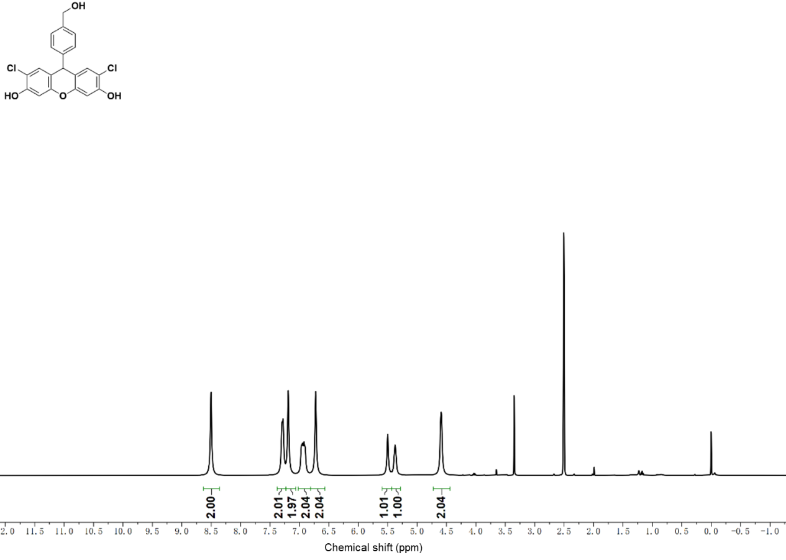
Supplementary Fig. 1. The ¹H NMR of compound 2.

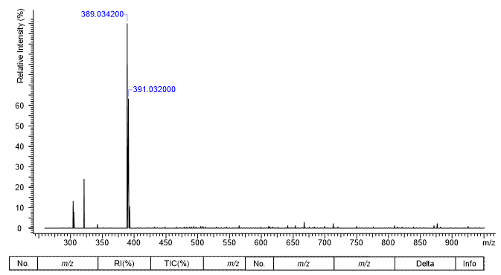
Supplementary Fig. 2. ESI-MS spectrum of compound 2.

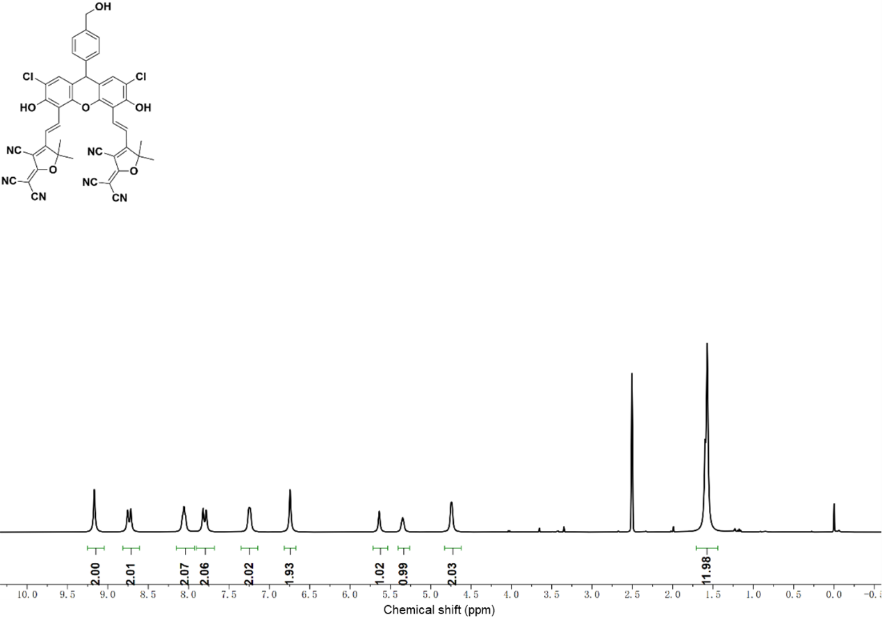
Supplementary Fig. 3. The ¹H NMR of compound 4.

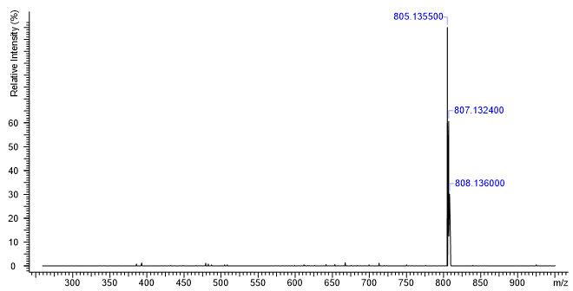
Supplementary Fig. 4. ESI-MS spectrum of compound 4.

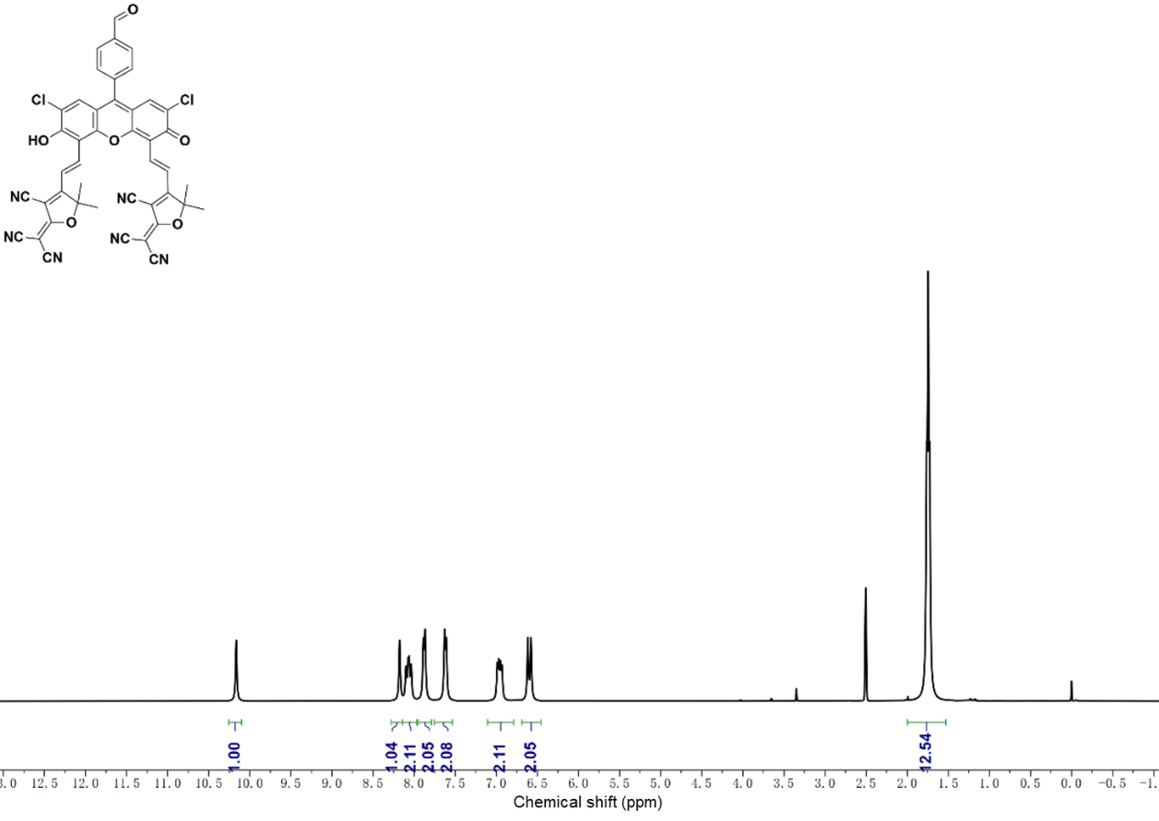
Supplementary Fig. 5. The ¹H NMR of compound 5.

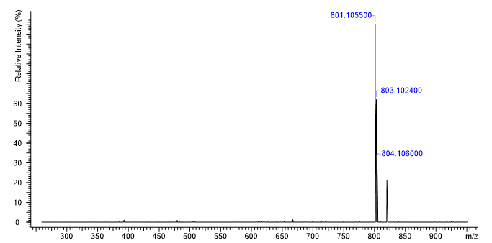
Supplementary Fig. 6. ESI-MS spectrum of compound 5.

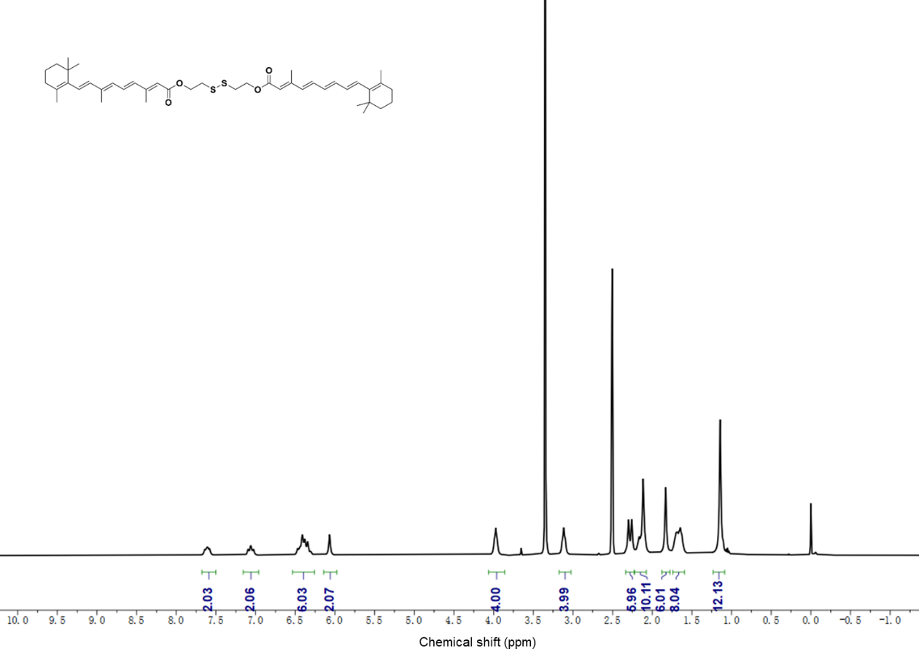
Supplementary Fig. 7. The ¹H NMR of compound 6.

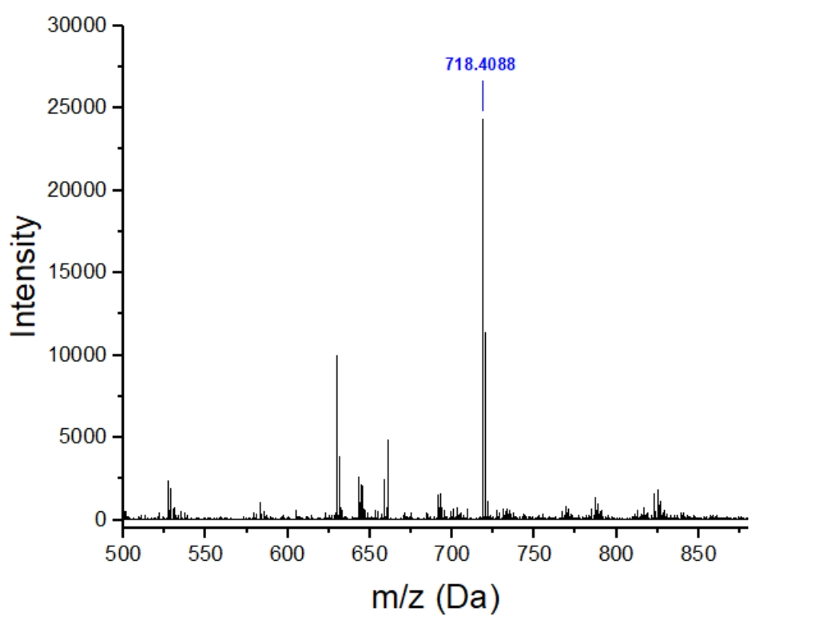
Supplementary Fig. 8. ESI-MS spectrum of compound 6.

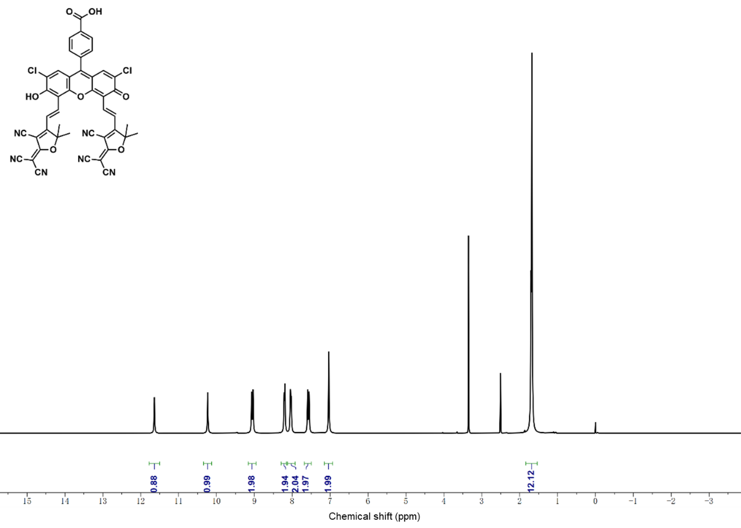
Supplementary Fig. 9. The ¹H NMR of PS-COOH.

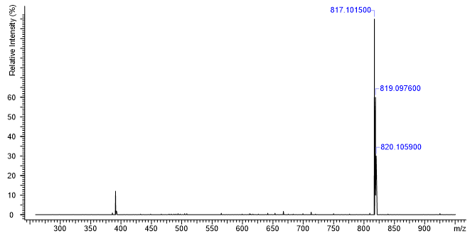
Supplementary Fig. 10. ESI-MS spectrum of PS-COOH.

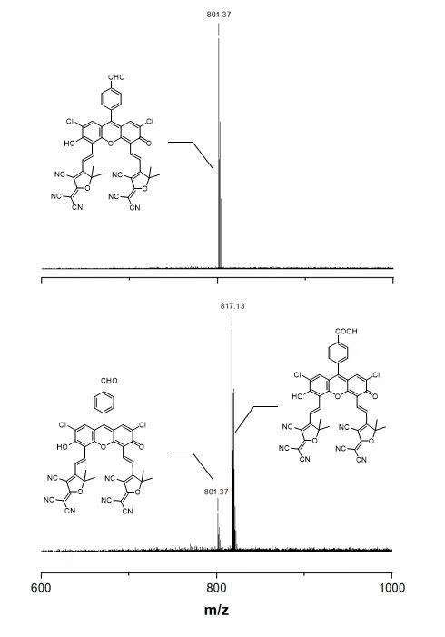
Supplementary Fig. 11. ESI-MS spectrum of PS-CHO (10 μM in PBS solution contained 10% DMSO) before and after incubation with 50 μg/mL ALDH for 4 h.

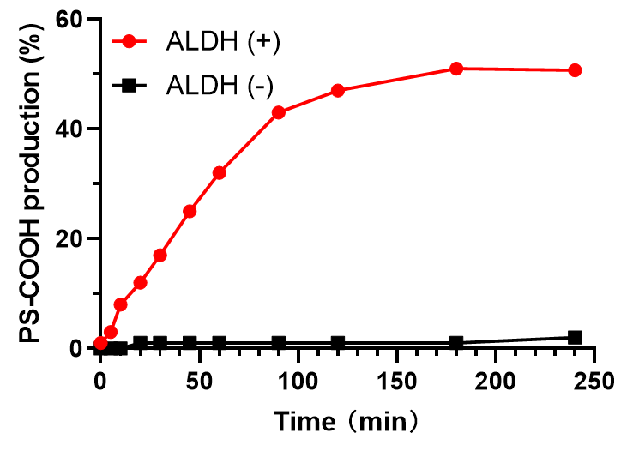
Supplementary Fig. 12. The PS-COOH production of PS-CHO (10 μM in PBS solution contained 10% DMSO) after incubation with 50 μg/mL ALDH for 4 h.

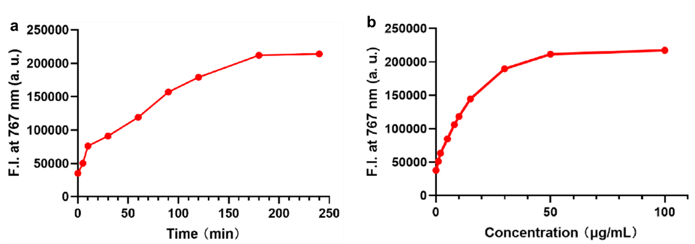
Supplementary Fig. 13. Fluorescence intensity at 767 nm detected in PS-CHO incubated with (a) 50 μg/mL ALDH at different times (0-240 min) and (b) different concentrations of ALDH (0-100 μg/mL) at 4 h.

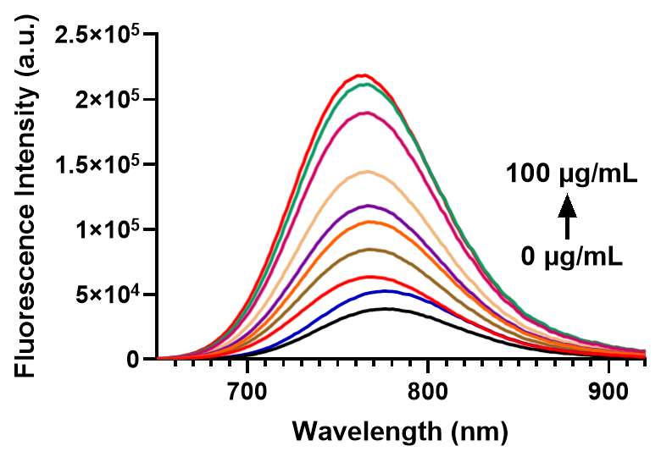
Supplementary Fig. 14. Fluorescence variation of PS-CHO incubated with ALDH at different concentrations (0-100 μg/mL) for 4 h.

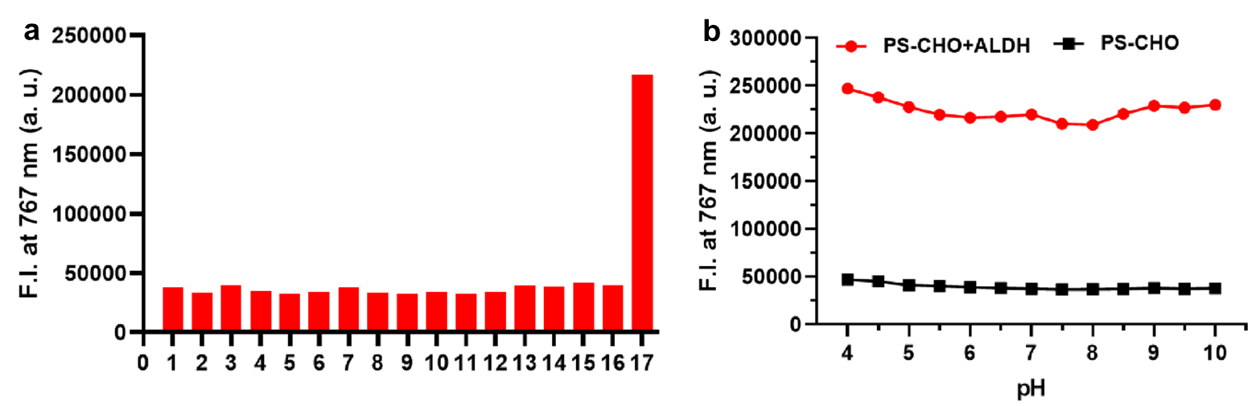
Supplementary Fig. 15. The fluorescence intensity at 767 nm of PS-CHO after treatment with different substances (a) and different pH conditions (b). All experiments were performed in PBS (pH 7.4, 10 mM) containing 10% (v/v) DMSO (1 mM for 1:K⁺, 2: Fe²⁺, 3: Al³⁺, 4: Cu²⁺, 5: Li⁺, 6: Mg²⁺; 10 mM for 7: Gly, 8: Arg, 9: Phe 10: Lys and 11: GSH; 50 μg/mL for 12: carboxylesterase (CAE); 13: alkaline phosphatase (ALP); 14: azoreductase (AZD); 15: nitroreductase (NTR); 16: Quinone oxidoreductase (NQ1); 17: ALDH).

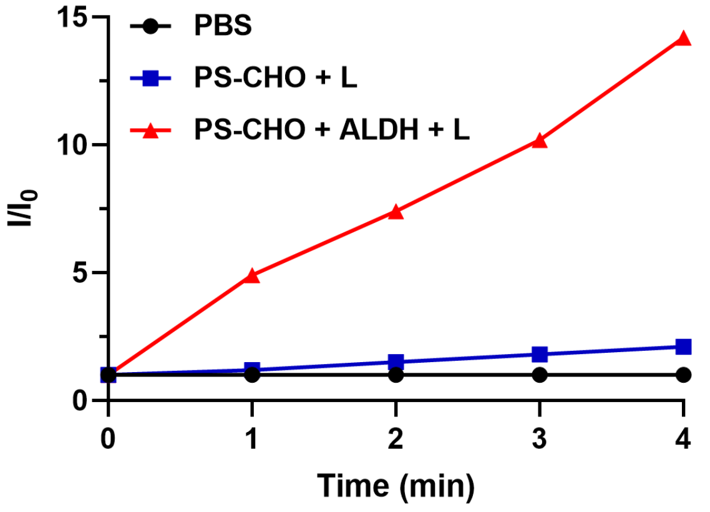
Supplementary Fig. 16. Total ROS generation for PS-CHO with or without ALDH at different times (0-4 mins) by DCFH-DA assay.

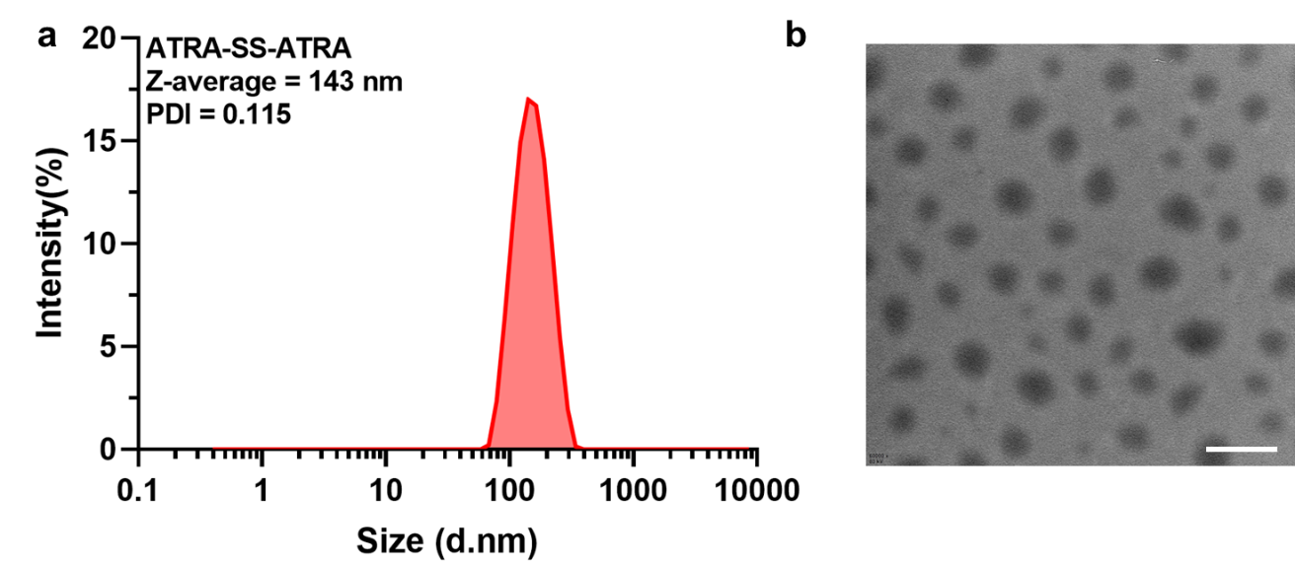
Supplementary Fig. 17. (a) The size distribution of ATRA-SS-ATRA by DLS. (b) The morphology of ATRA-SS-ATRA by TEM, Scale bar: 200 nm.

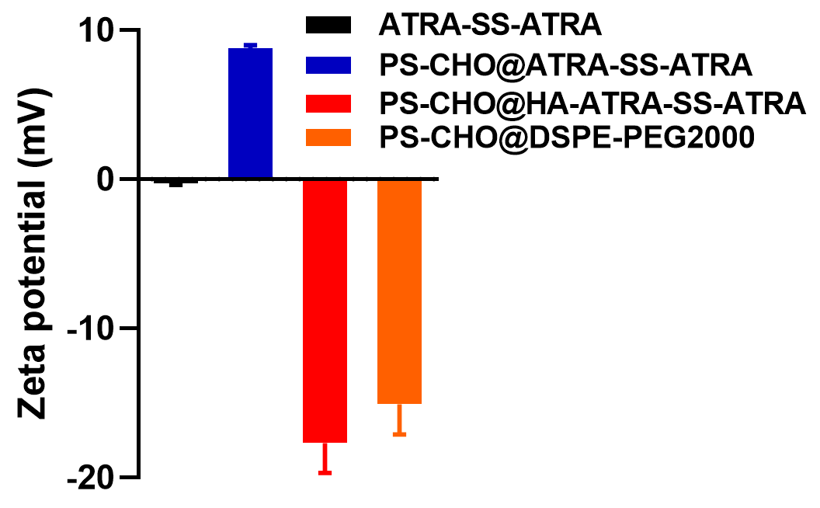
Supplementary Fig. 18. The zeta potential of different nanoparticles (ATRA-SS-ATRA, PS-CHO@ATRA-SS-ATRA, PS-CHO@HA-ATRA-SS-ATRA and PS-CHO@DSPE-PEG2000) by DLS. Data are presented as means ± SD (n = 3).

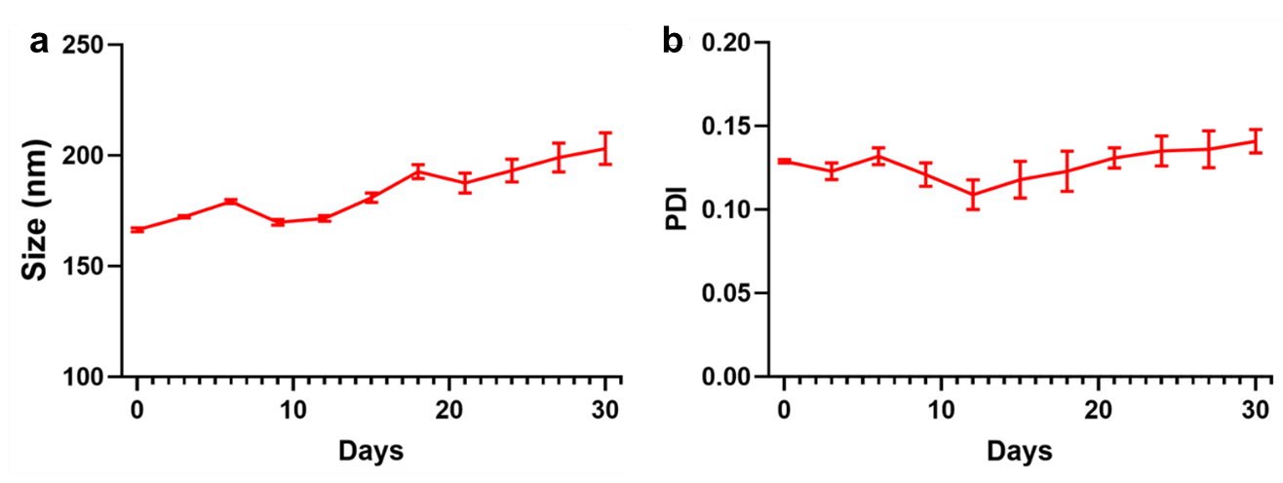
Supplementary Fig. 19. The size distribution (a) and PDI changes (b) of PS-CHO@ATRA-SS-ATRA in PBS solution within 30 days. Data are presented as means ± SD (n = 3).

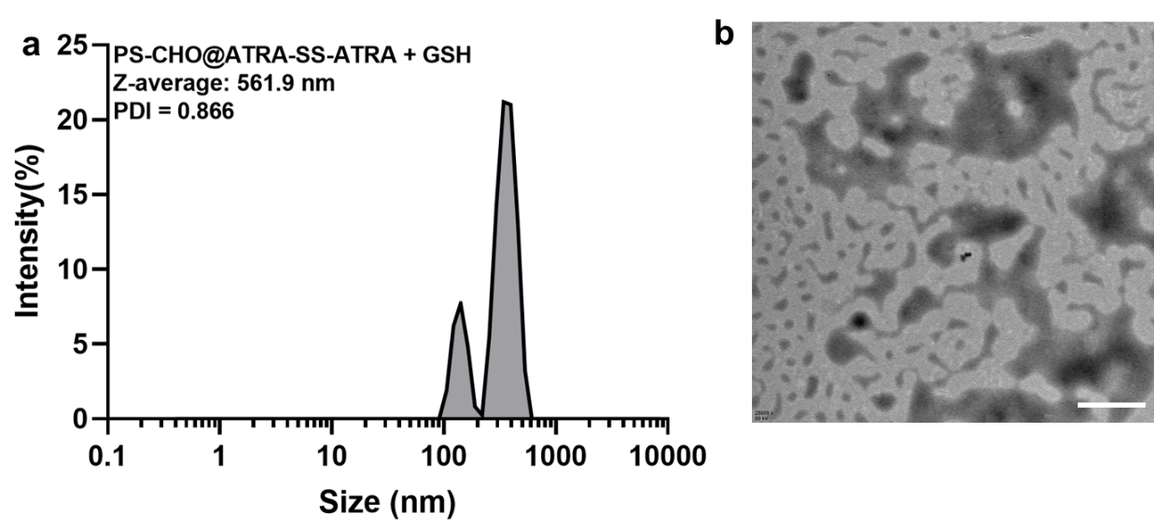
Supplementary Fig. 20. (a) The size distribution of PS-CHO@ATRA-SS-ATRA with GSH by DLS. (b) The morphology of PS-CHO@ATRA-SS-ATRA with 10 mM GSH by TEM, Scale bar: 200 nm.

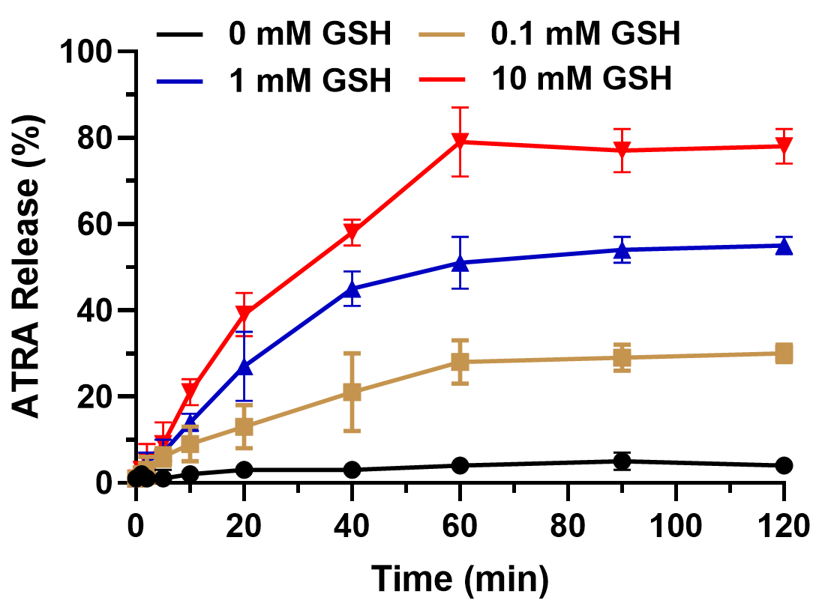
Supplementary Fig. 21. Cumulative ATRA release rate from PS-CHO@ATRA-SS-ATRA incubated with GSH (0, 0.1, 1 and 10 mM) by HPLC. Data are presented as means ± SD (n = 3).

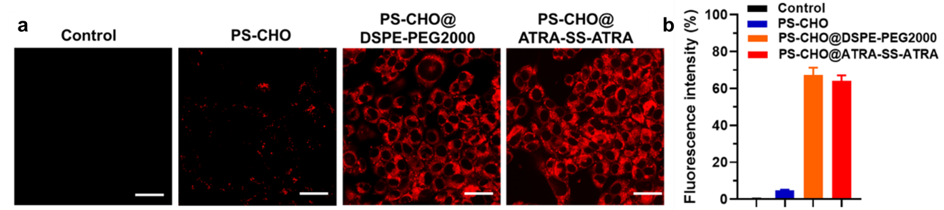
Supplementary Fig. 22. Confocal images (a) and flow cytometry analysis (b) of 4T1 cells treated with PS-CHO (1% DMSO), PS-CHO@DSPE-PEG2000 and PS-CHO@ATRA-SS-ATRA for 4 h, Scale bar: 20 μm. Data are presented as means ± SD (n = 3).

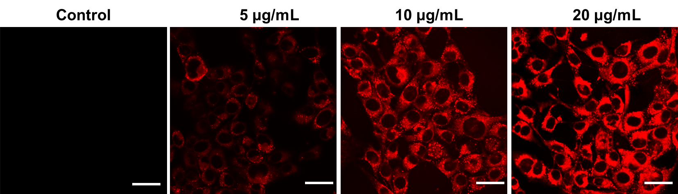
Supplementary Fig. 23. Confocal images of 4T1 cells treated with PS-CHO@ATRA-SS-ATRA with different concentrations (0, 5, 10 and 20 μg/mL) under hypoxia condition, Scale bar: 20 μm.

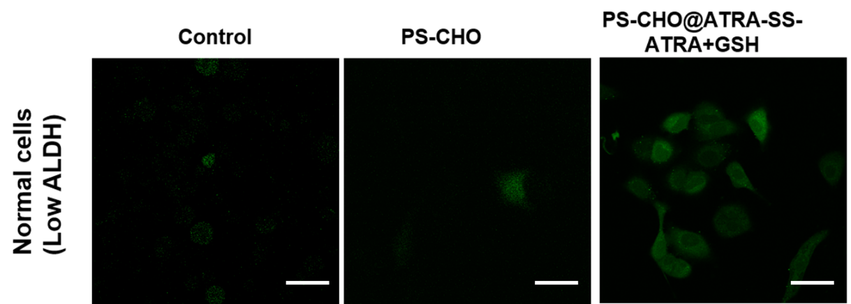
Supplementary Fig. 24. Confocal imaging of 3T3 cells incubated with PS-CHO@ATRA-SS-ATRA (with or without 10 mM GSH) and other formulations by light irradiation, which was further incubated with DCFH-DA for 30 min to determine intracellular ROS generation, Scale bar: 20 μm.

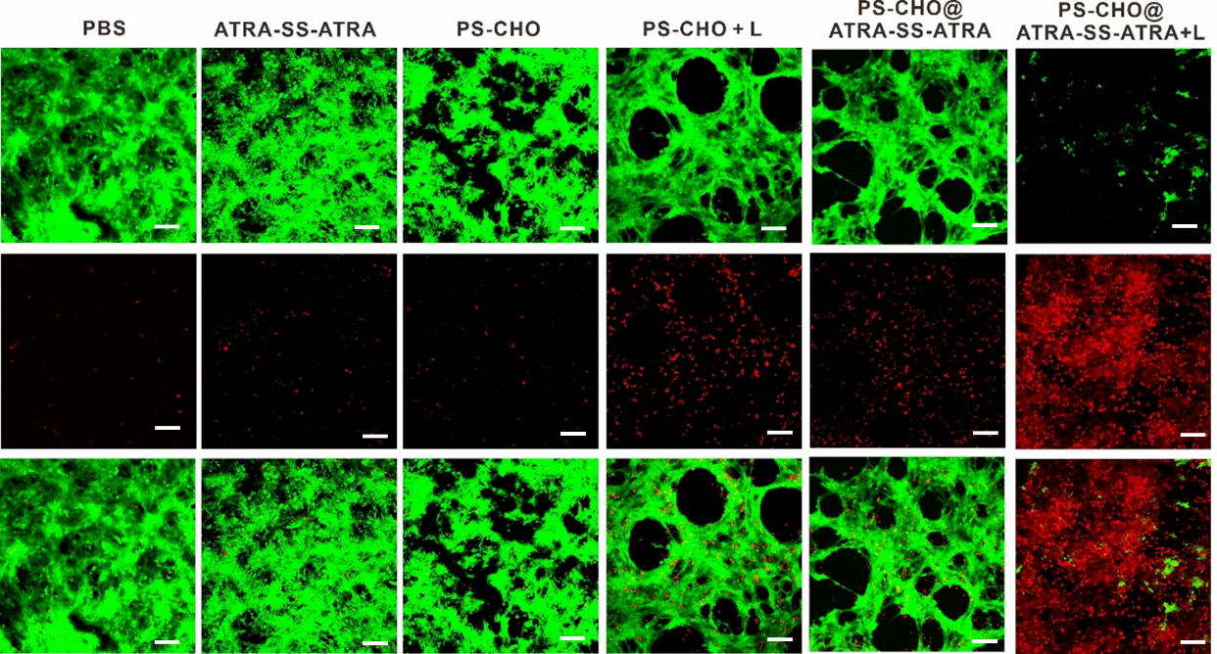
Supplementary Fig. 25. The LIVE/DEAD staining images of 4T1 cells by FDA/PI staining. Cells were treated with different formulations and incubated for 24 h, Scale bar: 20 μm.

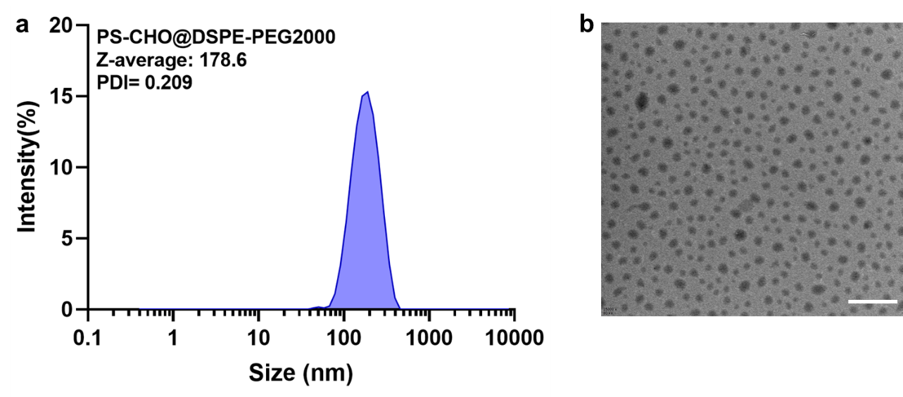
Supplementary Fig. 26. (a) The size distribution of PS-CHO@DSPE-PEG2000 by DLS. (b) The morphology of PS-CHO@DSPE-PEG2000 by TEM, Scale bar: 500 nm.

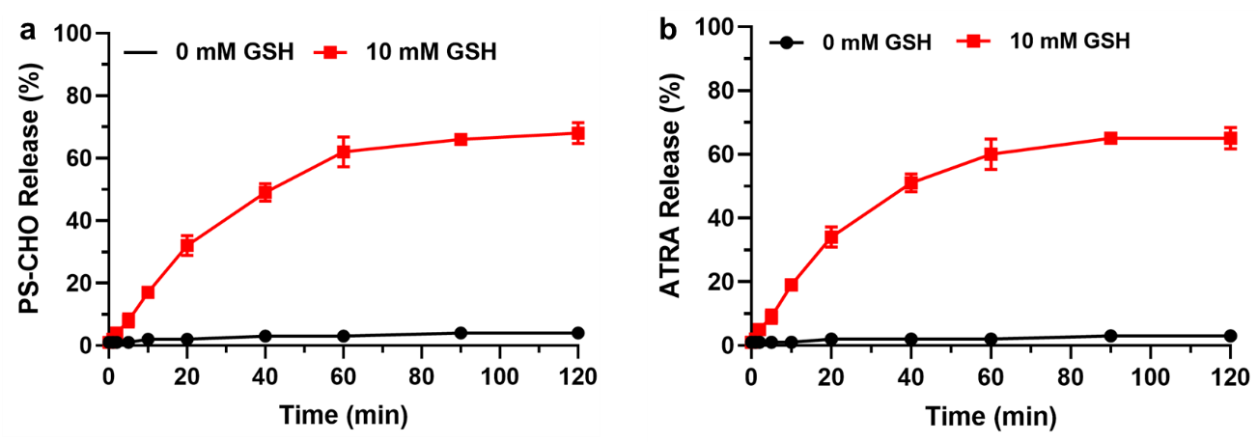
Supplementary Fig. S27. Cumulative PS-CHO (a) and ATRA (b) release rate from PS-CHO@HA-ATRA-SS-ATRA incubated with GSH (0 and 10 mM) by HPLC. Data are presented as means ± SD (n = 3).

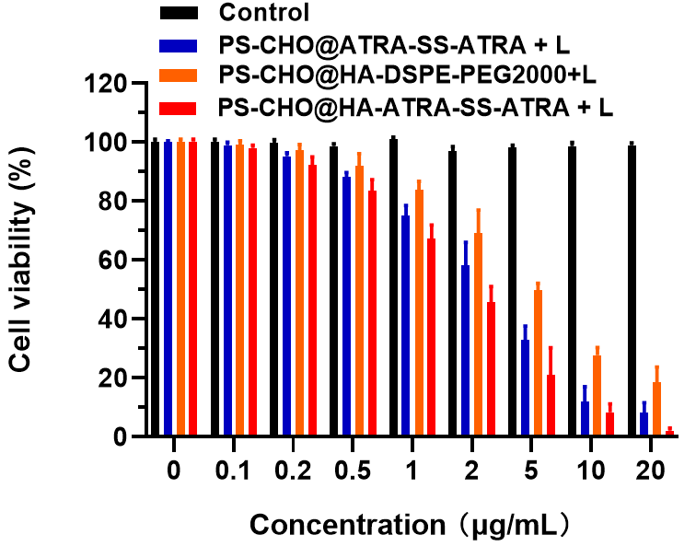
Supplementary Fig. 28. The cytotoxicity of different formulations to 4T1 cells under hypoxia conditions. Data are presented as means ± SD (n = 6).

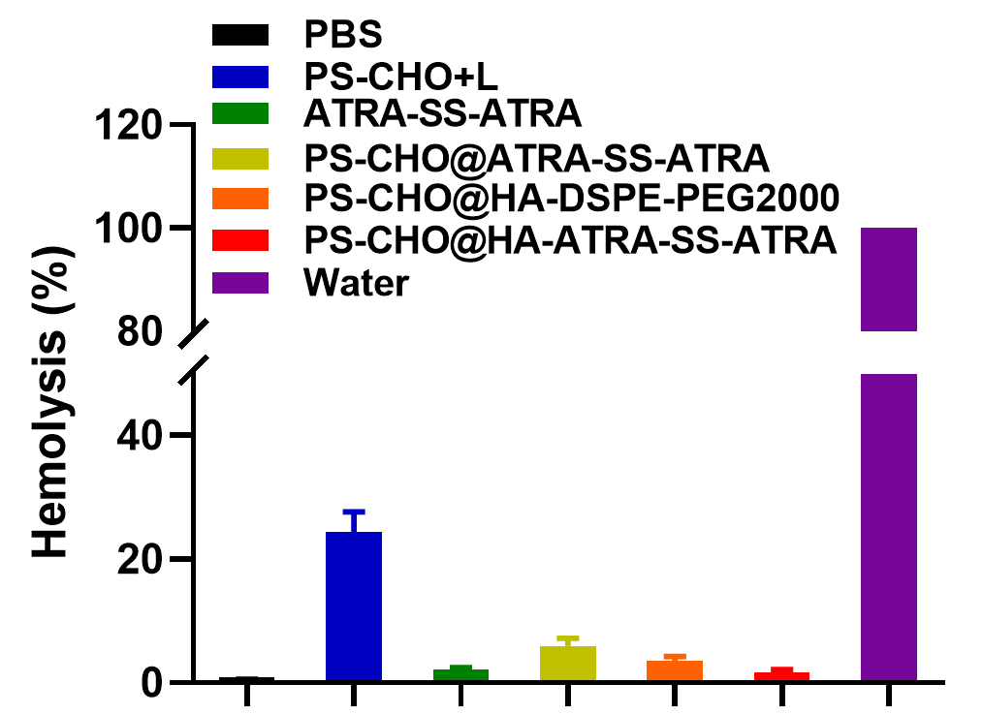
Supplementary Fig. 29. Hemolytic activity of the nanoparticles. The erythrocytes were incubated with different drug formulations at 2 mg/mL for 30 min. PBS and water were used as the negative and positive controls. Data are presented as means ± SD (n = 3).

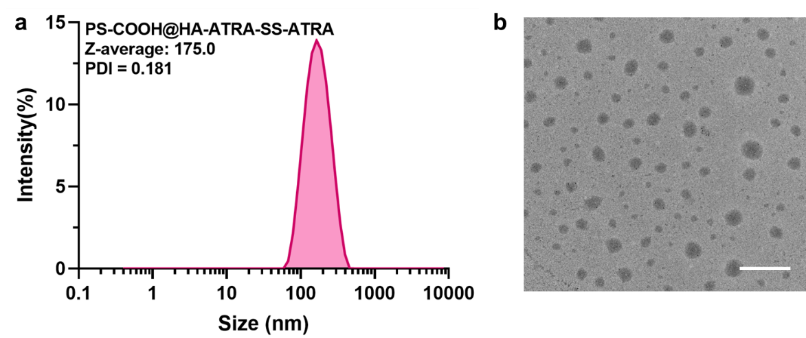
Supplementary Fig. 30. (a) The size distribution of PS-COOH@HA-ATRA-SS-ATRA by DLS. (b) The morphology of PS-CHO@HA-ATRA-SS-ATRA by TEM, Scale bar: 500 nm.

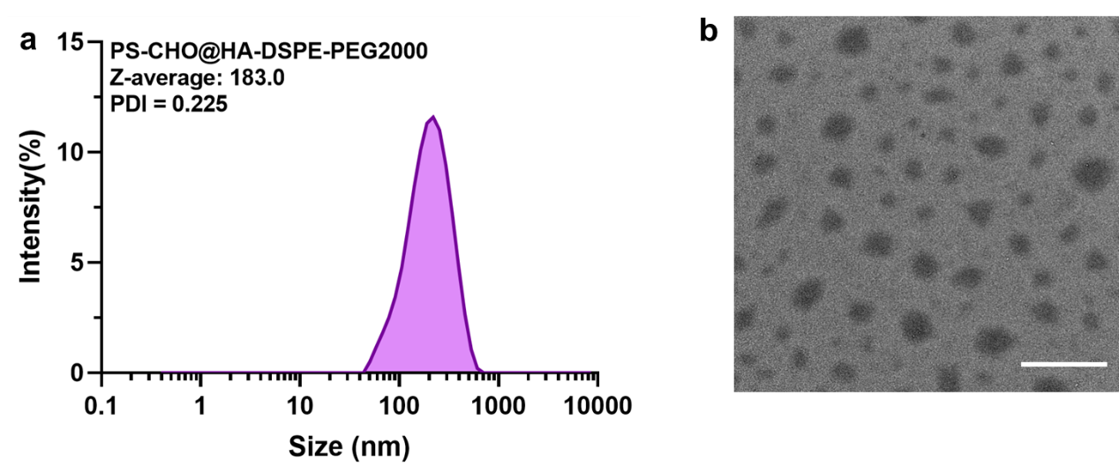
Supplementary Fig. 31. (a) The size distribution of PS-CHO@HA-DSPE-PEG2000 by DLS. (b) The morphology of PS-CHO@HA-DSPE-PEG2000 by TEM, Scale bar: 500 nm.

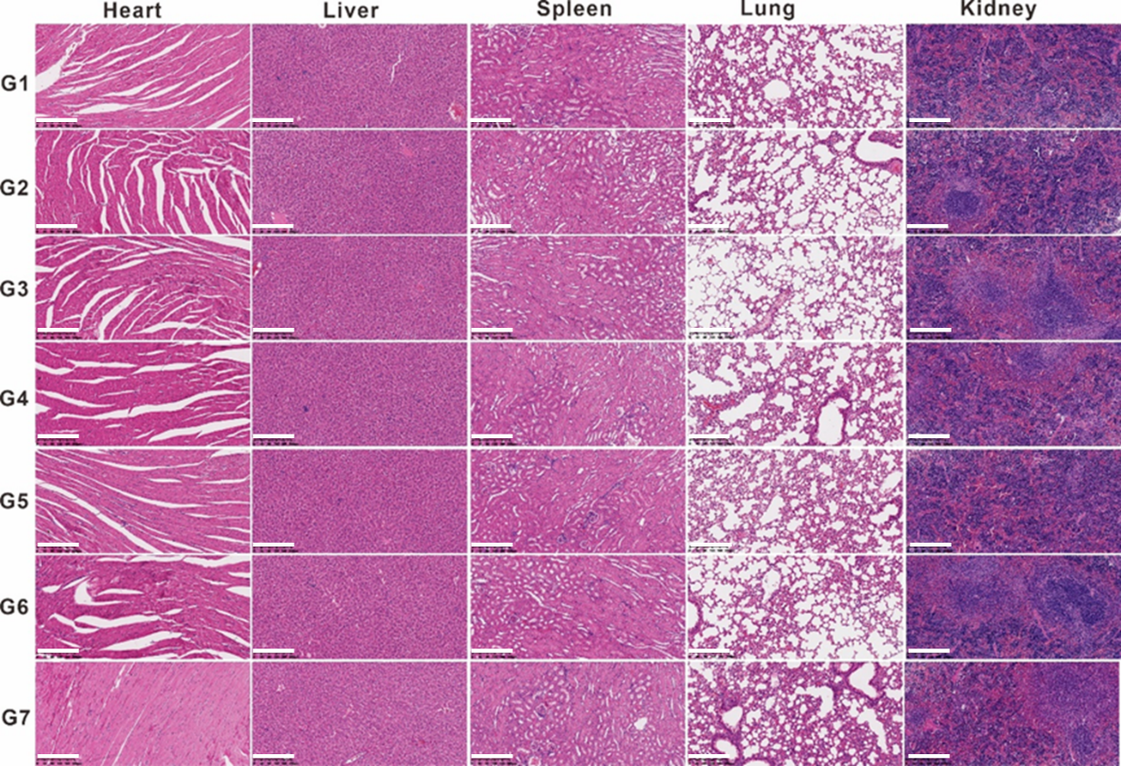
Supplementary Fig. 32. The H&E staining analysis of major organs (heart, liver, spleen, lung and kidney) of different formulations (G1-G7), Scale bar: 200 μm.

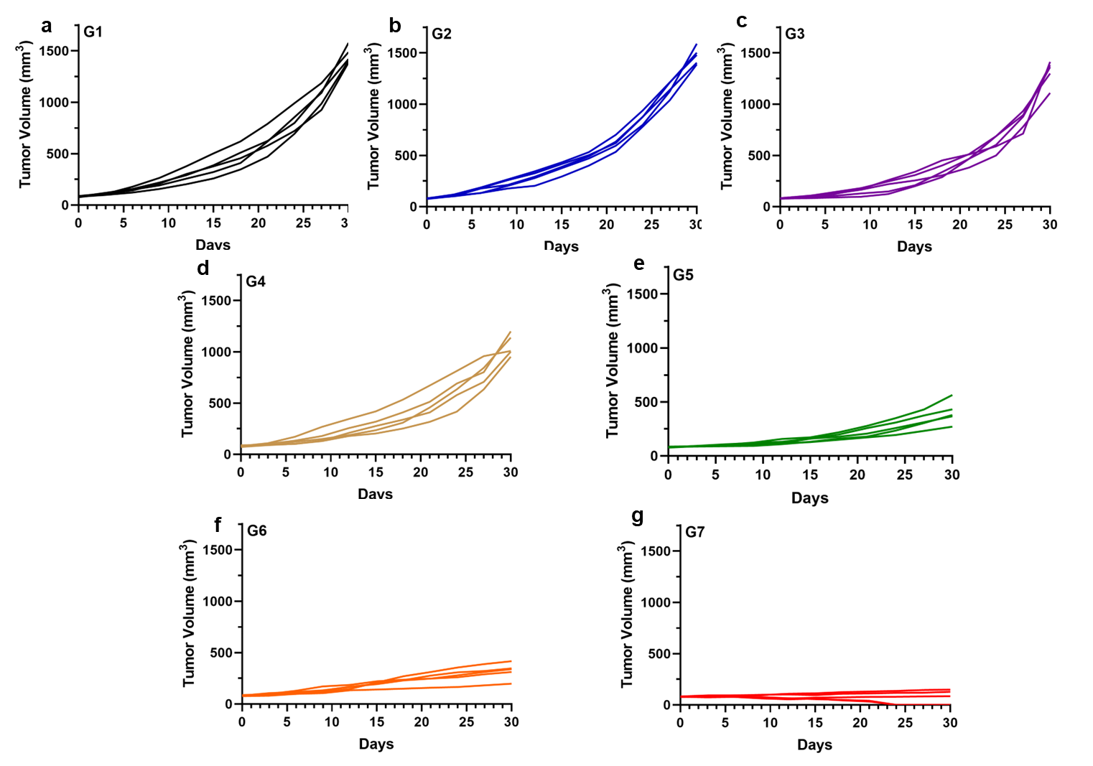
Supplementary Fig. 33. Tumor volume evolution of each mouse in different groups (G1-G7: a-g) after 30 days treatment.

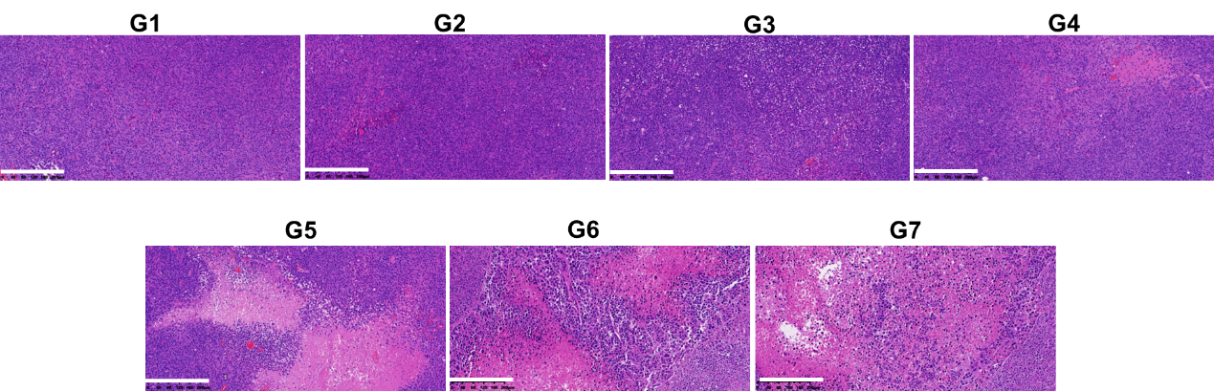
Supplementary Fig. 34. The H&E staining analysis of tissue of different formulations (G1-G7), Scale bar: 200 μm.

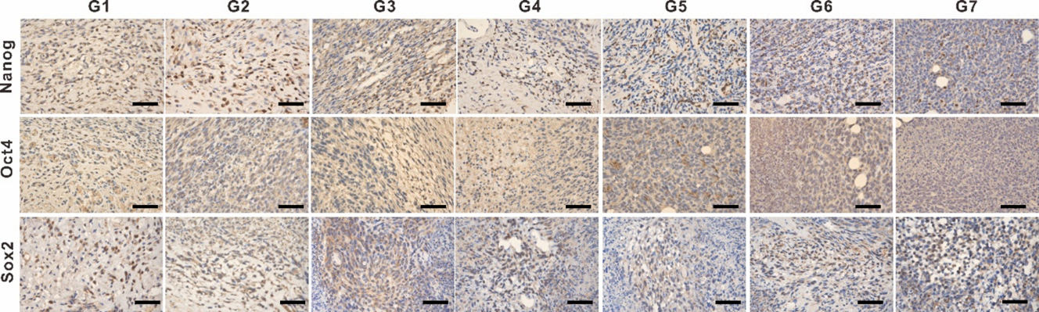
Supplementary Fig. 35. Representative immunohistochemical staining images of the tumor sections dissected from G1-G7 group, Scale bar: 200 μm.

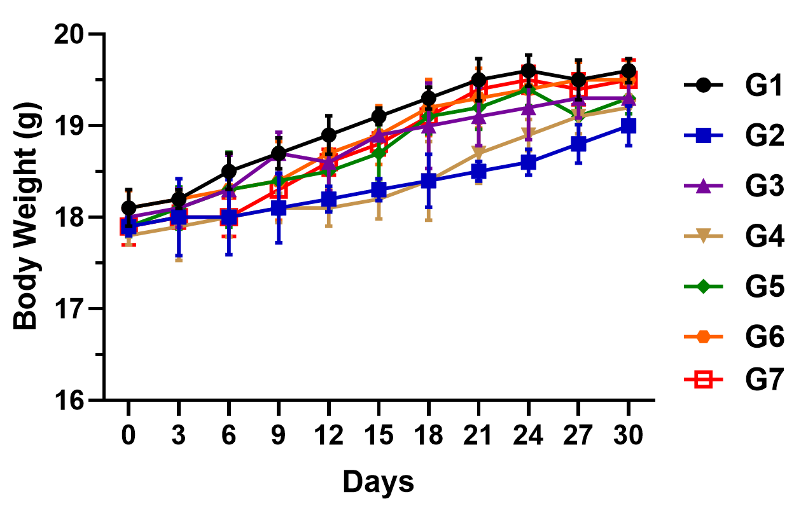
Supplementary Fig. 36. Body weight of mice in each group (G1-G7) at the period of 30 days treatment. Data are presented as means ± SD (n = 5).

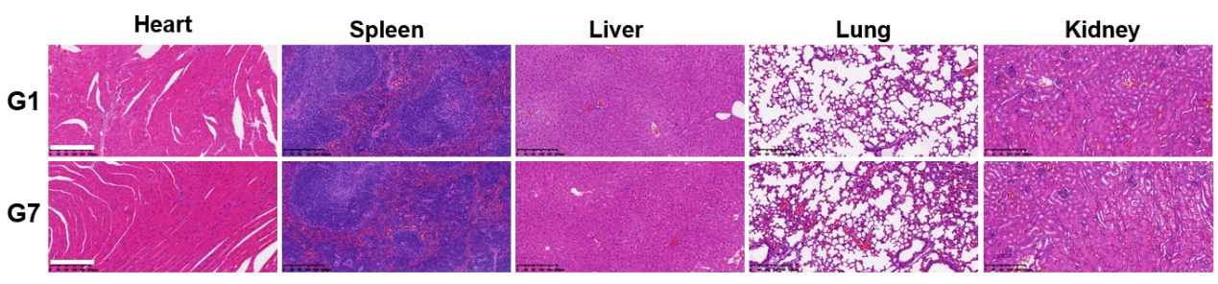
Supplementary Fig. 37. The H&E staining analysis of major organs (heart, liver, spleen, lung and kidney) of G1 and G7, Scale bar: 200 μm.

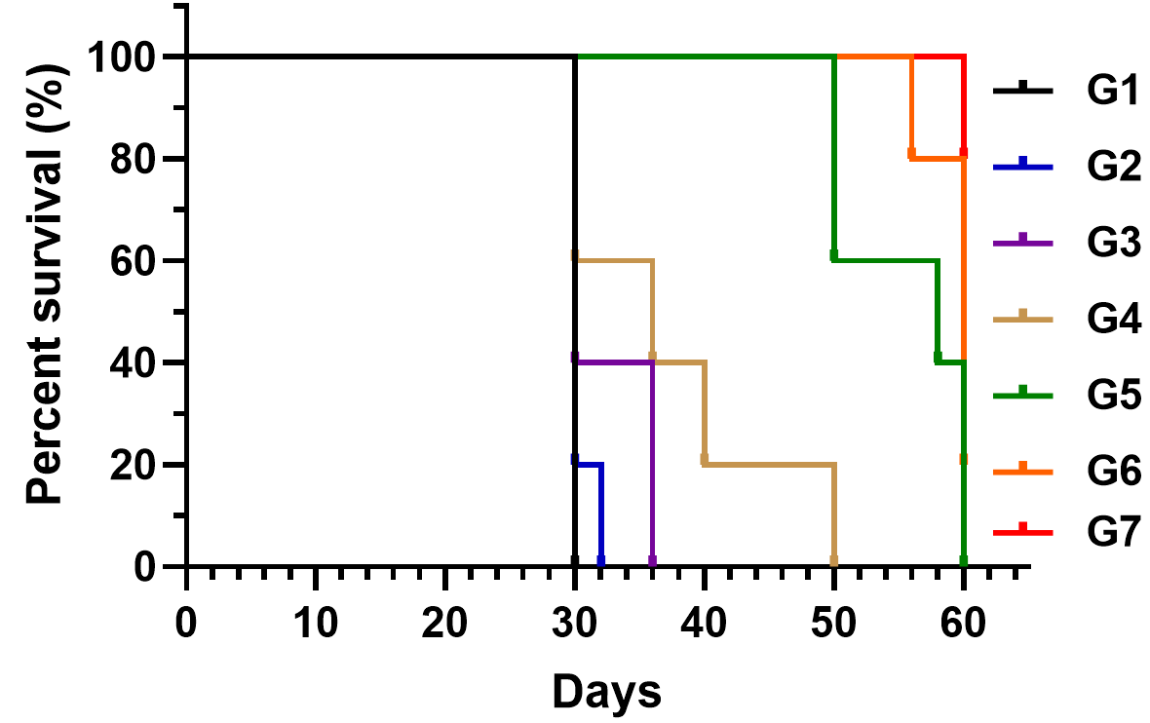
Supplementary Fig. 38. Survive curves of different treatment groups (G1-G7) in 60 days.

