Supplementary data
Table S1. Average nucleotide identity (ANI) analysis and digital DNA-DNA hybridization analysis between new species Microvirga amygdalina BT291^{T} and Microvirga alba BT350^{T} and type strains of Microvirga species for which all genomes have been published. Data of related type strains were taken from EzBioCloud (https://www.ezbiocloud.net/genome).
Strains |  |  |  |  |  | BT291^{T} |  | BT350^{T}
Taxon name | Strain name (type) | DNA G+C content (mol%) | Genome size (Mb) | contigs | DB accession numbers | ANI (%) | DDH (%) | ANI (%) | DDH (%)
Microvirga aerophila | DSM 21344 | 62.1 | 6.00 | 184 | GCA_003332305.1 | 77.5 | 21.6 | 78.7 | 22.1
Microvirga subterranea | DSM 14364 | 65.1 | 5.15 | 36 | GCA_003350535.1 | 78.5 | 21.9 | 79.1 | 22.5
Microvirga brassicacearum | CDVBN77 | 62.3 | 1.51 | 82 | GCA_008757455.1 | 75.9 | 20.5 | 77.0 | 21.1
Microvirga flocculans | ATCC BAA-817 | 64.3 | 4.03 | 30 | GCA_000518665.1 | 77.9 | 21.7 | 79.1 | 22.4
Microvirga guangxiensis | CGMCC 1.7666 | 61.4 | 4.72 | 34 | jgi.1041447.1 | 77.1 | 21.4 | 77.9 | 21.9
Microvirga lotononidis | WSM3557 | 63.0 | 7.08 | 18 | GCA_000262405.1 | 78.0 | 22.5 | 78.5 | 22.5
Microvirga lupini | Lut6 | 60.3 | 9.63 | 160 | GCA_000517005.1 | 77.6 | 22.8 | 78.6 | 22.8
Microvirga massiliensis | JC119 | 61.4 | 9.17 | 50 | GCA_001006805.1 | 76.3 | 20.0 | 73.6 | 21.1
Microvirga calopogonii | CCBAU 65841 | 62.5 | 7.41 | 249 | GCA_003347665.1 | 77.7 | 22.4 | 78.6 | 22.5
Microvirga ossetica | V5/3M | 62.7 | 9.63 | 6 | GCA_002741015.1 | 77.7 | 22.1 | 78.8 | 23.1
Microvirga vignae | BR3299 | 61.1 | 6.47 | 165 | GCA_001017175.1 | 77.0 | 21.0 | 78.1 | 21.9
Microvirga flavescens | c27j1 | 62.2 | 3.53 | 26 | GCA_003290125.1 | 77.0 | 21.0 | 78.0 | 22.3
Microvirga makkahensis | KCTC 23863 | 63.1 | 5.58 | 94 | GCA_009830105.1 | 77.1 | 21.3 | 77.9 | 22.0
Microvirga pakistanensis | NCCP-1258 | 63.3 | 5.76 | 723 | GCA_004458765.1 | 77.5 | 21.7 | 78.5 | 22.1

Table. S1 The negative results of strain BT291^{T} in API 20NE test and API ZYM test.
Physiological characteristics | BT291^{T}
API 20 NE
Nitrate reduction to NO₂ | -
Nitrate reduction to N₂ | -
Production of Indole | -
Production of acid from glucose | -
Arginine dihydrolase | -
Urease | -
β-Glucosidase (Esculin hydrolysis) | -
Protease (gelatin hydrolysis) | -
β-Galactosidase (PNPG) | -
D-Glucose | -
L-Arabinose | -
D-Mannose | -
D-Mannitol | -
N-Acetyl-D-glucosamine | -
D-Maltose | -
Gluconate | -
Caprate | -
Adipate | -
L-Malate | -
Phenyl acetate | -
API ZYM
Esterase (C8) | -
Lipase (C14) | -
Leucine arylamidase | -
Valine arylamidase | -
Cystine arylamidase | -
Trypsin | -
α-Chymotrypsin | -
Acid phosphatase | -
Naphtol-AS-BI-phosphohydrolase | -
α-Galactosidase | -
β-Galactosidase (ONPG) | -
β-Glucuronidase | -
α-Glucosidase (starch hydrolysis) | -
β-Glucosidase | -
N-Acetyl-β-glucosaminidase | -
α-Annosidase | -
α-Fucosidase | -

Table. S2 The negative results of strain BT350^{T} in API 20NE test and API ZYM test.
Physiological characteristics | BT350^{T}
API 20 NE
Nitrate reduction to NO₂ | -
Production of Indole | -
Production of acid from glucose | -
β-Glucosidase (Esculin hydrolysis) | -
Protease (gelatin hydrolysis) | -
β-Galactosidase (PNPG) | -
D-Glucose | -
L-Arabinose | -
D-Mannose | -
D-Mannitol | -
N-Acetyl-D-glucosamine | -
D-Maltose | -
Gluconate | -
Caprate | -
Adipate | -
L-Malate | -
Citrate | -
Phenyl acetate | -
API ZYM
Alkaline phosphatase | -
Esterase (C8) | -
Lipase (C14) | -
leucine arylamidase | -
Valine arylamidase | -
Cystine arylamidase | -
Trypsin | -
α-Chymotrypsin | -
Naphtol-AS-BI-phosphohydrolase | -
α-Galactosidase | -
β-Galactosidase (ONPG) | -
β-Glucuronidase | -
α-Glucosidase (starch hydrolysis) | -
β-Glucosidase | -
N-Acetyl-β-glucosaminidase | -
α-Mannosidase | -
α-Fucosidase | -

Fig. S1 Transmission electron micrograph of strains BT291^{T} (a) and BT350^{T} (b) from cultures grown on R2A agar for three days at 25 °C. Bars are 0.5 µm.
(a)
(b)
Fig. S2 Maximum-Parsimony phylogenetic tree based on 16S rRNA gene sequences, showing the relationships of strains BT291^{T} and BT350^{T} with closely related validly published species. Bootstrap values (>70 %) based on 1,000 replications are shown at the branch nodes. Phyllobacterium loti S658^{T} were used as an outgroup.
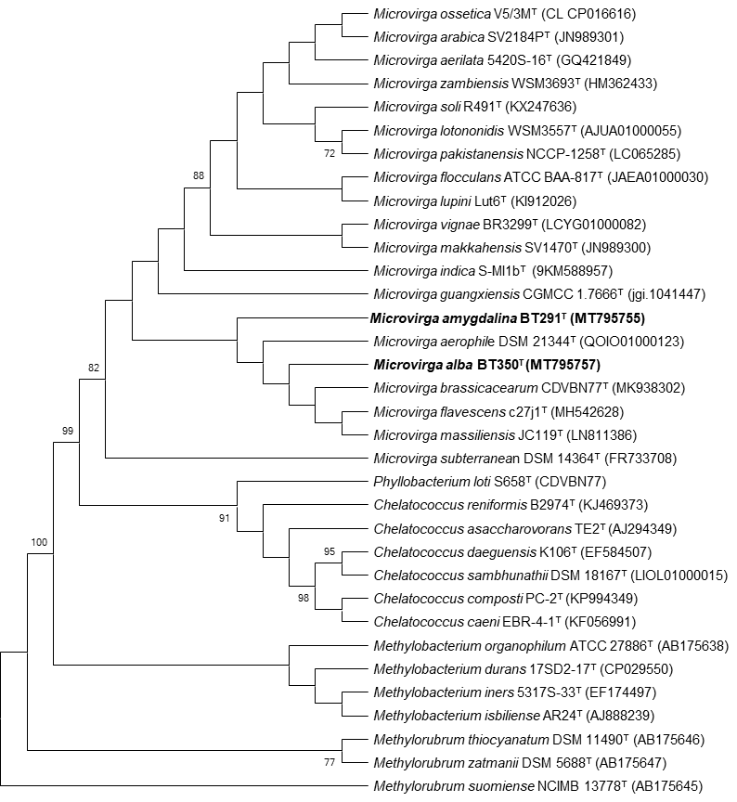
Fig. S3 Maximum-Likelihood phylogenetic tree based on 16S rRNA gene sequences showing the relationships of strains BT291^{T} and BT350^{T} with closely related validly published species. Bootstrap values (>70 %) based on 1,000 replications are shown at the branch nodes. Bar, 0.020 substitutions per nucleotide position. Phyllobacterium loti S658^{T} were used as an outgroup.
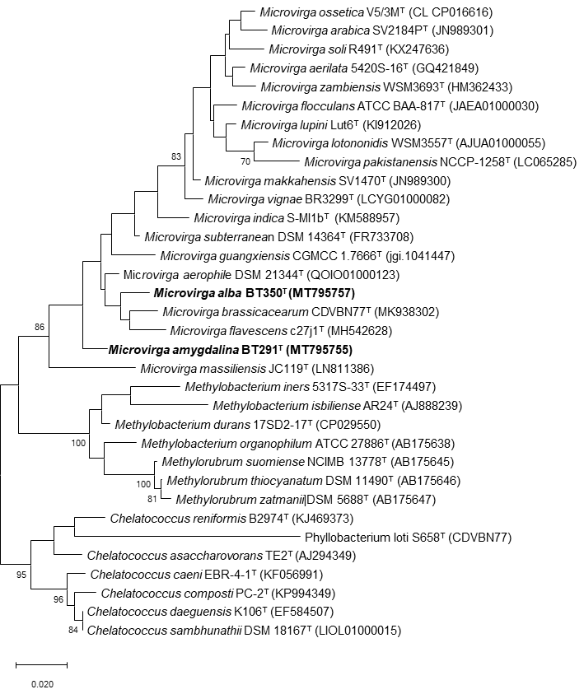
Fig. S4 Polar lipid profiles of strain BT291^{T} after two-dimensional chromatography.
(a) total lipids; (b) phospholipids; (c) aminolipids; (d) glycolipids.
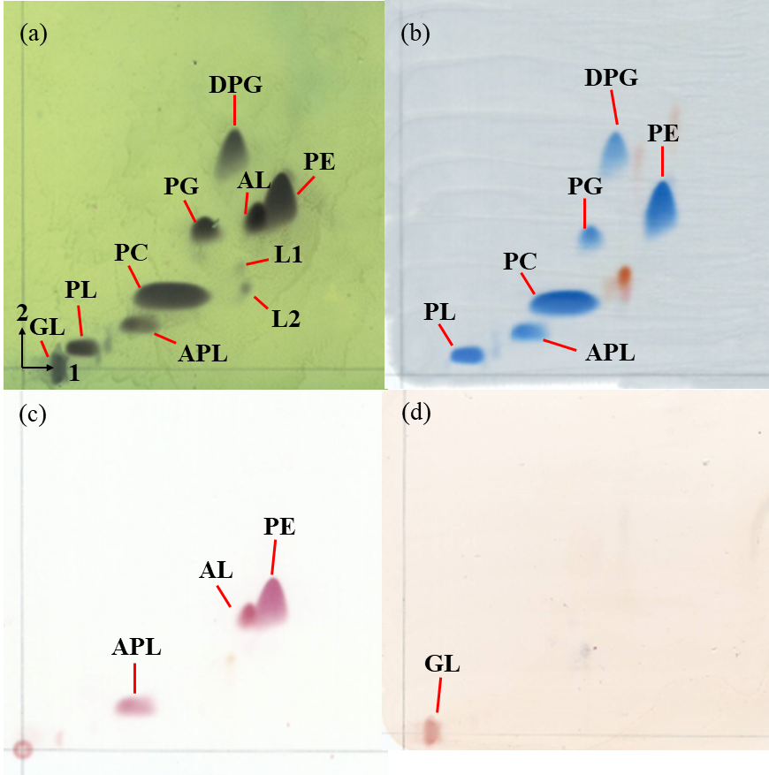
Abbreviations: L₁-L₂, lipid; PG, an unknown phosphatydilglycerol; APL, an unknown aminophospholipid; PE, an phosphatidylethanolamine; DPG, an unknown diphosphatydilglycerol; AL, an unknown aminolipid; PL, an unknown phospholipids; PC, an unknown phosphatidylcholine; GL, an unknown glycolipid.

Fig. S5 Polar lipid profiles of strain BT350^{T} after two-dimensional chromatography.
(a) total lipids; (b) phospholipids; (c) aminolipids; (d) glycolipids.
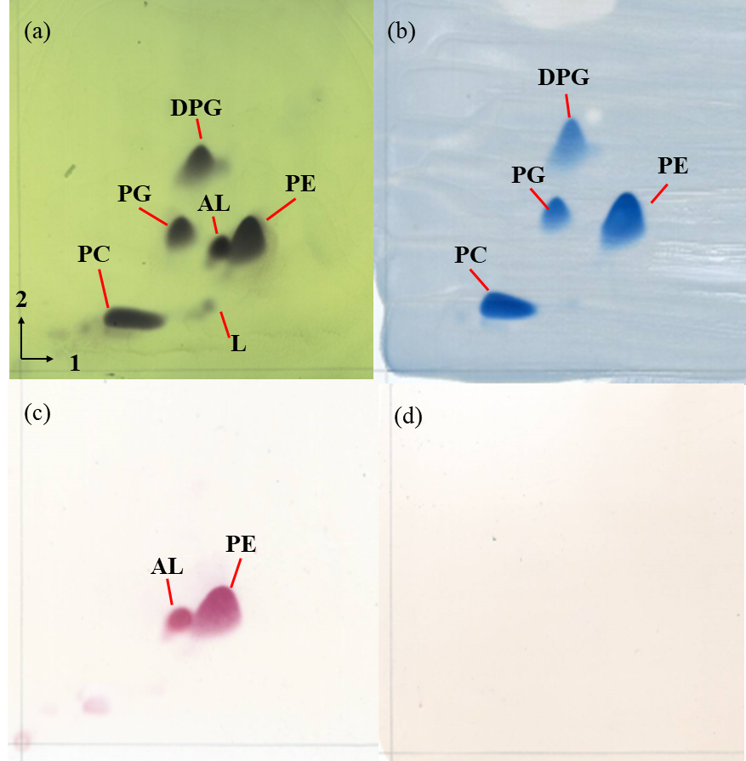
Abbreviations: L, an unknown lipid; PG, an unknown phosphatydilglycerol; PE, an phosphatidylethanolamine; DPG, an unknown diphosphatydilglycerol; AL, an unknown aminolipid; PC, phosphatidylcholine.

