Supplementary information

Enhanced Biosynthesis of Coated Silver Nanoparticles using Isolated Bacteria from Heavy Metal-Contaminated Soils and their Photothermal-based antibacterial activity: Integrating RSM Hybrid ANN-GA Strategies
World journal of Microbiology and Biotechnology
Meroua Safa Mechouche ^{a,b*}, Fateh Merouane ª, Ahmed Addad ^{c}, Lydia Karmazin^{d}, Rabah Boukherroub ^{b}, Nadjem Lakhdari ª
ª Biotechnology laboratory, Higher National School of Biotechnology Taoufik KHAZNADAR, nouveau Pôle universitaire Ali Mendjeli,BP. E66, Constantine, 25100, Algeria
^{b} Univ. Lille, CNRS, Univ. Polytechnique Hauts-de-France, UMR 8520, IEMN, F-59000, Lille, France
^{c} Univ. Lille, CNRS, UMR 8207 - UMET - Unité Matériaux et Transformations, 59000 Lille, France
^{d} Institut Chevreul FR2638, Pôle Diffraction et Diffusion des Rayons X, Cité Scientifique-Université de Lille, Avenue Paul Langevin, CEDEX, 59652 Villeneuve d’Ascq, France
Email: meroua-safa.mechouche.etu@univ-lille.fr
Telephone number: +33780800296

Materials and Methods

Quantification of nitrate reductase activity
Assessment of nitrate reductase in the resulting filtrates was performed as described by Harley (Harley 1993), using a 96-well plate. Specifically, 100 µL of each experimental filtrate was mixed separately with an assay medium (v/v) containing 30 mM of KNO₃ and 5% of propanol in a 0.1 M phosphate buffer of pH 7.5. This mixture was then incubated in the dark for 1 h. After incubation, the nitrites produced in the assay mixture were quantified by adding 50 µL of sulphanilamide and 50 µL of N-(1-naphthyl) ethylene diamine dihydrochloride (NEED) solutions. The pink color that developed was measured at 540 nm. Enzyme activity was determined by quantifying the increase in nitrite concentration in the solution over 1 h, for the initial sample volume (100 µL), and expressed as nmol of nitrite per hour per milliliter (nmol, h⁻¹, ml⁻¹). Each assay was conducted in triplicate, and the data presented in Table 2 represent the average values of these replicates.
Genetic Algorithm (GA) parameters
Table S1. Genetic Algorithm (GA) Parameter Settings for Culture Medium Component Optimization. The GA employs encoded bounds to define the limits within which the algorithm searches for optimal component values. The lower encoded bounds [-1] are detailed in brackets and signify the minimum values for each component of the culture medium. The upper encoded bounds [+1], also presented in brackets, represent the maximum values for each component.
Parameters | Options
Solver | GA
Number of variables | 5
Lower encoded bounds | [-1, -1, -1, -1, -1]
Upper encoded bounds | [+1, +1, +1, +1, +1]
Population size | 20
Population type | Double vector
Creation function | Feasible population
Scaling function | Rank
Selection function | Stochastic uniform
Crossover function | Two-point
Mutation function | Adaptative feasible
Migration | Forward
Generation | 500

AgNPs Characterization
UV-vis spectroscopy analysis
After observing the color change in each mixed reaction of AgNPs, ultraviolet-visible (UV-vis) spectrophotometry was employed as the primary analytical technique. The spectral analysis was conducted using an EVOLUTION 260 BIO spectrophotometer (Thermo Scientific), covering a wavelength range from 300 to 800 nm at a resolution of 1 nm.
Dynamic light scattering (DLS) and zeta potential measurement
In order to assess the size and zeta potential of AgNPs, a series of analyses were carried out using the Zetasizer Nano ZSP device (Malvern Instruments in Worcestershire, UK). The particle size distribution was determined at room temperature using dynamic light scattering (DLS), with milli-Q water as the dispersion medium using a scattering angle 173°. A 10 mM NaCl solution was used as the dispersion medium for zeta potential evaluation. The process was repeated three times; these tests were carried out using a capillary cell to accurately determine the mean nanoparticle size and the zeta potential.
X-ray diffraction (XRD) analysis
The crystallinity and purity of the produced AgNPs were analyzed by X-ray diffraction (XRD). The XRD analyses were conducted using a Rigaku Smartlab rotating anode X-ray diffractometer. The instrument was equipped with a 9 kW Cu-Kα radiation source, with a wavelength (λ) of 1.5418 Å. A step size of 0.02° was used and the instrument was set at a scan speed of 5°/min to ensure that each data point has enough counting time to attain an optimal signal-to-noise ratio. Data were collected over a 2θ range from 5° to 105° in order to capture the primary peaks corresponding to the crystal planes of AgNPs. The obtained peaks were further identified using DIFFRAC.EVA V5.2 software by comparing them to the Powder Diffraction File (PDF-4+ 2023) database of the International Center for Diffraction Data (ICDD). Moreover, the average crystallite sizes were determined using the Fundamental Parameters Approach (FPA) (Cheary and Coelho 1992). The specific implementation of FPA in JANA2006 is detailed by Petricek, V., Dusek, M., and Palatinus,L (Petříček et al. 2014).
Fourier-transform infrared (FT-IR) analysis
Fourier-Transform Infrared Spectroscopy (FT-IR) is essential for determining the functional groups on the surface of the AgNPs. The AgNPs were prepared for analysis by mixing them with potassium bromide at a 1:100 ratio and pressing them into a clear disk for 10 min. The resulting FT-IR spectra span the wavelength range from 4000 to 650 cm⁻¹. The spectra were recorded using Nicolet 8700 - Thermo Scientific FT-IR spectrometer,
Transmission Electron Microscopy (TEM) analysis
The TEM analysis in this study aimed to provide detailed information on the morphological and structural characteristics of the synthesized nanoparticles, including size, shape, and crystalline structure. Images of AgNPs were captured utilizing an FEI Titan Themis 300 TEM, which operated at an acceleration voltage of 300 KeV. High-resolution images of AgNPs were obtained using FEI Titan Themis 300 TEM at an acceleration voltage of 300 kV. Scanning transmission electron microscopy (STEM) and energy-dispersive X-ray spectroscopy (EDX) were used to analyze the elemental composition and distribution within individual nanoparticles. This was carried out using an FEI Titan Themis 300 TEM equipped with a Cs spherical aberration corrector (DCOR) probe for high-resolution imaging in STEM mode (resolution < 70 pm) and a Super-X EDX detector, which provides superior sensitivity for very rapid chemical mapping. This setup includes four Silicon Drift Detectors (SDD) integrated into the objective (S-TWIN). The samples were dispersed in Milli-Q water, and a drop of this nanoparticle dispersion was placed on a nickel-coated carbon film grid. The solvent was left to evaporate, and a thin layer of nanoparticles was deposited on the grid. Once the TEM images were obtained. The average size of AgNPs was calculated, taking into-account the particle size distribution (Equation S1) (Rodríguez Molina et al. 2019).
$D\left(3,2\right)= \frac{\sum_{i=1}^{n}{v_{i} D_{i}^{3}}}{\sum_{i=1}^{n}{v_{i}} D_{i}^{2}}$ (S1)
where D_{i}​ is the geometric diameter of the i-th particle, and v_{i}​ is the number of particles with this diameter.
Results and Discussion
Purified Streptomyces tuirus S16 strain
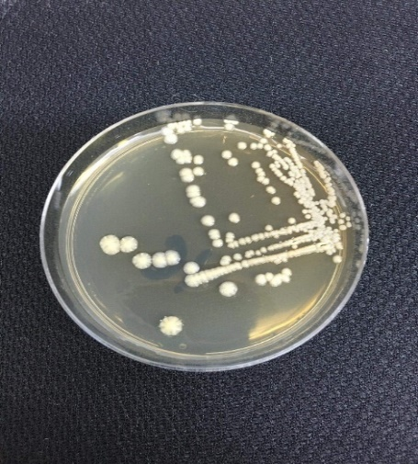  a) | 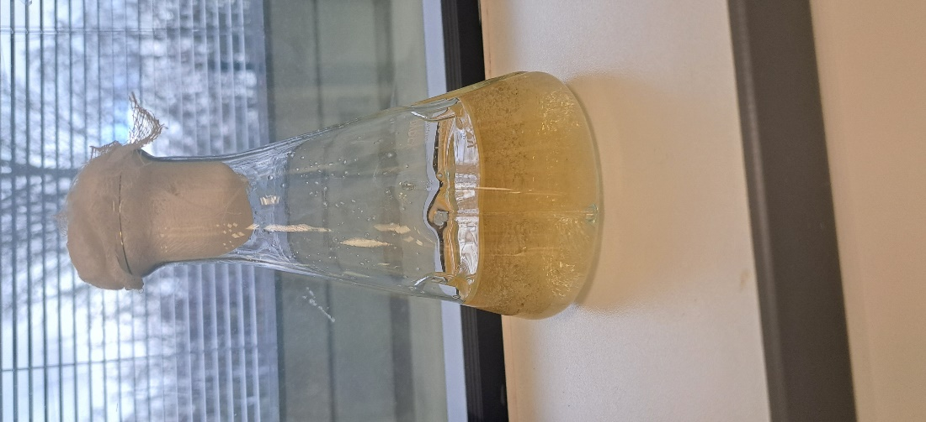  S16-Ben  b)

Figure S1. Photographs of Streptomyces tuirus S16 strain. (a) Pure S16 strain isolated in Bennett's agar medium after multiple purification steps, (b) S16 strain inoculated in optimized Bennett's medium for AgNPs biosynthesis

Biosynthesis optimization process using Genetic Algorithm (GA)

Figure S2. Fitness value evolution of NPs absorbance in the Genetic Algorithm (GA) across 500 generations for (a) AgNPs, and (b) AuNPs biosynthesis processes. Two types of fitness values are plotted: 'Best fitness', represented by dark dots, denotes the highest fitness score achieved in each generation, and 'Mean fitness', indicated by blue dots, represents the average fitness score across the population at each generation
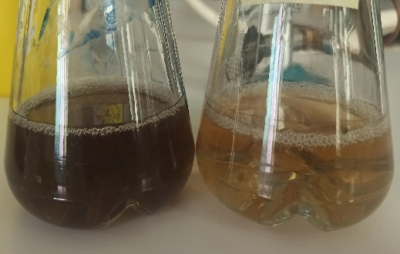
AgNPs
Opt-AgNPs
Figure S3. Photographs of optimized AgNPs vs. AgNPs. The images illustrate the differences in nanoparticle biosynthesis yield before and after the modeling and optimization process using RSM-ANN-GA system

High Resolution Transmission Electron Microscopy (HR-TEM) and EDX carbon map
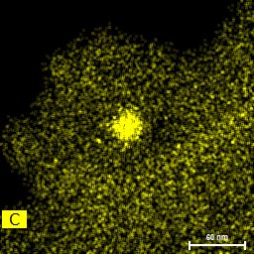
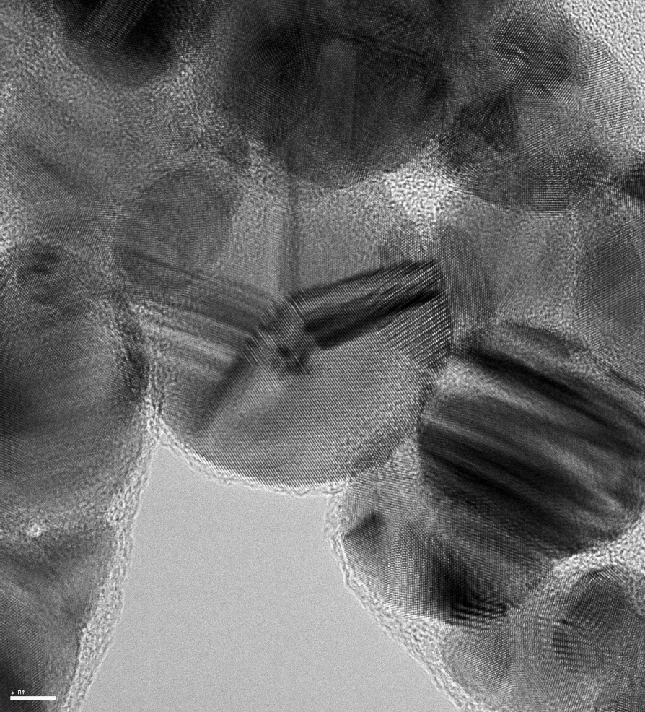
c)
a)
b)
Figure S4. (a) HR-TEM image and (b) EDX carbon maps of AgNPs sample. The TEM images show the carbonaceous layer on the surface of nanoparticles, which was further detected and confirmed by EDX. The regions analyzed by EDX are outlined with red frames, carefully selected from the edges to avoid carbon detection originating from the grid. The pronounced carbon spot in the EDX map of AgNPs is attributed to electron beam-induced contamination
Statistical analysis of photothermal-based antibacterial activity of silver nanoparticles

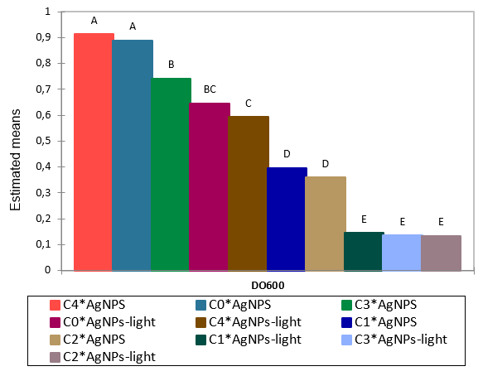
Figure S5. Bars representing Multiple pairwise comparisons for Concentration*Treatment (Tukey (HSD)) of AgNPs

References
Cheary RW, Coelho A (1992) A fundamental parameters approach to X-ray line-profile fitting. J Appl Crystallogr 25(2): 109‑121. https://doi.org/10.1107/S0021889891010804
Harley SM (1993) Use of a Simple, Colorimetric Assay to Demonstrate Conditions for Induction of Nitrate Reductase in Plants. Am Biol Teach 55(3): 162‑164.
Petříček, V, Dušek, M, Palatinus L (2014) Crystallographic Computing System JANA2006 : General features. Z Kristallogr Cryst Mater 229(5):345‑352. https://doi.org/10.1515/zkri-2014-1737
Rodríguez Molina H, Santos Muñoz JL, Domínguez Leal MI, Reina TR, Ivanova S, Centeno Gallego MÁ, Odriozola JA (2019) Carbon Supported Gold Nanoparticles for the Catalytic Reduction of 4-Nitrophenol. Front Chem 7: 548. https://www.frontiersin.org/articles/10.3389/fchem.2019.00548

