Appendix A.

Supplementary figure legends
Supplementary Figure 1. Experimental workflow
DNAs extracted from PBMCs were sequenced on Illumina HiSeq 4000 or NovaSeq 6000 using the error-corrected sequencing technique and analyzed by machine-learning method.

Supplementary Figure 2. Overview of the Error-corrected Sequencing metrics
To have sufficient sequencing depth for ensuring the accuracy of detection, all the tests were greater than 3,000X coverage in "unique sequencing depth".

Supplementary Figure 3. Number of variants identified in the discovery cohort
The red and blue bar indicated the number of synonymous and non-synonymous variants in each sample, respectively. P-values were calculated using two-sample T test with Welch’s correction.

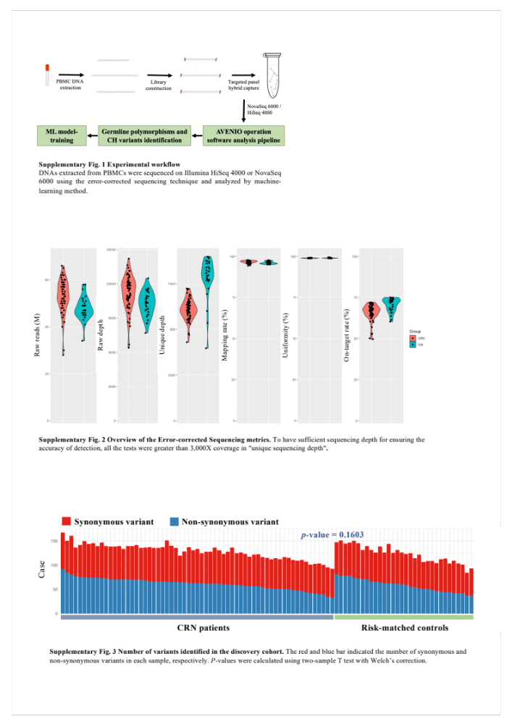

Supplementary Table1. Somatic mutations with VAF greater than 0.02
Sample group |  | Age |  | Gender |  | Gene |  | Variant |  | VAF (Deplex)
CRN patient |  | 65.8 |  | M |  | BRAF |  | Gly446val |  | 0.027
CRN patient |  | 56.3 |  | F |  | DDR2 |  | Pro496Ser |  | 0.044
CRN patient |  | 59.3 |  | M |  | MSH2 |  | Arg382His |  | 0.021
CRN patient |  | 72.4 |  | M |  | ROS1 |  | Arg1942Trp |  | 0.024
CRN patient |  | 49.4 |  | F |  | FGFR2 |  | Arg422Cys |  | 0.024
CRN patient |  | 62.0 |  | F |  | AR |  | Leu57Gln |  | 0.025
CRN patient |  | 76.4 |  | M |  | CSF1R |  | Trp159* |  | 0.050
Control group |  | 62.0 |  | M |  | PMS2 |  | His479Gln |  | 0.027
Control group |  | 69.0 |  | M |  | ROS1 |  | Val332Ala |  | 0.040
Control group |  | 64.0 |  | M |  | FLT1 |  | Ser1279Asn |  | 0.031
Control group |  | 64.0 |  | M |  | GNA11 |  | Arg114Gln |  | 0.026

