Supplementary Materials

Dynamic, personalized dose selection platform, CURATE.AI, in patients with solid tumors: case series and pilot feasibility trial

Agata Blasiak^{1,2,3,4,*}, Anh T. L. Truong^{1,2,3}, Lester W. J. Tan^{1,2,3}, Kirthika S. Kumar^{1,2}, Shi-Bei Tan^{1,2}, Chong Boon Teo⁵, Benjamin K. J. Tan⁵, Xavier Tadeo^{1,2}, Hon Lyn Tan⁶, Cheng Ean Chee^{5,6}, Wei Peng Yong^{6,7}, Dean Ho^{1,2,3,4,7,8,*}, Raghav Sundar^{2,5,6,7,*}

* Corresponding authors. Emails: agata.blasiak@nus.edu.sg (AB), biedh@nus.edu.sg (DH), mdcragh@nus.edu.sg (RS)

This PDF file includes:

Supplementary Text – Results
Supplementary Text – Discussion
Supplementary Text – Methods
Supplementary Text - References
Figure S1. Longitudinal capecitabine doses and CEA-based responses of the patients who did not respond to the regimen (A) or did not reach efficacy-driven CURATE.AI recommendations (B).
Figure S2. Pooled data (N=31) demonstrated that the change in the capecitabine effected dose affected the resulting carcinoembryonic antigen (CEA) value in the corresponding cycle.
Table S1. Patient demographics and response characteristic in sub-groups, depending on their response to the regimen and engagement level with CURATE.AI.
Table S2. Results of the primary and secondary outcome measures.
Table S3. Outcome measures and progression criteria for the PRECISE CURATE.AI pilot study, capecitabine in solid tumor cohort.
Table S4. Changes made to the protocol after recruitment of the first patient in PRECISE CURATE.AI pilot study relevant to capecitabine in solid tumor cohort
Table S5. Patient data types used for CURATE.AI operations.

Other Supplementary Materials for this manuscript include the following:

Data S1. Source patient data

Supplementary Text - Supplementary Results
The patients’ response characteristic in the sub-groups according to the CURATE.AI engagement stages (nonresponsive, calibration-intent, efficacy-driven dosing) were broadly independent of their demographics at the time of recruitment (Table S1). Four patients did not reach the CURATE.AI efficacy-driven dosing stage for the following reasons: relapse within the first three cycles of engagement in the trial (two patients), change in medical state unrelated to the trial (grade 3 heart failure), patient decision to discontinue due to the inconvenience of the trial (one patient) (Fig. S1B). Three patients did not respond to the treatment as they demonstrated progressive disease as per RECIST classification at the first standard-of-care computer tomography (CT) scan (Fig. S1A). 9/10 patients were deceased within the follow up period, up to the date of the manuscript submission.
Primary Outcome Measures – Applicability
CURATE.AI applicability was judged based on the predefined, numerical patient-level criteria and the expert panel’s opinion (Table S2 and S3). The panel members (N=3) judged CURATE.AI to be applicable to 60% (40% - 80% range; 6/10) of the patients and unanimously recommended continued investigational studies with CURATE.AI.
Three patients who reached the efficacy-driven dosing stage were the foundation of the score of 30% (3/10) to the Criteria 1.1, 1.2 and 1.4 (Table S2). CEA is known to demonstrate fluctuations unrelated to the tumor burden.¹ Accordingly, in our study, the correlation between absolute CEA level and RECIST criteria was moderate. To ameliorate this limitation, instead of the total CEA level we used a relative change in CEA per cycle as an input into CURATE.AI. The median prediction error of CURATE.AI during efficacy-driven dosing stage (N = 11 dosing events) was 74.0 ng/mL with 9.0 – 122.9 ng/mL IQR (45.37 % with 21.2 % - 70.25 % IQR) (Criterion 1.1). Systemic changes such as progression of disease affected the predictions accuracy. The profile generation required four to five dose-response pairs over four to five cycles, allowing all three patients to undergo and potentially benefit from dose selection augmented by CURATE.AI efficacy-driven stage for two to six cycles (Criterion 1.2). The profile generation was delayed by systemic changes experienced by the patients. All initial and dynamically adjusted profiles of the three patients that reached efficacy-driven dosing stage facilitated CURATE.AI dose recommendations within the prespecified dosing range that were accepted by the users for prescription (Criterion 1.4).
While systemic changes such as transient CEA surge, hospitalization episodes, and regimen change caused a delay in completing a profile, they were assimilated into CURATE.AI for a continued application of the generated profile in subsequent cycles. Four patients experienced these systemic changes (Criterion 1.5) with three patients experiencing surge-like phenomenon as revealed with high-frequency, weekly CEA measurements. Median time to peak was 6.0 days (6.0 – 9.5 days IQR) and total surge duration was 38.0 days (32.0 – 39.0 days IQR). CURATE.AI was not able to assimilate grade 3-related hospitalizations and relapse for the remaining patients.
Six patients demonstrated a dose-dependent response (i.e., the response to the drug changed with its dose) to capecitabine (Criterion 1.3). Three patients did not respond to the treatment independent of the dose and one patient’s engagement was too short to assess the dose-response relationship. The analysis of dosing events after the initiation dose from all nine patients that had CEA as a marker revealed additional nuances. For 31 of the dosing events for cycles of comparable length (17 - 26 days), the mean effected dose modulation size was 224.4 ± 152.1 mg taken twice daily (BID; mean 17.6 ± 15.7 %) and a corresponding median CEA change size was 40·7 ng/mL with 15.14 – 121.7 ng/mL IQR (mean 36.0 ± 32.0 %). 13 out of 31 of the CEA changes were above the 32.7 % reference change value (RCV),² which, together with a mild (R² = 0.226), positive correlation demonstrated a paradoxical dose-dependent relationship between capecitabine and CEA (Fig. S2). Of note, as our assumption was that each patient had their own, optimal dose at each cycle, a high goodness of fit of the pooled data was not expected.
Among the dosing events when CEA was trending up in the previous cycle, the effected dose was escalated in five dosing events (Fig. S2). However, only once such dose escalation resulted in CEA reduction. In contrast, four out of eight dose de-escalation reversed the CEA-rising trend, with two dose de-escalations resulting in the CEA reduction size above RCV. Of note, the dose escalation and the dose de-escalation decisions were preceded by the average CEA increases in the previous cycles of 45.6 % with 42.3 – 52.8 % IQR and 17.4 % with 10.3 – 38.9 % IQR respectively.
Secondary Outcome Measures – Implementation Factors
Secondary outcome measures focused on scientific and logistical feasibility of an RCT (Table S2 and S3) and were linked to identifying implementation factors. We observed that eight patients always adhered to the prescribed doses (effected dose equals prescribed dose; Criterion 2.1). To that end, the CURATE.AI doses recommended to the users took into account pill numbers to be taken by the patients to support their adherence.³ The median number of pills (500 mg and 150 mg in size) in CURATE.AI recommended doses was 4.00 with 3.00 – 4.00 IQR. Of note, the nine non-adherence events by the two non-adhering patients were readily detected and assimilated into the CURATE.AI operations.
Based on 49 dosing events, the mean reduction in the prescribed doses was 342.9 ± 243.2 mg (20.1 ± 13.8 %) – from a mean projected standard-of-care dose of 1687.8 ± 109.7 mg BID to the mean prescribed dose of 1344.9 ± 225.3 mg BID. Mean prescribed total dose reduction per patient was the highest in patients who reached efficacy-driven dosing (Table S1). All patients enrolled in the trial had both, prescribed and effected dose reduction beyond 10% of the projected standard-of-care (Criterion 2.5). Three physicians were involved in the trial as users. They considered CURATE.AI relevant in 36 out of 49 dosing events (73.5 %; Criterion 2.3) and prescribed the recommended dose in 35 out of those dosing events (97.2 %; Criterion 2.4). The reasons for not considering CURATE.AI included insufficient time from patient recruitment to the first dose administration and complex medical circumstances of the patient at the time of the dose selection. One rejection decision was attributed to risk aversion at the calibration stage, prior to the first CT scan. No malfunction (i.e., downtime or system failures) of CURATE.AI was noted and all the CURATE.AI dose recommendations were delivered on time (Criterion 2.2).
Systemic changes in the participants
Regimen change: Four patients experienced one regimen change, while one patient experienced two regimen changes as typical for progression of disease. Six of those events led to a recalibration with the dose for the first dosing cycle under new regimen deferred to the physician, yielding a 22.1 ± 18.9% dose reduction as compared to the projected standard-of-care dose (N = 5 patients). Patient CURATE011 experienced two regimen changes with fixed level CURATE.AI dose recommendations. The first one had a calibration intent and it reconfirmed point validity of the existing profile, which then supported efficacy-driven intent CURATE.AI dose recommendation after the subsequent regimen change. CURATE.AI can utilize both strategies, recalibration, and existing profile validation to operate during a regimen change.

Hospitalization: Seven patients experienced one to three hospitalization events each. CURATE.AI can operate in those circumstances by: using total dose per cycle to assimilate hospitalization-related short dose interruptions when the response is non-significantly and temporarily affected; excluding the data point from the profile if the response is significantly and temporarily affected, e.g. COVID-19 (N = 2 patients); adding a pre-cycle CEA measurement to obtain an updated data pair reflecting patient state before cycle if the hospitalization delayed the cycle start date (median delay was 13.5 days with 11.0 – 20.5 days IQR, N = 4 patients, n = 6 delays). Three patients experienced grade 3-related hospitalization events (six events in total). Of which, CURATE.AI was not able to assimilate one hospitalization event, when a patient experienced a serious adverse event (grade 3 heart failure; CURATE010) during the profile generation period. In that case, CURATE.AI was considered irrelevant, and shortly after the patient concluded their engagement with the trial (Fig. S1).

Change in State: Change in state stands for temporary or prolonged change in dose-dependent patient response not induced by regimen change or hospitalization, e.g., transient CEA surge or relapse. Due to high-frequency weekly CEA measurements in the initial cycles we observed surge-like phenomenon (CURATE002, CURATE005, CURATE011) for three patients, with a median time to peak of 6.0 days (6.0 – 9.5 days IQR) and total surge duration of 38.0 days (32.0 – 39.0 days IQR). This observation was also supported by the cycle 2/3 CT scans showing partial response for one patient and stable disease for two patients. For those patients, CURATE.AI only used post-surge CEA data (<20% below baseline level) to generate CURATE.AI profiles. The intent of the treatment in our study in terms of CEA response was to decrease its level, maintain it at a low level and delay the relapse. While the dynamic adaptation of the CURATE.AI profile rendered it capable to operate within the first two stages, CURATE.AI was not able to assimilate the relapse (4 patients). Interestingly, in the case of CURATE002, the difference between the predicted CEA level based on the generated profile and the measured CEA level in cycle 5-7 might have been indicative of the upcoming disease relapse, which was confirmed in the cycle 8 CT scan.
Effects on Clinical and Trial Workflow
The changes to the clinical workflow caused by CURATE.AI involvement included an additional step in the drug ordering with the pharmacy (inclusion of the CURATE.AI recommendation sheet), more frequent patient visits and data generation from high frequency blood draws in the first 2-4 cycles as well as higher oversight of patient adherence through pharmacovigilance. The physicians and pharmacists were the healthcare professionals whose roles were affected. Additionally, CURATE.AI deployment in a trial setting required higher frequency of data collection, processing, and transfer from the clinical research coordinator (CRC) team to the CURATE.AI team and back. We noted infrequent discrepancies between the toxicity data reported in the ongoing communication and those reported in aggregate at the time of the study conclusion. The discrepancies have been resolved, but, similar to other implementation factors, they point to the importance of the human-CDSS interface design.

Supplementary Text – Supplementary Discussion

Interpretation of the Results
The assessment of the primary outcome measure supports a future randomized control trial (RCT) of the CURATE.AI technology, with some changes to the study design. Such change may seek to increase the proportion of the patients that reached efficacy-driven dosing. One strategy would be to engage CURATE.AI only after patient response to the selected regimen is confirmed, i.e., after the first two cycles or first response assessment imaging. Additionally, CEA underwent surge-like behavior at the time of treatment induction for 30% (3/10) patients and demonstrated fluctuations which could have delayed CURATE.AI profile generation and hindered its accuracy. Both of those phenomena have been reported before, albeit with less longitudinal resolution.^{1,4} Additionally, CEA may have a limited correlation with RECIST response. While CEA offers well-established profile and ease of collection, alternative biomarkers should be considered. The logistical feasibility of the trial obtained a set of scores supporting feasibility of an RCT without changes (4/5 criteria) assuming the operational capability in this study can be replicated at a larger scale. With rapid developments in circulating tumor DNA (ctDNA) as a marker of residual tumor and tumor burden, this is an area of immense potential to be harnessed.
We additionally observed a paradoxical dose-response relationship of capecitabine and CEA. In one example, patient CURATE002 experienced a drop in CEA level at low effected doses in cycles 3 and 5, but not in cycle 4 at near- standard-of-care effected dose (Fig. 2; Supplementary Results) suggesting that for this patient, at that timepoint in their treatment, a capecitabine dose that was lower than standard-of-care may have similar or better CEA control compared to a high dose. Accordingly, when all patient data were pooled (Fig. S2), we detected a limited advantage of increasing capecitabine dose to lower the CEA level. This observation is counterintuitive to, and against the principles of MTD, but it is not without precedent. The previous GO2 clinical trial demonstrated that no frailty-based patient subgroup benefited from the higher dose of XELOX.⁵ Hall and colleagues propose the lower rate of dose reductions and stoppages as the potential mechanism.⁵ Our study additionally proposes the potential for a bespoke, dynamic dose selection as an alternative to MTD. While those results are promising, an appropriately sized RCT is necessary to study the effects of CURATE.AI on cancer control and minimization of side effects.
Safety
The toxicity rates in this study (30-50%), within the limitations of the small sample size, were broadly comparable to known toxicity rates for the relevant chemotherapy regimens (~40%).⁶ The rates of progressive disease at the first standard-of-care CT scan (30%) was comparable to the reported rates (~20-40%) of progressive disease within the first three months of chemotherapy in prior studies.^{7,8} Nonetheless, this study was not designed nor statistically powered to distinguish differences in efficacy and toxicity.
Limitations
There were limitations to this study that should be discussed in detail. Firstly, with regards to generating conclusions on the feasibility of PRECISE CURATE.AI RCT, the extent of human involvement in operating CURATE.AI and generating CURATE.AI recommendations should be considered. A larger scale RCT will require a redesign of the human involvement to match the increased scale of CURATE.AI operations and the required dynamic and longitudinal communication with users in multiple locations. Nevertheless, this study facilitated the assessment of user and patient adherence, which is critical for implementing CURATE.AI. An additional limitation is the potential bias in the clinical panel opinion due to the panel members’ affiliation with the institution that hosted this study. The research team tried to mitigate this challenge by performing and reporting numerical assessments together with the panel’s judgement.
Supplementary Text - Supplementary Methods
Trial Reporting Standards
The trial covers the reporting items according to CONSORT-AI. ⁹ We additionally drew from the DECIDE-AI– reporting guideline for the early-stage clinical evaluation of decision support systems driven by artificial intelligence¹⁰ and from the CONSORT 2010 statement: extension to randomized pilot and feasibility trials.¹¹ The updates to the previously published protocol¹² are reported according to SPIRIT-AI¹³ and included as a supplement – see summary of changes with reasons (Table S4). Patients were not involved in the development of the research question, the study design, or the conduct of this study.
Experimental Design
PRECISE CURATE.AI was an open-label, single-center, single-arm, prospective feasibility trial in patients diagnosed with advanced solid tumors at/for palliative-intent treatment with single-agent capecitabine, capecitabine in combination with oxaliplatin (XELOX), capecitabine in combination with irinotecan (XELIRI) provided in typically three-week-long cycles. Biologics such as bevacizumab were permitted as clinically indicated. All recruited patients received treatment augmented by CURATE.AI dose recommendations for capecitabine only, while other drug dosages were prescribed at physicians’ discretion. The doses of other drugs prescribed were determined independent of the CURATE.AI augmented capecitabine doses (e.g. physicians did not increase oxaliplatin or irinotecan dose if capecitabine dose was decreased for that particular cycle). The dosing range for the recommendations was prespecified as 50-100% of the capecitabine standard-of-care dose, defined as 1000 mg/m² for capecitabine in combination, and 1250 mg/m² single agent capecitabine (unless adjusted by users to account for patient’s comorbidities and organ dysfunction). User-communicated changes to the dosing range for any of the dosing events were incorporated into CURATE.AI operations as data inputs (Table S5).
Recruitment Sites and Recruitment Criteria
The recruitment was open in two Singapore hospitals: National University Hospital (NUH) and Ng Teng Fong General Hospital from 20th August 2020 to 10th Nov 2021, however, all patients were recruited at NUH. The recruitment was concluded after reaching the pre-specified recruitment objective of ten patients. No patient replacement was pursued.
Candidate participants were identified by the physician co-investigators during the routine clinical practice - patients diagnosed with advanced solid tumors at/for treatment with single-agent capecitabine, capecitabine in combination with oxaliplatin (XELOX), capecitabine in combination with irinotecan (XELIRI). Additionally, the recruited patients fulfilled the following criteria: above 21 years of age, ECOG performance status of 0-2, treatment received not for curative intent, measurable disease defined by raised response marker (e.g. CEA, CA19-9), laboratory criteria within the 21 of starting treatment: a) Absolute neutrophil count (ANC) ≥ 1,000/mm3 and platelet ≥ 50,000/mm3; b) total bilirubin ≤ 1.5 x the upper limit of the normal range (ULN). Alanine aminotransferase (ALT) and aspartate aminotransferase (AST) ≤ 3 x ULN of ≤ 5 ULN if involvement of the liver; c) calculated creatinine clearance ≥ 30 mL/min or creatinine < 1.5 x ULN. Patients who were lactating or pregnant, patients with any contraindication and/or hypersensitivity to the planned treatment, patients with mental disorder expected to affect adherence were excluded from the recruitment. All participants signed informed consent before the trial-related procedures. No blinding was performed.
Treatments and Procedures
After the enrolment, standard-of-care longitudinal blood draws were performed to collect the patient’s biomarker levels before and after each cycle. Research-specific intracycle blood draws were optional and did not exceed more than two per cycle. Patients underwent monitoring and other planned or emergency treatments as per standard-of-care. The patient engagement was planned as no longer than 12 months with survival follow up for three years every six months.
Users of CURATE.AI Recommendations
The users of CURATE.AI recommendations were the physicians engaged as a principal investigator and two co-investigators. The principal investigator took part in the conceptualization of the study, the co-investigators were introduced to the principles of CURATE.AI during site initiation visit (SIV), prior to the first patient enrolment. Although no formal training was provided, all users had additional opportunities to familiarize themselves with CURATE.AI during grand rounds and seminars as well as published literature. The CURATE.AI output was presented to the users at each dosing event via email as a recommendation sheet that included information on the dose recommendation and the recommendation’s intent. The users were free to ask additional questions to the CURATE.AI team at any time.
Human Oversight of CURATE.AI
All steps of the CURATE.AI dose recommendation generation involved human oversight. Prespecified patient data (Table S5) were anonymized and provided by the CRC to the CURATE.AI team via email together with the recommendation delivery deadline with a median of 2 working days (range of 1-6 days). At least two, trained individuals from the CURATE.AI team were involved in each dosing event to pre-process the input data, interpret the algorithmic operations result, and validate the recommendation in the context of the patient journey (e.g., expected patient medication adherence) before providing it to the users. The users were free to accept or reject the CURATE.AI recommendation or to deem it irrelevant to the particular dosing event, e.g., due to the tight drug administration schedule.
The treatment response was monitored with the Response Evaluation Criteria in Solid Tumors (RECIST). RECIST classifies treatment responses of target lesions as complete response, partial response, progressive disease, and stable disease. If the patient experienced clinically relevant grade 3 or 4 non-hematological toxicity (according to Common Terminology Criteria for Adverse Events (CTCAE) version 4.0) at a particular dose, the next dose recommendation by CURATE.AI was restricted to a lower dose.
Outcomes – Applicability and Implementation Factors
The primary outcome measure was the percentage of participants in whom we successfully applied CURATE.AI profile, as concluded by expert judgement based on the numerical assessment of the primary outcome measure (Table S3). This was the main outcome used to judge the feasibility of the RCT according to ‘the traffic light system’ defining progression criteria.¹¹ The expert panel consisted of three medical oncologists, part of the Phase I clinical trial unit of the National University Cancer Institute, Singapore. The panelists were provided with the primary and secondary outcome measures and the individual patient journey graphs. The secondary outcome measures and the exploratory outcome measures focused on scientific and logistical feasibility as part of identifying relevant implementation factors, as well as efficacy and toxicity, respectively (Table S3).
Statistical Analysis
Kolmogorov-Smirnov test was used to assess data normality for datasets with more than 30 datapoints. Normally distributed data are presented as mean ± standard deviation (SD). Non-normally distributed and small data sets are presented as median and interquartile range (IQR).
Role of Funding Sources
The study was performed as an independent, investigator-sponsored study. Funders had no role in study design, data collection, data analysis, data interpretation, or manuscript writing. The corresponding authors had full access to the data and carried the final responsibility for the submission of the manuscript.

References
1. Mayer RJ, Garnick MB, Steele GDJ, Zamcheck N. Carcinoembryonic antigen (CEA) as a monitor of chemotherapy in disseminated colorectal cancer. Cancer 1978;42(3 Suppl):1428–33. 10.1002/1097-0142(197809)42:3+<1428::aid-cncr2820420808>3.0.co;2-h
2. Plebani M, Giacomini A, Beghi L, et al. Serum tumor markers in monitoring patients: interpretation of results using analytical and biological variation. Anticancer Res 1996;16(4B):2249–52.
3. Cohen J, Beaubrun A, Bashyal R, Huang A, Li J, Baser O. Real-world adherence and persistence for newly-prescribed HIV treatment: single versus multiple tablet regimen comparison among US medicaid beneficiaries. AIDS Res Ther 2020;17(1):12. 10.1186/s12981-020-00268-1
4. Ailawadhi S, Sunga A, Rajput A, Yang GY, Smith J, Fakih M. Chemotherapy-Induced Carcinoembryonic Antigen Surge in Patients with Metastatic Colorectal Cancer. Oncology 2006;70(1):49–53. 10.1159/000091184
5. Hall PS, Swinson D, Cairns DA, et al. Efficacy of Reduced-Intensity Chemotherapy With Oxaliplatin and Capecitabine on Quality of Life and Cancer Control Among Older and Frail Patients With Advanced Gastroesophageal Cancer: The GO2 Phase 3 Randomized Clinical Trial. JAMA Oncol 2021;7(6):869–77. 10.1001/jamaoncol.2021.0848
6. Glynne-Jones R, Counsell N, Quirke P, et al. Chronicle: results of a randomised phase III trial in locally advanced rectal cancer after neoadjuvant chemoradiation randomising postoperative adjuvant capecitabine plus oxaliplatin (XELOX) versus control. Ann Oncol 2014;25(7):1356–62. 10.1093/annonc/mdu147
7. Cassidy J, Clarke S, Díaz-Rubio E, et al. Randomized phase III study of capecitabine plus oxaliplatin compared with fluorouracil/folinic acid plus oxaliplatin as first-line therapy for metastatic colorectal cancer. J Clin Oncol Off J Am Soc Clin Oncol 2008;26(12):2006–12. 10.1200/JCO.2007.14.9898
8. Rothenberg ML, Cox JV, Butts C, et al. Capecitabine plus oxaliplatin (XELOX) versus 5-fluorouracil/folinic acid plus oxaliplatin (FOLFOX-4) as second-line therapy in metastatic colorectal cancer: a randomized phase III noninferiority study. Ann Oncol 2008;19(10):1720–6. 10.1093/annonc/mdn370
9. Liu X, Cruz Rivera S, Moher D, et al. Reporting guidelines for clinical trial reports for interventions involving artificial intelligence: the CONSORT-AI extension. Lancet Digit Health 2020;2(10):e537–48. 10.1016/S2589-7500(20)30218-1
10. Vasey B, Nagendran M, Campbell B, et al. Reporting guideline for the early-stage clinical evaluation of decision support systems driven by artificial intelligence: DECIDE-AI. Nat Med 2022;28(5):924–33. 10.1038/s41591-022-01772-9
11. Eldridge SM, Chan CL, Campbell MJ, et al. CONSORT 2010 statement: extension to randomised pilot and feasibility trials. BMJ 2016;355. https://www.bmj.com/content/355/bmj.i5239. 10.1136/bmj.i5239
12. Tan BKJ, Teo CB, Tadeo X, et al. Personalised, Rational, Efficacy-Driven Cancer Drug Dosing via an Artificial Intelligence SystEm (PRECISE): A Protocol for the PRECISE CURATE.AI Pilot Clinical Trial. Front Digit Health 2021;3:635524. 10.3389/fdgth.2021.635524
13. Rivera SC, Liu X, Chan A-W, et al. Guidelines for clinical trial protocols for interventions involving artificial intelligence: the SPIRIT-AI extension. Lancet Digit Health 2020;2(10):e549–60. https://doi.org/10.1016/S2589-7500(20)30219-3

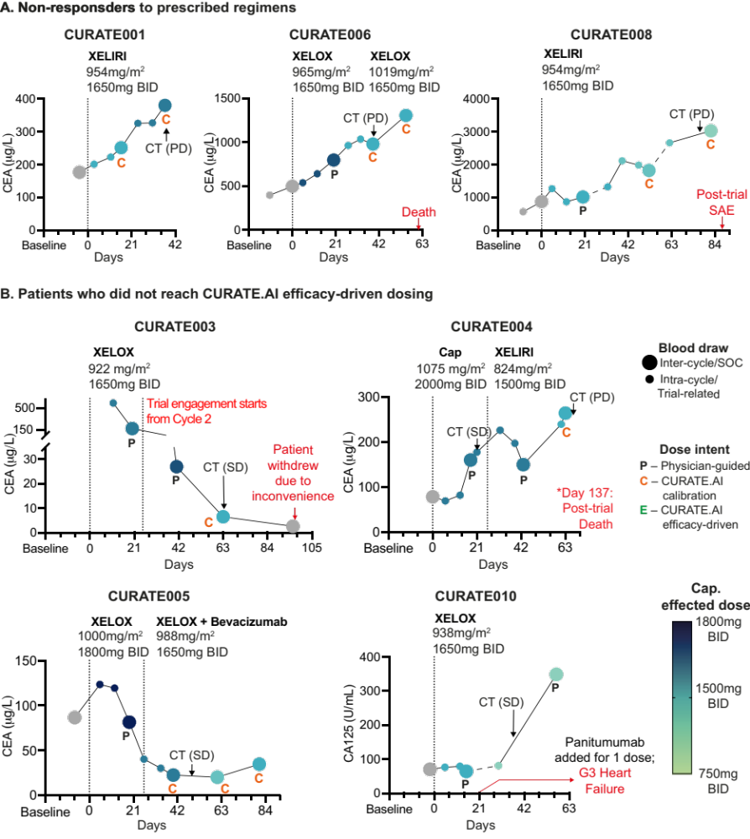 Figure S1. Longitudinal capecitabine doses and CEA-based responses of the patients who did not respond to the regimen (A) or did not reach efficacy-driven CURATE.AI recommendations (B). Effected dose of capecitabine in each cycle vs patient response as measured with longitudinal CEA changes. Standard-of-care (SOC) doses for each patient and each regimen are listed under the regimen’s name. CT(*) stands for computer tomography and the SD and PD stand for stable disease and progressive disease, respectively, according to the RECIST criteria. G3 stands for grade 3.

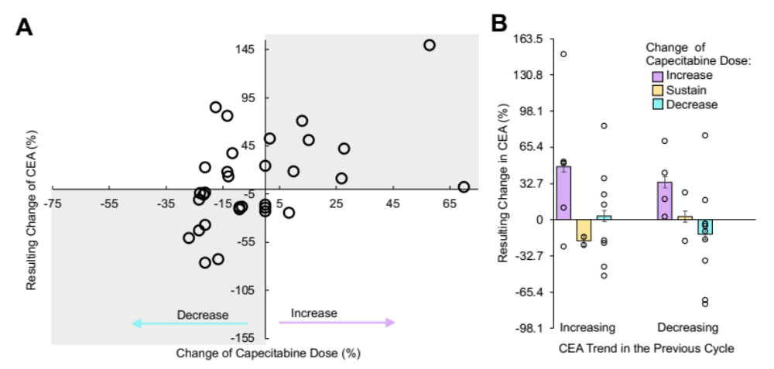
Figure S2. Pooled data (N=31) demonstrated that the change in the capecitabine effected dose affected the resulting carcinoembryonic antigen (CEA) value in the corresponding cycle. (A) Mild paradoxical dose-response relationship of capecitabine and CEA. Grey shade highlights the dosing events when increasing the dose was followed by an increase of the CEA, and decreasing the dose was followed by the decrease in CEA. (B) Average % CEA change following the capecitabine dose modulation in consideration to the CEA trend in the previous cycle: increasing or decreasing. Error bar = Standard Deviation.

Table S1. Patient demographics and response characteristic in sub-groups, depending on their response to the regimen and engagement level with CURATE.AI. CEA stands for carcinoembryonic antigen. SOC stands for standard-of-care. Cap stands for capecitabine. BID stands for twice a day
 | Non-responders to the regimen (N=3) | Did not reach CURATE.AI efficacy-driven dosing (N=4) | Reached CURATE.AI efficacy-driven dosing (N=3)
Age [years], median (range) | 69 (57 – 74) | 57·5 (45 – 68) | 63 (52 - 71)
Number of females | 0 | 0 | 0
Baseline CEA [μg/L], median (range) | 395·1 (176·7 - 564) | 86·6 (78·4 - 578·2)* | 114·6 (21·6 - 683)
Average prescribed cap dose reduction in each cycle per patient compared to projected SOC, median (range) | 250 (233·3 – 500) mg BID  15·2 (14·1 - 30·3) % | 275·0 (166·6 – 500) mg BID  16·6 (10·1 - 30·3) % | 431·3 (273·1-437·5)  mg BID  24·1 (15·7 - 26·1) %
Cycles under the trial, median (range) | 3 (2 - 3) | 2.5 (2 - 4) | 8 (8 - 13)
*N = 3, excluding the patient with elevated CA-125;

Table S2. Results of the primary and secondary outcome measures. Numerical primary outcome measures focused on CURATE.AI applicability and served as the basis for the expert panel assessment. The secondary outcome measures focused on logistical and scientific feasibility. Field color signifies a support of randomized controlled trial (RCT) under pre-defined traffic light system. Green: a future RCT is definitely feasible. Yellow: a future RCT is possibly feasible if its design is appropriately modified. Red: a future RCT is unfeasible in its current form. CEA stands for carcinoembryonic antigen.
Primary Outcome Measures
CURATE.AI applicability: percentage of participants in whom we successfully apply CURATE.AI profile [% patients]:
1.1. Marker error/variance (biological/analytical) is sufficiently small to allow accurate predictions | 30% (3/10); 3 patients who reached efficacy-driven dosing stage were treated with 11 dosing events augmented with efficacy-driven CURATE.AI dose recommendations.
1.2. Profile can be generated sufficiently early for the participant to potentially benefit; | 30% (3/10); 3 patients who reached efficacy-driven dosing had their profile generated within 4-5 cycles which constituted 50% or less of their trial engagement and the patients underwent 2-6 cycles in the efficacy-driven dosing stage.
1.3. Dose-dependent (d-d) relationship is observed | 60% (6/10); d-d relationship was observed in 6 patients. 3 patients (non-responders) demonstrated stable CEA increase despite dose modulation; the relationship cannot be assessed in 1 patient that had <2 dosing cycles.
1.4. Profile is actionable | 30% (3/10); 3 patients’ profiles provided actionable recommendations, within the safety bounds.
1.5. Systemic changes in the participant that require profile recalibration are rare or readily assimilated into the CURATE.AI algorithm. | 40% (4/10); 4 patients had systemic changes that were readily assimilated into CURATE.AI
Secondary Outcome Measures
2.1. Patient adherence  [% Patients] | 80% (8/10); The non-adherence events by the 2 patients were assimilated into CURATE.AI operations.
2.2. Timely delivery of CURATE.AI recommendations to the user  [% dosing decisions] | 100 % (36/36); CURATE.AI dose recommendations were provided in time for all dosing decision when CURATE.AI was considered relevant.
2.3. CURATE.AI relevance  [% dosing decisions] | 73.5 % (36/49); CURATE.AI relevance was limited for the initial dosing decision and complex cases.
2.4. User adherence  [% dosing decisions] | 97.2 % (35/36); Users chose to follow CURATE.AI recommendation in all but one dosing decisions when CURATE.AI was considered relevant.
2.5. Clinically significant dose changes [% patients] | 100 % (10/10); All patients in this trial were prescribed doses with reduction exceeding 10 % compared to projected SOC.

Table S3. Outcome measures and progression criteria for the PRECISE CURATE.AI pilot study, capecitabine in solid tumour cohort. The outcome measures are based on ‘the traffic light system’: traffic light system. Green: a future randomized control trial (RCT) is definitely feasible. Yellow: a future RCT is possibly feasible if its design is appropriately modified. Red: a future RCT is unfeasible in its current form.

Outcome Measures | Green | Yellow | Red
Primary Outcome Measures
CURATE.AI applicability: percentage of participants in whom we successfully apply CURATE.AI profile.  A decision on whether we “successfully apply” the CURATE.AI profile requires expert judgement and cannot be made based on a purely numerical process. The expert panel will consider the following factors with careful regard for the individual circumstances of each participant:  - Error/variance (biological/analytical) is sufficiently small to allow accurate predictions;  - Profile can be generated sufficiently early for the participant to potentially benefit;  - Dose-dependent relationship is observed;  - Profile is actionable (i.e., fulfils the co-investigator’s pre-specified safety requirements);  - Systemic changes in the participant which require profile recalibration are rare or readily assimilated into the CURATE.AI algorithm. | >70% | 10-70% | <10%
Secondary Outcome Measures
Patient adherence: percentage of participants who always adhered to the prescribed dose whenever they took their medication, as measured by the standardized pharmacovigilance protocol. | >90% | 10-90% | <10%
Timely delivery of CURATE.AI recommendations to the physician: percentage of CURATE.AI recommendations provided in time for the next chemotherapy cycle, across all participants and cycles. | 100% | 10-99% | <10%
CURATE.AI relevance: percentage of dosing events across all participants and cycles in which CURATE.AI recommendation is considered in the clinical decision-making process | <70% | 10-70% | <10%
Physician adherence: percentage of CURATE.AI recommended doses that were used by the co-investigator. | >70% | 10-70% | <10%
Clinically significant dose changes: percentage of participants in whom the CURATE.AI-guided cumulative dose is substantially (≥10%) different from the projected standard-of-care cumulative dose, which is defined as the maximum dose of the modulated drug* multiplied by the number of completed chemotherapy cycles. | >20% | 1-20% | 0%
Exploratory Outcome Measures
Efficacy:  - Percentage of trial participants with clinical progressive disease (defined as the co-investigator deeming that the patient will not benefit any further from the chemotherapy regimen and considering stopping it) at the time of the first radiological assessment performed as per standard-of-care.  - Temporal variation in response marker (E.g., CEA/CA19-9) level from baseline to trial conclusion.  - Maximal reduction in response marker (E.g., CEA/CA19-9) level measured as part of baseline investigations | N.A. | N.A. | N.A.
Toxicity: percentage of trial participants with clinically relevant toxicities of grades 3-4 based on CTCAE version 4.0. | N.A. | N.A. | N.A.
Data collection and explorative analysis of ctDNA as:  (1) a response marker in serial measurements at given clinical context and after modulated dosing;  (2) potential input for CURATE.AI | N.A. | N.A. | N.A.
Data collection and explorative analysis of CEA, CA19-9, and/or other traditional response markers in higher frequency serial measurements after modulated dosing in relation to standard frequency readings and other efficacy measures, e.g., RECIST criteria | N.A. | N.A. | N.A.
Table S4. Changes made to the protocol after recruitment of the first patient in PRECISE CURATE.AI pilot study relevant to capecitabine in solid tumor cohort. SOC stands for standard-of-care.

Protocol version | Section change was made to | Changes | Reason
V3  (23-Sep-2020) | Outcome measures | Specifying the calculation for the maximum allowable per cycle cumulative dose as the multiplication of the SOC dose with the dosing frequency in one cycle. | Clarity
V3  (23-Sep-2020) | Biomarkers | Specifying experimental response marker ctDNA is only collected and analysed retrospectively. | Clarity
V3  (23-Sep-2020) | Study design | An interim analysis for an expanded RCT to be done at the end of participation of the first 10 patients in the solid tumour cohort. | Clarity
V5  (30-Apr-2021) | Inclusion criteria | Allowing patients who have already begun treatment on the same regimen to enrol and allowing the use of their previously recorded treatment data into the CURATE.AI process. | Expanding trial inclusion
V5  (30-Apr-2021) | Outcome measures | Adding a new secondary outcome measure for CURATE.AI relevance: Percentage of dosing events where CURATE.AI recommendation is considered in clinical decision-making process | Feasibility outcome measure
V6  (19-Aug-2021) | Study design | Specifying a reference timepoint for dosing cycles. | Administrative
V6  (19-Aug-2021) | Study design | Permitting regimen changes of the same drug of interest at the approval of the principal investigator. | Expanding trial inclusion
V6  (19-Aug-2021) | Study design | Introducing the need for a case-review discussion with the principal investigator when treatment interruption lasts beyond 28 days. | Administrative
V6  (19-Aug-2021) | Study design | Introducing an option for continued patient engagement for up to 24 months if approved by the principal investigator in consultation with the study sponsors, patient, and the treating physician. | Extending patient engagement beyond the duration of the trial.
V6  (19-Aug-2021) | Study design | Conducting patient survival follow-up via telephone every 6 months for 3 years after completion of the trial. | Survival follow-up
V6  (19-Aug-2021) | Study visits and procedures | Categorizing and specifying procedures performed as part of SOC or only for research purposes. | Clarity
V8  (19-May-2022) | Biomarkers | Introducing flexibility to the type of response markers that can be used in CURATE.AI. | Expanding trial inclusion
V8  (19-May-2022) | Inclusion of additional patient information into CURATE.AI | Allowing the collection of patient’s previously recorded treatment data up till 6 months from trial engagement, at the approval of the principal investigator, to be included in the CURATE.AI process. | Contextual information based on past events
V8  (19-May-2022) | Inclusion criteria | Restricting recruitment to Singapore and Singapore Permanent Residents. Non-residents can be recruited only at the approval of the principal investigator and sponsor. | Trial Practicality

Table S5. Patient data types used for CURATE.AI operations. All data are collected prospectively, and high data quality is ensured at the time of collection. Clinical Research Coordinator (CRC) anonymizes the data before they are passed over to the CURATE.AI team. EHR – electronic health record.
Purpose in CURATE.AI Operations | Input data received via email from CRC  [original source] | Pre-Processing and  Handling of Missing/Low-Quality Data
Scheduling Information | Date of blood test  [laboratory test documentation] | Scheduling Information is used to verify if the duration between the last marker test results and start date of the next cycle is less than a week (preferably three days). Data points that do not overlap with the cycle dates are excluded.
Scheduling Information | Date of cycle start and end  [hospital triaging data]
Effected capecitabine dose | Prescribed dose of capecitabine  [trial dedicated EHR] | The effected dose is calculated for the cycle duration, based on patient adherence to the prescribed dose. Capecitabine effected dose history can be used to generate patient CURATE.AI profile. Dosing range restriction informs on which part of the profile to retrieve the recommendation from.
Effected capecitabine dose | Capecitabine effected dose history  [trial dedicated and hospital EHRs]
Effected capecitabine dose | Patient adherence  [pharmacovigilance performed under the trial]
Effected capecitabine dose | Dosing range restriction  [treating physician]
Phenotypic  Response | Response marker – CEA, CA19-9, CA125 – level at the start and end of each cycle  [laboratory test documentation] | The percentage changes in response marker levels per cycle are calculated using response marker levels at the end of each cycle. These percentage changes are used to generate patient CURATE.AI profile. They can also inform about the change in state or systemic changes.
Drug-related blood toxicities | Biomarkers - Absolute neutrophils count (ANC)/neutrophils, platelet count, haemoglobin (Hb), white blood cell (WBC) count, creatinine level  [laboratory test documentation] | The biomarkers that may indicate toxicities are monitored throughout the treatment to infer potential drug-related toxicities and indirectly inform on the potential of the dosing range restriction.
Adverse events | Details of adverse events, including description, severity, duration, hospitalisation duration, likelihood of being related to capecitabine, and whether they are dose-limiting  [trial dedicated EHR] | Details of adverse events are used to inform on acute or prolonged systemic change that may require exclusion of the outlying data points and/or recalibration of the patient CURATE.AI profile if the systemic change is prolonged. It also indirectly information on the potential of the dosing range restriction.
Concomitant drugs | Changes in concomitant drugs  [trial dedicated EHR] | Changes in concomitant drugs are used to inform about a systemic change that may require recalibration.

