Table S1. Degradation intermediates of RhB over RGO aerogel/TiO₂/MoS₂ for 150 min via GC-MS analysis.
Number | Compound name | Structure | Retention time  (min) | Basic fragments
1 | Butanamide |  | 2.535 | 29,43,71,87
2 | Delphinic acid |  | 2.632 | 43,57,102
3 | Isohexane |  | 5.471 | 43,57,71,86
4 | o-Xylene |  | 6.332 | 76,91,106
5 | 4-(diethylamino) benzoic acid |  | 9.978 | 164,193
6 | 1,3-Isobenzofurandione |  | 14.600 | 76,148
Fig. S1. EDS of the RGO aerogel/TiO₂/MoS₂.
Fig. S2. The removal performance of the RGO aerogel/TiO₂/MoS₂ and no catalyst. (80 mL of 40 mg L⁻¹ RhB and 0.01g catalyst used in this experiment at pH value of 7, humic acid was 10mg/L, sodium alginate was 5mg/L and bogie serum protein was 5mg/L.)
Fig. S3. The adsorption-desorption curves of RhB. (80 mL of 40 mg L⁻¹ RhB and 0.01g RGO aerogel/TiO₂/MoS₂ used in this experiment at pH value of 7)
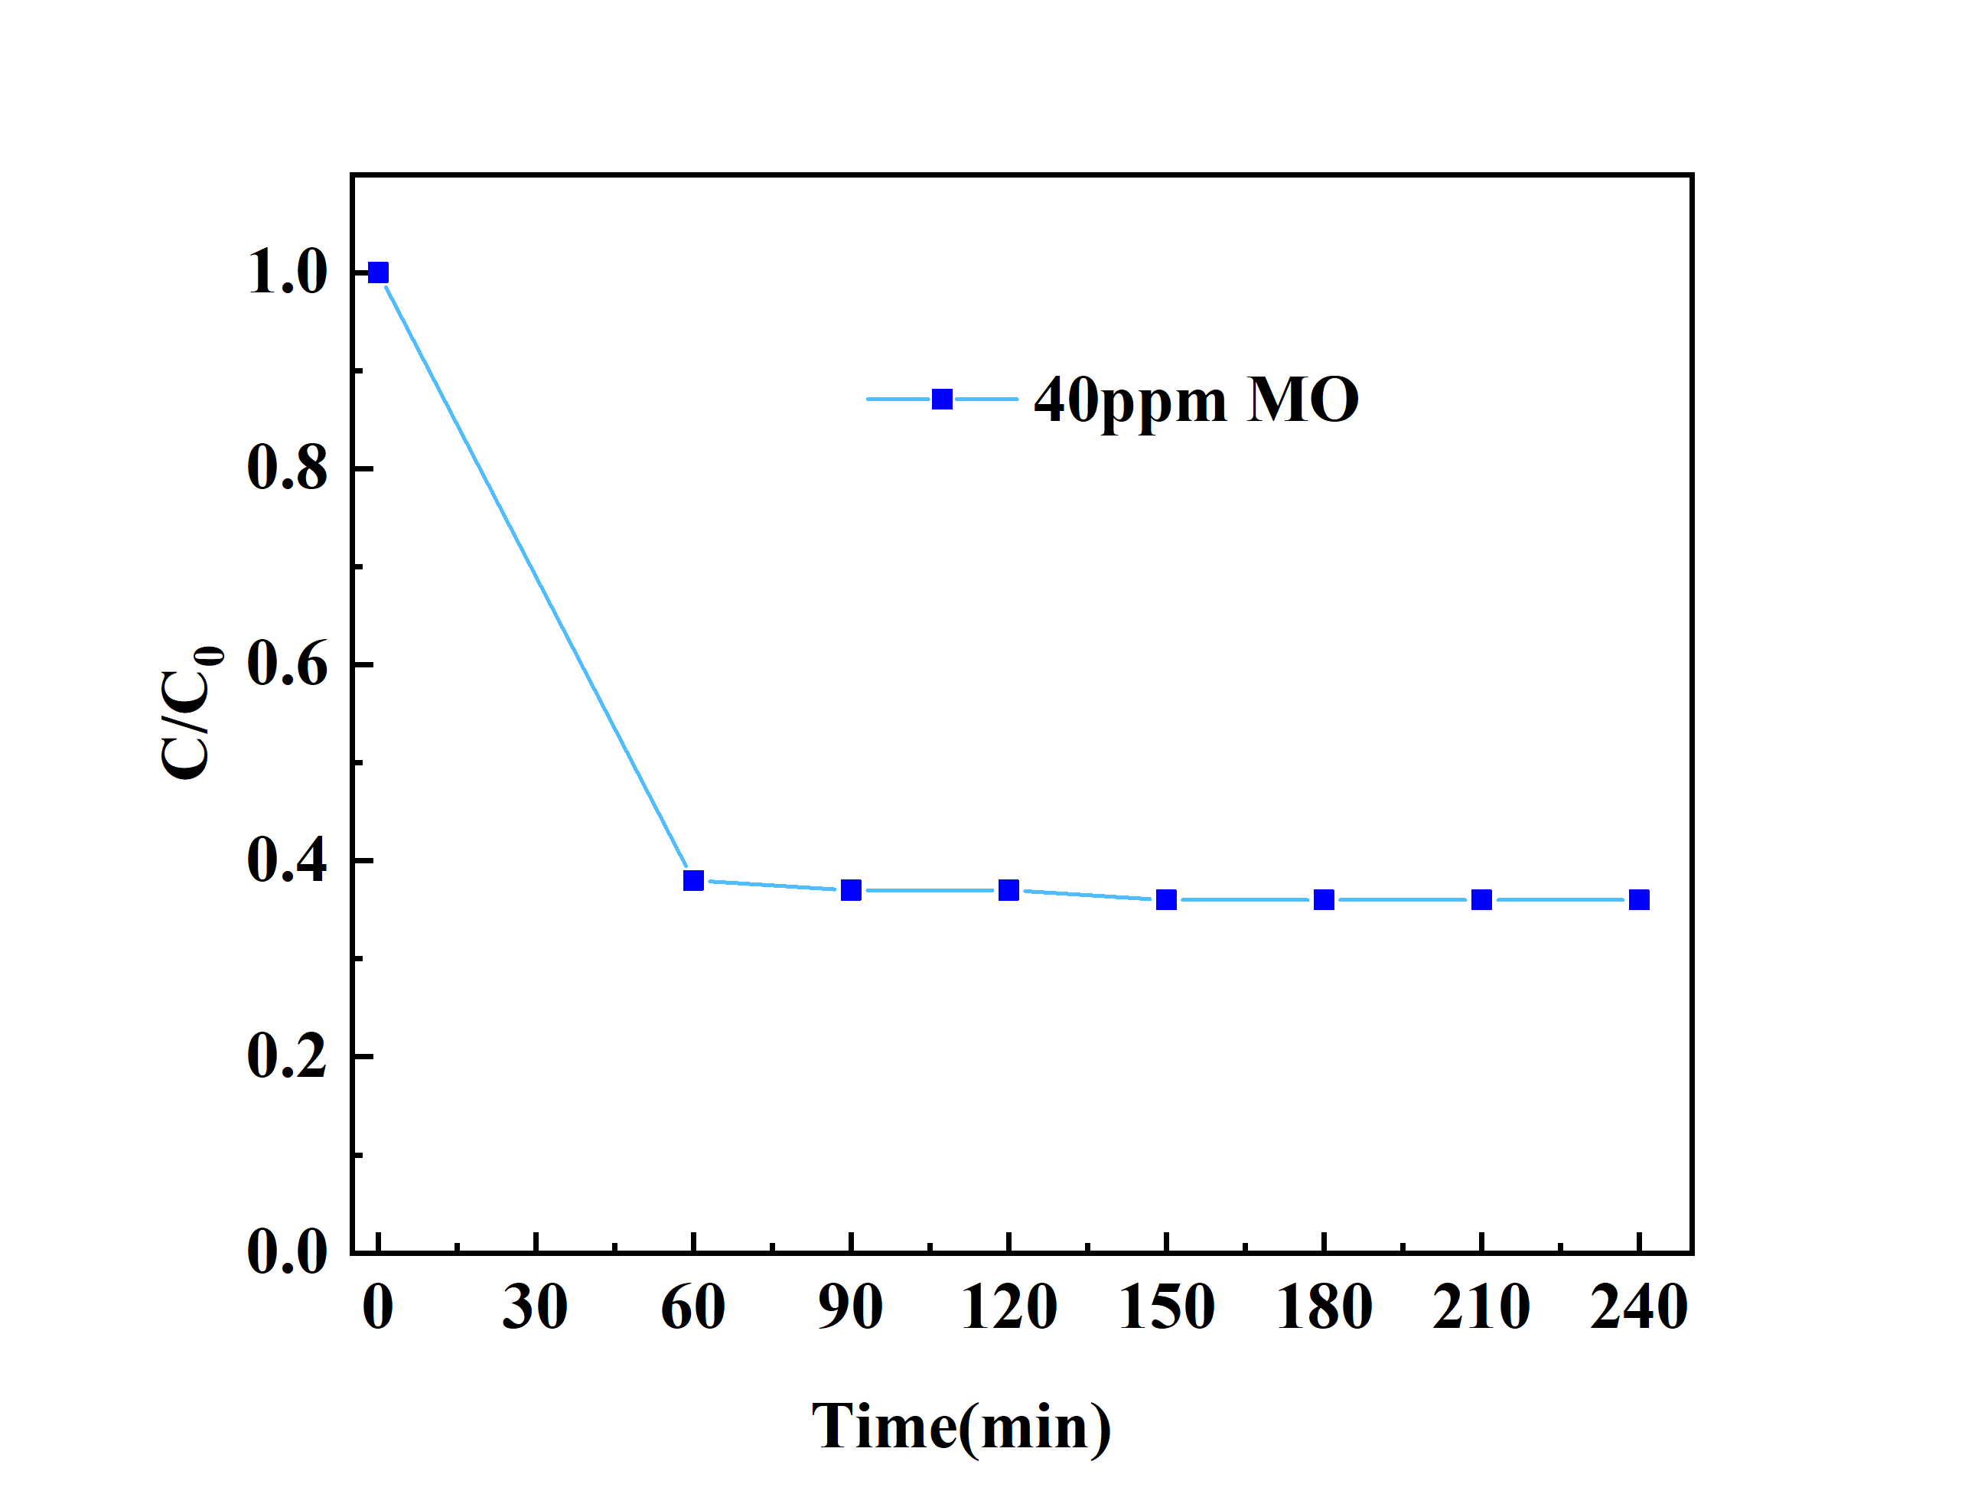
Fig. S4. The degradation curves of MO. (80 mL of 40 mg L⁻¹ solution and 0.01g RGO aerogel/TiO₂/MoS₂ used in this experiment at pH value of 4)

Fig. S5. The degradation curves of TC. (80 mL of 40 mg L⁻¹ solution and 0.01g RGO aerogel/TiO₂/MoS₂ used in this experiment at pH value of 7)

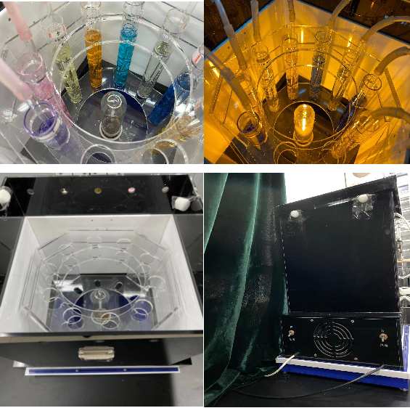
Fig. S6. A self-innovated photocatalytic reaction device.

