Table 1:
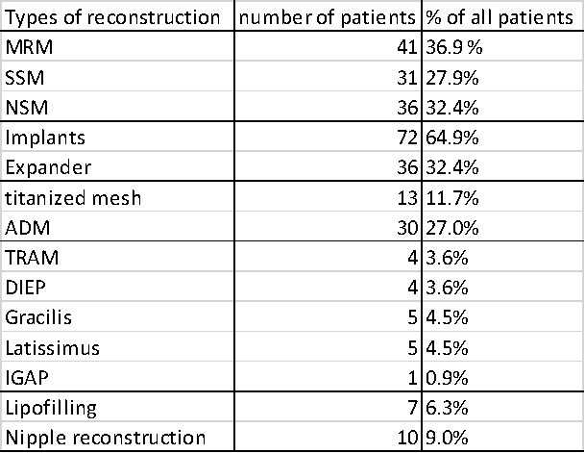
Nearly all types of ablations are done with the same frequency. When opting for an implant-based reconstruction, it is performed in 64.9% with direct-to-implant. Under 20% of patients prefer flap reconstruction over an implant-based reconstruction. Not all patients who are reconstructed with an implant receive a mesh for stabilization.
Abbreviations: MRM, modified radical mastectomy; SSM, skin-sparing mastectomy; NSM, nipple-sparing mastectomy; ADM, acellular dermal matrix; TRAM, transverse rectus abdominus myocutaneous; DIEP, deep inferior epigastric perforators; IGAP, inferior gluteal artery perforator.

