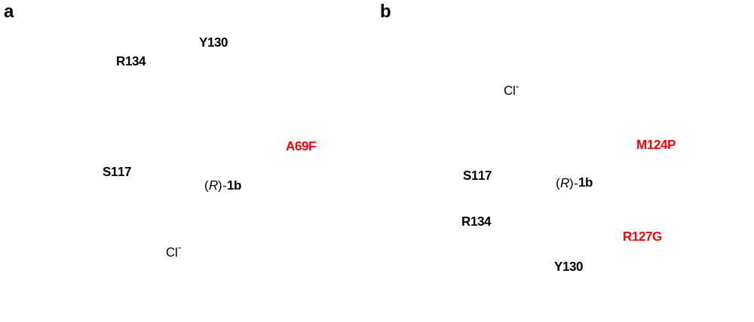
Extended Data Fig. 1 | Detailed comparison of mutated residues of the mutant HheD8-M3 with the wild type HheD8-WT/AF. a, Close-up view of the A69F mutation in the active site. b, Close-up view of the M124P and R127G mutations in the active site. HheD8-M3 (PDB code: 8XXB) is shown as blue cartoon. HheD8-WT/AF (AFDB code: AF-N6YXW4-F1) is shown as gray cartoon. Catalytic triad S117-Y130-R134, the mutated residues (A69F, M124P, and R127G), and (R)-1b are highlighted in sticks. The ligand Cl⁻ is highlighted in green sphere.
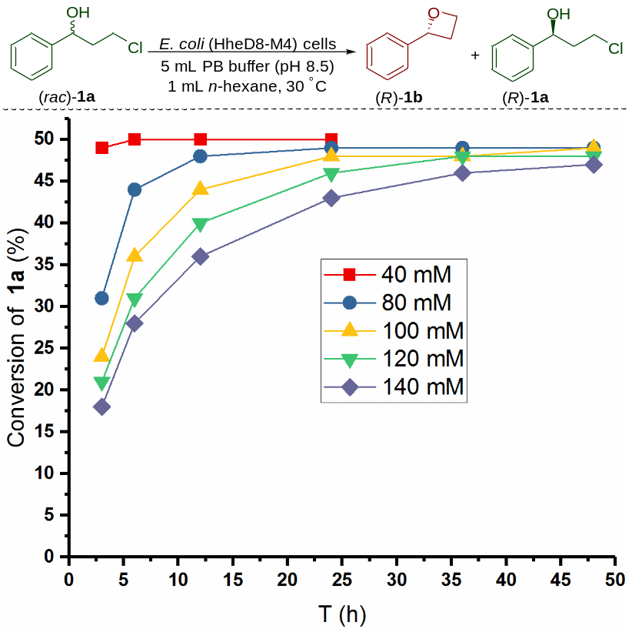
Extended Data Fig. 2 | Time-course studies of the enantioselective dehalogenation reaction of (rac)-1a at different substrate concentrations.
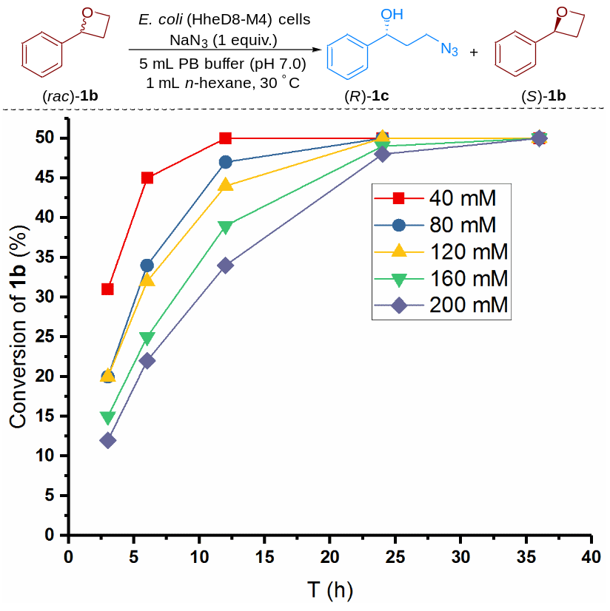
Extended Data Fig. 3 | Time-course studies of the enantioselective azide-mediated ring-opening reaction of (rac)-1b at different substrate concentrations.
Extended Data Table 1 | Data collection and refinement statistics.
 | HheD8-M3/Cl⁻
Data collection
Space group | P 62 2 2
Cell dimensions
a, b, c (Å) | 138.56, 138.56, 66.82
α, β, γ (°) | 90.00, 90.00, 90.00
Resolution (Å) | 40-2.4 (2.486-2.4)
R_{sym} or R_{merge} | 0.09077 (0.616)
I / σI | 38.88 (9.21)
Completeness (%) | 99.75 (99.39)
Redundancy | 37.5 (39.0)
Refinement
Resolution (Å) | 2.40
No. reflections | 15241 (1477)
R_{work} / R_{free} | 0.185 / 0.190
No. atoms
Protein | 1652
Ligand (Cl⁻) | 1
Water | 39
B-factors
Protein | 51.44
Ligand/ion | 53.18
Water | 50.26
R.m.s. deviations
Bond lengths (Å) | 0.007
Bond angles (°) | 1.25
One crystal was used to obtain this dataset. The values in parentheses are for the highest-resolution shell.

