Supplementary material

1. Analytical methods

1.1. Grain size measurements

Sediment grain size analyses (<2 mm fraction) were performed using a Malvern-Panalytical Mastersizer 3000 particle-size analyzer equipped with a Hydro LV module following the instrumental conditions outlined in Belzile and Montero-Serrano (2022)¹, at the Institut des sciences de la mer (ISMER) of University of Québec in Rimouski (UQAR). Prior to analysis, sediment samples were pretreated with 10 mL of hydrogen peroxide (H₂O₂; 30% v/v) to remove organic matter and isolate the detrital fraction of the sediment. Carbonates were not removed from sediment samples, as this can provide information on primary production and sediment provenance². Sediment samples were diluted with ~20 mL of sodium hexametaphosphate, sieved at <2 mm, and disaggregated using an in-house rotator for 12 hours prior to particle size measurements. The grain size data obtained was processed using the GRADISTAT software version 9.1³. The sortable silt means size (SS_{mean}) flow speed proxy, which corresponds to the mean grain size of the non-cohesive silt fraction (10–63 μm) and the percentage of sortable silt (SS%) in the <63 μm fraction⁴ was calculated using the approach developed by McCave and Andrews (2019) ⁵. Results are presented in tables 1 and 2.

1.2. Determination of calcite and dolomite by quantitative X-ray diffraction

Calcite and dolomite were determined by quantitative X-ray diffraction (qXRD) following the method developed by Eberl,D.D. (2003) ⁶ at ISMER-UQAR. For the analyses, ~1 g of each sample (<2 mm fraction) was spiked with 0.25 g of corundum and then ground in a McCrone micronizing mill using 5 mL of ethanol to obtain a homogenous powder. The slurry was oven dried in the hood and then slightly homogenized with an agate mortar. Next, 0.5 mL of vertrel was added to the mixture to prevent the possible agglomeration of finer particles. The powder sample was then sieved (<500 µm), side-loaded into the holders and analyzed on a PANalytical X’Pert Powder diffractometer. Samples were scanned from 5° to 65° two-theta in steps of 0.02° two-theta, with a counting time of 2 seconds per step. For the quantification of the calcite and dolomite, sediment XRD scans obtained were converted into mineral weight percent (wt. %) using the R package “powdR”⁷. powdR uses a full pattern summation approach that permits the quantification of whole-sediment mineralogy with an average absolute bias of 0.6% for non-clay minerals⁷. The quality of the fitting procedure was evaluated for the R-weighted profile (rwp; best least-squares fit between observed and calculated model). The rwp for the samples analyzed ranged from 0.17 to 0.22 (median 0.18). An rwp value between 0.2 and 0.3 indicates a good fit for geological samples⁸. Results are presented in table 3.

1.3. Nd & Pb isotope measurements

Chemical separation and Nd-Pb isotopic analyses were conducted at Geotop-UQAM. Prior to analysis, 1 g of each sample was wet sieved through a 64-µm Nitex® mesh and then oven-dried (~80°C). Samples were digested in Teflon closed beakers, with a combination of HF, HCl and HNO₃, at 110°C. Pb separation was performed using resin AG1X8: matrix elution with HBr 0.8N and Pb recovery with HCl 6N, following the procedures described in Maccali et al. (2012) and Manhes et al. (1980) ^{9,10}. Nd was then separated following analytical procedure described in Maccali et al. (2013) and Song et al. (2022)^{11,12}: digested samples were subjected to iron removal using AG1X8 resin columns with 6N HCl twice, replacing the resin each time. The samples were dried, treated with 14N HNO₃, and dried again. Next, light rare earth elements (LREE) separation was performed using TRU SPEC® resin. The matrix was eluted with 1N HNO₃, and LREE were eluted and collected with 0.05N HNO₃. The concentrated LREE samples underwent Nd separation using LN Spec® resin. The first elution with 4 mL of 0.25N HCl removes Ce, allowing Nd collection afterwards, with 2 mL of 0.25N HCl. Nd and Pb isotope ratios (¹⁴³Nd/¹⁴⁴Nd, ²⁰⁷Pb/²⁰⁶Pb) were analyzed on a Nu Plasma II, a Multi-Collector Inductively Coupled Plasma Mass Spectrometer (MC-ICP-MS) with Aridus II desolvating membrane at Geotop-UQAM. Replicate analyses of the standard JNdi-1 yielded mean values of ¹⁴³Nd/¹⁴⁴Nd = 0.512071 ±0.000029 (2σ; n=15), 0.512084±0.000051 (2σ; n=11) and 0.512079 ±0.000042 (2σ; n=5), in three batches of analyses. Results on JNdi-1 are slightly below the reference value (0.512115±0.000007)¹³, as it is typical of Nd measurements on MC-ICP-MS due to mass bias after oxide formation in the plasma¹⁴. Therefore, results were normalized to 0.512115¹³. The external reproducibility (2σ) of ε_{Nd(0)} values deduced from repeated measurements of the JNdi-1 standard was 0.8 ε_{Nd(0)} units. Nd isotope ratios are expressed as ε_{Nd(0)} = [(¹⁴³Nd/¹⁴⁴Nd)_{sample}/(¹⁴³Nd/¹⁴⁴Nd)_{CHUR}-1]×10000, with the present-day (¹⁴³Nd/¹⁴⁴Nd)_{CHUR} of 0.512638^{15,16}. For Pb measurements, instrumental mass bias was corrected using thallium (Tl) doping and internal normalization to NBS 981 following Woodhead (2002) ¹⁷. Reproducibility of Pb measurements was assessed using standard CGPB-1. Procedural blanks were negligible compared with the sample size. Results are presented in table 4.

2. Sortable silts vs biogenic carbonate fluxes
During warm intervals, biogenic carbonates add to detrital supplies. Throughout most of the sequence, the calcite and grain size data are relatively well correlated, with maximums values linked to increased Western Boundary Undercurrent (WBUC; as recorded by SS_{mean} bottom current strength proxy) and enhanced biogenic carbonate fluxes during interglacials. A few outlier values are linked to the maximum biogenic carbonate fluxes (Figure S1) of the likely warmer ~3060 to ~3090 ka interval in the Blake-Mizen et al.'s age model (2019)¹⁸.

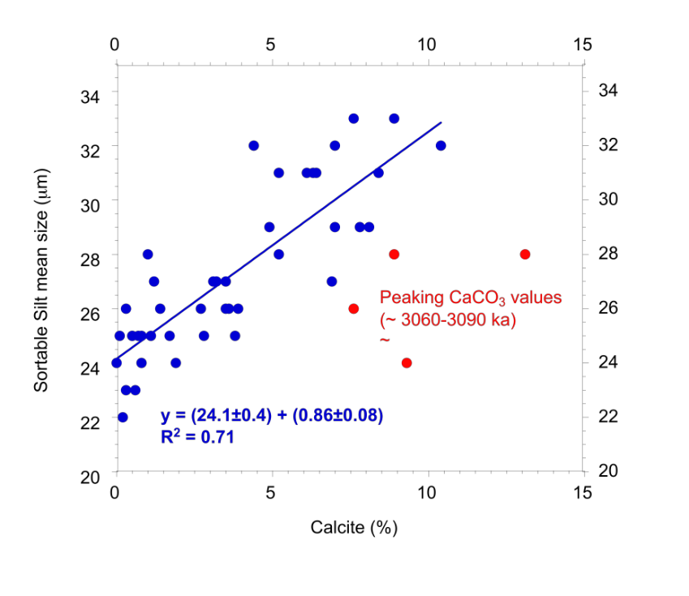

Figure S1: Correlation of calcite (%) vs sortable silt mean size (µm). The outliers, in red, correspond to the peaking CaCO₃-values of the 3060-3090 ka interval (see Figure 3, main text).

3. Age models

3.1 Blake Mizen et al. (2019) vs paleomagnetic anchors

The age model from Blake-Mizen et al. (2019)¹⁸ encompasses four paleomagnetic reversals (Gauss-Mauyama, Kaena top, Kaena bottom and Mammoth top) and uses twenty-nine points that link the sedimentary record from site U1307 to the previously dated site U1308 ^{19,20} from magnetic inclination and relative paleointensity correlations. The age model for site U1308 was established using the benthic oxygen isotope record, which was combined with relative paleointensity to produce an integrated, high-resolution magneto-isotopic stratigraphy. The age model for site U1307 neglects possible differences in the sedimentary rates between glacials/interglacials by employing linear interpolation between the 33 anchor points. Figure S 2 depicts the age (ka) vs depth (rmcd) using all the 33 anchor points (red line) vs. using only the 4 magnetic anchors (blue line). The offset between the two models may imply a ∼ 40 ky shift at the bottom of the core. This uncertainty is large enough to mask any correlation with the Earth’s obliquity.
Table S1: Age and uncertainty of paleomagnetic anchor ages.
Magnetic Reversal | Age (ka) | ±1σ Age (ka)
Gauss/Matuyama | 2595²⁰ | --
Kaena top | 3029²⁰ | --
Kaena bottom | 3116²⁰ | 15²¹
Mammoth top | 3207²⁰ | 15²¹

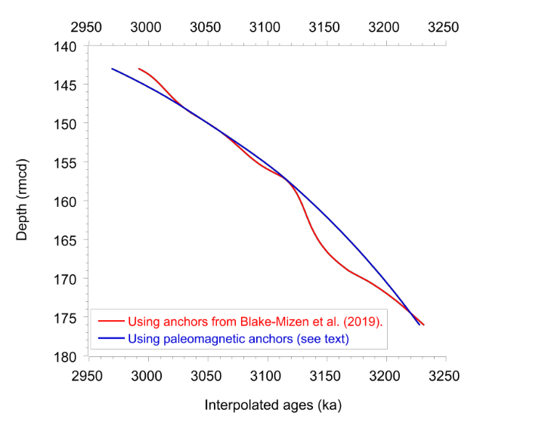
Figure S2: Interpolated ages (ka) vs depth (rmcd) using either the Blake-Mizen et al.'s model (2019)¹⁸ or only the four paleomagnetic anchor ages.

3.2 CaCO₃-free sediment accumulation vs the age models

The impact of biogenic carbonate fluxes on sedimentation rate has been estimated by comparing the bulk vs carbonate-free sediment accumulations of the investigated sequence. The only significant offset is observed in the upper part of the sequence when the biogenic carbonate is close to 10%. Nevertheless, the cumulative offset between the carbonate-free and bulk sediment accumulation reaches about 20 ka: a value sufficient to blur peak-to-peak correlation of U1307 records with the obliquity cycle, whatever the age model used.

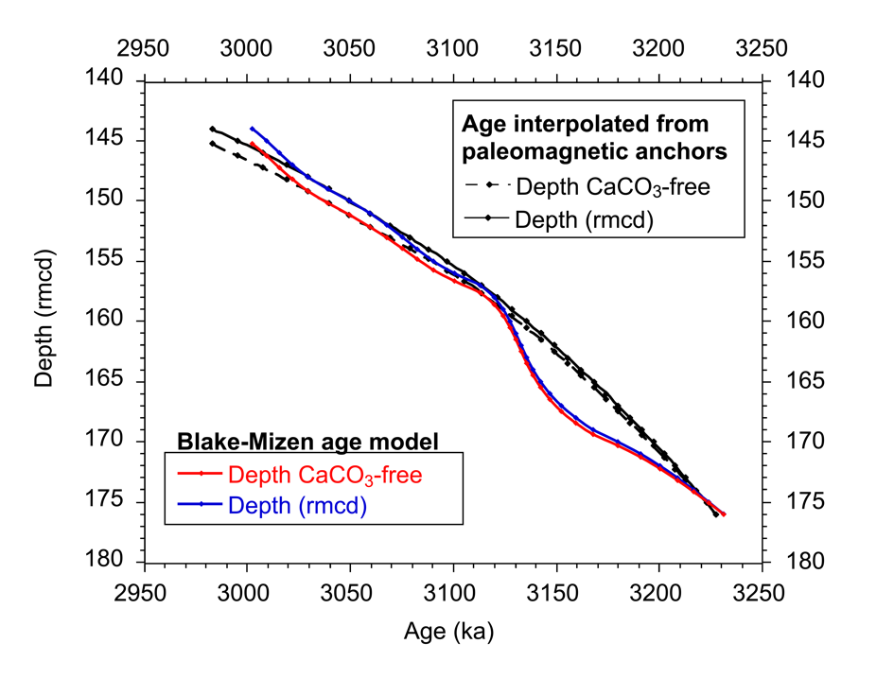
Figure S3: Interpolated ages (ka) vs depth (rmcd) of bulk and carbonate-free sediment.

4. Spectral analysis

Spectral analyses were performed using the time-series analysis software Acycle 2.8 ²². Nd and Pb isotope data were first interpolated using a sample rate of 3.9 ky, which is the median of the original sampling rate. In the periodogram of the εNd(0) series, frequencies at which the signal has significant power are 0.021 (47 ky), 0.049 (20 ky) and 0.054 (18 ky). Nonetheless, only the 0.049 frequency exceeds the 99% confidence level. In the Pb isotope series, frequencies at which the signal has significant power are 0.021 (47 ka), 0.026 (38 ky), 0.034 (29 ky) and 0.049 (20 ky), but none exceeding the 99% confidence level. The lack of a clear obliquity forcing (~ 41 ka) is interpreted as a consequence of uncertainties in the age model documented above.

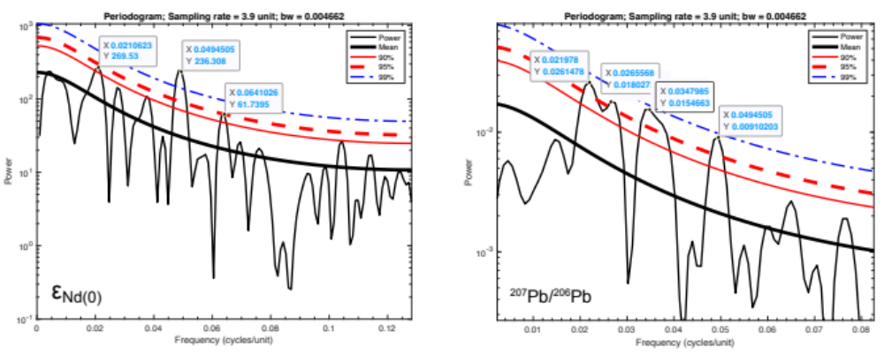
Figure S4: Power spectrum of the εNd(0) and ²⁰⁷Pb/²⁰⁶Pb series. Here, bw is the bandwidth.

References

1. Belzile, C. & Montero-Serrano, J.-C. Quantifying simulated fine sand fraction in muddy sediment using laser diffraction. Can. J. Earth Sci. 59, 455–461 (2022).
2. Deschamps, C., Montero‐Serrano, J. & St‐Onge, G. Sediment Provenance Changes in the Western Arctic Ocean in Response to Ice Rafting, Sea Level, and Oceanic Circulation Variations Since the Last Deglaciation. Geochem. Geophys. Geosystems 19, 2147–2165 (2018).
3. Blott, S. J. & Pye, K. GRADISTAT: a grain size distribution and statistics package for the analysis of unconsolidated sediments. Earth Surf. Process. Landf. 26, 1237–1248 (2001).
4. McCave, I. N., Manighetti, B. & Robinson, S. G. Sortable silt and fine sediment size/composition slicing: Parameters for palaeocurrent speed and palaeoceanography. Paleoceanography 10, 593–610 (1995).
5. McCave, I. N. & Andrews, J. T. Distinguishing current effects in sediments delivered to the ocean by ice. I. Principles, methods and examples. Quat. Sci. Rev. 212, 92–107 (2019).
6. Eberl,D.D. USGS Open-File Report 2003-78: User’s Guide to RockJock -- A Program for Determining Quantitative Mineralogy from Powder X-Ray Diffraction Data. https://pubs.usgs.gov/of/2003/of03-078/ (2003).
7. Butler, B. M. & Hillier, S. powdR: An R package for quantitative mineralogy using full pattern summation of X-ray powder diffraction data. Comput. Geosci. 147, 104662 (2021).
8. Introduction to the Rietveld method. in The Rietveld method (ed. Young, R. A.) 1–38 (Oxford Univ. Press, Oxford, 1993).
9. Maccali, J., Hillaire‐Marcel, C., Carignan, J. & Reisberg, L. C. Pb isotopes and geochemical monitoring of Arctic sedimentary supplies and water mass export through Fram Strait since the Last Glacial Maximum. Paleoceanography 27, 2011PA002152 (2012).
10. Manhes, G., Allègre, C. J., Dupré, B. & Hamelin, B. Lead isotope study of basic-ultrabasic layered complexes: Speculations about the age of the earth and primitive mantle characteristics. Earth Planet. Sci. Lett. 47, 370–382 (1980).
11. Song, T. et al. A reassessment of Nd-isotopes and clay minerals as tracers of the Holocene Pacific water flux through Bering Strait. Mar. Geol. 443, 106698 (2022).
12. Maccali, J., Hillaire-Marcel, C., Carignan, J. & Reisberg, L. C. Geochemical signatures of sediments documenting Arctic sea-ice and water mass export through Fram Strait since the Last Glacial Maximum. Quat. Sci. Rev. 64, 136–151 (2013).
13. Tanaka, T. et al. JNdi-1: a neodymium isotopic reference in consistency with LaJolla neodymium. Chem. Geol. 168, 279–281 (2000).
14. Frères, E., Weis, D., Newman, K., Amini, M. & Gordon, K. Oxide Formation and Instrumental Mass Bias in MC‐ICP‐MS: An Isotopic Case Study of Neodymium. Geostand. Geoanalytical Res. 45, 501–523 (2021).
15. Jacobsen, S. B. & Wasserburg, G. J. Sm-Nd isotopic evolution of chondrites. Earth Planet. Sci. Lett. 50, 139–155 (1980).
16. Faure, G., Mensing, T. M. & Faure, G. Isotopes: Principles and Applications. (Wiley, Hoboken, N.J, 2005).
17. Woodhead, J. A simple method for obtaining highly accurate Pb isotope data by MC-ICP-MS. J. Anal. At. Spectrom. 17, 1381–1385 (2002).
18. Blake-Mizen, K. et al. Southern Greenland glaciation and Western Boundary Undercurrent evolution recorded on Eirik Drift during the late Pliocene intensification of Northern Hemisphere glaciation. Quat. Sci. Rev. 209, 40–51 (2019).
19. Channell, J. E. T., Hodell, D. A., Xuan, C., Mazaud, A. & Stoner, J. S. Age calibrated relative paleointensity for the last 1.5 Myr at IODP Site U1308 (North Atlantic). Earth Planet. Sci. Lett. 274, 59–71 (2008).
20. Channell, J. E. T., Hodell, D. A. & Curtis, J. H. Relative paleointensity (RPI) and oxygen isotope stratigraphy at IODP Site U1308: North Atlantic RPI stack for 1.2–2.2 Ma (NARPI-2200) and age of the Olduvai Subchron. Quat. Sci. Rev. 131, 1–19 (2016).
21. Deino, A. L. et al. Chronostratigraphy of the Baringo-Tugen Hills-Barsemoi (HSPDP-BTB13-1A) core – 40Ar/39Ar dating, magnetostratigraphy, tephrostratigraphy, sequence stratigraphy and Bayesian age modeling. Palaeogeogr. Palaeoclimatol. Palaeoecol. 570, 109519 (2021).
22. Li, M., Hinnov, L. & Kump, L. Acycle: Time-series analysis software for paleoclimate research and education. Comput. Geosci. 127, 12–22 (2019).

