Supporting Material
of
Steam Turbine Anomaly Detection: An unsupervised learning using Enhanced LSTM Variational Autoencoder
Weiming Xu^{a,#}, and Peng Zhang^{a,∗}
a Department of Mechanical Engineering, City University of Hong Kong, Kowloon Tong, Kowloon, 999077, Hong Kong

1. Formulation of Local Outlier Factor (LOF)
Local Outlier Factor (LOF) operates on the principle of quantifying the anomaly degree of each sample by comparing its density with its neighboring points for anomaly detection[1, 2]. In essence, LOF determines outlier status by assigning a local outlier factor that reflects the neighborhood density of each sample point.
- If the local outlier factor approaches one, it signifies that the sample point's local density closely resembles that of its neighbors.
- A local outlier factor less than one suggests that the sample point, resides in a relatively dense area, distinguishing it from an outlier.
- Conversely, if the local outlier factor significantly exceeds one, it indicates that the sample point is notably distant from neighboring points and is more likely to be an anomaly.
In the local outlier factor algorithm, apart from selecting the distance measure, it's crucial to determine the number of local neighborhood points. Let's consider a dataset denoted as D, where the current point under evaluation is O, and the number of neighboring points is represented by k. Here, d_{k}(O) denotes the distance to the k-th farthest point, computed from O as the reference point. It's noteworthy that when the k-th farthest point encompasses i points, the distance remains constant, such that d_{k}(O) = d_{k+1}(O) = ... = d_{k+i}(O). As illustrated in Fig. S1, d₄(O) equals d₅(O).
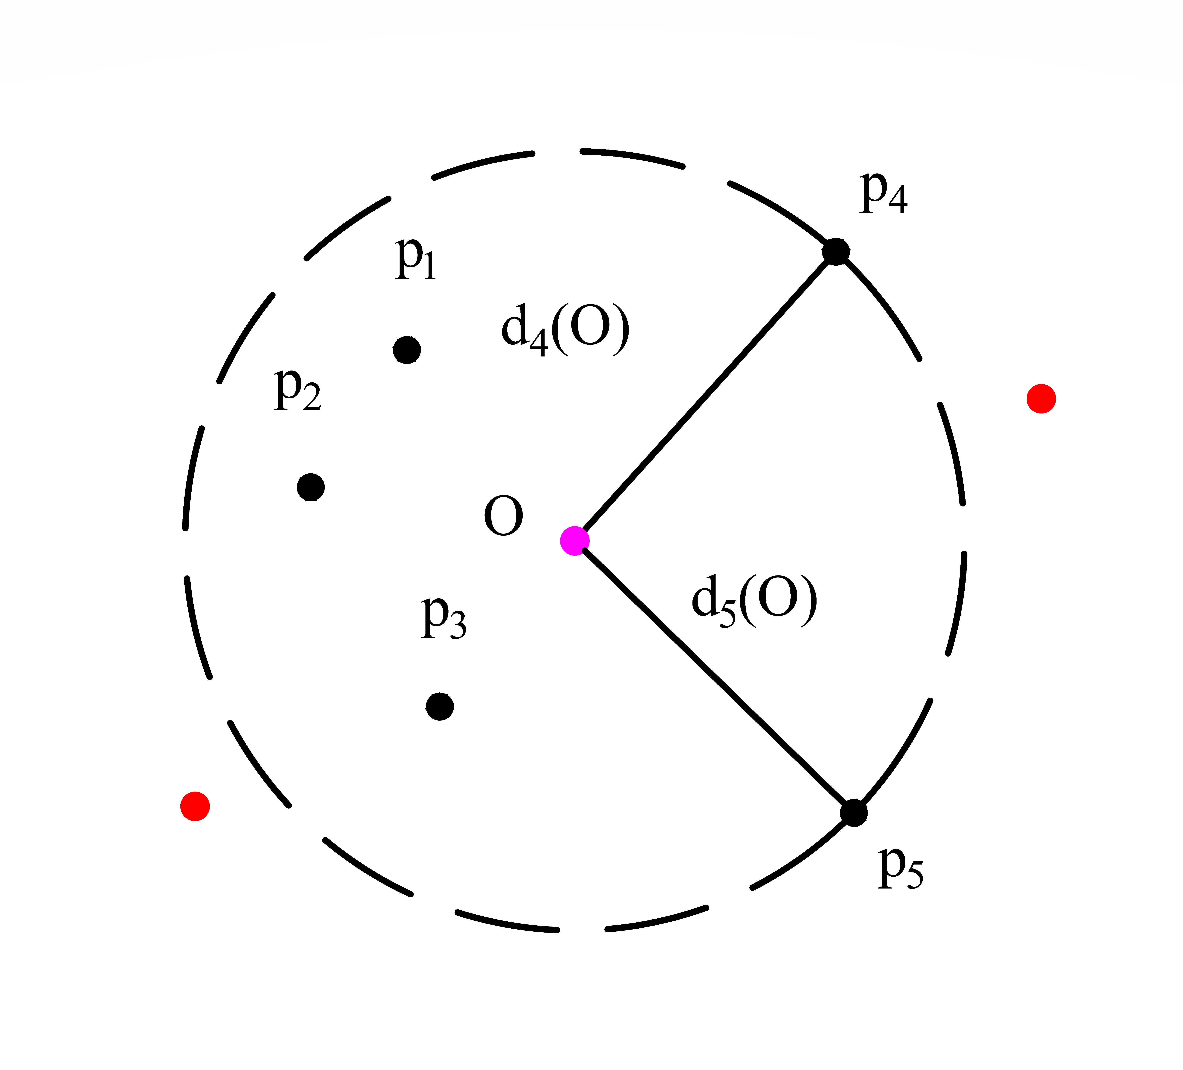
Figure S1. The 5-th distance of point O.

The distance metric employed is the Euclidean distance, with its representation method depicted in equation (1):

$$d\left(X,Y\right)=\sqrt{\sum_{i=1}^{m}{{\left(x_{i}-y_{i}\right)}^{2}}}$$ | ( 1 )
The k-neighborhood N_{k}(O) of point O adheres to equation (2):
$$N_{k}\left(O\right)=[p∈D|d(O,p)≤d_{k}(O)]$$ | ( 2 )
When there are i points where the above k-th distance is equal $N_{k}\left(O\right)=N_{k+1}\left(O\right)=N_{k+2}\left(O\right)=⋯=N_{k+i}\left(O\right)$. As shown in Fig. S2, the neighborhood of point O is $N_{4}\left(O\right)=N_{5}\left(O\right)=\left\{p_{1},p_{2},p_{3},p_{4},p_{5}\right\}$.
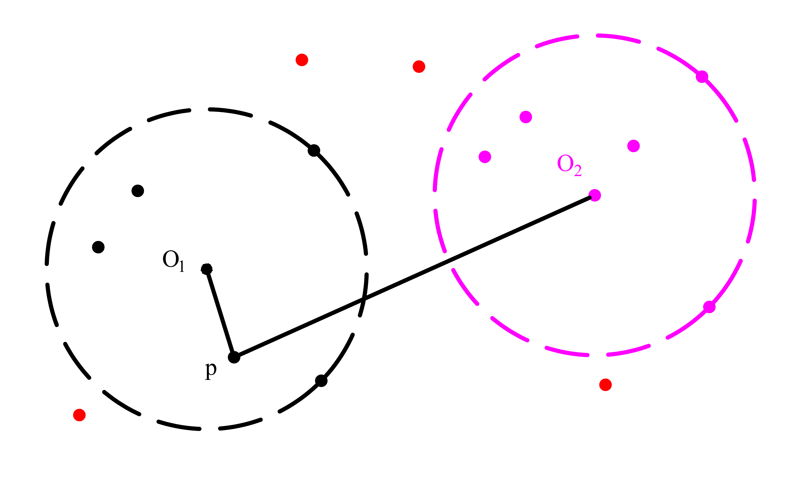
Figure S1. The schematic diagram of reachable distance an reachable distance

The reachable distance serves as the foundation for computing the local reachable density. For any point p within the neighborhood, the reachable distance to point O is denoted as the k-th distance $d_{k}\left(O\right)$. When assessing the local reachable density of data points within a neighborhood, the reachable distance consistently remains $d_{k}\left(O\right)$. The reachable distance for the entire dataset is calculated according to equation (3).
$$d_{k}\left(O,p\right)=max[d_{k}\left(O\right),d_{k}\left(O,p\right)]$$ | ( 3 )
As shown in Fig. S2, the reachable distance from $O_{1}$ to point p is $d_{k}\left(O_{1},p\right)$, and the reachable distance from $O_{2}$ to point p is $d_{k}\left(O_{2},p\right)$, The average reachable distance $\overline{d_{k}}$ can be expressed as:
$\overline{d_{k}}=\sum_{p∈N_{k}\left(O\right)}{\frac{d_{k}\left(O,p\right)}{k}}]$ | ( 4 )
The local reachable density is the inverse of the average reachable distance, as shown in equation (5).
$$ρ=\frac{1}{\sum_{p∈N_{k}\left(O\right)}{\frac{d_{k}\left(O,p\right)}{k}}}=\frac{k}{\sum_{p∈N_{k}\left(O\right)}{d_{k}\left(O,p\right)}}$$ | ( 5 )
The local outlier factor is computed by taking the mean value of the ratio of the local density in the k-neighborhood of each point p within the neighborhood of point O to the local density of point O, as illustrated in equation (6).
$${LOF}_{k}(O)=\frac{\sum_{p∈N_{k}\left(O\right)}{\frac{ρ_{k}\left(p\right)}{ρ_{k}\left(O\right)}}}{k}$$ | ( 6 )
2. Formulation of Gaussian Mixture Model (GMM)
Gaussian Mixture Modeling (GMM), a type of clustering method based on machine learning, was gained widespread popularity in mode recognition. GMM is a probability model that consists of K subdistributions, each of which is a single Gaussian model. The probability density function (PDF) of a Gaussian Mixture Model (GMM) is formed by a linear combination of individual Gaussian probability density functions. If there are K Gaussian distributions, each is defined by its own mean, covariance, and weight. The overall PDF is a weighted sum of these individual Gaussian PDFs, with each Gaussian distribution's contribution determined by its corresponding weight. The expression of the PDF for a GMM with K Gaussian components is shown in Eq. (7). Where $X=(x_{1},x_{2},⋯,x_{n})$ is the input of GMM. $ω_{i}$, $μ_{i}$ and $Σ_{i}$ represents the weight, mean and covariance matrix of the i-th Gaussian distribution, respectively. Moreover, $\sum{ω_{i}}=1$ and the probability distribution $N\left(X|μ_{i}, Σ_{i}\right)$ is expressed as Eq. (8).
 | $$P(X)=\sum_{i=1}^{k}{ω_{i}N\left(X|μ_{i}, Σ_{i}\right)}$$ | (7)
 | $$N\left(X|μ_{i}, Σ_{i}\right)=\frac{1}{2π^{d/2}{\left|Σ_{i}\right|}^{1/2}}exp\left\{-\frac{1}{2}{\left(X-μ_{i}\right)}^{T}{Σ_{i}}^{-1}(X-μ_{i})\right\}$$ | (8)
The GMM parameters are optimized by the expectation-maximization algorithm (EM). The Expectation-Maximization (EM) algorithm is an iterative optimization technique employed to refine the parameters of the GMM, particularly in scenarios involving latent variables or missing data. Through a series of iterative computations, EM progressively enhances the GMM parameters, allowing for a better fit to the observed data [3].

3. Reconstruction Loss of Present Training and Validation Data in ELSTMVAE-VAF_GMM
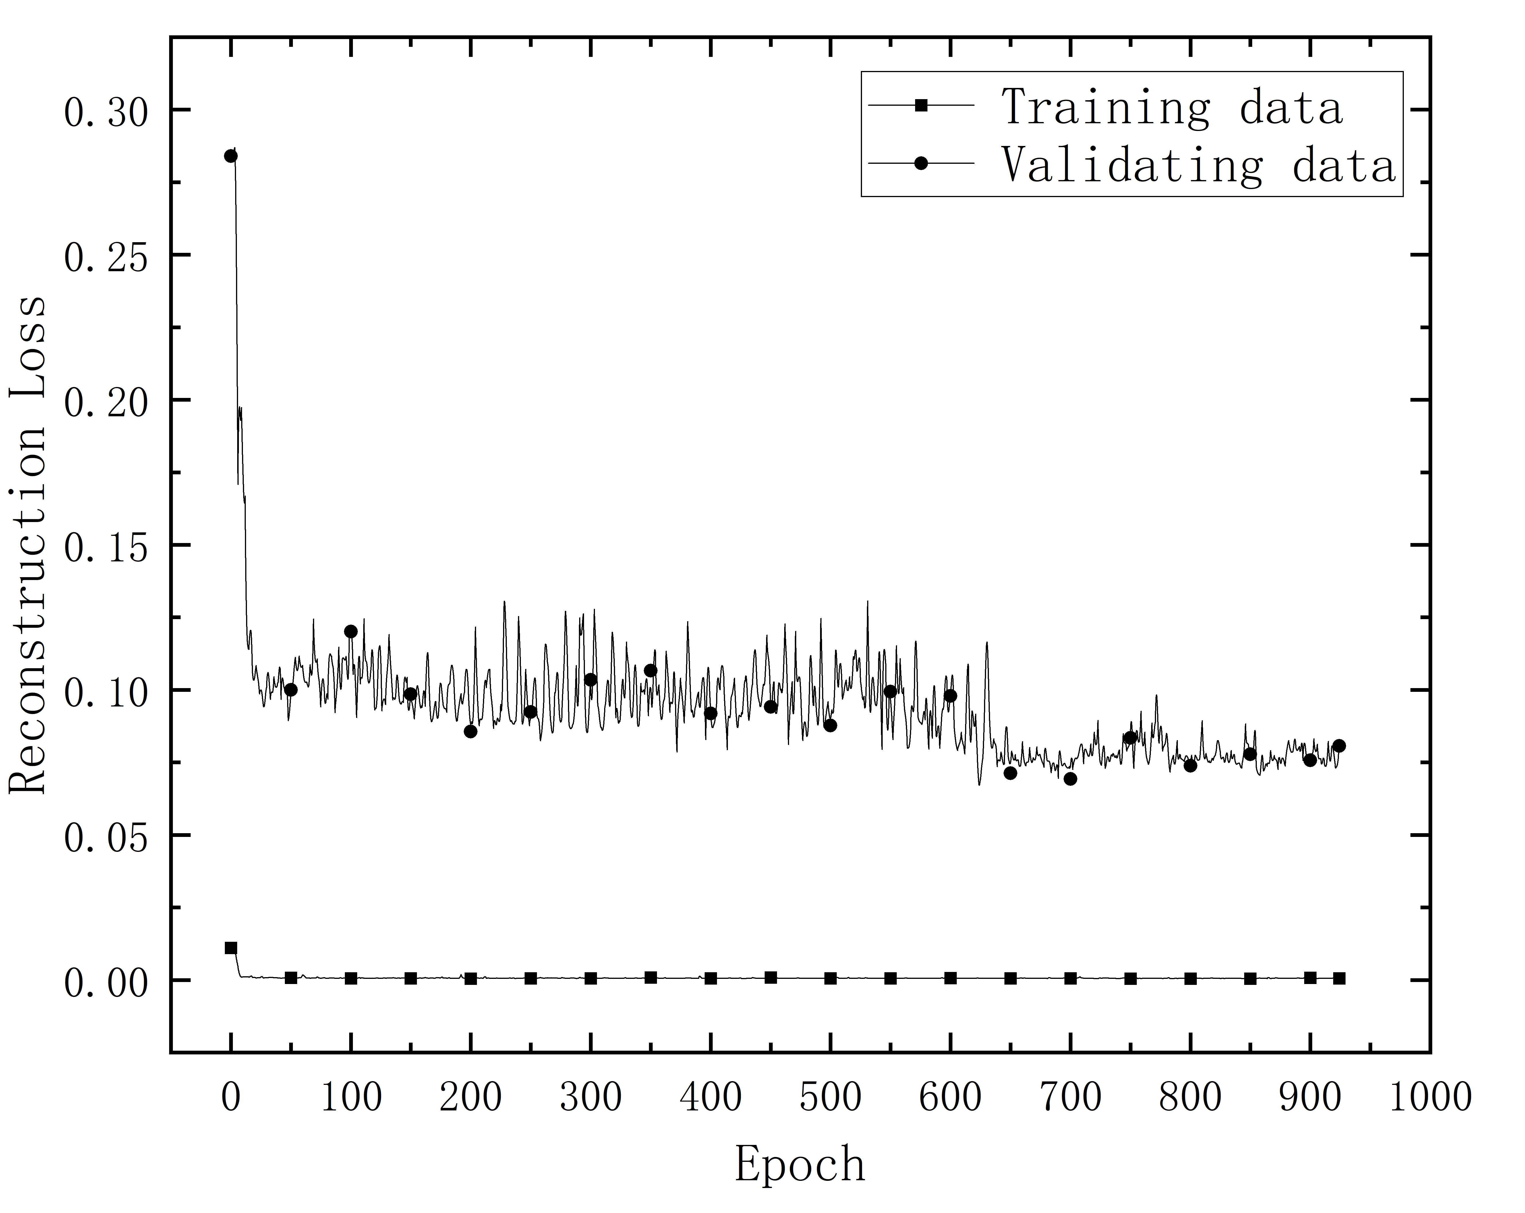
Figure S3. The reconstruction loss of training and validating data through the present ELSTMVAE-VAF_GMM model.

4. Feature of Reconstruction Errors of the Testing Data using ELSTMVAE-VAF_GMM
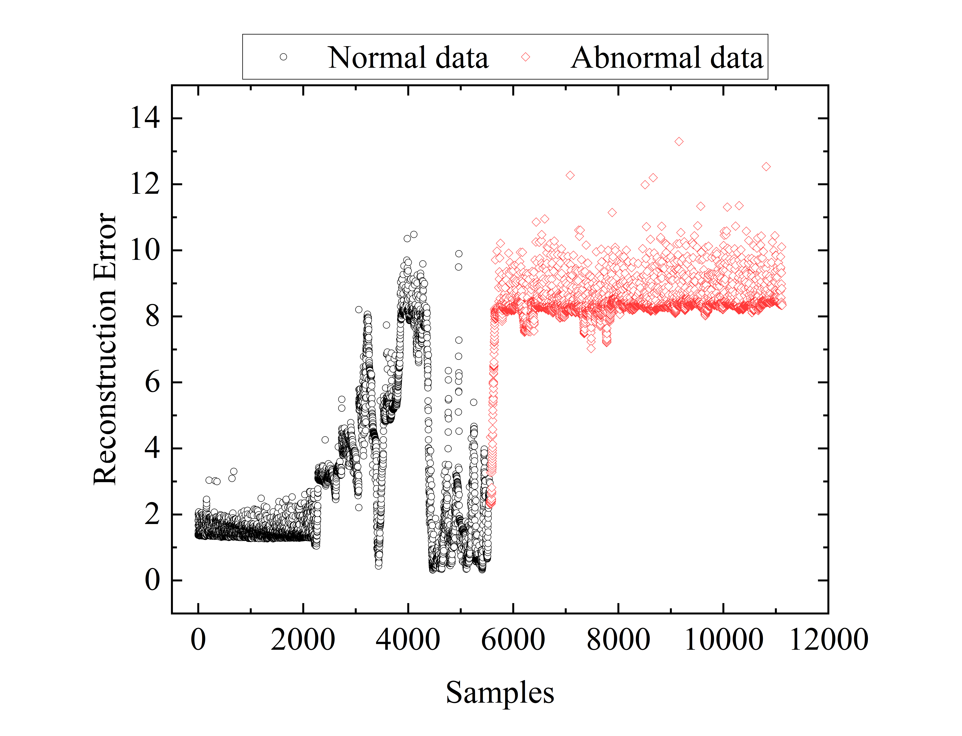
Figure S4. Feature of reconstruction errors of the testing data using ELSTMVAE-VAF_GMM

Reference
[1] A. Nowak-Brzezińska, C. Horyń, Outliers in rules-the comparision of LOF, COF and KMEANS algorithms, Procedia Computer Science, 176 (2020) 1420-1429.
[2] Z. Cheng, C. Zou, J. Dong, in: Proceedings of the conference on research in adaptive and convergent systems, 2019, pp. 161-168.
[3] L.R. Ghimire, R. Chitrakar, Integration of Expectation Maximization using Gaussian Mixture Models and Naïve Bayes for Intrusion Detection, Journal of Computer Science Research, 3 (2021) 1-10.

∗ Corresponding author E-mail address: penzhang@cityu.edu.hk, Tel: (852)34429561. # The authors equally contributed to the work.

