SUPPLEMENTARY MATERIAL

Supplementary Information 1. Dataset descriptions (pg. 2)
Supplementary Information 2. Mortality data description (pg. 3)
Supplementary References (pg. 3)
Supplementary Table 1. Composition of frailty indices (pg. 4)
Supplementary Table 2. Population-level effects from Bayesian mixed-effects gamma regression models of frailty index scores (pg. 5)
Supplementary Table 3. Mean difference in frailty index scores between incident dementia and censored participants (the reference group) (pg. 6)
Supplementary Figure 1. Sex-stratified results in ELSA (pg. 7)
Supplementary Figure 2. Sex-stratified results in HRS (pg. 8)
Supplementary Figure 3. Sex-stratified results in MAP (pg. 9)
Supplementary Figure 4. Sex-stratified results in NACC (pg. 10)
Supplementary Analysis Script (pg. 11)

Supplementary Information 1. Dataset descriptions
English Longitudinal Study of Ageing (ELSA)
ELSA is a longitudinal panel study of a representative sample of community-dwelling adults aged 50 years or older in England ¹. Data collection occurs in waves every two years, which include interviews and self-report questionnaires, with additional nurse visits for the assessment of biomarkers every four years. Refreshment samples were recruited at waves 3, 4, 6, 7, and 9. Ethical approval for each of the ELSA waves was granted by the National Research Ethics Service (London Multicentre Research Ethics Committee). All participants provided written informed consent. Data can be requested at https://ukdataservice.ac.uk/. In this study, we used data from waves 1 (2002–03) to 9 (2018–19), which included 16,685 participants.
Health and Retirement Study (HRS)
The University of Michigan Health and Retirement Study (HRS) is a longitudinal panel study that surveys a representative sample of older adults in the United States ². The HRS survey has been conducted every two years since 1992, which includes questions on, for example, health status, function, health care use, finances and living arrangements. Ethical approval for the HRS Study was obtained from the University of Michigan Institutional Review Board. Data access can be requested at https://hrs.isr.umich.edu/. Data from three HRS subsamples were included in this study: the initial HRS cohort; the Asset and Health Dynamics Among the Oldest Old (AHEAD); and the Children of the Depression (CODA). We included only participants who had self-completed the core interview in 1998 – those with a proxy/exit interview in 1998 were excluded. Data from 19,341 participants were used in this study, which were collected between January 1998 and November 2017.
Rush Memory and Aging Project (MAP)
MAP is a clinical-pathological cohort study of older adults who complete annual clinical evaluations ³. Since its initiation in 1997, MAP has recruited participants from residential facilities, senior and subsidised housing, church groups and social service agencies in northeastern Illinois, United States. Eligibility is based on willingness to sign (i) an informed consent and (ii) an Anatomical Gift Act, agreeing to donate their brain, spinal cord and other biospecimens at their death. Participants also signed a repository consent allowing their data to be used in other studies. MAP was approved by an Institutional Review Board of Rush University Medical Center. Data access can be requested at www.radc.rush.edu. Data from 2,299 participants were used in this study.

National Alzheimer’s Coordinating Center (NACC)
NACC data are contributed by Alzheimer's Disease Research Centers (ADRCs) in the United States ⁴. Since 2005, these ADRCs have employed prospective, standardised and longitudinal data collection methods involving detailed, approximately annual clinical evaluations of study participants. Participants are recruited via clinician referral, self-referral by participants or family members, active recruitment in community organisations, and by other means. The Uniform Data Set (UDS) comprises information on, for example, participants' sociodemographics, neurological examination findings, functional status and clinical diagnoses. Informed consent was obtained at the individual ADRCs. The NACC is approved by the University of Washington Institutional Review Board. Data access can be requested at https://naccdata.org. Data from 49,412 participants assessed between September 2005 and August 2023 at 46 ADRCs were used in this study.
Supplementary Information 2. Mortality data description
Data on the occurrence and date of death were available for HRS, MAP and NACC but not ELSA. In ELSA, mortality data are available only until wave 6 (2012); more recent data are available but data sharing agreements restrict access to within the ELSA team. In HRS, mortality data were drawn from the national mortality register. In MAP, mortality data were derived through a combination of date of autopsy (if available), as well as quarterly/annual participant contacts and manual searches of the Social Security Death Index by research assistants. In NACC, mortality data were available only for those participants with continuing, active participation and were reported by the ADRCs to NACC through a milestones form.
Supplementary References
1. Steptoe, A., Breeze, E., Banks, J. & Nazroo, J. Cohort profile: the English longitudinal study of ageing. Int J Epidemiol 42, 1640–1648 (2013).
2. Sonnega, A. et al. Cohort Profile: the Health and Retirement Study (HRS). Int J Epidemiol 43, 576–585 (2014).
3. Bennett, D. A. et al. Religious Orders Study and Rush Memory and Aging Project. J Alzheimers Dis 64, S161–S189 (2018).
4. Beekly, D. L. et al. The National Alzheimer’s Coordinating Center (NACC) database: the Uniform Data Set. Alzheimer Dis Assoc Disord 21, 249–258 (2007).

Supplementary Table 1. Composition of frailty indices
No. | ELSA | HRS | MAP | NACC
1 | Walking 100 metres | Dressing | Congestive heart failure | Diagnosis of depression
2 | Sitting for 2 hours | Walking in house | Diabetes | Delusions
3 | Getting up from chair | Bathing/showering | Depression | Hallucinations
4 | Climbing several flights of stairs | Eating | Cancer | Agitation or aggression
5 | Climbing one flight of stairs | Getting in and out of bed | Osteoporosis | Anxiety
6 | Stooping, kneeling or crouching | Use toilet | Falls | Apathy or indifference
7 | Reaching or extending arms above shoulder level | Shop groceries | Joint pain | Disinhibition
8 | Pulling or pushing large objects | Use telephone | Diastolic blood pressure | Irritability or lability
9 | Lifting over 10 pounds | Manage money | Hypertension | Night-time behaviours
10 | Picking up a coin from a table | Preparing a hot meal | Grip strength | Psychiatric disorder
11 | Dressing | Taking medications | Walking speed | History of seizures
12 | Walking across a room | Walking one block | Fatigue (everything I did was an effort) | Not satisfied with life
13 | Bathing or showering | Walking several blocks | Travelling in the community | Lacking energy
14 | Eating | Climbing one flight of stairs | Meal prep | Appetite and eating problems
15 | Getting in and out of bed | Lifting 5 kg | Managing finances | Hypertension
16 | Using the toilet | Getting up from chair | Using telephone | Heart attack
17 | Using a map | Stooping | Shopping | Atrial fibrillation
18 | Preparing a hot meal | Reaching | Physical activity | Heart failure
19 | Shopping for groceries | Picking up a coin | Head injury | Other cardiovascular disease
20 | Making telephone calls | Heart problems | Polypharmacy | Diagnosis of stroke
21 | Taking medications | High blood pressure | Taking care of home | Low body massive index
22 | Doing work around the house or garden | Stroke | Walk half a mile | Focal neurological symptoms
23 | Managing money | Diabetes | Walk up and down stairs | Focal neurological signs
24 | High blood pressure | Chronic lung disease | Managing medications | Abnormal vision
25 | Angina | Arthritis | Light housekeeping | Abnormal hearing
26 | Heart attack | Cancer | Heavy housekeeping | Diabetes
27 | Congestive heart failure | Incontinence | Eating | Hypercholesterolemia
28 | Abnormal heart rhythm | Self-rated health | Dressing | Vitamin B12 deficiency
29 | Diabetes or high blood sugar | Underweight | Bathing | Thyroid disease
30 | Stroke | Hearing impairment | Toileting | Incontinence (urinary)
31 | Lung disease | Visual impairment (close) | Walking | Incontinence (bowel)
32 | Asthma | Visual impairment (distant) | Getting from bed to chair | Difficulty with paying bills
33 | Arthritis | Sleep problems | Stroke | Difficulty with shopping
34 | Osteoporosis | Pain | Heart problems | Difficulty with meal preparation
35 | Cancer | Depressed | Claudication | Difficulty with transportation
36 | Psychiatric condition | Sad | Finger tap | Difficulty with community affairs
37 | Depressed | Felt everything was effort | Leg stand | Traumatic brain injury
38 | Everything was an effort | Lonely | Pegboard | Motor function (falls)
39 | Restless sleep | Could not get going | Pinch strength | Motor function (slowness)
40 | Happy (rev.) | Enjoyed life (rev.) | Fatigue (I could not get going) | Difficulty arising from a chair
41 | Lonely | - | Body mass index | Difficulty with postural stability
42 | Enjoyed life (rev.) | - | - | Abnormal posture
43 | Sad | - | - | Abnormal gait
44 | Could not get going | - | - | Somatic complaints
45 | Self-reported general health | - | - | -
46 | Self-reported eyesight | - | - | -
47 | Self-reported hearing | - | - | -
48 | Fallen since last interview | - | - | -
49 | Hip fracture | - | - | -
50 | Joint replacement | - | - | -
51 | Had pain whilst walking | - | - | -
Note: Health and functional deficits highlighted in grey were excluded from the second frailty index used in sensitivity analyses due to being independently associated (P < 0.05) with incident dementia in multivariable Cox proportional hazards models adjusted for age, sex, education and all other deficits. ELSA, English Longitudinal Study of Ageing; HRS, Health and Retirement Study; MAP, Rush Memory and Aging Project; NACC, National Alzheimer’s Coordinating Center; rev., reverse coded.

Supplementary Table 2. Population-level effects from Bayesian mixed-effects gamma regression models of frailty index scores
Model parameter | SF | ELSA | HRS | MAP | NACC
Age  (per year) |  | 0.021  (0.019, 0.024) | 0.008  (0.006, 0.010) | 0.017  (0.014, 0.020) | 0.014  (0.013, 0.016)
Female  (ref: male) |  | 0.223  (0.188, 0.259) | 0.174  (0.149, 0.200) | 0.160  (0.109, 0.202) | -0.033  (-0.054, -0.013)
Intermediate education  (ref: lower) |  | -0.157  (-0.196, -0.116) | -0.135  (-0.168, -0.102) | 0.052  (-0.086, 0.191) | -0.103  (-0.176, -0.030)
Higher education  (ref: lower) |  | -0.260  (-0.307, -0.214) | -0.271  (-0.308, -0.233) | -0.10  (-0.233, 0.031) | -0.183  (-0.252, -0.113)
Incident dementia  (ref: censored) |  | 0.249  (0.055, 0.447) | 0.099  (0.001, 0.198) | -0.228  (-0.488, 0.029) | 0.160  (-0.003, 0.321)
Time  (censored) | 1 | 0.002  (-0.045, 0.049) | 0.314  (0.291, 0.337) | 0.358  (0.230, 0.489) | 0.511  (0.465, 0.558)
Time  (censored) | 2 | 0.186  (0.136, 0.235) | 0.417  (0.387, 0.447) | 0.511  (0.367, 0.656) | 0.602  (0.549, 0.655)
Time  (censored) | 3 | 0.217  (0.172, 0.262) | 0.538  (0.510, 0.565) | 0.476  (0.334, 0.617) | 0.546  (0.496, 0.597)
Time  (censored) | 4 | 0.389  (0.354, 0.422) | 0.601  (0.577, 0.625) | 0.635  (0.522, 0.747) | 0.514  (0.475, 0.553)
Time  (censored) | 5 | 0.340  (0.251, 0.430) | 0.833  (0.781, 0.885) | 0.928  (0.654, 1.205) | 1.084  (0.983, 1.183)
Time  (censored) | 6 | 0.608  (0.579, 0.637) | 0.668  (0.649, 0.687) | 0.625  (0.565, 0.687) | 0.451  (0.427, 0.476)
Time x incident dementia  (ref: censored) | 1 | 0.039  (-0.157, 0.232) | -0.046  (-0.135, 0.040) | 0.377  (0.131, 0.618) | -0.024  (-0.173, 0.128)
Time x incident dementia  (ref: censored) | 2 | -0.200  (-0.413, 0.012) | -0.020  (-0.127, 0.087) | 0.349  (0.079, 0.621) | -0.039  (-0.210, 0.135)
Time x incident dementia  (ref: censored) | 3 | 0.004  (-0.197, 0.202) | -0.077  (-0.176, 0.023) | 0.544  (0.283, 0.800) | 0.208  (0.045, 0.374)
Time x incident dementia  (ref: censored) | 4 | -0.139  (-0.286, 0.006) | -0.025  (-0.103, 0.052) | 0.334  (0.126, 0.541) | 0.289  (0.165, 0.413)
Time x incident dementia  (ref: censored) | 5 | -0.022  (-0.436, 0.384) | -0.036  (-0.235, 0.163) | 0.822  (0.300, 1.336) | 0.188  (-0.141, 0.523)
Time x incident dementia  (ref: censored) | 6 | 0.418  (0.305, 0.531) | 0.034  (-0.022, 0.087) | 0.433  (0.320, 0.547) | 0.725  (0.650, 0.800)
Note: Values represent estimates (95% credible interval). Models also included fixed effects of event group, age, sex and education, as well as a random participant intercepts and slopes. S.F., Spline function; ELSA, English Longitudinal Study of Ageing; HRS, Health and Retirement Study; MAP, Rush Memory and Ageing Project; NACC, National Alzheimer’s Coordinating Center.

Supplementary Table 3. Mean difference in frailty index scores between incident dementia and censored participants (the reference group)
Years before dementia | ELSA |  | HRS |  | MAP |  | NACC
Years before dementia | Diff. | P | Diff. | P | Diff. | P | Diff. | P
20 | - | - | 0.106 | 0.025 | 0.020 | 0.404 | - | -
19 | - | - | - | - | 0.018 | 0.326 | - | -
18 | - | - | 0.028 | 0.002 | 0.031 | 0.110 | - | -
17 | - | - | - | - | 0.018 | 0.202 | -0.011 | 0.497
16 | 0.015 | 0.282 | 0.023 | <0.001 | 0.017 | 0.158 | -0.008 | 0.327
15 | - | - | - | - | 0.014 | 0.224 | 0.003 | 0.595
14 | 0.013 | 0.155 | 0.021 | <0.001 | 0.015 | 0.177 | -0.001 | 0.914
13 | - | - | - | - | 0.018 | 0.051 | 0.001 | 0.902
12 | 0.031 | 0.005 | 0.014 | 0.001 | 0.019 | 0.024 | 0.000 | 0.936
11 | - | - | - | - | 0.019 | 0.014 | -0.003 | 0.386
10 | 0.023 | 0.005 | 0.011 | 0.007 | 0.023 | 0.001 | -0.003 | 0.315
9 | - | - | - | - | 0.025 | <0.001 | 0.001 | 0.633
8 | 0.025 | <0.001 | 0.013 | <0.001 | 0.026 | <0.001 | 0.005 | 0.016
7 | - | - | - | - | 0.024 | <0.001 | 0.007 | <0.001
6 | 0.044 | <0.001 | 0.012 | 0.002 | 0.023 | <0.001 | 0.012 | <0.001
5 | - | - | - | - | 0.031 | <0.001 | 0.014 | <0.001
4 | 0.032 | <0.001 | 0.009 | 0.026 | 0.040 | <0.001 | 0.016 | <0.001
3 | - | - | - | - | 0.054 | <0.001 | 0.026 | <0.001
2 | 0.055 | <0.001 | 0.018 | <0.001 | 0.060 | <0.001 | 0.038 | <0.001
1 | - | - | - | - | 0.064 | <0.001 | 0.054 | <0.001
0 | 0.191 | <0.001 | 0.035 | <0.001 | 0.117 | <0.001 | 0.121 | <0.001
Note: Mean differences were derived using expected frailty index scores calculated from Bayesian mixed-effects gamma regression models that included fixed effects of time, time x event group, age, sex and education, as well as random participant intercepts and slopes. Prior to deriving these mean differences, time (years before event) was rounded to the nearest whole number. ELSA, English Longitudinal Study of Ageing; HRS, Health and Retirement Study; MAP, Rush Memory and Aging Project; NACC, National Alzheimer’s Coordinating Center.

Supplementary Figure 1. Sex-stratified results in ELSA
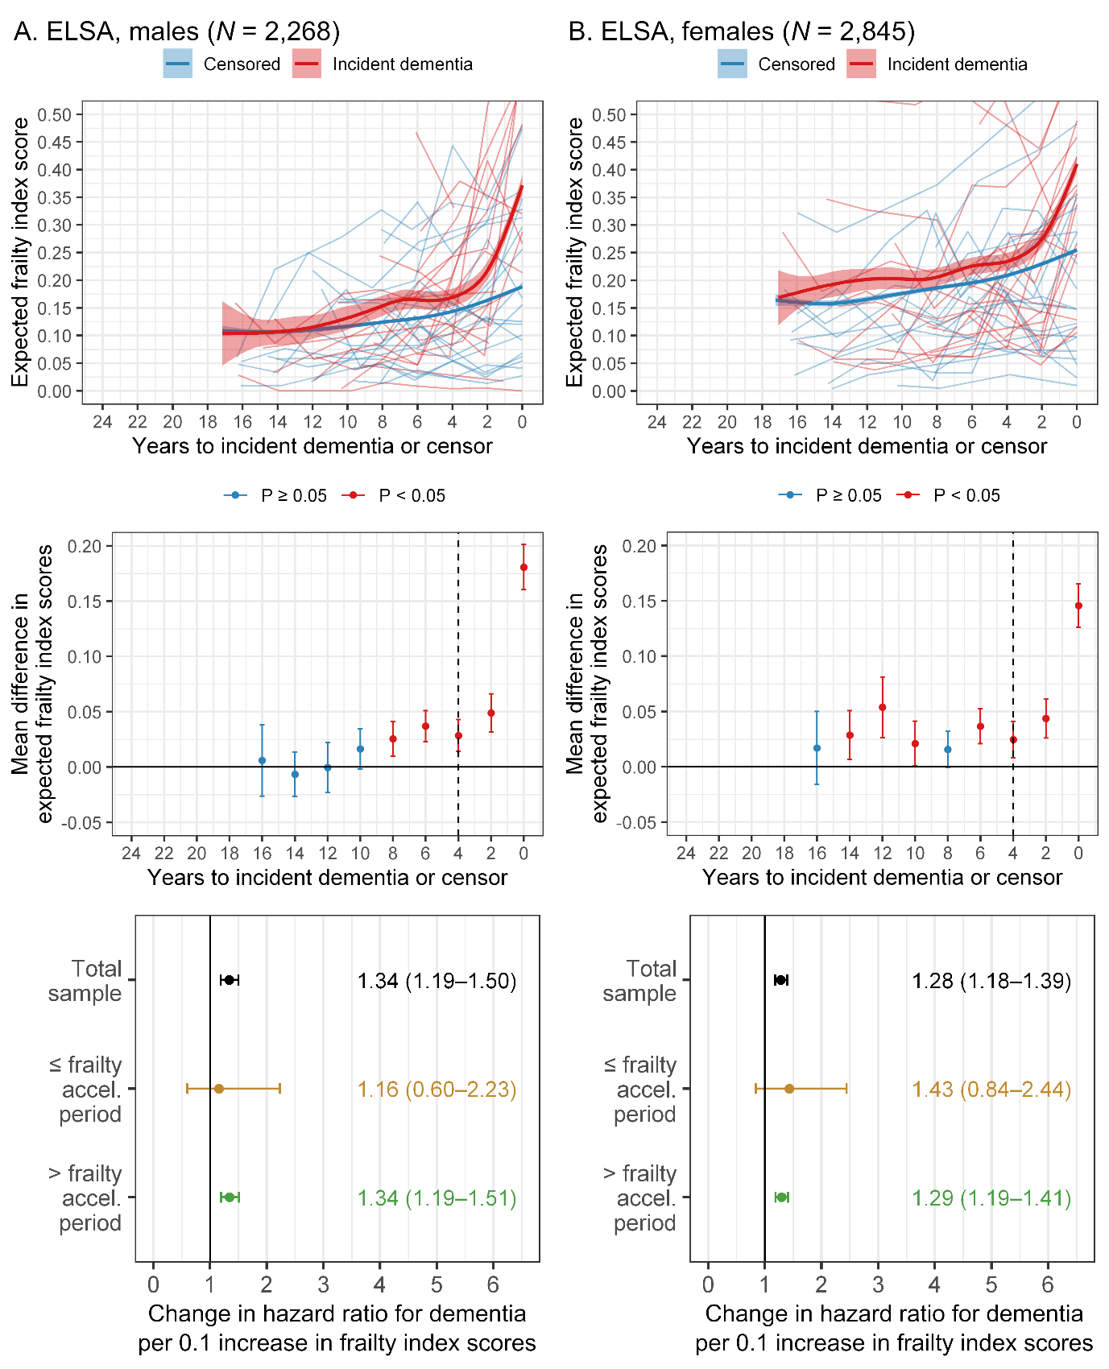
Note: Plots in the top two rows used expected frailty index scores calculated from Bayesian mixed-effects gamma regression models that included fixed effects of time, time x event group, age and education, as well as random participant intercepts and slopes. For the trajectory plots (first row), the thicker lines are mean trajectories surrounded by 95% credible intervals and the thinner lines represent raw (unadjusted) data from 20 participants randomly selected from each group. For the vertical forest plots (second row), mean differences (95% confidence intervals) are between the censored group (reference line) and the incident dementia group and the dashed line represents the estimated start of the pre-dementia frailty acceleration period. For the horizontal forest plots (third row), hazard ratios were calculated from Cox proportional hazards models that included covariates of age and education. ELSA, English Longitudinal Study of Ageing.
Supplementary Figure 2. Sex-stratified results in HRS
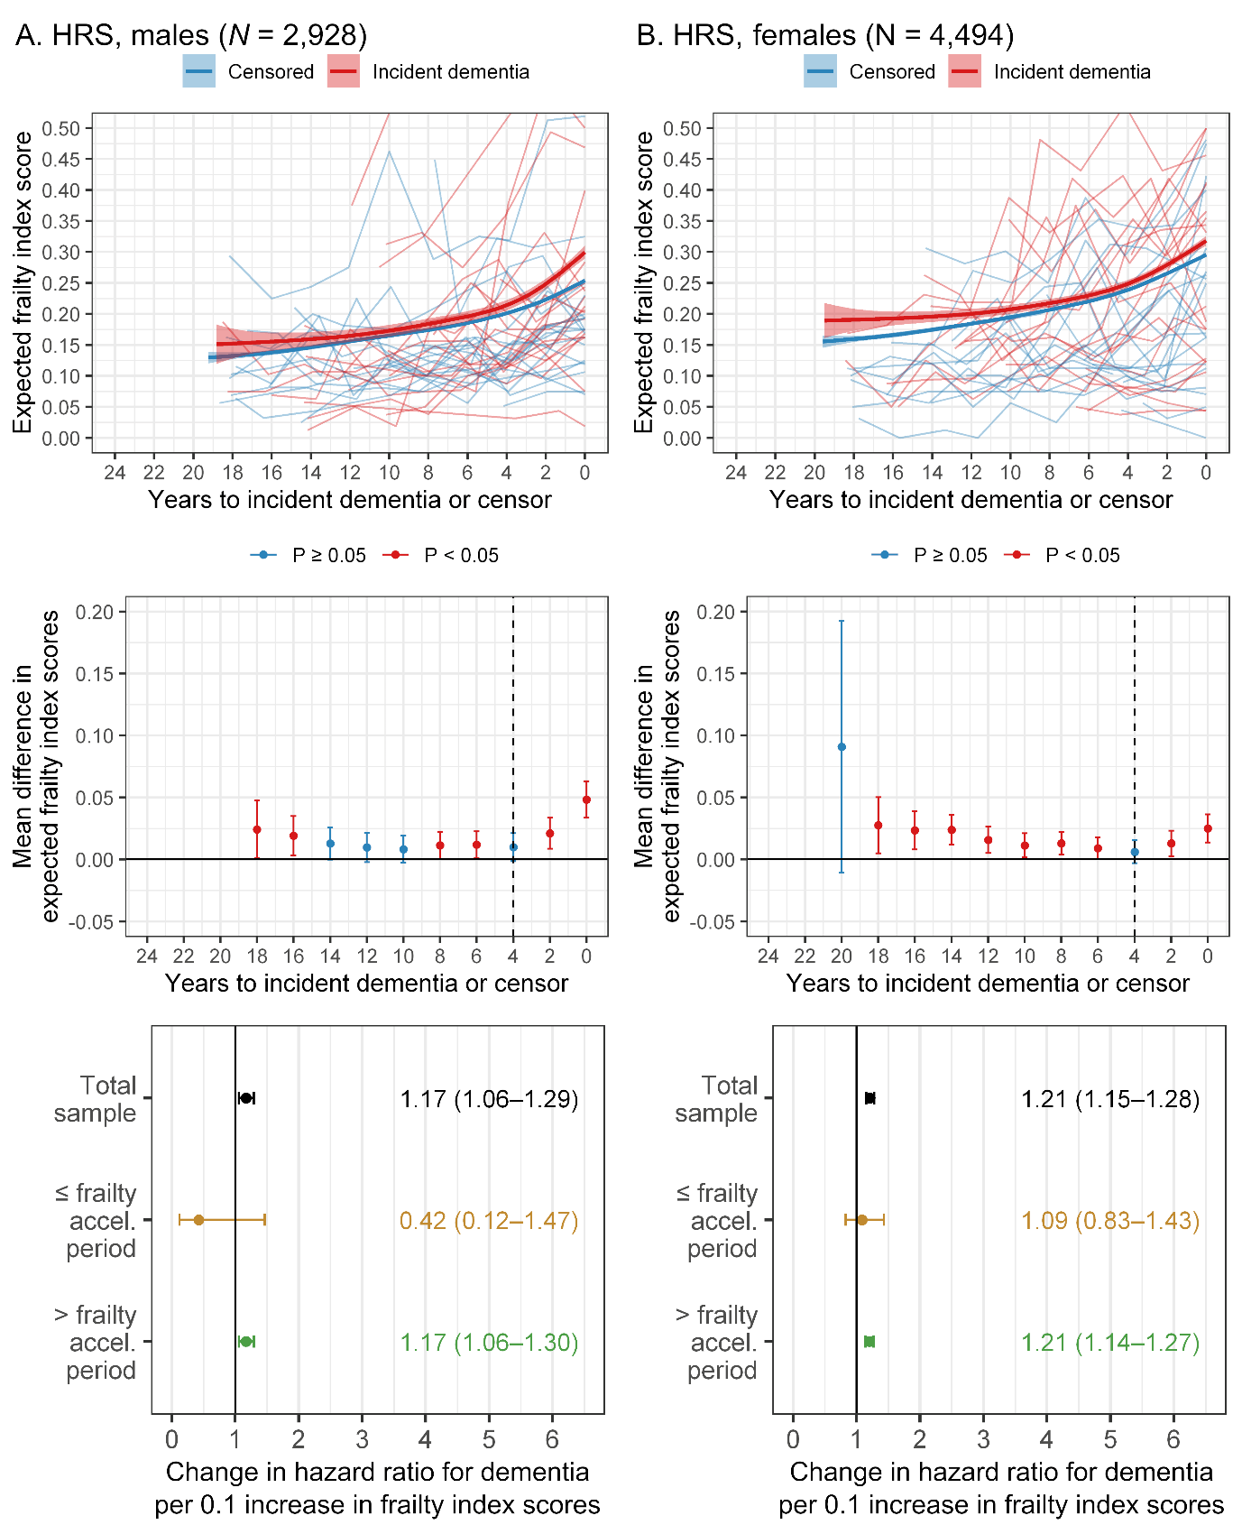
Note: Plots in the top two rows used expected frailty index scores calculated from Bayesian mixed-effects gamma regression models that included fixed effects of time, time x event group, age and education, as well as random participant intercepts and slopes. For the trajectory plots (first row), the thicker lines are mean trajectories surrounded by 95% credible intervals and the thinner lines represent raw (unadjusted) data from 20 participants randomly selected from each group. For the vertical forest plots (second row), mean differences (95% confidence intervals) are between the censored group (reference line) and the incident dementia group and the dashed line represents the estimated start of the pre-dementia frailty acceleration period. For the horizontal forest plots (third row), hazard ratios were calculated from Cox proportional hazards models that included covariates of age and education. HRS, Health and Retirement Study.
Supplementary Figure 3. Sex-stratified results in MAP
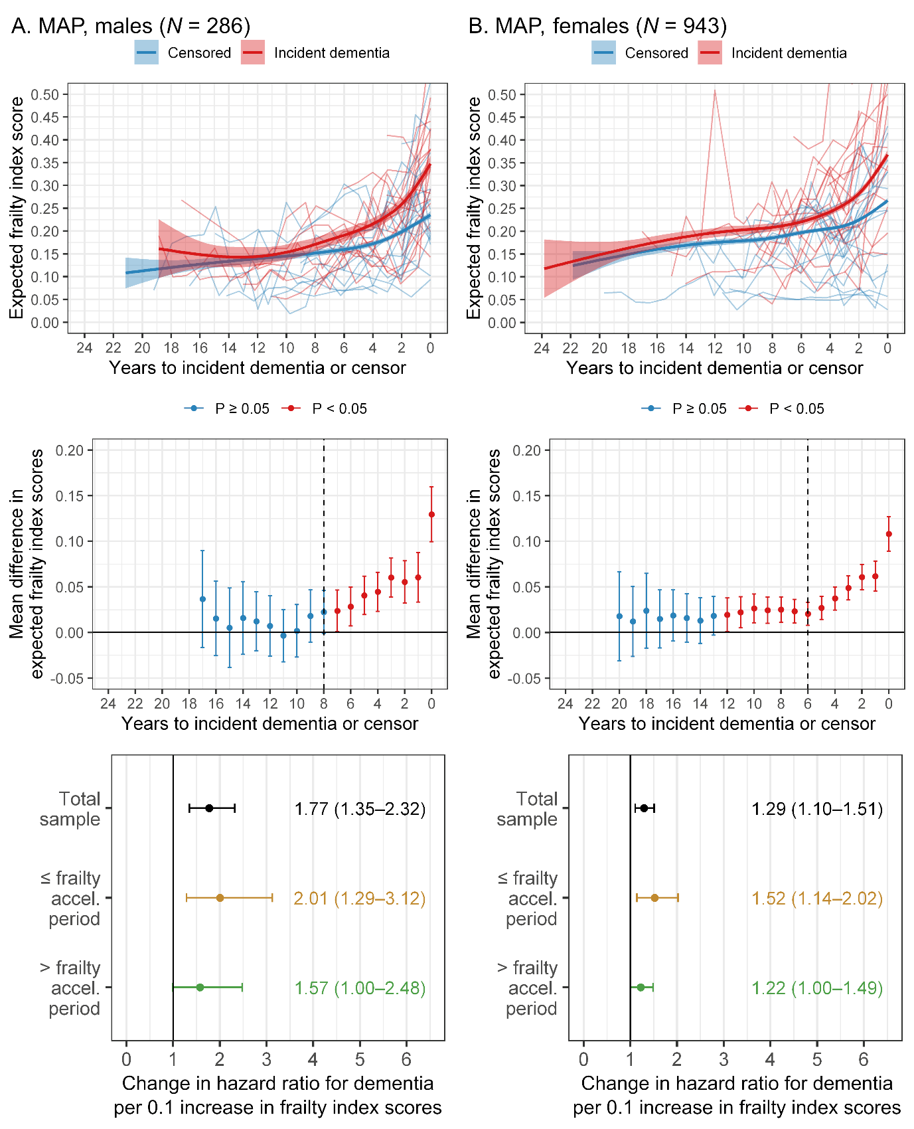
Note: Plots in the top two rows used expected frailty index scores calculated from Bayesian mixed-effects gamma regression models that included fixed effects of time, time x event group, age and education, as well as random participant intercepts and slopes. For the trajectory plots (first row), the thicker lines are mean trajectories surrounded by 95% credible intervals and the thinner lines represent raw (unadjusted) data from 20 participants randomly selected from each group. For the vertical forest plots (second row), mean differences (95% confidence intervals) are between the censored group (reference line) and the incident dementia group and the dashed line represents the estimated start of the pre-dementia frailty acceleration period. For the horizontal forest plots (third row), hazard ratios were calculated from Cox proportional hazards models that included covariates of age and education. MAP, Rush Memory and Aging Project.
Supplementary Figure 4. Sex-stratified results in NACC
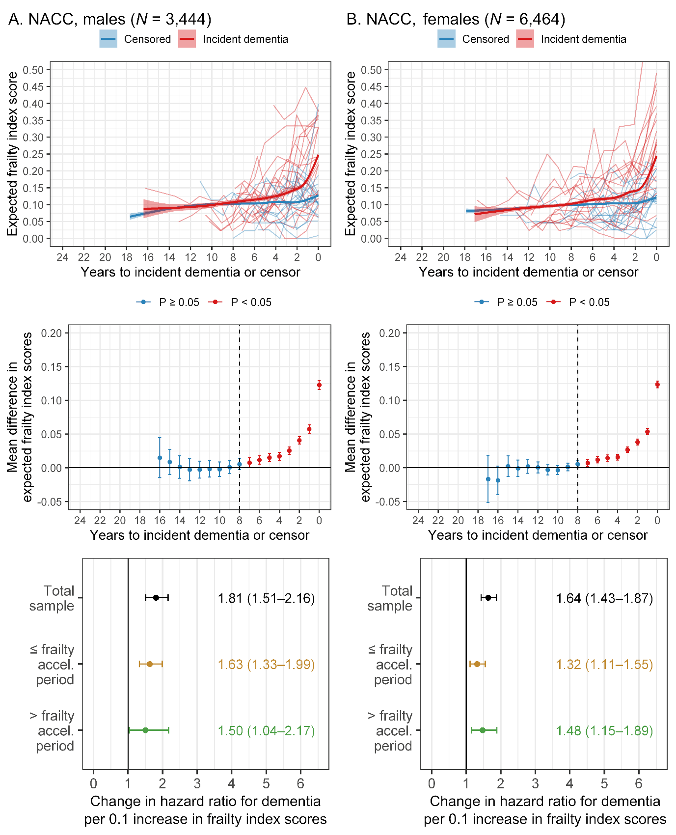
Note: Plots in the top two rows used expected frailty index scores calculated from Bayesian mixed-effects gamma regression models that included fixed effects of time, time x event group, age and education, as well as random participant intercepts and slopes. For the trajectory plots (first row), the thicker lines are mean trajectories surrounded by 95% credible intervals and the thinner lines represent raw (unadjusted) data from 20 participants randomly selected from each group. For the vertical forest plots (second row), mean differences (95% confidence intervals) are between the censored group (reference line) and the incident dementia group and the dashed line represents the estimated start of the pre-dementia frailty acceleration period. For the horizontal forest plots (third row), hazard ratios were calculated from Cox proportional hazards models that included covariates of age and education. NACC, National Alzheimer’s Coordinating Center.
Supplementary Analysis Script
(To be appended once finalised for publication)

