Supplementary Information

Companion basil plants prime the tomato wound response through volatile signaling in a mixed planting system

Plant Cell Reports

Authors: Riichiro Yoshida^{1,2}, Shoma Taguchi¹, Chihiro Wakita¹, Shinichiro Serikawa¹, Hiroyuki Miyaji¹

Affiliations:
¹Laboratory of Horticultural Science, Faculty of Agriculture, Kagoshima University, 1-21-24 Kohrimoto, Kagoshima, Kagoshima 890-0065
²The United Graduate School of Agricultural Sciences, Kagoshima University, 1-21-24 Kohrimoto, Kagoshima, Kagoshima, 890-0065, Japan

Correspondence to: ryoshida@agri.kagoshima-u.ac.jp

Supplementary Table

Table S1. Information of primers and gene used in this study.
Genes name | Forward primer | Reverse primer
Pin2 | GGATTTAGCGGACTTCCTTCTG | ATGCCAAGGCTTGTACTAGAGAATG
LOXD | ATCTCCCAAGTGAAACACCACA | TCATAAACCCTGTCCCATTCTTC
AOS | TACCAACCATTTGCAACGAA | CGCACTGTTTATTCCCCACT
AOC | CTCGGAGATCTTGTCCCCTTT | CTCCTTTCTTCTCTTCTTCGTGCT
PSYS | TCACCATGAGAAGGGAGGAG | TGCATCATCATCTCCTTCAA
MYC2 | AGCAGGAGCATCGGAAGAA | CCAAATCGGGCTGGAACTA
SIMPK1 | GGGCTAGCTCGTGTCACTTC | GGAGTGCCAATCAACTCCAT
SIMPK2 | AATTCCACCACCTCAACGAG | GGCTTCAAGTCCCTATGCAA
SIMPK3 | CCGGAGCTTTTGTTGAACTC | GTGGGAGTTGCCTGACGTAT
Wfi1 | CTGCTTGGAAGAAGAAATC | GAATTTTGCATCGTACAATAG
VSP2 | TCAGTGACCGTTGGAAGTTGTG | GTTCGAACCATTAGGCTTCAATATG
Tomato ACTIN | AGACGCCTATGTGCGGAGATG | GAGGACAGGATGCTCCTCAG
Arabidopsis ACTIN | AGTGGTCGTACAACCGGTATTGT | GATGGCATGAGGAAGAGAGAAAC

Supplementary Figures
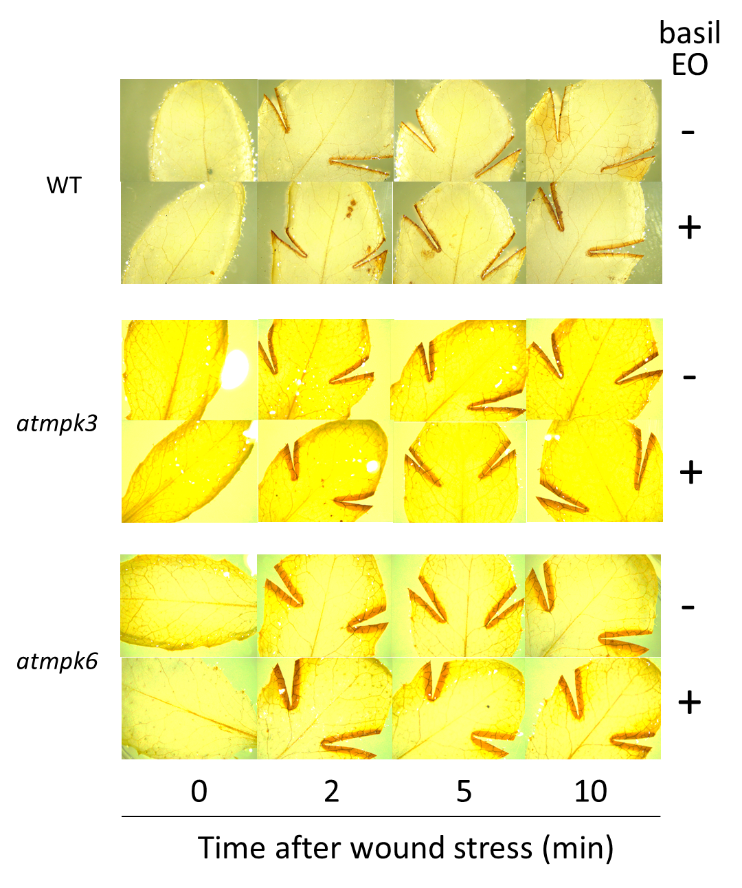

Fig. S1 DAB staining of wounded Arabidopsis leaves. WT, atmpk3, and atmpk6 plants were pre-exposed to basil EO for 15 h, then wounded with scissors. – and + indicate the absence and presence, respectively, of pre-exposure to basil EO.

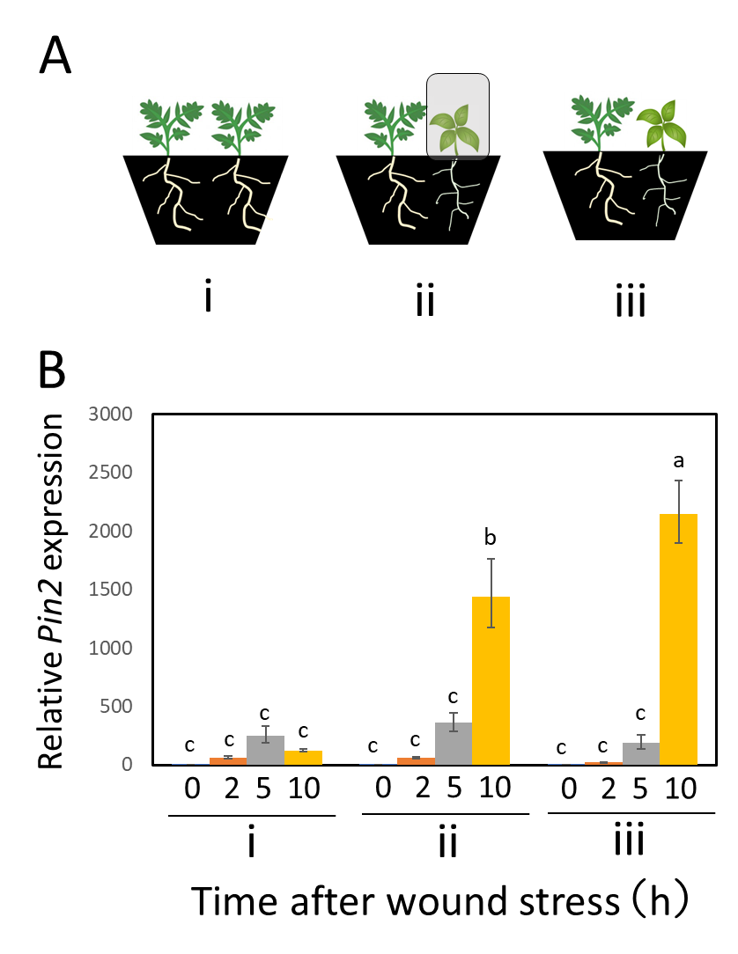

Fig S2 Experiment to evaluate above- and belowground priming of the tomato wound response by basil plants. (A) Three experimental plots were established: (i) tomato plants without basil; (ii) mixed planting of tomato and basil plants, with a transparent plant box used to cover aboveground basil plant parts during the growth period; (iii) mixed planting of uncovered tomato and basil plants. (B) Effects of basil on expression of the wound response gene Pin2 in tomato leaves. Leaves were wounded on both sides with scissors, sampled at the indicated times, and subjected to qPCR analysis. Bars represent means ± SDs from three independent experiments. Different letters indicate significant differences (P < 0.05, one-way ANOVA followed by Tukey’s test; n = 3).

