Supplementary information
Stage -Specific Antimalarial Activity of Alkaloidal Fractions of the Avicennia africana P. Beauv. (Avicenniaceae) Leaf Extract
Mustapha A. Ahmed^{1,3}, Francis Ackah-Armah¹, George Ghartey-Kwansah¹, Patrick M. Fynn⁴, Felix K. Zoiku⁵, Ebenezer Ofori-Attah⁶ and Christian K. Adokoh²

¹Department of Biomedical Sciences, School of Allied Health Sciences, College of Health and Allied Sciences, University of Cape Coast, Cape Coast, Ghana.
²Department of Forensic Sciences, School of Biological Science, College of Agriculture and Natural Sciences, University of Cape Coast, Cape Coast, Ghana.
³Small Animal Teaching Hospital, SVM, CBAS, University of Ghana, Legon, Accra, Ghana
⁴Department of Chemistry, School of Physical Sciences, College of Agriculture and Natural Sciences, University of Cape Coast, Cape Coast, Ghana
⁵Department of Epidemiology, Noguchi Memorial Institute for Medical Research, College of Health Sciences, University of Ghana, Legon, Accra, Ghana
⁶Department of Clinical Pathology, Noguchi Memorial Institute for Medical Research, College of Health Sciences, University of Ghana, Legon, Accra, Ghana

Introduction
Effective treatment of malaria greatly depends on the ability of the drug to act at a specific stage of the parasite developmental stages. Fractions of crude extract may exhibit variety of activities and however it is imperative to study the effects of these fractions on the parasite to enhance discovery and development of new antimalarial. The elucidation of fraction of leaf alkaloidal extract is crucial and data is presented here.

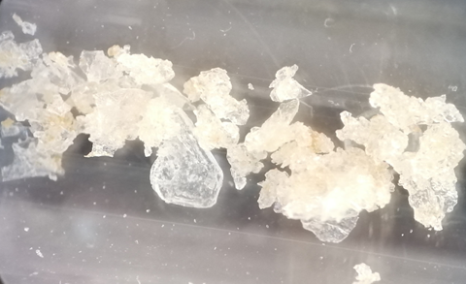
Fig S1: White chalky to colourless crystal of A. africana alkaloid (AAQ1) fraction (Hexane/CHCl₃)

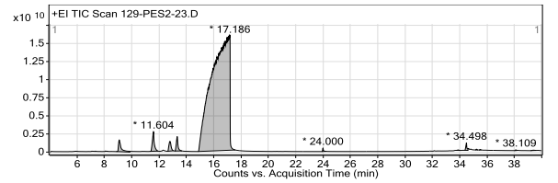
Figure S2: GC-MS profile of AAA1 of A. africana shows the retention time (min) of the compounds on the X-axis, and the Y-axis represents the percentage (%) of peak area.
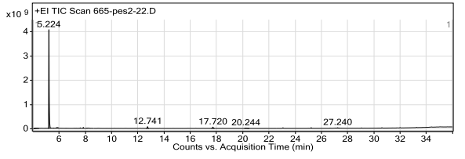
Figure S3: GC-MS profile of AAQ1 of A. africana shows the retention time (min) of the compounds on the X-axis, and the Y-axis represents the percentage (%) of peak area
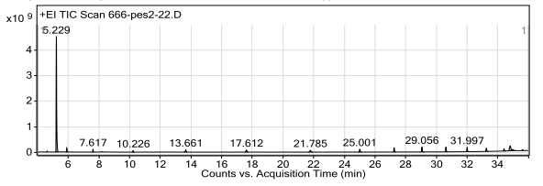
Figure S4: GC-MS profile of AAQ2 of A. africana shows the retention time (min) of the compounds on the X-axis, and the Y-axis represents the percentage (%) of peak area.

Table S1: GC-MS profiling of phytocompounds in solvent fraction AAA1 of the alkaloidal extract of A. africana leaves
RT/min | Name of compound | MF | MS | MW (g/mol) | Peak area (%)
9.103 | trans Cinnamic acid amide | C₉H₉NO | 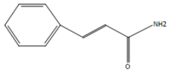 | 147.17 | 1.43
11.604 | 1-[3-(2,6,6-Trimethyl-cyclohex-2-enyl)-4,5-dihydro-3H-pyrazol-4-yl]-ethano | C₁₄H₂₂N₂O | 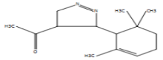 | 234.34 | 1.67
12.804 | 8-Carbamoylquinoline | C₁₀H₈N₂O | 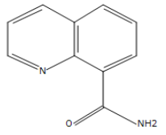 | 172.18 | 0.95
13.335 | 8-Carbamoylquinoline | C₁₀H₈N₂O |  | 172.18 | 1.07
17.186 | 8-Carbamoylquinoline | C₁₀H₈N₂O | 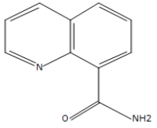 | 172.18 | 94.24
24.000 | Phenethenyl cyanide, 3,4,5-trimethoxy-, (cis)- | C₁₂H₁₃NO₃ | 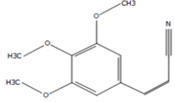 | 219.24 | 0.12
33.891 | 6-Amino-5-cyano-4-(5-cyano-2,4-dimethyl-1H-pyrrol-3-yl)- 2-methyl-4H-pyran-3- carboxylic acid ethyl ester | C₁₇H₁₈N₄O₃ | 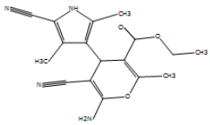 | 326.35 | 0.03
34.498 | .alpha.-N-Normethadol | C₂₀H₂₇NO | 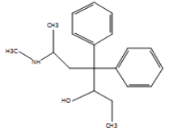 | 297.40 | 0.37
35.227 | 6-Amino-5-cyano-4-(5-cyano-2,4-dimethyl-1H-pyrrol-3-yl)- 2-methyl-4H-pyran-3- carboxylic acid ethyl ester | C₁₇H₁₈N₄O₃ | 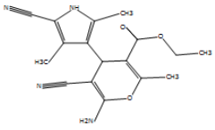 | 326.35 | 0.03
35.504 | 6-Amino-5-cyano-4-(5-cyano-2,4-dimethyl-1H-pyrrol-3-yl)- 2-methyl-4H-pyran-3- carboxylic acid ethyl ester | C₁₇H₁₈N₄O₃ | 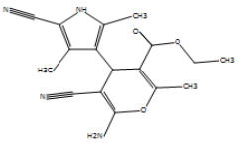 | 326.35 | 0.02
GC-MS = Gas chromatography-mass spectrometry, RT= Retention time (mins), MF= Molecular formula, MW= Molecular weight, MS= Molecular structure, AAA1= fraction of Alkaloids of A. africana leaf
Table S2: GC-MS profiling of phytocompounds in solvent fraction AAQ1 of the alkaloidal extract of A. africana leaves
RT/min | Name of compound | MF | MS | MW  (g/mol) | Peak area (%)
4.219 | (S)-(+)-1- Cyclohexylethylamine | C₈H₁₇N | 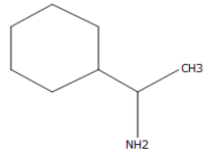 | 127.23 | 2.81
5.224 | Razoxane | C₁₁H₁₆N₄O₄ | 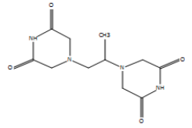 | 268.27 | 90.56
20.244 | (S)-(+)-1- Cyclohexylethylamine | C₈H₁₇N | 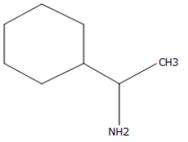 | 127.23 | 1.06
27.240 | dl-Phenylephrine | C₉H₁₃NO₂ | 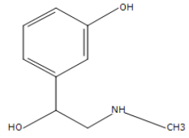 | 167.2 | 0.94
GC-MS = Gas chromatography-mass spectrometry, RT= Retention time (mins), MF= Molecular formula, MW= Molecular weight, MS= Molecular structure, AAQ1= fraction of Alkaloids of A. africana leaf

Table S3: GC-MS profiling of phytocompounds in solvent fraction AAQ2 of the alkaloidal extract of A. africana leaves
RT/min | Name of compound | MF | MS | MW  (g/mol) | Peak area (%)
5.229 | Dexrazoxane | C₁₁H₁₆N₄O₄ | 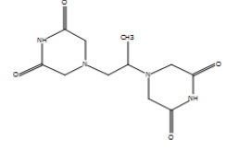 | 268.27 | 62.12
30.615 | methanesulfonamide, N-[2-[ethyl(3- methylphenyl) amino]ethyl]- | C₁₂H₂₀N₂O₂S | 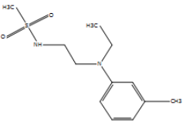 | 279.36 | 3.11
31.997 | methanesulfonamide, N-[2-[ethyl(3-methylphenyl) amino]ethyl]- | C₁₂H₂₀N₂O₂S |  | 279.36 | 2.76
33.247 | 2-Adamantylamine, TMS derivative | C₁₃H₂₅NSi | 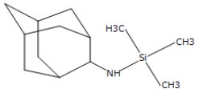 | 223.43 | 2.22
GC-MS = Gas chromatography-mass spectrometry, RT= Retention time (mins), MF= Molecular formula, MW= Molecular weight, MS= Molecular structure, AAQ2= fraction of Alkaloids of A. africana leaf

⁎ Corresponding author:cadokoh@ucc.edu.gh

