Supplementary Material

Supplementary Methods: Exclusion of EEG segments due to epileptic activity
Below, in the upcoming 5 pages, we display representative EEG traces for segments that were excluded or included due to the presence (or absence, respectively) of epileptic activity (similarly to Fig. 2 of Avvenuti et al., 2020⁹⁶), as marked by a trained neurologist (Supplementary Fig. 1).

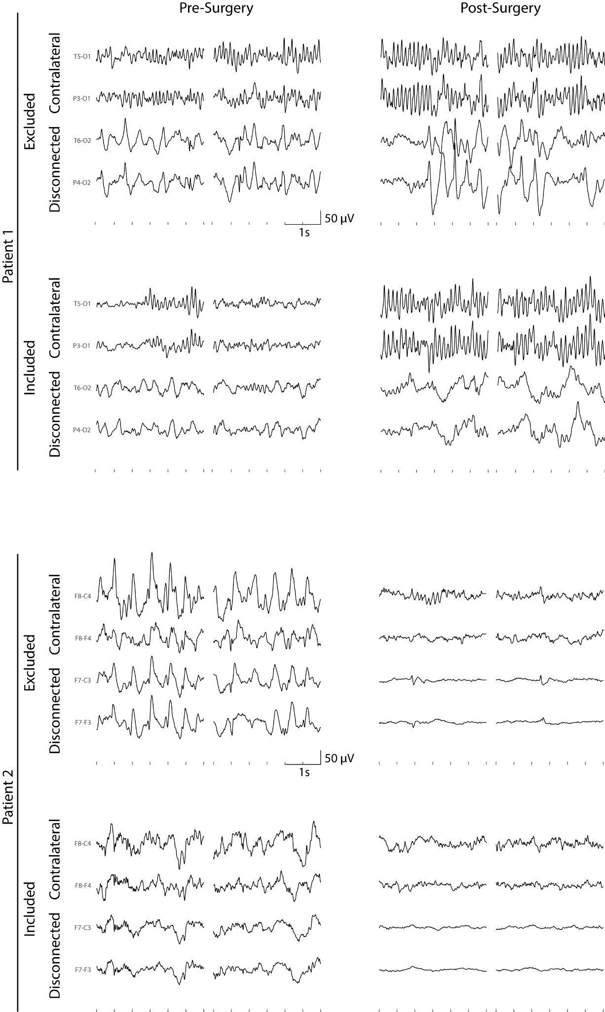
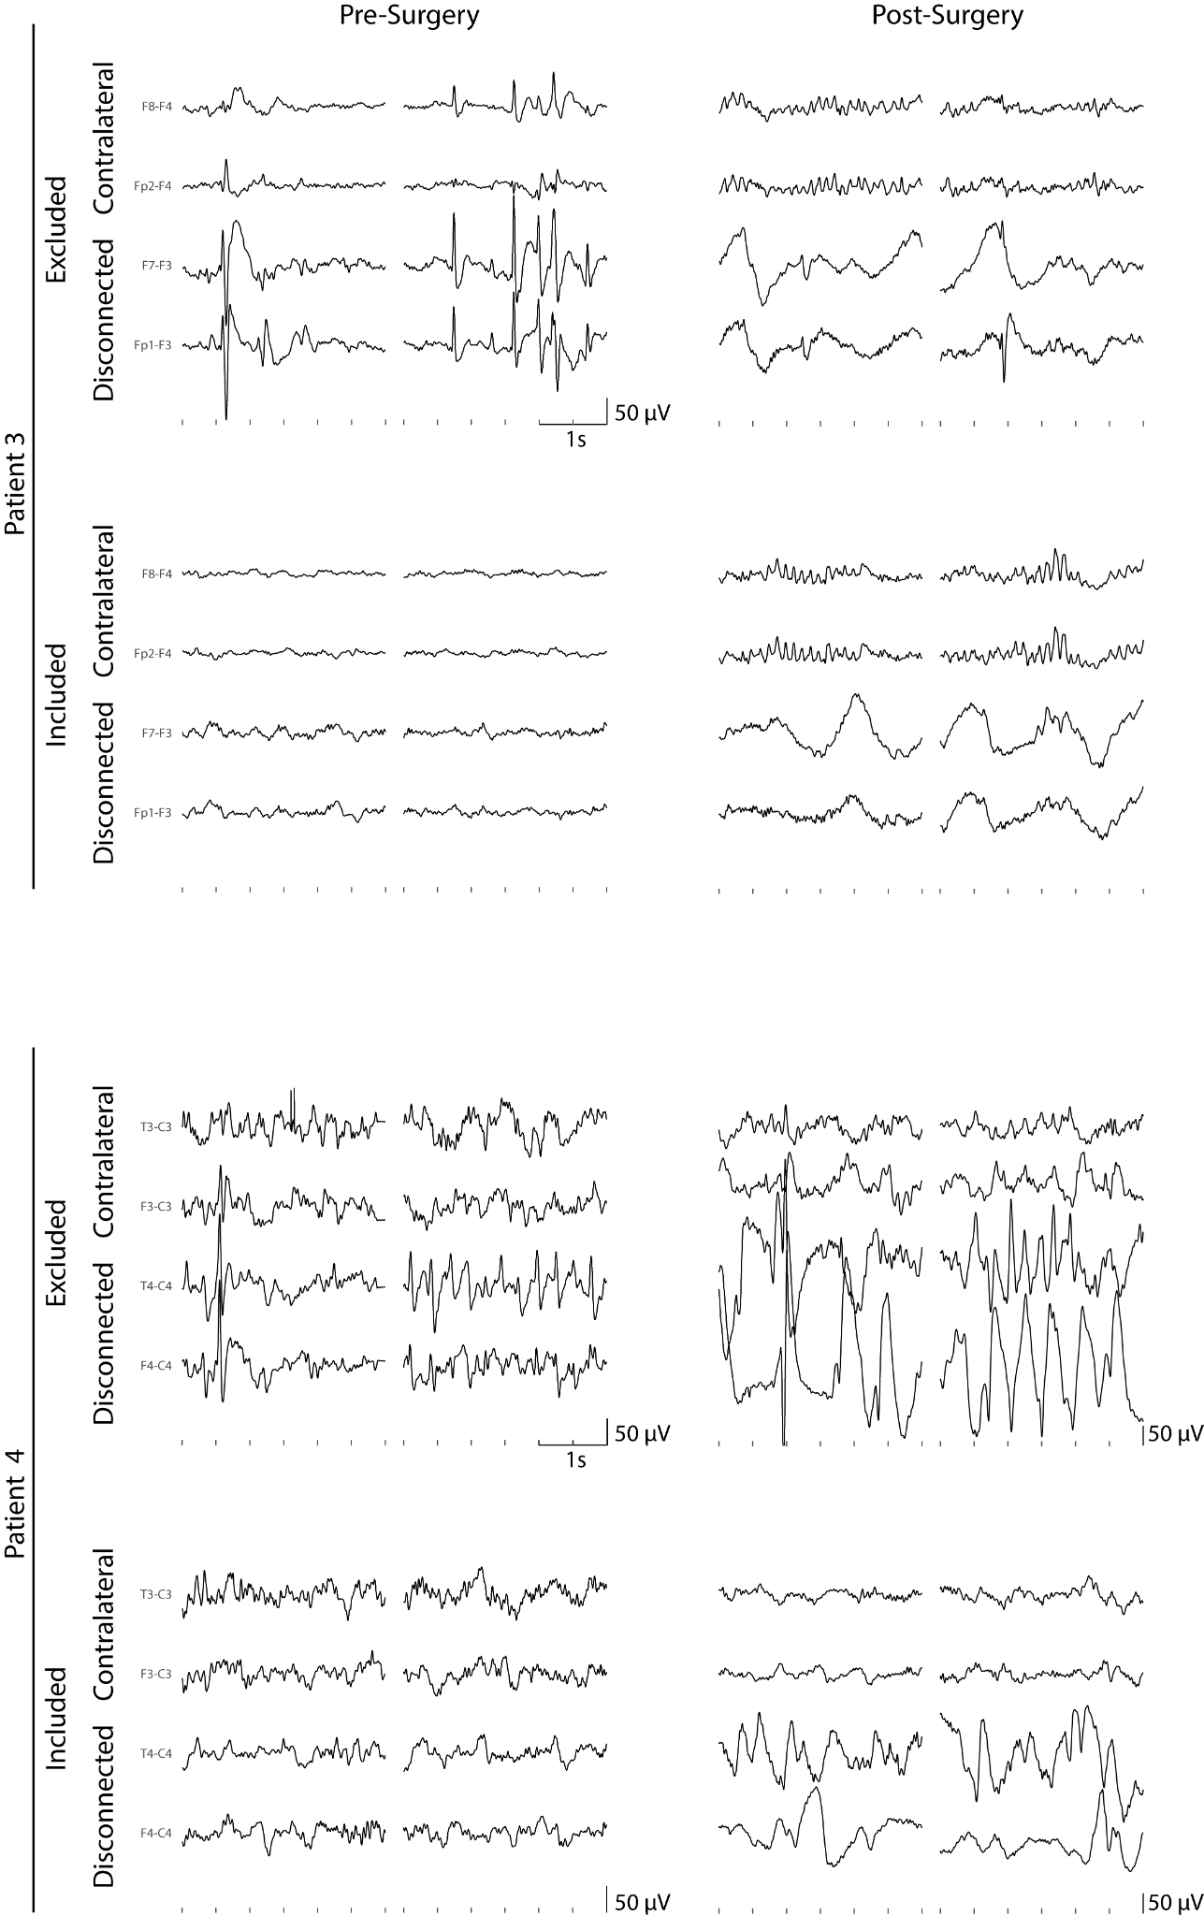
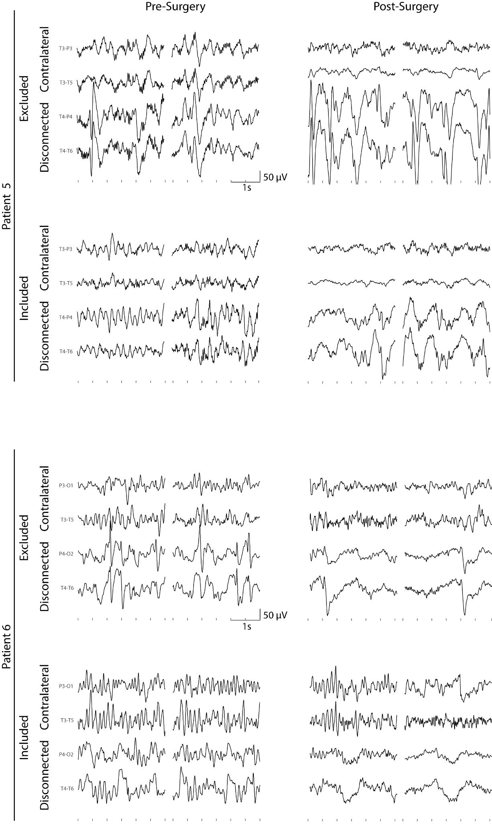
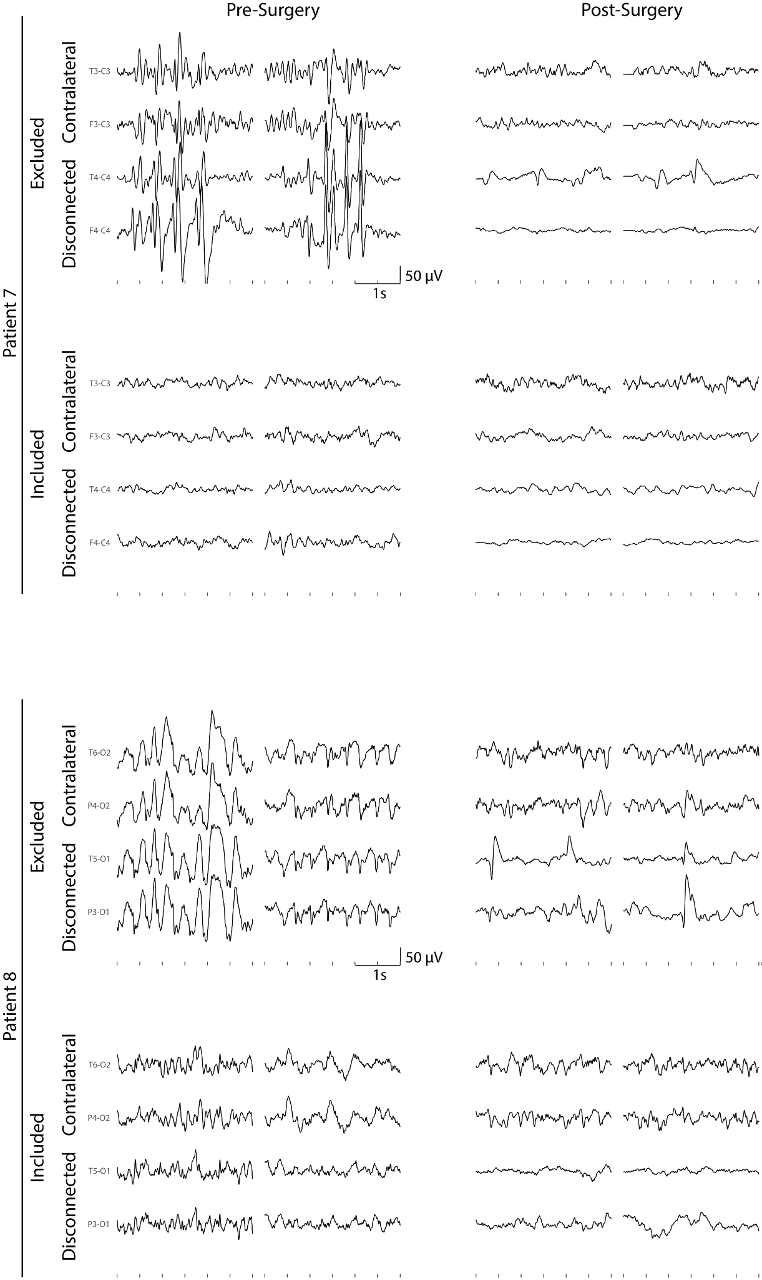
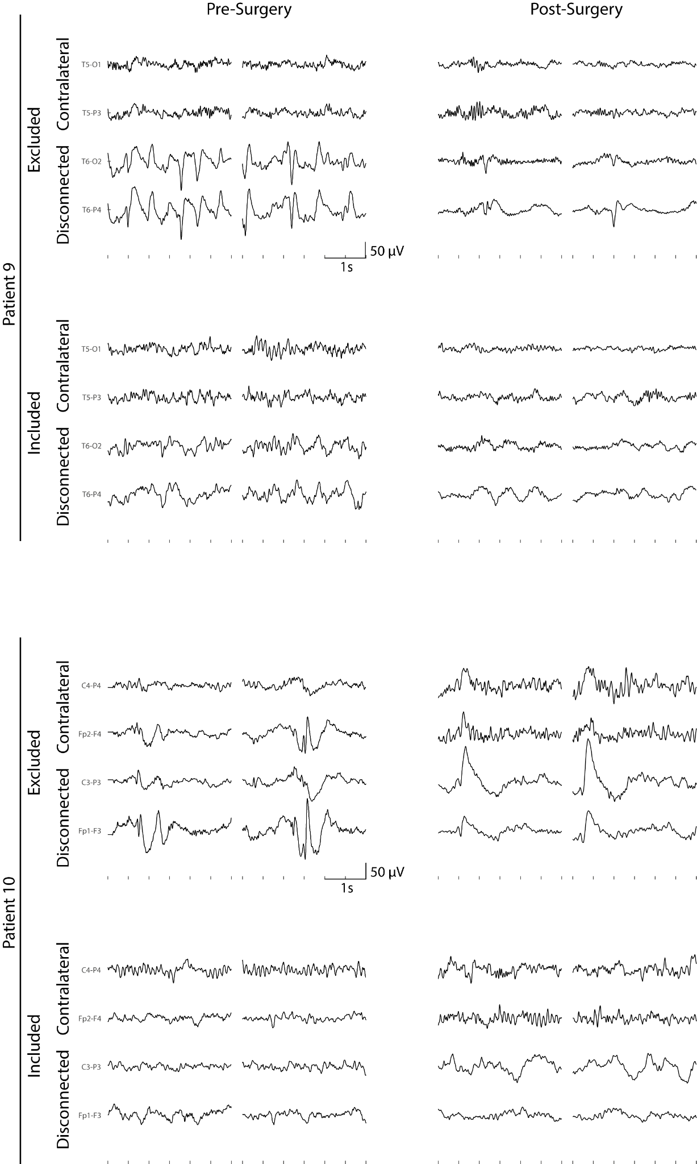
Supplementary Figure 1. Excluded or included data segments due to epileptic activity
We display representative EEG traces for segments that were excluded or included due to the presence (or absence, respectively) of epileptic activity, as marked by a trained neurologist. Each page of the previous five pages displays two patients. For each patient, in each session (pre- and post-surgery), for both included and excluded epochs, we display two representative segments (of 3 seconds each, the same length used for each periodogram in the PSD estimation). Each segment displays activity from two bipolar contacts in the disconnected cortex (chosen for display purposes individually for each patient) and two in the contralateral side (the corresponding homologous contralateral contacts). By only retaining segments that do not display epileptic graphoelements, we minimized the chance that epileptic activity might constitute a bias for the observed spectral changes following hemispherotomy.

Supplementary methods: fitting of the spectral exponent
Specifically, our fitting algorithm first resamples the PSD over log-spaced frequency bins (upsampling to ensure that the lower frequencies are adequately represented and leveraged with respect to the higher frequencies), then performs a preliminary linear fit (in log-log axes). Subsequently it identifies peaks (large residuals from the preliminary fit, > 1 median absolute deviation, also displaying a peak/inflection point) along with the base of the peaks (frequency bins with positive residuals adjacent to peaks), and re-fits linearly the PSD after discarding the identified peaks. The identified PSD trend corresponds to the aperiodic 1/f component, and its slope corresponds to the spectral exponent. Details of the procedure have been published in Colombo et al., 2019⁴¹ and the code is available online at: https://github.com/milecombo/spectralExponent/blob/master/README.md.
The PSD aperiodic component consistently decays over frequencies, approximately according to an inverse power-law. Such decay can be characterized either by a negative spectral exponent value (as in⁴¹¹⁸⁹⁷⁹⁸), as we do in this study, or equivalently, by a positive value ⁴⁶⁴⁷⁴⁹, according to the formula used for fitting and depending on the use of the absolute value.
PSD residuals, after the removal of the aperiodic component (1/f-like trend), display peaks in the typical delta, theta, alpha and beta band, corresponding to periodic activity (Supplementary Fig. 2).

Supplementary Methods: estimation of aperiodic activity while accounting for periodic activity
A preliminary power-law fit of the PSD (by means of a linear fit under log-log axis) allowed us to identify peaks deviating from the PSD 1/f-like aperiodic background, and thus corresponding to the PSD periodic component.
In order to better estimate the aperiodic component, peaks and their base are subsequently excluded from a second power-law fit. The proportion of electrodes whereby a frequency bin was excluded, on average across patients, is displayed at the bottom of Supplementary Fig. 2.
The residuals/deviations from the second power-law fit of the PSD, averaged across electrodes and patients via geometric mean (in line with the main Fig. 1C) correspond to the estimated periodic component of the PSD (top of Supplementary Fig. 2).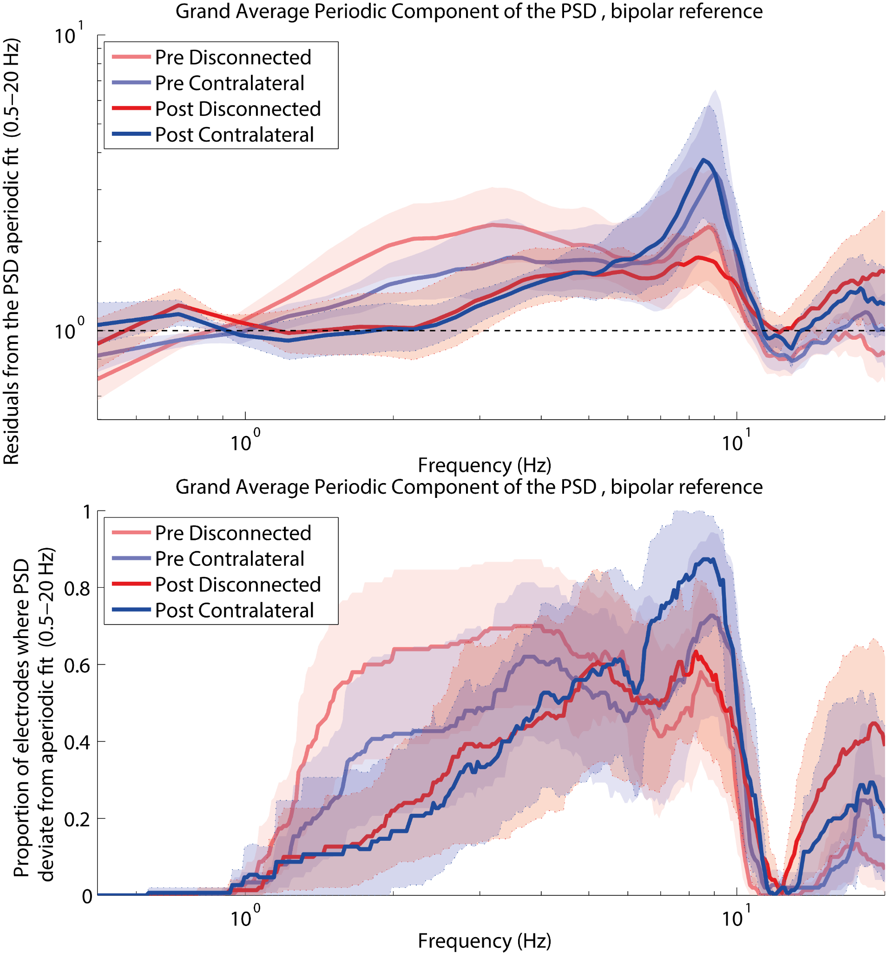Supplementary Fig. 2. Residuals/Periodic Component and Proportion of channels excluded from fit
Inspection of the periodic component of the PSD, as well as of the proportion of electrodes across frequencies displaying peaks highlights the presence of delta, theta, and beta oscillatory activity. Sigma peaks, indexing a thalamocortical synchronization phenomenon typical of NREM sleep, could not be observed.

Supplementary Methods: Mixed effects models
First, two mixed effect models were built to assess whether each univariate EEG marker (spectral exponent and Slow-Delta power) differed across spatial side (Disconnected and Contralateral side), temporal sessions (Pre and Post surgical disconnection) or due to possible spatio-temporal interaction effects, while controlling for the nesting of the spatial and temporal variables within participants. Specifically, each univariate marker was considered as a response variable, the spatial side, the temporal session as well as their interaction were entered as fixed effects, while spatial side and temporal session, grouped by subject, were entered as random effects. Thus, the resulting formula was:
EEG feature~ SpatialSide + Time + SpatialSide*Time + ( 1 + SpatialSide + Time | Subject)
F-tests were performed for each fixed-effects term, by means of a type-3 ANOVA for the linear mixed-effects model.
According to the ANOVA on the mixed effect models (Supplementary Table 1), the Slow-Delta power showed no significant effect of spatial side, a significant effect of time, and, importantly, a large, significant effect of the interaction between spatial side and time.
The spectral exponent showed a significant effect of spatial side, a large, significant effect of time, and, importantly, a large, significant effect of the interaction between spatial side and time.

Slow-Delta Power (0.5-2 Hz)
Term | F-stat | DF1 | DF2 | p
Intercept | 504,70 | 1 | 36 | 9,02E-23
SpatialSide | 0,04 | 1 | 36 | 0,83
Time | 9,21 | 1 | 36 | 0,0044
SpatialSide*Time | 15,74 | 1 | 36 | 0,0003

Spectral Exponent (0.5-20 Hz)
Term | F-stat | DF1 | DF2 | p
Intercept | 878,15 | 1 | 36 | 6,99E-27
SpatialSide | 4,16 | 1 | 36 | 0,04889
Time | 22,04 | 1 | 36 | 3,8E-05
SpatialSide*Time | 46,43 | 1 | 36 | 5,77E-08
Supplementary Table 1. ANOVA of mixed effect models reveal a significant interaction between time and spatial side, indexing that the surgical disconnection differently affected each hemisphere. Degrees of Freedom relative to the ANOVA Fisher statistic (F-stat) are reported as DF1 and DF2. Significant p-values of the F tests, for each term of the linear mixed effect model, are highlighted in bold

The results from the mixed effects models pointed to a change in the degree of narrow- and broad-band slowing following surgical disconnection that differently affected each hemisphere. Thus, the statistical pattern was further explored by means of a series of pairwise contrasts across conditions (paired t-tests), under the hypothesis that that the degree of narrow-band and broad-band slowing would be larger in the disconnected cortex with respect to the contralateral, and post-surgery with respect to the pre-surgery session. Further, we hypothesized that the disconnected cortex would show a greater increase following surgery, in the degree of narrow- and broad-band slowing, with respect to the contralateral cortex.
Greater narrow-band slowing is indexed by larger Slow Delta Power values, while greater broad-band slowing is indexed by more negative Spectral Exponent values (i.e. larger in absolute values). The results are described in the main text and reported in Supplementary Table 2. Briefly, following surgery, larger narrow-band and broad-band slowing was observed in the disconnected cortex–as compared to the pre-surgery session, and as compared to the contralateral cortex–leading to a significant inter-hemispheric asymmetry, which was larger relative to the pre-surgery session.

 | Paired Contrast |  | Average values |  |  | Stat. | p-values
Slow Delta Power (0.5-2 Hz)
Context | Group 1 | Group 2 | μ Group1 | μ Group2 | d | t | p | pFDR
Difference Post-Pre | Contra  lateral | Disconnected | 0,129 | 0,601 | -1.020 | -3,146 | 0,01181 | 0,01969
Pre | Contra  lateral | Disconnected | 1,750 | 1,770 | -0.069 | -0,228 | 0,82464 | 0,82464
Post | Contra  lateral | Disconnected | 1,879 | 2,372 | -1.208 | -4,245 | 0,00216 | 0,01079
Contralateral | Pre | Post | 1,750 | 1,879 | -0.454 | -1,462 | 0,17765 | 0,22206
Disconnected | Pre | Post | 1,770 | 2,372 | -1.446 | -3,215 | 0,01058 | 0,01969
Spectral Exponent (0.5-20 Hz)
Context | Group 1 | Group 2 | μ Group1 | μ Group2 | d | t | p | pFDR
Difference Post-Pre | Contra  lateral | Disconnected | -0,175 | -0,644 | 1.501 | 6,464 | 0,00012 | 0,00020
Pre | Contra  lateral | Disconnected | -1,446 | -1,590 | 0.734 | 2,395 | 0,04022 | 0,05027
Post | Contra  lateral | Disconnected | -1,621 | -2,234 | 2.050 | 7,118 | 0,00006 | 0,00020
Contralateral | Pre | Post | -1,446 | -1,621 | 0.618 | 1,786 | 0,10769 | 0,10769
Disconnected | Pre | Post | -1,590 | -2,234 | 2.962 | 6,455 | 0,00012 | 0,00020

Supplementary Table 2: Pairwise Contrasts across spatial and temporal conditions on EEG slowing features. The context column specifies how the values are considered: either within a temporal condition (Pre, Post), within a spatial condition (Contralateral, Disconnected), or as a difference between the two temporal condition (Post-Pre difference). The Paired Contrasts columns specify the groups (spatial or temporal) considered for the contrast. The ‘Average values’ display the values within each of the two groups (μ Group1, μ Group2). The ‘Stat.’ column displays Cohen’s d (a common measure of the effect size), the t-statistic for each contrast, resulting from a paired t-test across the two groups. For each feature (Slow Delta Power, top; Spectral Exponent, bottom), the p-values columns display the uncorrected one-sided p-values (p) from the t-test and the p-values after multiple comparison correction with a false discovery rate approach across the columns (p-FDR), by means of the linear-step up procedure originally introduced by Benjamini and Hochberg (1995). Significant p values (p <0.05), either before or after correction for multiple comparisons, are highlighted in bold. Note the overall larger effect sizes for the spectral exponent, as estimated by Cohen's d values.

Supplementary Results: Results in the patient dataset of the Spectral Exponent, estimated between 1-20 Hz
In order to compare spectral exponent values across datasets, we considered a narrower frequency range than in the main section (Fig. 1, 2, 3), and replicated the main findings over this frequency range in the patient dataset.
As mentioned in the Methods section of the main text, to directly compare spectral exponent values across datasets, we aligned the preprocessing pipeline of the patients with cortical disconnection to that of the previously published study on the reference pediatric sample⁴⁶. Hence, in the patients’ dataset, we increased the Butterworth high-pass filter from 0.1 to 0.5 Hz, and consequently restricted the fitting range of the spectral exponent from 0.5-20 Hz to 1-20 Hz (i.e. with the lower bound set at a frequency where the filter effects were dissipated and the expected PSD decay was observed), according to the procedure used in the reference dataset⁴⁶.
While in the main text we report the contrasts within the patient dataset on the spectral exponent estimated between 0.5-20 Hz (Fig. 1, 2, 3), we here report the contrasts on the spectral exponent estimated between 1-20 Hz, after raising the cut-off frequency of the high-pass filter from 0.1 Hz to 0.5 Hz.
As shown in Supplementary Fig. 3, we observed a mild inter-hemispheric asymmetry before surgery, a marked inter-hemispheric asymmetry after surgery, and a decrease after surgery of the spectral exponent (1-20 Hz) to more negative values, localized in the disconnected cortex. Thus, even after restricting the frequency range under study (from 0.5-20 Hz to 1-20 Hz), all findings on the spectral exponent were consistently replicated in the patient dataset.

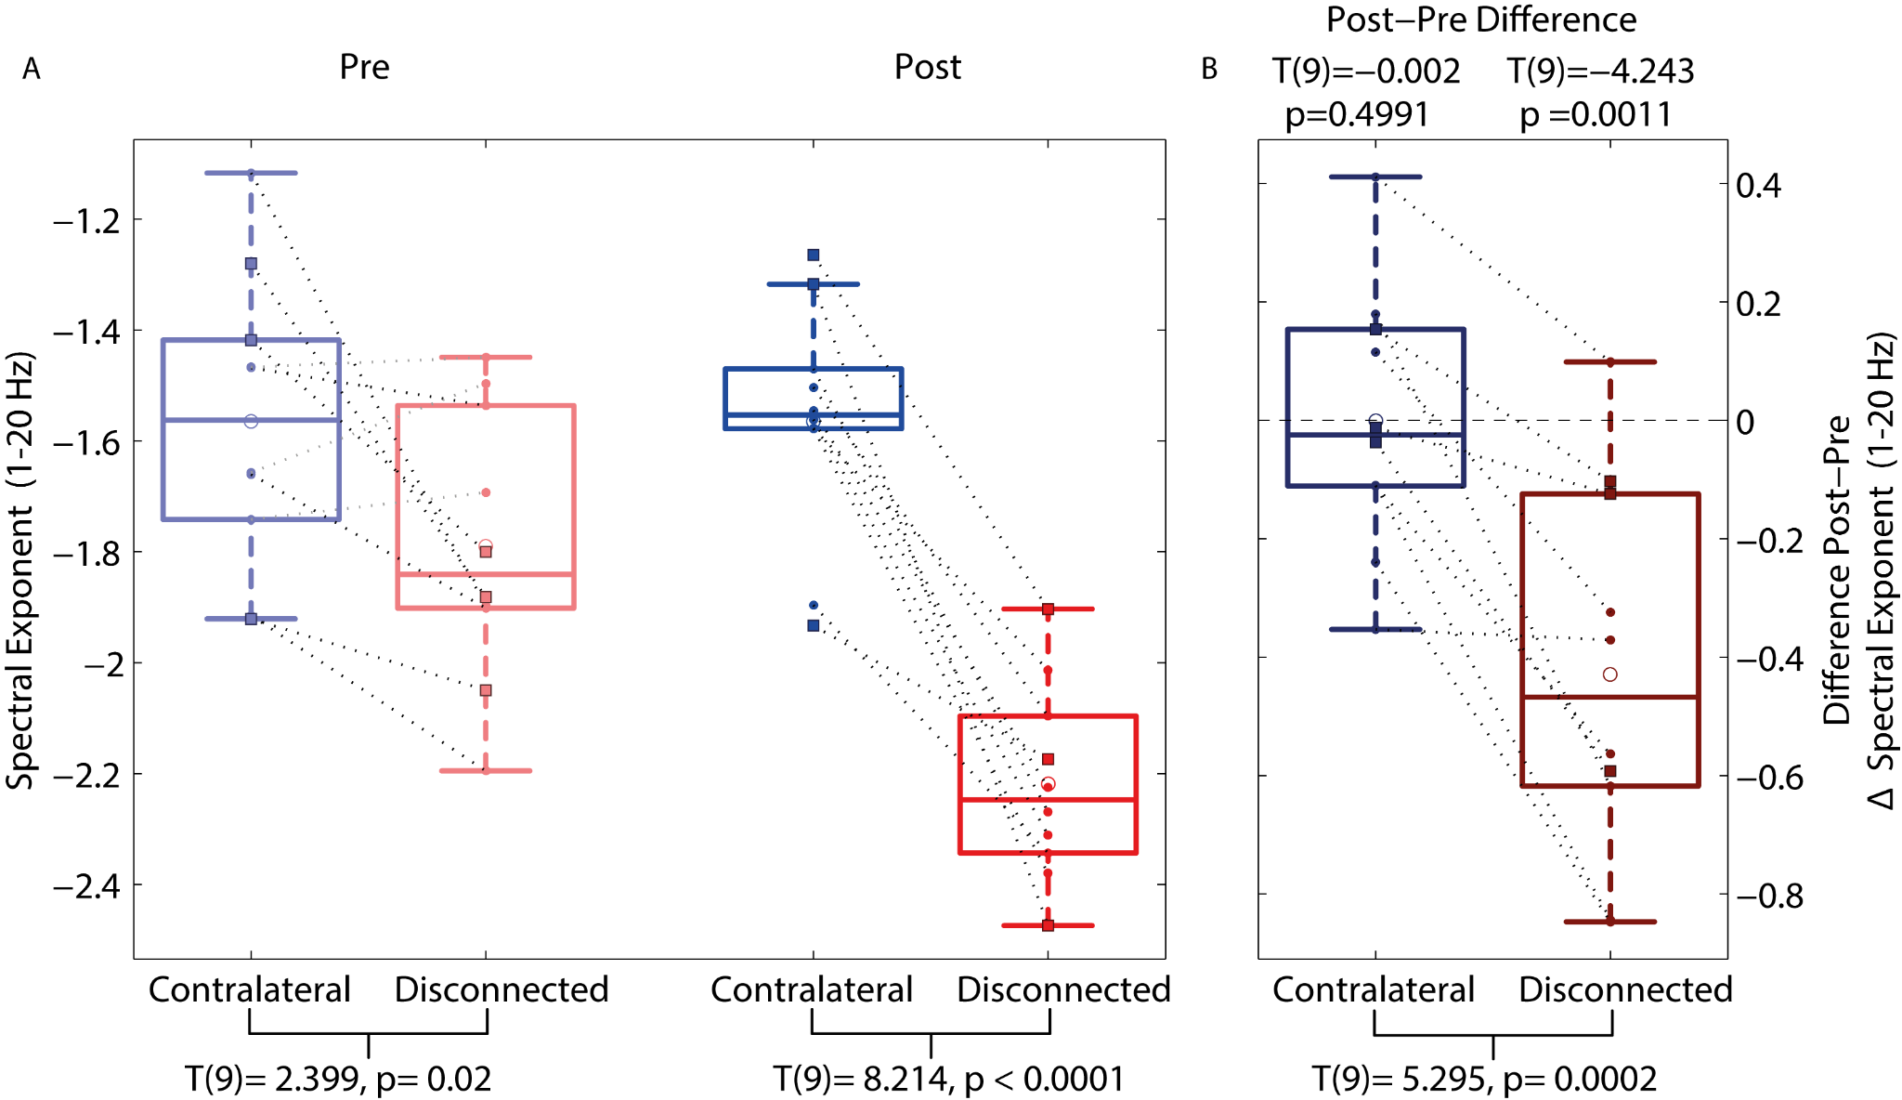

Supplementary Fig. 3. Replication of the findings of Fig. 2 in the patient dataset on the spectral exponent, estimated over the 1-20 Hz range. A) The spectral exponent (1-20 Hz) was significantly more negative in the disconnected than in the contralateral cortex, in the session before surgery (Pre) and, particularly, in the session after surgery (Post), whereby consistent inter-hemispheric asymmetry was observed in all patients (statistics for the contrast between sites are shown at the bottom of the graph, separately for the pre- and post-session). B) Following surgery, the PSD became steeper in the disconnected cortex; as indexed by a significant pre-post decrease of the spectral exponent, observed in all patients (Additional statistics to contrast the difference against 0 are shown at the top of the graph, separately for each side). Patients who received a temporo-parieto-occipital disconnection (squares with a black outline) displayed an overall similar pattern to that of patients who received a hemispherotomy (small dots).

Patient  Num | Surgery  Side | Surgical area | Etiology | Age (y) | Months to Follow-up | sex
1 | R | posterior | malformation | 11,83 | 30 | M
2 | L | hemisphere | ischemic | 6,50 | 7 | M
3 | L | hemisphere | ischemic | 8,17 | 13 | F
4 | R | hemisphere | malformation | 7,08 | 35 | M
5 | R | posterior | malformation | 2,58 | 16 | M
6 | R | posterior | ischemic | 10,17 | 20 | F
7 | R | hemisphere | malformation | 10,67 | 19 | M
8 | L | hemisphere | ischemic | 5,00 | 31 | M
9 | R | hemisphere | ischemic | 8,33 | 8 | F
10 | L | hemisphere | ischemic | 11,00 | 20 | F
Supplementary Table 3. Demographic information for each patient that underwent cortical disconnection of a single entire hemisphere (hemispherotomy), or of the parieto-occipito-temporal area (hereby noted as posterior), lateralized to one hemisphere. The underlying etiology was either ischemic or a congenital malformation. L stands for Left, R for Right, M for male, F for Female.

Supplementary Results: Comparing EEG slowing after cortical disconnection between patients with Hemispherotomy and those with Temporo-Parieto-Occipital disconnection
In our study, we included patients with a lateralized surgical disconnection of different extents, from a large cortical portion (temporo-parieto-occipital disconnection, TPO, 3 patients), to a whole hemisphere (hemispherotomy, 7 patients). Thus, we here ascertained whether the two sub-groups showed a similar narrow-band and broad-band EEG slowing induced by the surgical disconnection; while in the main text we focused on the overall pattern observed across both sub-groups. As reported in the Methods section of the main text, for each individual patient we considered only the EEG channels placed over the scalp above the disconnected cortex post-surgery (6 nearest neighbor bipolar derivations for TPO, and 15 for hemispherotomy), and over the homologous contralateral region, then considered the median value across electrodes of each EEG feature (slow delta power and spectral exponent). A close inspection of the boxplots in Figure 3 reveals that patients who received a TPO (displayed as square markers) display the same qualitative pattern reported in the main text across all patients (hemispherotomy patients are displayed as circles). All three TPO patients showed an inter-hemispheric asymmetry, and a change in the disconnected cortex following surgery, that was coherent with what was observed in the whole sample and in hemispherotomy patients, for both the narrow-band and broad-band slowing EEG features.
Specifically, TPO patients showed larger slowing (i.e. larger delta power and more negative spectral exponent) in the disconnected cortex following surgery as compared to the contralateral (3/3 patients), and as compared to the same cortex before surgery (3/3 patients). Similarly, hemispherotomy patients showed a larger degree of slowing in the disconnected cortex following surgery as compared to the contralateral (6/7 showed larger slow delta power and 7/7 more negative spectral exponent), and also as compared to the same cortex before surgery (6/7 showed increased slow delta power and 7/7 decreased spectral exponent to more negative values).
Further, pairwise t-tests were performed in the sub-group of hemispherotomy patients only (7 patients, leading to contrasts with sufficient statistical power). In this subgroup, we could replicate the effects of surgery reported in the main text across the whole sample. Hemispherotomy patients showed a larger degree of slowing in the disconnected hemisphere following surgery as compared to the contralateral (larger slow delta power: t(6)= -2.933, p=0.013; more negative negative spectral exponent: t(6)=9.452, p<.00001), and also as compared to the same hemisphere before surgery (increased slow delta power: t(6)= 2.365, p = 0.028; decreased spectral exponent to more negative values: t(6)=6.956, p=0.0002). Moreover, the disconnected hemisphere underwent a greater change following surgery as compared to the contralateral hemisphere, leading to increased inter-hemispheric asymmetry following surgery (slow delta power: t(6)= -2.431, p = 0.026; decreased spectral exponent to more negative values: t(6)=8.832, p =0.0001).

In sum, we ascertained that cortical disconnection resulted in a degree of neurophysiological slowing (both narrow-band and broad-band) localized in the disconnected cortex that was similar between patients with TPO disconnection and those with hemispherotomy. Studies with a larger sample size of patients with a TPO disconnection are needed to better observe whether these patients present subtle neurophysiological specificities.

Supplementary Results: Comparing narrow-band vs broad-band slowing in cortical isolation
We adopted a bootstrap procedure to estimate whether the neurophysiological correlates of hemispherotomy were better captured by a narrow-band or by a broad-band slowing.
We considered four contrasts of interest: two spatial contrasts (Contralateral vs Disconnected, in both Pre and Post -session) and two temporal contrasts (Pre vs Post, for both the Contralateral and Disconnected side). Specifically, for each iteration of 1000 bootstrap resamples with replacement, we assessed a specific contrast by means of a paired t-test and considered the strength of statistical evidence for each of the two features (T statistic), and the difference in statistical evidence between the two features (ΔT statistic).
Thus, we obtained a bootstrapped distribution of T for each feature (displayed in Supplementary Fig. 4), and a bootstrapped distribution of ΔT indexing the difference in statistical evidence between features.
Similarly, we derived the T and ΔT statistic for the observed sample, considered entirely.
We then considered the proportion of bootstraps in which the bootstrapped ΔT statistic had an opposite sign to the observed ΔT statistic, P(sign(ΔT_{boot}) ≠ sign(ΔT_{observed})), denoted for brevity as P_{sign≠} ; e.g. for an observed negative difference in T statistics between the two features (ΔT <0), we report the proportion of positive ΔT across bootstraps, P(ΔT_{boot}>0). Note that, for this specific supplementary analysis, in order to compare the size of statistical evidence of the spectral exponent with that of the Slow-Delta Power, we considered the absolute value of the (always negatively signed) Spectral Exponent, resulting in T-statistics with a coherent sign across features.
The Spectral Exponent, as compared to Slow-Delta Power, showed stronger statistical evidence in detecting inter-hemispheric differences in the pre-surgical disconnection session (Spectral Exponent: T(9)=2.395; Slow-Delta Power: T(9)=0.228, Difference in T-statistics between features: ΔT=2.167, P_{sign≠} = 0.032, top-left panel).
Further, the Spectral Exponent, as compared to Slow-Delta Power, showed stronger statistical evidence in detecting the change due to hemispherotomy in the disconnected hemisphere (Spectral Exponent: T(9)=6.455; Slow-Delta Power: T(9)=3.215, difference in T-statistics between features: ΔT=3.24, P_{sign≠} =0.042, bottom-right panel).

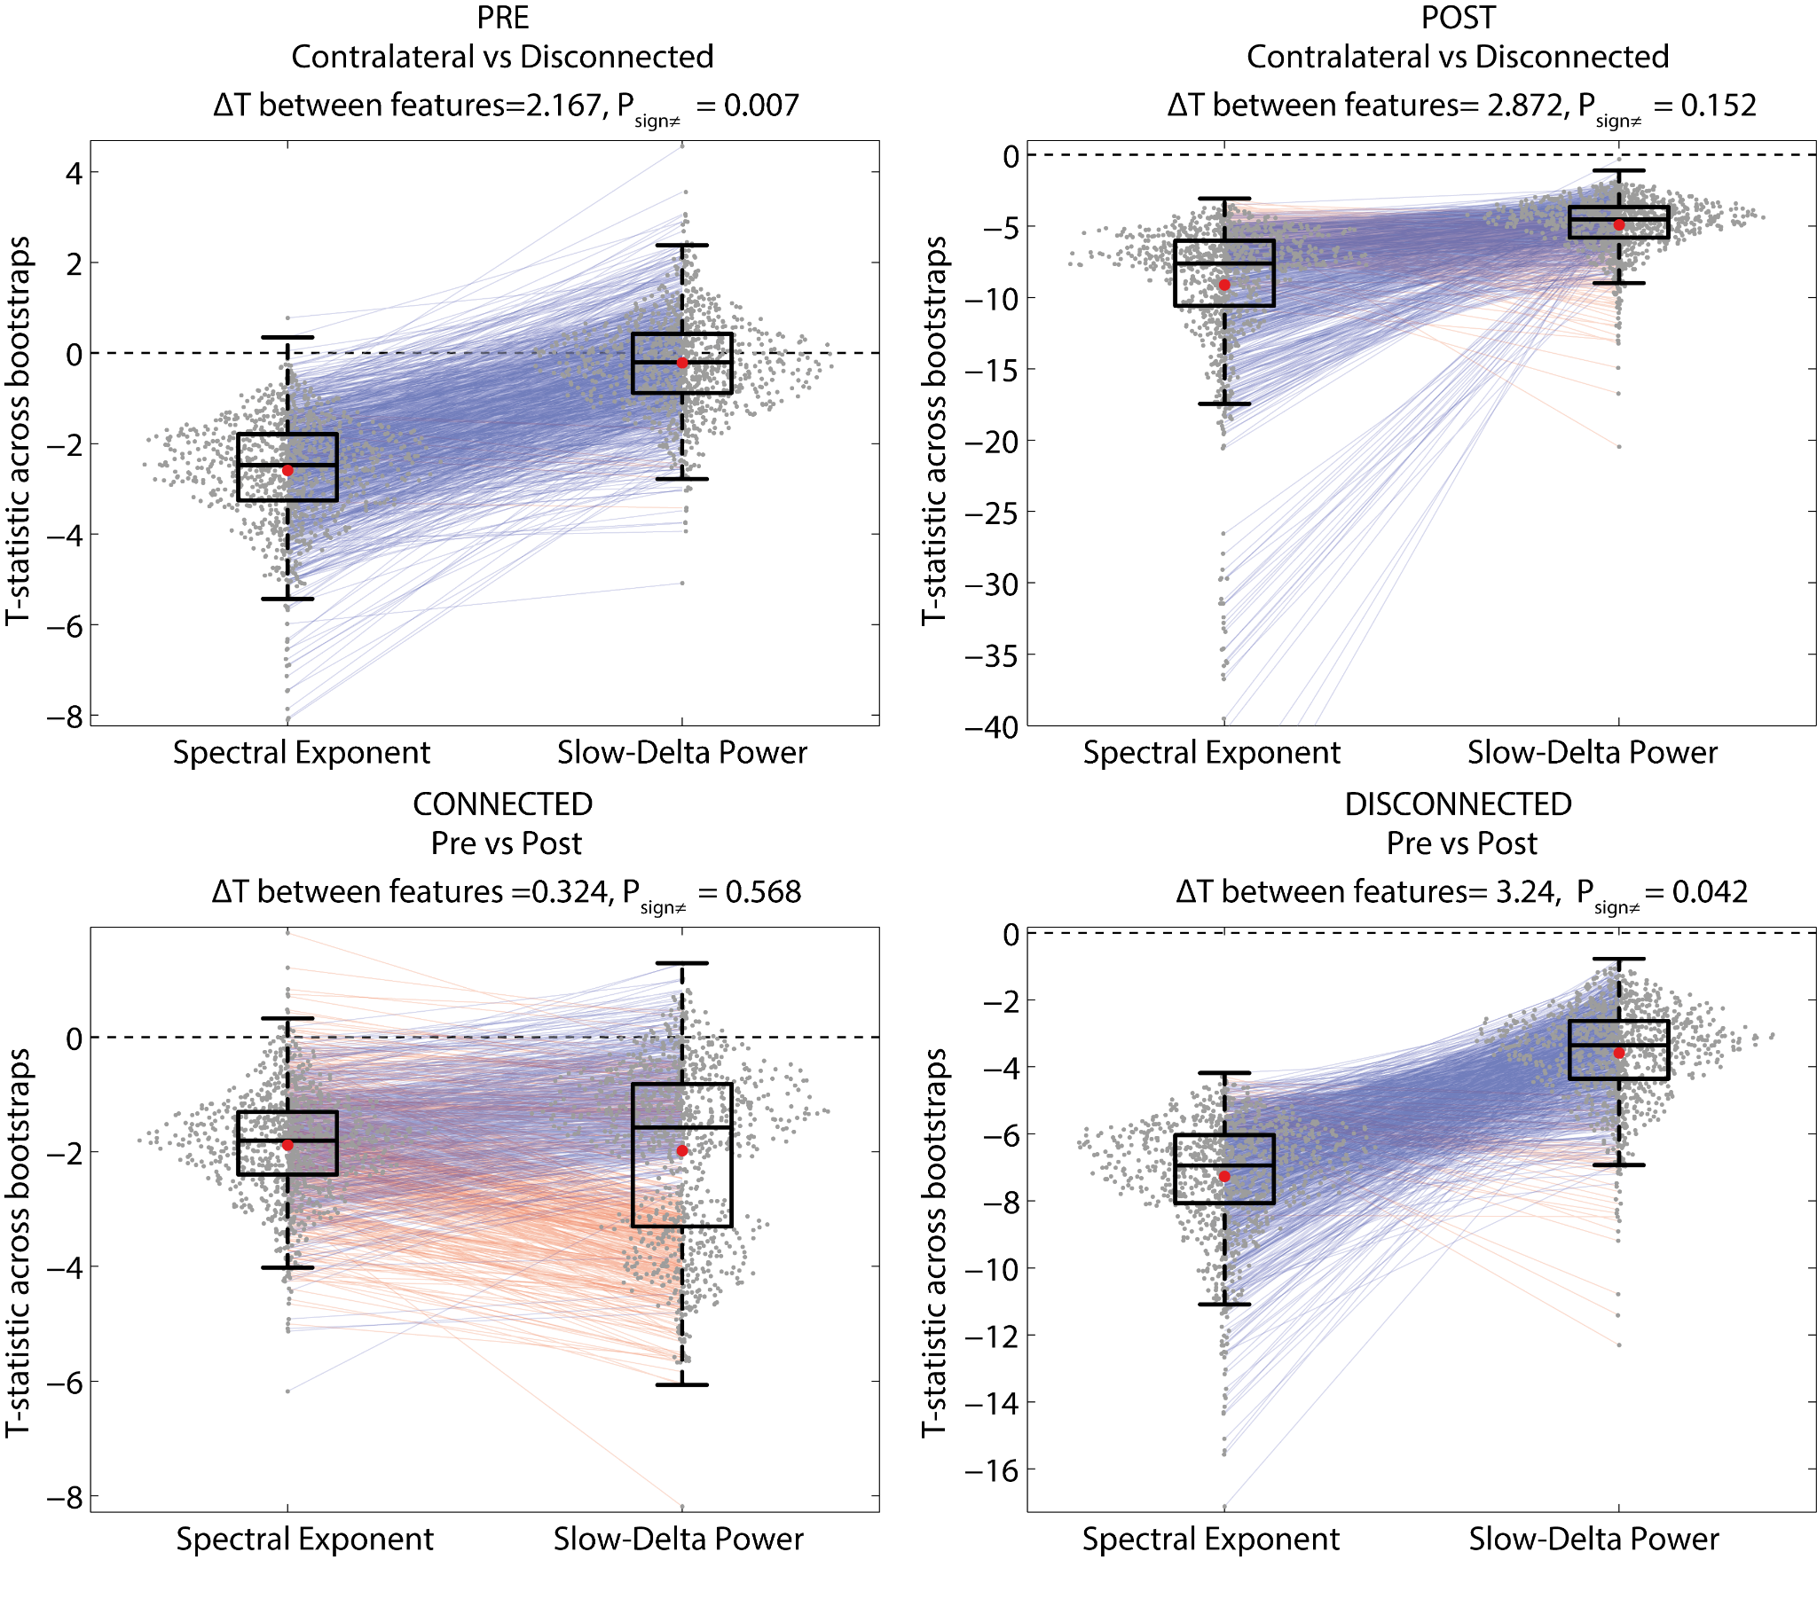
Supplementary Fig.4. Bootstrap analysis revealed that the Spectral Exponent showed stronger statistical effects than Slow-Delta Power in detecting the electrophysiological effect of cortical isolation on the disconnected hemisphere. The features’ distributions of T-statistics, drawn pairwise across bootstraps, revealed that the Spectral Exponent, as compared to Slow-Delta Power, showed stronger statistical evidence in detecting inter-hemispheric differences in the pre-surgical disconnection session (top-left panel, PRE, contralateral vs disconnected contrast), as well as in detecting the change due to hemispherotomy in the disconnected hemisphere (bottom-right panel, Pre vs Post difference, DISCONNECTED). The mean of each distribution is shown as a red dot; bootstrap iterations whereby the difference in T-values between features (ΔT) showed an opposite sign are plotted in different colors (transparent blue and red lines); the title reports the observed ΔT between features relative to the whole sample, and the proportion of bootstraps in which the bootstrapped ΔT statistic had an opposite sign to the observed ΔT statistic (P_{sign≠}).

Supplementary Results: Comparison of spectral exponent with the reference distribution of sleep and wake
In order to compare the spectral exponent values of the patients with cortical disconnection to those of the reference pediatric sample, we estimated the typical difference between pairs of conditions across the datasets, through bootstrap analysis.
Specifically, bootstrap analysis estimated the distribution of pairwise differences between the mean spectral exponent values in healthy pediatric participants (during wakefulness or N1, N2 or N3 sleep) on the one hand, and the mean values in the isolated or contralateral cortex (before or after surgery) on the other hand. Results are shown in Supplementary Fig. 5.

Accordingly, the disconnected cortex after surgery had mean spectral exponent values resembling those of deep sleep (similarly close to N2 and N3 sleep), but considerably distinct from those of N1 sleep and, even more, from those of wakefulness, as shown by the large positive differences. The same cortex before surgery showed mean values closest to N1 sleep. The healthy contralateral cortex, both before and after surgery, showed mean values that were close to those of wakefulness, albeit on the lower percentiles, and considerably distinct from those of N2 and N3 sleep, as shown by the large negative differences.

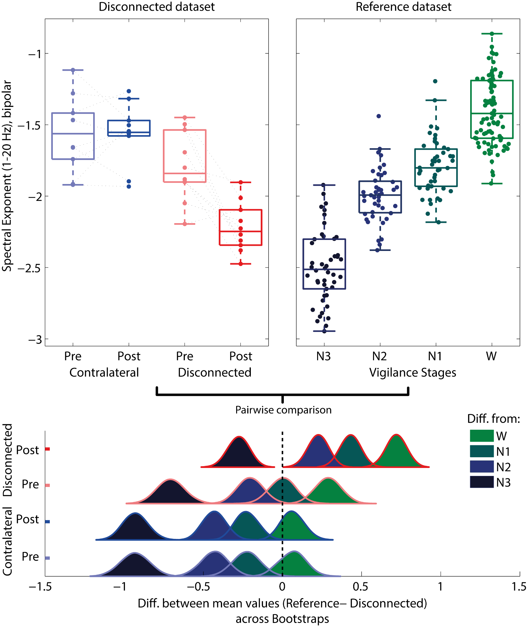
Supplementary Fig. 5. Comparing the Spectral Exponent in hemispherotomy and in a reference pediatric sample across Wake and Sleep revealed that the values of the isolated hemisphere are compatible with those of deep NREM sleep, between N2 and N3.
The figure extends Fig. 3 of the main text. The top panel displays spectral exponent (1-20 Hz) values in the two datasets: in patients before and after cortical isolation (the disconnected dataset, top-left panel), and in a reference pediatric sample across wake and NREM sleep (reference sleep dataset, top-right panel).
Bootstrap analysis estimated the distribution of pairwise differences between the mean of conditions, across the two datasets. A mean difference of zero corresponds to the central dotted line, with positive differences on the right. The distribution that is closest to the zero- mean difference line corresponds to the pair of states that show the smallest mean difference.

