File One - Supplemental Content:
All Research Stuy Instruments – such as Screening Questionnaires Tools, Search Summary Tables, Data Capturing sheets etc.,
Title: Mapping Evidence in Teaching Palliative Care in Undergraduate Curriculum of Healthcare Professionals Qualification: A Systematic Scoping Review Protocol
Table of Contents
Section One: Search Strategy Pilot Results Record 2
The Search Summary Table (SST), with pilot results 3
The Search Strategy pilot results analysis was completed for the Web of Science database report with 180,108 publications selected. 4
Section Two: Screening Tools and Data-charting (Google Forms screening tools) 6
Title and Abstract - Level 1 Screening Form 7
Full-Text - Level 2 Screening Form (Preliminary Two) 9
Data Extraction - Level 3 Screening Form (Preliminary Three) 12
Section Three: Classification of papers into categories of themes and subthemes 7
Categories of themes and subthemes of interest 8
What is the range of appropriate pedagogies? 10
What is the effectiveness of Educational Intervention for teaching Palliative and End-of-life Care 11
Meta-analysis Data Capturing Sheet - Promoting Perceived Competence Among HealthCare Professionals 12

Section One:
Search Strategy Pilot Results Record
The pilot-test results of the research study instruments are presented in this section to showcase the feasibility and strength of the proposed study.

The Search Summary Table (SST), with pilot results
Project Title: Teaching Palliative Care in the Undergraduate Curriculum of Healthcare Professional Qualification: A Systematic Scoping Review
Included references | Format | Database Searches [ date run: / / ; date re-run: / / ] |  |  |  |  | Supplementary Searches
 |  | PubMed | Web of Science | PsycINFO | CINAHL | MEDLINE | fcs | bcs | hs | wss | org
Included ref 1
Included ref 2
Included ref 3
No. of included refs
No. of unique refs
Yield |  | 3,448
No. of refs screened
Sensitivity
Precision

Search-related information for the librarian or information specialist |  | The summative metrics of effective searching
No. of database searched = |  | Overall sensitivity =
Sum of yields = |  | Overall precision =
No. of refs that underwent Title & Abstract screening = |  | NNR =
No. of refs that underwent Full-text (FT) screening = |  | NNR FT =
No. of included refs from database searching = |  | NNS =
Total no. of included refs =

Codes | Supplementary search codes | Format codes
x = found from the search | fcs = forwards citation search | jnl = journal article
y = in database; found when search strategy re-run | bcs = backwards citation search | ths = PhD thesis
n = not in the database | hs = hand search
z = in the database; not found using the search strategy | wss = web site search | Other codes
(red) = databases where searches re-run | org = from contacting organisations | FT = full text
NNR = number needed to read. 1/overall precision
NNR FT = number needed to read at FT to find one included reference
NNS = number needed to screen to find one reference to include for FT screening

The Search Strategy pilot results analysis was completed for the Web of Science database report with 180,108 publications selected.
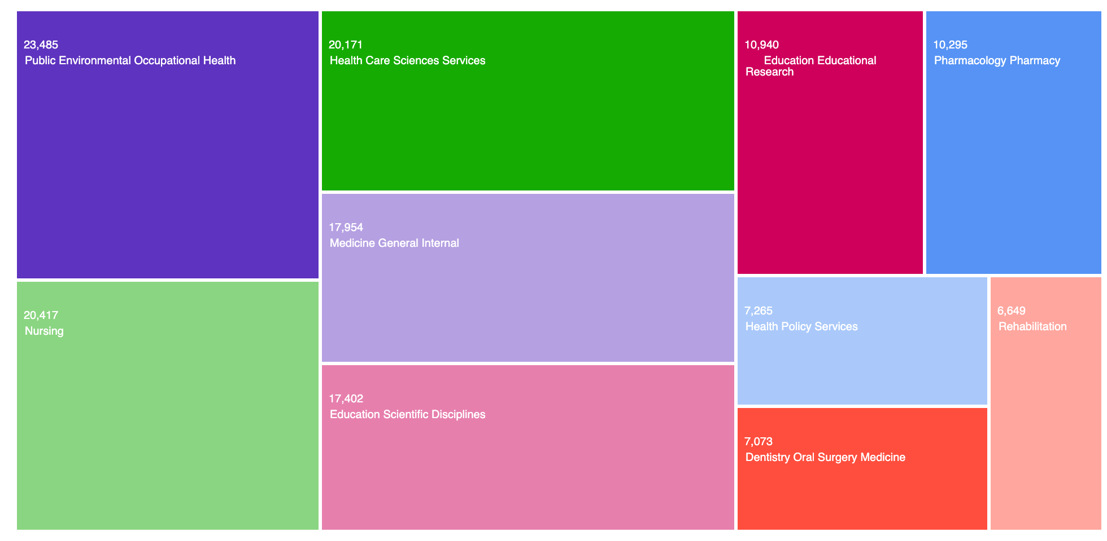
Figure 1: Distributions of the publications selected from Web of Science Core Collection by Categories
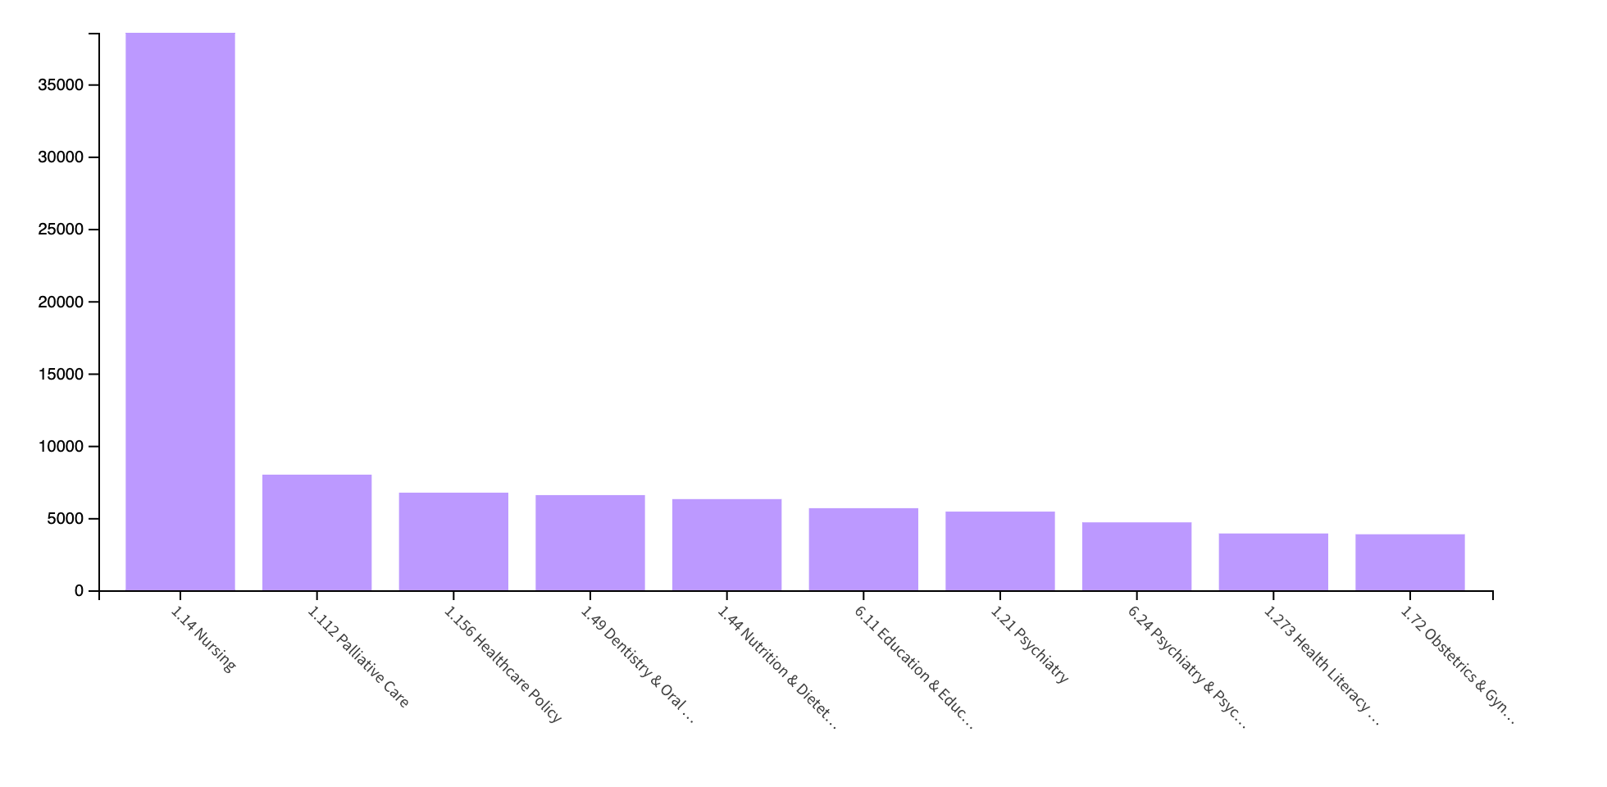
Figure 2: Distributions of the publications selected from Web of Science Core Collection Citation Topic

Section Two:
Screening Tools and Data-charting (Google Forms screening tools)
In the section, the research instruments are presented

The Evidence on Teaching Palliative Care in Undergraduate Curriculum of Healthcare Professional Qualification:
A Systematic Scoping Review

Title and Abstract - Level 1 Screening Form
(Preliminary One)
* Indicates required question
- Author, Year

- Title *

- What is the Aim/ or Objectives of this research study? *

- Does this research study present evidence on Teaching Palliative Care in Undergraduate Curriculum of Healthcare Professional Qualification?
For more information, check out NIA’s article on "What Are Palliative Care, End of life and Hospice Care?"
Mark only one oval.
Yes No

- Does this research study present evidence of any outcome related to the Effectiveness/ Impact of teaching strategies? *
For more examples of outcomes of interest, any assessment or programme evaluation of the “Effectiveness/ Impact” such as structured interviews and student satisfaction surveys, refer to Fig 2 in the study protocol.
Mark only one oval.
Yes
No

- Who is the Screen-er? *
Mark only one oval.
Screen-er One Screen-er Two Screen-er Three

This content is neither created nor endorsed by Google.

Forms

The Evidence on Teaching Palliative Care in Undergraduate Curriculum of Healthcare Professional Qualification:
A Systematic Scoping Review

Full-Text - Level 2 Screening Form (Preliminary Two)
* Indicates required question
- Author, Year *

- Title *

- What is the Aim/ or Objectives of this research study? *

- This research study was conducted in which country according to the World Bank country income classifications *?
Updated country income classifications are available here.

Mark only one oval.
LOW-INCOME ECONOMIES ($1,085 OR LESS)
LOWER-MIDDLE INCOME ECONOMIES ($1,086 TO $4,255) UPPER-MIDDLE-INCOME ECONOMIES ($4,256 TO $13,205) HIGH-INCOME ECONOMIES ($13,205 OR MORE)

- Does this research study present evidence on Teaching Palliative Care in the Undergraduate Curriculum of Healthcare Professional Qualification? *
For more information, check out NIA’s article on "What Are Palliative Care, End of life and Hospice Care?"
Mark only one oval.
Yes No

- Does this research study present evidence on the approaches/ practices in palliative and end-of-life (EOL) care teaching, education/ or training competencies? *
For more examples of the approaches/ practices of interest, such as any modalities, processes, objectives, motivations, challenges, facilitating characteristics/ resources in the teaching, education/ or training competencies in palliative and end-of-life (EOL) care, please refer to Fig 2 in the study protocol.
Mark only one oval.
Yes No

- Does this research study present evidence on Pedagogies in the Teaching of palliative and end-of-life (EOL) care? *
For more examples of the Pedagogies of interest, such as any focusing on Reflection, Experiential Learning, Role-modelling, Dialectic Methods, and Didactic Methods, refer to Fig 2 in the study protocol.
Mark only one oval.
Yes No

- Does this research study present evidence on any outcome related to the Effectiveness/ Impact of teaching strategies? *
For more examples of outcomes of interest, any assessment or programme evaluation of the “Effectiveness/ Impact” such as structured interviews, student satisfaction surveys refer to Fig 2 in the study protocol.
Mark only one oval.
Yes No
- Does this research study present evidence on the Comparisons of the various Approaches/ Practices, or Pedagogies in palliative and end-of-life (EOL) care teaching, education/ or training competencies? *
Mark only one oval.
Yes
No

- Does this research study present evidence on any outcome related to the Effectiveness of palliative and end-of-life (EOL) care of teaching strategies? *
Mark only one oval.
Yes No

- Does this research study present evidence on any outcome related to the Impact of palliative and end-of-life (EOL) care of teaching strategies? *
Mark only one oval.
Yes
No

- Who is the Screen-er? *
Mark only one oval.
1st Reviewer (**)
2nd Reviewer (**)

This content is neither created nor endorsed by Google.

Forms

The Evidence on Teaching Palliative Care in Undergraduate Curriculum of Healthcare Professional Qualification:
A Systematic Scoping Review

Data Extraction - Level 3 Screening Form (Preliminary Three)
* Indicates required question
- Author, Year *

- What is the Aim/ or Objectives of this research study? *

- Type of Structured Intervention *
Mark only one oval.
 Brief Course - Modules, Seminars, or Workshops Focused on Comprehensive Palliative Care
 Clinical Program - Clinical rotation, Clinical experience, Clinical placement
 Longitudinal Programs - Longitudinal courses, that involves three or more sessions spanning at least one academic term or a period of several months
 Simulation-based Learning Experiences - Hospice simulation  Topic-specific Courses

- Description of Structured Intervention *
Include the duration of program

- Teaching settings/ Site, Country of Study *
Examples: Hospital-Based Healthcare, University, Community-Based Healthcare, and Training Platforms employed (In-person/ Or Online/ Or Other), include People/institutions leading the program

- Level of training program/s described in the article *
Check all that apply.
 Undergraduate Postgraduate
Continuing education
Other:

- Study Design
Examples: Retrospective Pretest/ Post Test Survey, Structured interviews, Mixed Methods

- Response rate and Participant group (*) *
(*) HC Professional group receiving the training

- Main PC content (Topic) of the program *
Example: Pain management, Other types of symptom management; EoL discussions with patients; EoL discussions with family members; Spirituality; Cultural dimensions of death

- Educational methods / Pedagogies in the Teaching of PC *
Check all that apply.
Didactic Methods Dialectic Methods Role-modelling
Experiential Learning
Focused on Reflection
Other:

- Elaboration *
Elaborate on the educational methods / pedagogies employed in the teaching of PC

- Reason for Use *
Elaborate on the reason for use of the educational methods/ pedagogies employed in the teaching of PC

- Type of Outcome (Kirkpatrick level) *
Example: Learner satisfaction, Self reported impact on knowledge and skills and Behaviors (1,2,3)
Check all that apply.
Level 1: Reaction (Learners found the training to be relevant to their role, engaging, and useful)
Level 2: Learning (a. Learners as acquired the Knowledge, Skills; b. Modification of Attitudes, Perceptions, Confidence, and Commitment that the training program is focused on)
Level 3: Behavior (It measures behavioral changes after learning and shows if the learners are taking what they learned in training and applying it as they do their job)
Level 4: Results (Focuses on whether or not the targeted outcomes resulted from the training program, alongside the support and accountability of a. Change in organisational practice; b. Benefits to patients and relatives/carers
Other:

- Pre/ Post- Intervention Outcomes (*), and effectiveness *
(*) indicates statistically significant result, approaches used to evaluate the program outcomes

- Authors Recommendations *
Example: Future Research and Practice

- Barriers/ Challenges encountered in the design and implementation of the program *

- Authors Conclusions *
Research study key findings

- Study Team Notes *
All systematic and random error adjusted, confounding, adjusted covariates, effect medication etc.

This content is neither created nor endorsed by Google.

 Forms

Section Three:
Classification of papers into categories of themes and subthemes
In this section the study data collating, summarising, and reporting of the results tools are presented -.

Categories of themes and subthemes of interest
Themes | Subthemes | Table
Curriculum  (Type of Structured Intervention) | - Brief Course - Modules, Seminars, or Workshops Focused on Comprehensive Palliative Care  - Clinical Program - Clinical rotation, Clinical experience, Clinical placement  - Longitudinal Programs - Longitudinal courses, that involves three or more sessions spanning at least one academic term or a period of several months  - Simulation-based Learning Experiences - Hospice simulation  - Topic-specific Courses | Supplementary Table #
Main PC content (Topic) of the program  (7 Domains, Core Competency Framework for Health and Social Care Professionals) | Competence domains and contents:  - Overarching values and knowledge;  - Communication skills;  - Symptom management, maintaining comfort and well-being of patients and families;  - Psychosocial and spiritual care;  - End-of-life decision-making;  - Bereavement care; and  - Self-care and self-reflection. | Supplementary Table #
Teaching Methods  (Educational Methods / Pedagogies in the Teaching of PC) | Range of appropriate pedagogies  - Didactic Methods.  - Dialectic Methods  - Role-modelling  - Experiential Learning  - Focused on Reflection | Supplementary Table 1
Teaching Settings  (training platform) | Community  Long-term care settings  Home visits  Hospice  Rehabilitation  University  Online | Supplementary Table #
Type of Outcome  (Kirkpatrick level) | The Kirkpatrick Evaluation Model  - Level 1: Reaction (Learners found the training to be relevant to their role, engaging, and useful);  - Level 2: Learning (a. Learners as acquired the Knowledge, Skills; b. Modification of Attitudes, Perceptions, Confidence, and Commitment that the training program is focused on);  - Level 3: Behavior (It measures behavioral changes after learning and shows if the learners are taking what they learned in training and applying it as they do their job)  - Level 4: Results (Focuses on whether or not the targeted outcomes resulted from the training program, alongside the support and accountability of a. Change in organisational practice; b. Benefits to patients and relatives/carers | Supplementary Table 2

What is the range of appropriate pedagogies?
Table 1: Supplementary - Educational Methods / Pedagogies in the Teaching of PC
Subthemes (n = No. of Studies) | Target HC Group(s) | Educational Methods / Pedagogies in the Teaching of PC
Subthemes (n = No. of Studies) | Target HC Group(s) | Didactic | Dialectic | Role-modelling | Experiential Learning | Focused on Reflection
Brief Course - (n = #) | # disciplines in health and social care:
Clinical Program - (n = #) | # disciplines in health and social care:
Longitudinal Programs - (n = #) | # disciplines in health and social care:
Simulation-based Learning Experiences - (n = #) | # disciplines in health and social care:
Topic-specific Courses - (n = #) | # disciplines in health and social care:
Specific Examples of Teaching and Learning Strategies of interest for Palliative Care:
Reflection of experience/role modelling, Clinical discussion, Group work for presentation, Roleplay, E-Learning/Distance learning, Portfolio learning, Mentorship and preceptorship, Directed reading, Self-directed reading, Lecture, Active learning, serious games, Case-based learning, Contact with real patients, Creative arts, E-learning, Elective courses and workshops, Experiential learning, Flipped classroom, Hidden curriculum, Reflective learning/journaling, Simulation and standardised patients, and Other or multiple teaching methods.

What is the effectiveness of Educational Intervention for teaching Palliative and End-of-life Care
Table 2: Supplementary - Type of Outcome (Kirkpatrick level)
Subthemes (n = No. of Studies) | Target HC Group(s) | How levels of Kirkpatrick levels are assessed in the curriculums
Subthemes (n = No. of Studies) | Target HC Group(s) | Level 1: Reaction | Level 2: Learning | Level 3: Behaviour | Level 4: Results
Brief Course - (n = #) | # disciplines in health and social care:
Clinical Program - (n = #) | # disciplines in health and social care:
Longitudinal Programs - (n = #) | # disciplines in health and social care:
Simulation-based Learning Experiences - (n = #) | # disciplines in health and social care:
Topic-specific Courses - (n = #) | # disciplines in health and social care:

Meta-analysis Data Capturing Sheet - Promoting Perceived Competence Among HealthCare Professionals
Table 3: Supplementary - Type of Outcome (Kirkpatrick level)
Author, Year | Type of Structured Intervention | Intervention Group |  | Control Group |  | SMD
Author, Year | Type of Structured Intervention | Mean (SD) | N | Mean (SD) | N

