SUPPLEMENTARY MATERIALS

Supplementary S1: Forward-backward Italian translation of the FIT Questionnaire.

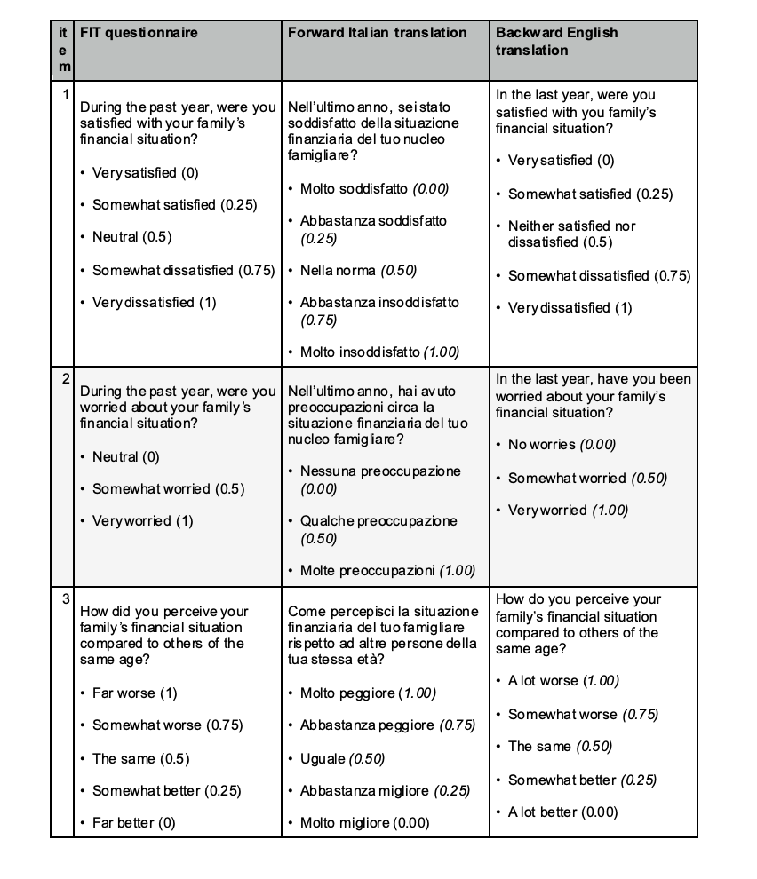

Supplementary S2: FITALY questionnaire v1.0. The modifications from the translated FIT questionnaire are highlighted in yellow.

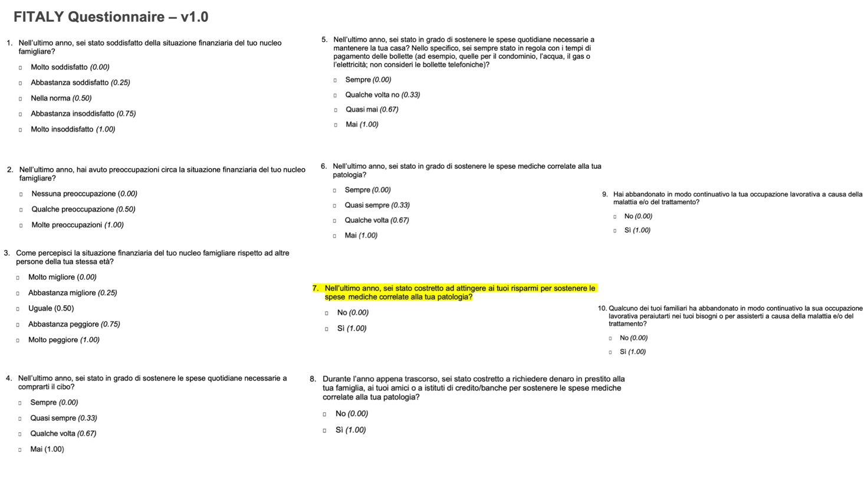

Supplementary S3: FITALY questionnaire v2.0. The modifications from FITALY questionnaire v1.0 are highlighted in yellow.
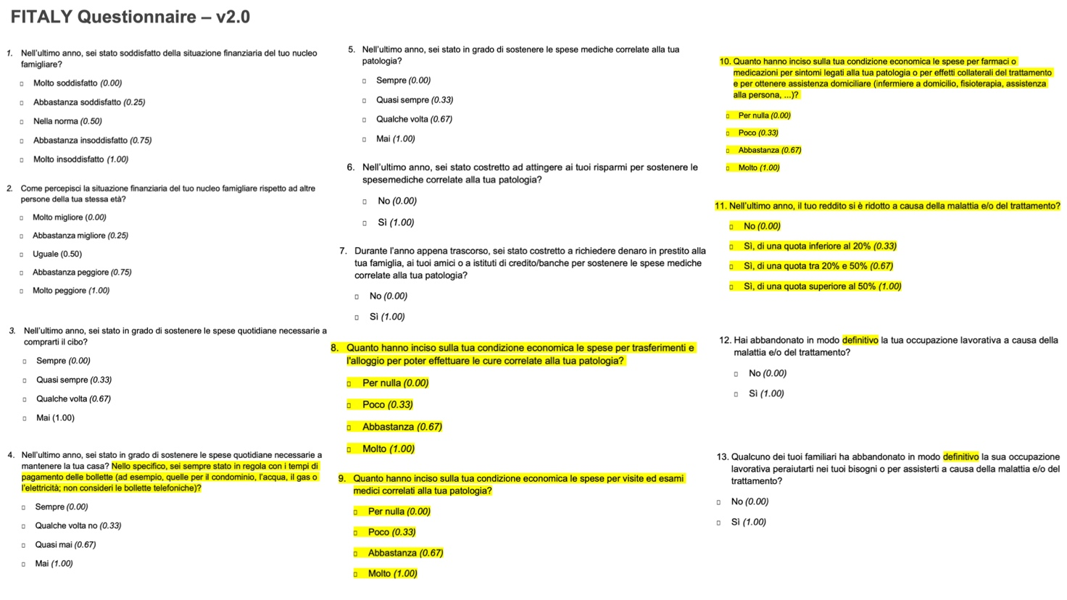

Supplementary S4: FITALY questionnaire Final Version. The modifications from FITALY questionnaire v2.0 are highlighted in yellow.

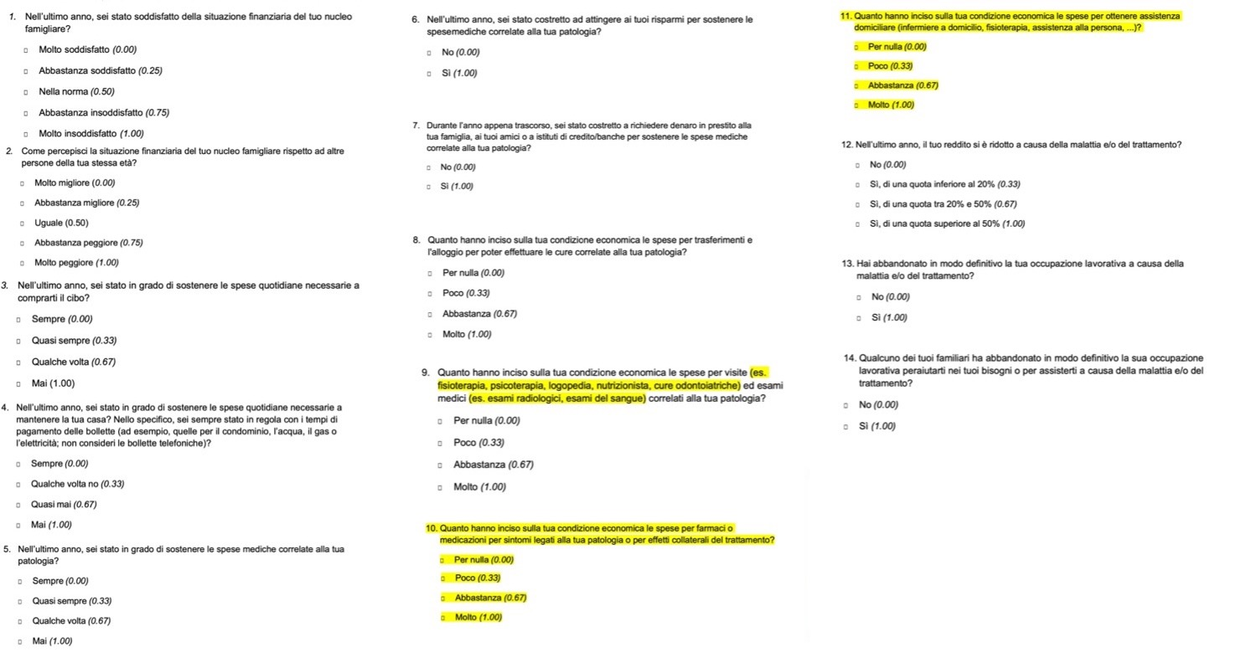
Supplementary S5: The Cognitive Debriefing (CD) form used during the validation process.
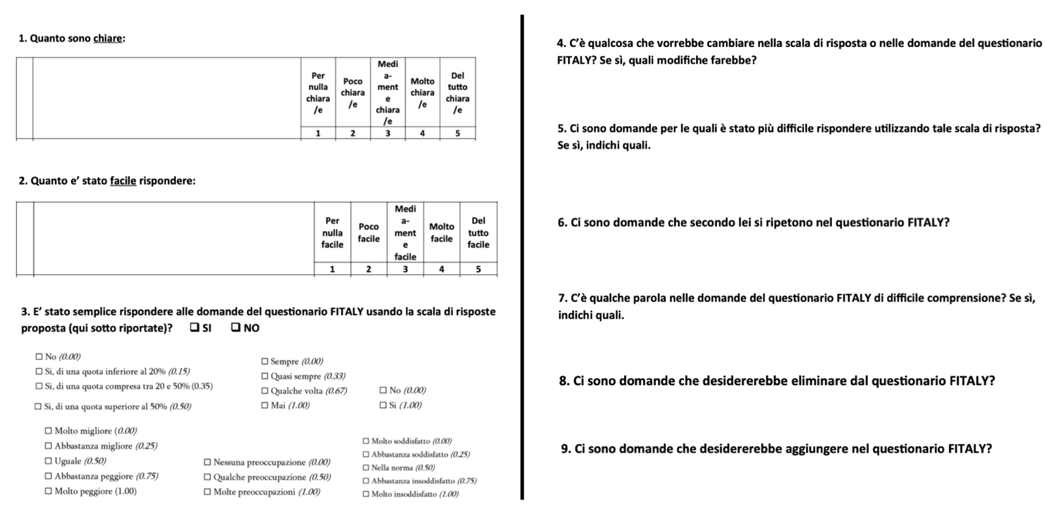

Supplementary S6: Backward American English translation of the final version of the FITALY questionnaire.

