Supplementary information

Associations of 2,922 genetically predicted plasma protein levels with mental illness and response to treatment

Supplementary information
Supplementary Methods. 4
Description of colocalisation criteria. 4
Supplementary Table 1. 6
Supplementary Table 2. 15
Supplementary Figure 1. Colocalisation results of MR-significant gene for major depressive disorder passing evidential threshold (H4 > 0.7), BTN2A1. Figures on the left-hand side 23
Supplementary Figure 2. Colocalisation results of MR-significant gene for major depressive disorder passing evidential threshold (H4 > 0.7), DUSP13. Figures on the left-hand side 24
Supplementary Figure 3. Colocalisation results of MR-significant gene for major depressive disorder passing evidential threshold (H4 > 0.7), FCN1. Figures on the left-hand side 25
Supplementary Figure 4. Colocalisation results of MR-significant gene for opioid use disorder passing evidential threshold (H4 > 0.7), FES. Figures on the left-hand side 26
Supplementary Figure 5. Colocalisation results of MR-significant gene for opioid use disorder passing evidential threshold (H4 > 0.7), FURIN. Figures on the left-hand side 27
Supplementary Figure 6. Colocalisation results of MR-significant gene for opioid use disorder passing evidential threshold (H4 > 0.7), NRP1. Figures on the left-hand side 28
Supplementary Figure 7. Colocalisation results of MR-significant gene for opioid use disorder passing evidential threshold (H4 > 0.7), OMG. Figures on the left-hand side 29
Supplementary Figure 8. Colocalisation results of MR-significant gene for opioid use disorder passing evidential threshold (H4 > 0.7), TANK. Figures on the left-hand side 30
Supplementary Figure 9. Colocalisation results of MR-significant gene for opioid use disorder passing evidential threshold (H4 > 0.7), WASHC3. Figures on the left-hand side 31
Supplementary Figure 10. Colocalisation results of MR-significant gene for schizophrenia passing evidential threshold (H4 > 0.7), ADAM22. Figures on the left-hand side 32
Supplementary Figure 11. Colocalisation results of MR-significant gene for schizophrenia passing evidential threshold (H4 > 0.7), BTN2A1. Figures on the left-hand side 33
Supplementary Figure 12. Colocalisation results of MR-significant gene for schizophrenia passing evidential threshold (H4 > 0.7), CD40. Figures on the left-hand side 34
Supplementary Figure 13. Colocalisation results of MR-significant gene for schizophrenia passing evidential threshold (H4 > 0.7), CDHR1. Figures on the left-hand side 35
Supplementary Figure 14. Colocalisation results of MR-significant gene for schizophrenia passing evidential threshold (H4 > 0.7), ESAM. Figures on the left-hand side 36
Supplementary Figure 15. Colocalisation results of MR-significant gene for schizophrenia passing evidential threshold (H4 > 0.7), FKBPL. Figures on the left-hand side 37
Supplementary Figure 16. Colocalisation results of MR-significant gene for schizophrenia passing evidential threshold (H4 > 0.7), MAX. Figures on the left-hand side 38
Supplementary Figure 17. Colocalisation results of MR-significant gene for schizophrenia passing evidential threshold (H4 > 0.7), MDK. Figures on the left-hand side 39
Supplementary Figure 18. Colocalisation results of MR-significant gene for schizophrenia passing evidential threshold (H4 > 0.7), PDIA3. Figures on the left-hand side 40
Supplementary Figure 19. Colocalisation results of MR-significant gene for schizophrenia passing evidential threshold (H4 > 0.7), PFKFB2. Figures on the left-hand side 41
Supplementary Figure 20. Colocalisation results of MR-significant gene for schizophrenia passing evidential threshold (H4 > 0.7), VSIG2. Figures on the left-hand side 42
Supplementary Figure 21. Colocalisation results of MR-significant gene for schizophrenia passing evidential threshold (H4 > 0.7), YOD1. Figures on the left-hand side 43
Supplementary Figure 22. Colocalisation results of MR-significant gene for bipolar disorder passing evidential threshold (H4 > 0.7), BTN2A1. Figures on the left-hand side 44
Supplementary Figure 23. Colocalisation results of MR-significant gene for bipolar disorder passing evidential threshold (H4 > 0.7), CX3CL1. Figures on the left-hand side 45
Supplementary Figure 24. Colocalisation results of MR-significant gene for bipolar disorder passing evidential threshold (H4 > 0.7), DNPH1. Figures on the left-hand side 46
Supplementary Figure 25. Colocalisation results of MR-significant gene for bipolar disorder passing evidential threshold (H4 > 0.7), FES. Figures on the left-hand side 47
Supplementary Figure 26. Colocalisation results of MR-significant gene for bipolar disorder passing evidential threshold (H4 > 0.7), NCAM1. Figures on the left-hand side 48
Supplementary Figure 27. Colocalisation results of MR-significant gene for bipolar disorder passing evidential threshold (H4 > 0.7), OPLAH. Figures on the left-hand side 49
Supplementary Figure 28. Colocalisation results of MR-significant gene for bipolar disorder passing evidential threshold (H4 > 0.7), PBXIP1. Figures on the left-hand side 50
Supplementary Figure 29. Colocalisation results of MR-significant gene for bipolar disorder passing evidential threshold (H4 > 0.7), PMVK. Figures on the left-hand side 51
Supplementary Figure 30. Colocalisation results of MR-significant gene for bipolar disorder passing evidential threshold (H4 > 0.7), SCRN1. Figures on the left-hand side 52
Supplementary Figure 31. Colocalisation results of MR-significant gene for bipolar disorder passing evidential threshold (H4 > 0.7), THOP1. Figures on the left-hand side 53
Supplementary Figure 32. Colocalisation results of MR-significant gene for bipolar disorder passing evidential threshold (H4 > 0.7), WFDC12. Figures on the left-hand side 54
Supplementary Figure 33. Colocalisation results of MR-significant gene for treatment resistance in depression passing evidential threshold (H4 > 0.7), ST13. Figures on the left-hand side 55
Supplementary Figure 34. Manhattan plot of Mendelian randomisation Wald ratio estimates for treatment resistance in schizophrenia. Lead cis-pQTL was used as instrument for each plasma protein. Significantly associated proteins are highlighted in orange. Labels are provided for the top 20 significantly associated proteins, and all colocalising proteins (H4 > 0.7 at 𝑝₁₂ = 5e−6). The black line marks the threshold for significance, adjusted for false discovery rate (FDR) at 𝑝 < 0.05. 56
Supplementary Figure 35. Manhattan plot of Mendelian randomisation Wald ratio estimates for antidepressant treatment response. Lead cis-pQTL was used as instrument for each plasma protein. Significantly associated proteins are highlighted in orange. Labels are provided for the top 20 significantly associated proteins, and all colocalising proteins (H4 > 0.7 at 𝑝₁₂ = 5e−6). The black line marks the threshold for significance, adjusted for false discovery rate (FDR) at 𝑝 < 0.05. 57
Supplementary Figure 36. Manhattan plot of Mendelian randomisation Wald ratio estimates for obsessive compulsive disorder. Lead cis-pQTL was used as instrument for each plasma protein. Significantly associated proteins are highlighted in orange. Labels are provided for the top 20 significantly associated proteins, and all colocalising proteins (H4 > 0.7 at 𝑝₁₂ = 5e−6). The black line marks the threshold for significance, adjusted for false discovery rate (FDR) at 𝑝 < 0.05. 58
Supplementary Figure 37. Manhattan plot of Mendelian randomisation Wald ratio estimates for panic disorder. Lead cis-pQTL was used as instrument for each plasma protein. Significantly associated proteins are highlighted in orange. Labels are provided for the top 20 significantly associated proteins, and all colocalising proteins (H4 > 0.7 at 𝑝₁₂ = 5e−6). The black line marks the threshold for significance, adjusted for false discovery rate (FDR) at 𝑝 < 0.05. 59
References 60

Supplementary Methods.
Description of colocalisation criteria.

Colocalisation is a method that tests whether variants within a particular genomic region are responsible for effects on one or both traits, classifying these effects into one of five hypotheses:
- H0: No causal variants
- H1: Causal variant for trait 1 only
- H2: Causal variant for trait 2 only
- H3: Distinct causal variants for trait 1 and trait 2
- H4: Shared causal variant for trait 1 and trait 2
As a Bayesian method, colocalisation necessitates setting three prior probabilities: 𝑝₁, 𝑝₂, and 𝑝₁₂, which represent the prior probabilities that any random SNP in the region is associated with trait 1, trait 2, or both traits, respectively. The default values for 𝑝₁and 𝑝₂ are set at 1 x 10⁻⁴ and are justified because these broadly reflect an assumption that aligns with a 99% confidence of a true association upon observing a p-value < 5 x 10⁻⁸ in a GWAS, while 𝑝₁₂ requires more nuanced consideration.
Performing colocalisation after MR helps to determine whether there are causal variants shared between the protein and mental illness or related treatment response outcome, or whether distinct variants drive the observed association. A high posterior probability H4 suggests that the MR findings were less likely due to confounding by LD.
As discussed in the Materials and method section of the main article, colocalisation was performed using the coloc package in R using an increasingly stringent 𝑝₁₂ of 1 x 10⁻⁵, 5 x 10⁻⁶, 1 x 10⁻⁶ (1). A decision rule of H4 > 0.7 was employed and signals with H4 > 0.7 at 𝑝₁₂ = 5 x 10⁻⁶ were considered colocalising (1). Analyses were performed for all MR-significant plasma protein-mental illness outcome pairs. Both Mendelian randomisation and colocalisation results were visualised using ggplot2 (2).

Supplementary Table 1.
Plasma proteins passing the evidential threshold for Mendelian randomisation analyses.

Psychiatric outcome | Gene | Protein | SNP | Beta | Standard error | FDR-adjusted p-value
Major depressive disorder (MDD) | BTN2A1 | Q7KYR7 | rs10484439 | -0.079 | 0.021 | 2.121E-02
Major depressive disorder (MDD) | CD40 | P25942 | rs12624433 | -0.056 | 0.013 | 6.878E-03
Major depressive disorder (MDD) | DAG1 | Q14118 | rs6446277 | -0.417 | 0.071 | 1.107E-05
Major depressive disorder (MDD) | DUSP13 | Q6B8I1 | rs10762658 | -0.071 | 0.016 | 5.548E-03
Major depressive disorder (MDD) | EPHA10 | Q5JZY3 | rs4653328 | 0.638 | 0.153 | 6.933E-03
Major depressive disorder (MDD) | FCN1 | O00602 | rs10114736 | 0.056 | 0.014 | 1.132E-02
Major depressive disorder (MDD) | FEN1 | P39748 | rs174559 | 0.752 | 0.179 | 6.878E-03
Major depressive disorder (MDD) | FES | P07332 | rs2071382 | 0.184 | 0.034 | 7.864E-05
Major depressive disorder (MDD) | GIGYF2 | Q6Y7W6 | rs4973561 | 1.029 | 0.207 | 5.152E-04
Major depressive disorder (MDD) | ITIH4 | Q14624 | rs12488303 | -0.070 | 0.018 | 1.837E-02
Major depressive disorder (MDD) | KHK | P50053 | rs10175737 | 0.049 | 0.012 | 1.551E-02
Major depressive disorder (MDD) | LAG3 | P18627 | rs3782735 | 0.095 | 0.026 | 3.361E-02
Major depressive disorder (MDD) | LATS1 | O95835 | rs9478848 | -0.279 | 0.072 | 1.837E-02
Major depressive disorder (MDD) | LRP11 | Q86VZ4 | rs10214845 | 0.028 | 0.007 | 2.123E-02
Major depressive disorder (MDD) | LRRC37A2 | A6NM11 | rs10221243 | 0.019 | 0.005 | 3.213E-02
Major depressive disorder (MDD) | LTBP2 | Q14767 | rs888414 | -0.169 | 0.044 | 1.837E-02
Major depressive disorder (MDD) | MST1 | P26927 | rs10049087 | 0.053 | 0.012 | 2.872E-03
Major depressive disorder (MDD) | MTSS2 | Q765P7 | rs7191938 | 0.532 | 0.153 | 4.940E-02
Major depressive disorder (MDD) | NCAM1 | P13591 | rs10502165 | -0.084 | 0.018 | 1.233E-03
Major depressive disorder (MDD) | PARP1 | P09874 | rs1805404 | -0.127 | 0.035 | 2.890E-02
Major depressive disorder (MDD) | PHOSPHO1 | Q8TCT1 | rs1962412 | 0.729 | 0.204 | 3.601E-02
Major depressive disorder (MDD) | PPP1R14D | Q9NXH3 | rs11855641 | -0.300 | 0.079 | 2.119E-02
Major depressive disorder (MDD) | PRKAR2A | P13861 | rs7434187 | 0.385 | 0.089 | 5.548E-03
Major depressive disorder (MDD) | PTPN1 | P18031 | rs6126017 | 0.544 | 0.157 | 4.940E-02
Major depressive disorder (MDD) | RABGAP1L | Q5R372 | rs2901785 | -0.242 | 0.068 | 3.601E-02
Major depressive disorder (MDD) | RAD51 | Q06609 | rs4924501 | -1.194 | 0.241 | 5.152E-04
Major depressive disorder (MDD) | SEMA3F | Q13275 | rs74461473 | -0.132 | 0.035 | 2.207E-02
Major depressive disorder (MDD) | SERPING1 | P05155 | rs10896631 | -0.094 | 0.025 | 2.182E-02
Major depressive disorder (MDD) | UBE2L6 | O14933 | rs28362947 | 0.069 | 0.018 | 2.182E-02
Major depressive disorder (MDD) | UBXN1 | Q04323 | rs174559 | 0.816 | 0.194 | 6.878E-03
Opioid use disorder | ADD1 | P35611 | rs1012365 | -0.100 | 0.029 | 4.294E-02
Opioid use disorder | ADH1B | P00325 | rs1693430 | 0.419 | 0.097 | 5.660E-03
Opioid use disorder | ATRAID | Q6UW56 | rs1141313 | 0.065 | 0.016 | 1.042E-02
Opioid use disorder | BCL2L15 | Q5TBC7 | rs34122108 | 0.113 | 0.031 | 3.116E-02
Opioid use disorder | BTN2A1 | Q7KYR7 | rs3799378 | -0.069 | 0.017 | 9.514E-03
Opioid use disorder | CACNA1C | Q13936 | rs1006737 | 0.587 | 0.167 | 4.195E-02
Opioid use disorder | COPE | O14579 | rs34746918 | 0.841 | 0.239 | 4.195E-02
Opioid use disorder | CTLA4 | P16410 | rs4675338 | 0.578 | 0.167 | 4.487E-02
Opioid use disorder | EIF4E | P06730 | rs6831352 | -0.681 | 0.184 | 2.789E-02
Opioid use disorder | EIF5A | P63241 | rs7223364 | 0.851 | 0.227 | 2.425E-02
Opioid use disorder | FES | P07332 | rs17514846 | 0.178 | 0.032 | 2.095E-05
Opioid use disorder | FGF21 | Q9NSA1 | rs28400012 | 0.350 | 0.091 | 1.962E-02
Opioid use disorder | FURIN | P09958 | rs17514846 | -0.169 | 0.030 | 2.095E-05
Opioid use disorder | GCG | P01275 | rs115562071 | 0.609 | 0.159 | 1.962E-02
Opioid use disorder | GGACT | Q9BVM4 | rs1097595 | -0.047 | 0.010 | 6.981E-04
Opioid use disorder | HIP1 | O00291 | rs78587454 | -0.405 | 0.101 | 1.042E-02
Opioid use disorder | IZUMO1 | Q8IYV9 | rs12979144 | 0.889 | 0.186 | 9.182E-04
Opioid use disorder | LRRC25 | Q8N386 | rs10164319 | -0.056 | 0.016 | 4.294E-02
Opioid use disorder | NAA80 | Q93015 | rs13064381 | 0.374 | 0.079 | 1.132E-03
Opioid use disorder | NRP1 | O14786 | rs10080 | -0.057 | 0.016 | 4.195E-02
Opioid use disorder | OGA | O60502 | rs3781299 | -0.127 | 0.036 | 4.195E-02
Opioid use disorder | OMG | P23515 | rs11080149 | 0.197 | 0.046 | 5.660E-03
Opioid use disorder | OTUD6B | Q8N6M0 | rs12675931 | 0.389 | 0.108 | 3.622E-02
Opioid use disorder | PCSK9 | Q8NBP7 | rs693668 | -0.104 | 0.028 | 2.425E-02
Opioid use disorder | PRKAR2A | P13861 | rs7434187 | 0.472 | 0.083 | 2.095E-05
Opioid use disorder | RABGAP1L | Q5R372 | rs2901785 | -0.228 | 0.065 | 4.195E-02
Opioid use disorder | S100P | P25815 | rs3822263 | -0.099 | 0.027 | 2.789E-02
Opioid use disorder | SERPING1 | P05155 | rs10896631 | -0.099 | 0.024 | 9.514E-03
Opioid use disorder | TANK | Q92844 | rs6432674 | -0.377 | 0.084 | 3.081E-03
Opioid use disorder | UBE2L6 | O14933 | rs28362948 | 0.076 | 0.018 | 5.660E-03
Opioid use disorder | USP28 | Q96RU2 | rs1713674 | -0.283 | 0.076 | 2.425E-02
Opioid use disorder | WASHC3 | Q9Y3C0 | rs1858173 | -0.222 | 0.053 | 8.302E-03
Schizophrenia | ACE | P12821 | rs1055086 | -0.077 | 0.017 | 3.926E-04
Schizophrenia | ACP5 | P13686 | rs10403399 | -0.088 | 0.030 | 4.822E-02
Schizophrenia | ADAM22 | Q9P0K1 | rs1002204 | -0.100 | 0.023 | 1.103E-03
Schizophrenia | ADAMTSL4 | Q6UY14 | rs7549723 | 0.137 | 0.042 | 2.271E-02
Schizophrenia | ADGRB3 | O60242 | rs1006997 | 0.053 | 0.017 | 3.223E-02
Schizophrenia | ADRA2A | P08913 | rs10787401 | -1.064 | 0.277 | 4.286E-03
Schizophrenia | AGER | Q15109 | rs204993 | 0.247 | 0.053 | 2.446E-04
Schizophrenia | AGRP | O00253 | rs7185709 | 0.421 | 0.137 | 3.801E-02
Schizophrenia | AIF1 | P55008 | rs2261033 | -0.567 | 0.076 | 4.109E-11
Schizophrenia | AKT3 | Q9Y243 | rs320339 | -0.653 | 0.129 | 4.052E-05
Schizophrenia | ARHGEF10 | O15013 | rs12155817 | 0.094 | 0.028 | 1.783E-02
Schizophrenia | BAG4 | O95429 | rs56365338 | 1.239 | 0.205 | 2.612E-07
Schizophrenia | BLMH | Q13867 | rs1050565 | -0.047 | 0.014 | 2.255E-02
Schizophrenia | BNIP3L | O60238 | rs3779916 | 0.466 | 0.154 | 4.231E-02
Schizophrenia | BTN2A1 | Q7KYR7 | rs10484439 | -0.367 | 0.037 | 2.910E-20
Schizophrenia | BTN3A2 | P78410 | rs10105 | 0.128 | 0.031 | 1.773E-03
Schizophrenia | CACNB3 | P54284 | rs7975385 | 0.281 | 0.078 | 9.963E-03
Schizophrenia | CACYBP | Q9HB71 | rs76088187 | 0.295 | 0.062 | 1.838E-04
Schizophrenia | CAPS | Q13938 | rs74792734 | 0.313 | 0.082 | 4.699E-03
Schizophrenia | CCDC134 | Q9H6E4 | rs55906525 | 0.434 | 0.137 | 3.142E-02
Schizophrenia | CD14 | P08571 | rs11554680 | -0.113 | 0.029 | 4.186E-03
Schizophrenia | CD40 | P25942 | rs12624433 | -0.096 | 0.024 | 2.605E-03
Schizophrenia | CD46 | P15529 | rs7550273 | -0.305 | 0.103 | 4.754E-02
Schizophrenia | CDHR1 | Q96JP9 | rs7916271 | -0.131 | 0.034 | 4.050E-03
Schizophrenia | CDHR5 | Q9HBB8 | rs1061501 | 0.067 | 0.022 | 3.791E-02
Schizophrenia | CEP170 | Q5SW79 | rs12741781 | -0.636 | 0.126 | 4.052E-05
Schizophrenia | CERT | Q9Y5P4 | rs10942737 | 0.607 | 0.158 | 4.293E-03
Schizophrenia | CETN3 | O15182 | rs4873 | 0.152 | 0.049 | 3.561E-02
Schizophrenia | CGREF1 | Q99674 | rs10170963 | -0.099 | 0.027 | 8.286E-03
Schizophrenia | CHAC2 | Q8WUX2 | rs78694551 | 0.246 | 0.062 | 2.797E-03
Schizophrenia | CHCHD6 | Q9BRQ6 | rs9874911 | 0.098 | 0.032 | 4.375E-02
Schizophrenia | CHMP1A | Q9HD42 | rs460879 | -0.383 | 0.081 | 2.022E-04
Schizophrenia | CIRBP | Q14011 | rs740405 | 0.798 | 0.251 | 3.021E-02
Schizophrenia | CKB | P12277 | rs111280186 | -2.293 | 0.438 | 1.992E-05
Schizophrenia | CKMT1A_CKMT1B | P12532 | rs2288768 | 0.153 | 0.040 | 4.989E-03
Schizophrenia | CLEC14A | Q86T13 | rs10151239 | 0.308 | 0.105 | 4.822E-02
Schizophrenia | CLSPN | Q9HAW4 | rs72659684 | 1.414 | 0.357 | 2.798E-03
Schizophrenia | CNTN2 | Q02246 | rs1002926 | -0.100 | 0.029 | 1.629E-02
Schizophrenia | CRKL | P46109 | rs5759874 | -0.958 | 0.318 | 4.344E-02
Schizophrenia | CSNK2A1 | P68400 | rs6033744 | -1.222 | 0.373 | 2.357E-02
Schizophrenia | CTRL | P40313 | rs7187289 | 0.415 | 0.101 | 1.951E-03
Schizophrenia | CTSF | Q9UBX1 | rs1044522 | -0.121 | 0.041 | 4.575E-02
Schizophrenia | CTSS | P25774 | rs1027699 | -0.070 | 0.022 | 3.223E-02
Schizophrenia | DCTN1 | Q14203 | rs73949333 | -1.374 | 0.446 | 3.784E-02
Schizophrenia | DDHD2 | O94830 | rs2306899 | 0.457 | 0.079 | 1.229E-06
Schizophrenia | DEFB4A_DEFB4B | O15263 | rs73184376 | -0.476 | 0.119 | 2.605E-03
Schizophrenia | DENR | O43583 | rs897392 | -0.839 | 0.208 | 2.329E-03
Schizophrenia | DNAJA2 | O60884 | rs111167189 | -1.032 | 0.328 | 3.221E-02
Schizophrenia | DNER | Q8NFT8 | rs10498240 | 0.110 | 0.033 | 1.789E-02
Schizophrenia | DNM1 | Q05193 | rs10987937 | -0.109 | 0.034 | 3.021E-02
Schizophrenia | DNPH1 | O43598 | rs111577855 | 0.173 | 0.033 | 2.496E-05
Schizophrenia | DPEP2 | Q9H4A9 | rs5923 | -0.214 | 0.056 | 4.687E-03
Schizophrenia | DPP6 | P42658 | rs3734960 | 0.092 | 0.031 | 4.575E-02
Schizophrenia | DRG2 | P55039 | rs12952723 | -1.528 | 0.373 | 1.972E-03
Schizophrenia | ECI2 | O75521 | rs2783073 | 0.083 | 0.028 | 4.647E-02
Schizophrenia | ECM1 | Q16610 | rs1011546 | -0.133 | 0.030 | 4.913E-04
Schizophrenia | EFEMP1 | Q12805 | rs3791679 | -0.149 | 0.043 | 1.444E-02
Schizophrenia | EGF | P01133 | rs2298979 | -0.185 | 0.060 | 3.801E-02
Schizophrenia | EHBP1 | Q8NDI1 | rs4286259 | -0.140 | 0.039 | 1.091E-02
Schizophrenia | EIF2AK2 | P19525 | rs11894449 | -0.173 | 0.051 | 1.718E-02
Schizophrenia | EP300 | Q09472 | rs79724799 | 1.586 | 0.455 | 1.319E-02
Schizophrenia | ERBB4 | Q15303 | rs6735267 | 0.184 | 0.044 | 1.333E-03
Schizophrenia | ERC2 | O15083 | rs4974197 | 0.518 | 0.151 | 1.511E-02
Schizophrenia | ESAM | Q96AP7 | rs11604175 | 0.442 | 0.062 | 2.248E-10
Schizophrenia | F2 | P00734 | rs11038982 | 0.334 | 0.078 | 1.167E-03
Schizophrenia | FES | P07332 | rs2071382 | 0.540 | 0.060 | 1.886E-16
Schizophrenia | FGF2 | P09038 | rs10005301 | -0.041 | 0.014 | 4.444E-02
Schizophrenia | FKBPL | Q9UIM3 | rs2507976 | 0.883 | 0.166 | 1.331E-05
Schizophrenia | FOS | P01100 | rs75813792 | 1.315 | 0.416 | 3.154E-02
Schizophrenia | FURIN | P09958 | rs4932372 | -0.283 | 0.045 | 4.644E-08
Schizophrenia | FUT1 | P19526 | rs838136 | -0.718 | 0.239 | 4.444E-02
Schizophrenia | GAL | P22466 | rs2012605 | 0.305 | 0.090 | 1.671E-02
Schizophrenia | GALNT10 | Q86SR1 | rs1002020 | -0.089 | 0.027 | 2.022E-02
Schizophrenia | GCC1 | Q96CN9 | rs11563658 | -1.767 | 0.559 | 3.142E-02
Schizophrenia | GFRA3 | O60609 | rs11950736 | 0.322 | 0.106 | 4.275E-02
Schizophrenia | GJA8 | P48165 | rs56378024 | 1.766 | 0.442 | 2.630E-03
Schizophrenia | GLYR1 | Q49A26 | rs71388581 | -1.218 | 0.348 | 1.298E-02
Schizophrenia | GOLGA3 | Q08378 | rs11147139 | -0.255 | 0.079 | 2.744E-02
Schizophrenia | GPHA2 | Q96T91 | rs7103328 | 0.139 | 0.040 | 1.355E-02
Schizophrenia | GRAP2 | O75791 | rs138016 | -0.689 | 0.217 | 3.099E-02
Schizophrenia | GRIN2B | Q13224 | rs36009351 | 1.462 | 0.407 | 9.603E-03
Schizophrenia | GSR | P00390 | rs2551710 | 0.191 | 0.065 | 4.829E-02
Schizophrenia | HAVCR2 | Q8TDQ0 | rs12653744 | -0.273 | 0.092 | 4.750E-02
Schizophrenia | HEXIM1 | O94992 | rs77243715 | 0.398 | 0.109 | 7.938E-03
Schizophrenia | HIP1R | O75146 | rs10847864 | -0.282 | 0.096 | 4.919E-02
Schizophrenia | HLA-A | P04439 | rs1002044 | -0.059 | 0.012 | 3.801E-05
Schizophrenia | HLA-E | P13747 | rs1049281 | -0.175 | 0.033 | 2.014E-05
Schizophrenia | HMMR | O75330 | rs2964340 | -1.153 | 0.376 | 3.801E-02
Schizophrenia | HMOX2 | P30519 | rs2270363 | 0.324 | 0.074 | 8.145E-04
Schizophrenia | HSPA2 | P54652 | rs12894807 | 0.280 | 0.074 | 5.582E-03
Schizophrenia | IL20 | Q9NYY1 | rs2883036 | 0.623 | 0.192 | 2.515E-02
Schizophrenia | IL33 | O95760 | rs78100995 | -0.760 | 0.220 | 1.384E-02
Schizophrenia | ISLR2 | Q6UXK2 | rs2062309 | 0.126 | 0.041 | 3.836E-02
Schizophrenia | ITIH1 | P19827 | rs678 | 0.427 | 0.057 | 4.109E-11
Schizophrenia | ITIH3 | Q06033 | rs1010552 | -0.216 | 0.029 | 4.143E-11
Schizophrenia | ITIH4 | Q14624 | rs12488303 | -0.229 | 0.031 | 7.118E-11
Schizophrenia | IZUMO1 | Q8IYV9 | rs838133 | 1.720 | 0.357 | 1.269E-04
Schizophrenia | KHK | P50053 | rs10175737 | 0.088 | 0.022 | 2.329E-03
Schizophrenia | KIAA0319 | Q5VV43 | rs1053598 | -0.105 | 0.031 | 1.825E-02
Schizophrenia | KIAA1549 | Q9HCM3 | rs2718131 | -1.342 | 0.325 | 1.773E-03
Schizophrenia | KIR2DL3 | P43628 | rs11084366 | 0.199 | 0.067 | 4.647E-02
Schizophrenia | KYAT1 | Q16773 | rs2293968 | -0.229 | 0.057 | 2.630E-03
Schizophrenia | LAP3 | P28838 | rs4698612 | 0.413 | 0.135 | 3.801E-02
Schizophrenia | LRP1 | Q07954 | rs7398375 | -1.180 | 0.343 | 1.496E-02
Schizophrenia | LRRC37A2 | A6NM11 | rs10221243 | -0.055 | 0.010 | 5.227E-06
Schizophrenia | LTA | P01374 | rs10456389 | -0.114 | 0.032 | 8.633E-03
Schizophrenia | LTB | Q06643 | rs9266071 | -0.195 | 0.051 | 4.817E-03
Schizophrenia | LUZP2 | Q86TE4 | rs7925326 | 0.168 | 0.047 | 1.091E-02
Schizophrenia | MAMDC2 | Q7Z304 | rs12683555 | 0.145 | 0.039 | 7.734E-03
Schizophrenia | MAP1LC3A | Q9H492 | rs1205334 | 1.296 | 0.339 | 4.595E-03
Schizophrenia | MAPK9 | P45984 | rs11738309 | -0.197 | 0.062 | 3.142E-02
Schizophrenia | MAPRE3 | Q9UPY8 | rs75662315 | -1.319 | 0.328 | 2.463E-03
Schizophrenia | MAX | P61244 | rs2781375 | -0.379 | 0.091 | 1.650E-03
Schizophrenia | MDK | P21741 | rs7951870 | -0.950 | 0.114 | 3.481E-14
Schizophrenia | METAP1D | Q6UB28 | rs11695630 | -0.534 | 0.179 | 4.647E-02
Schizophrenia | MFAP3L | O75121 | rs79989634 | -0.746 | 0.243 | 3.801E-02
Schizophrenia | MFAP4 | P55083 | rs55661368 | -0.329 | 0.096 | 1.533E-02
Schizophrenia | MLN | P12872 | rs1075379 | -0.092 | 0.021 | 9.019E-04
Schizophrenia | MST1 | P26927 | rs10049087 | -0.089 | 0.022 | 2.206E-03
Schizophrenia | NAGA | P17050 | rs4822084 | 0.369 | 0.056 | 7.909E-09
Schizophrenia | NBN | O60934 | rs3758146 | 0.653 | 0.190 | 1.511E-02
Schizophrenia | NCAM1 | P13591 | rs10502165 | -0.153 | 0.030 | 4.052E-05
Schizophrenia | NECTIN1 | Q15223 | rs12800445 | -0.667 | 0.207 | 2.744E-02
Schizophrenia | NEO1 | Q92859 | rs12908199 | 0.385 | 0.116 | 2.136E-02
Schizophrenia | NLGN2 | Q8NFZ4 | rs2428362 | 1.131 | 0.367 | 3.791E-02
Schizophrenia | NXPH1 | P58417 | rs113184982 | -1.139 | 0.351 | 2.555E-02
Schizophrenia | OTUD6B | Q8N6M0 | rs12675931 | -0.686 | 0.197 | 1.319E-02
Schizophrenia | PBXIP1 | Q96AQ6 | rs2135219 | 0.613 | 0.167 | 7.778E-03
Schizophrenia | PDIA3 | P30101 | rs2447195 | 0.945 | 0.158 | 3.279E-07
Schizophrenia | PDLIM7 | Q9NR12 | rs2630759 | -0.630 | 0.202 | 3.496E-02
Schizophrenia | PFKFB2 | O60825 | rs1560 | 0.194 | 0.041 | 2.108E-04
Schizophrenia | PGR | P06401 | rs1301784 | 1.221 | 0.412 | 4.754E-02
Schizophrenia | PHOSPHO1 | Q8TCT1 | rs1962412 | 1.219 | 0.356 | 1.516E-02
Schizophrenia | PLA2G7 | Q13093 | rs6907892 | 0.259 | 0.087 | 4.647E-02
Schizophrenia | PLEKHO1 | Q53GL0 | rs72692857 | -1.028 | 0.180 | 1.715E-06
Schizophrenia | PMVK | Q15126 | rs12144978 | 0.604 | 0.147 | 1.829E-03
Schizophrenia | PRDX6 | P30041 | rs7524592 | -0.225 | 0.053 | 1.293E-03
Schizophrenia | PRG2 | P13727 | rs3741085 | 0.323 | 0.084 | 4.286E-03
Schizophrenia | PRG3 | Q9Y2Y8 | rs1867128 | -0.285 | 0.083 | 1.577E-02
Schizophrenia | PSMC3 | P17980 | rs68002803 | -3.425 | 0.478 | 1.958E-10
Schizophrenia | PTK7 | Q13308 | rs77231564 | -0.693 | 0.173 | 2.553E-03
Schizophrenia | PTN | P21246 | rs10271620 | 0.287 | 0.052 | 5.515E-06
Schizophrenia | PTPRF | P10586 | rs12076635 | -0.398 | 0.092 | 8.904E-04
Schizophrenia | QPCT | Q16769 | rs10196818 | 0.146 | 0.038 | 4.881E-03
Schizophrenia | RAB6A | P20340 | rs9666440 | 0.577 | 0.159 | 8.724E-03
Schizophrenia | RABEP1 | Q15276 | rs1602914 | -0.450 | 0.106 | 1.163E-03
Schizophrenia | RALY | Q9UKM9 | rs1054534 | 0.347 | 0.108 | 2.803E-02
Schizophrenia | RANBP1 | P43487 | rs76889809 | 0.443 | 0.136 | 2.429E-02
Schizophrenia | RBP5 | P82980 | rs10845598 | 0.095 | 0.030 | 3.448E-02
Schizophrenia | RGL2 | O15211 | rs210152 | 1.572 | 0.344 | 3.404E-04
Schizophrenia | RILPL2 | Q969X0 | rs11507738 | -0.564 | 0.170 | 2.007E-02
Schizophrenia | RNF5 | Q99942 | 6:32634952_G_T | 2.328 | 0.275 | 1.701E-14
Schizophrenia | SDCCAG8 | Q86SQ7 | rs953492 | 0.152 | 0.038 | 2.630E-03
Schizophrenia | SEMA3G | Q9NS98 | rs13083798 | -4.902 | 0.524 | 1.226E-17
Schizophrenia | SERPINC1 | P01008 | rs9286896 | -0.556 | 0.120 | 2.446E-04
Schizophrenia | SERPING1 | P05155 | rs10896631 | -0.233 | 0.047 | 7.485E-05
Schizophrenia | SIRPA | P78324 | rs1569960 | -0.020 | 0.006 | 3.021E-02
Schizophrenia | SLC44A4 | Q53GD3 | rs17206350 | -1.287 | 0.317 | 2.281E-03
Schizophrenia | SNAP29 | O95721 | rs73159197 | -0.328 | 0.111 | 4.803E-02
Schizophrenia | SNU13 | P55769 | rs2070904 | 1.360 | 0.419 | 2.548E-02
Schizophrenia | SPINK8 | P0C7L1 | rs10446426 | 0.088 | 0.029 | 4.231E-02
Schizophrenia | SPINT1 | O43278 | rs12915860 | -0.119 | 0.038 | 3.496E-02
Schizophrenia | ST13 | P50502 | rs9611442 | 0.660 | 0.155 | 1.167E-03
Schizophrenia | STAMBP | O95630 | rs73949333 | -0.734 | 0.238 | 3.784E-02
Schizophrenia | STK4 | Q13043 | rs6031955 | -0.603 | 0.142 | 1.163E-03
Schizophrenia | STXBP1 | P61764 | rs2251106 | -0.430 | 0.137 | 3.225E-02
Schizophrenia | SUGP1 | Q8IWZ8 | rs17751061 | 0.179 | 0.035 | 3.801E-05
Schizophrenia | SYT1 | P21579 | rs9788205 | 1.089 | 0.355 | 3.801E-02
Schizophrenia | TEF | Q10587 | rs4822025 | 0.385 | 0.128 | 4.444E-02
Schizophrenia | THRAP3 | Q9Y2W1 | rs475591 | -1.186 | 0.335 | 1.138E-02
Schizophrenia | TIE1 | P35590 | rs3768046 | 0.157 | 0.042 | 6.350E-03
Schizophrenia | TMEM25 | Q86YD3 | rs2071702 | -0.140 | 0.034 | 2.158E-03
Schizophrenia | TNFAIP8L2 | Q6P589 | rs4970991 | 0.500 | 0.144 | 1.376E-02
Schizophrenia | TNFRSF4 | P43489 | rs6675798 | -0.247 | 0.071 | 1.349E-02
Schizophrenia | TOP1MT | Q969P6 | rs11136324 | -1.313 | 0.333 | 3.056E-03
Schizophrenia | TPBGL | P0DKB5 | rs7123202 | -0.958 | 0.325 | 4.822E-02
Schizophrenia | TPM3 | P06753 | rs4845657 | -1.384 | 0.304 | 3.613E-04
Schizophrenia | TRIM26 | Q12899 | rs2263297 | -0.898 | 0.205 | 7.667E-04
Schizophrenia | TSHB | P01222 | rs12401352 | -1.572 | 0.448 | 1.262E-02
Schizophrenia | TUBB3 | Q13509 | rs8045560 | -1.051 | 0.279 | 5.356E-03
Schizophrenia | TWF2 | Q6IBS0 | rs610060 | -0.975 | 0.118 | 5.821E-14
Schizophrenia | UBE2L6 | O14933 | rs28362947 | 0.169 | 0.035 | 8.603E-05
Schizophrenia | UFD1 | Q92890 | rs701447 | -1.217 | 0.336 | 8.633E-03
Schizophrenia | VASN | Q6EMK4 | rs11076826 | 0.094 | 0.032 | 4.647E-02
Schizophrenia | VSIG2 | Q96IQ7 | rs11604175 | -0.299 | 0.042 | 2.248E-10
Schizophrenia | VWA1 | Q6PCB0 | rs1077906 | 0.086 | 0.028 | 3.893E-02
Schizophrenia | YOD1 | Q5VVQ6 | rs1044145 | 0.343 | 0.072 | 1.753E-04
Schizophrenia | YTHDF3 | Q7Z739 | rs7462242 | -1.447 | 0.460 | 3.223E-02
Bipolar disorder | AGER | Q15109 | rs204993 | 0.222 | 0.068 | 4.370E-02
Bipolar disorder | AGXT | P21549 | rs111324526 | 0.131 | 0.041 | 4.394E-02
Bipolar disorder | APOA4 | P06727 | rs1729405 | -0.224 | 0.069 | 4.370E-02
Bipolar disorder | B4GAT1 | O43505 | rs10219183 | 0.173 | 0.039 | 8.754E-04
Bipolar disorder | BAG4 | O95429 | rs56365338 | 1.012 | 0.264 | 1.028E-02
Bipolar disorder | BRD3 | Q15059 | rs6479631 | -1.466 | 0.393 | 1.339E-02
Bipolar disorder | BTN2A1 | Q7KYR7 | rs10484439 | -0.277 | 0.041 | 2.967E-08
Bipolar disorder | CALCA | P01258 | rs10766197 | -0.334 | 0.092 | 1.620E-02
Bipolar disorder | CCL28 | Q9NRJ3 | rs1531804 | -0.652 | 0.192 | 3.110E-02
Bipolar disorder | CD40 | P25942 | rs12624433 | -0.141 | 0.030 | 3.448E-04
Bipolar disorder | CDHR1 | Q96JP9 | rs7916271 | -0.171 | 0.044 | 8.014E-03
Bipolar disorder | CKB | P12277 | rs111280186 | -1.683 | 0.484 | 2.595E-02
Bipolar disorder | CLEC3B | P05452 | rs13065490 | 0.167 | 0.047 | 2.319E-02
Bipolar disorder | CORO6 | Q6QEF8 | rs7219250 | 1.931 | 0.515 | 1.259E-02
Bipolar disorder | CRIP2 | P52943 | rs4983413 | -0.302 | 0.094 | 4.649E-02
Bipolar disorder | CSF3 | P09919 | rs9898547 | 0.420 | 0.124 | 3.330E-02
Bipolar disorder | CTSB | P07858 | rs10097870 | -0.144 | 0.040 | 1.911E-02
Bipolar disorder | CTSF | Q9UBX1 | rs1044522 | -0.191 | 0.052 | 1.424E-02
Bipolar disorder | CX3CL1 | P78423 | rs683544 | -0.207 | 0.049 | 2.203E-03
Bipolar disorder | DCTN1 | Q14203 | rs73949333 | -1.660 | 0.519 | 4.663E-02
Bipolar disorder | DDHD2 | O94830 | rs2306899 | 0.389 | 0.102 | 1.028E-02
Bipolar disorder | DNPH1 | O43598 | rs111577855 | 0.141 | 0.037 | 1.028E-02
Bipolar disorder | DSG3 | P32926 | rs10084010 | 0.157 | 0.040 | 7.126E-03
Bipolar disorder | ECM1 | Q16610 | rs1011546 | -0.157 | 0.033 | 3.674E-04
Bipolar disorder | ECSCR | Q19T08 | rs4835644 | 2.287 | 0.615 | 1.339E-02
Bipolar disorder | EEF1D | P29692 | rs7010805 | 1.634 | 0.326 | 1.025E-04
Bipolar disorder | FEN1 | P39748 | rs174559 | 2.180 | 0.372 | 2.694E-06
Bipolar disorder | FES | P07332 | rs2071382 | 0.401 | 0.075 | 2.656E-05
Bipolar disorder | FKBP14 | Q9NWM8 | rs62446673 | -1.540 | 0.336 | 5.503E-04
Bipolar disorder | GAD2 | Q05329 | rs2504179 | -1.742 | 0.522 | 3.700E-02
Bipolar disorder | GCG | P01275 | rs115562071 | 1.243 | 0.382 | 4.370E-02
Bipolar disorder | GMFG | O60234 | rs251906 | 0.488 | 0.151 | 4.370E-02
Bipolar disorder | GPR15L | Q6UWK7 | rs4399275 | -0.154 | 0.046 | 3.459E-02
Bipolar disorder | HLA-E | P13747 | rs1049281 | -0.182 | 0.041 | 8.661E-04
Bipolar disorder | ITIH1 | P19827 | rs678 | 0.387 | 0.074 | 5.192E-05
Bipolar disorder | ITIH3 | Q06033 | rs1010552 | -0.186 | 0.037 | 9.610E-05
Bipolar disorder | ITIH4 | Q14624 | rs12488303 | -0.180 | 0.041 | 1.155E-03
Bipolar disorder | LAMP1 | P11279 | rs9549739 | -0.704 | 0.173 | 4.215E-03
Bipolar disorder | LAYN | Q6UX15 | rs10502147 | -0.140 | 0.038 | 1.685E-02
Bipolar disorder | LYSMD3 | Q7Z3D4 | rs10514327 | 0.618 | 0.186 | 3.816E-02
Bipolar disorder | MAP1LC3A | Q9H492 | rs1205334 | 1.393 | 0.431 | 4.370E-02
Bipolar disorder | MDK | P21741 | rs7951870 | -0.489 | 0.138 | 2.219E-02
Bipolar disorder | MLN | P12872 | rs1075379 | -0.090 | 0.026 | 3.096E-02
Bipolar disorder | NCAM1 | P13591 | rs10502165 | -0.186 | 0.040 | 3.448E-04
Bipolar disorder | OPLAH | O14841 | rs55895668 | 0.311 | 0.054 | 3.063E-06
Bipolar disorder | PAGR1 | Q9BTK6 | rs11546678 | -1.164 | 0.346 | 3.459E-02
Bipolar disorder | PARP1 | P09874 | rs1805404 | -0.273 | 0.079 | 2.646E-02
Bipolar disorder | PBXIP1 | Q96AQ6 | rs2135219 | 1.070 | 0.204 | 4.148E-05
Bipolar disorder | PI3 | P19957 | rs1007137 | -0.181 | 0.038 | 3.036E-04
Bipolar disorder | PIK3IP1 | Q96FE7 | rs1034587 | 0.117 | 0.036 | 4.370E-02
Bipolar disorder | PLEKHO1 | Q53GL0 | rs72692857 | -0.914 | 0.197 | 4.335E-04
Bipolar disorder | PMVK | Q15126 | rs12144978 | 0.888 | 0.177 | 1.025E-04
Bipolar disorder | PSMC3 | P17980 | rs68002803 | -1.883 | 0.582 | 4.370E-02
Bipolar disorder | PSRC1 | Q6PGN9 | rs61394658 | -0.276 | 0.085 | 4.370E-02
Bipolar disorder | PTK7 | Q13308 | rs77231564 | -0.732 | 0.199 | 1.516E-02
Bipolar disorder | QPCT | Q16769 | rs10196818 | 0.169 | 0.046 | 1.410E-02
Bipolar disorder | RABGAP1L | Q5R372 | rs2901785 | 0.607 | 0.152 | 5.611E-03
Bipolar disorder | SAT2 | Q96F10 | rs1017163 | -0.113 | 0.035 | 4.724E-02
Bipolar disorder | SCRN1 | Q12765 | rs11770210 | -0.515 | 0.096 | 2.656E-05
Bipolar disorder | SDC4 | P31431 | rs2741454 | 0.148 | 0.042 | 2.068E-02
Bipolar disorder | SEMA3G | Q9NS98 | rs13083798 | -4.669 | 0.659 | 3.909E-09
Bipolar disorder | SEMA4C | Q9C0C4 | rs12994966 | 1.523 | 0.368 | 3.328E-03
Bipolar disorder | SLC39A5 | Q6ZMH5 | rs4759218 | -0.417 | 0.127 | 4.168E-02
Bipolar disorder | SLC4A1 | P02730 | rs13306780 | -1.059 | 0.198 | 2.770E-05
Bipolar disorder | SMPD3 | Q9NY59 | rs2307022 | -0.745 | 0.215 | 2.643E-02
Bipolar disorder | SMTN | P53814 | rs7287178 | 0.781 | 0.240 | 4.370E-02
Bipolar disorder | SNAP23 | O00161 | rs16973320 | 2.049 | 0.396 | 5.450E-05
Bipolar disorder | SORT1 | Q99523 | rs61394658 | -0.198 | 0.061 | 4.370E-02
Bipolar disorder | SSBP1 | Q04837 | rs10239407 | -1.510 | 0.451 | 3.572E-02
Bipolar disorder | ST13 | P50502 | rs9611442 | 0.635 | 0.182 | 2.595E-02
Bipolar disorder | STAMBP | O95630 | rs73949333 | -0.887 | 0.277 | 4.663E-02
Bipolar disorder | STAU1 | O95793 | rs73138221 | -1.658 | 0.474 | 2.512E-02
Bipolar disorder | STK4 | Q13043 | rs6031955 | -0.619 | 0.171 | 1.717E-02
Bipolar disorder | SUGP1 | Q8IWZ8 | rs17751061 | 0.185 | 0.039 | 3.434E-04
Bipolar disorder | THOP1 | P52888 | rs1076447 | 0.172 | 0.040 | 2.008E-03
Bipolar disorder | TIMP4 | Q99727 | rs10433537 | -0.146 | 0.039 | 1.256E-02
Bipolar disorder | TMCO5A | Q8N6Q1 | rs11856370 | -1.141 | 0.346 | 4.051E-02
Bipolar disorder | TSPAN8 | P19075 | rs1028035 | -0.109 | 0.034 | 4.831E-02
Bipolar disorder | TWF2 | Q6IBS0 | rs610060 | -0.944 | 0.148 | 1.529E-07
Bipolar disorder | TXNDC9 | O14530 | rs2290261 | -0.703 | 0.186 | 1.183E-02
Bipolar disorder | UBXN1 | Q04323 | rs174559 | 2.366 | 0.404 | 2.694E-06
Bipolar disorder | VAV3 | Q9UKW4 | rs1619485 | -0.558 | 0.175 | 4.724E-02
Bipolar disorder | VPS28 | Q9UK41 | rs11777835 | 2.326 | 0.467 | 1.130E-04
Bipolar disorder | WDR46 | O15213 | rs9271365 | 1.201 | 0.361 | 3.767E-02
Bipolar disorder | WFDC12 | Q8WWY7 | rs1007137 | 0.139 | 0.029 | 3.036E-04
Bipolar disorder | ZFYVE19 | Q96K21 | rs10152371 | 0.090 | 0.026 | 3.096E-02
Treatment resistance in depression | ST13 | P50502 | rs1005402 | 0.336 | 0.070 | 4.366E-03

Supplementary Table 2.
Described functions for genes of interest identified from colocalisation. MDD: major depressive disorder; OUD: opioid use disorder; TRD: treatment resistance in depression.

Psychiatric Trait | Gene | Description | References
MDD, bipolar disorder, schizophrenia | BTN2A1 | BTN2A is an integral membrane protein involved in lipid, fatty-acid and sterol metabolism. It has been implicated in T-cell regulation and metabolic syndrome | Cano, C. E., Pasero, C., De Gassart, A., Kerneur, C., Gabriac, M., Fullana, M., ... & Olive, D. (2021). BTN2A1, an immune checkpoint targeting Vγ9Vδ2 T cell cytotoxicity against malignant cells. Cell Reports, 36(2).  Oguri, M., Kato, K., Yoshida, T., Fujimaki, T., Horibe, H., Yokoi, K., Watanabe, S., Satoh, K., Aoyagi, Y., Tanaka, M., Yoshida, H., Shinkai, S., Nozawa, Y., Shin, D. J., Lee, J. H., Jang, Y., & Yamada, Y. (2011). Association of a genetic variant of BTN2A1 with metabolic syndrome in East Asian populations. Journal of medical genetics, 48(11), 787–792. https://doi.org/10.1136/jmg.2010.088138
MDD | DUSP13 | DUSP13 is a dual specificity tyrosine and serine/threonine phosphatase, Previous proteomic studies have implicated DUSP13 as a putatively causal variant for MDD. | Deng, Y. T., Ou, Y. N., Wu, B. S., Yang, Y. X., Jiang, Y., Huang, Y. Y., ... & Yu, J. T. (2022). Identifying causal genes for depression via integration of the proteome and transcriptome from brain and blood. Molecular Psychiatry, 27(6), 2849-2857.
MDD | FCN1 | FCN1 is involved in the function of the immune system, sharing similarity to proteins found in the complement cascade. It has been implicated in autoimmune disorders such as rheumatoid arthritis and inflammatory bowel disease. | Chen, X., Gao, Y., Xie, J., Hua, H., Pan, C., Huang, J., ... & Li, P. (2023). Identification of FCN1 as a novel macrophage infiltration-associated biomarker for diagnosis of pediatric inflammatory bowel diseases. Journal of Translational Medicine, 21(1), 203.  Vander Cruyssen, B. E. R. T., Nuytinck, L., Boullart, L., Elewaut, D., Waegeman, W., Van Thielen, M., ... & De Keyser, F. (2007). Polymorphisms in the ficolin 1 gene (FCN1) are associated with susceptibility to the development of rheumatoid arthritis. Rheumatology, 46(12), 1792-1795.
OUD | FURIN | UFRIN is a protease involved in several secretory pathways, and implicated in the pathogenesis of COVID. It has been implicated in neuroinflammation and neuropsychiatric disease in relation to as well as independently of interactions with pathogens. It has previously been linked with schizophrenia and OUD. | Zhang, Y., Gao, X., Bai, X., Yao, S., Chang, Y. Z., & Gao, G. (2022). The emerging role of furin in neurodegenerative and neuropsychiatric diseases. Translational Neurodegeneration, 11(1), 39.  Deak, J. D., Zhou, H., Galimberti, M., Levey, D. F., Wendt, F. R., Sanchez-Roige, S., ... & Gelernter, J. (2022). Genome-wide association study in individuals of European and African ancestry and multi-trait analysis of opioid use disorder identifies 19 independent genome-wide significant risk loci. Molecular Psychiatry, 27(10), 3970-3979.  Hou, Y., Liang, W., Zhang, J., Li, Q., Ou, H., Wang, Z., ... & Zhao, C. (2018). Schizophrenia-associated rs4702 G allele-specific downregulation of FURIN expression by miR-338-3p reduces BDNF production. Schizophrenia research, 199, 176-180.
OUD | NRP1 | NRP1 is involved in cell migration signalling, and has involved in COVID cell entry. It has been implicated as working with FURIN to facilitated SARS-CoV2 pathogenesis, including psychiatric sequelae. | Kumar, A., Narayan, R. K., Kumar, S., Pareek, V., Kumari, C., Jha, R. K., & Prasoon, P. (2022). NRP1 and furin as putative mediators of SARS-CoV-2 entry into human brain cells. Re: GEN Open, 2(1), 103-109.
OUD | OMG | OMG is involved in neuron projection regeneration and neuronal response to injury.
OUD | TANK | TANK is involved in the regulation of the tumor necrosis factor receptor family, and is associated with response to infection and cancer pathogenesis.
OUD | WASHC3 | Predicted to be involved in actin filament polymerization and exocytosis. Part of WASH complex. [provided by Alliance of Genome Resources, Apr 2022]
Schizophrenia | ADAM22 | ADAM22 encodes for a membrane-anchored protein involved in cell-cell interactions. It demonstrates high expression in the brain and has been implicated in the development of the brain. It has also been implicated as required for peripheral nervous system myelination. | Sun, Y. P., Deng, K. J., Wang, F., Zhang, J., Huang, X., Qiao, S., & Zhao, S. (2004). Two novel isoforms of Adam23 expressed in the developmental process of mouse and human brains. Gene, 325, 171-178.  Muona, M., Fukata, Y., Anttonen, A. K., Laari, A., Palotie, A., Pihko, H., ... & Lehesjoki, A. E. (2016). Dysfunctional ADAM22 implicated in progressive encephalopathy with cortical atrophy and epilepsy. Neurology: Genetics, 2(1), e46.  Ozkaynak, E. (2009). From Lgi4 to Adam22: Novel Players in Peripheral Nervous System Development and Myelination.
Schizophrenia | CD40 | CD40 is a member of the TNF-receptor superfamily, and is required for the activation of adaptive immune cells following antigen presentation. CD40 is required for microglial activation and has been implicated in neuroinflammation associated with Alzheimers and sepsis. Additionally, CD40 has been implicated in depression, and has been found to be associated with schizophrenia-treatment response. | Leo, R., Di Lorenzo, G., Tesauro, M., Razzini, C., Forleo, G. B., Chiricolo, G., ... & Romeo, F. (2006). Association between enhanced soluble CD40 ligand and proinflammatory and prothrombotic states in major depressive disorder: pilot observations on the effects of selective serotonin reuptake inhibitor therapy. Journal of Clinical Psychiatry, 67(11), 1760-1766.  Michels, M., Danieslki, L. G., Vieira, A., Florentino, D., Dall’Igna, D., Galant, L., ... & Petronilho, F. (2015). CD40-CD40 ligand pathway is a major component of acute neuroinflammation and contributes to long-term cognitive dysfunction after sepsis. Molecular medicine, 21, 219-226.  Lago, S. G., Tomasik, J., Van Rees, G. F., Rustogi, N., Vázquez-Bourgon, J., Papiol, S., ... & Bahn, S. (2022). Peripheral lymphocyte signaling pathway deficiencies predict treatment response in first-onset drug-naïve schizophrenia. Brain, Behavior, and Immunity, 103, 37-49.
Schizophrenia | CDHR1 | CDHR1 is a member of the cadherin superfamily. It has high expression in the caudate, hypothalamus and nucleus accumbens, and has been implicated in Tourette’s and schizophrenia. | Zhang, T., Hou, L., Chen, D. T., McMahon, F. J., Wang, J. C., & Rice, J. P. (2018). Exome sequencing of a large family identifies potential candidate genes contributing risk to bipolar disorder. Gene, 645, 119-123.  Cao, X., Zhang, Y., Abdulkadir, M., Deng, L., Fernandez, T. V., Garcia-Delgar, B., ... & Xing, J. (2021). Whole-exome sequencing identifies genes associated with Tourette’s disorder in multiplex families. Molecular psychiatry, 26(11), 6937-6951.
Schizophrenia | ESAM | ESAM is involved in cell to cell adhesion, and is required for the formation of tight-junctions, as well as cytoskeleton organisation. It has been identified as being involved in several psychiatric disorders, including schizophrenia. | Pouget, J. G., Gonçalves, V. F., Schizophrenia Working Group of the Psychiatric Genomics Consortium, Spain, S. L., Finucane, H. K., Raychaudhuri, S., ... & Knight, J. (2016). Genome-wide association studies suggest limited immune gene enrichment in schizophrenia compared to 5 autoimmune diseases. Schizophrenia Bulletin, 42(5), 1176-1184.  Lu, T., Forgetta, V., Greenwood, C. M., Zhou, S., & Richards, J. B. (2023). Circulating proteins influencing psychiatric disease: A Mendelian randomization study. Biological Psychiatry, 93(1), 82-91.
Schizophrenia | FKBPL | FKBPL is involved in immune regulation, and has been implicated as a risk factor for cardiovascular disease. It has also been implicated in the long-term effects of clozapine on genome methylation. | Januszewski, A. S., Watson, C. J., O’Neill, V., McDonald, K., Ledwidge, M., Robson, T., ... & McClements, L. (2020). FKBPL is associated with metabolic parameters and is a novel determinant of cardiovascular disease. Scientific reports, 10(1), 21655.  Pérez-Aldana, B. E., Martínez-Magaña, J. J., Mayén-Lobo, Y. G., Dávila-Ortiz de Montellano, D. J., Aviña-Cervantes, C. L., Ortega-Vázquez, A., ... & Monroy-Jaramillo, N. (2022). Clozapine long-term treatment might reduce epigenetic age through hypomethylation of longevity regulatory pathways genes. Frontiers in Psychiatry, 13, 870656.
Schizophrenia | MAX | MAX is a bHLHZ transcription factor, which interacts with Mad Mxi1 and Myc. It is implicated in cancer pathogenesis. | Bindra, R. S., & Glazer, P. M. (2007). Co-repression of mismatch repair gene expression by hypoxia in cancer cells: role of the Myc/Max network. Cancer letters, 252(1), 93-103.  Wagner, A. J., Le Beau, M. M., Diaz, M. O., & Hay, N. (1992). Expression, regulation, and chromosomal localization of the Max gene. Proceedings of the National Academy of Sciences, 89(7), 3111-3115.
Schizophrenia | MDK | MDK is a heparin-binding growth factor, involved in cell growth and angiogenesis. It is implicated in cancer pathogenesis. It has also been implicated in schizophrenia and addiction, with a role in the regulation of dopamine signalling within the striatum. | Shimizu, E., & Matsuzawa, D. (2012). Midkine in psychiatric and neurodegenerative diseases. In Midkine: from embryogenesis to pathogenesis and therapy (pp. 165-170). Dordrecht: Springer Netherlands.  Tarantino, L., & Bucan, M. (2000). Dissection of behavior and psychiatric disorders using the mouse as a model. Human molecular genetics, 9(6), 953-965.  Rietschel, M., Mattheisen, M., Degenhardt, F., Mühleisen, T. W., Kirsch, P., Esslinger, C., ... & Cichon, S. (2012). Association between genetic variation in a region on chromosome 11 and schizophrenia in large samples from Europe. Molecular psychiatry, 17(9), 906-917.
Schizophrenia | PDIA3 | PDIA3 is an integral protein within the endoplasmic reticulum, and is involved in promoting protein folding and catalysing disulfide bond formation. It has been implicated in schizophrenia-associated neuroinflammation. | Tsai, S. Y., Catts, V. S., Fullerton, J. M., Corley, S. M., Fillman, S. G., & Weickert, C. S. (2018). Nuclear receptors and neuroinflammation in schizophrenia. Molecular neuropsychiatry, 3(4), 181-191.  Chichiarelli, S., Altieri, F., Paglia, G., Rubini, E., Minacori, M., & Eufemi, M. (2022). ERp57/PDIA3: new insight. Cellular & Molecular Biology Letters, 27(1), 12.
Schizophrenia | PFKFB2 | PFKFB2 is involved in the regulation of glycolysis, encoding a kinase and phosphatase domain which regulates fructose-2,6-bisphosphate levels in the heart. PFKFB2 has been shown to be genetically linked to schizophrenia, and has been shown to downregulate in response to certain treatments. | Stone, W. S., Faraone, S. V., Su, J., Tarbox, S. I., Van Eerdewegh, P., & Tsuang, M. T. (2004). Evidence for linkage between regulatory enzymes in glycolysis and schizophrenia in a multiplex sample. American Journal of Medical Genetics Part B: Neuropsychiatric Genetics, 127(1), 5-10.  Sullivan, C. R., Mielnik, C. A., O’Donovan, S. M., Funk, A. J., Bentea, E., DePasquale, E. A., ... & McCullumsmith, R. E. (2019). Connectivity analyses of bioenergetic changes in schizophrenia: identification of novel treatments. Molecular neurobiology, 56, 4492-4517.
Schizophrenia | VSIG2 | VSIG2 is a component of the plasma membrane, and has been implicated as a target for cancer immunotherapy. | Zhou, X., Khan, S., Huang, D., & Li, L. (2022). V-Set and immunoglobulin domain containing (VSIG) proteins as emerging immune checkpoint targets for cancer immunotherapy. Frontiers in Immunology, 13, 938470.
Schizophrenia | YOD1 | YOD1 is a deubiquitinating enzyme, involved in the regulation of autophagy.
Bipolar disorder | CX3CL1 | CX3CL1 is a chemokine, binding to CX3CL1R. It is highly expressed in the CNS, and has been implicated in several autoimmune and neurodegenerative conditions. CX3CL1 has been implicated in MDD and cognitive sequlae of stress through its role in regulation of microglia. CX3CL1 has been found to be reduced in schizophrenia patients. | Subbarayan, M. S., Joly-Amado, A., Bickford, P. C., & Nash, K. R. (2022). CX3CL1/CX3CR1 signaling targets for the treatment of neurodegenerative diseases. Pharmacology & Therapeutics, 231, 107989.  Liu, Y., Zhang, T., Meng, D., Sun, L., Yang, G., He, Y., & Zhang, C. (2020). Involvement of CX3CL1/CX3CR1 in depression and cognitive impairment induced by chronic unpredictable stress and relevant underlying mechanism. Behavioural brain research, 381, 112371.  Hill, S. L., Shao, L., & Beasley, C. L. (2021). Diminished levels of the chemokine fractalkine in post-mortem prefrontal cortex in schizophrenia but not bipolar disorder. The World Journal of Biological Psychiatry, 22(2), 94-103.
Bipolar disorder | DNPH1 | DNPH1 is a nucleotide hydrolase and is involved in generation of nucleotides for cellular use. It is implicated in cancer pathogenosis. It has been implicated in schizophrenia and bipolar disorder | Lu, T., Forgetta, V., Greenwood, C. M., Zhou, S., & Richards, J. B. (2023). Circulating proteins influencing psychiatric disease: A Mendelian randomization study. Biological Psychiatry, 93(1), 82-91.  Cheng, W., Frei, O., van der Meer, D., Wang, Y., O’Connell, K. S., Chu, Y., ... & Andreassen, O. A. (2021). Genetic association between schizophrenia and cortical brain surface area and thickness. JAMA psychiatry, 78(9), 1020-1030.
Bipolar disorder, OUD | FES | FES encodes a tyrosine kinase, involved in cellular transformation, hematopoiesis and growth factor and cytokine signalling. It has been identified as a risk loci for OUD. | Kember, R. L., Vickers-Smith, R., Xu, H., Toikumo, S., Niarchou, M., Zhou, H., ... & Kranzler, H. R. (2022). Cross-ancestry meta-analysis of opioid use disorder uncovers novel loci with predominant effects in brain regions associated with addiction. Nature neuroscience, 25(10), 1279-1287.
Bipolar disorder | NCAM1 | NCAM1 is a cell adhesion protein, which is involved in the development of the central nervous system through facilitating neurogenesis and growth cone mobility. It is also involved in signal transduction for matrix-related receptors, as well as playing a positive role in immune cell expansion. It has been identified to be involved in bipolar and schizophrenia | Atz, M. E., Rollins, B., & Vawter, M. P. (2007). NCAM1 association study of bipolar disorder and schizophrenia: polymorphisms and alternatively spliced isoforms lead to similarities and differences. Psychiatric genetics, 17(2), 55-67.
Bipolar disorder | OPLAH | OPLAH is involved in the metabolism of proline to glutamate.
Bipolar disorder | PBXIP1 | PBXIP1 is a transcription factor modulator, interacting with PBX1 as well as the estrogen receptors. It has been implicated in cancer pathogenesis. | Khumukcham, S. S., & Manavathi, B. (2021). Two decades of a protooncogene HPIP/PBXIP1: uncovering the tale from germ cell to cancer. Biochimica et Biophysica Acta (BBA)-Reviews on Cancer, 1876(1), 188576.
Bipolar disorder | PMVK | PMVK is a peroxisomal enzyme. It has been associated with Parkinson’s disease | Matsumoto, Y., Nagayama, H., Nakaoka, H., Toyoda, A., Goto, T., & Koide, T. (2021). Combined change of behavioral traits for domestication and gene‐networks in mice selectively bred for active tameness. Genes, Brain and Behavior, 20(3), e12721.
Bipolar disorder | SCRN1 | SCRN1 is involved in exocytosis, and has been identified as being involved in fertility. SCRN1 has been implicated as a biomarker for Alzheimer’s disease and thhas been implicated as a shared loci in bipolar and IBD. | Wang, B. R., Wang, J., Tian, T., Zhang, S. X., Zhao, Y. Q., Meng, S. Y., ... & Ni, J. (2024). Genetic correlation, shared loci, but no causality between bipolar disorder and inflammatory bowel disease: A genome-wide pleiotropic analysis. Journal of Affective Disorders, 348, 167-174.  Pires, G., McElligott, S., Drusinsky, S., Halliday, G., Potier, M. C., Wisniewski, T., & Drummond, E. (2019). Secernin-1 is a novel phosphorylated tau binding protein that accumulates in Alzheimer’s disease and not in other tauopathies. Acta Neuropathologica Communications, 7, 1-17.
Bipolar disorder | THOP1 | THOP1 is a kininase and involved in regulation of innate immune cells. It has previously been found to be associated with bipolar disorder and Alzheimer’s, as it can cleave beta-amyloid precursor protein. | Kember, R. L., Georgi, B., Bailey-Wilson, J. E., Stambolian, D., Paul, S. M., & Bućan, M. (2015). Copy number variants encompassing Mendelian disease genes in a large multigenerational family segregating bipolar disorder. BMC genetics, 16, 1-16.
Bipolar disorder | WFDC12 | WFDC12 is a protease inhibitor and is involved in the regulation of inflammation, and has been associated with psychological distress. | Glasgow, A. M., Small, D. M., Scott, A., McLean, D. T., Camper, N., Hamid, U., ... & Taggart, C. C. (2015). A role for whey acidic protein four-disulfide-core 12 (WFDC12) in the regulation of the inflammatory response in the lung. Thorax, 70(5), 426-432.  Koshimizu, H., Nogawa, S., Asano, S., Ikeda, M., Iwata, N., Takahashi, S., ... & Miyakawa, T. (2019). Genome-wide association study identifies a novel locus associated with psychological distress in the Japanese population. Translational psychiatry, 9(1), 52.
TRD | ST13 | ST13 is an adaptor protein involved in facilitating the interaction between HSP70 and HSP90, involved in the regulation of the glucocorticoid receptor. It has previously been identified as a biomarker for postpartum depression. In addition, FKBP5, which interacts with ST13, has been highly implicated in conferring risk of PTSD, depression, schizophrenia and anxiety | Mehta, D., Newport, D. J., Frishman, G., Kraus, L., Rex-Haffner, M., Ritchie, J. C., ... & Binder, E. B. (2014). Early predictive biomarkers for postpartum depression point to a role for estrogen receptor signaling. Psychological medicine, 44(11), 2309-2322.  Zannas, A. S., Wiechmann, T., Gassen, N. C., & Binder, E. B. (2016). Gene–stress–epigenetic regulation of FKBP5: clinical and translational implications. Neuropsychopharmacology, 41(1), 261-274.

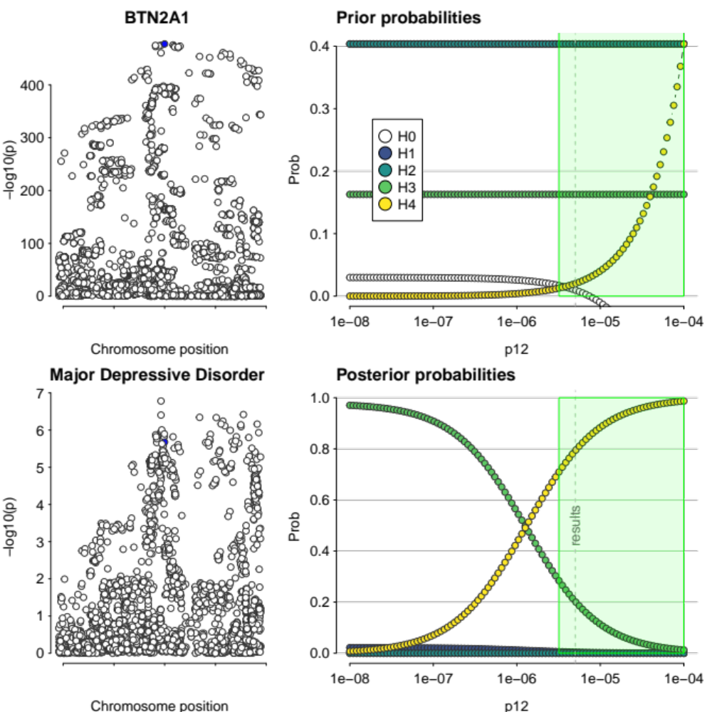
Supplementary Figure 1. Colocalisation results of MR-significant gene for major depressive disorder passing evidential threshold (H4 > 0.7), BTN2A1. Figures on the left-hand side show regional association plots of the colocalising genomic region. Right-hand side figures show prior and posterior probabilities plotted across the whole range of 𝑝₁₂. The green region shows the range of values of 𝑝₁₂ for which the decision rule H4 > 0.7 is satisfied. The grey dotted line indicates 𝑝₁₂ = 5 x 10⁻⁶.

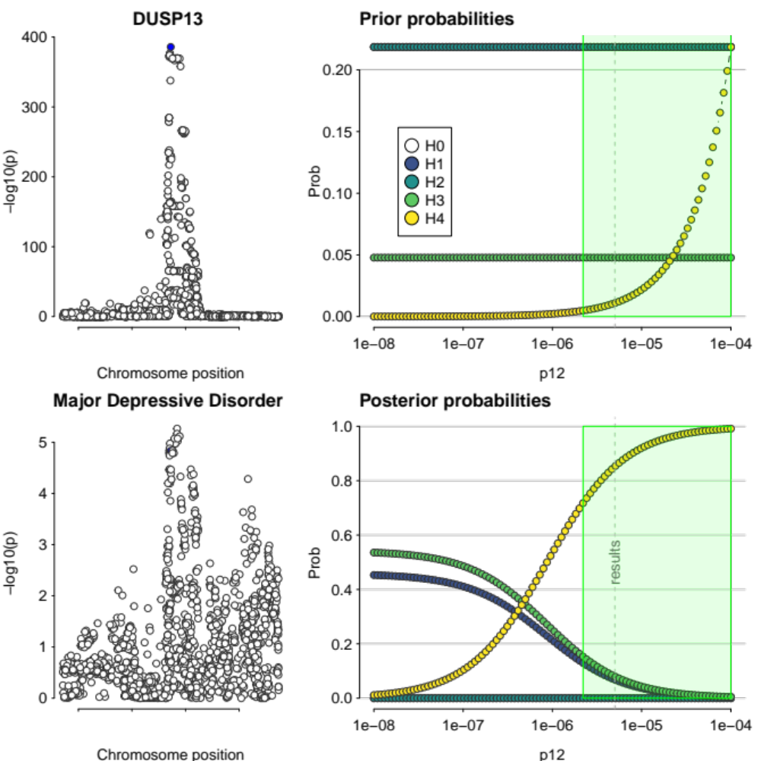
Supplementary Figure 2. Colocalisation results of MR-significant gene for major depressive disorder passing evidential threshold (H4 > 0.7), DUSP13. Figures on the left-hand side show Regional association plots of the colocalising genomic region. Right-hand side figures show prior and posterior probabilities plotted across the whole range of 𝑝₁₂. The green region shows the range of values of 𝑝₁₂ for which the decision rule H4 > 0.7 is satisfied. The grey dotted line indicates 𝑝₁₂ = 5 x 10⁻⁶.

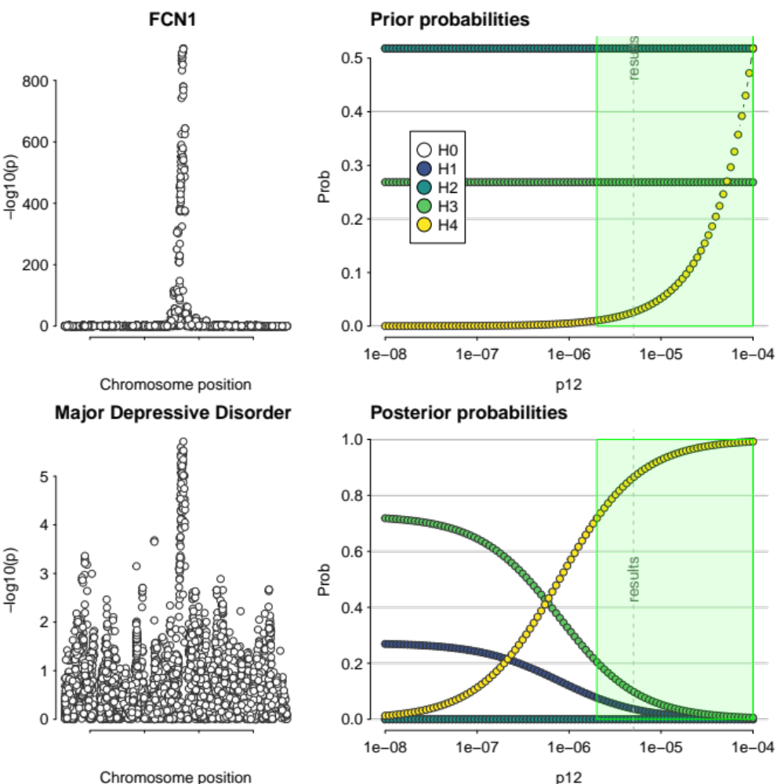
Supplementary Figure 3. Colocalisation results of MR-significant gene for major depressive disorder passing evidential threshold (H4 > 0.7), FCN1. Figures on the left-hand side show Regional association plots of the colocalising genomic region. Right-hand side figures show prior and posterior probabilities plotted across the whole range of 𝑝₁₂. The green region shows the range of values of 𝑝₁₂ for which the decision rule H4 > 0.7 is satisfied. The grey dotted line indicates 𝑝₁₂ = 5 x 10⁻⁶.

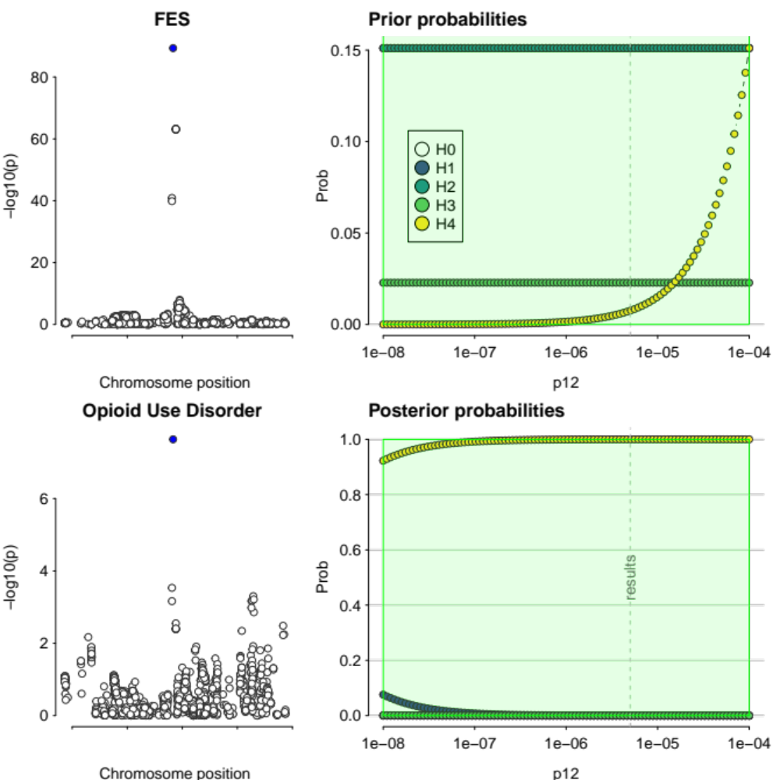
Supplementary Figure 4. Colocalisation results of MR-significant gene for opioid use disorder passing evidential threshold (H4 > 0.7), FES. Figures on the left-hand side show Regional association plots of the colocalising genomic region. Right-hand side figures show prior and posterior probabilities plotted across the whole range of 𝑝₁₂. The green region shows the range of values of 𝑝₁₂ for which the decision rule H4 > 0.7 is satisfied. The grey dotted line indicates 𝑝₁₂ = 5 x 10⁻⁶.

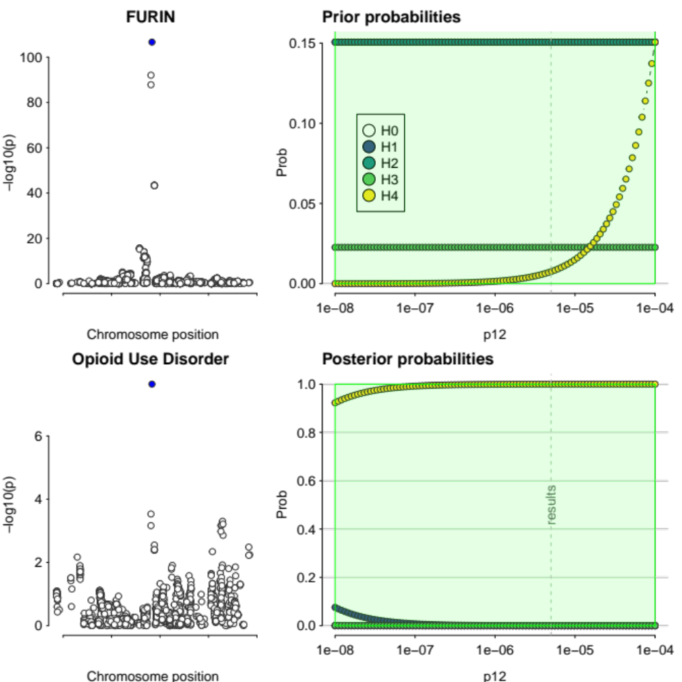
Supplementary Figure 5. Colocalisation results of MR-significant gene for opioid use disorder passing evidential threshold (H4 > 0.7), FURIN. Figures on the left-hand side show Regional association plots of the colocalising genomic region. Right-hand side figures show prior and posterior probabilities plotted across the whole range of 𝑝₁₂. The green region shows the range of values of 𝑝₁₂ for which the decision rule H4 > 0.7 is satisfied. The grey dotted line indicates 𝑝₁₂ = 5 x 10⁻⁶.

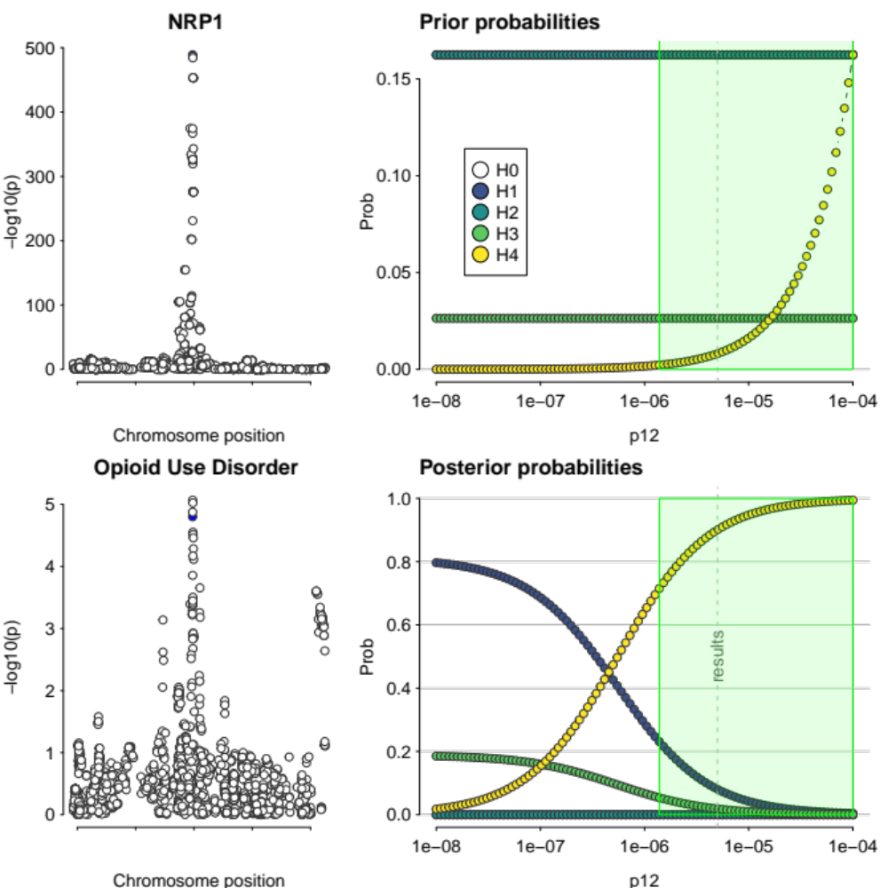
Supplementary Figure 6. Colocalisation results of MR-significant gene for opioid use disorder passing evidential threshold (H4 > 0.7), NRP1. Figures on the left-hand side show Regional association plots of the colocalising genomic region. Right-hand side figures show prior and posterior probabilities plotted across the whole range of 𝑝₁₂. The green region shows the range of values of 𝑝₁₂ for which the decision rule H4 > 0.7 is satisfied. The grey dotted line indicates 𝑝₁₂ = 5 x 10⁻⁶.

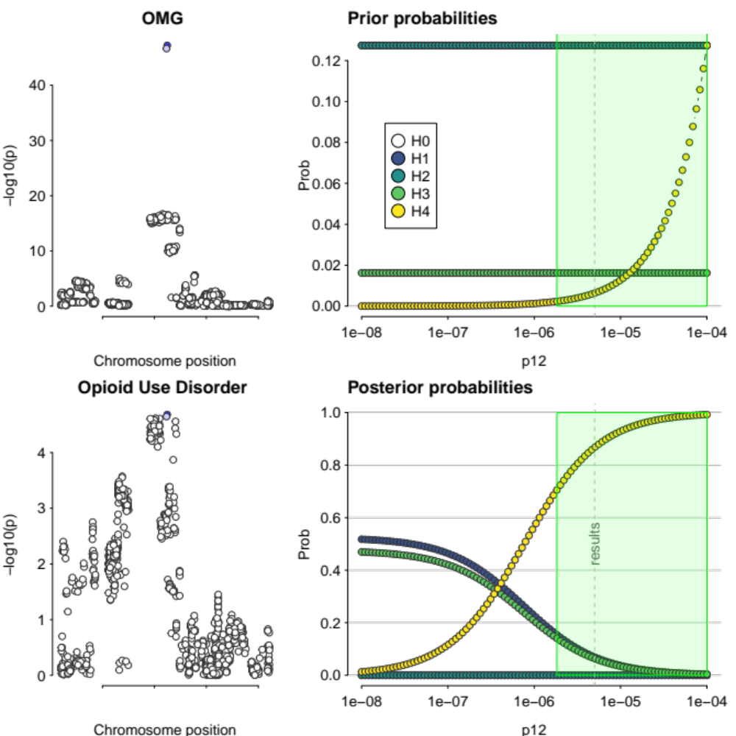
Supplementary Figure 7. Colocalisation results of MR-significant gene for opioid use disorder passing evidential threshold (H4 > 0.7), OMG. Figures on the left-hand side show Regional association plots of the colocalising genomic region. Right-hand side figures show prior and posterior probabilities plotted across the whole range of 𝑝₁₂. The green region shows the range of values of 𝑝₁₂ for which the decision rule H4 > 0.7 is satisfied. The grey dotted line indicates 𝑝₁₂ = 5 x 10⁻⁶.

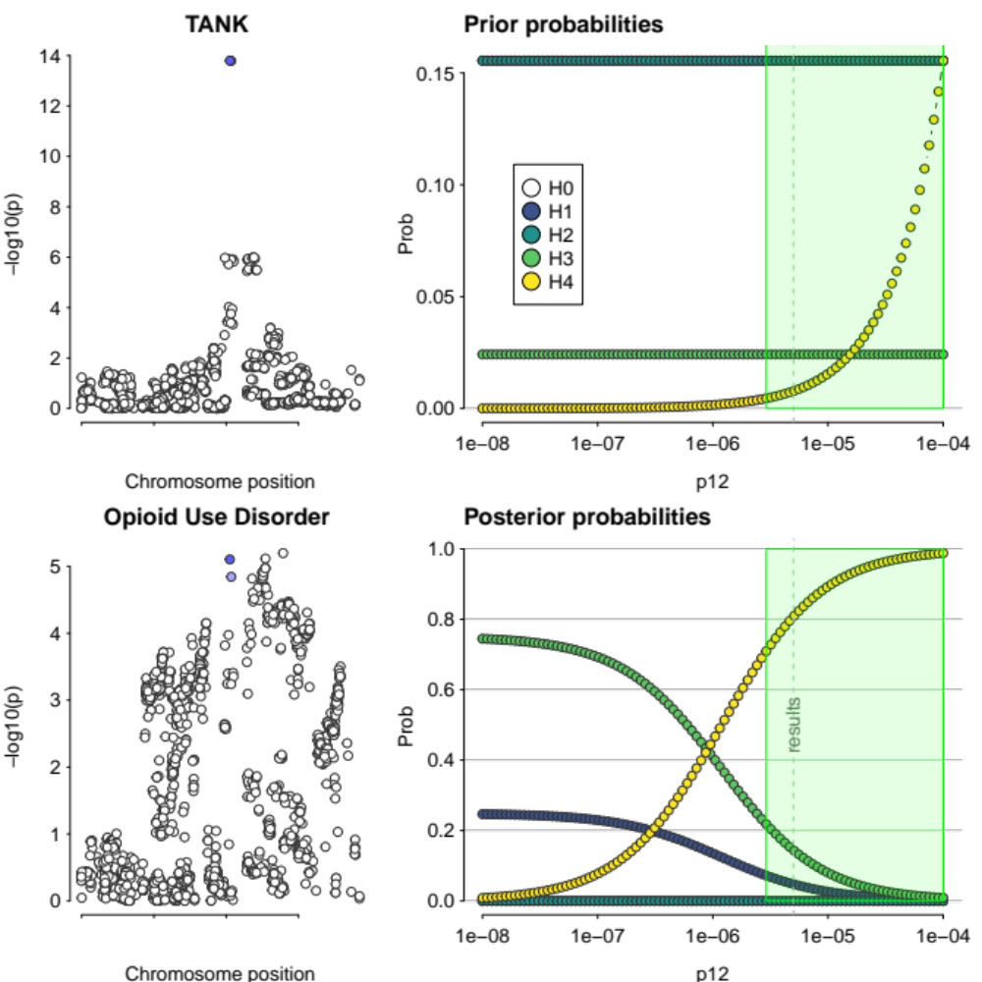
Supplementary Figure 8. Colocalisation results of MR-significant gene for opioid use disorder passing evidential threshold (H4 > 0.7), TANK. Figures on the left-hand side show Regional association plots of the colocalising genomic region. Right-hand side figures show prior and posterior probabilities plotted across the whole range of 𝑝₁₂. The green region shows the range of values of 𝑝₁₂ for which the decision rule H4 > 0.7 is satisfied. The grey dotted line indicates 𝑝₁₂ = 5 x 10⁻⁶.

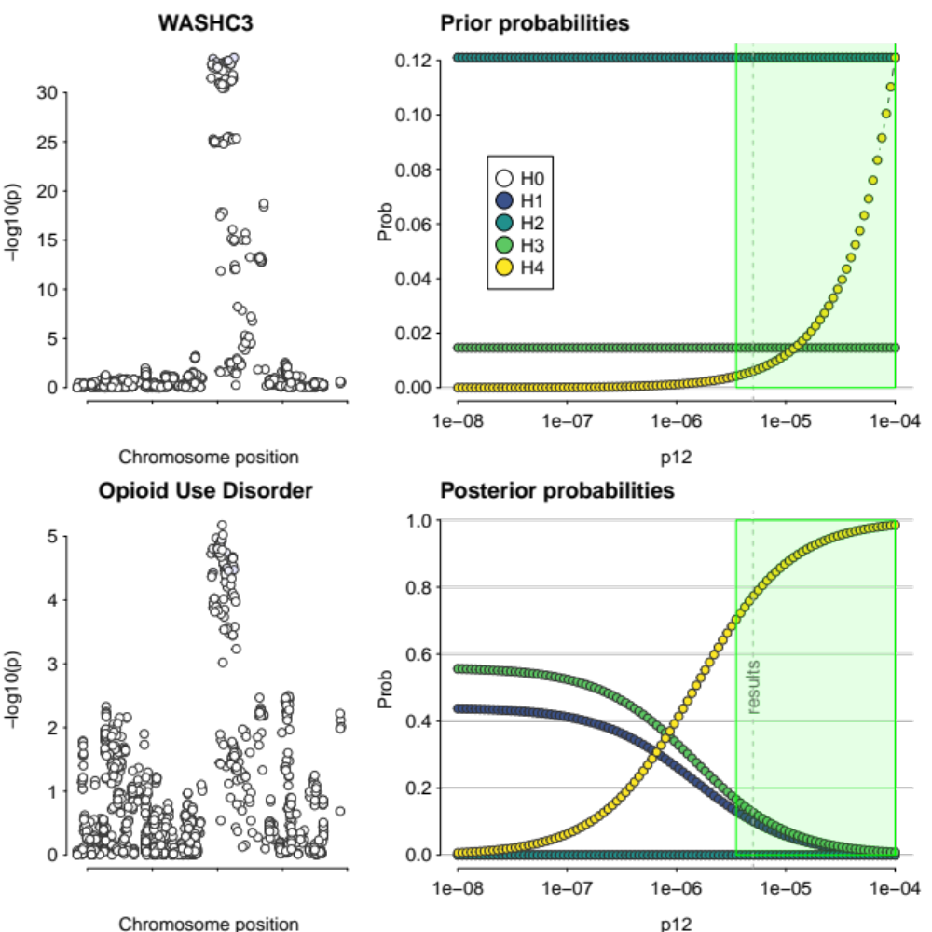
Supplementary Figure 9. Colocalisation results of MR-significant gene for opioid use disorder passing evidential threshold (H4 > 0.7), WASHC3. Figures on the left-hand side show Regional association plots of the colocalising genomic region. Right-hand side figures show prior and posterior probabilities plotted across the whole range of 𝑝₁₂. The green region shows the range of values of 𝑝₁₂ for which the decision rule H4 > 0.7 is satisfied. The grey dotted line indicates 𝑝₁₂ = 5 x 10⁻⁶.

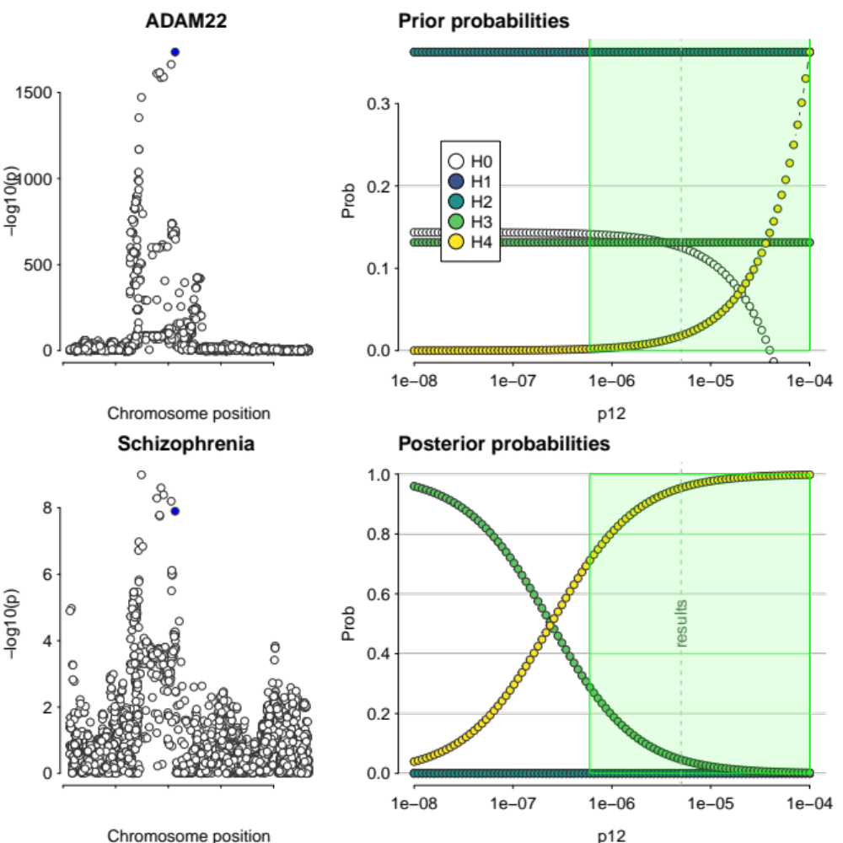
Supplementary Figure 10. Colocalisation results of MR-significant gene for schizophrenia passing evidential threshold (H4 > 0.7), ADAM22. Figures on the left-hand side show Regional association plots of the colocalising genomic region. Right-hand side figures show prior and posterior probabilities plotted across the whole range of 𝑝₁₂. The green region shows the range of values of 𝑝₁₂ for which the decision rule H4 > 0.7 is satisfied. The grey dotted line indicates 𝑝₁₂ = 5 x 10⁻⁶.

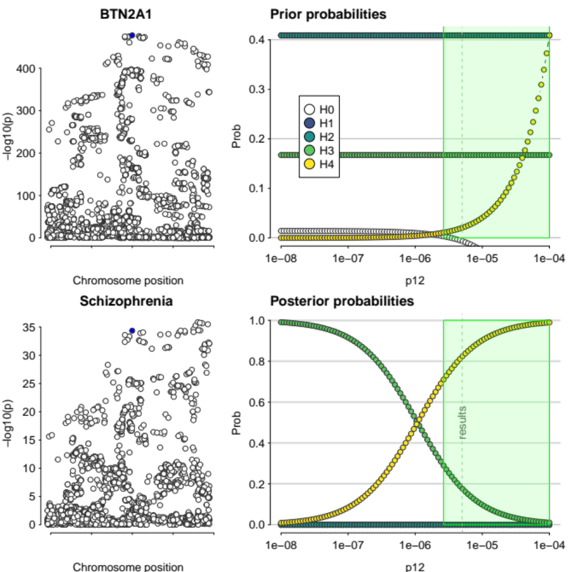
Supplementary Figure 11. Colocalisation results of MR-significant gene for schizophrenia passing evidential threshold (H4 > 0.7), BTN2A1. Figures on the left-hand side show Regional association plots of the colocalising genomic region. Right-hand side figures show prior and posterior probabilities plotted across the whole range of 𝑝₁₂. The green region shows the range of values of 𝑝₁₂ for which the decision rule H4 > 0.7 is satisfied. The grey dotted line indicates 𝑝₁₂ = 5 x 10⁻⁶.

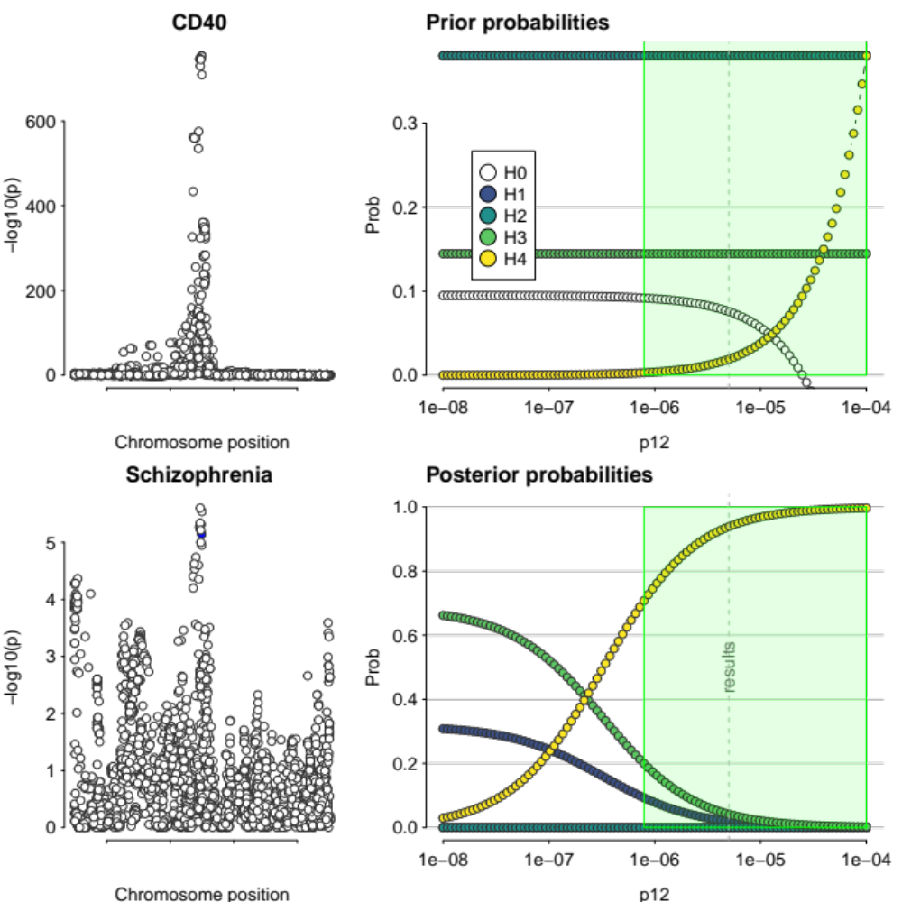
Supplementary Figure 12. Colocalisation results of MR-significant gene for schizophrenia passing evidential threshold (H4 > 0.7), CD40. Figures on the left-hand side show Regional association plots of the colocalising genomic region. Right-hand side figures show prior and posterior probabilities plotted across the whole range of 𝑝₁₂. The green region shows the range of values of 𝑝₁₂ for which the decision rule H4 > 0.7 is satisfied. The grey dotted line indicates 𝑝₁₂ = 5 x 10⁻⁶.

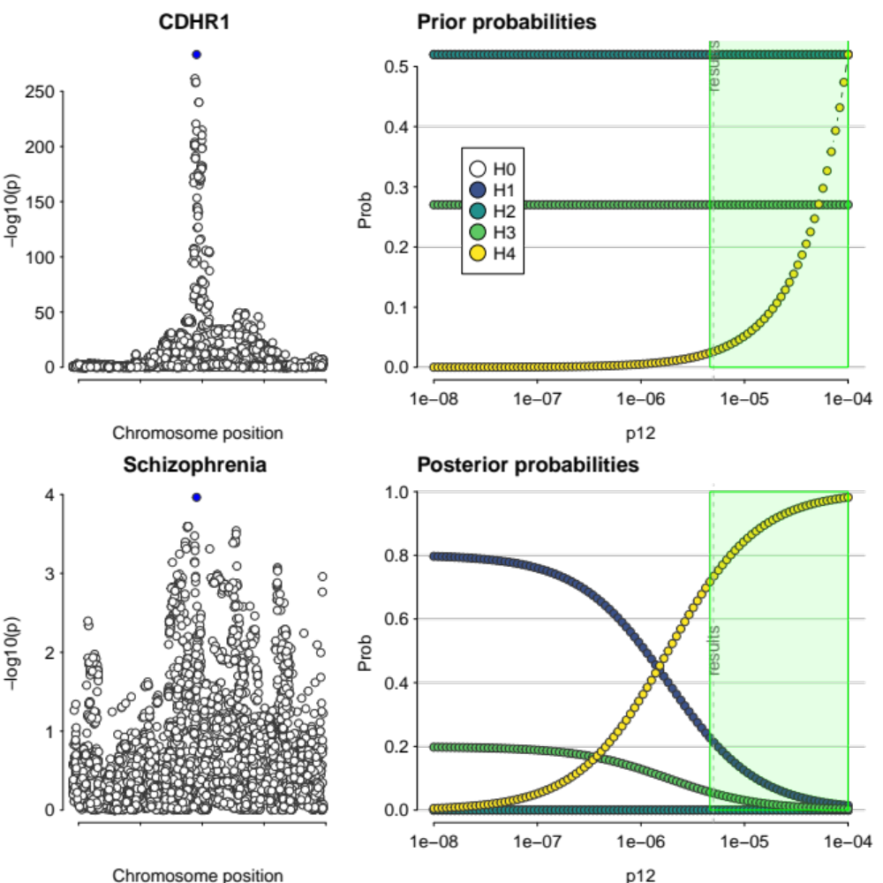
Supplementary Figure 13. Colocalisation results of MR-significant gene for schizophrenia passing evidential threshold (H4 > 0.7), CDHR1. Figures on the left-hand side show Regional association plots of the colocalising genomic region. Right-hand side figures show prior and posterior probabilities plotted across the whole range of 𝑝₁₂. The green region shows the range of values of 𝑝₁₂ for which the decision rule H4 > 0.7 is satisfied. The grey dotted line indicates 𝑝₁₂ = 5 x 10⁻⁶.

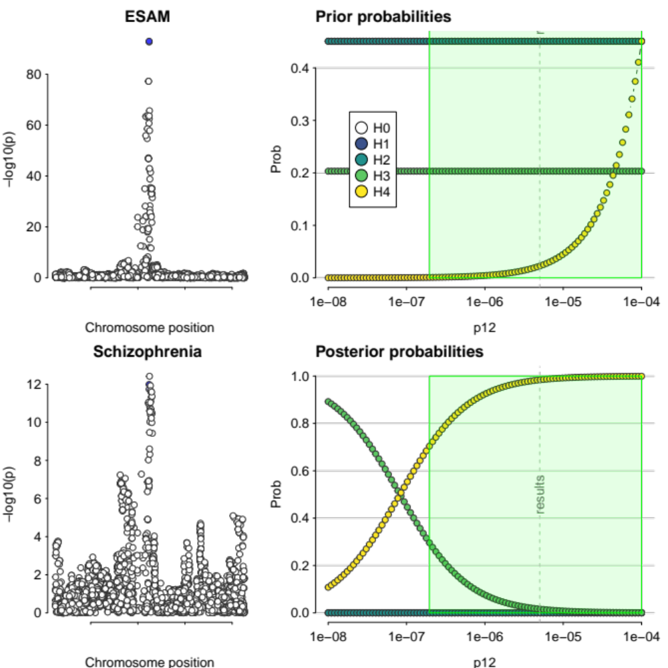
Supplementary Figure 14. Colocalisation results of MR-significant gene for schizophrenia passing evidential threshold (H4 > 0.7), ESAM. Figures on the left-hand side show Regional association plots of the colocalising genomic region. Right-hand side figures show prior and posterior probabilities plotted across the whole range of 𝑝₁₂. The green region shows the range of values of 𝑝₁₂ for which the decision rule H4 > 0.7 is satisfied. The grey dotted line indicates 𝑝₁₂ = 5 x 10⁻⁶.

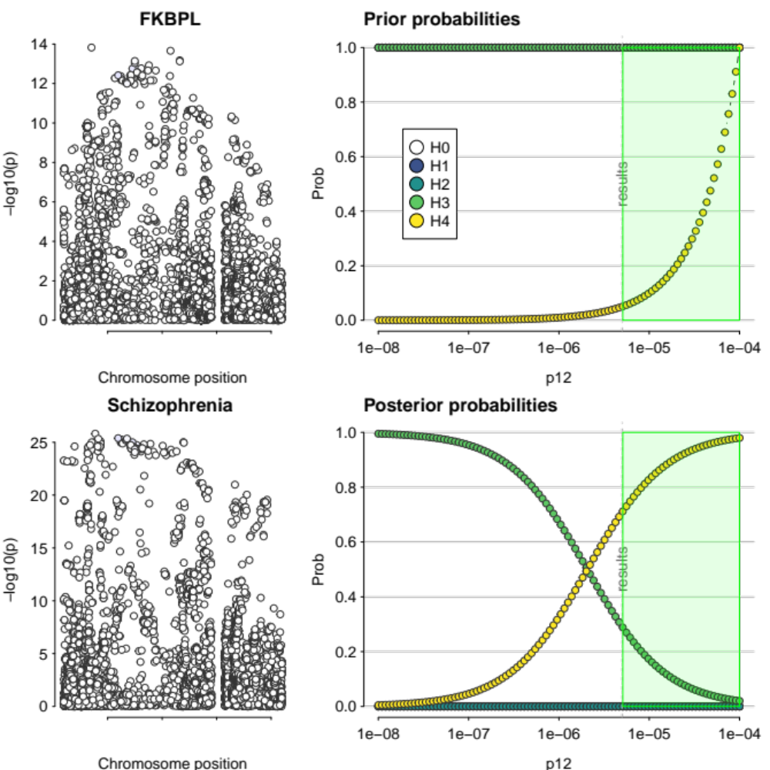
Supplementary Figure 15. Colocalisation results of MR-significant gene for schizophrenia passing evidential threshold (H4 > 0.7), FKBPL. Figures on the left-hand side show Regional association plots of the colocalising genomic region. Right-hand side figures show prior and posterior probabilities plotted across the whole range of 𝑝₁₂. The green region shows the range of values of 𝑝₁₂ for which the decision rule H4 > 0.7 is satisfied. The grey dotted line indicates 𝑝₁₂ = 5 x 10⁻⁶.

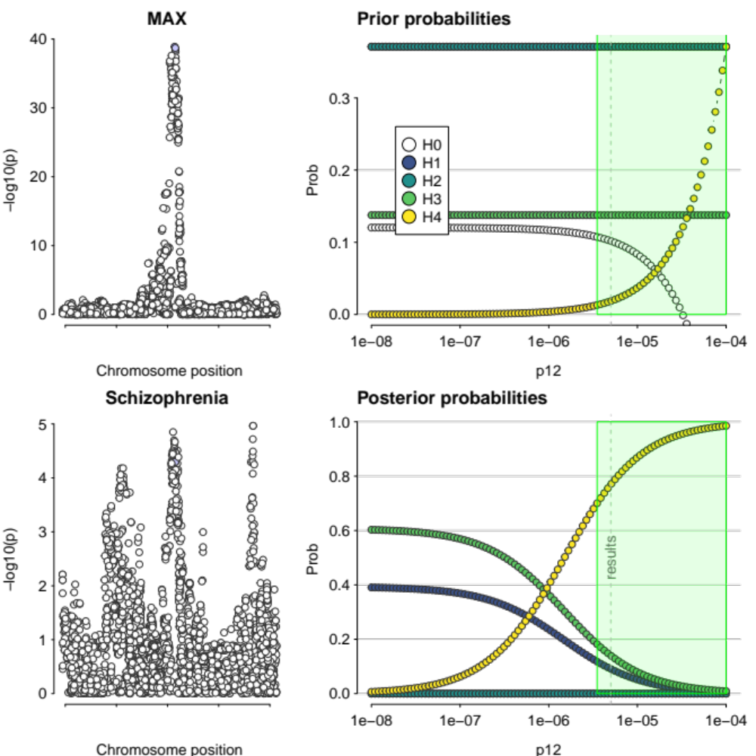
Supplementary Figure 16. Colocalisation results of MR-significant gene for schizophrenia passing evidential threshold (H4 > 0.7), MAX. Figures on the left-hand side show Regional association plots of the colocalising genomic region. Right-hand side figures show prior and posterior probabilities plotted across the whole range of 𝑝₁₂. The green region shows the range of values of 𝑝₁₂ for which the decision rule H4 > 0.7 is satisfied. The grey dotted line indicates 𝑝₁₂ = 5 x 10⁻⁶.

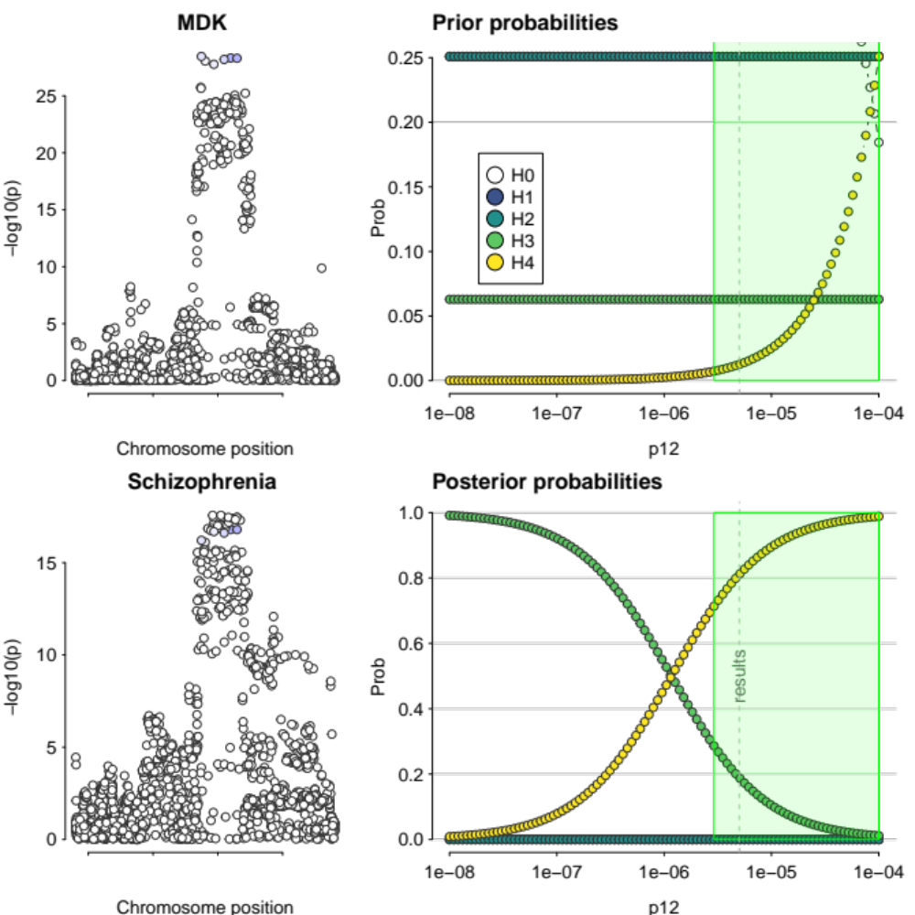
Supplementary Figure 17. Colocalisation results of MR-significant gene for schizophrenia passing evidential threshold (H4 > 0.7), MDK. Figures on the left-hand side show Regional association plots of the colocalising genomic region. Right-hand side figures show prior and posterior probabilities plotted across the whole range of 𝑝₁₂. The green region shows the range of values of 𝑝₁₂ for which the decision rule H4 > 0.7 is satisfied. The grey dotted line indicates 𝑝₁₂ = 5 x 10⁻⁶.

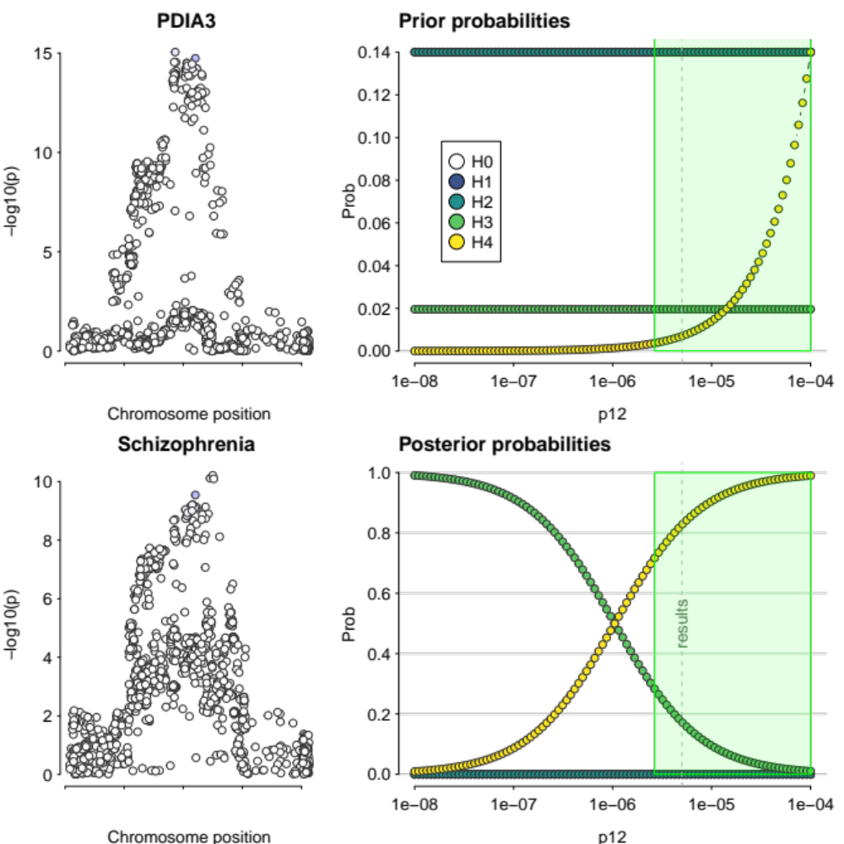
Supplementary Figure 18. Colocalisation results of MR-significant gene for schizophrenia passing evidential threshold (H4 > 0.7), PDIA3. Figures on the left-hand side show Regional association plots of the colocalising genomic region. Right-hand side figures show prior and posterior probabilities plotted across the whole range of 𝑝₁₂. The green region shows the range of values of 𝑝₁₂ for which the decision rule H4 > 0.7 is satisfied. The grey dotted line indicates 𝑝₁₂ = 5 x 10⁻⁶.

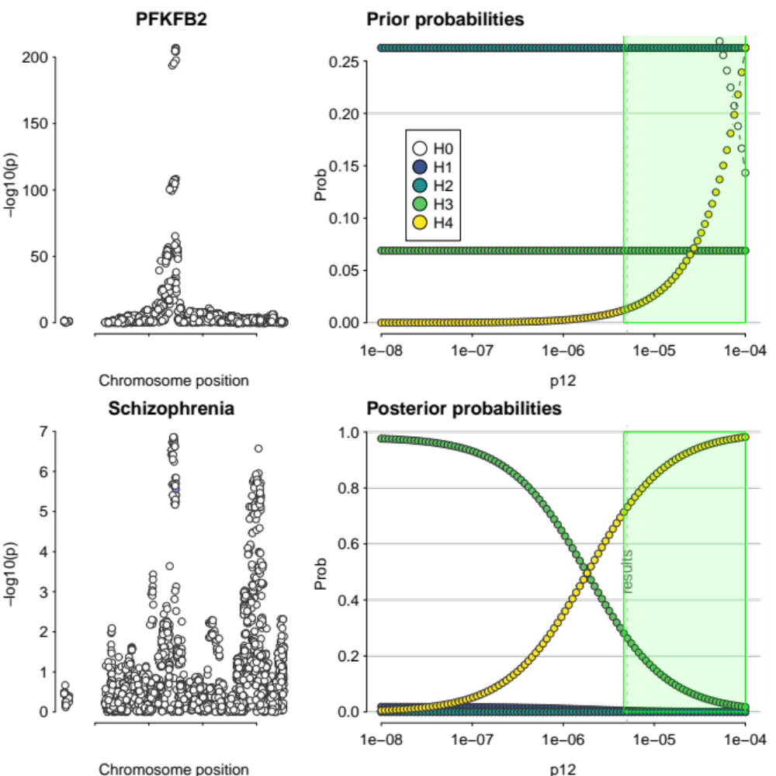
Supplementary Figure 19. Colocalisation results of MR-significant gene for schizophrenia passing evidential threshold (H4 > 0.7), PFKFB2. Figures on the left-hand side show Regional association plots of the colocalising genomic region. Right-hand side figures show prior and posterior probabilities plotted across the whole range of 𝑝₁₂. The green region shows the range of values of 𝑝₁₂ for which the decision rule H4 > 0.7 is satisfied. The grey dotted line indicates 𝑝₁₂ = 5 x 10⁻⁶.

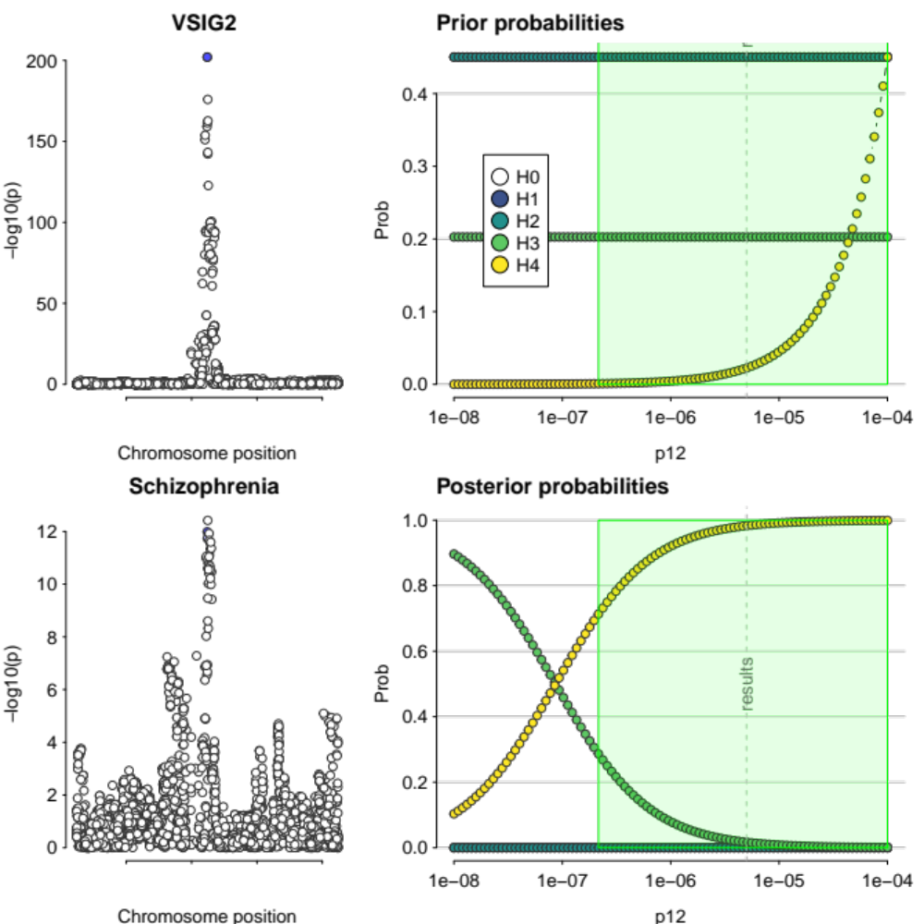
Supplementary Figure 20. Colocalisation results of MR-significant gene for schizophrenia passing evidential threshold (H4 > 0.7), VSIG2. Figures on the left-hand side show Regional association plots of the colocalising genomic region. Right-hand side figures show prior and posterior probabilities plotted across the whole range of 𝑝₁₂. The green region shows the range of values of 𝑝₁₂ for which the decision rule H4 > 0.7 is satisfied. The grey dotted line indicates 𝑝₁₂ = 5 x 10⁻⁶.

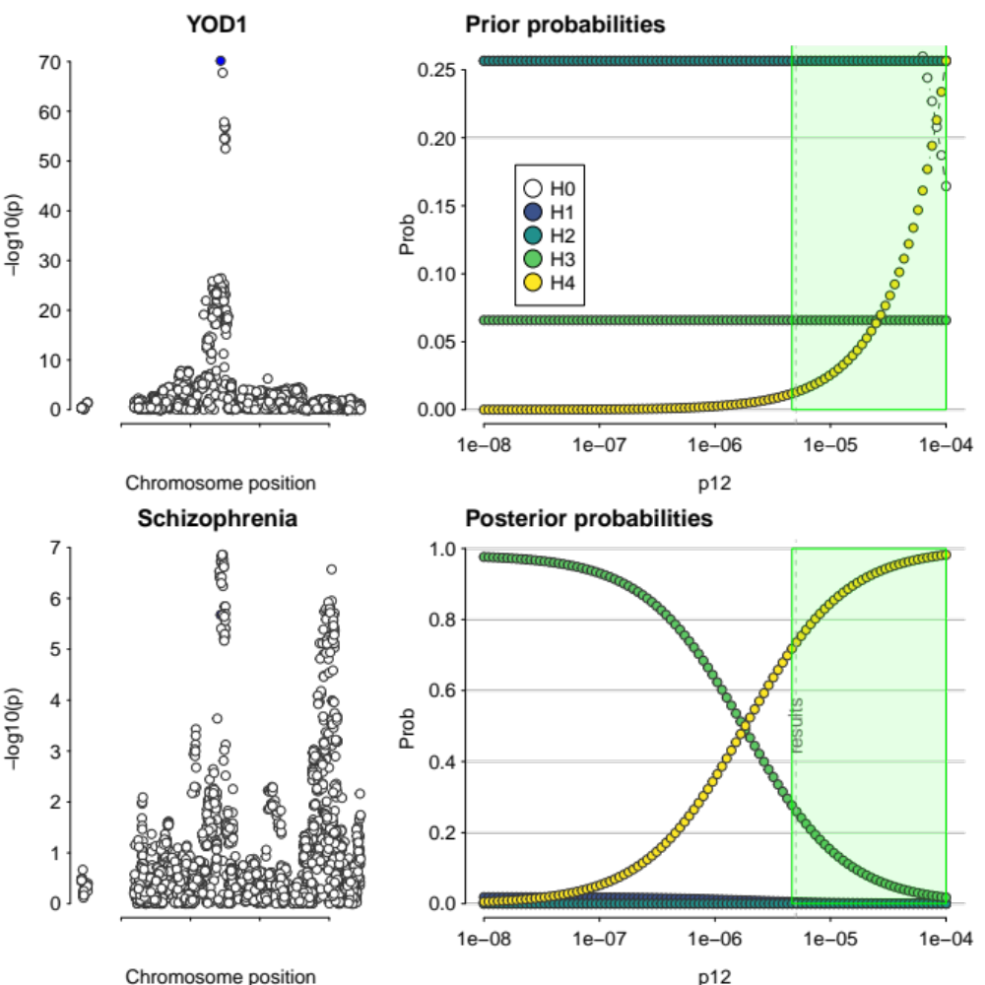
Supplementary Figure 21. Colocalisation results of MR-significant gene for schizophrenia passing evidential threshold (H4 > 0.7), YOD1. Figures on the left-hand side show Regional association plots of the colocalising genomic region. Right-hand side figures show prior and posterior probabilities plotted across the whole range of 𝑝₁₂. The green region shows the range of values of 𝑝₁₂ for which the decision rule H4 > 0.7 is satisfied. The grey dotted line indicates 𝑝₁₂ = 5 x 10⁻⁶.

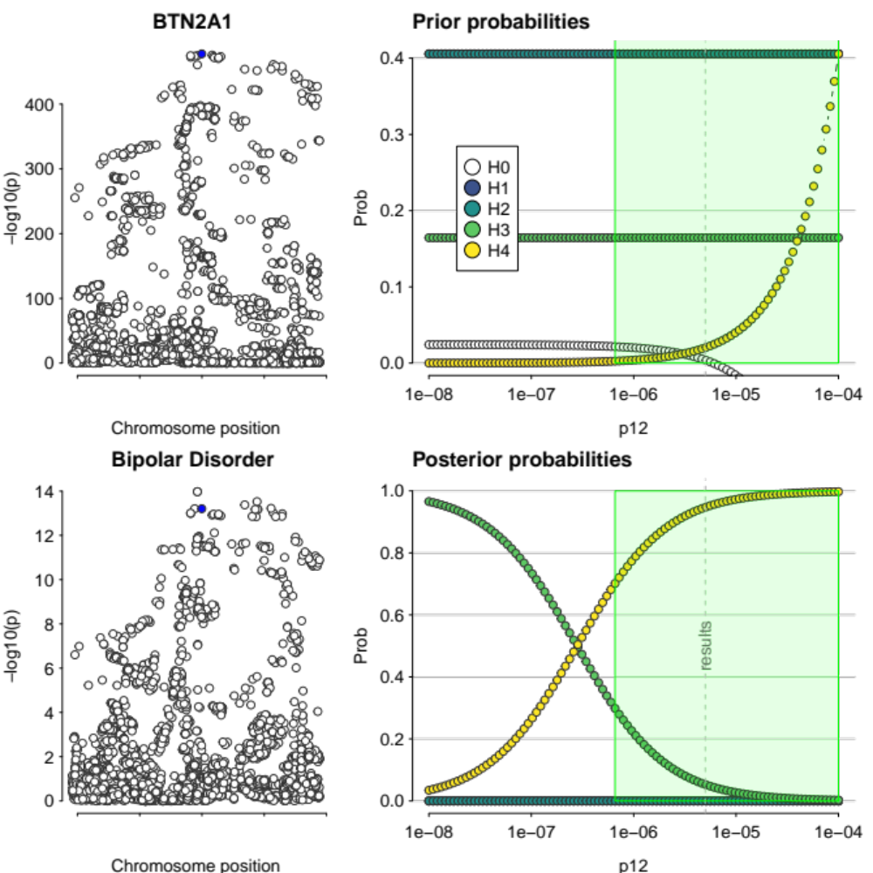
Supplementary Figure 22. Colocalisation results of MR-significant gene for bipolar disorder passing evidential threshold (H4 > 0.7), BTN2A1. Figures on the left-hand side show Regional association plots of the colocalising genomic region. Right-hand side figures show prior and posterior probabilities plotted across the whole range of 𝑝₁₂. The green region shows the range of values of 𝑝₁₂ for which the decision rule H4 > 0.7 is satisfied. The grey dotted line indicates 𝑝₁₂ = 5 x 10⁻⁶.

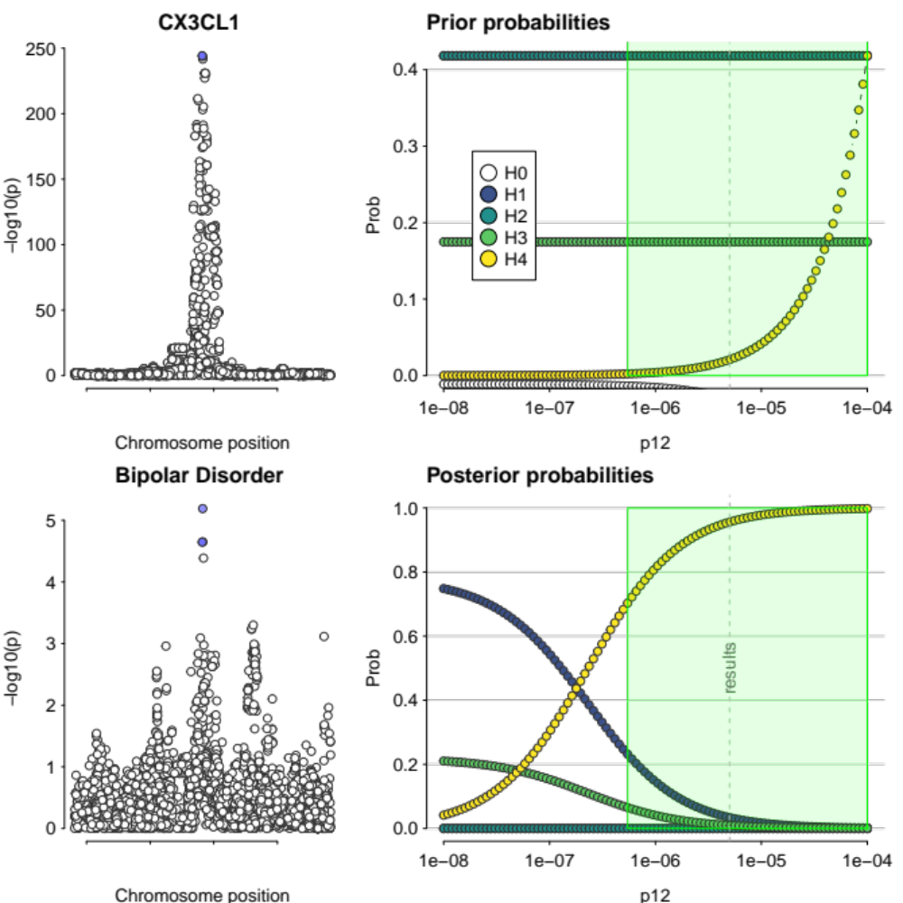
Supplementary Figure 23. Colocalisation results of MR-significant gene for bipolar disorder passing evidential threshold (H4 > 0.7), CX3CL1. Figures on the left-hand side show Regional association plots of the colocalising genomic region. Right-hand side figures show prior and posterior probabilities plotted across the whole range of 𝑝₁₂. The green region shows the range of values of 𝑝₁₂ for which the decision rule H4 > 0.7 is satisfied. The grey dotted line indicates 𝑝₁₂ = 5 x 10⁻⁶.

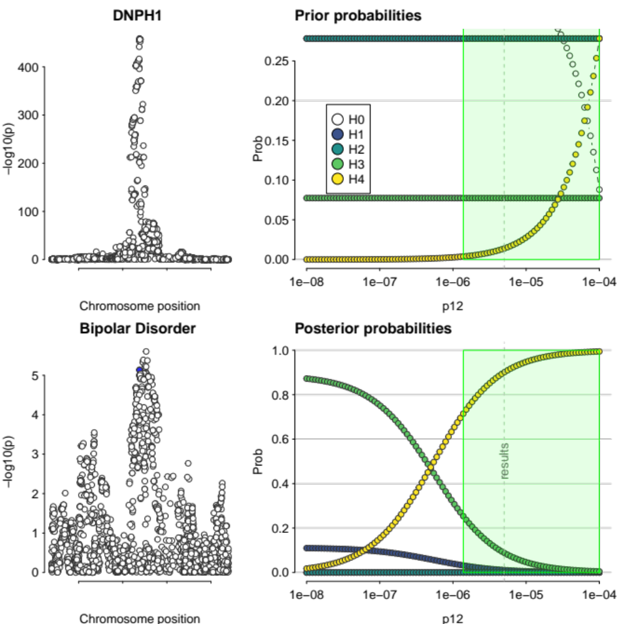
Supplementary Figure 24. Colocalisation results of MR-significant gene for bipolar disorder passing evidential threshold (H4 > 0.7), DNPH1. Figures on the left-hand side show Regional association plots of the colocalising genomic region. Right-hand side figures show prior and posterior probabilities plotted across the whole range of 𝑝₁₂. The green region shows the range of values of 𝑝₁₂ for which the decision rule H4 > 0.7 is satisfied. The grey dotted line indicates 𝑝₁₂ = 5 x 10⁻⁶.

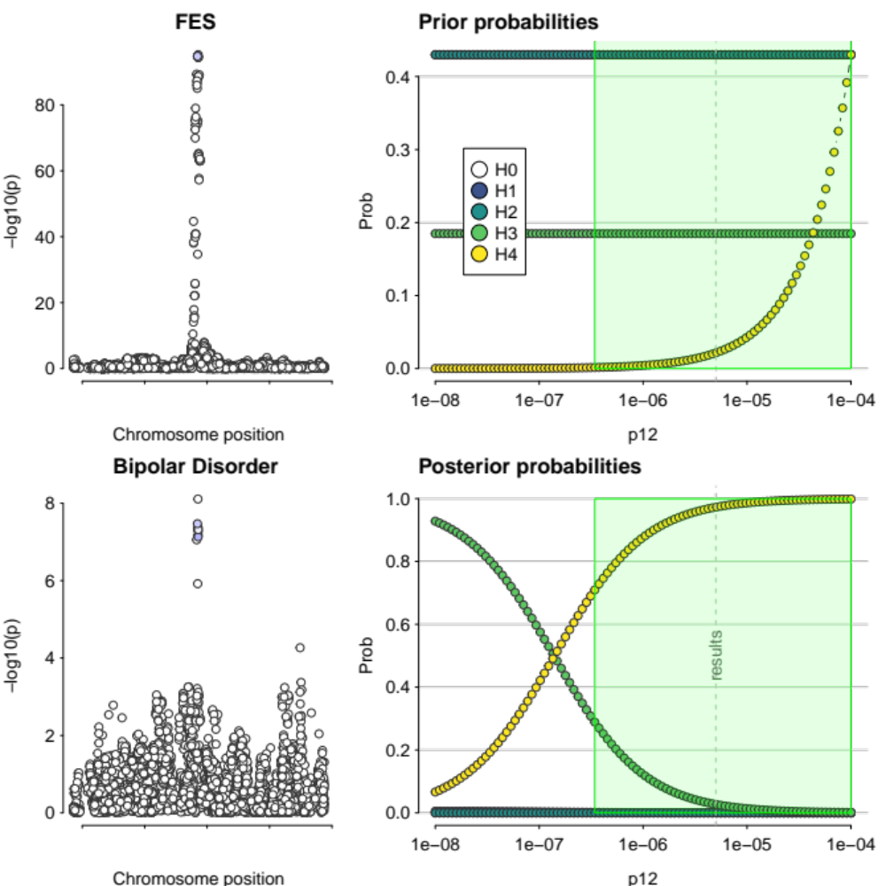
Supplementary Figure 25. Colocalisation results of MR-significant gene for bipolar disorder passing evidential threshold (H4 > 0.7), FES. Figures on the left-hand side show Regional association plots of the colocalising genomic region. Right-hand side figures show prior and posterior probabilities plotted across the whole range of 𝑝₁₂. The green region shows the range of values of 𝑝₁₂ for which the decision rule H4 > 0.7 is satisfied. The grey dotted line indicates 𝑝₁₂ = 5 x 10⁻⁶.

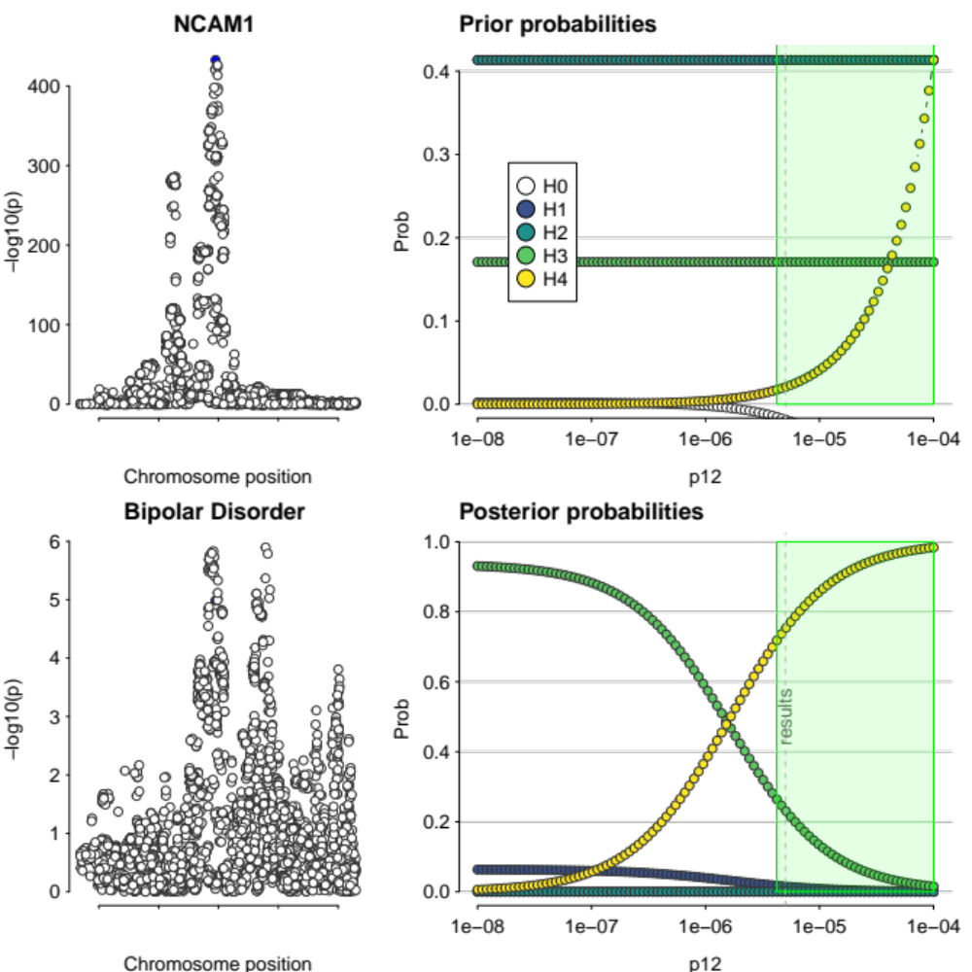
Supplementary Figure 26. Colocalisation results of MR-significant gene for bipolar disorder passing evidential threshold (H4 > 0.7), NCAM1. Figures on the left-hand side show Regional association plots of the colocalising genomic region. Right-hand side figures show prior and posterior probabilities plotted across the whole range of 𝑝₁₂. The green region shows the range of values of 𝑝₁₂ for which the decision rule H4 > 0.7 is satisfied. The grey dotted line indicates 𝑝₁₂ = 5 x 10⁻⁶.

Supplementary Figure 27. Colocalisation results of MR-significant gene for bipolar disorder passing evidential threshold (H4 > 0.7), OPLAH. Figures on the left-hand side show Regional association plots of the colocalising genomic region. Right-hand side figures show prior and posterior probabilities plotted across the whole range of 𝑝₁₂. The green region shows the range of values of 𝑝₁₂ for which the decision rule H4 > 0.7 is satisfied. The grey dotted line indicates 𝑝₁₂ = 5 x 10⁻⁶.

Supplementary Figure 28. Colocalisation results of MR-significant gene for bipolar disorder passing evidential threshold (H4 > 0.7), PBXIP1. Figures on the left-hand side show Regional association plots of the colocalising genomic region. Right-hand side figures show prior and posterior probabilities plotted across the whole range of 𝑝₁₂. The green region shows the range of values of 𝑝₁₂ for which the decision rule H4 > 0.7 is satisfied. The grey dotted line indicates 𝑝₁₂ = 5 x 10⁻⁶.

Supplementary Figure 29. Colocalisation results of MR-significant gene for bipolar disorder passing evidential threshold (H4 > 0.7), PMVK. Figures on the left-hand side show Regional association plots of the colocalising genomic region. Right-hand side figures show prior and posterior probabilities plotted across the whole range of 𝑝₁₂. The green region shows the range of values of 𝑝₁₂ for which the decision rule H4 > 0.7 is satisfied. The grey dotted line indicates 𝑝₁₂ = 5 x 10⁻⁶.

Supplementary Figure 30. Colocalisation results of MR-significant gene for bipolar disorder passing evidential threshold (H4 > 0.7), SCRN1. Figures on the left-hand side show Regional association plots of the colocalising genomic region. Right-hand side figures show prior and posterior probabilities plotted across the whole range of 𝑝₁₂. The green region shows the range of values of 𝑝₁₂ for which the decision rule H4 > 0.7 is satisfied. The grey dotted line indicates 𝑝₁₂ = 5 x 10⁻⁶.

Supplementary Figure 31. Colocalisation results of MR-significant gene for bipolar disorder passing evidential threshold (H4 > 0.7), THOP1. Figures on the left-hand side show Regional association plots of the colocalising genomic region. Right-hand side figures show prior and posterior probabilities plotted across the whole range of 𝑝₁₂. The green region shows the range of values of 𝑝₁₂ for which the decision rule H4 > 0.7 is satisfied. The grey dotted line indicates 𝑝₁₂ = 5 x 10⁻⁶.

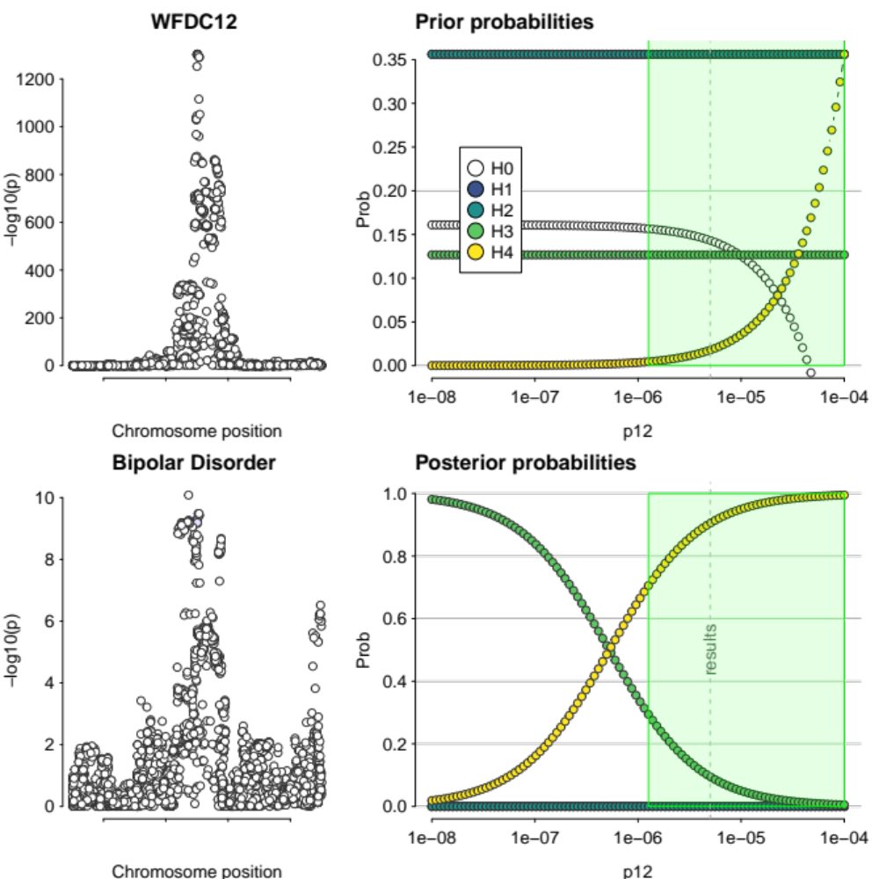
Supplementary Figure 32. Colocalisation results of MR-significant gene for bipolar disorder passing evidential threshold (H4 > 0.7), WFDC12. Figures on the left-hand side show Regional association plots of the colocalising genomic region. Right-hand side figures show prior and posterior probabilities plotted across the whole range of 𝑝₁₂. The green region shows the range of values of 𝑝₁₂ for which the decision rule H4 > 0.7 is satisfied. The grey dotted line indicates 𝑝₁₂ = 5 x 10⁻⁶.

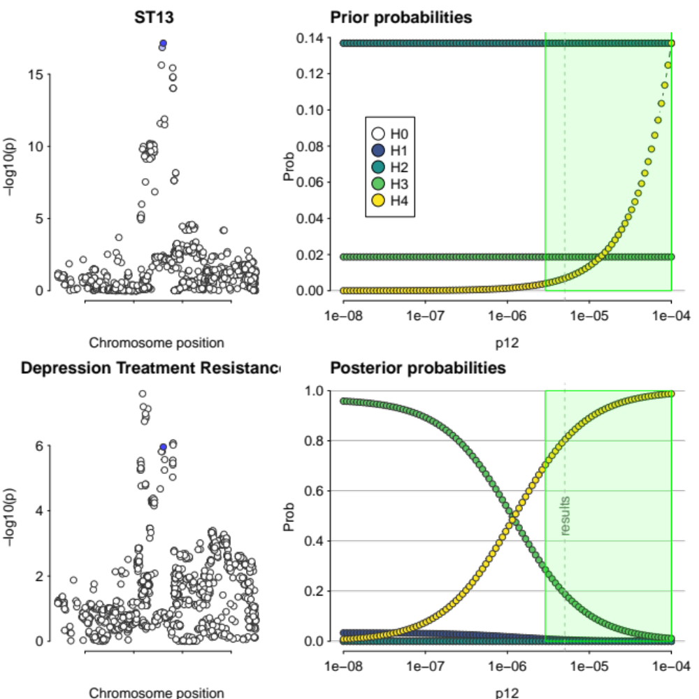
Supplementary Figure 33. Colocalisation results of MR-significant gene for treatment resistance in depression passing evidential threshold (H4 > 0.7), ST13. Figures on the left-hand side show Regional association plots of the colocalising genomic region. Right-hand side figures show prior and posterior probabilities plotted across the whole range of 𝑝₁₂. The green region shows the range of values of 𝑝₁₂ for which the decision rule H4 > 0.7 is satisfied. The grey dotted line indicates 𝑝₁₂ = 5 x 10⁻⁶.

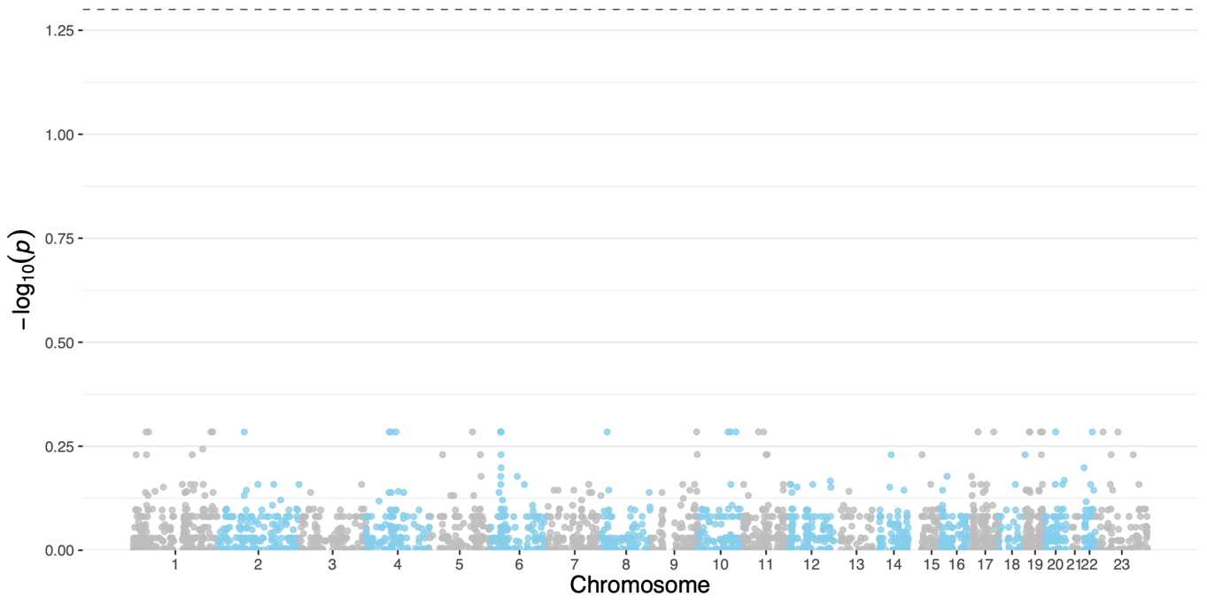

Supplementary Figure 34. Manhattan plot of Mendelian randomisation Wald ratio estimates for treatment resistance in schizophrenia. Lead cis-pQTL was used as instrument for each plasma protein. Significantly associated proteins are highlighted in orange. Labels are provided for the top 20 significantly associated proteins, and all colocalising proteins (H4 > 0.7 at 𝑝₁₂ = 5e−6). The black line marks the threshold for significance, adjusted for false discovery rate (FDR) at 𝑝 < 0.05.
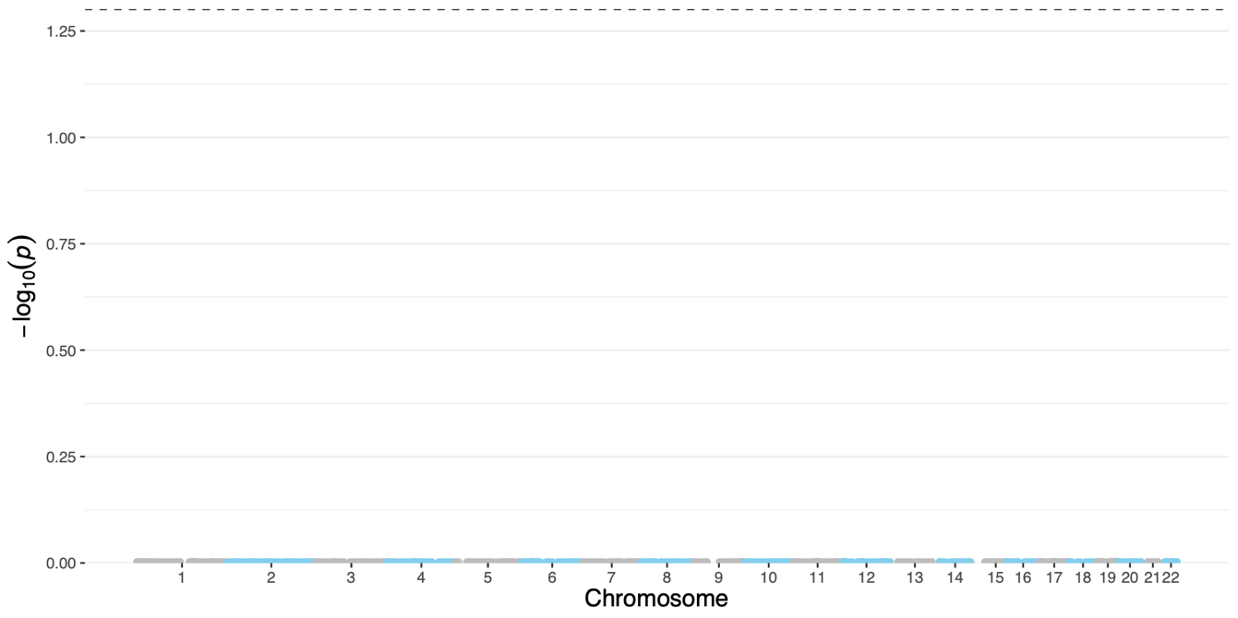

Supplementary Figure 35. Manhattan plot of Mendelian randomisation Wald ratio estimates for antidepressant treatment response. Lead cis-pQTL was used as instrument for each plasma protein. Significantly associated proteins are highlighted in orange. Labels are provided for the top 20 significantly associated proteins, and all colocalising proteins (H4 > 0.7 at 𝑝₁₂ = 5e−6). The black line marks the threshold for significance, adjusted for false discovery rate (FDR) at 𝑝 < 0.05.

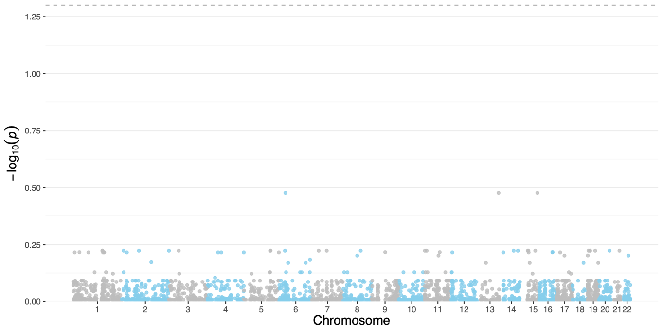

Supplementary Figure 36. Manhattan plot of Mendelian randomisation Wald ratio estimates for obsessive compulsive disorder. Lead cis-pQTL was used as instrument for each plasma protein. Significantly associated proteins are highlighted in orange. Labels are provided for the top 20 significantly associated proteins, and all colocalising proteins (H4 > 0.7 at 𝑝₁₂ = 5e−6). The black line marks the threshold for significance, adjusted for false discovery rate (FDR) at 𝑝 < 0.05.

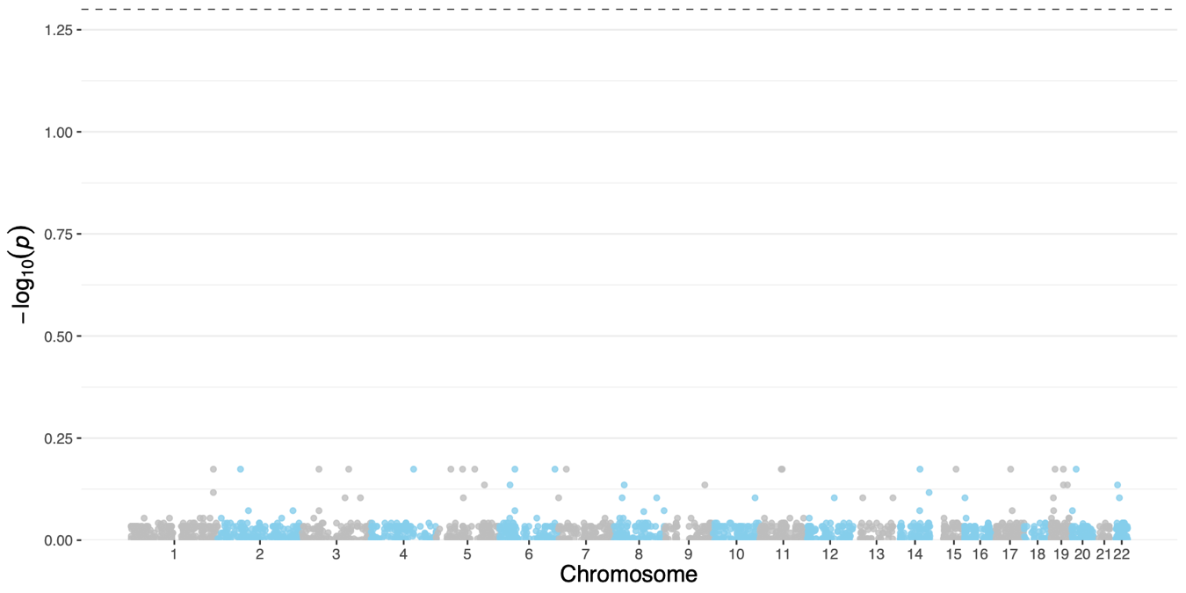

Supplementary Figure 37. Manhattan plot of Mendelian randomisation Wald ratio estimates for panic disorder. Lead cis-pQTL was used as instrument for each plasma protein. Significantly associated proteins are highlighted in orange. Labels are provided for the top 20 significantly associated proteins, and all colocalising proteins (H4 > 0.7 at 𝑝₁₂ = 5e−6). The black line marks the threshold for significance, adjusted for false discovery rate (FDR) at 𝑝 < 0.05.

References
- Foley CN, Staley JR, Breen PG, Sun BB, Kirk PDW, Burgess S, et al. A fast and efficient colocalization algorithm for identifying shared genetic risk factors across multiple traits. Nature Communications. 2021 Feb;12(1):764.
- Stats (version 3.6.2). RDocumentation. https://rdocumentation.org/packages/stats/versions/3.6.2.

