What is the origin of conductivity in water-poor reverse micelles?
Thomas Zemb ^{a,*}, Sandrine Dourdain ª, Tobias Lopian ª, Jean-Francois Dufrêche ^{b}, Robert Franz Schmidt ^{b}, Werner Kunz ^{c}

ª Institut de Chimie Séparative de Marcoule, ICSM UMR 5257 - CEA/CNRS/UM/ENSCM, 30207 Marcoule, France
^{b} Stranski-Laboratorium für Physikalische und Theoretische Chemie, Institut für Chemie, Technische Universität Berlin, Straße des 17. Juni 124, 10623 Berlin, Germany
^{c} Institute of Physical and Theoretical Chemistry, University of Regensburg, 93040 Regensburg, Germany

1. Detail of phase diagram
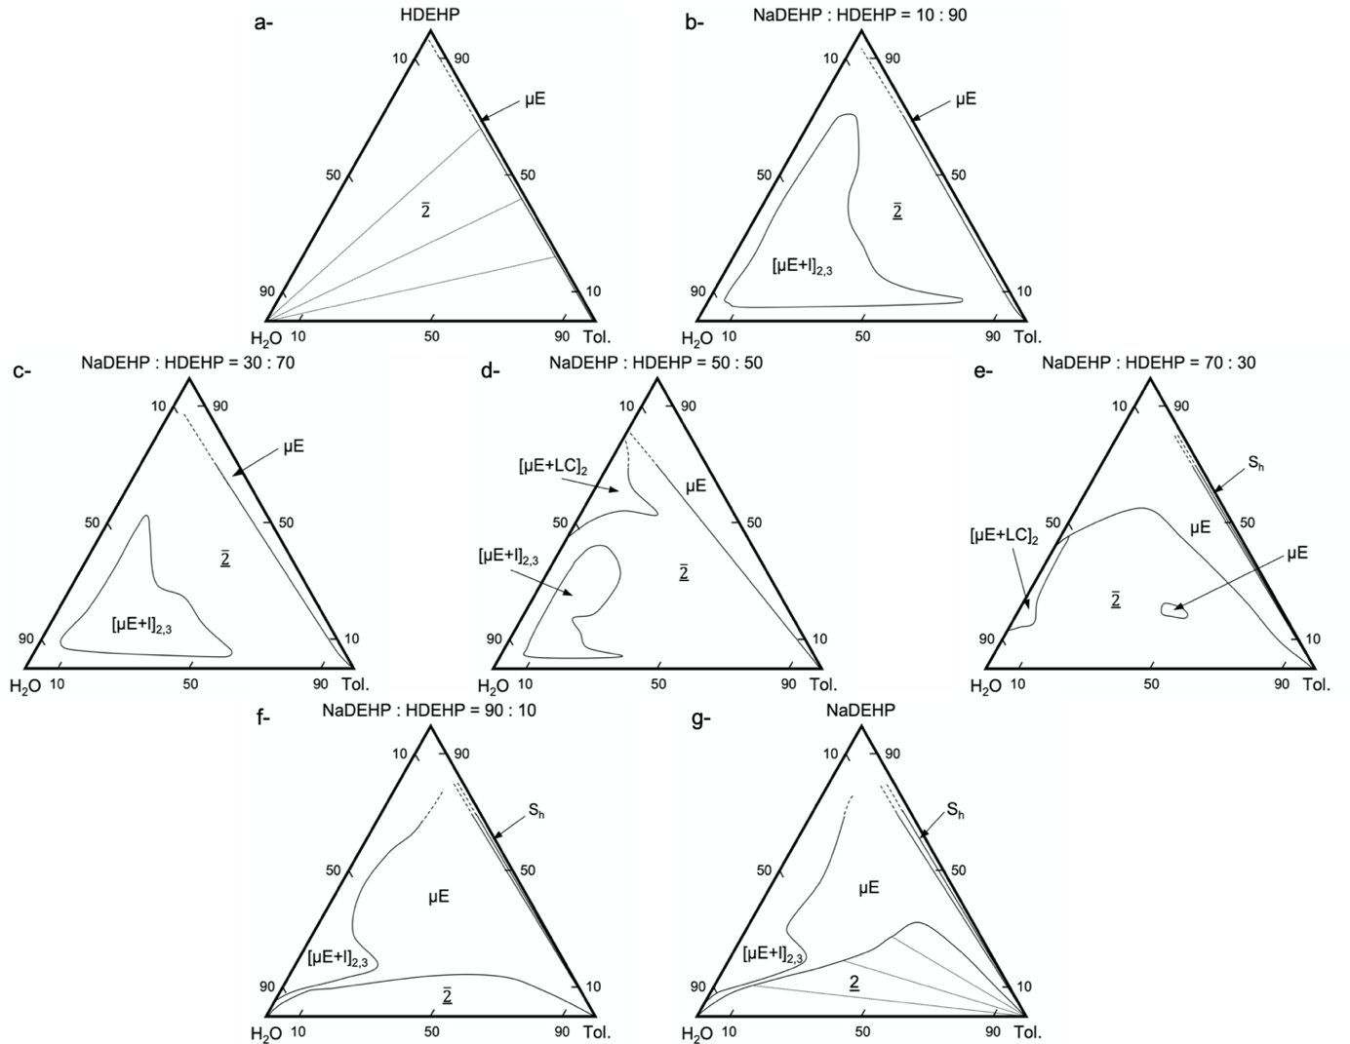
Figure S1: Experimental pseudo-ternary phase diagrams of toluene/H-Na-DEHP/water in wt% for different ratios of H to Na. (a) 𝑍 = 0; (b) 𝑍 = 0.1; (c) 𝑍 = 0.3; (d) 𝑍 = 0.5; (e) 𝑍 = 0.7; (f) 𝑍 = 0.9; (g) 𝑍 = 1. Reproduced with permission from ref [1].

Figure S1 shows triangular sections of the phase prism obtained for different values of Z, where μE stands for monophasic region, 2 for Biphasic liquid-liquid region, [μE+I]2,3 for multiple phases, [μE+LC]2 for lyotropic phase, [μE+LC]3 for 3 phases and Sb stands for biphasic solid-liquid region.

2. Small angle X-ray scattering measurements
SAXS measurements were performed on a home-built SAXS camera at ICSM in Marcoule. The setup involves a Molybdenum source delivering a 1-mm-large circular beam of 17.4 keV. A monochromatic beam is obtained by a Fox-2D® multi-shell mirror, and collimation of the beam is achieved using 2 sets of “scatterless” slits, which turns out to be crucial for the quantification of weak scattering near the beam-stop, together with precise monitoring of the transmission of the sample and solvents used as the reference. The diffraction patterns were recorded with a MAR345 two-dimensional imaging plate with a typical duration of 1 hour. The measurements were performed with transmission geometry using 3-mm glass capillaries. The measurements are shown in Figure S2 and the corresponding color code in shown in Table S1. The extrapolated scattering intensities for Q 0 are shown in Figure S3.

Figure S2: Small angle scattering patterns as absolute intensities (cm⁻¹) versus scattering vector Q. Left: higher water to DEHP molar ratio (w₀=5) for which free cations are circulate in polar domains. Middle: medium water to DEHP molar ratio (w₀=3.) at the transition between micelles and microemulsions: some ions start to transport current more than fluctuations only. Right: low water to DEHP molar ratio (w₀=2) for which all cations are bound to the interface. All spectra correspond to connected or no-connected polar channels structures at colloidal scale, with a mesh size corresponding to a bump around q = 2 nm⁻¹ (3 nm) for the highest polar volume fraction. The peak common to all spectra close to 10 q = 2 nm⁻¹ correspond solvent microstructure.
Table : Colour code for small-angle X-ray scattering curves shown in Figure S2.
Φ extr + water | 0 | 0.002 | 0.005 | 0.01 | 0.015 | 0.02
Colour | Black | Violet | Brown | Red | Orange | Yellow
Φ extr + water | 0.05 | 0.075 | 0.1 | 0.125 | 0.15 | 0.2
Colour | Light green | Dark green | Cyan | Blue | Dark blue | Purple

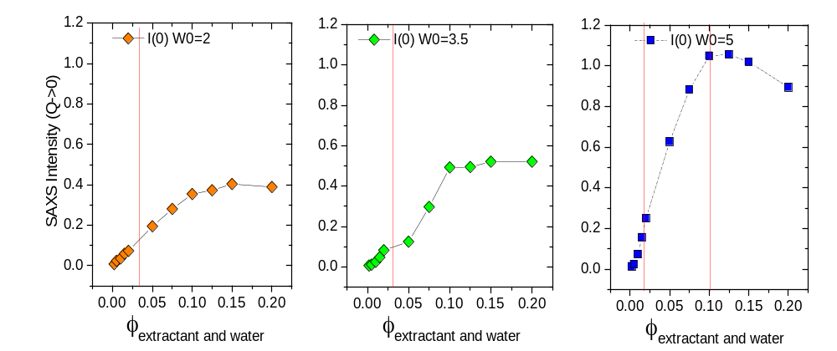
Figure S3: Extrapolation to Q = 0 of the SAXS patters shown in Figure S1. The red lines are guides to the eyes and correspond to the same lines shown in Figure 5 in the main text.
3. Raw data of the conductivity for dilution with oil
W0=2 | PHI extr +water | [NaDEHP] (mol/L) | [H20] (mol/L) | Conductivité (S/cm) | Reduced Cond
 | 0 |  |  | 1.41E-11 | --
 | 0.002 | 0.0054 | 0.0108 | 2.01E-10 | 0.173
 | 0.005 | 0.0134 | 0.0268 | 1.32E-09
 | 0.01 | 0.0268 | 0.0536 | 5.04E-09 | 0.187
 | 0.015 | 0.0402 | 0.0804 | 1.20E-08 | 0.198
 | 0.02 | 0.0536 | 0.1072 | 2.26E-08 | 0.211
 | 0.05 | 0.134 | 0.268 | 1.59E-07 | 0.233
 | 0.075 | 0.201 | 0.402 | 3.42E-07 | 0.218
 | 0.1 | 0.268 | 0.536 | 5.35E-07 | 0.187
 | 0.125 | 0.335 | 0.67 | 7.21E-07 | 0.157
 | 0.15 | 0.402 | 0.804 | 9.16E-07 | 0.135
 | 0.2 | 0.536 | 1.072 | 1.21E-06 | 0.095
W0=3.5 | PHI extr +water | [NaDEHP] (mol/L) | [H20] (mol/L) | Conductivité (S/cm) | Reduced Cond
 | 0 |  |  | 1.41E-11
 | 0.002 | 0.005 | 0.0175 | 2.87E-09 | --
 | 0.005 | 0.0126 | 0.0441 | 9.00E-10 | 0.07812
 | 0.01 | 0.0251 | 0.08785 | 4.90E-09 | 0.10818
 | 0.015 | 0.0377 | 0.13195 | 1.25E-08 | 0.11841
 | 0.02 | 0.0502 | 0.1757 | 2.33E-08 | 0.12513
 | 0.05 | 0.1256 | 0.4396 | 1.37E-07 | 0.11463
 | 0.075 | 0.1884 | 0.6594 | 2.80E-07 | 0.10181
 | 0.1 | 0.2512 | 0.8792 | 4.78E-07 | 0.09558
 | 0.125 | 0.314 | 1.099 | 6.78E-07 | 0.08496
 | 0.15 | 0.3768 | 1.3188 | 8.87E-07 | 0.07544
 | 0.2 | 0.5023 | 1.75805 | --
W0=5 | PHI extr +water | [NaDEHP] (mol/L) | [H20] (mol/L) | Conductivité (S/cm) | Reduced Cond
 | 0 |  |  | 1.4055E-11 | --
 | 0.002 | 0.0047 | 0.0235 | 2.89162E-10 | 0.0976
 | 0.005 | 0.0118 | 0.059 | 2.223E-9 | 0.117
 | 0.01 | 0.0236 | 0.118 | 1.38617E-8 | 0.1893
 | 0.015 | 0.0354 | 0.177 | 3.30691E-8 | 0.1987
 | 0.02 | 0.0472 | 0.236 | 5.57244E-8 | 0.1873
 | 0.05 | 0.1179 | 0.5895 | 2.4868E-7 | 0.1318
 | 0.075 | 0.1769 | 0.8845 | 5.62624E-7 | 0.1298
 | 0.1 | 0.2359 | 1.1795 | 1.47148E-6 | 0.1879
 | 0.125 | 0.2948 | 1.474 | 4.10362E-6 | 0.3291
 | 0.15 | 0.3538 | 1.769 | 1.15236E-5 | 0.63
 | 0.2 | 0.4717 | 2.3585 | 3.79162E-5 | 1.1195

1. Conductivity raw data corresponding to water dilution for different weight fraction S₀*of XDEHP in the solvent
S₀*=0.1
(orange in Figure 2)
 | W₀ | [NaDEHP] (mol/L) | [H20] (mol/L) | Conductivité (10⁻⁶ S/cm)
 | 1.02 | 0.27 | 0.2754 | 6.5E-7
 | 1.78 | 0.27 | 0.4806 | 4.5E-7
 | 2.95 | 0.27 | 0.7965 | 4.5E-7
 | 4.11 | 0.27 | 1.1097 | 0.000005
 | 5.27 | 0.27 | 1.4229 | 2.47E-5
 | 6.44 | 0.27 | 1.7388 | --
S₀*=0.25
(green in Figure 2)

 | W₀ | [NaDEHP] (mol/L) | [H20] (mol/L) | Conductivité (10⁻⁶ S/cm)
 | 1.05 | 0.68 | 0.714 | 1.05E-6
 | 1.52 | 0.68 | 1.0336 | 1.3E-6
 | 1.99 | 0.68 | 1.3532 | 1.15E-6
 | 2.93 | 0.68 | 1.9924 | 1.55E-6
 | 3.4 | 0.68 | 2.312 | 3.2E-6
 | 3.86 | 0.68 | 2.6248 | 1.35E-5
 | 4.33 | 0.68 | 2.9444 | 6.66E-5
 | 4.8 | 0.68 | 3.264 | 1.838E-4
 | 5.27 | 0.68 | 3.5836 | 3.02E-4
 | 6.21 | 0.68 | 4.2228 | 5.52E-4
 | 7.15 | 0.68 | 4.862 | 8.38E-4
 | 8.09 | 0.68 | 5.5012 | 0.00108

S₀*=0.5
(blue in Figure 2)
 | W₀ | [NaDEHP] (mol/L) | [H20] (mol/L) | Conductivité (10⁻⁶ S/cm)
 | 1.27 | 0.976 | 1.23952 | 9.00E-07
 | 1.5 | 0.976 | 1.464 | 1.5E-6
 | 1.73 | 0.976 | 1.68848 | 2.05E-6
 | 1.97 | 0.976 | 1.92272 | 2.6E-6
 | 2.2 | 0.976 | 2.1472 | 3.6E-6
 | 2.43 | 0.976 | 2.37168 | 5.6E-6
 | 2.66 | 0.976 | 2.59616 | 7.8E-6
 | 2.89 | 0.976 | 2.82064 | 1.01E-5
 | 3.13 | 0.976 | 3.05488 | 1.94E-5
 | 3.36 | 0.976 | 3.27936 | 4.36E-5
 | 3.59 | 0.976 | 3.50384 | 7.69E-5
 | 4.05 | 0.976 | 3.9528 | 2.07E-4
 | 4.52 | 0.976 | 4.41152 | 4.24E-4
 | 4.98 | 0.976 | 4.86048 | 7.28E-4
 | 5.45 | 0.976 | 5.3192 | 0.00101
 | 5.91 | 0.976 | 5.76816 | 0.00139
 | 6.61 | 0.976 | 6.45136 | 0.0019
 | 7.3 | 0.976 | 7.1248 | 0.00241
 | 8 | 0.976 | 7.808 | 0.00291
 | 8.69 | 0.976 | 8.48144 | 0.0034
 | 9.39 | 0.976 | 9.16464 | 0.0037
 | 10.55 | 0.976 | 10.2968 | 0.00436
 | 11.71 | 0.976 | 11.42896 | 0.0048
 | 12.87 | 0.976 | 12.56112 | 0.0052
 | 14.03 | 0.976 | 13.69328 | 0.00556
 | 15.19 | 0.976 | 14.82544 | 0.00587
 | 17.51 | 0.976 | 17.08976 | 0.00637
 | 19.83 | 0.976 | 19.35408 | 0.00679
 | 22.15 | 0.976 | 21.6184 | 0.00716
 | 24.47 | 0.976 | 23.88272 | 0.0075
 | 26.78 | 0.976 | 26.13728 | 0.00782
 | 31.42 | 0.976 | 30.66592 | 0.00841
 | 36.06 | 0.976 | 35.19456 | 0.00892
 | 40.7 | 0.976 | 39.7232 | 0.00937

References
1. El Maangar A, Lopian T, Dourdain S, et al (2022) Diluent effects on the stability range of w/o micellar systems and microemulsions made with anionic extractants. EPJ N-Nuclear Sciences & Technologies 8:28. https://doi.org/10.1051/epjn/2022025

