A novel murine model of infective endocarditis mimics human pathophysiology
Benedikt Bartsch*, Ansgar Ackerschott, Muntadher Al-Zaidi, Raul Nicolas Jamin, Mariam Louis Fathy Nazir, Moritz Altrogge, Lars Fester, Jessica Lambertz, Mark Coburn, Georg Nickenig, Sebastian Zimmer, Christina Katharina Weisheit
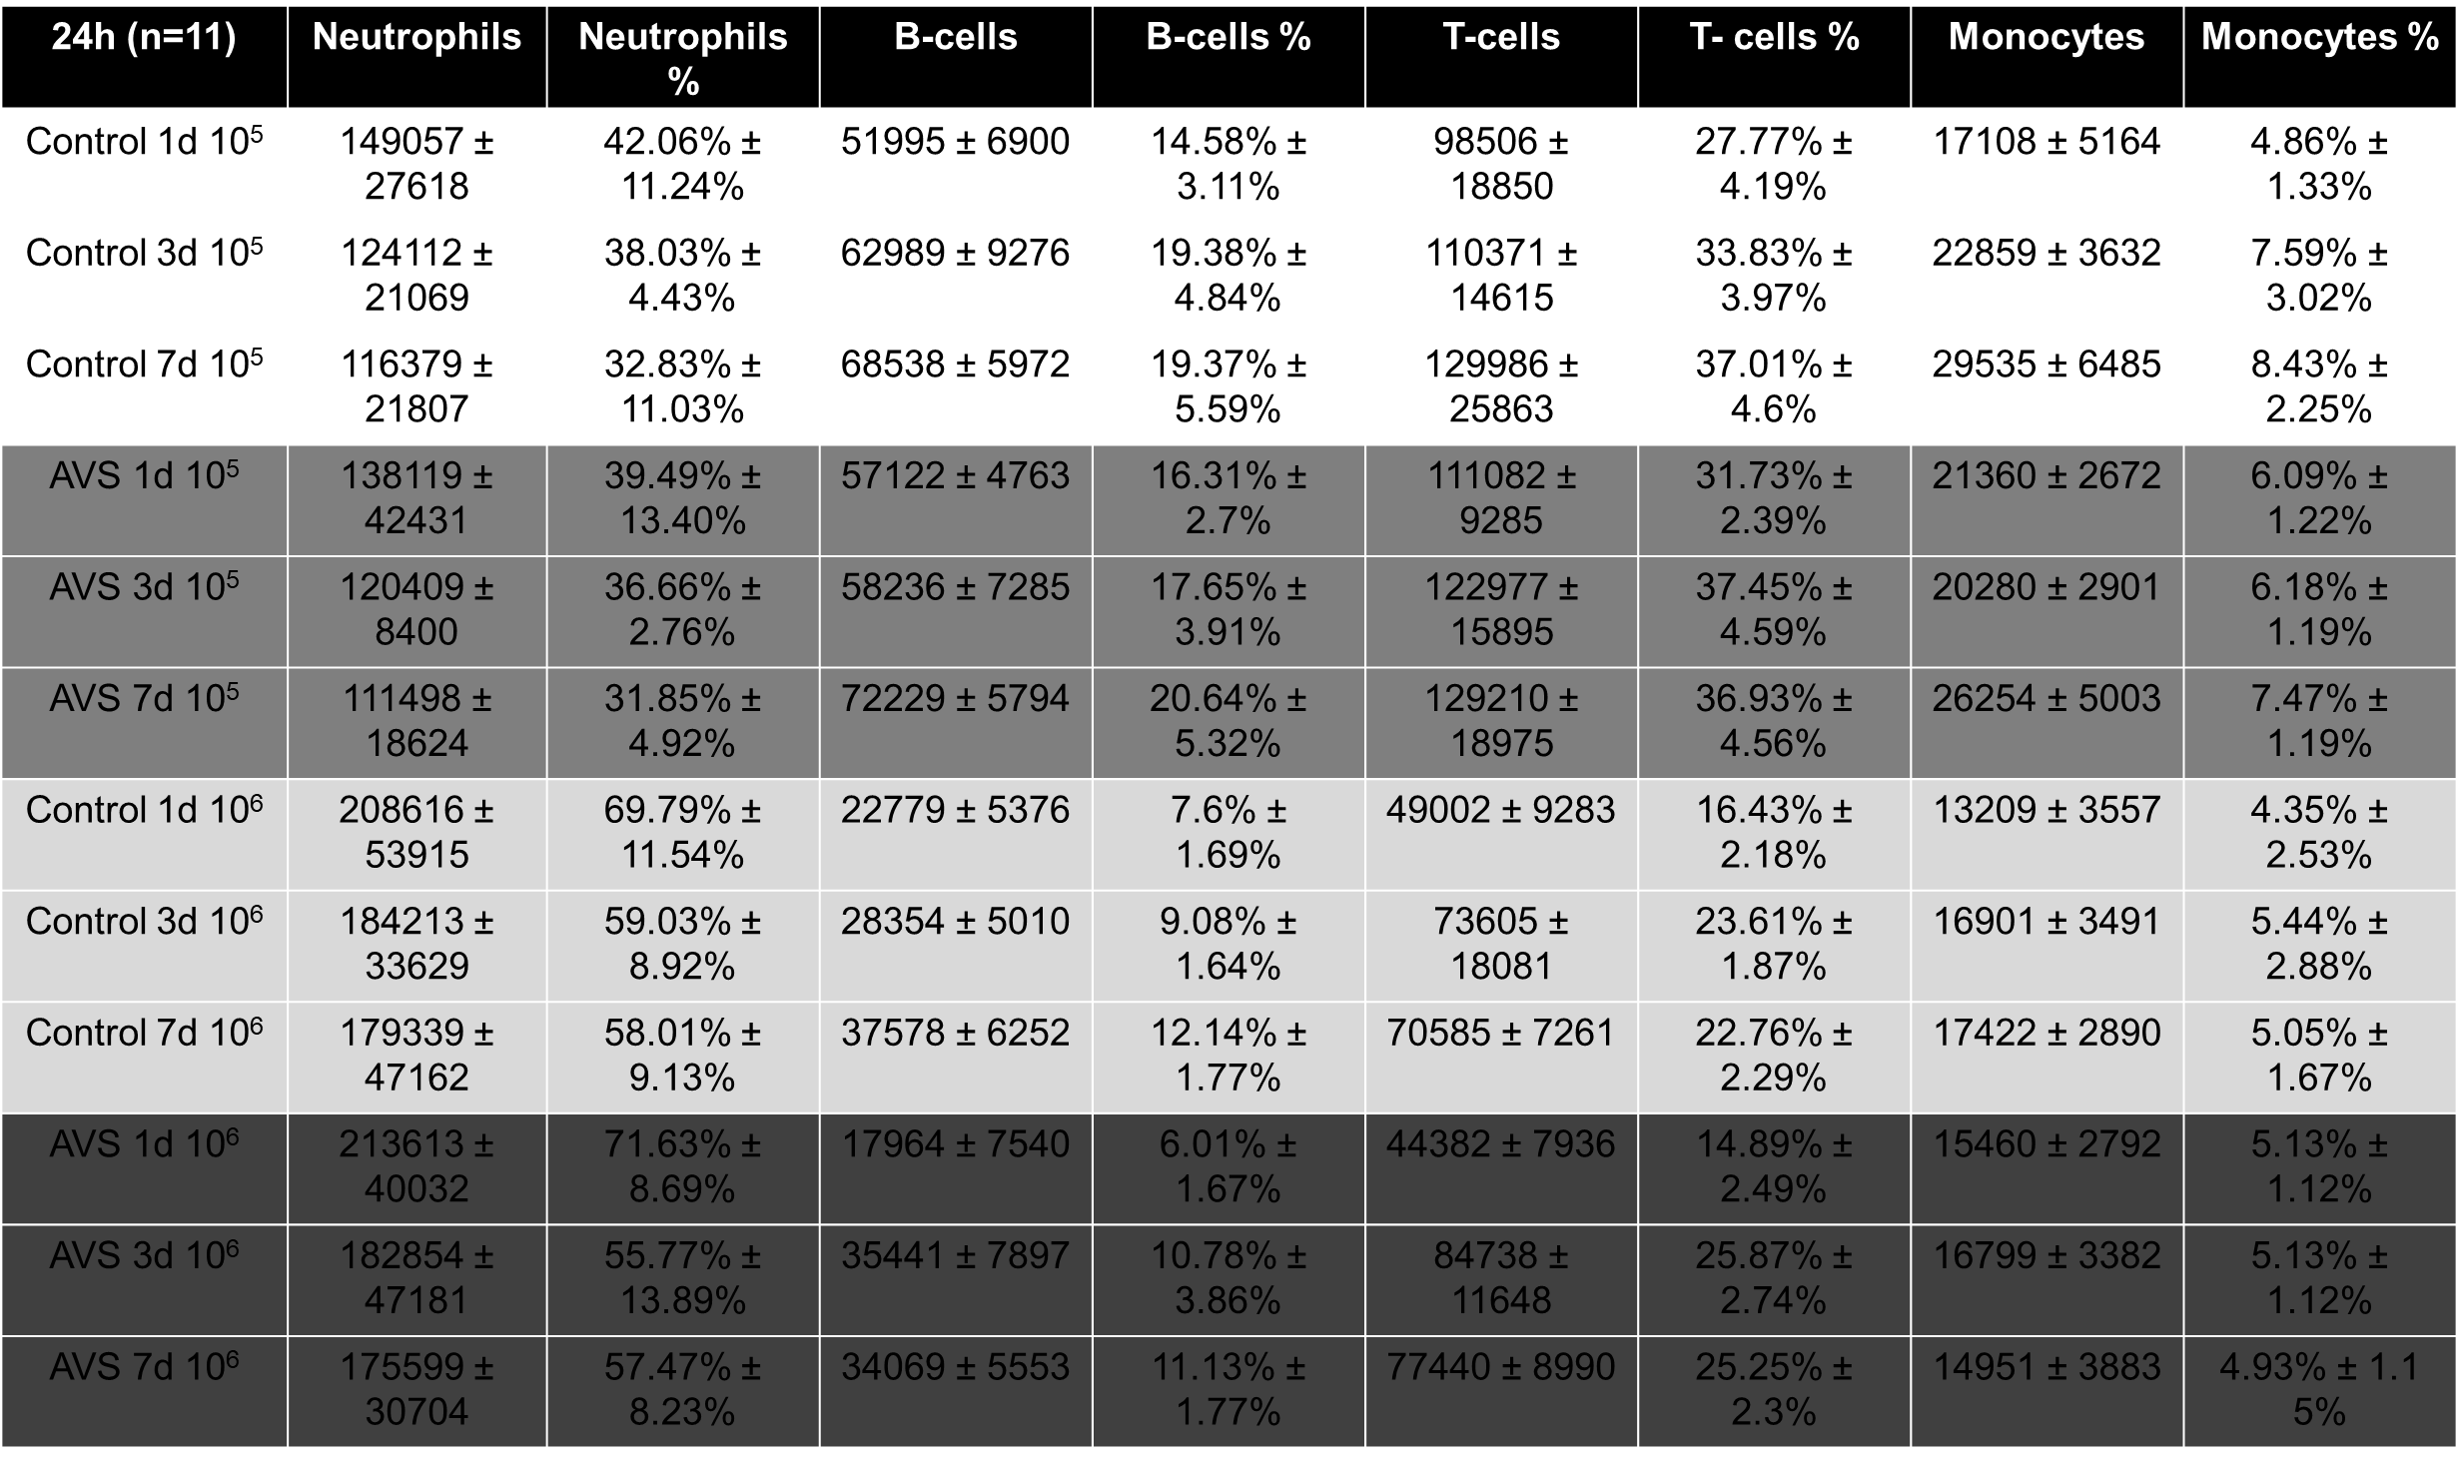
Supplemental Table 1 Flow cytometry from murine blood samples
Blood samples were drawn before sacrifice either 1d, 3d or 7d after wire-injury. Bacterial challenge was performed 24h after wire-injury. Cells were stained for LD, B220, CD11b, CD45, Ly6G and CD3. Data is presented as mean ± SEM.
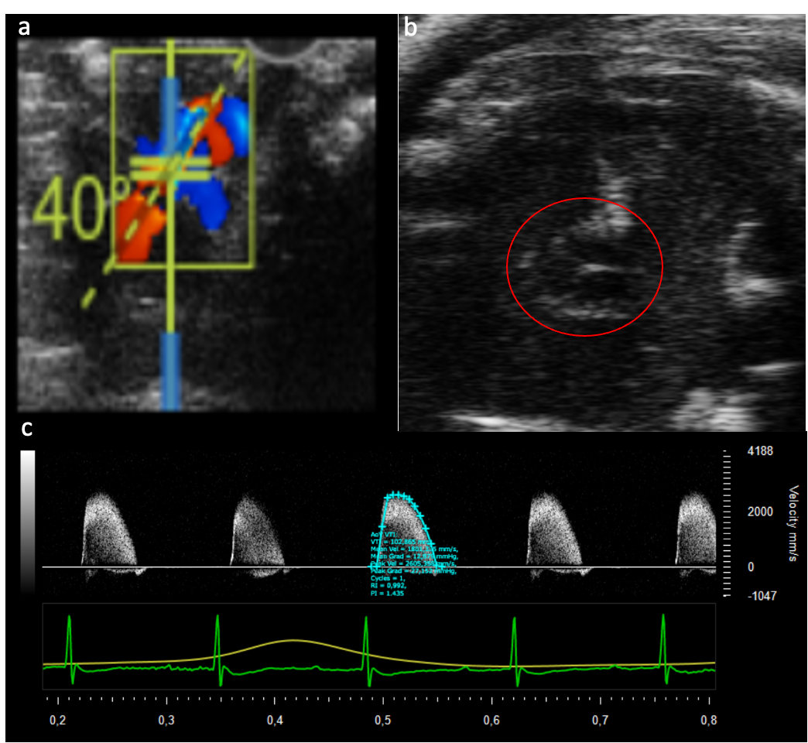
Supplemental Figure 1 Exemplary images of echogradiographic analysis
(a + c) Aortic valve peak velocity and gradients were measured in the suprasternal view with a pulse-wave-Doppler using angle correction between 40° and 50°. (b) Exemplary image of aortic valve cusp diameter in suprasternal short axis view.

