Assessment of extreme climate stress across China’s maize harvest region in CMIP6 simulations

Dengpan Xiao^{1,2*} Zexu Shi¹ Xinmin Chen^{1*} Yang Lu^{1,2} Huizi Bai³ Man Zhang^{1,2} Dandan Ren⁴ Yongqing Qi⁵

¹College of Geography Science, Hebei Normal University, Shijiazhuang 050024, China
²Hebei Laboratory of Environmental Evolution and Ecological Construction, Shijiazhuang 050024, China
³Hebei Technology Innovation Center for Geographic Information Application, Institute of Geographical Sciences, Hebei Academy of Sciences, Shijiazhuang 050011, China
⁴School of Resources and Environment (College of Carbon Neutrality), Linyi University, Linyi 276000, China.
⁵Key Laboratory for Agricultural Water Resources, Hebei Key Laboratory for Agricultural Water Saving, Center for Agricultural Resources Research, Institute of Genetics and Developmental Biology, Chinese Academy of Sciences, Shijiazhuang 050021, China

* Corresponding authors:
Dengpan Xiao, xiaodp@sjziam.ac.cn;
Xinmin Chen, may_chenxm@163.com;
Dengpan Xiao, ORCID: 0000-0001-6900-1237
Table S1 Correlation coefficient (CC) between each GCM, the multi-model arithmetic mean (AM), independence weighted mean (IWM) and observed values for the 6 extreme climate indices (ECIs) during 1981–2014, The non-shaded numbers were the root mean square error of the GCM not corrected for bias, and the shaded numbers were the root mean square error of the GCM corrected for bias. NA denoted no available value.
GCMs | HD (d) |  | HSI (℃) |  | HCD (d) |  | R20 (d) |  | CWD (d) |  | CDD (d)
ACC1 | 0.27 | 0.66 | -0.04 | 0.28 | 0.18 | 0.59 | 0.67 | 0.73 | 0.68 | 0.72 | 0.62 | 0.73
ACC2 | 0.24 | 0.58 | -0.07 | 0.13 | 0.17 | 0.50 | 0.68 | 0.71 | 0.72 | 0.75 | 0.53 | 0.76
CAN | 0.23 | 0.65 | 0.24 | 0.40 | 0.18 | 0.56 | 0.34 | 0.68 | 0.60 | 0.61 | 0.67 | 0.75
CMC | 0.54 | 0.71 | 0.36 | 0.40 | 0.47 | 0.64 | 0.36 | 0.72 | 0.67 | 0.71 | 0.66 | 0.77
ECE1 | 0.47 | 0.64 | 0.27 | 0.31 | 0.41 | 0.56 | 0.65 | 0.72 | 0.76 | 0.77 | 0.75 | 0.73
ECE2 | 0.47 | 0.61 | 0.21 | 0.24 | 0.41 | 0.53 | 0.66 | 0.73 | 0.78 | 0.78 | 0.75 | 0.73
ECE3 | 0.31 | 0.59 | 0.20 | 0.31 | 0.25 | 0.52 | 0.63 | 0.71 | 0.76 | 0.77 | 0.73 | 0.75
FGO | 0.17 | 0.61 | -0.04 | 0.21 | 0.13 | 0.52 | 0.02 | 0.67 | 0.59 | 0.64 | 0.36 | 0.77
GFD | 0.41 | 0.66 | 0.15 | 0.30 | 0.33 | 0.58 | 0.52 | 0.72 | 0.69 | 0.71 | 0.65 | 0.73
INM1 | 0.22 | 0.61 | 0.16 | 0.42 | 0.20 | 0.58 | 0.33 | 0.55 | 0.63 | 0.65 | 0.71 | 0.77
INM2 | 0.19 | 0.60 | 0.09 | 0.33 | 0.17 | 0.56 | 0.40 | 0.64 | 0.65 | 0.66 | 0.69 | 0.77
IPS | 0.32 | 0.64 | 0.16 | 0.38 | 0.25 | 0.58 | 0.26 | 0.68 | 0.59 | 0.61 | 0.71 | 0.75
KAC | 0.32 | 0.57 | -0.06 | 0.13 | 0.27 | 0.49 | 0.67 | 0.72 | 0.71 | 0.73 | 0.66 | 0.73
MIR | 0.39 | 0.64 | 0.36 | 0.39 | 0.33 | 0.54 | 0.56 | 0.75 | 0.70 | 0.71 | 0.62 | 0.78
MPI1 | 0.42 | 0.63 | 0.35 | 0.30 | 0.38 | 0.56 | 0.48 | 0.72 | 0.66 | 0.70 | 0.72 | 0.72
MPI2 | 0.24 | 0.57 | 0.28 | 0.37 | 0.18 | 0.51 | 0.37 | 0.70 | 0.62 | 0.68 | 0.70 | 0.72
MRI | 0.48 | 0.64 | 0.20 | 0.34 | 0.38 | 0.56 | 0.53 | 0.73 | 0.71 | 0.72 | 0.69 | 0.77
NOR | 0.43 | 0.67 | 0.04 | 0.28 | 0.34 | 0.58 | 0.56 | 0.71 | 0.69 | 0.71 | 0.58 | 0.78
AM | 0.56 | 0.79 | 0.22 | 0.44 | 0.49 | 0.73 | 0.70 | 0.82 | 0.81 | 0.83 | 0.78 | 0.84
IWM | 0.66 | 0.80 | NA | NA | 0.58 | 0.75 | 0.77 | 0.83 | 0.83 | 0.85 | 0.79 | 0.82

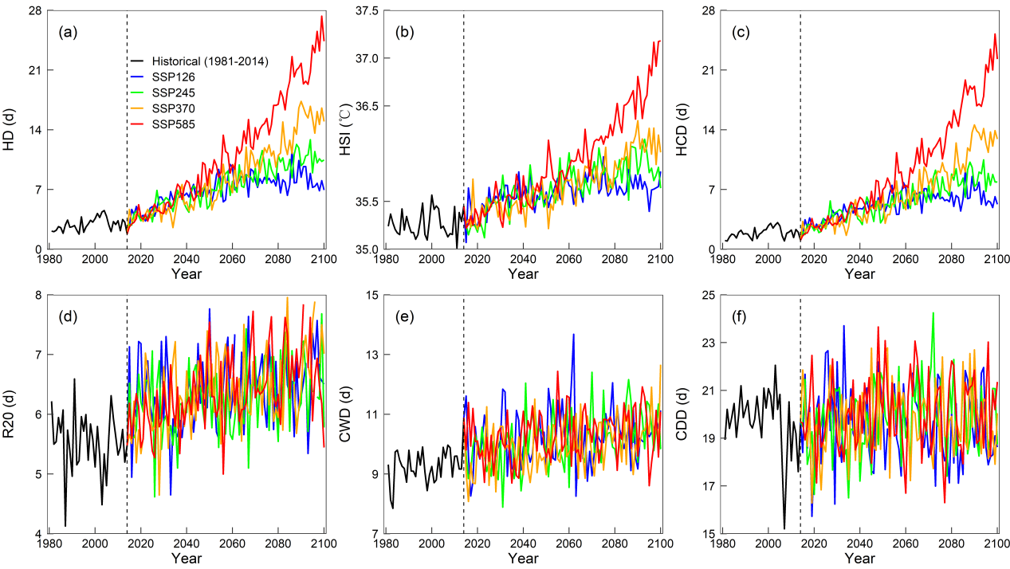
Fig. S1 The trends of 6 extreme climate indices (ECIs) in Zone Ⅱ during historical and future periods under four climate scenarios

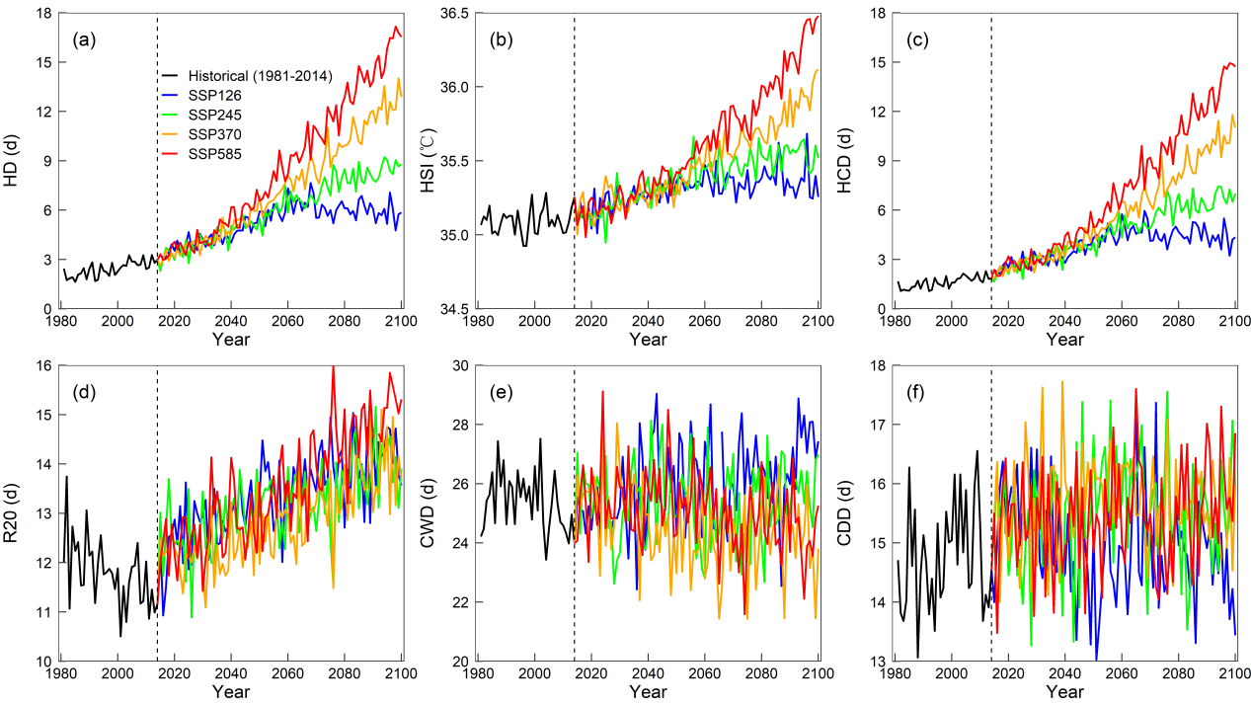
Fig. S2 The trends of 6 extreme climate indices (ECIs) in Zone Ⅲ during historical and future periods under four climate scenarios

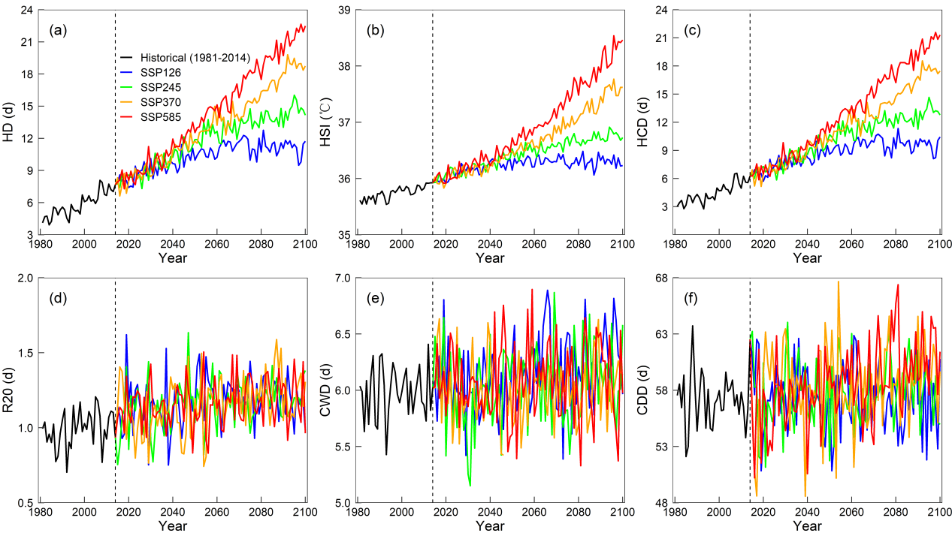
Fig. S3 The trends of 6 extreme climate indices (ECIs) in Zone Ⅳ during historical and future periods under four climate scenarios

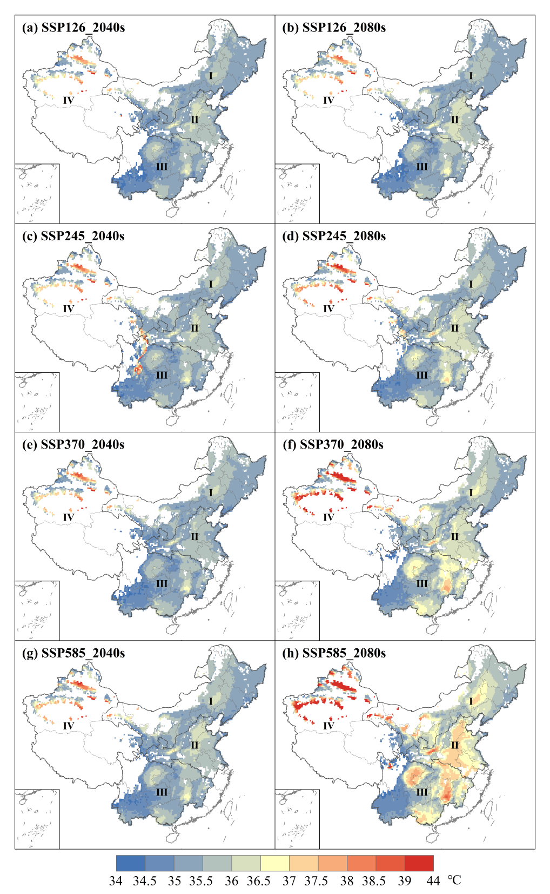
Fig. S4 Spatial distribution of HSI during 2040s (2031–2060) (a,c,e,g) and 2080s (2071–2100) (b,d,f,h) under SSP126 (a,b), SSP245 (c,d), SSP370 (e,f) and SSP585 (g,h)

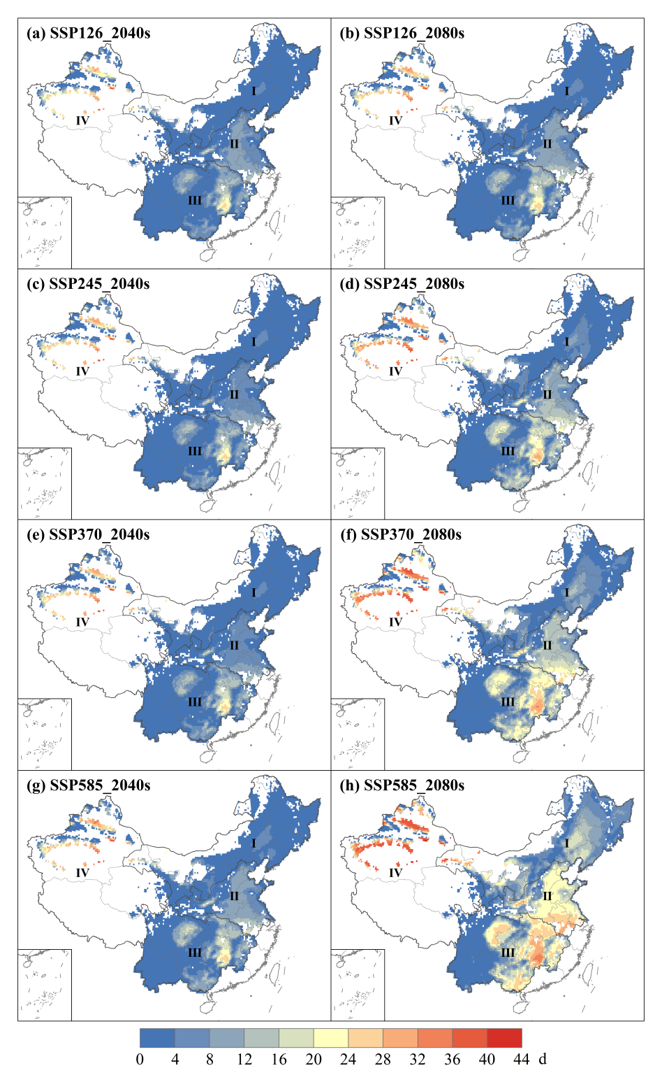
Fig. S5 Spatial distribution of HCD during 2040s (2031–2060) (a,c,e,g) and 2080s (2071–2100) (b,d,f,h) under SSP126 (a,b), SSP245 (c,d), SSP370 (e,f) and SSP585 (g,h)

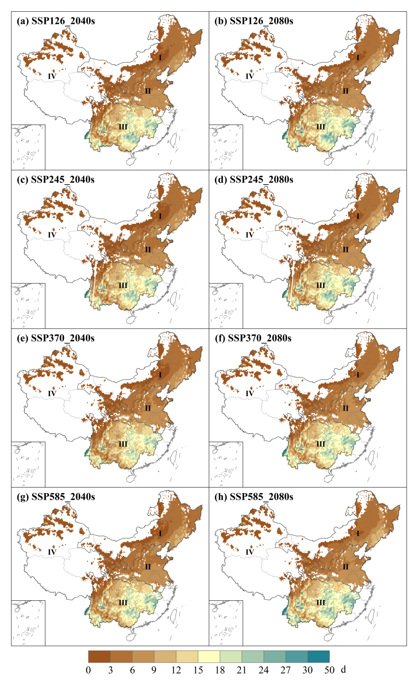
Fig. S6 Spatial distribution of R20 during 2040s (2031–2060) (a,c,e,g) and 2080s (2071–2100) (b,d,f,h) under SSP126 (a,b), SSP245 (c,d), SSP370 (e,f) and SSP585 (g,h)
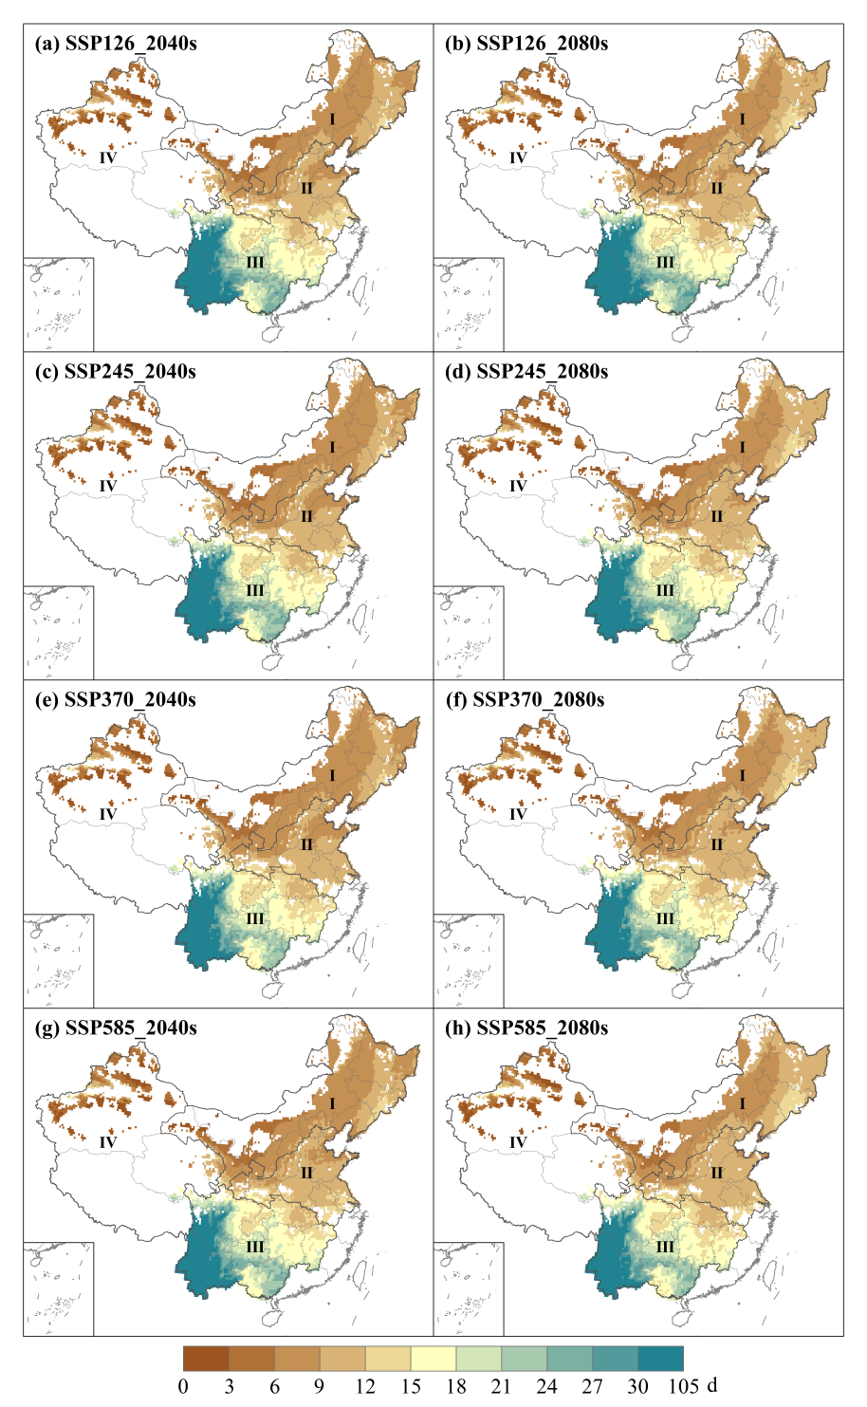
Fig. S7 Spatial distribution of CWD during 2040s (2031–2060) (a,c,e,g) and 2080s (2071–2100) (b,d,f,h) under SSP126 (a,b), SSP245 (c,d), SSP370 (e,f) and SSP585 (g,h)
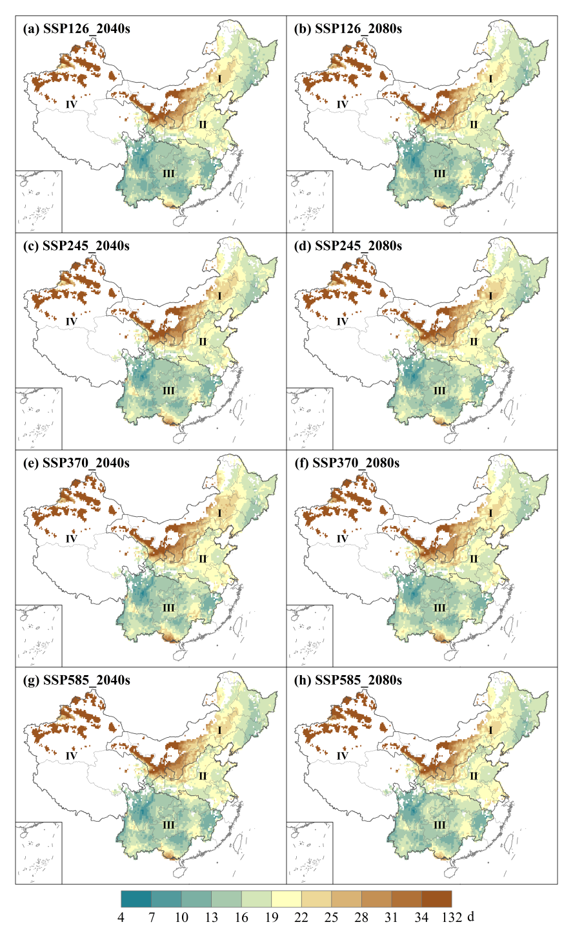
Fig. S8 Spatial distribution of CDD during 2040s (2031–2060) (a,c,e,g) and 2080s (2071–2100) (b,d,f,h) under SSP126 (a,b), SSP245 (c,d), SSP370 (e,f) and SSP585 (g,h)

