Electronic Material to the Letter submitted to Journal of Nanomaterials

Title:
Biocompatible Cobalt Oxide Nanoparticles for X-ray Fluorescence Microscopy
Authors:
Christian Scott¥, Sophia Miller#, Pierre Moenne-Loccoz$, Craig Eliot Barnes¥, Martina Ralle*#

Affiliations
¥Department of Chemistry; University of Tennessee; Knoxville, TN 37996-1600
#Department of Molecular and Medical Genetics; Oregon Health & Science University; Portland, OR 97239
$Department of Chemical Physiology and Biochemistry, Oregon Health and Science University, Portland, OR 97239

Email address of corresponding authors: Craig Barnes (cebarnes@utk.edu); Martina Ralle (rallem@ohsu.edu)

Keywords: cobalt oxide nanoparticles, biocompatible, stealth coating, X-ray fluorescence microscopy; bioorthogonal chemistry, click chemistry
Electronic Materials:Detailed synthetic procedures, NMR spectra, ICPMS, PXRD, TEM data; biochemical protocols
Statement of Conflict of Interest: The authors declare no competing financial interest.
Data Availability: All data is provided in the electronic supplementary material in addition to their corresponding references

Acknowledgements and Funding.
Research in this publication was supported by the National Institutes of Health award (R21 GM129592) to Martina Ralle, and Christian Scott. Sophia Miller was supported by the Medical Research Foundation of Oregon. ICPMS measurements were performed in the OHSU Elemental Analysis Core with partial support from the National Institutes of Health (S10OD028492). Electron microscopy was performed at the Multiscale Microscopy Core, a member of the OHSU University Shared Resource Cores.

Contents
Cobalt oxide (CoO) Nanoparticle Synthesis and Characterization 3
Cobalt(II) acetylacetonate dihydrate [Co(acac)₂(H₂O)₂] 3
Cobalt oxide Octadecyl amine coated nanoparticles 3
Ligand exchange strategy to obtain hydrophilic CoO nanoparticles 4
Interdigitation strategy to obtain hydrophilic CoO nanoparticles 4
Ligand exchange nanoparticle characterization 6
Powder X-ray Diffraction 6
Inductively coupled plasma mass spectroscopy 7
Single particle inductively coupled plasma mass spectroscopy (sp-ICPMS) 8
IR Study: Azide determination 10
Copolymer Chemicals: 13
Synthetic Protocols 16
Procedures for preparing the components of the PEG coating molecules on the CoO nanoparticles 16
MeO-PEG-OH (PEG₁₀₀₀) 16
MeO-PEG₁₀₀₀-COOH 16
MeO-PEG₁₀₀₀-NHS 16
MeO-PEG₁₀₀₀-nDOPA 17
PEG-2000 17
HO-PEG₂₀₀₀-OTs 17
2HO-PEG₂₀₀₀-N₃ 18
COOH-PEG₂₀₀₀-N₃ 18
NHS-PEG₂₀₀₀-N₃ 18
nDOPA-PEG₂₀₀₀-N₃ 19
Nitrodopamine 19
NMR Spectral Data 20

Cobalt oxide (CoO) Nanoparticle Synthesis and Characterization

Cobalt(II) acetylacetonate dihydrate [Co(acac)₂(H₂O)₂]
Cobalt (II) acetylacetonate dihydrate [Co(acac)₂(H₂O)₂] was synthesized following procedures described in Ellern et al.[1] 2,4 pentanedione 40.015g (0.4 mol 1eq) was added dropwise to ice cold, 150mL, sodium hydroxide solution (16.02g, 0.4 mol, 1eq). Once all the material was added the solution warmed to room temperature and stirred until all the white precipitate dissolved. To this solution, 47.659g CoCl₂•6H₂O (0.2 mol, 0.5eq) in 250mL H₂O was added dropwise over 2 hours. The resulting solid is filtered, washed with ice-cold 18MΩ H₂O (500mL), and allowed to dry to a moist paste. The solid is redissolved in a refluxing mixture of 260mL chloroform and 390mL absolute ethanol. The red solution cooled to room temperature and placed in the fridge overnight. The orange/ pink crystals were filtered off washed with cold absolute ethanol and dried on the filter resulting in a free-flowing powder. Yield: 48.305g (81.7%)

Cobalt oxide Octadecyl amine coated nanoparticles
CoO NPs were synthesized using cobalt (II) acetylacetonate dihydrate [Co(acac)₂(H₂O)₂] using published procedures with slight modifications.[2] To synthesize the nanoparticles [Co(acac)₂(H₂O)₂] (0.6g, 2mmol) is mixed with octadecylamine (10mL, 8.64g) and placed in a 280°C salt bath for 1h with vigorous stirring open to the atmosphere. The pink mixture quickly turns black as the Co(acac)₂ is decomposed to the corresponding CoO-NP. After 1h hour the material was cooled to room temperature, excess octadecylamine is removed from the top of reaction flask and the black solid is dissolved in absolute ethanol 40mL. The black solution is centrifuged, and the supernatant is discarded. The resulting pellet is dissolved in 1-2mL of heptane followed by the addition of 12mL of ethanol and centrifuged once more. This process is repeated until the supernatant remains a pale clear yellow color (~4 washes). The pellet is dissolved in 7mL of heptane, vortexed for 1 min, sonicated for 10 min, and centrifuged for 3-5 min to remove any large, aggregated material. The black liquid is then passed through a 0.22-micron PTFE syringe filter and dried under vacuum at 60°C resulting in a hard waxy black material (0.140 g).

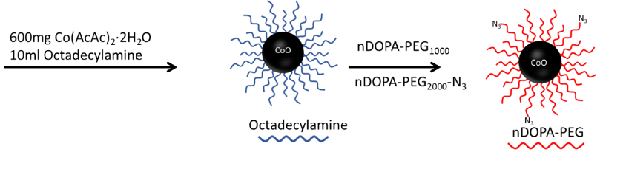
Ligand exchange strategy to obtain hydrophilic CoO nanoparticles
To exchange the hydrophobic octadecylamine coating on the nanoparticles with water soluble nDOPA-PEG-OMe/N₃ coating the obtained NP material (50mg) is transferred to a 4-dram vial along with 100mg of nDOPA-PEG-OMe/N₃ (0-10% azide) and dissolved in 10mL of chloroform. The vial is sonicated for 2h, stirred overnight, and sonicated an additional hour. The chloroform is removed using a rotary evaporator at 50°C. Once dried 10mL of ultra-pure water was added and the material was stirred for an additional hour and sonicated for 10 min. The now yellow-brown aqueous later was filtered through a hydrophilic 0.22µm PTFE syringe filter leaving behind the undissolved material. Excess PEG was removed using 100k MWCO centrifugal filter using 5 x 10mL water washings. The concentrated NP solution was diluted to 2mL creating a stock solution.

Interdigitation strategy to obtain hydrophilic CoO nanoparticles
To produce water-soluble NPs a modified procedure was followed.[3] First 10mg of C18-NPs is dissolved in 2ml of chloroform and 10mg of maleic anhydride alt octadecyl vinyl ether (7k MW) is added and stirred overnight. The following day a 5-molar excess of amino-polyethylene glycol monomethyl ether (M_{w} 550) with 0-100% α-amino, ω-azido- polyethylene glycol (M_{w} 600) and reacted overnight. The following day 2ml 18MΩ water containing 20uL of ethanol amine was added and the chloroform was removed. Next 2ml of chloroform was added, the mixture was shaken to remove any water-insoluble byproducts, centrifuged (3500rpm 15 min). The corresponding aqueous phase was further purified using 100k MWCO spin filters with 5x washings (3ml, 18MΩ H₂O). The resulting concentrated solution was diluted to 2ml forming a pale brown solution that remains stable for several weeks.
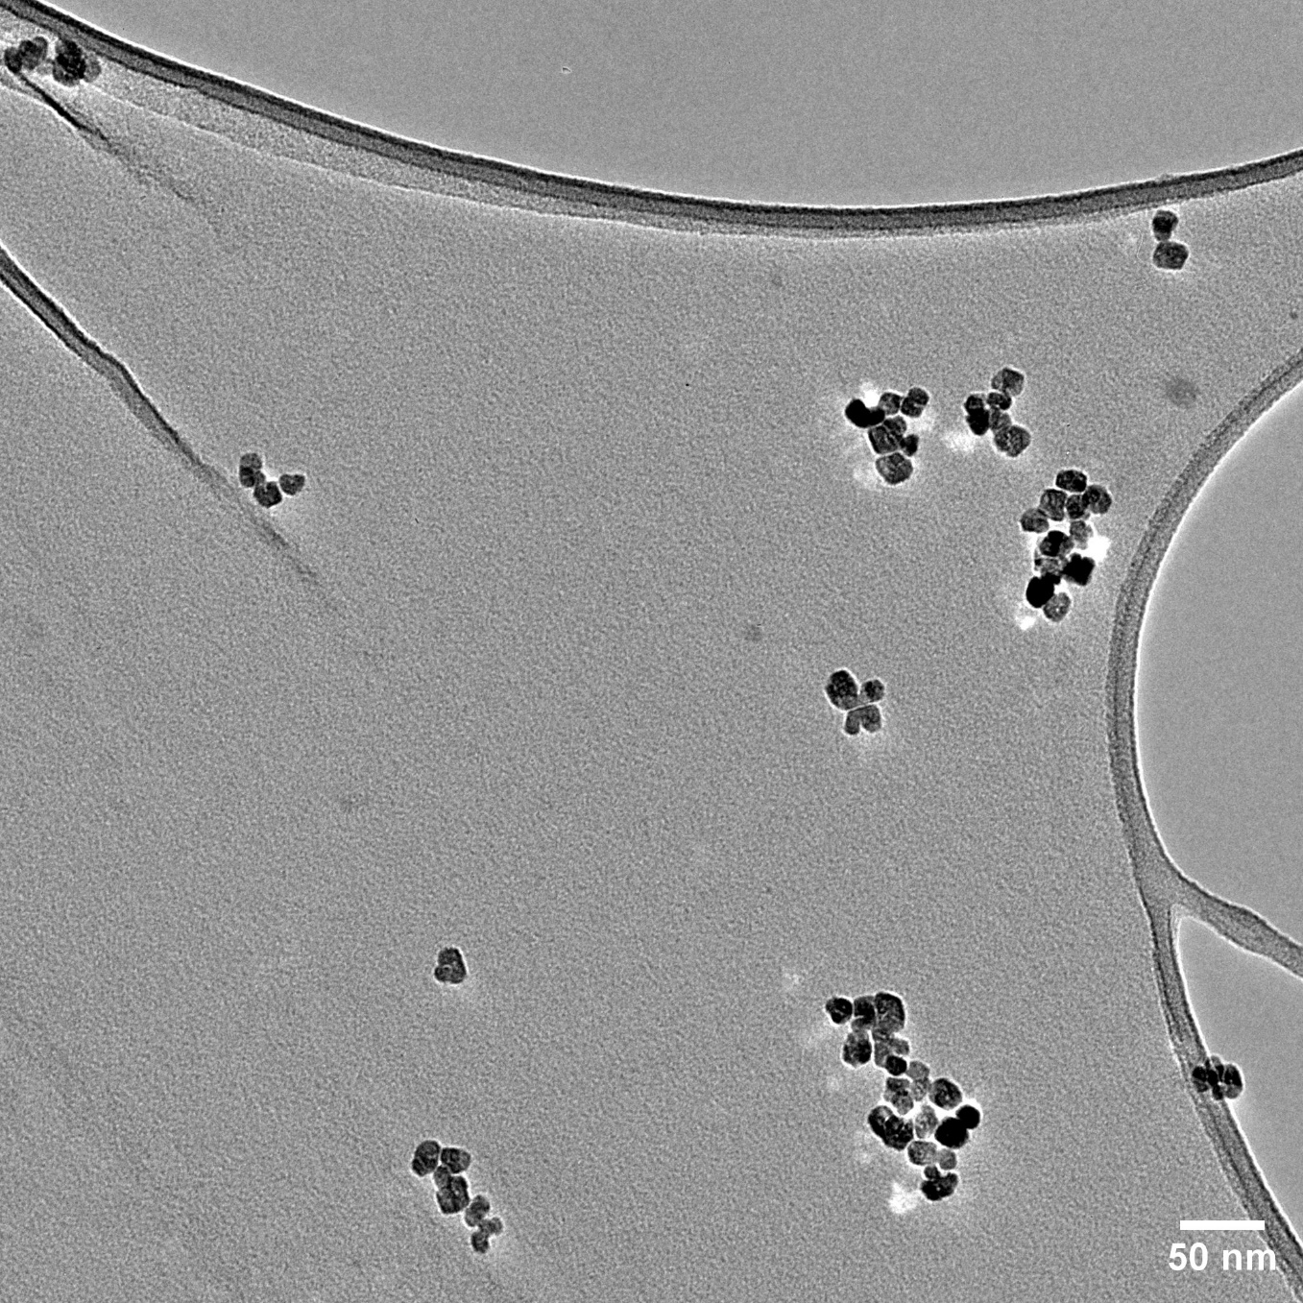
Figure S1 TEM of CoO-Octadecylamine coated NPs as synthesized and purified by washing with ethanol.

Ligand exchange nanoparticle characterization

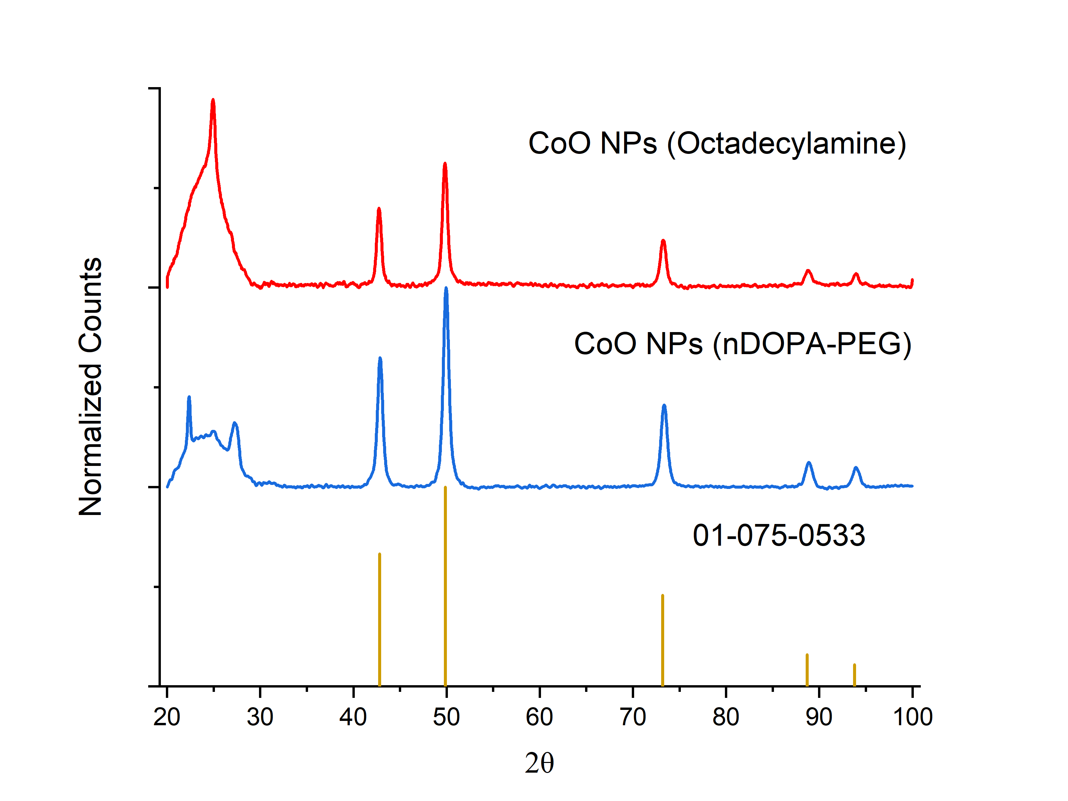
Powder X-ray Diffraction
Figure S2 CoO NPs prior to ligand exchange (CoO-octadecylamine) and post ligand exchange (CoO-nDOPA). Collected on Panalytical Empyrean with Co Anode. K_{α} 1.789 Å. The broad peaks from ~20-30 2θ are attributed to the amorphous material (octadecylamine and PEG) surrounding the NPs.

Scherrer analysis of the diffractograms shown in Table S1. The shape factor chosen was 0.94 and wavelength of 1.789 Å were used in the calculations.

Table S1. Position and full with at half maximum (FWHM) of CoO-NPs
CoO-nDOPA NPs |  |  | CoO-octadecylamine NPs
Pos. [°2θ] | FWHM [°2θ] | Particle size (nm) | Pos. [°2θ] | FWHM Left [°2θ] | Particle size (nm)
42.648 | 0.5117 | 20.21 | 42.888 | 0.5117 | 20.23
49.651 | 0.614 | 17.29 | 49.874 | 0.614 | 17.31
72.836 | 0.614 | 19.50 | 73.042 | 0.921 | 13.02
88.195 | 0.7164 | 18.73 | 88.465 | 0.7164 | 18.77
93.199 | 0.7164 | 19.57 | 93.418 | 0.8187 | 17.16
Average Diameter (nm) |  | 19.06 | Average Diameter (nm) |  | 17.30

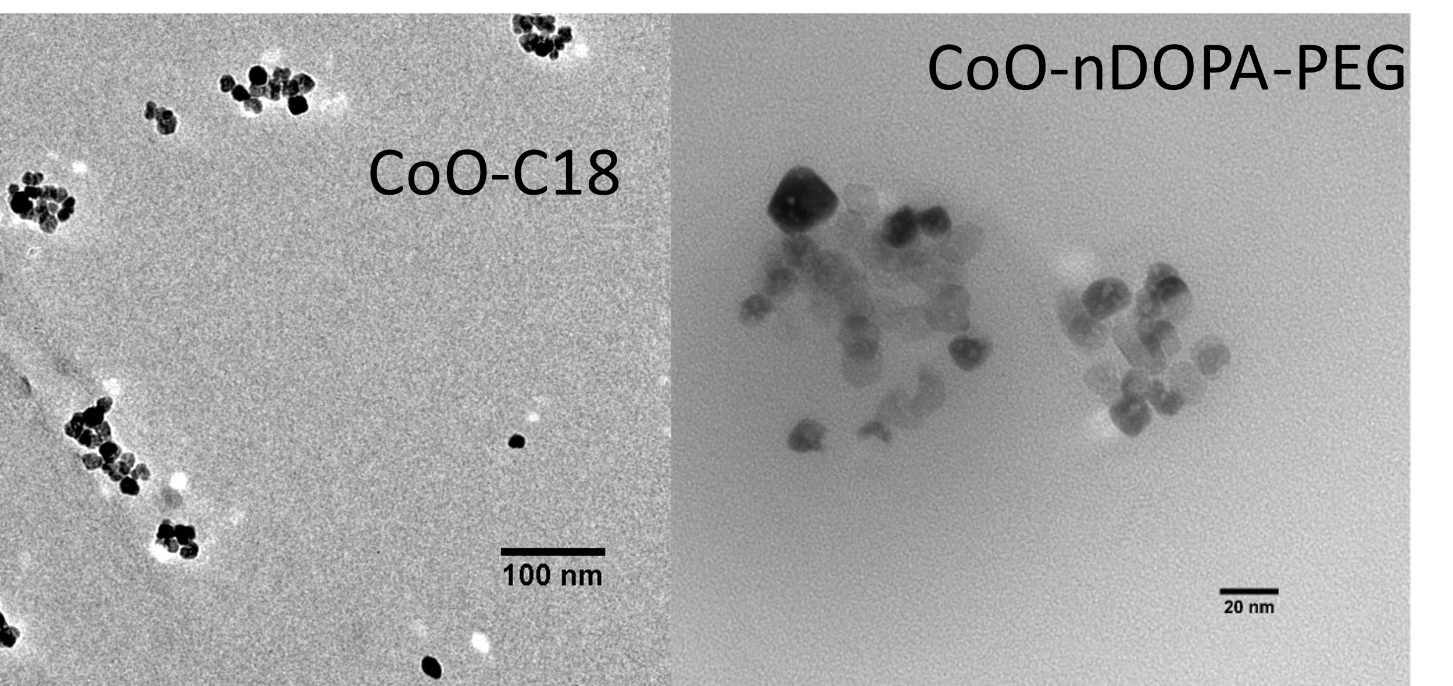
Figure S3 TEM of CoO-Octadecylamine coated NPs (left) and CoO-nDOPA coated NPs right.

Inductively coupled plasma mass spectroscopy
(ICPMS) analyses were performed using an Agilent 8900 ICP-QQQ equipped with an SPS4 autosampler. The system was operated at a radio frequency power of 1550 W, an argon plasma gas flow rate of 15 L/min, Ar carrier gas flow rate of 0.9 L/min. Data were quantified using weighed, serial dilutions of a multi-element standard (CEM 2, (VHG labs, VHG-SM70B-100) for Co. Data were quantified using a 12-point calibration curve. For each sample, data were acquired in triplicate and averaged. A coefficient of variance (CoV) was determined from frequent measurements of a sample containing 10 ppb of Co. To ensure accuracy of the calibration curve a NIST water standard (SRM 1683f) was prepared at 8x dilution and measured.

Single particle inductively coupled plasma mass spectroscopy (sp-ICPMS)
Single particle ICPMS is a relatively new technique to characterize the size distribution and concentration of NP samples.[4] NP analyte solutions are diluted to the nanomolar range and are sprayed into the instrument at a low flow rate (100 µl/min). Each particle produces an individual “plume” of elements in the Ar plasma that is measured as individual event in time-resolved mode. Data analysis for each individual event reveals both, the size and size distribution of the NPs in the solution. spICPMS analyses of both the original octadecylamine coated CoO nanoparticles and the final PEG-coated nanoparticles yielded similar NP size distributions similar to PXRD and TEM analyses with maxima between 18 and 20 nm.
The size distributions of the CoO NPs were analyzed using an Agilent 8900 ICP-QQQ equipped with a single particle setup from Elemental Scientific Instruments (ESI). Instrument and measurement details are described in Table S2. All nanoparticle samples were vortexed and sonicated for 3 minutes prior to measurement to reduce particle agglomeration. Data was processed using the Agilent MassHunter software with the ESIFast plug-in. Nebulization efficiency was determined by the software using the calculated mean particle size of a platinum nanoparticle reference material (NanoXComposix, PTCN50-50M). For data analysis, the particle detection range was set to exclude nanoparticle signals ≤ 16 nm, as these nanoparticles exceed the lower limit of detection (Figure S4).

Table S2. spICPMS instrument details

Group | Parameter | Value
ICPMS components for nanoparticle analysis | Instrument Model | Agilent 8900-QQQ
ICPMS components for nanoparticle analysis | Nebulizer | CytoNeb 50
ICPMS components for nanoparticle analysis | Spray Chamber | CytoSpray
ICPMS components for nanoparticle analysis | Autosampler | Elemental Scientific Instruments MicroFAST
Instrument Settings | RF Power | 1550 W
Instrument Settings | Nebulizer gas flow | 0.60 ml/min
Instrument Settings | Sample flow rate | 0.010 ml/min
Instrument Settings | Dwell Time | 100 μs
Instrument Settings | Acquisition Time | 60 s
Instrument Settings | Reaction Gas | He
Instrument Settings | Monitored Isotopes (m/z) | ⁵⁹Co⁺

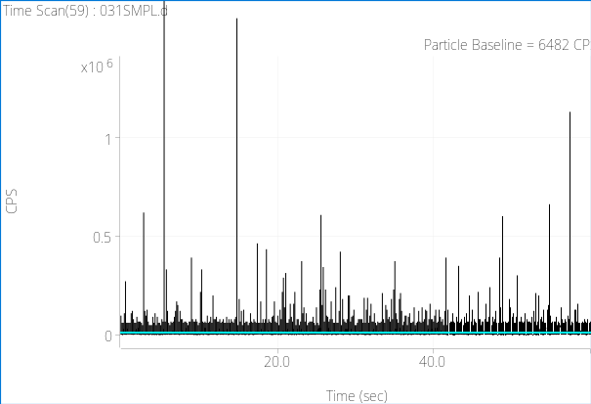
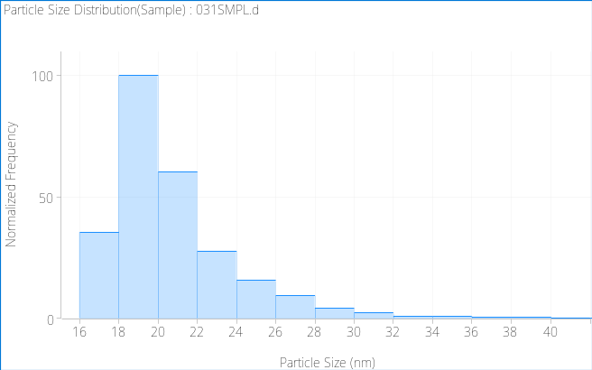
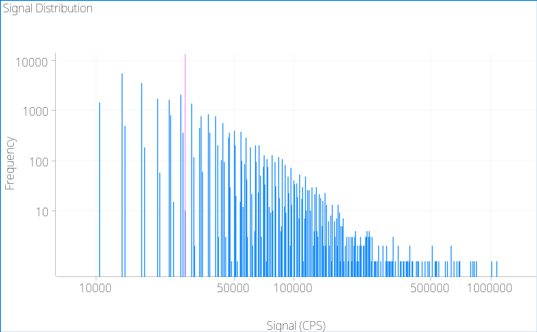
sp-ICPMS measurements were conducted to confirm the CoO nanoparticle diameter found by XRD and TEM and to determine the size distribution of the CoO nanoparticles. Analysis from three independent samples found the mean diameter to be consistently in the range of 18 – 20 nm. SpICPMS experiments performed on a suspension of uncoated CoO nanoparticles confirmed 19 nm as average diameter.
(a)
(c)
(b)
Figure S4 Measurement results of CoO nanoparticles via sp-ICPMS, displayed in MassHunter as detected counts per second (CPS) over time with an automatically calculated baseline signal of 6482 CPS (a), frequency of each signal (b), and a histogram of calculated particle size in nanometers (c).

TEM
Pre and post functionalization TEM images were obtained to verify that NP size and/or aggregation was not affected by post synthesis modifications. From the TEM images it can be observed that the NPs look nearly identical in size and shape to the original hydrophobic nanoparticles (see Figures S1, S3).

IR Study: Azide determination
Azide detection limit determination was conducted using an aqueous solution sample holder for FTIR analysis. Azide detection was not observed for the ligand exchanged NPs due to the low concentration of NPs and thus the low concentration of azide groups within the solution. The detection of the azide stretch at ~2100 of pure azide-PEG-nDOPA in solution showed a slight stretch however, it was not observed once ligand exchanged with octadecylamine. The interdigitation displayed an azide visible azide stretch with as low as 20% azide coating in the surface of the NP giving us confidence that we have successfully incorporated azide functionality into the NP system.
In Figure S5 the top three thin traces: the azide stretch mode in neat NH₂-PEG₄-N₃ (top black trace) is observed at 2106 cm⁻¹ and shifts +12 cm⁻¹ in water but retains its intensity. As expected the mode is not observed in HO-PEG1000-OMe (top red trace).
Two middle traces: The azide mode is also detected at 2118 cm⁻¹ in a water solution of N₃-PEG2000-nDOPA, although it nearly coincides with the broad 2130 cm⁻¹ band from H₂O (bending+libration combination band). Three bottom traces: After concentrating the CoO-N₃ solution ~ 3 fold by evaporation over a dry argon flow and after subtraction of the water background, C-H stretching modes from PEG at 2924 and 2852 cm⁻¹ are clearly detectable (bottom red trace, multiplied 20 time relative to the starting spectra of CoO-N₃ and water), but the concentration of the nanoparticles remains too low to detect the azide stretch. The N₃ and CH stretches have comparable intensities in the spectrum of N₃-PEG2000, so we can expect the observed I(νN₃)/I(νCH) to be representative of the PEG2000-N₃ to PEG1000-OMe ratio. We could increase the sensitivity by drying further the NP samples, but we are likely to still struggle if the PEG2000-N₃/PEG1000-OMe ratio is very low.
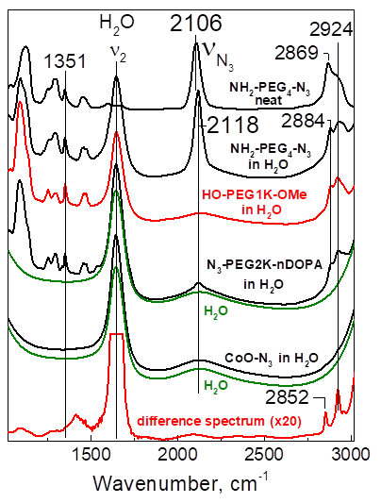
Figure S5 Ligand exchanged CoO-NPS All samples were sandwiched between 2 CaF₂ windows with a 15 μm Teflon spacer. Absorption spectra (against empty chamber background spectrum) were collected with 4-cm⁻¹ resolution at room temperature. The IR spectral window is limited by the CaF₂ absorbance below 1000 cm⁻¹ and the water ν₁ absorbance above 3000 cm⁻¹. To simply the data comparison, spectra were normalized on the PEG 1351 cm⁻¹ band (out-of-plane CH₂ deformation) and vertically offset.

All interdigitated samples were partly dried using a compressed argon gas flow to reduce the water signal background around 2100 cm⁻¹ and consequently the concentration in NPs is not matched from sample to sample. Nevertheless, the intensities of the mid-frequency modes between 1000 and 1500 cm⁻¹ are comparable suggesting that the NP concentrations are similar in all samples. These bands could be used as internal intensity standard to allow more precise quantitation of azide group content (Figure S6)
Large differential signals from the strong water band at 1644 cm⁻¹ mask any potential signal of interest in the 1500-1900 cm⁻¹ region. Deviation in water background signal also affect the baseline of the difference spectra in the high-frequency region, but asymmetric azide stretches are clearly identified between 2110 and 2121 cm⁻¹. The azide stretch upshifts with increasing azide group content, presumably reflecting the change in electrostatic/dielectric constant at the NP surface. In all cases, the bandwidth of the azide band at half-height is very broad, around 40 to 50 cm⁻¹, indicative of major inhomogeneous broadening.
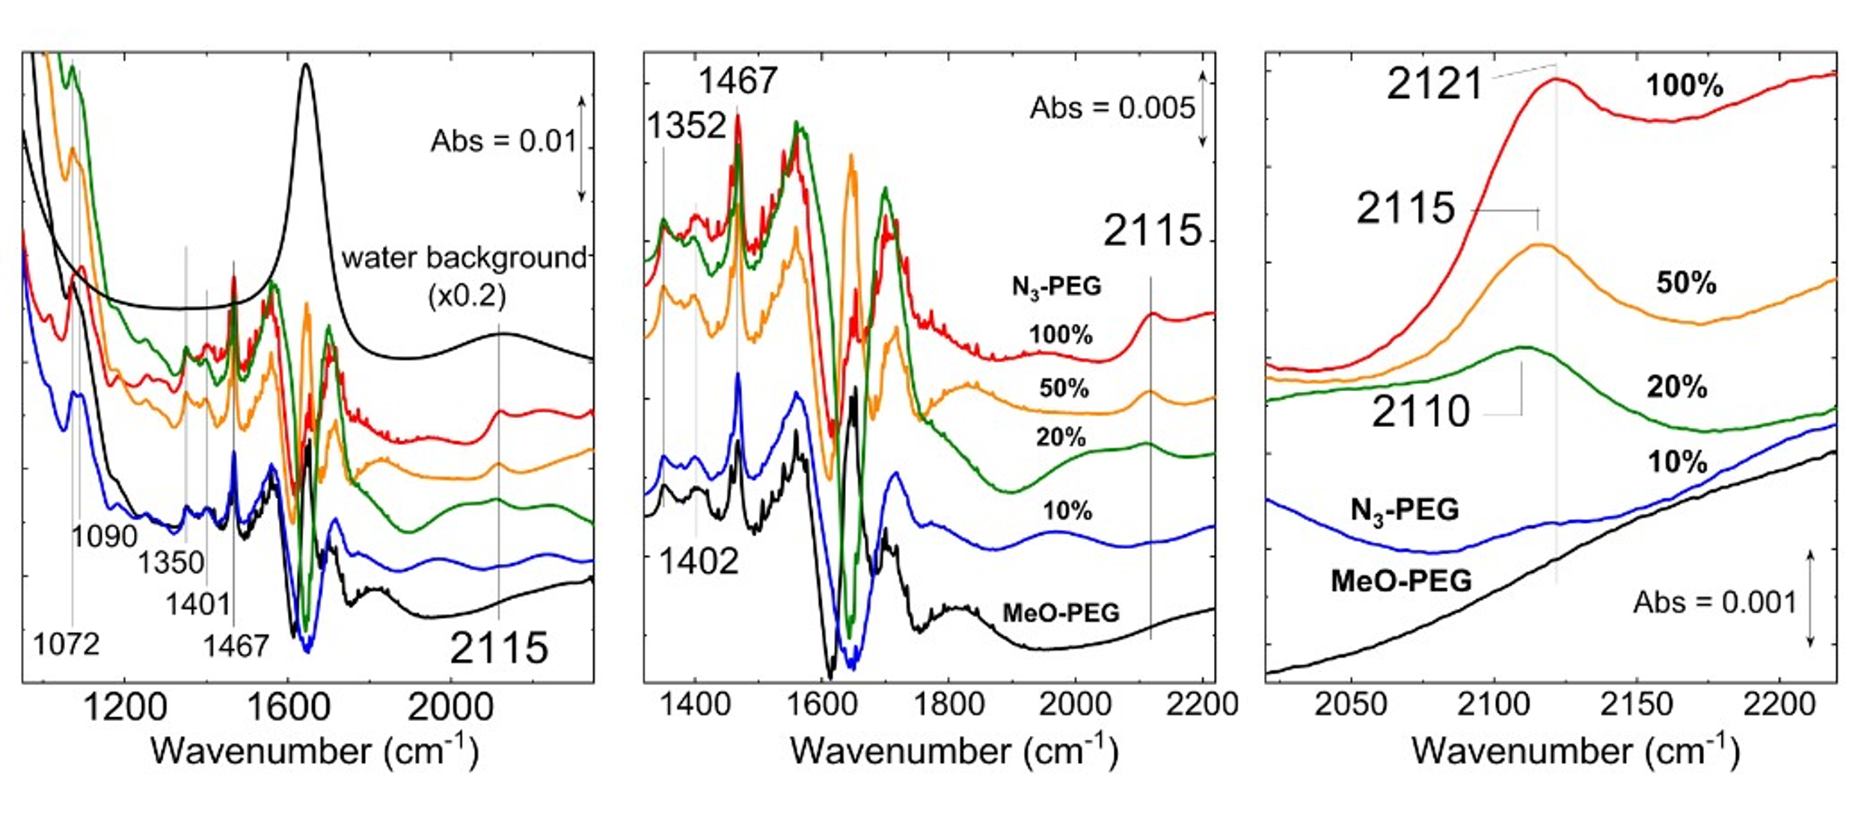
Currently, the 10% N3 content is barely observable above the poor baseline. However, the quality and sensitivity of these FTIR data could be improved if samples could be prepared at 3 or 4 time higher concentration (each IR film only requires 20 μL) with matched NP concentrations for all samples so that the MeO-NPs spectrum can be used as blank to generate difference spectra and minimal background/baseline problem associated with changes in solvating water signals
Figure S6 All spectra were collected with 2-cm-1 resolution on 15-μm films of aqueous solutions of CoO-NPs. The figures below show the FTIR spectrum of the water blank (black top trace on first panel only) and the difference spectra obtained for MeO-PEG-550-NH2-CoO-C18-C18-MAL (black bottom trace), N3-PEG600-NH2-100%-CoO-C18-C18-MAL (red trace), N3-PEG600-NH2-50%-CoO-C18-C18-MAL (orange trace), N3-PEG600-NH2-15%-CoO-C18-C18-MAL (green trace), and N3-PEG600-NH2-10%-CoO-C18-C18-MAL (blue trace). The water spectrum was divided by 50 and all traces were offset for clarity.

Copolymer Chemicals:
Octadecyl vinyl ether/maleic anhydride (1:1) copolymer (7k Mw), styrene/maleic anhydride (2:1) copolymer (7k Mw) were purchased from Scientific Polymer Products (Figure S7). Poly(isobutylene-co-maleic anhydride) (6k Mw) was obtained from Sigma-Aldrich. All copolymers were used as received. All other chemicals were purchased through Fisher Scientific and dried prior to use.
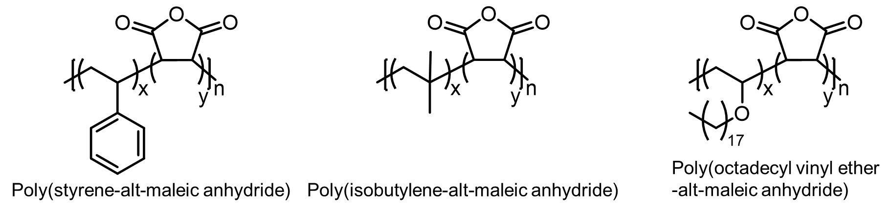
Figure S7. Three polymers tested for interdigitation of CoO-C₁₈-NH₂ nanoparticles.

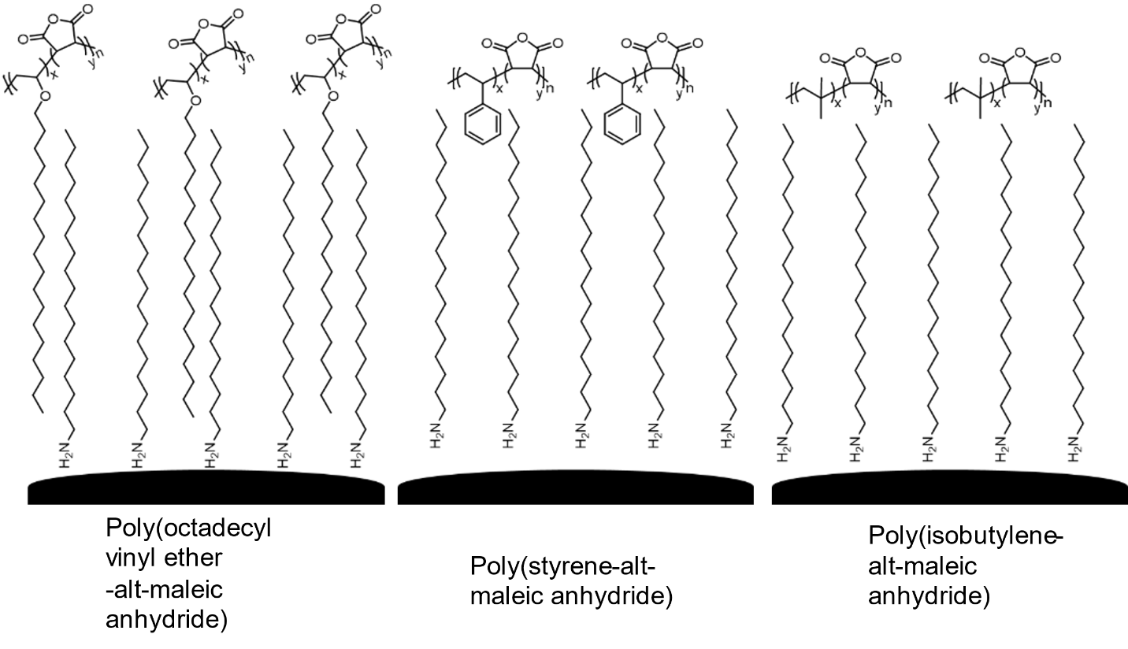
Figure S8. Illustration of interdigitation polymers tested to generate a water soluble NP

1. Ellern, J.B., et al., Hexacoordinate Complexes of Bis(2,4-Pentanedionato)Cobalt(II): [Bis (Acetylacetonato) Cobalt(II)], in Inorganic Syntheses. 1968. p. 82-89.
2. Purkayastha, D.D., B. Sarma, and C.R. Bhattacharjee, Surfactant-assisted low-temperature synthesis of monodispersed phase pure cubic CoO solid nanoparallelepipeds via thermal decomposition of cobalt(II) acetylacetonate. Materials Letters, 2013. 107: p. 71-74.
3. Schieber, C., et al., Conjugation of transferrin to azide-modified CdSe/ZnS core-shell quantum dots using cyclooctyne click chemistry. Angewandte Chemie (International ed. in English), 2012. 51(42): p. 10523.
4. Lee, S., et al., Nanoparticle Size Detection Limits by Single Particle ICP-MS for 40 Elements. Environmental Science & Technology, 2014. 48(17): p. 10291-10300.
5. Pohlit, H., et al., Silver Oxide Mediated Monotosylation of Poly(ethylene glycol) (PEG): Heterobifunctional PEG via Polymer Desymmetrization. Macromolecules, 2017. 50(23): p. 9196-9206.

- A

Synthetic Protocols

Procedures for preparing the components of the PEG coating molecules on the CoO nanoparticles

MeO-PEG-OH (PEG₁₀₀₀)

MeO-PEG₁₀₀₀-COOH
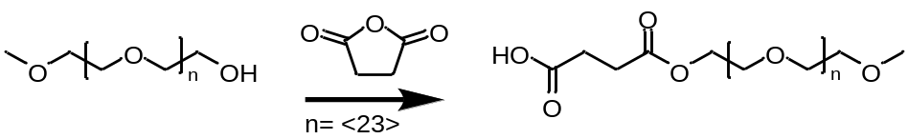
MeO-PEG₁₀₀₀-OH 5.019g (5 mmol, 1eq) was dissolved in dry chloroform to make a 0.05M solution (100mL) to this succinic anhydride 1.25g (12.4 mmol, 2.5eq) and 0.061g 4-dimethylaminopyridine (0.5 mmol, 0.1 eq) were sequentially added and refluxed in a nitrogen atmosphere overnight. The following day chloroform was removed, the crude product was dissolved in 25 mL 18MΩ water, washed with 50mL hexane: ethyl acetate (1:1), extracted with 50mL DCM (3x), dried over MgSO₄, filtered. The product was dried overnight at 50°C in vacuo yielding a waxy white solid. Yield: 5.507g, (99%).

MeO-PEG₁₀₀₀-NHS
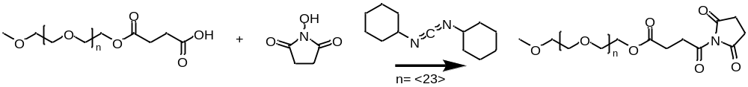
MeO-PEG₁₀₀₀-COOH (15) 1.647g (1.6 mmol, 1eq) was dissolved in 75 mL DCM, cooled to 0°C followed by the addition of 0.1900g NHS (1.65mmol, 1 eq) and reacted for 15 minutes. To this solution DCC 0.3444g (1.66mmol, 1eq) in 6mL DCM was added dropwise (~30min) the mixture warmed to RT and reacted overnight. The following day the urea salts were filtered off and the solution was washed with 15mL 18MΩ H₂O (2x) and washed with 10mL saturated NaCl solution (2x). The material was dried using MgSO₄, filtered through celite, and dried in vacuo at 40°C overnight. Yield: 1.098g, (61%).

MeO-PEG₁₀₀₀-nDOPA

MeO-PEG₁₀₀₀-NHS (16) 3.02 g (2.5 mmol, 1eq) was dissolved in 15mL DMF followed by the addition of 1.1 mL 4-methylmorpholine (10 mmol, 4 eq) to this 1.115g (3.76 mmol, 1.5 eq) nitro-dopamine hemi sulfate (25) was added in one portion. The mixture was overnight at RT. The following day the solvent was removed, the crude product was redissolved in DCM, and filtered. Solvent was removed once more, and the material was dissolved in a minimal amount of DCM and precipitated in ice cold diethyl ether. The precipitation process was repeated a second time to obtain the final product. Yield: 2.752 g, (84%).

PEG-2000

HO-PEG₂₀₀₀-OTs
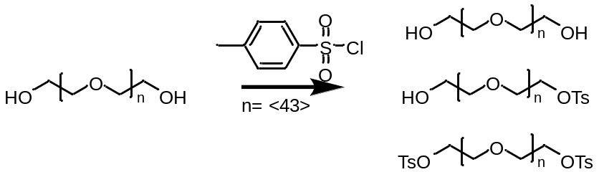

Tosyl-PEG₂₀₀₀-hydroxyl (HO-PEG₂₀₀₀-OTs) was prepared using a published procedure.[5] Using the published protocol we expected a higher then statistical distribution of products as the Ag₂O allows one end of the PEG to adsorb to the surface allowing the “tail” end of the PEG to be preferentially reacted. First dried dihydroxyl HO-PEG₂₀₀₀-OH 2.774g (1.39mmol, 1eq) was dissolved in anhydrous toluene (25mL) and heated to 35-40°C to this silver oxide 0.4712g (2.03mmol, 1.5eq), potassium iodide 0.0462g (0.278mmol, 0.2eq) were added under a nitrogen counterflow. After 15 minutes tosyl chloride 0.2734g (1.43 mmol, 1.03eq) was added in one portion. The reaction stirred overnight at 40°C. The following day the solution was filtered through a pad a celite, washed with DCM and dried under vacuum at 50-60°C. The material was carried on without any further purification. Yield: 2.818g, (94.2%).

2HO-PEG₂₀₀₀-N₃
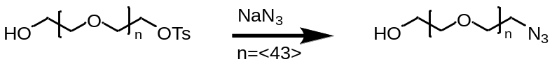
HO-PEG₂₀₀₀-OTs (18) 2.818g (1.31mmol, 1eq) was dissolved in 20mL anhydrous DMF followed by the addition of sodium azide 0.1709g (2.63 mmol, 2eq) and heated to 80°C under a nitrogen atmosphere. The following day DMF was removed under vacuum at 80°C the waxy material was cooled dissolved in DCM and filtered through a celite pad and dried under vacuum at 50-60°C. Yield: 2.335g (88.1%).

COOH-PEG₂₀₀₀-N₃
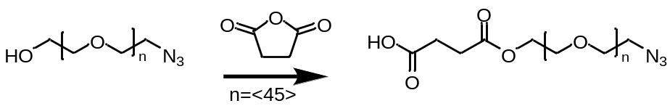
N₃-PEG₂₀₀₀-OH (19) 2.335g (1.15 mmol, 1eq) was dissolved in 20mL anhydrous THF followed by the addition of succinic anhydride 0.1754g (1.74mmol, 1.5eq) and 4-dimethylaminopyridine 0.005g (0.041 mmol, 0.035eq) and to reacted overnight at RT. The material was dried under vacuum at 50-60°C. The dried material was dissolved in a minimal amount of DCM (~1-2mL) and precipitated in ice cold diethyl ether. The precipitate was collected, dried and redissolved in DCM and precipitated once more. Yield: 1.419g (58.5%).

NHS-PEG₂₀₀₀-N₃
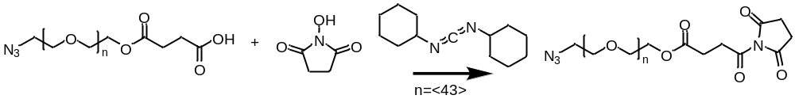
N₃-PEG₂₀₀₀-COOH (20) 1.419g (0.673 mmol, 1eq), 0.1682g NHS (1.46 mmol, 2.1 eq), 0.2987g DCC (1.45 mmol, 2.1 eq) were all combined in 20 mL dry DCM. The reaction mixture reacted overnight at RT. The following day reaction mixture was filtered through celite to remove the insoluble material. The solvent was removed under vacuum and the residue dissolved in a minimal amount of DCM ~1-2mL and precipitated in ice cold diethyl ether. The precipitation process was repeated a second time to obtain the final product. Yield: 0.968g, (63%).

nDOPA-PEG₂₀₀₀-N₃

N₃-PEG₂₀₀₀-NHS (21) 0.4974g (0.22 mmol, 1eq), was dissolved 15mL of DMF followed by the addition of 100uL 4-methylmorpholine (0.9 mmol, 4 eq) to this 0.1179g (0.39 mmol, 1.8 eq) nitro-dopamine hemi sulfate was added in one portion and allowed to react overnight at RT. The following day the solvent was removed, redissolved in DCM, and filtered. Solvent was removed once more, and the material was dissolved in a minimal amount of DCM and precipitated in ice cold diethyl ether. The precipitation process was repeated a second time to obtain the final product. Yield: 0.393g (77%).

Nitrodopamine
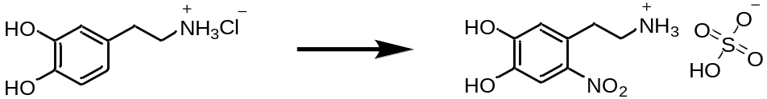
2.501g dopamine HCl (13.2mmol, 1eq) was dissolved in 100mL water followed by NaNO2 3.162g (45.8 mmol, 3.5eq) the solution was cooled in a ice bath to this 15mL (20% H2SO4) was added dropwise ~45 min the solution went from clear to a deep orange with a mustard color precipitate. The mixture was warmed to RT over night the following day the material was filtered, washed with ice cold water 150mL, MeOH 50mL and EtOH/Et₂O (1;1) 50mL. The material was dried under vacuum overnight to obtain a mustard color product. Yield: 2.06g (52%).

References for Synthetic Protocols

NMR Spectral Data
All NMR spectra were obtained using a 500 MHz NMR instrument (¹H) and referenced to chloroform-d (7.26ppm), except for (25) which was obtained in D₂O (4.79ppm).

