Supporting Information to

Position-Specific Nucleoside Sugar Modifications in mRNA ORF: Enhancing Translational Function through Complete Chemical Synthesis of mRNA

Hiroto Iwai^{1,†}, Yasuaki Kimura^{2,†}, Masakazu Honma¹, Kosuke Nakamoto², Keiichi Motosawa¹, Takayuki Atago¹, Kana Asano¹, Fumitaka Hashiya³, Naoko Abe², Keiko Kobayashi¹, Ryoko Ogisu², Atsushi Hashimoto¹, Keiko Hiraishi¹, Seiji Saito¹, Junichiro Yamamoto¹ and Hiroshi Abe^{2,3,4,5}
¹Research Unit, Research Division, Kyowa Kirin Co., Ltd., 3-6-6, Asahi-machi, Machida-shi, Tokyo 194-8533, Japan
²Department of Chemistry, Graduate School of Science, Nagoya University, Furo, Chikusa, Nagoya 464-8602, Japan
³Research Center for Materials Science, Nagoya University, Furo, Chikusa, Nagoya 464-8602, Japan
⁴CREST, Japan Science and Technology Agency, 7, Gobancho, Chiyoda-ku, Tokyo 102-0076, Japan
⁵Institute for Glyco-core Research (iGCORE), Nagoya University, Furo-cho, Chikusa-ku, Nagoya, Aichi 464-8601, Japan
†These authors contributed equally:Hiroto Iwai and Yasuaki Kimura.

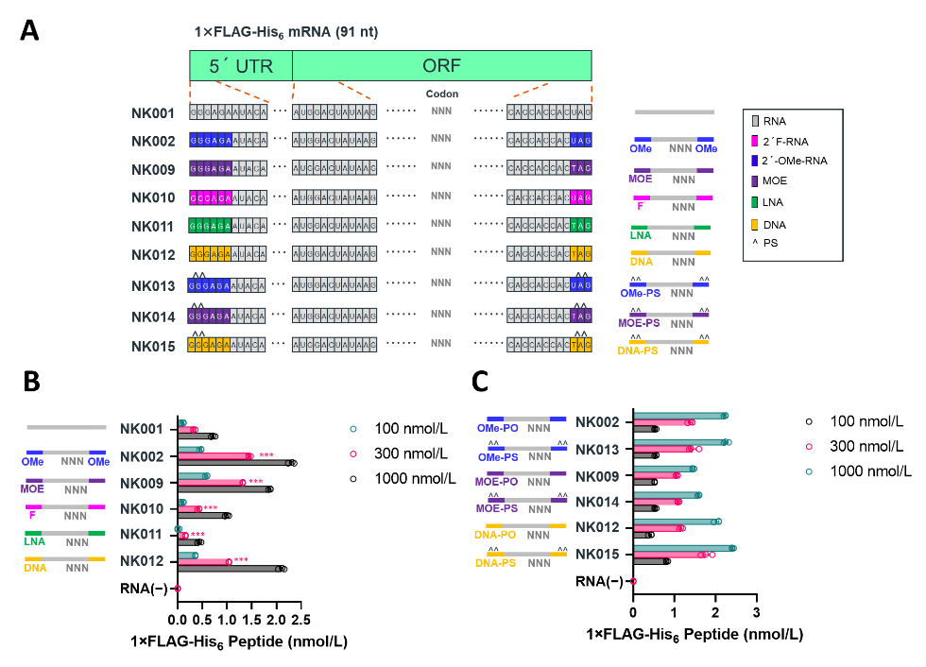

Figure S1 Effect of sugar and backbone modification of 5' and 3' termini of mRNA on the translational activity.
(A) Design and sequence of sugar and backbone modifications of chemically synthesized mRNAs. (B, C) The concentration of encoded peptides from each mRNA obtained after 30 min of reaction in the HeLa cell lysate in the in vitro translation system. (n = 3). Data are presented as the mean ± standard error. Statistically significant differences for each mRNA from “NK001” (B) in one-way ANOVA followed by Dunnett’s test are marked as follows. n.s., p > 0.05; *p < 0.05; **p < 0.01; ***p < 0.001.
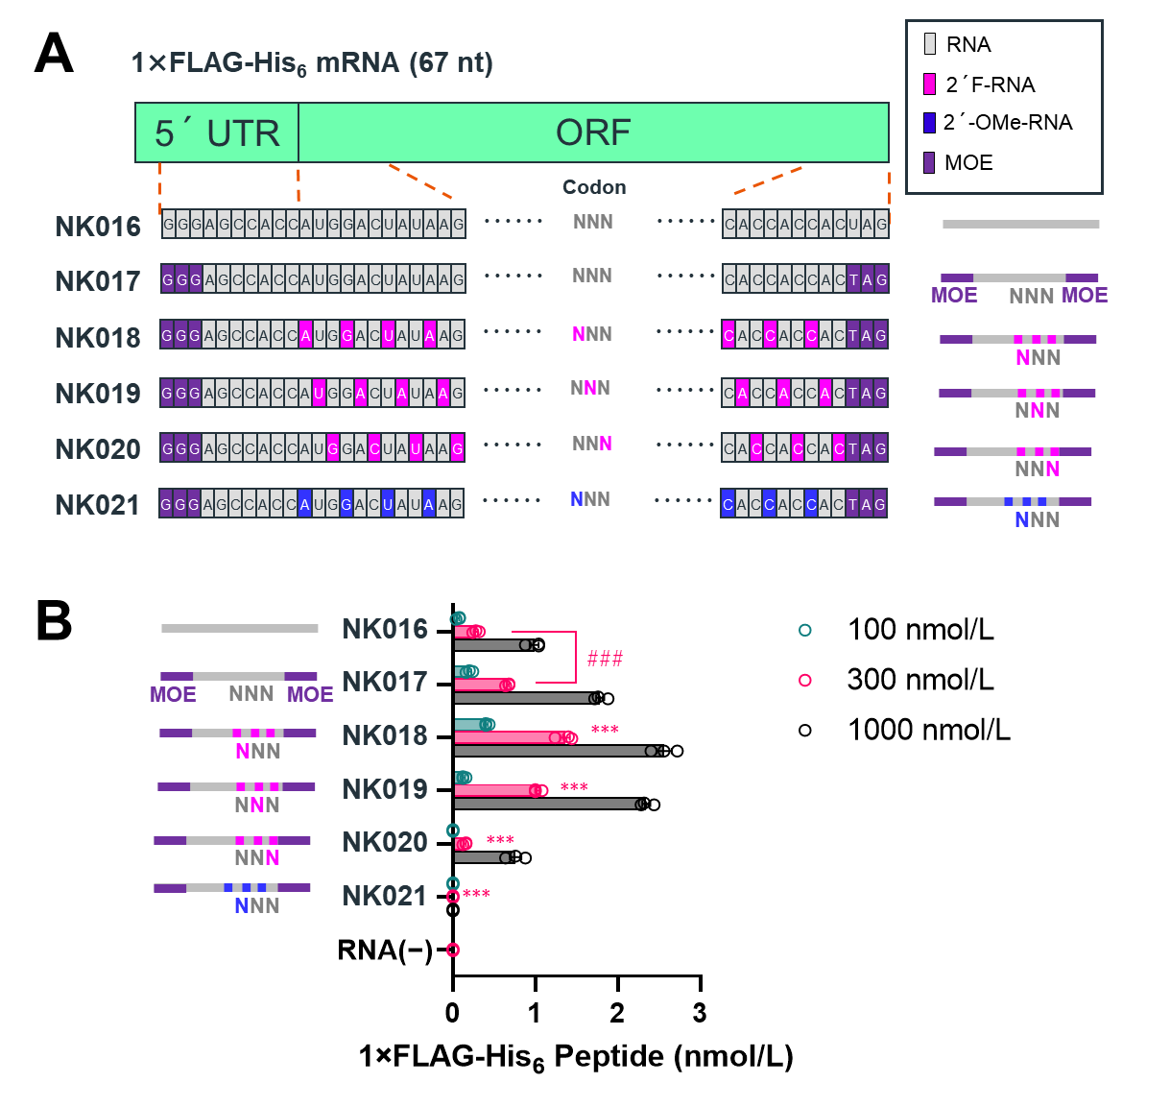

Figure S2 Effect of sugar modification of the 5' and 3' termini and ORF of mRNA on translational activity.
(A) Design and sequence of sugar and backbone modifications of chemically synthesized mRNAs. (B) The concentration of encoded peptides from each mRNA obtained after 30 min reaction of the HeLa cell lysate in the in vitro translation system (n = 3). Data are presented as the mean ± standard error. Statistically significant differences between “NK016” and “NK017” in Student’s t-test are marked as follows. n.s., p > 0.05; #p < 0.05; ##p < 0.01; ###p < 0.001. The statistically significant differences for each mRNA from “NK017” in one-way ANOVA followed by Dunnett’s test are marked as follows. n.s., p > 0.05; *p < 0.05; **p < 0.01; ***p < 0.001.
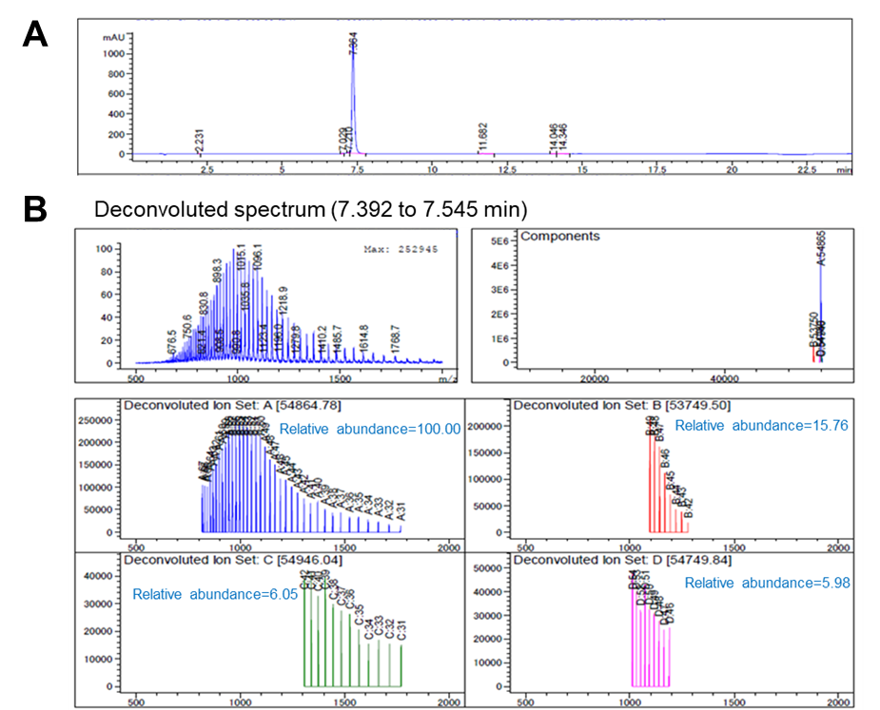

Figure S3. Results of the LC/MS analysis of NK052. (A) LC analysis chart of ligated RNA, (B) Decovoluted spectrum for a peak from 7.392 to 7.545 min. Mainly obsereved mass (deconvoluted): 54684.78, calcd.mass: 54862.7.

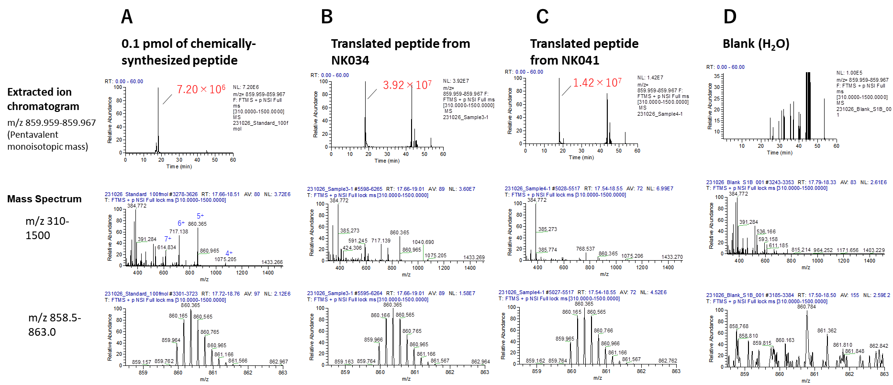
Figure S4 MS analysis of translated peptides from chemically synthesized mRNAs.
Extracted ion chromatograms and mass spectrum data of (A) chemically synthesized peptides, (B) translated peptide from NK034, (C) translated peptide from NK041, and (D) H₂O.

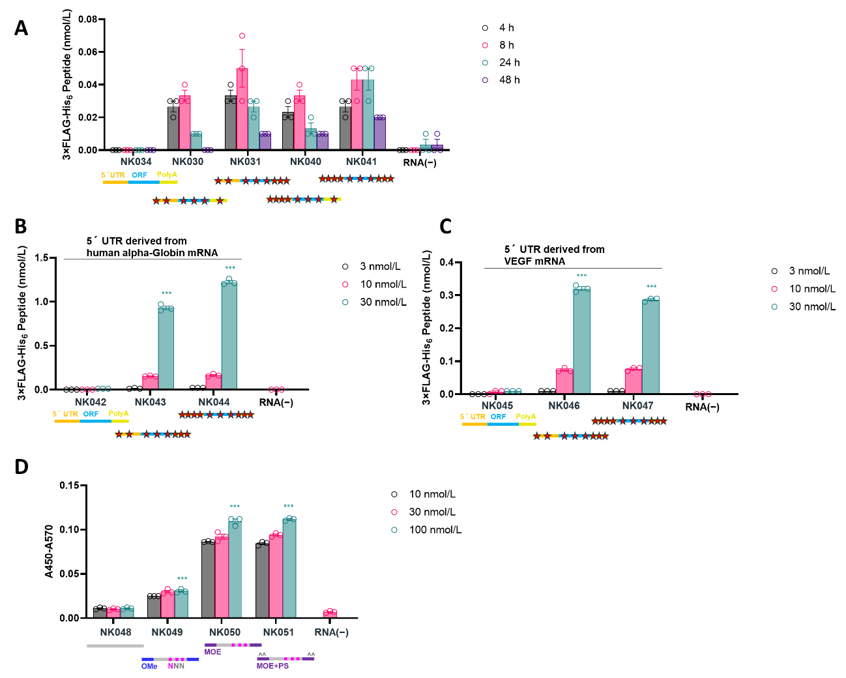
Figure S5 Translation activity of sugar and backbone-modified synthetic mRNAs in in vitro cell culture.
(A) Time course of concentration of encoded peptide from hAoSMC after electroporation of each mRNA (n = 3). (B, C) The concentration of encoded peptide from HeLa cells 5 h after the transfection of each mRNA using Lipofectamine messengerMAX (n = 3). (D) Absorbance indicating the concentration of encoded protein from HeLa cells 5 h after the transfection of each mRNA using Lipofectamine messengerMAX (n = 3). Data are presented as the mean ± standard error. The statistically significant differences for each mRNA from “NK042” (B), “NK045” (C), or “NK048” (D) in one-way ANOVA followed by Dunnett’s test are marked as follows. n.s., p > 0.05; *p < 0.05; **p < 0.01; ***p < 0.001.
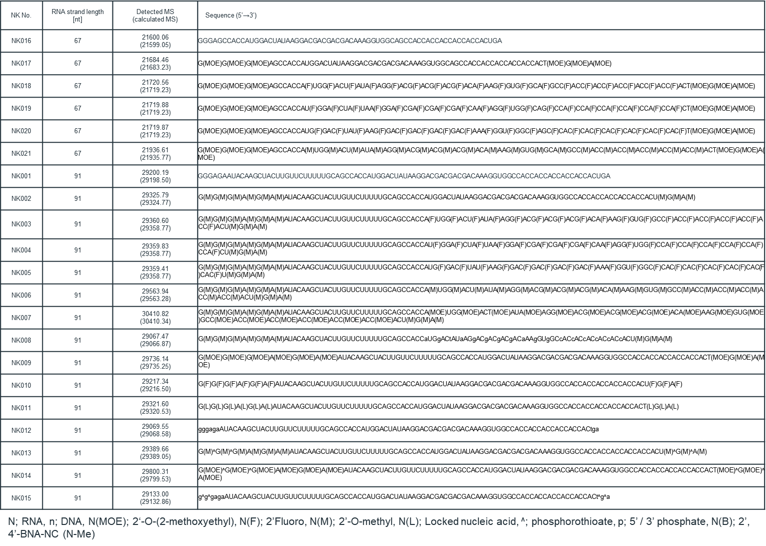
Table S1. List of RNA fragments used in this study and MS data

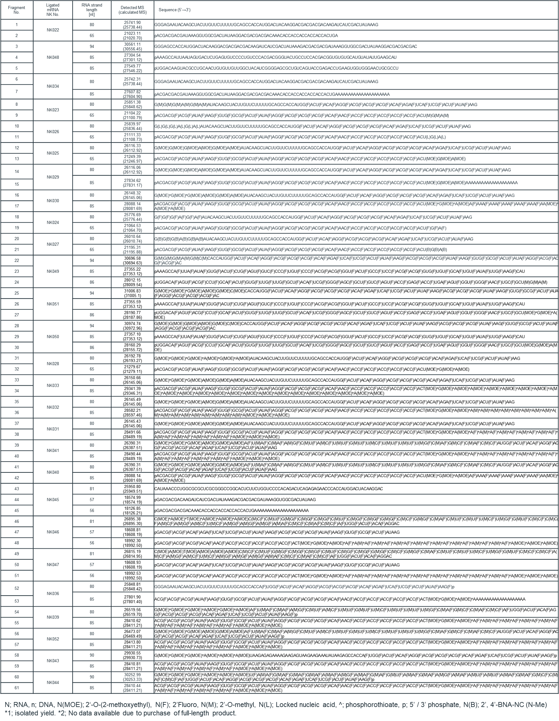
Table S2. List of ligated mRNAs and MS data

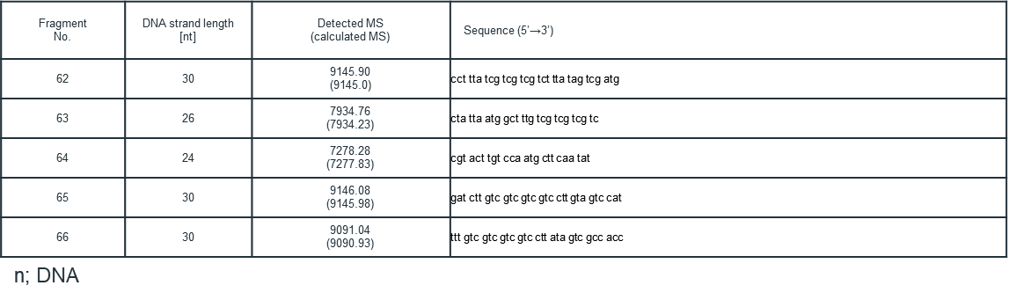
Table S3. List of splint DNA for enzymatic/chemical ligation and MS data

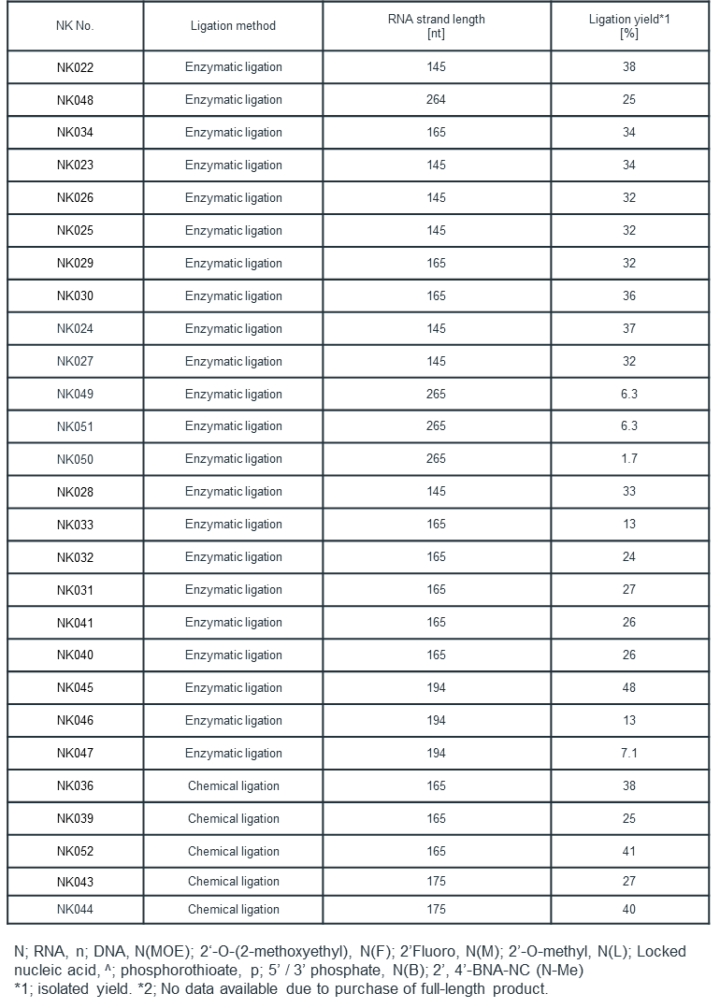
Table S4. Ligation yields of mRNAs

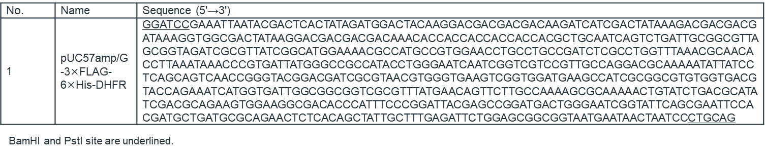
Table S5. DNA Sequence of plasmid DNA for IVT

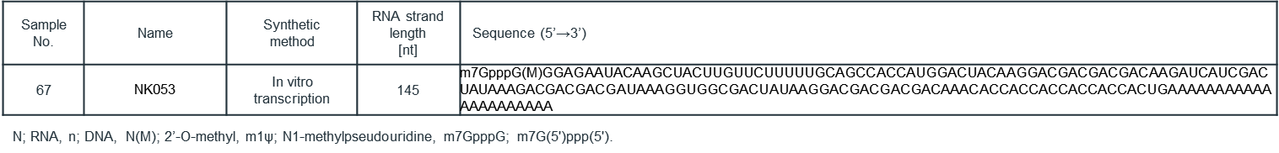
Table S6. List of evaluation samples（IVT-mRNA）
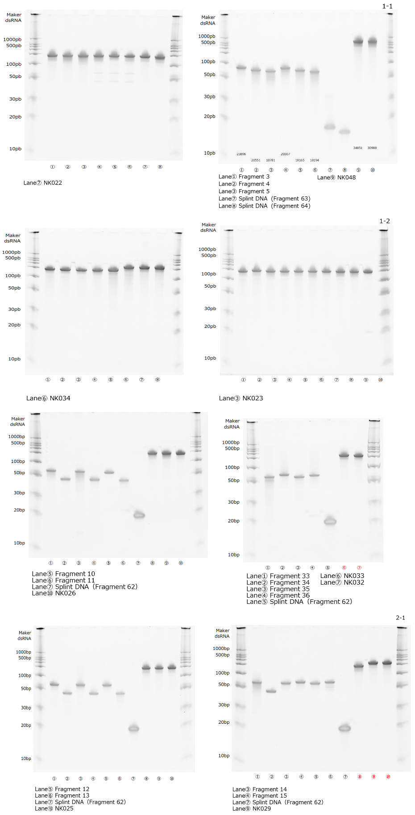
Figure S7 continued
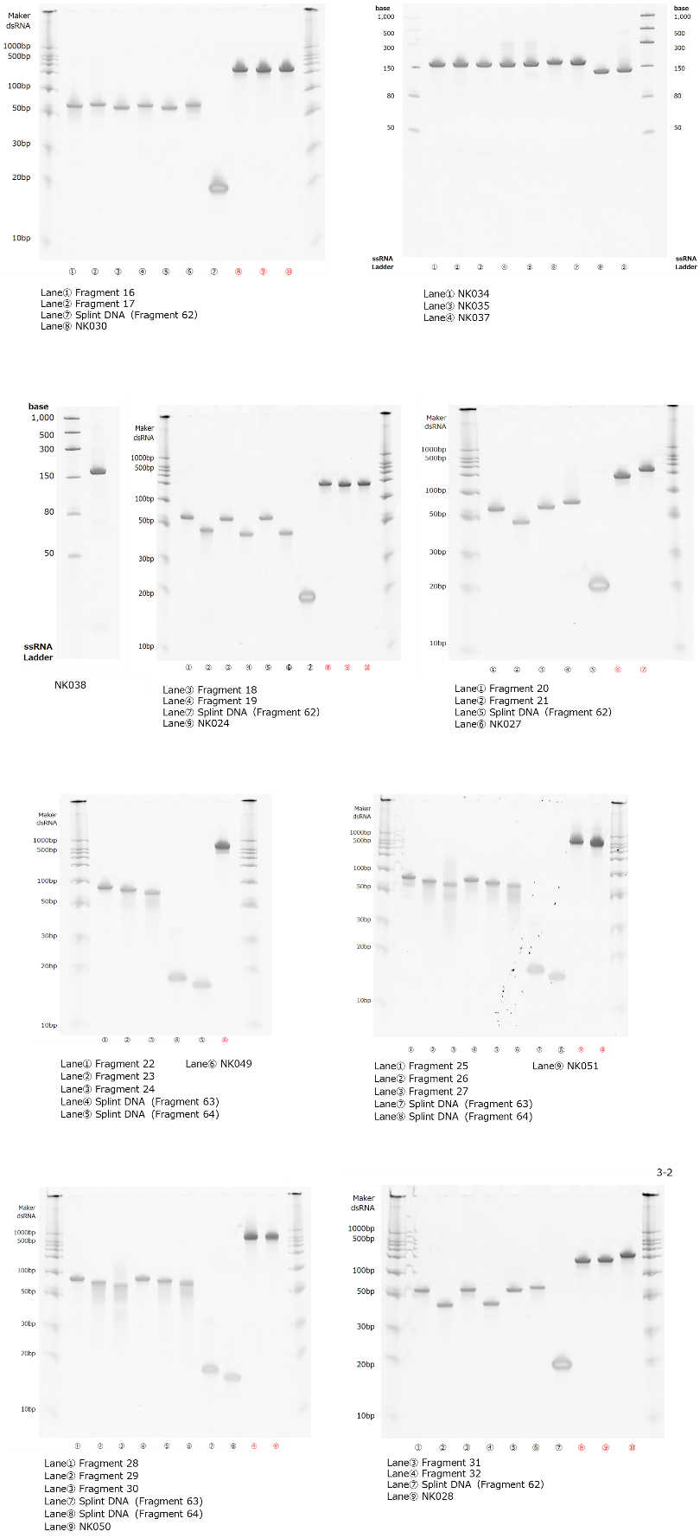
Figure S7 continued
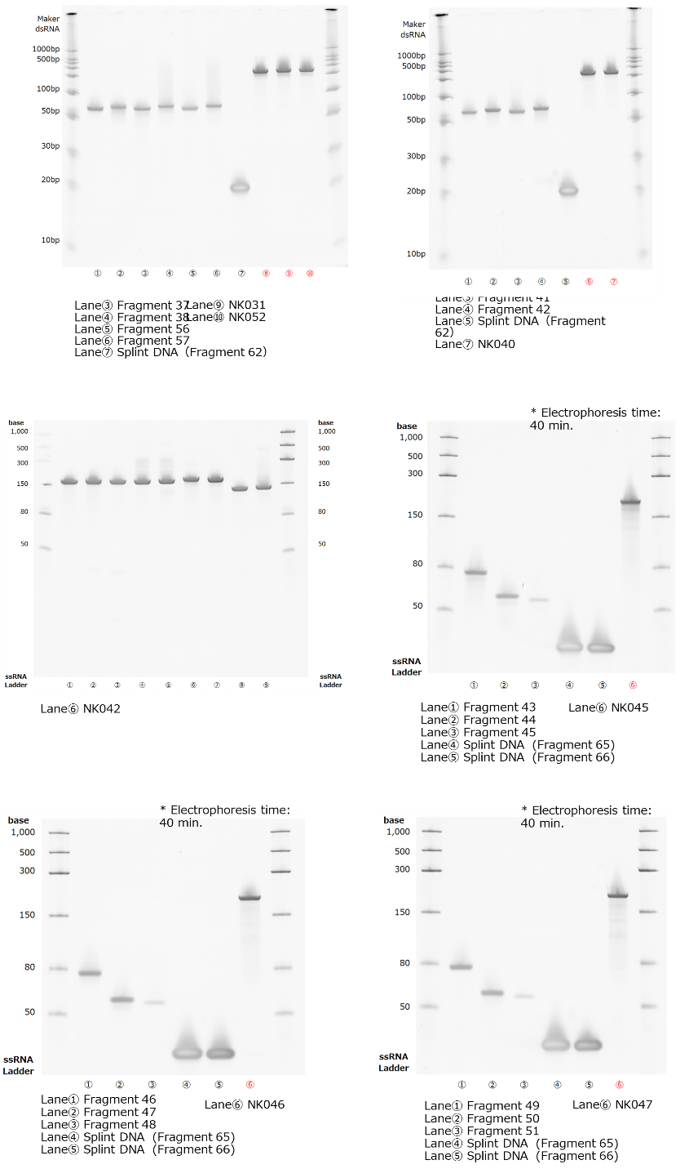
Figure S7: dPAGE analysis of RNAs used in this study. (NK034, NK023, NK026, NK033, NK032, NK025, NK029, NK030, NK035, NK037, NK038, NK024, NK027, NK049, NK051, NK050, NK028, NK031,NK052, NK040, NK042, NK045, NK046, NK047)

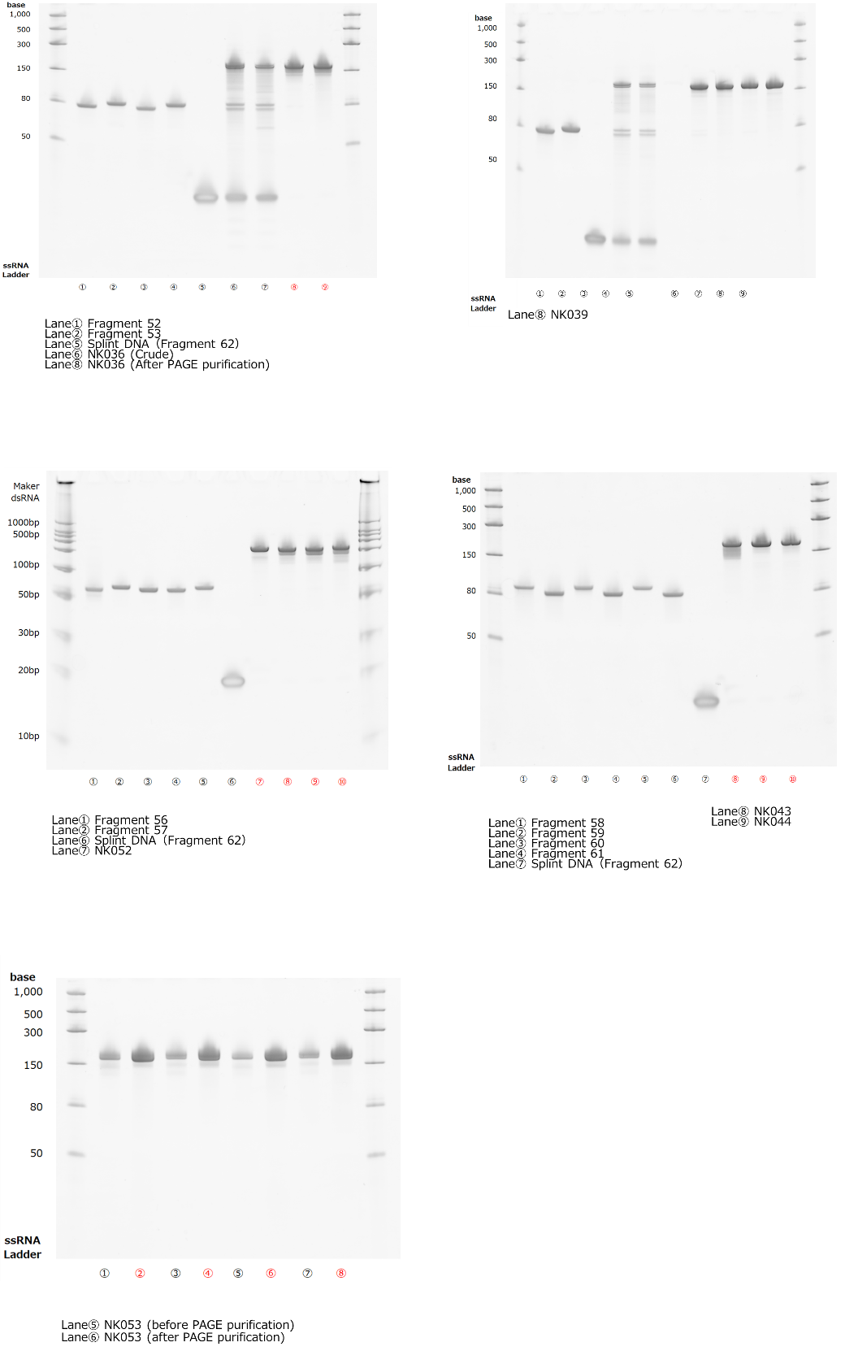
Figure S8 dPAGE analysis of chemical ligation reaction (NK036, NK039, NK052, NK043, NK044) and IVT (NK053)

