Supplementary Figure Legends
Supplementary Figure 1. Forest plots of pairwise meta-analyses and network meta-analyses of speech performance in all patients.
Supplementary Figure 2. Forest plots of pairwise meta-analyses and network meta-analyses of speech performance of patients in chronic phase.
Supplementary Figure 3. Forest plots of pairwise meta-analyses and network meta-analyses of motor aphasia performance in all patients.
Supplementary Figure 4. Forest plots of pairwise meta-analyses and network meta-analyses of motor aphasia performance of patients in chronic phase.
Supplement Figure 5. Forest plots of pairwise meta-analyses and network meta-analyses of sensory aphasia performance in all patients.
Supplementary Figure 6. Forest plots of pairwise meta-analyses and network meta-analyses of sensory aphasia performance of patients in chronic phase.

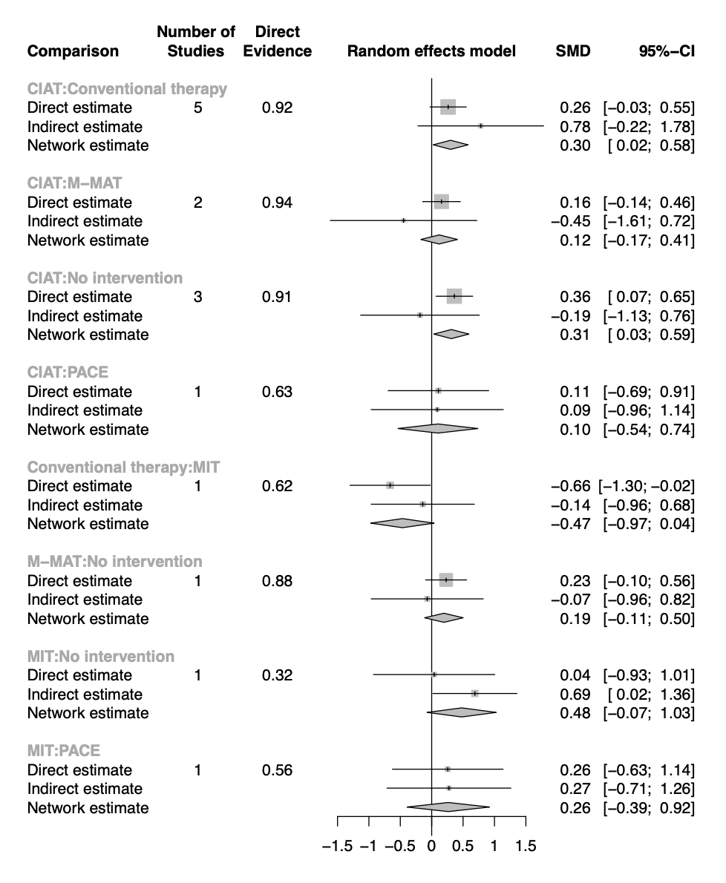
Supplementary Figure 1. Forest plots of pairwise meta-analyses and network meta-analyses of speech performance in all patients. SMD, standard mean difference; 95% CI, 95% credible interval; CIAT, constraint-induced aphasia therapy; PACE, promoting aphasics’ communicative effectiveness; CSLT, computerized speech and language therapy; MIT, melodic intonation therapy; M-MAT, multimodality aphasia therapy.
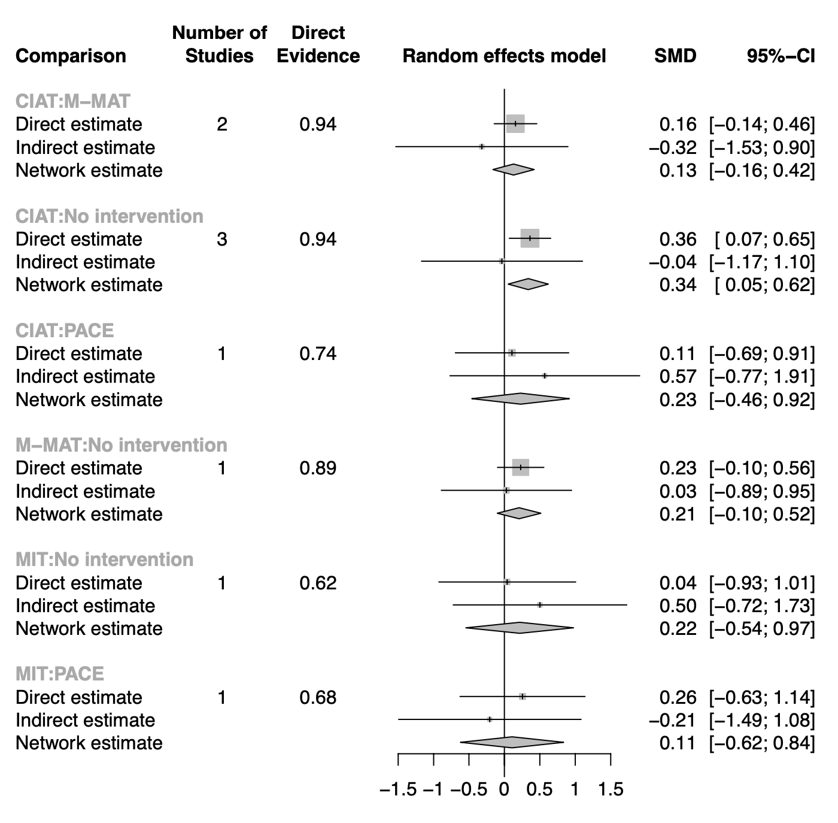
Supplementary Figure 2. Forest plots of pairwise meta-analyses and network meta-analyses of speech performance of patients in chronic phase. SMD, standard mean difference; 95% CI, 95% credible interval; CIAT, constraint-induced aphasia therapy; PACE, promoting aphasics’ communicative effectiveness; CSLT, computerized speech and language therapy; MIT, melodic intonation therapy; M-MAT, multimodality aphasia therapy.
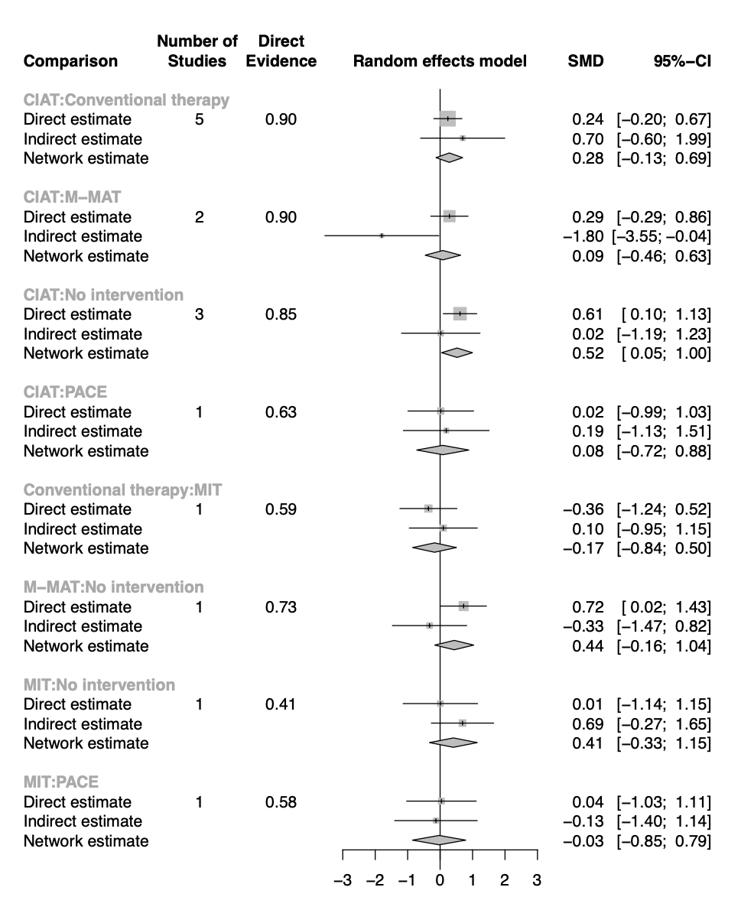Supplementary Figure 3. Forest plots of pairwise meta-analyses and network meta-analyses of motor aphasia performance in all patients. SMD, standard mean difference; 95% CI, 95% credible interval; CIAT, constraint-induced aphasia therapy; PACE, promoting aphasics’ communicative effectiveness; MIT, melodic intonation therapy; M-MAT, multimodality aphasia therapy.
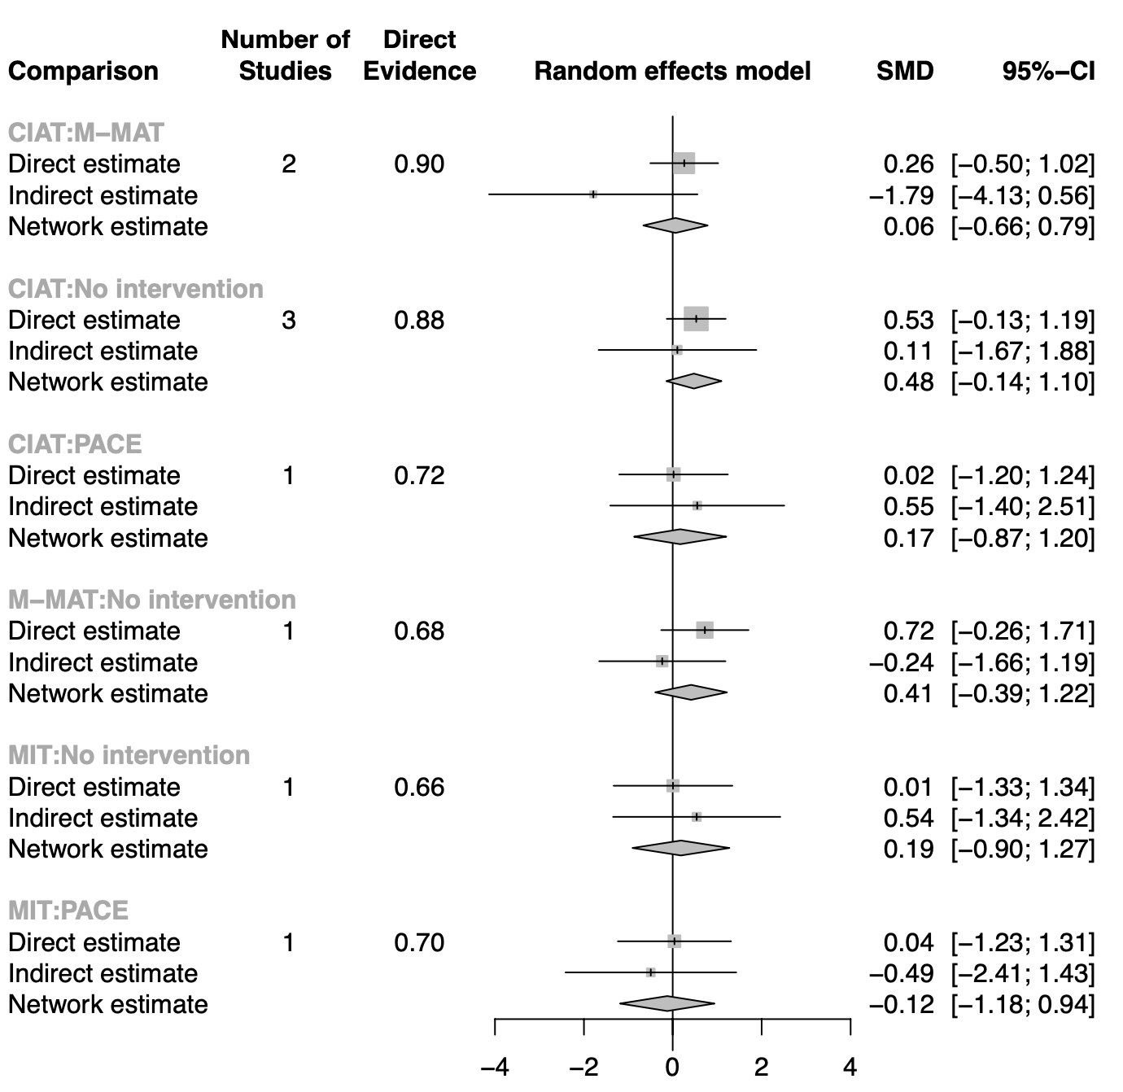Supplementary Figure 4. Forest plots of pairwise meta-analyses and network meta-analyses of motor aphasia performance of patients in chronic phase. SMD, standard mean difference; 95% CI, 95% credible interval; CIAT, constraint-induced aphasia therapy; PACE, promoting aphasics’ communicative effectiveness; MIT, melodic intonation therapy; M-MAT, multimodality aphasia therapy.
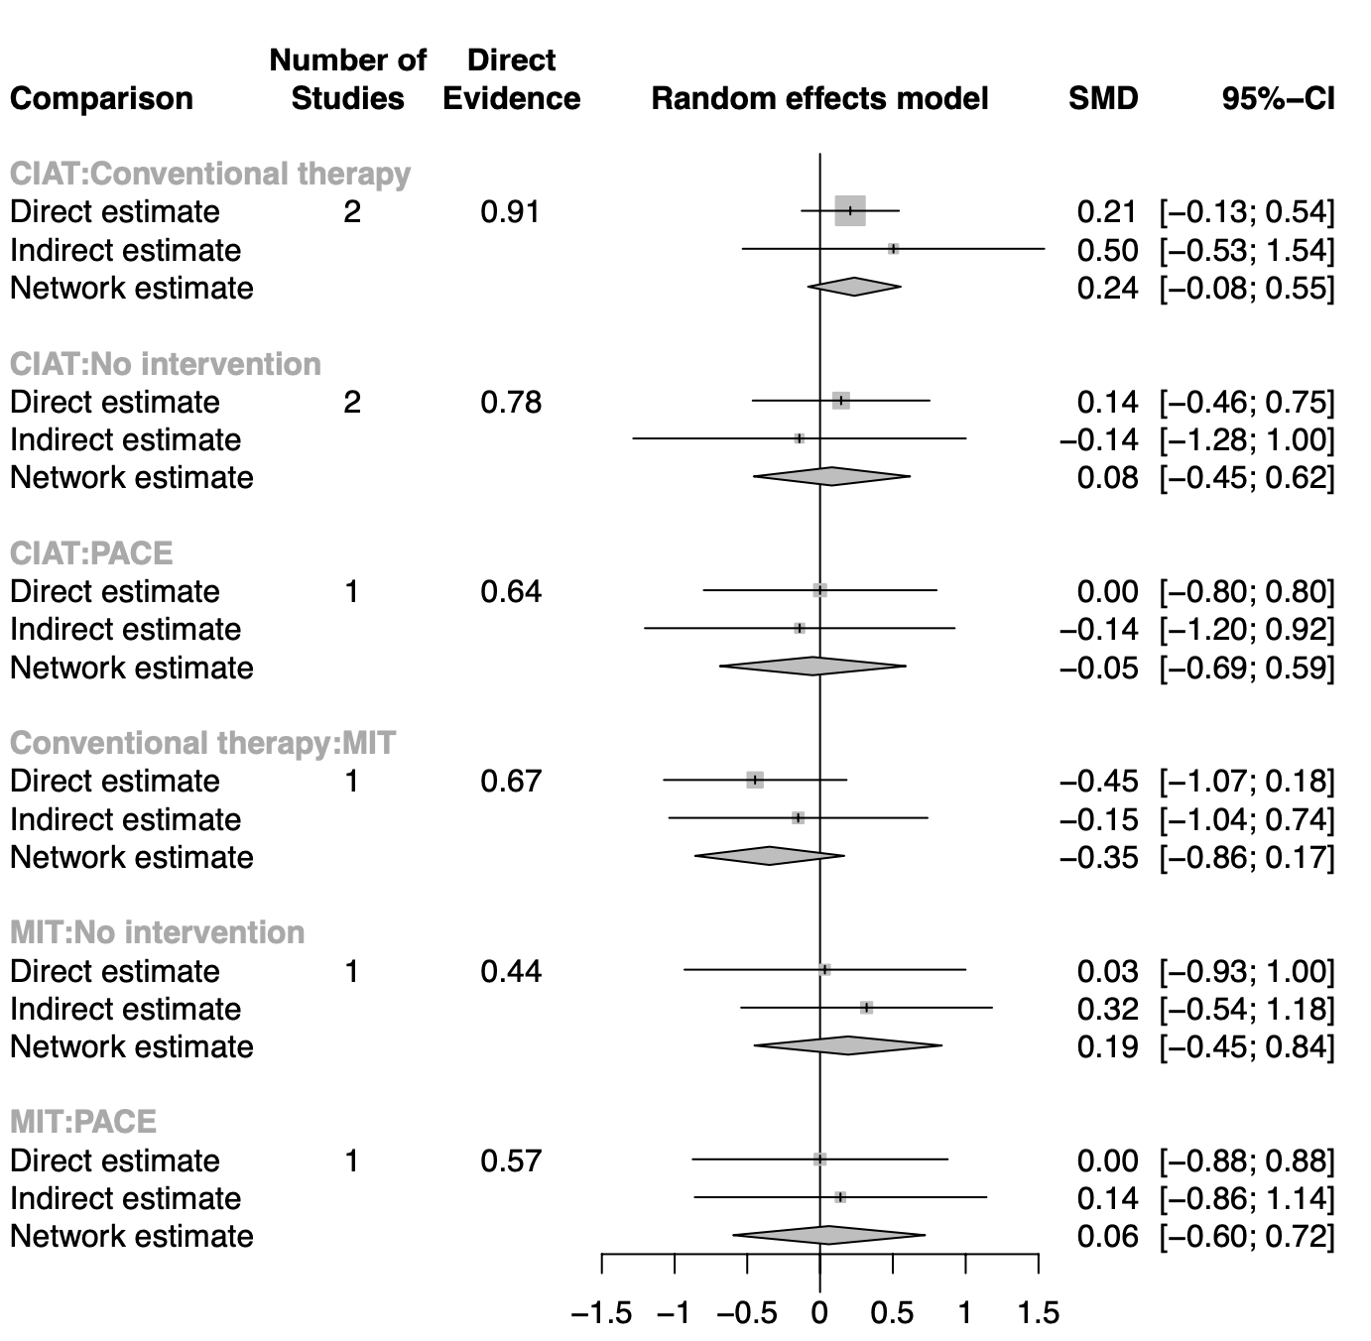Supplement Figure 5. Forest plots of pairwise meta-analyses and network meta-analyses of sensory aphasia performance in all patients. SMD, standard mean difference; 95% CI, 95% credible interval; CIAT, constraint-induced aphasia therapy; PACE, promoting aphasics’ communicative effectiveness; MIT, melodic intonation therapy.
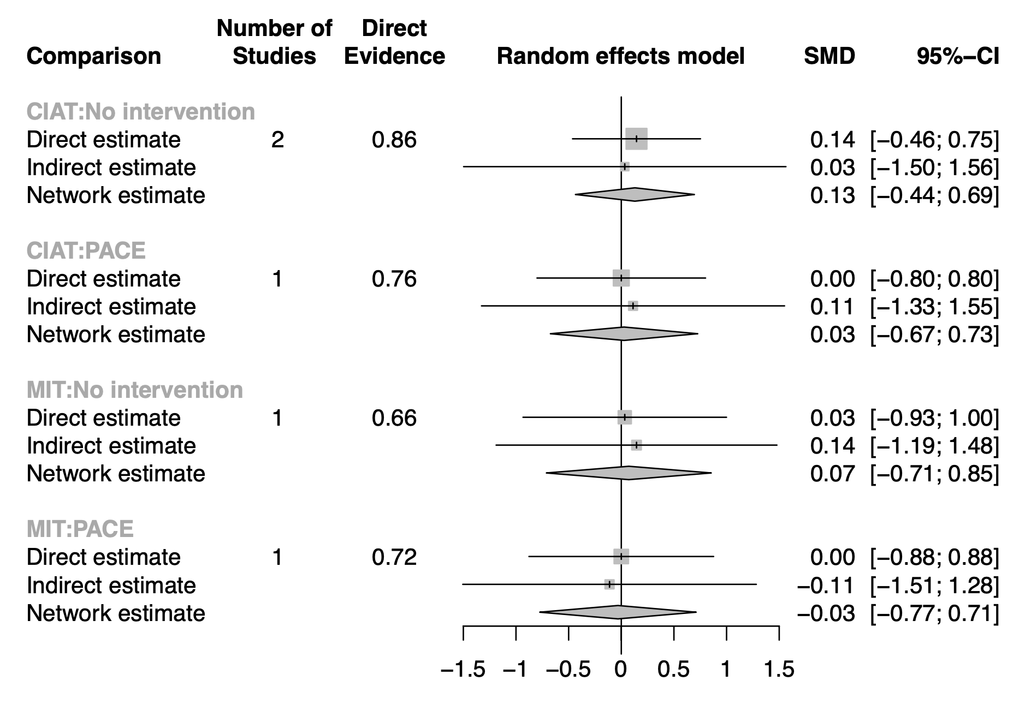Supplementary Figure 6. Forest plots of pairwise meta-analyses and network meta-analyses of sensory aphasia performance of patients in chronic phase. SMD, standard mean difference; 95% CI, 95% credible interval; CIAT, constraint-induced aphasia therapy; PACE, promoting aphasics’ communicative effectiveness; MIT, melodic intonation therapy.
Supplementary Table Legends
Supplementary Table 1. Characteristics of the Selected Randomized Controlled Trials
Supplementary Table 2. Assessment of Inconsistencies Among Studies Regarding Speech Performance in All Patients
Supplementary Table 3. Network Meta-Analysis Results for Speech Performance of Patients in the Chronic Phase
Supplementary Table 4. Assessment of Inconsistencies Among Studies Regarding Speech Performance of Patients in the Chronic Phase
Supplementary Table 5. Network Meta-Analysis Results for Motor Aphasia Performance in All Patients
Supplementary Table 6. Assessment of Inconsistencies Among Studies Regarding Motor Aphasia Performance in All Patients
Supplementary Table 7. Network Meta-Analysis Results for Motor Aphasia Performance of Patients in the Chronic Phase
Supplementary Table 8. Assessment of Inconsistencies Among Studies Regarding Motor Aphasia Performance of Patients in the Chronic Phase
Supplementary Table 9. Network Meta-Analysis Results for Sensory Aphasia Performance in All Patients
Supplementary Table 10. Assessment of Inconsistencies Among Studies Regarding Sensory Aphasia Performance in All Patients
Supplementary Table 11. Network Meta-Analysis Results for Sensory Aphasia Performance of Patients in the Chronic Phase
Supplementary Table 12. Assessment of Inconsistencies Among Studies Regarding Sensory Aphasia Performance of Patients in the Chronic Phase

Supplementary Table 1. Characteristics of the Selected Randomized Controlled Trials
Author, year | Study design | Inclusion criteria | Intervention group |  |  |  |  | Longest follow-up | Outcome measurement
Author, year | Study design | Inclusion criteria | Group | Number of patients | Age (years), mean (SD) | Time since aphasia onset (months), mean (SD) | Intervention protocol | Longest follow-up | Outcome measurement
Kurland et al., 2016²² | Parallel | 1) Diagnosed with poststroke aphasia; 2) Time since aphasia onset > 6 months | Experimental group | 12 | Mean (range) 68.6 (55-78) | 35.6 (6-142) | CIAT: 10 consecutive workdays × 3 h per day | At the end of the interventions | Picture naming, BNT and, BDAE
Kurland et al., 2016²² | Parallel |  | Control group | 12 | 65 (46-81) | 17.8 (7-82) | PACE: 10 consecutive workdays × 3 h per day | At the end of the interventions | Picture naming, BNT and, BDAE
Ciccone et al., 2015²¹ | Parallel | 1) Acute stroke diagnosed within 48 hours of hospital admission; 2) Aphasia diagnosis (confirmed by score of <13/20 on the shortened Frenchay Aphasia Screening Test) and aphasia severity score of <93.7 on the AQ of WAB | Experimental group | 10 | 69.4 (15.0) | Days 5.6 (2.3) | CIAT: 45-60 min, 5 days a week for 20 sessions over 5 weeks (15-20 h total) | 26 weeks after the interventions | WAB
Ciccone et al., 2015²¹ | Parallel |  | Control group | 8 | 72.6 (14.1) | Days 4.8 (2.3) | Conventional therapy: 45-60 min, 5 days a week for 20 sessions over 5 weeks (15-20 h total) | 26 weeks after the interventions | WAB
Nenert et al., 2017²³ | Parallel | Diagnosis of single ischemic stroke in the left middle cerebral artery | Experimental group | 11 | 58 (10.6) | Median (IQR) 60.2 (48.9) | CIAT: 10 daily sessions × 4 h | 3 months after the interventions | Mini-CAL, BNT, and PPVT
Nenert et al., 2017²³ | Parallel |  | Control group | 8 | 50 (13.3) | Median (IQR) 41.9 (30) | No intervention | 3 months after the interventions | Mini-CAL, BNT, and PPVT
Pierce et al., 2023²⁵ | Parallel | 1) Aged ≥17 years; 2) Chronic aphasia resulting from stroke (>6 months duration) confirmed by WAB-R-AQ < 93.8; 3); fluent in English prior to stroke | Experimental group | 10 | 60.5 (11.5) | Median (IQR) 46.5 (47.5) | CIAT: 2 h × 3 days × 5 weeks (30 h total) | 3 months after the interventions | WAB and naming battery
Pierce et al., 2023²⁵ | Parallel |  | Control group | 16 | 66.1 (11.2) | Median (IQR) 30.5 (35.5) | M-MAT: 2 h × 3 days × 5 weeks (30 h total) | 3 months after the interventions | WAB and naming battery
Rose et al., 2022²⁷ | Parallel | 1) Aged ≥18 years; 2) Chronic aphasia resulting from stroke of any type (>6 months duration) confirmed by an AQ of <93.8 on the WAB-R-AQ at the time of screening | Experimental group | 71 | Median (IQR) 63.93 (19.79) | Years, median (IQR) 2.41 (4.22) | CIAT: 3 h × 5 days per week × 2 weeks (30 h total) | 3 months after the interventions | WAB and naming battery
Rose et al., 2022²⁷ | Parallel |  | Experimental group | 75 | Median (IQR) 63.77 (21.02) | Years, median (IQR) 2.97 (3.81) | M-MAT: 3 h × 5 days per week × 2 weeks (30 h total) | 3 months after the interventions | WAB and naming battery
Rose et al., 2022²⁷ | Parallel |  | Control group | 70 | Median (IQR) 63.16 (14.10) | Years, median (IQR) 2.58 (2.87) | No intervention | 3 months after the interventions | WAB and naming battery
Sickert et al., 2013²⁸ | Parallel | First-ever stroke with aphasia in the subacute stage (time since lesion onset 1-4 months poststroke) | Experimental group | 50 | 60.7 (41-81) | Days 36.7 (28-84) | CIAT: 2 h per day × 15 days | 3 weeks after the interventions | AAT and CAL
Sickert et al., 2013²⁸ | Parallel |  | Control group | 50 | 60.2 (34-84) | Days 32.9 (28-112) | Conventional therapy: 2 h per day × 15 days | 3 weeks after the interventions | AAT and CAL
Stahl et al., 2017³⁰ | Crossover | Poststroke chronic nonfluent aphasia | Experimental group | 6 | 45.5 (10.6) | 45.7 (26.8) | CIAT treatment for 3.5 h per session for 6 consecutive working days, followed by 6-day washout period, then crossover to conventional therapy for 3.5 h per session for 6 consecutive working days | At the end of the interventions | ACT
Stahl et al., 2017³⁰ | Crossover | Poststroke chronic nonfluent aphasia | Control group | 8 | 53.3 (11.9) | 109.4 (84.5) | Conventional therapy for 3.5 h per session for 6 consecutive working days, followed by 6-day washout period, then crossover to CIAT for 3.5 h per session for 6 consecutive working days | At the end of the interventions | ACT
Szaflarski et al., 2015³¹ | Parallel | Chronic aphasia related to a single ischemic stroke in the left middle cerebral artery distribution | Experimental group | 14 | 57 (11) | Median (IQR) 38 (59) | CIAT: 4 h × 10 consecutive business days (40 h total) | 3 months after the interventions | BNT, PPVT, and mini-CAL
Szaflarski et al., 2015³¹ | Parallel |  | Control group | 10 | 51 (13) | Median (IQR) 30 (58) | No intervention | 3 months after the interventions | BNT, PPVT, and mini-CAL
Vuksanović et al., 2018³³ | Crossover | Nonfluent poststroke aphasia | Experimental group | 8 | 61.4 (8.7) | Weeks 11.7 (13.7) | CIAT for 1 h × 5 times per week × 4 weeks, then crossover to conventional therapy 1 h × 5 times per week × 4 weeks | 4 weeks after the interventions | Cookie theft picture description task and BNT
Vuksanović et al., 2018³³ | Crossover | Nonfluent poststroke aphasia | Control group | 9 | 60.3 (10.5) | Weeks 15.8 (15.7) | Conventional therapy for 1 h × 5 times per week × 4 weeks, then crossover to CIAT for 1 h × 5 times per week × 4 weeks | 4 weeks after the interventions | Cookie theft picture description task and BNT
Wilssens et al., 2015³⁴ | Parallel | 1) Adult age; 2) Single and first-ever stroke in the left hemisphere confirmed by structural brain imaging; 3) Fluent aphasia with a combined semantic and phonological deficit | Experimental group | 5 | 63 (8) | 61 (48) | CIAT for 2-3-h sessions per day × 9 or 10 consecutive working days | 1 week after the interventions | AAT and ANELT
Wilssens et al., 2015³⁴ | Parallel |  | Control group | 4 | 71 (9) | 52 (25) | Semantic therapy (BOX therapy) for 2-3-h sessions per day × 9 or 10 consecutive working days | 1 week after the interventions | AAT and ANELT
Woldag et al., 2016³⁵ | Parallel | Acute aphasia after first-ever stroke | Experimental group | 20 | 71.3 (7.2) | Days 20.6 (10.9) | CIAT: 3 h × 10 workdays (30 h total) | At the end of the interventions | CAL and AAT
Woldag et al., 2016³⁵ | Parallel | Acute aphasia after first-ever stroke | Control group | 20 | 70.3 (11.2) | Days 19.9 (10.0) | Conventional communication therapy: 3 h × 10 workdays (30 h total) | At the end of the interventions | CAL and AAT
Palmer et al., 2019²⁴ | Parallel | 1) Aged ≥18 years; 2) Aphasia diagnosis confirmed by a speech and language therapist after one or more strokes at least 4 months before randomization; 3) Difficulties finding words but able to perform a simple matching task on the StepByStep computer program | Experimental group | 83 | 64.9 (13.0) | Years 2.9 (2.9) | CSLT for 6 months | 6 months after the interventions | TOMs and change in word finding performance
Palmer et al., 2019²⁴ | Parallel |  | Control group | 86 | 64.9 (13.0) | Years 2.8 (2.6) | Conventional communication for 6 months | 6 months after the interventions | TOMs and change in word finding performance
Spaccavento et al., 2021²⁹ | Parallel | 1) Aphasia resulting from unilateral left-hemisphere lesion; 2) Absence of premorbid cognitive impairment or mental health disorders | Experimental group | 13 | 57.38 (9.23) | Days 25.92 (25.99) | CSLT: 1 session per day of ±50 min × 5 days a week × 8 weeks | At the end of the interventions | AAT
Spaccavento et al., 2021²⁹ | Parallel |  | Control group | 9 | 64.11 (15.04) | Days 20 (10.66) | Conventional therapy: 1 session per day of ±50 min × 5 days a week × 8 weeks | At the end of the interventions | AAT
Van Der Meulen et al., 2016³² | Parallel | 1) Aged 18-80 years; 2) >1 year poststroke | Experimental group | 10 | 58.1 (15.2) | 33.1 (19.4) | MIT: 5 h per week × 6 weeks | At the end of the interventions | ANELT and AAT
Van Der Meulen et al., 2016³² | Parallel | 1) Aged 18-80 years; 2) >1 year poststroke | Control group | 7 | 63.6 (12.7) | 42.6 (23.7) | No intervention | At the end of the interventions | ANELT and AAT
Raglio et al., 2016²⁶ | Parallel | Patients with poststroke aphasia | Experimental group | 10 | 58.6 (12.4) | Years 3.4 (4.1) | MIT: individual 30-min sessions twice a week × 15 weeks (30 sessions total) | At the end of the interventions | AAT, Token test, and BNT
Raglio et al., 2016²⁶ | Parallel | Patients with poststroke aphasia | Control group | 10 | 56.7 (10.5) | Years 3.8 (3.3) | PACE: individual 45-min sessions twice a week × 15 weeks (30 sessions total) | At the end of the interventions | AAT, Token test, and BNT
Zhang et al., 2021³⁶ | Parallel | 1) Meeting the diagnostic criteria for nonfluent aphasia; 2) Time since aphasia onset ≥15, hospitalized patients; 3) Aged 18-70 years | Experimental group | 20 | 52.90 (9.08) | 2.57 (1.74) | MIT: 30 min × 5 times a week × 8 consecutive weeks | At the end of the interventions | BDAE
Zhang et al., 2021³⁶ | Parallel |  | Control group | 20 | 54.05 (10.81) | 1.96 (1.38) | Conventional communication therapy: 30 min × 5 times a week × 8 consecutive weeks | At the end of the interventions | BDAE
CIAT, constraint-induced aphasia therapy; PACE, promoting aphasics’ communicative effectiveness; M-MAT, multimodality aphasia therapy; BDAE, Boston Diagnostic Aphasia Examination; BNT, Boston Naming Test; CSLT, computerized speech and language therapy; AAT, Aachener Aphasia Test; ANELT, Amsterdam–Nijmegen Everyday Language Test; WAB-AQ, Western Aphasia Battery–Aphasia Quotient; PPVT, Peabody Picture Vocabulary Test; mini-CAL, mini-Communicative Activity Log; TOMs, Therapy Outcome Measures; CETI, Communicative Effectiveness Index; CAL, Communicative Activity Log; ACT, Action Communication Test; MIT, melodic intonation therapy; SD, standard deviation; IQR, interquartile range.

Supplementary Table 2. Assessment of Inconsistencies Among All Studies Regarding Speech Performance in All Patients
Comparison | Number of studies | Network meta-analysis | Direct comparison | Indirect comparison | Difference between direct and indirect comparisons | Lower limit of 95% CI | Upper limit of 95% CI | P value
CIAT vs. conventional therapy | 5 | 0.3019 | 0.2619 | 0.7823 | 0.5204 | −1.5608 | 0.5201 | 0.327
CIAT vs. M-MAT | 2 | 0.119 | 0.1567 | −0.4476 | 0.6043 | −0.6002 | 1.8088 | 0.3255
CIAT vs. no intervention | 3 | 0.3134 | 0.3613 | −0.1865 | 0.5478 | −0.4414 | 1.5371 | 0.2778
CIAT vs. PACE | 1 | 0.1 | 0.1069 | 0.0879 | 0.019 | −1.3033 | 1.3413 | 0.9775
Conventional therapy vs. MIT | 1 | −0.4661 | −0.662 | −0.1416 | −0.5204 | −1.5608 | 0.5201 | 0.327
M-MAT vs. no intervention | 1 | 0.1944 | 0.2301 | −0.0713 | 0.3014 | −0.6486 | 1.2514 | 0.5341
MIT vs. no intervention | 1 | 0.4776 | 0.0392 | 0.6879 | −0.6487 | −1.8237 | 0.5264 | 0.2793
MIT vs. PACE | 1 | 0.2642 | 0.2557 | 0.2747 | −0.019 | −1.3413 | 1.3033 | 0.9775
CI, credible interval; CIAT, constraint-induced aphasia therapy; PACE, promoting aphasics’ communicative effectiveness; CSLT, computerized speech and language therapy; MIT, melodic intonation therapy; M-MAT, multimodality aphasia therapy.

Supplementary Table 3. Network Meta-Analysis Results for Speech Performance of Patients in the Chronic Phase
Pairwise meta-analysis
BOX therapy | 0.23 [−1.09; 1.55] | - | - | - | - | - | -
0.23 [−1.09; 1.55] | CIAT | - | 0.08 [−0.98; 1.14] | - | 0.16 [−0.14; 0.46] | 0.11 [−0.69; 0.91] | 0.36 [ 0.07; 0.65]
0.27 [−1.45; 1.99] | 0.04 [−1.06; 1.14] | CSLT | 0.05 [−0.26; 0.35] | - | - | - | -
0.31 [−1.38; 2.01] | 0.08 [−0.98; 1.14] | 0.05 [−0.26; 0.35] | Conventional therapy | - | - | - | -
0.35 [−1.18; 1.88] | 0.12 [−0.65; 0.89] | 0.08 [−1.26; 1.43] | 0.04 [−1.27; 1.35] | MIT | - | 0.26 [−0.63; 1.14] | 0.04 [−0.93; 1.01]
0.36 [−0.99; 1.71] | 0.13 [−0.16; 0.42] | 0.09 [−1.05; 1.23] | 0.05 [−1.05; 1.14] | 0.01 [−0.79; 0.81] | M-MAT | - | 0.23 [−0.10; 0.56]
0.46 [−1.03; 1.95] | 0.23 [−0.46; 0.92] | 0.19 [−1.11; 1.49] | 0.15 [−1.12; 1.41] | 0.11 [−0.62; 0.84] | 0.10 [−0.63; 0.83] | PACE | -
0.57 [−0.79; 1.92] | 0.34 [ 0.05; 0.62] | 0.30 [−0.84; 1.44] | 0.25 [−0.84; 1.35] | 0.22 [−0.54; 0.97] | 0.21 [−0.10; 0.52] | 0.11 [−0.61; 0.82] | No intervention
Network meta-analysis
Data expressed as SMD [95% credible interval]. Significant results are underscored. “-” means data not applicable.
CIAT, constraint-induced aphasia therapy; PACE, promoting aphasics’ communicative effectiveness; CSLT, computerized speech and language therapy; MIT, melodic intonation therapy; M-MAT, multimodality aphasia therapy.

Supplementary Table 4. Assessment of Inconsistencies Among Studies Regarding Speech Performance of Patients in the Chronic Phase
Comparison | Number of studies | Network meta-analysis | Direct comparison | Indirect comparison | Difference between direct and indirect comparisons | Lower limit of 95% CI | Upper limit of 95% CI | P value
CIAT vs. M-MAT | 2 | 0.1293 | 0.1567 | −0.3187 | 0.4754 | −0.7765 | 1.7273 | 0.45668
CIAT vs. no intervention | 3 | 0.3367 | 0.3613 | −0.0351 | 0.3964 | −0.7769 | 1.5697 | 0.5078
CIAT vs. PACE | 1 | 0.2287 | 0.1069 | 0.569 | −0.462 | −2.022 | 1.098 | 0.5616
M-MAT vs. no intervention | 1 | 0.2074 | 0.2301 | 0.0279 | 0.2022 | −0.7744 | 1.1788 | 0.6849
MIT vs. no intervention | 1 | 0.2164 | 0.0392 | 0.5013 | −0.462 | −2.022 | 1.098 | 0.5616
MIT vs. PACE | 1 | 0.1084 | 0.2557 | −0.2063 | 0.462 | −1.098 | 2.022 | 0.5616
CIAT vs. M-MAT | 2 | 0.1293 | 0.1567 | −0.3187 | 0.4754 | −0.7765 | 1.7273 | 0.45668
CIAT vs. no intervention | 3 | 0.3367 | 0.3613 | −0.0351 | 0.3964 | −0.7769 | 1.5697 | 0.5078
CI, credible interval; CIAT, constraint-induced aphasia therapy; PACE, promoting aphasics’ communicative effectiveness; CSLT, computerized speech and language therapy; MIT, melodic intonation therapy; M-MAT, multimodality aphasia therapy.

Supplementary Table 5. Network Meta-Analysis Results for Motor Aphasia Performance in All Patients
Pairwise meta-analysis
CSLT | - | - | - | - | - | 0.61 [ 0.03; 1.18] | -
0.32 [−0.39; 1.03] | CIAT | −0.09 [−1.55; 1.36] | 0.29 [−0.29; 0.86] | 0.02 [−0.99; 1.03] | - | 0.24 [−0.20; 0.67] | 0.61 [ 0.10; 1.13]
0.23 [−1.39; 1.85] | −0.09 [−1.55; 1.36] | BOX therapy | - | - | - | - | -
0.41 [−0.48; 1.30] | 0.09 [−0.46; 0.63] | 0.18 [−1.37; 1.73] | M-MAT | - | - | - | 0.72 [ 0.02; 1.43]
0.40 [−0.63; 1.44] | 0.08 [−0.72; 0.88] | 0.18 [−1.48; 1.84] | −0.00 [−0.96; 0.95] | PACE | −0.04 [−1.11; 1.03] | - | -
0.44 [−0.45; 1.32] | 0.11 [−0.57; 0.80] | 0.21 [−1.40; 1.81] | 0.03 [−0.82; 0.87] | 0.03 [−0.79; 0.85] | MIT | 0.36 [−0.52; 1.24] | 0.01 [−1.14; 1.15]
0.61 [ 0.03; 1.18] | 0.28 [−0.13; 0.69] | 0.38 [−1.13; 1.89] | 0.20 [−0.48; 0.87] | 0.20 [−0.65; 1.05] | 0.17 [−0.50; 0.84] | Conventional therapy | -
0.84 [ 0.01; 1.68] | 0.52 [ 0.05; 1.00] | 0.62 [−0.91; 2.15] | 0.44 [−0.16; 1.04] | 0.44 [−0.45; 1.33] | 0.41 [−0.33; 1.15] | 0.24 [−0.37; 0.84] | No intervention
Network meta-analysis
Data expressed as SMD [95% credible interval]. Significant results are underscored. “-” means data not applicable.
CIAT, constraint-induced aphasia therapy; PACE, promoting aphasics’ communicative effectiveness; CSLT, computerized speech and language therapy; MIT, melodic intonation therapy; M-MAT, multimodality aphasia therapy.

Supplementary Table 6. Assessment of Inconsistencies Among Studies Regarding Motor Aphasia Performance in All Patients
Comparison | Number of studies | Network meta-analysis | Direct comparison | Indirect comparison | Difference between direct and indirect comparisons | Lower limit of 95% CI | Upper limit of 95% CI | P value
CIAT vs. conventional therapy | 5 | 0.2834 | 0.2375 | 0.6959 | −0.4585 | −1.8265 | 0.9096 | 0.5113
CIAT vs. M-MAT | 2 | 0.086 | 0.2869 | −1.7956 | 2.0825 | 0.23504 | 3.9299 | 0.0272
CIAT vs. no intervention | 3 | 0.5218 | 0.6132 | 0.0201 | 0.5931 | −0.7222 | 1.9085 | 0.3768
CIAT vs. PACE | 1 | 0.082 | 0.0197 | 0.1885 | −0.1688 | −1.8327 | 1.495 | 0.8423
Conventional therapy vs. MIT | 1 | −0.1709 | −0.3602 | 0.0982 | −0.4585 | −1.8266 | 0.9096 | 0.5113
M-MAT vs. no intervention | 1 | 0.4359 | 0.7233 | −0.3254 | 1.0487 | −0.2952 | 2.3927 | 0.1262
MIT vs. no intervention | 1 | 0.4093 | 0.0071 | 0.691 | −0.6839 | −2.179 | 0.8112 | 0.37
MIT vs. PACE | 1 | −0.0305 | 0.0397 | −0.1292 | 0.1688 | −1.495 | 1.8327 | 0.8423
CI, credible interval; CIAT, constraint-induced aphasia therapy; PACE, promoting aphasics’ communicative effectiveness; CSLT, computerized speech and language therapy; MIT, melodic intonation therapy; M-MAT, multimodality aphasia therapy.

Supplementary Table 7. Network Meta-Analysis Results for Motor Aphasia Performance of Patients in the Chronic Phase
Pairwise meta-analysis
CSLT | - | - | - | - | - | 0.80 [−0.17; 1.78] | -
0.53 [−1.19; 2.24] | CIAT | −0.09 [−1.70; 1.51] | 0.26 [−0.50; 1.02] | 0.02 [−1.20; 1.24] | - | 0.27 [−1.13; 1.68] | 0.53 [−0.13; 1.19]
0.43 [−1.92; 2.78] | −0.09 [−1.70; 1.51] | BOX therapy | - | - | - | - | -
0.59 [−1.27; 2.45] | 0.06 [−0.66; 0.79] | 0.16 [−1.60; 1.92] | M-MAT | - | - | - | 0.72 [−0.26; 1.71]
0.70 [−1.31; 2.70] | 0.17 [−0.87; 1.20] | 0.26 [−1.65; 2.18] | 0.11 [−1.13; 1.34] | PACE | −0.04 [−1.31; 1.23] | - | -
0.82 [−1.24; 2.87] | 0.29 [−0.84; 1.43] | 0.39 [−1.58; 2.35] | 0.23 [−1.06; 1.51] | 0.12 [−0.94; 1.18] | MIT | - | 0.01 [−1.33; 1.34]
0.80 [−0.17; 1.78] | 0.27 [−1.13; 1.68] | 0.37 [−1.77; 2.51] | 0.21 [−1.37; 1.80] | 0.11 [−1.64; 1.85] | −0.02 [−1.83; 1.79] | Conventional therapy | -
1.01 [−0.82; 2.83] | 0.48 [−0.14; 1.10] | 0.57 [−1.15; 2.30] | 0.41 [−0.39; 1.22] | 0.31 [−0.80; 1.41] | 0.19 [−0.90; 1.27] | 0.20 [−1.34; 1.74] | No intervention
Network meta-analysis
Data expressed as SMD [95% credible interval]. Significant results are underscored. “-” means data not applicable.
CIAT, constraint-induced aphasia therapy; PACE, promoting aphasics’ communicative effectiveness; CSLT, computerized speech and language therapy; MIT, melodic intonation therapy; M-MAT, multimodality aphasia therapy.

Supplementary Table 8. Assessment of Inconsistencies Among Studies Regarding Motor Aphasia Performance of Patients in the Chronic Phase
Comparison | Number of studies | Network meta-analysis | Direct comparison | Indirect comparison | Difference between direct and indirect comparisons | Lower limit of 95% CI | Upper limit of 95% CI | P value
CIAT vs. M-MAT | 2 | 0.0638 | 0.2596 | −1.7885 | 2.048 | −0.4177 | 4.5138 | 0.1035
CIAT vs. no intervention | 3 | 0.4776 | 0.5294 | 0.1053 | 0.4241 | −1.4712 | 2.3194 | 0.661
CIAT vs. PACE | 1 | 0.1691 | 0.0197 | 0.5521 | −0.5324 | −2.8372 | 1.7724 | 0.6507
M-MAT vs. no intervention | 1 | 0.4138 | 0.7233 | −0.2356 | 0.9589 | −0.7693 | 2.6871 | 0.2768
MIT vs. no intervention | 1 | 0.1859 | 0.0071 | 0.5395 | −0.5324 | −2.8372 | 1.7724 | 0.6507
MIT vs. PACE | 1 | −0.1226 | 0.0397 | −0.4927 | 0.5324 | −1.7724 | 2.8372 | 0.6507
CI, credible interval; CIAT, constraint-induced aphasia therapy; PACE, promoting aphasics’ communicative effectiveness; MIT, melodic intonation therapy; M-MAT, multimodality aphasia therapy.

Supplementary Table 9. Network Meta-Analysis Results for Sensory Aphasia Performance in All Patients
Pairwise meta-analysis
MIT | - | 0.00 [−0.88; 0.88] | - | 0.03 [−0.93; 1.00] | - | 0.45 [−0.18; 1.07]
−0.14 [−1.57; 1.29] | BOX therapy | - | 0.25 [−1.07; 1.58] | - | - | -
0.06 [−0.60; 0.72] | 0.20 [−1.27; 1.67] | PACE | −0.00 [−0.80; 0.80] | - | - | -
0.11 [−0.43; 0.65] | 0.25 [−1.07; 1.58] | 0.05 [−0.59; 0.69] | CIAT | 0.14 [−0.46; 0.75] | - | 0.21 [−0.13; 0.54]
0.19 [−0.45; 0.84] | 0.34 [−1.09; 1.76] | 0.13 [−0.66; 0.92] | 0.08 [−0.45; 0.62] | No intervention | - | -
0.30 [−0.69; 1.29] | 0.44 [−1.16; 2.05] | 0.24 [−0.84; 1.32] | 0.19 [−0.72; 1.10] | 0.11 [−0.93; 1.15] | CSLT | 0.05 [−0.80; 0.90]
0.35 [−0.17; 0.86] | 0.49 [−0.87; 1.85] | 0.29 [−0.39; 0.96] | 0.24 [−0.08; 0.55] | 0.15 [−0.44; 0.75] | 0.05 [−0.80; 0.90] | Conventional therapy
Network meta-analysis
Data are expressed as SMD [95% credible interval]. Significant results are underscored. “-” means data not applicable.
CIAT, constraint-induced aphasia therapy; PACE, promoting aphasics’ communicative effectiveness; CSLT, computerized speech and language therapy; MIT, melodic intonation therapy.

Supplementary Table 10. Assessment of Inconsistencies Among Studies Regarding Sensory Aphasia Performance in All Patients
Comparison | Number of studies | Network meta-analysis | Direct comparison | Indirect comparison | Difference between direct and indirect comparisons | Lower limit of 95% CI | Upper limit of 95% CI | P value
CIAT vs. conventional therapy | 2 | 0.2359 | 0.2079 | 0.504 | −0.2961 | −1.3837 | 0.7915 | 0.5936
CIAT vs. no intervention | 2 | 0.0815 | 0.1447 | −0.1421 | 0.2867 | −1.0072 | 1.5807 | 0.6641
CIAT vs. PACE | 1 | −0.0506 | 0 | −0.1402 | 0.1402 | −1.1914 | 1.4718 | 0.8365
Conventional therapy vs. MIT | 1 | −0.3472 | −0.4461 | −0.15 | −0.2961 | −1.3837 | 0.7915 | 0.5936
MIT vs. no intervention | 1 | 0.1929 | 0.0331 | 0.3198 | −0.2867 | −1.5807 | 1.0072 | 0.6641
MIT vs. PACE | 1 | 0.0608 | 0 | 0.1402 | −0.1402 | −1.4718 | 1.1914 | 0.8365
CI, credible interval; CIAT, constraint-induced aphasia therapy; PACE, promoting aphasics’ communicative effectiveness; MIT, melodic intonation therapy.

Supplementary Table 11. Network Meta-Analysis Results for Sensory Aphasia Performance of Patients in the Chronic Phase
Pairwise meta-analysis
BOX therapy | 0.25 [−1.07; 1.58] | - | - | -
0.25 [−1.07; 1.58] | CIAT | 0.00 [−0.80; 0.80] | - | 0.14 [−0.46; 0.75]
0.28 [−1.22; 1.78] | 0.03 [−0.67; 0.73] | PACE | −0.00 [−0.88; 0.88] | -
0.31 [−1.25; 1.87] | 0.06 [−0.76; 0.88] | 0.03 [−0.71; 0.77] | MIT | 0.03 [−0.93; 1.00]
0.38 [−1.06; 1.82] | 0.13 [−0.44; 0.69] | 0.10 [−0.69; 0.90] | 0.07 [−0.71; 0.85] | No intervention
Network meta-analysis
Data expressed as SMD [95% credible interval]. Significant results are underscored.“-” means data not applicable.
CIAT, constraint-induced aphasia therapy; PACE, promoting aphasics’ communicative effectiveness; MIT, melodic intonation therapy.

Supplementary Table 12. Assessment of Inconsistencies Among Studies Regarding Sensory Aphasia Performance of Patients in the Chronic Phase
Comparison | Number of studies | Network meta-analysis | Direct comparison | Indirect comparison | Difference between direct and indirect comparisons | Lower limit of 95% CI | Upper limit of 95% CI | P value
CIAT vs. no intervention | 2 | 0.1295 | 0.1447 | 0.0331 | 0.1116 | −1.5348 | 1.7579 | 0.8943
CIAT vs. PACE | 1 | 0.0264 | 0 | 0.1116 | −0.1116 | −1.7579 | 1.5348 | 0.8943
MIT vs. no intervention | 1 | 0.0715 | 0.0331 | 0.1447 | −0.1116 | −1.7579 | 1.5348 | 0.8943
MIT vs. PACE | 1 | −0.0316 | 0 | −0.1116 | 0.1116 | −1.5348 | 1.7579 | 0.8943
CI, credible interval; CIAT, constraint-induced aphasia therapy; PACE, promoting aphasic communicative effectiveness; MIT, melodic intonation therapy.

