Week | Content | Outcome Goals
1  2  3  4  5  6  7  8 | INTRODUCTION TO DBT SKILLS  - Group guidelines  - Goals of DBT skills training  - Biosocial model  - Introduction to Mindfulness  - Wise Mind  DT: CRISIS SURVIVAL  - Mindfulness exercise  - Introduction and goals of DT  - STOP  - TIPP  - PROS and CONS  - Homework tasks  IE: COMMUNICATION  - Homework review  - Mindfulness exercise  - Introduction and goals of IE  - DEAR MAN  - Homework tasks  IE: HEALTHY RELATIONSHIPS  - Homework review  - Mindfulness exercise  - Introduction to session  - GIVE  - FAST  - Homework tasks  DT: SHORT-TERM RELIEF  - Homework review  - Mindfulness exercise  - Introduction to session  - Distraction: ACCEPTS  - SELF-SOOTHING  - Homework tasks  ER: REDUCING NEGATIVE EMOTIONS  - Homework review  - Mindfulness exercise  - Introduction and goals of ER  - ABC  - PLEASE  - Homework tasks  ER: CHANGING YOUR RESPONSE  - Homework review  - Mindfulness exercise  - Introduction to session  - CHECK THE FACTS  - PROBLEM SOLVING  - Homework tasks  ER: CHANGING YOUR RESPONSE.  CELEBRATIONS AND GOODBYE'S  - Homework review  - Mindfulness exercise  - OPPOSITE ACTION  - Sustaining use of DBT skills  - Celebrations and awards | - Accountability and autonomy  - Understanding of DBT skills  - Self-regulation and attentional control within sessions  - Reduce physiological arousal and initial distress experienced  - Replace maladaptive coping behaviours with easily available and effective strategies  - Increase assertiveness and positive outcomes  - Reduce conflict and associated distress through building and maintaining positive relationships  - Increase social connectedness and self-esteem  - Maintain self-respect in non-confrontational manner  - Replace maladaptive behaviours through positive distractions  - Improve physical and psychological self-care  - Incorporate self-regulation into daily routine  - Recognise mind-body connection for managing emotions  - Increase awareness of emotional state and corresponding coping strategy  - Promote autonomy and competence through problem-solving  - Increase control of thoughts, feelings, and behaviours in response to emotions  - ensure positive ending to intervention and recognise individual successes
Additional file 1.
Session 1: Introduction to DBT
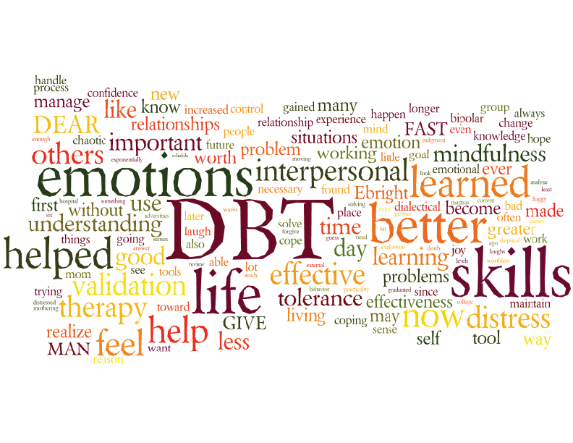





Guidelines
- We may not all know each other now, but over the next 8 sessions we will work together to learn skills which can help us live happier lives.
- We will start by discussing some general guidelines, and adding any other you feel may be important.
1. Participants in training support each other at all times

2. Any information shared is kept confidential outside of training

3. Arrive on time for training, and stay until the end

4. Try and do the practice exercises each week in between training

5. Don't come to sessions under the influence of drugs or alcohol


6. Give help to each other when asked, and accept help and advice if given

Any other guidelines you would like to add?

Goals
- We will learn and practice skills to help us change patterns that are linked to problems in our lives, and emotions and thoughts which are causing distress.

We will learn to DECREASE: We will learn to INCREASE:
- Chaos in our lives - Being able to tolerate distress
- Impulsive behaviour - Making more mindful decisions
- Conflict with others - Positive relationships and respect
- Up-and-down emotions - Control over our emotions

Task: What thoughts/feelings/behaviours would you like to change?

What I want to INCREASE:

What I want to DECREASE:

Biosocial Model of Emotions
- Why is it so hard to control our emotions and actions?

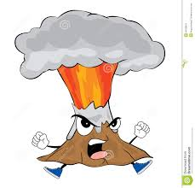
BIO
Our biological make-up can mean that some people's emotions are more intense, and more difficult to control than others

There must be something wrong with me!
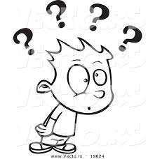

I don't understand why you're getting so upset!

SOCIAL
Our environment (people around us) can influence our emotional experience such as being told that we are overreacting, or giving in to bad behaviour

How can Mindfulness Help?
- Mindfulness means paying attention to our feelings and thoughts in the present moment and without judgement

- Most often we are on ‘auto pilot’, and caught up with thoughts about the past and the future

- Without mindfulness, we respond to situations automatically, often controlled by our emotions…

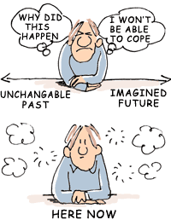

TASK: Can you think of any examples??

The Three States of Mind

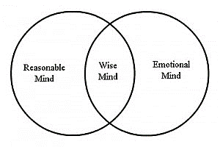
BEST OF BOTH!!
Impulsive
Mood-dependent
Emotion focused
Facts and logic are not important
Rational
Logical
Task focused
Values and feelings are not important.
Ideal for making difficult decisions
Helps us know how to react in situations
Often linked to intuition, or a "gut feeling" of what is right

EXAMPLE: You are in a relationship where your emotions conflict: you feel love, but also anger, frustration, hurt and disappointment.
- By bringing together EMOTION MIND and REASONABLE MIND we can make the best decision based on our values and goals, and not let our emotional attachment get in the way.
Practicing Wise Mind
WHAT we do: Observe, Describe and Participate in what is happening
HOW we do this: Don't judge, Stay focused, Do what works

TASK: Choose one "what" skill, and one "how" skill to practice over the next week

WHAT Skills | HOW Skills
___ Observe  ___ Describe  ___ Participate | ___ Don’t judge  ___ Stay focused  ___ Do What Works

Briefly describe each situation, and how you practiced the skills:

Briefly describe how using the skills affected your thoughts, feelings or behavior:

Session 2: Distress Tolerance

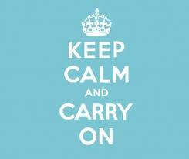

Crisis Survival Skills

Mindfulness Exercise

- Balloon Tennis (2 minutes)

- Task: Either in pairs or as a group hit the balloon to one another
- Think about where you will send the balloon next, and how hard or soft your shot needs to be
- Stay alert throughout the task in case it comes towards you!!

- What thoughts did you have during this exercise?
- What did you find most difficult?

Introduction and Goals
What does "distress" mean to you?
- Psychological suffering? "She felt great distress due to the bad news"
- Being in danger? "The passengers on the stranded ship were very distressed"
- Experiencing physical pain? "After the tackle the player looked in distress"

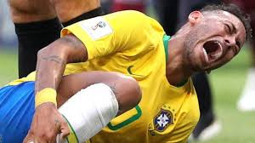
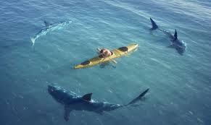
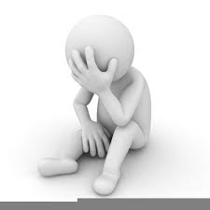

- Everyone experiences distress differently, both in what types of situation cause this feeling, and how they think and feel at that moment.

- When experiencing feelings of panic and fear, it is difficult not to act impulsively, and sometimes then make the situation worse.

- By learning to tolerate these difficult feelings, and distract our attention to positive things, we can make wiser choices to help us cope more effectively with the situation.



In this session, we will focus on how we can use distress tolerance skills to help us get through a crisis, rather than using solutions to cope with the pain which may actually make things worse.

? What do we mean by a "crisis"?
? What urges may we have which we think will help us cope better?
STOP Skills
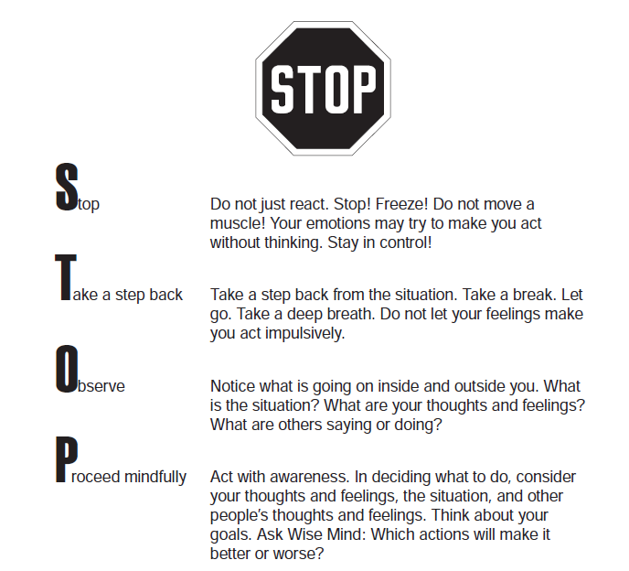
- Helps keep us from acting impulsively on difficult emotions, and stop a bad situation becoming worse

TIP Skills
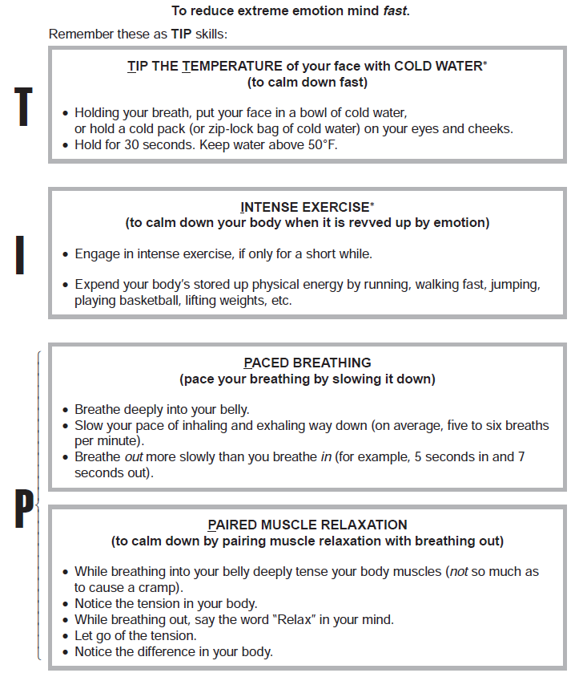
- Ways to change our body chemistry, and quickly reduce heightened emotions
Pros and Cons Skills
- Helps us decide between two options when we are in a crisis situation: either acting impulsively on our emotions, or resisting potentially destructive urges
TASK
Think back to a time when you faced a crisis which was especially difficult to tolerate, and possibly led to impulsive actions and destructive behaviours to try and cope…
Name the impulsive urge: ………………………………………………………………………………………………
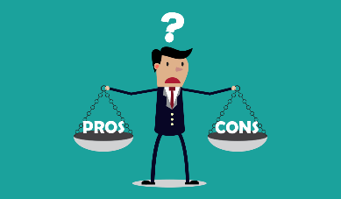
Use the boxes below to list the positive (pros) and negative (cons) consequences of being impulsive (acting on the urge), or tolerating the distress (not acting on the urge)
Try and include both short-term and long-term effects of each.

 | Pros (Advantages) | Cons (Disadvantages)
Acting on urge
Not acting on urge

Practice Exercises
TIP Skills
Due Date
Choose one TIPP skill to practice this week. Check it off now and prepare yourself to use this skill when emotional arousal gets very high.
Rate your emotional arousal before you use the skill: 1–100:
TIPP your body chemistry with:
Temperature
Alter your body temperature by holding your breath and placing head in bowl of cold water. Or, splash cold water on your face or place a cold gel mask on your eyes or forehead. Hold for at least 30 seconds. Works best if bent over forward.
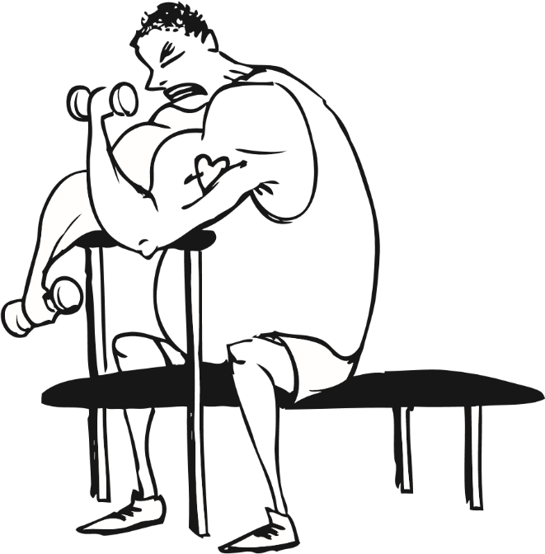
Intense exercise
Run in place, do a high-intensity weight circuit, jump, put on music and dance (10–15 minutes). Don’t overdo it!
Paced breathing
Slow down your breath so that you’re breathing in for about 4 seconds and out for 5–8 seconds. Do this for 1–2 minutes to bring down your arousal.
Progressive muscle relaxation
Tense and relax each muscle group, head to toe, one muscle group at a time.

Rate your emotional arousal after using the skill: 1–100:

Session 3: Interpersonal Effectiveness

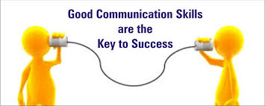

Communicating What YOU Want

Mindfulness Exercise

- Jelly Babies (2 minutes)

- Using one finger, balance the sweet on the table
- DON'T CHEAT!!!
- Try your best not to let it fall

- What was in your mind for those 2 minutes?
- Were you aware of any distractions?

Introduction and Goals
- Do you get what you want from other people?
- Do you find it hard to say "no"?

- Are your opinions and values taken seriously by other people?
All of these things require communication skills, which may be stopping you from achieving your goals…


Can you think of any factors which make effective communication hard for you?

Other reasons may include:
- Worrying about what others will think, if you do or say what you actually want
- Emotions getting in the way of what you want, and controlling what you actually say or do
- Difficulty in deciding what is best, and so saying "no" / giving in to everything that other people ask
- Sometimes even at your 'skilful best' you may not actually achieve what you want… how do you cope with this, and still keep self-respect?

- How can we overcome these challenges, and effectively obtain what we want and need...?


DEAR MAN Skills

DESCRIBE  EXPRESS  ASSERT  REWARD | MINDFUL  APPEAR CONFIDENT  NEGOTIATE

What to do
Describe the situation. Stick to the facts.
"You asked me to lend you money"

Express your feelings about the situation.
"My benefits have decreased, and I'm worried I may not have enough for bills"

Assert yourself by asking for what you want or saying no clearly.
"I can't lend you the money at the moment"

Reward the person by explaining the positive effects.
"I would be really relieved if you could stop asking me, and hope it won't affect our friendship"

How to do it
Mindfully: Keep your focus on what you want. Repeat your opinion again if necessary. Ignore threats and stick to your point.

Appear Confident: Use a confident tone of voice. Make good eye contact. Don’t doubt yourself.

Negotiate: Be willing to GIVE TO GET. Try and help them find alternative solutions to the problem.

Task: Role Play
- Think of a scenario (made up or real), where DEAR MAN skills could be used
- This could be about you wanting to get something (returning an item to a shop), or saying no to someone else (a partner asking to stay over)
WHAT you said:
Describe …………………………………………………………………………………………………………………………………………………………………………………………………………………………………………………………
Express …………………………………………………………………………………………………………………………………………………………………………………………………………………………………………………………
Assert …………………………………………………………………………………………………………………………………………………………………………………………………………………………………………………………
Reward …………………………………………………………………………………………………………………………………………………………………………………………………………………………………………………………
HOW were you:
Mindful …………………………………………………………………………………………………………………………………………………………………………………………………………………………………………………………
Appearing Confident …………………………………………………………………………………………………………………………………………………………………………………………………………………………………………………………
Negotiate …………………………………………………………………………………………………………………………………………………………………………………………………………………………………………………………

Practice Exercise
Describe one situation during the week in which you used your DEAR MAN skills
___________________________________________________________________________________________________________________________________________________________________________

What did you want from the other person?
___________________________________________________________________________________________________________________________________________________________________________

DEAR MAN Skills used (write down how you used each one):

Describe (Describe the situation; just the facts):

Express (feelings):

Assert:

Reward:

Mind:

Appear Confident:

Negotiate:

What was the result of using your DEAR MAN Skills?
___________________________________________________________________________________________________________________________________________________________________________

Session 4: Interpersonal Effectiveness



Keeping healthy relationships and maintaining self-respect

Mindfulness Exercise

- Mindful Listening (3 minutes)

- Break into pairs and sit next to that person
- Choose one 'speaker' and one 'listener'
- Speakers: talk about something really important
- Listeners: act like you're bored and not interested at all
- Swap roles and repeat

- How did it feel to talk to someone not being mindful?
- Try again but this time pay attention- what differences did you notice?

Introduction and Goals
- In the last session we learned skills to effectively get what we want (DEAR MAN), BUT…
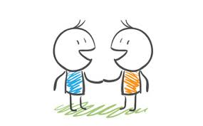

- How can we make sure we keep good relationships?

GOAL: Relationship effectiveness is all about improving or maintaining a good relationships, while at the same time trying to obtain your objective.
Effective communication focuses on how you go about trying to improve the relationship, or make people want to give you what you need. For example do you ask, or do you demand? Do you listen to the other person, or do you cut this person off?

- How can we make sure we keep our self-respect?

GOAL: Self-respect effectiveness is about helping us to keep or improve our self-respect, while at the same time we try to get what we want.
Effective communication focuses on how to ask for what you want, without going against your values and beliefs. For example do you sacrifice your own needs for fear of losing the relationship, or do you feel good for staying true to yourself?


In this session we will learn two new skills, which can be used to achieve the goals above

GIVE Skills
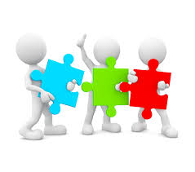
- When your GOAL is to build or maintain good relationships
GENTLE
INTERESTED
VALIDATE
EASY MANNER

GENTLE BE NICE AND RESPECTFUL
- No attacks (verbal or physical)
- No threats (be calm, no drama)
- No judging (don't preach or blame)
- No sneering (avoid eye-rolling, don't walk away)

INTERESTED ACT INTERESTED IN THE OTHER PERSON
- Listen with eye-contact
- Don't interrupt
- Be patient

VALIDATE OTHER PEOPLES FEELINGS AND THOUGHTS
- Use WORDS: "I understand" "That sounds tough"
- Use ACTIONS: Nodding in agreement

EASY MANNER USE A LITTLE HUMOUR AND SMILE
- Try to be light-hearted
- Sit next to the person if they are seated
- Don't have an attitude

FAST Skills
- When your GOAL is to keep your self-respect

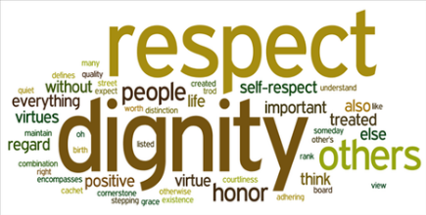
FAIR
APOLOGIES
STICK TO VALUES
TRUTHFUL

F - (Be) FAIR To YOURSELF and to the OTHER person
* DO validate feelings

A - (No) APOLOGIES For you request, or having an opinion
* DON'T look ashamed

S - STICK TO VALUES And be clear about you believe in
* DO stick to your guns, but be fair

T - (Be) TRUTHFUL Don't lie, make excuses, or exaggerate
* DON'T act helpless

Task: Role Play

Scenario 1: A good friend of yours is spending a lot of time with someone who has bullied you in the past

- Which skill would we use to deal with this?
- Describe how each of the 4 stages could be used to help with this situation
___________________________________________________________
___________________________________________________________
______________________________________________________________________________________________________________________

Scenario 2: A friend is meant to be giving you a lift home from a party, but you have seen them drinking/taking drugs

- Which skill would we use to deal with this?
- Describe how each of the 4 stages could be used to help with this situation
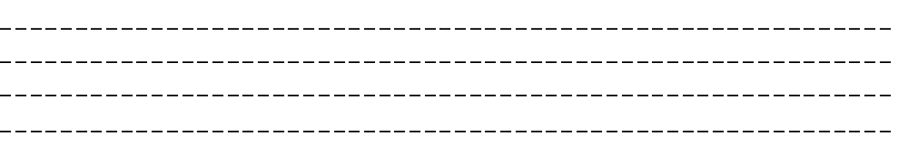

* How may these conversations be different if you didn't use the GIVE / FAST skill?

Practice Exercise
Write down any examples of situations during the week where you used GIVE skills to maintain or build relationships

GENTLE

INTERESTED

VALIDATE

EASY MANNER

Write down any examples of situations during the week where you used FAST skills to keep your self-respect

FAIR

A POLOGIES

STICK TO VALUES

TRUTHFUL

Session 5: Distress Tolerance

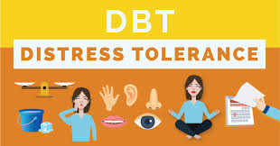

Short-term Relief from Stress and Pain

Mindfulness Exercise

- Observation of music (2 minutes)

- Listen to this piece of music
- Try and observe your thoughts, emotions, and physical feelings
- Listen to the second piece of music
- Again, observe thoughts, emotions and physical feelings

- Did you notice any differences between the two?
- If yes, what were these and why?

Introduction and Goals
- In Session 2 we learned skills to STOP us from acting impulsively... can you remember these? (hint: there may be a clue in the question!!).

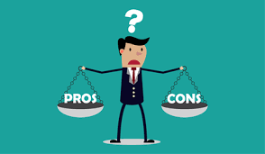



- Today we will learn about a range of skills to help ease the pain and suffering which is often felt in times of crisis.

- While these skills may not directly solve all your problems, they can help to provide short-term relief from painful emotions.

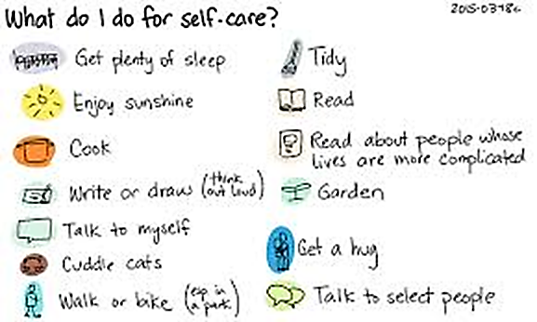

- We will learn 2 approaches in this session:

1. DISTRACTION: Lowering your distress in the moment.
2. SELF-CARE: Finding ways to be mindfully kind to yourself.

Distraction Skills: ACCEPTS
- Which of these do you think may help you?
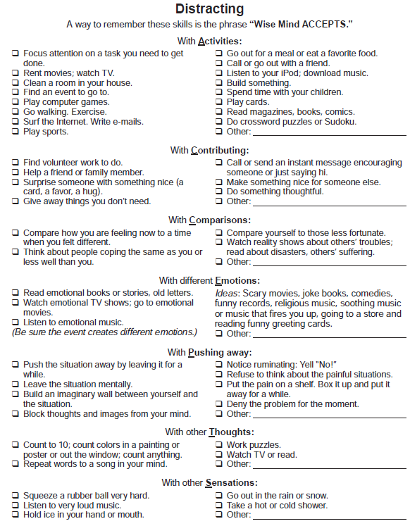
- Could different techniques be used in different situations?

Self-Care Skills: USING THE SENSES
- This may not feel natural to you at first, but with practice it can really help!!

Group Task:
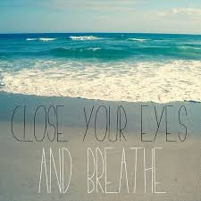
- Rate your current distress level from 1-100
- Choose something on the table
- Using one (or more) of your senses, fully experience this for 5 minutes- Rate your distress again
- What did you think and feel?

Practice Exercise: ACCEPTS Skills

Briefly describe the stressful situation you were in when you chose to practice your skill:

Did using this skill help you to
1) Cope with uncomfortable urges and feelings and/or
2) Avoid conflict of any kind?
Circle: YES NO

If YES, please describe how it helped:

If NO, please describe why you believe it did not help:

If you did not practice this skill, please explain why:

Extra Practice: Crisis Survival Skills
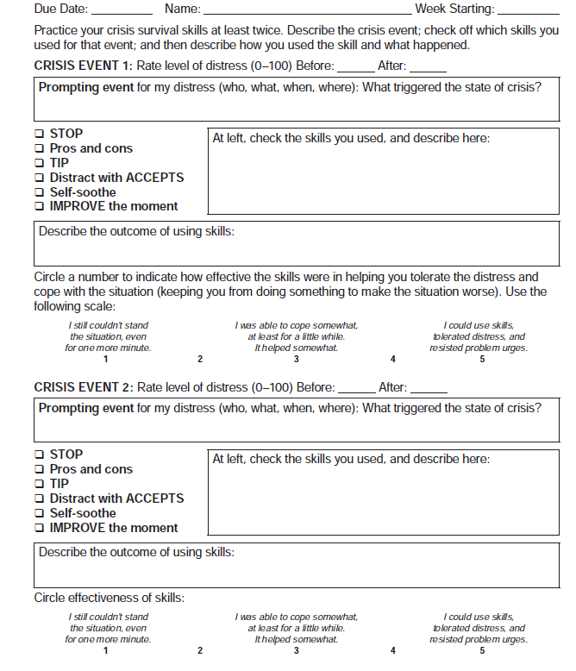
- Over the next week, observe any situations where you have used any of the skills learned in the two sessions.

Session 6: Emotion Regulation



Protecting Yourself from Negative Emotions

Mindfulness Exercise

- Positive Memories (2 minutes)

- Think back to an event when you felt happy and relaxed
- Taking deep breaths, focus your mind on that memory only
- Observe what you could see, hear, taste and feel
- Try and remember as much details as you possibly can

- Did you notice any changes in your feelings or emotions?
- What (if anything) did you find most difficult about the practice?

Introduction and Goals
WHY ARE EMOTIONS SO IMPORTANT?
1. Emotions help give us information – is this always correct?
e.g. "I love him, so he must be good for me"

2. Emotions help us to communicate – how may this influence other people?
e.g. Showing we are sad may cause someone to give some support

3. Emotions help prepare us for action – but we can't always control how we react
e.g. When frightened, we may either fight, freeze, or run!

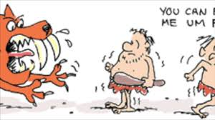

Emotional Dysregulation…

Do you often experience intense emotions? (anger, frustration, sadness)

How does this affect the way you behave? (drinking, drugs, self-harming)

Do these behaviours help the problem? (how do they affect your emotions?)

Goals of Emotion Regulation

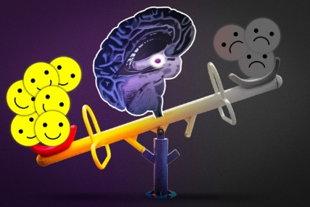
- Able to label and understand emotions

- Able to change emotional responses

- Reduce vulnerability to emotional mind
But HOW can positive emotions outweigh negative??...
ABC Skills
Taking control of our Emotion Mind

A | ACCUMULATE POSITIVE EXPERIENCES  Short Term: Do pleasant things that are possible right now.  e.g. Increase pleasant activities  Long Term: Make changes in your life so positive events will occur more often. Build a life worth living.  e.g. Take small steps towards long-term goals
B | BUILD MASTERY  Do things that are challenging, so you can build confidence and a sense of achievement  e.g. Plan at least one activity each day which will make you feel competent and more in control of your life
C | COPE AHEAD OF TIME WITH  EMOTIONAL SITUATIONS  Create a plan ahead of time so that you are prepared to cope skillfully with emotional situations.  1. Imagine your 'worst case scenario'  2. Rehearse in your mind what you would do and say  3. Practice this strategy – take control of the outcome!

What pleasant activities could you try and start doing to practice the "A" and "B" skills?

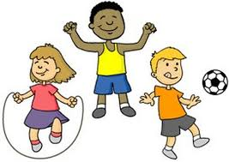



PLEASE Skills
Taking care of your mind by taking care of your body

Treat PhysicaL illness Take care of your body. See a doctor when necessary. Take medication as prescribed.

Balance Eating Eat regularly and mindfully. Make sure to get enough nutrition. Don't overeat or under eat.

Avoid Mood-Altering drugs Stay off non-prescribed drugs like cannabis or alcohol. Be aware of caffeine intake.

Balance Sleep Try to get the amount of sleep that helps you feel good (7-9 hours is ideal). Try to keep a regular sleep schedule.

Get Exercise Do some sort of exercise every day; try to build up to 20 minutes of intense exercise every day.

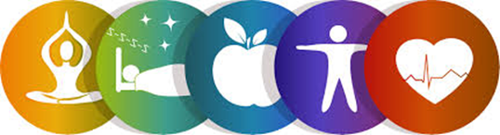

Practice Exercise
Choose one ABC and one PLEASE skill below to practice this week:

Accumulating Positive Experiences____
Choose 1
Building Mastery ____
Coping Ahead____
and
Treat PhysicaL Illness ____
Balance Eating ____
Avoid Mood Altering drugs ____
Choose 1
Balance Sleep ____
Get Exercise ____

- Which ABC SKILL did you use:
______________________________________________________________________________________________________________________
- Which PLEASE SKILL did you use:
______________________________________________________________________________________________________________________
- Did using the skills help you:
1) to feel better? YES/NO
2) to be more able to handle stress? YES/NO
If YES, describe how they helped:
______________________________________________________________________________________________________________________
If NO, describe why you think they did not help:
______________________________________________________________________________________________________________________

Session 7: Emotion Regulation
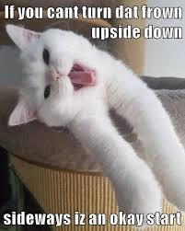

Changing Your Emotional Response

Mindfulness Exercise

- Sweet Switch (3 minutes)

- Choose your favourite sweet from the box on the table
- Put it in front of you and really imagine yourself eating the sweet
- Now pass your sweet to the person on your left!

- What are your initial thoughts and feelings?

- Now slowly eat the new sweet
- Close your eyes: focus on the smell, taste and texture

- What did you experience through the whole exercise?
- Did you notice your emotions change at any point?

Introduction and Goals

Sometimes our emotions may control our thoughts, and make a problem seem much worse than it actually is…

Q: How do we know if this emotion is correct?

A: Check the facts
Emotion
Fear | There is a threat to life, health, or well-being.
Sadness | You have lost something or someone, OR things are not the way you expected or wanted or hoped for.
Anger | An important goal is being blocked, OR you or someone you care about has been attacked, hurt, insulted, or threatened.
Jealousy | A relationship that is important to you is threatened or in danger of being lost.
Shame | You will be rejected from a very important group if characteristics of yourself or of your behavior are made public.
Guilt | Your own behavior violates your own values or moral code.
"Does the emotion fit the situation?"

YES NO
USE PROBLEM SOLVING
TO COPE WITH THE EMOTION
(This Session)

USE OPPOSITE ACTION
TO CHANGE THE EMOTION
(Next Session)

Problem Solving Skills

Step 1: Figure out and DESCRIBE the problem.


Step 2: Check ALL the facts- make sure you have the right problem situation!

Step 3: What’s your GOAL – what needs to change for you to feel okay?

Step 4: BRAINSTORM- think of as many solutions as you can.
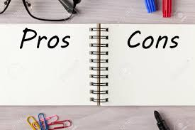
Step 5: CHOOSE the solution(s) that are likely to work- consider the Pros and Cons?

Step 6: ACTION! Try the solution

Step 7: DID IT WORK? YES – REWARD YOURSELF!!!

NO – DON'T GIV E UP, TRY ANOTHER SOLUTION!

Practice Exercise
This week try using the steps below to practice if your problem solving skills can help a situation which triggers painful emotions:

Step 1: What’s the problem? What emotion do you want to change?

Step 2: Check the facts (What are they? Does this emotion fit?)

Step 3: What’s my goal – what will make me feel better?

Step 4: My brainstorming ideas (possible solutions to the problem):
1.
2.
3.
Step 5: Consider the pros and cons.. Which solution shall I try:

Step 6: Action! Try the solution…

Step 7: Evaluate - did it work? If not, go back to step 5 and try another one of your solutions

Session 8: Final Week!

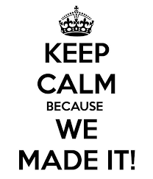

Opposite Action to Change Emotions…
Celebrations and Goodbye's!

Mindfulness Exercise

- Understanding each other

- Write down at least one 'worry thought' you are having at the moment
- Put this into the box in the middle
- Pick out one of the 'worries' (not your own!)
- Read out to the group

- As a group discuss why this worry is valid (show understanding)
- What DBT skills could help with this worry?

Opposite Action Skills
RECAP (Session 7): When our emotions DON'T FIT THE FACTS, we CAN change them by acting OPPOSITE to how we FEEL:
Step 1 | Identify and name the emotion you want to change
Step 2 | Check the facts
Step 3 | Identify and describe your action urges
Step 4 | Ask: Will this emotion make things better or worse?
Step 5 | Think of the opposite action to your action urges
Step 6 | Act opposite ALL THE WAY to your action urges!
Step 7 | Repeat acting opposite until your emotion changes
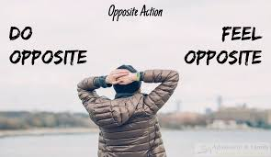

For example:

FEAR RUN OR AVOID APPROACH
SADNESS ISOLATE GET OUT AND ABOUT
SHAME HIDE BE OPEN- TELL SOMEONE

What other examples can you think of?...

Practice Exercise
- Try and use OPPOSITE ACTION for an emotional response you want to change
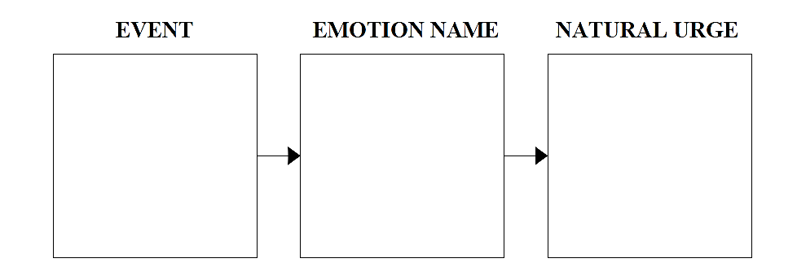
- Describe below what happened (when either if you did / did not follow the urge)
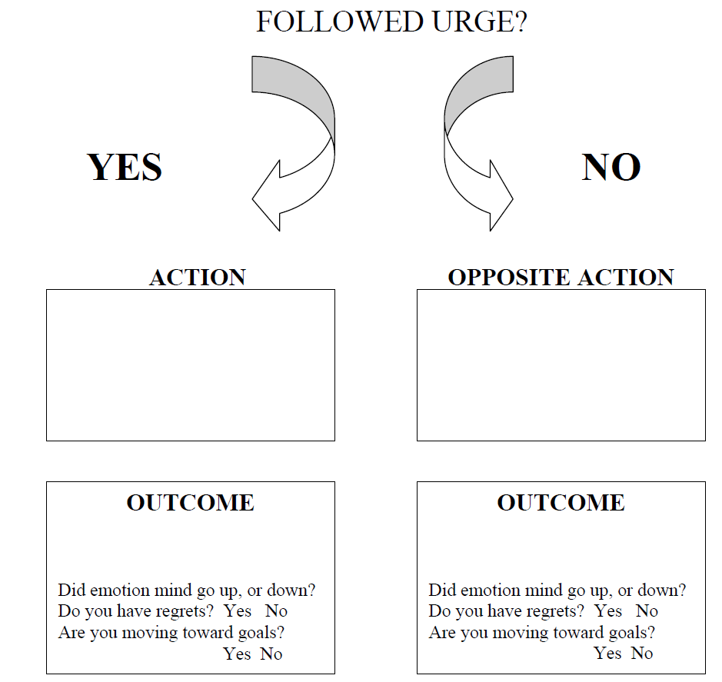
Accomplishments

TASK:
Write down one thing you have learned from coming to this training, and one thing which you think need to practice more…
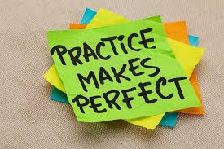

DISCUSSION:
From the skills we feel we have mastered, what situations in life can you think of where these may be useful to you?

What advice can you give to each other, in relation to the skills we feel we need to practice more?

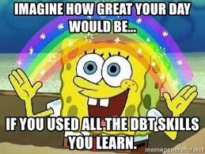

Celebration Time!!!

- The rest of this session is a time for us to celebrate everything we have learned and achieved

- Feel free to discuss your experiences of the training (good and bad are both equally important!)

- If there is anything you are still unsure about, or would like extra advice on for the future- now is the time to ask!!

