Supporting information for Developing conceptions of forgiveness across the lifespan

Table of Content
Table S1. Statistics for simple effect of Condition within each Age Group and pairwise comparisons for Victim Prosocial Behavior. 4
Table S2. Statistics for simple effect of Condition within each Age Group and pairwise comparisons for Victim’s Empathy for the Offender. 5
Table S3. Statistics for simple effect of Condition within each Age Group and pairwise comparisons for Victim’s Future Trust of the Offender. 6
Table S4. Statistics for simple effect of Condition within each Age Group and pairwise comparisons for Victim’s Avoidance of the Offender. 7
Table S5. Statistics for simple effect of Condition within each Age Group and pairwise comparisons for Victim’s Willingness to Gossip about the Offender. 8
Table S6. Statistics for simple effect of Condition within each Age Group and pairwise comparisons for Victim’s Pursuit of Revenge. 9
Table S7. Statistics for simple effect of Condition within each Age Group and pairwise comparisons for Offender Recidivism. 10
Table S8. Statistics for simple effect of Condition within each Age Group and pairwise comparisons for Victim Affective Change. 11
Table S9. Statistics for simple effect of Condition within each Age Group and pairwise comparisons for Offender Affective Change. 12
Table S10. Statistics for simple effect of Condition within each Age Group and pairwise comparisons for Bystander Affective Change. 13
Table S11. Statistics for simple effect of Condition within each Age Group and pairwise comparisons for Others’ Willingness to Interact with the Victim. 14
Table S12. Statistics for simple effect of Condition within each Age Group and pairwise comparisons for Others’ Willingness to Interact with the Offender. 15
Table S13. Statistics for simple effect of Age Group within each Condition and pairwise comparisons for Victim Prosocial Behavior. 16
Table S14. Statistics for simple effect of Age Group within each Condition and pairwise comparisons for Victim Empathy for the Offender. 17
Table S15. Statistics for simple effect of Age Group within each Condition and pairwise comparisons for Victim’s Future Trust of the Offender. 18
Table S16. Statistics for simple effect of Age Group within each Condition and pairwise comparisons for Victim’s Avoidance of the Offender. 19
Table S17. Statistics for simple effect of Age Group within each Condition and pairwise comparisons for Victim’s Willingness to Gossip about the Offender. 20
Table S18. Statistics for simple effect of Age Group within each Condition and pairwise comparisons for Victim’s Pursuit of Revenge. 21
Table S19. Statistics for simple effect of Age Group within each Condition and pairwise comparisons for Offender Recidivism. 22
Table S20. Statistics for simple effect of Age Group within each Condition and pairwise comparisons for Victim Affective Change. 23
Table S21. Statistics for simple effect of Age Group within each Condition and pairwise comparisons for Offender Affective Change. 24
Table S22. Statistics for simple effect of Age Group within each Condition and pairwise comparisons for Bystander Affective Change. 25
Table S23. Statistics for simple effect of Age Group within each Condition and pairwise comparisons for Others’ Willingness to Interact with the Victim. 26
Table S24. Statistics for simple effect of Age Group within each Condition and pairwise comparisons for Others’ Willingness to Interact with the Offender. 27
Table 25 | Statistical values for main effects, interaction effects, and simple effects for each item. 28
Table 26 | Statistical values for main effects of Vignette and interaction effects between Vignette and Condition for each item. 29
Table S27. Word frequency for children’s, adolescents’, and adults’ free-response answers to the question, “Can you tell me what you think the word ‘punish’ means?”. 30
Table S28. Word frequency for children’s, adolescents’, and adults’ free-response answers to the question, “Can you tell me what you think the word ‘forgive’ means?”. 32
Figure S1. Participants’ ratings as a function of Condition (punishment, do nothing, forgiveness) (on the left) and as a function of Age Group (children, adolescents, adults) and Condition (punishment, do nothing, forgiveness) (on the right) for the three items included in the “Prosocial Thoughts and Emotions” category. 34
Figure S2. Participants’ ratings as a function of Condition (punishment, do nothing, forgiveness) (on the left) and as a function of Age Group (children, adolescents, adults) and Condition (punishment, do nothing, forgiveness) (on the right) for the three items included in the “Antisocial Behaviors” category. 35
Figure S3. Participants’ ratings as a function of Condition (punishment, do nothing, forgiveness) (on the left) and as a function of Age Group (children, adolescents, adults) and Condition (punishment, do nothing, forgiveness) (on the right) for the three items included in the “Affective Change” category. 36
Figure S4. Participants’ ratings as a function of Condition (punishment, do nothing, forgiveness) (on the left) and as a function of Age Group (children, adolescents, adults) and Condition (punishment, do nothing, forgiveness) (on the right) for the three items included in the “Affiliative Interest” category. Error bars represent +/- confidence intervals. 37
Figure S5. Participants’ ratings as a function of Condition (punishment, do nothing, forgiveness) and Vignette (Bike, Clay, Drawing) for Victim Prosocial Behavior. 38
Figure S6. Participants’ ratings as a function of Condition (punishment, do nothing, forgiveness) and Vignette (Bike, Clay, Drawing) for Victim’s Empathy for the Offender. 39
Figure S7. Participants’ ratings as a function of Condition (punishment, do nothing, forgiveness) and Vignette (Bike, Clay, Drawing) for Victim’s Trust of the Offender. 40
Figure S8. Participants’ ratings as a function of Condition (punishment, do nothing, forgiveness) and Vignette (Bike, Clay, Drawing) for Victim’s Avoidance of the Offender. 41
Figure S9. Participants’ ratings as a function of Condition (punishment, do nothing, forgiveness) and Vignette (Bike, Clay, Drawing) for Victim’s Willingness to Gossip About the Offender. 42
Figure S10. Participants’ ratings as a function of Condition (punishment, do nothing, forgiveness) and Vignette (Bike, Clay, Drawing) for Victim’s Pursuit of Revenge. 43
Figure S11. Participants’ ratings as a function of Condition (punishment, do nothing, forgiveness) and Vignette (Bike, Clay, Drawing) for Offender Recidivism. 44
Figure S12. Participants’ ratings as a function of Condition (punishment, do nothing, forgiveness) and Vignette (Bike, Clay, Drawing) for Victim Affective Change. 45
Figure S13. Participants’ ratings as a function of Condition (punishment, do nothing, forgiveness) and Vignette (Bike, Clay, Drawing) for Offender Affective Change. 46
Figure S14. Participants’ ratings as a function of Condition (punishment, do nothing, forgiveness) and Vignette (Bike, Clay, Drawing) for Bystander Affective Change. 47
Figure S15. Participants’ ratings as a function of Condition (punishment, do nothing, forgiveness) and Vignette (Bike, Clay, Drawing) for Others’ Evaluation of the Victim. 48
Figure S16. Participants’ ratings as a function of Condition (punishment, do nothing, forgiveness) and Vignette (Bike, Clay, Drawing) for Others’ Evaluation of the Offender. 49

Table S1. Statistics for simple effect of Condition within each Age Group and pairwise comparisons for Victim Prosocial Behavior.

Prosocial Behavior
Age Group | F-value | p-value | Contrasts
 |  |  |  | Estimate | p-value
Children | F(2, 384)=34.25 | p < .001* | Forgive – Do Nothing | -1.40 | <.001*
Children | F(2, 384)=34.25 | p < .001* | Forgive – Punish | -1.73 | <.001*
Children | F(2, 384)=34.25 | p < .001* | Do Nothing – Punish | -0.33 | .400
Adolescents | F(2, 634)=90.83 | p < .001* | Forgive – Do Nothing | -1.68 | <.001*
Adolescents | F(2, 634)=90.83 | p < .001* | Forgive – Punish | -1.85 | <.001*
Adolescents | F(2, 634)=90.83 | p < .001* | Do Nothing – Punish | -0.18 | .716
Adults | F(2, 589)=83.06 | p < .001* | Forgive – Do Nothing | -1.39 | <.001*
Adults | F(2, 589)=83.06 | p < .001* | Forgive – Punish | -1.58 | <.001*
Adults | F(2, 589)=83.06 | p < .001* | Do Nothing – Punish | -1.93 | .450

Table S2. Statistics for simple effect of Condition within each Age Group and pairwise comparisons for Victim’s Empathy for the Offender.

Empathy
Age Group | F-value | p-value | Contrasts
 |  |  |  | Estimate | p-value
Children | F(2, 384)=3.46 | p=.032* | Forgive – Do Nothing | -0.43 | .198
Children | F(2, 384)=3.46 | p=.032* | Forgive – Punish | -0.59 | .034*
Children | F(2, 384)=3.46 | p=.032* | Do Nothing – Punish | -0.16 | 1.00
Adolescents | F(2, 634)=36.46 | p < .001* | Forgive – Do Nothing | -1.16 | <.001*
Adolescents | F(2, 634)=36.46 | p < .001* | Forgive – Punish | -1.40 | <.001*
Adolescents | F(2, 634)=36.46 | p < .001* | Do Nothing – Punish | -0.23 | .540
Adults | F(2, 588)=65.55 | p < .001* | Forgive – Do Nothing | -1.62 | <.001*
Adults | F(2, 588)=65.55 | p < .001* | Forgive – Punish | -1.57 | <.001*
Adults | F(2, 588)=65.55 | p < .001* | Do Nothing – Punish | 0.06 | 1.00

Table S3. Statistics for simple effect of Condition within each Age Group and pairwise comparisons for Victim’s Future Trust of the Offender.

Trust
Age Group | F-value | p-value | Contrasts
 |  |  |  | Estimate | p-value
Children | F(2, 384)=17.16 | p < .001* | Forgive – Do Nothing | -1.16 | <.001*
Children | F(2, 384)=17.16 | p < .001* | Forgive – Punish | -1.16 | <.001*
Children | F(2, 384)=17.16 | p < .001* | Do Nothing – Punish | < 0.01 | 1.00
Adolescents | F(2, 637)=61.92 | p < .001* | Forgive – Do Nothing | -1.36 | <.001*
Adolescents | F(2, 637)=61.92 | p < .001* | Forgive – Punish | -1.51 | <.001*
Adolescents | F(2, 637)=61.92 | p < .001* | Do Nothing – Punish | -0.15 | .949
Adults | F(2, 589)=25.75 | p < .001* | Forgive – Do Nothing | -0.79 | <.001*
Adults | F(2, 589)=25.75 | p < .001* | Forgive – Punish | -0.83 | <.001*
Adults | F(2, 589)=25.75 | p < .001* | Do Nothing – Punish | -0.03 | 1.00

Table S4. Statistics for simple effect of Condition within each Age Group and pairwise comparisons for Victim’s Avoidance of the Offender.

Avoidance
Age Group | F-value | p-value | Contrasts
 |  |  |  | Estimate | p-value
Children | F(2, 384)=15.98 | p < .001* | Forgive – Do Nothing | 1.02 | <.001*
Children | F(2, 384)=15.98 | p < .001* | Forgive – Punish | 1.27 | <.001*
Children | F(2, 384)=15.98 | p < .001* | Do Nothing – Punish | 0.26 | .849
Adolescents | F(2, 633)=93.08 | p < .001* | Forgive – Do Nothing | 2.01 | <.001*
Adolescents | F(2, 633)=93.08 | p < .001* | Forgive – Punish | 1.92 | <.001*
Adolescents | F(2, 633)=93.08 | p < .001* | Do Nothing – Punish | -0.09 | 1.00
Adults | F(2, 590)=119.6 | p < .001* | Forgive – Do Nothing | 2.20 | <.001*
Adults | F(2, 590)=119.6 | p < .001* | Forgive – Punish | 1.57 | <.001*
Adults | F(2, 590)=119.6 | p < .001* | Do Nothing – Punish | -0.63 | <.001*

Table S5. Statistics for simple effect of Condition within each Age Group and pairwise comparisons for Victim’s Willingness to Gossip about the Offender.

Willingness to Gossip
Age Group | F-value | p-value | Contrasts
 |  |  |  | Estimate | p-value
Children | F(2, 384)=12.46 | p < .001* | Forgive – Do Nothing | 0.81 | <.001*
Children | F(2, 384)=12.46 | p < .001* | Forgive – Punish | 1.03 | <.001*
Children | F(2, 384)=12.46 | p < .001* | Do Nothing – Punish | 0.23 | .904
Adolescents | F(2, 635)=52.73 | p < .001* | Forgive – Do Nothing | 0.98 | <.001*
Adolescents | F(2, 635)=52.73 | p < .001* | Forgive – Punish | 1.82 | <.001*
Adolescents | F(2, 635)=52.73 | p < .001* | Do Nothing – Punish | 0.84 | <.001*
Adults | F(2, 590)=138.0 | p < .001* | Forgive – Do Nothing | 1.55 | <.001*
Adults | F(2, 590)=138.0 | p < .001* | Forgive – Punish | 2.48 | <.001*
Adults | F(2, 590)=138.0 | p < .001* | Do Nothing – Punish | 0.94 | <.001*

Table S6. Statistics for simple effect of Condition within each Age Group and pairwise comparisons for Victim’s Pursuit of Revenge.

Pursuit of Revenge
Age Group | F-value | p-value | Contrasts
 |  |  |  | Estimate | p-value
Children | F(2, 383)=7.58 | p < .001* | Forgive – Do Nothing | 0.78 | .004*
Children | F(2, 383)=7.58 | p < .001* | Forgive – Punish | 0.83 | .002*
Children | F(2, 383)=7.58 | p < .001* | Do Nothing – Punish | 0.06 | 1.00
Adolescents | F(2, 633)=48.90 | p < .001* | Forgive – Do Nothing | 0.89 | <.001*
Adolescents | F(2, 633)=48.90 | p < .001* | Forgive – Punish | 1.76 | <.001*
Adolescents | F(2, 633)=48.90 | p < .001* | Do Nothing – Punish | 0.87 | <.001*
Adults | F(2, 588)=96.55 | p < .001* | Forgive – Do Nothing | 0.89 | <.001*
Adults | F(2, 588)=96.55 | p < .001* | Forgive – Punish | 2.14 | <.001*
Adults | F(2, 588)=96.55 | p < .001* | Do Nothing – Punish | 1.26 | <.001*

Table S7. Statistics for simple effect of Condition within each Age Group and pairwise comparisons for Offender Recidivism.

Offender Recidivism
Age Group | F-value | p-value | Contrasts
 |  |  |  | Estimate | p-value
Children | F(2, 384)=0.45 | p = .74 | Forgive – Do Nothing | 0.20 | 1.00
Children | F(2, 384)=0.45 | p = .74 | Forgive – Punish | 0.26 | 1.00
Children | F(2, 384)=0.45 | p = .74 | Do Nothing – Punish | 0.06 | 1.00
Adolescents | F(2, 637)=18.75 | p < .001* | Forgive – Do Nothing | 1.11 | <.001*
Adolescents | F(2, 637)=18.75 | p < .001* | Forgive – Punish | 0.52 | .012*
Adolescents | F(2, 637)=18.75 | p < .001* | Do Nothing – Punish | -0.59 | .004*
Adults | F(2, 592)=49.18 | p < .001* | Forgive – Do Nothing | 1.22 | <.001*
Adults | F(2, 592)=49.18 | p < .001* | Forgive – Punish | -0.22 | .496
Adults | F(2, 592)=49.18 | p < .001* | Do Nothing – Punish | -1.43 | <.001*

Table S8. Statistics for simple effect of Condition within each Age Group and pairwise comparisons for Victim Affective Change.

Victim Affective Change
Age Group | F-value | p-value | Contrasts
 |  |  |  | Estimate | p-value
Children | F(2, 384)=20.39 | p < .001* | Forgive – Do Nothing | -1.27 | <.001*
Children | F(2, 384)=20.39 | p < .001* | Forgive – Punish | -1.29 | <.001*
Children | F(2, 384)=20.39 | p < .001* | Do Nothing – Punish | -0.02 | 1.00
Adolescents | F(2, 631)=47.71 | p < .001* | Forgive – Do Nothing | -1.63 | <.001*
Adolescents | F(2, 631)=47.71 | p < .001* | Forgive – Punish | -1.23 | <.001*
Adolescents | F(2, 631)=47.71 | p < .001* | Do Nothing – Punish | 0.40 | .069
Adults | F(2, 588)=101.5 | p < .001* | Forgive – Do Nothing | -2.23 | <.001*
Adults | F(2, 588)=101.5 | p < .001* | Forgive – Punish | -1.73 | <.001*
Adults | F(2, 588)=101.5 | p < .001* | Do Nothing – Punish | 0.50 | .007*

Table S9. Statistics for simple effect of Condition within each Age Group and pairwise comparisons for Offender Affective Change.

Offender Affective Change
Age Group | F-value | p-value | Contrasts
 |  |  |  | Estimate | p-value
Children | F(2, 384)=49.30 | p < .001* | Forgive – Do Nothing | -1.36 | <.001*
Children | F(2, 384)=49.30 | p < .001* | Forgive – Punish | -2.20 | <.001*
Children | F(2, 384)=49.30 | p < .001* | Do Nothing – Punish | -0.84 | <.001*
Adolescents | F(2, 630)  =101.60 | p < .001* | Forgive – Do Nothing | -1.38 | <.001*
Adolescents | F(2, 630)  =101.60 | p < .001* | Forgive – Punish | -2.27 | <.001*
Adolescents | F(2, 630)  =101.60 | p < .001* | Do Nothing – Punish | -0.89 | <.001*
Adults | F(2, 590)  =128.40 | p < .001* | Forgive – Do Nothing | -1.27 | <.001*
Adults | F(2, 590)  =128.40 | p < .001* | Forgive – Punish | -2.46 | <.001*
Adults | F(2, 590)  =128.40 | p < .001* | Do Nothing – Punish | -1.19 | <.001*

Table S10. Statistics for simple effect of Condition within each Age Group and pairwise comparisons for Bystander Affective Change.

Bystander Affective Change
Age Group | F-value | p-value | Contrasts
 |  |  |  | Estimate | p-value
Children | F(2, 384)=21.43 | p < .001* | Forgive – Do Nothing | -1.06 | <.001*
Children | F(2, 384)=21.43 | p < .001* | Forgive – Punish | -1.41 | <.001*
Children | F(2, 384)=21.43 | p < .001* | Do Nothing – Punish | -0.35 | .363
Adolescents | F(2, 632)=33.43 | p < .001* | Forgive – Do Nothing | -1.04 | <.001*
Adolescents | F(2, 632)=33.43 | p < .001* | Forgive – Punish | -1.39 | <.001*
Adolescents | F(2, 632)=33.43 | p < .001* | Do Nothing – Punish | -0.34 | .157
Adults | F(2, 590)=26.94 | p < .001* | Forgive – Do Nothing | -1.14 | <.001*
Adults | F(2, 590)=26.94 | p < .001* | Forgive – Punish | -0.93 | <.001*
Adults | F(2, 590)=26.94 | p < .001* | Do Nothing – Punish | 0.22 | .565

Table S11. Statistics for simple effect of Condition within each Age Group and pairwise comparisons for Others’ Willingness to Interact with the Victim.

Others’ Willingness to Interact with Victim
Age Group | F-value | p-value | Contrasts
 |  |  |  | Estimate | p-value
Children | F(2, 384)=21.45 | p < .001* | Forgive – Do Nothing | -0.13 | 1.00
Children | F(2, 384)=21.45 | p < .001* | Forgive – Punish | -1.27 | <.001*
Children | F(2, 384)=21.45 | p < .001* | Do Nothing – Punish | -1.14 | <.001*
Adolescents | F(2, 634)=44.41 | p < .001* | Forgive – Do Nothing | -1.06 | <.001*
Adolescents | F(2, 634)=44.41 | p < .001* | Forgive – Punish | -1.62 | <.001*
Adolescents | F(2, 634)=44.41 | p < .001* | Do Nothing – Punish | -0.56 | .004*
Adults | F(2, 586)=35.19 | p < .001* | Forgive – Do Nothing | -1.09 | <.001*
Adults | F(2, 586)=35.19 | p < .001* | Forgive – Punish | -1.24 | <.001*
Adults | F(2, 586)=35.19 | p < .001* | Do Nothing – Punish | -0.15 | 1.00

Table S12. Statistics for simple effect of Condition within each Age Group and pairwise comparisons for Others’ Willingness to Interact with the Offender.

Others’ Willingness to Interact with Offender
Age Group | F-value | p-value | Contrasts
 |  |  |  | Estimate | p-value
Children | F(2, 384)=9.17 | p < .001* | Forgive – Do Nothing | -0.85 | <.001*
Children | F(2, 384)=9.17 | p < .001* | Forgive – Punish | -0.84 | <.001*
Children | F(2, 384)=9.17 | p < .001* | Do Nothing – Punish | 0.01 | 1.00
Adolescents | F(2, 639)=16.03 | p < .001* | Forgive – Do Nothing | -0.91 | <.001*
Adolescents | F(2, 639)=16.03 | p < .001* | Forgive – Punish | -0.80 | <.001*
Adolescents | F(2, 639)=16.03 | p < .001* | Do Nothing – Punish | 0.11 | 1.00
Adults | F(2, 589)=11.26 | p < .001* | Forgive – Do Nothing | -0.68 | <.001*
Adults | F(2, 589)=11.26 | p < .001* | Forgive – Punish | -0.66 | <.001*
Adults | F(2, 589)=11.26 | p < .001* | Do Nothing – Punish | 0.02 | 1.00

Table S13. Statistics for simple effect of Age Group within each Condition and pairwise comparisons for Victim Prosocial Behavior.

Prosocial Behavior
Condition | F-value | p-value | Contrasts
 |  |  |  | Estimate | p-value
Forgive | F(2, 537)=18.46 | p < .001* | Children – Adolescents | -0.47 | .043*
Forgive | F(2, 537)=18.46 | p < .001* | Children – Adults | -1.15 | <.001*
Forgive | F(2, 537)=18.46 | p < .001* | Adolescents – Adults | -0.68 | <.001*
Do Nothing | F(2, 534)=23.25 | p < .001* | Children – Adolescents | -0.75 | <.001*
Do Nothing | F(2, 534)=23.25 | p < .001* | Children – Adults | -1.14 | <.001*
Do Nothing | F(2, 534)=23.25 | p < .001* | Adolescents – Adults | -0.39 | .025*
Punish | F(2, 536)=20.29 | p < .001* | Children – Adolescents | -0.60 | <.001*
Punish | F(2, 536)=20.29 | p < .001* | Children – Adults | -1.00 | <.001*
Punish | F(2, 536)=20.29 | p < .001* | Adolescents – Adults | -0.40 | .011*

Table S14. Statistics for simple effect of Age Group within each Condition and pairwise comparisons for Victim Empathy for the Offender.

Empathy
Condition | F-value | p-value | Contrasts
 |  |  |  | Estimate | p-value
Forgive | F(2, 533)=0.51 | p = .602 | Children – Adolescents | -0.14 | 1.00
Forgive | F(2, 533)=0.51 | p = .602 | Children – Adults | -0.20 | .953
Forgive | F(2, 533)=0.51 | p = .602 | Adolescents – Adults | -0.05 | 1.00
Do Nothing | F(2, 536)=24.99 | p < .001* | Children – Adolescents | -0.87 | <.001*
Do Nothing | F(2, 536)=24.99 | p < .001* | Children – Adults | -1.40 | <.001*
Do Nothing | F(2, 536)=24.99 | p < .001* | Adolescents – Adults | -0.53 | .007*
Punish | F(2, 537)=18.14 | p < .001* | Children – Adolescents | -0.94 | <.001*
Punish | F(2, 537)=18.14 | p < .001* | Children – Adults | -1.18 | <.001*
Punish | F(2, 537)=18.14 | p < .001* | Adolescents – Adults | -0.24 | .542

Table S15. Statistics for simple effect of Age Group within each Condition and pairwise comparisons for Victim’s Future Trust of the Offender.

Trust
Condition | F-value | p-value | Contrasts
 |  |  |  | Estimate | p-value
Forgive | F(2, 538)=26.42 | p < .001* | Children – Adolescents | -0.49 | .048*
Forgive | F(2, 538)=26.42 | p < .001* | Children – Adults | -1.41 | <.001*
Forgive | F(2, 538)=26.42 | p < .001* | Adolescents – Adults | -0.92 | <.001*
Do Nothing | F(2, 535)=21.77 | p < .001* | Children – Adolescents | -0.69 | <.001*
Do Nothing | F(2, 535)=21.77 | p < .001* | Children – Adults | -1.05 | <.001*
Do Nothing | F(2, 535)=21.77 | p < .001* | Adolescents – Adults | -0.35 | .034*
Punish | F(2, 537)=25.66 | p < .001* | Children – Adolescents | -0.84 | <.001*
Punish | F(2, 537)=25.66 | p < .001* | Children – Adults | -1.08 | <.001*
Punish | F(2, 537)=25.66 | p < .001* | Adolescents – Adults | -0.24 | .235

Table S16. Statistics for simple effect of Age Group within each Condition and pairwise comparisons for Victim’s Avoidance of the Offender.

Avoidance
Condition | F-value | p-value | Contrasts
 |  |  |  | Estimate | p-value
Forgive | F(2, 534)=3.75 | p = .024* | Children – Adolescents | -0.11 | 1.00
Forgive | F(2, 534)=3.75 | p = .024* | Children – Adults | 0.36 | .229
Forgive | F(2, 534)=3.75 | p = .024* | Adolescents – Adults | 0.47 | .024*
Do Nothing | F(2, 537)=39.48 | p < .001* | Children – Adolescents | 0.88 | <.001*
Do Nothing | F(2, 537)=39.48 | p < .001* | Children – Adults | 1.55 | <.001*
Do Nothing | F(2, 537)=39.48 | p < .001* | Adolescents – Adults | 0.67 | <.001*
Punish | F(2, 536)=6.40 | p = .002* | Children – Adolescents | 0.50 | .023*
Punish | F(2, 536)=6.40 | p = .002* | Children – Adults | 0.66 | .002*
Punish | F(2, 536)=6.40 | p = .002* | Adolescents – Adults | 0.16 | 1.00

Table S17. Statistics for simple effect of Age Group within each Condition and pairwise comparisons for Victim’s Willingness to Gossip about the Offender.

Willingness to Gossip
Condition | F-value | p-value | Contrasts
 |  |  |  | Estimate | p-value
Forgive | F(2, 535)=2.26 | p = .105 | Children – Adolescents | 0.36 | .111
Forgive | F(2, 535)=2.26 | p = .105 | Children – Adults | 0.28 | .335
Forgive | F(2, 535)=2.26 | p = .105 | Adolescents – Adults | -0.08 | 1.00
Do Nothing | F(2, 537)=12.66 | p < .001* | Children – Adolescents | 0.51 | .035*
Do Nothing | F(2, 537)=12.66 | p < .001* | Children – Adults | 1.02 | <.001*
Do Nothing | F(2, 537)=12.66 | p < .001* | Adolescents – Adults | 0.51 | .011*
Punish | F(2, 537)=40.07 | p < .001* | Children – Adolescents | 1.15 | <.001*
Punish | F(2, 537)=40.07 | p < .001* | Children – Adults | 1.73 | <.001*
Punish | F(2, 537)=40.07 | p < .001* | Adolescents – Adults | 0.58 | .002*

Table S18. Statistics for simple effect of Age Group within each Condition and pairwise comparisons for Victim’s Pursuit of Revenge.

Pursuit of Revenge
Condition | F-value | p-value | Contrasts
 |  |  |  | Estimate | p-value
Forgive | F(2, 535)=11.28 | p < .001* | Children – Adolescents | -0.30 | .247
Forgive | F(2, 535)=11.28 | p < .001* | Children – Adults | -0.79 | <.001*
Forgive | F(2, 535)=11.28 | p < .001* | Adolescents – Adults | -0.49 | .004*
Do Nothing | F(2, 534)=6.66 | p = .001* | Children – Adolescents | -0.19 | 1.00
Do Nothing | F(2, 534)=6.66 | p = .001* | Children – Adults | -0.68 | .003*
Do Nothing | F(2, 534)=6.66 | p = .001* | Adolescents – Adults | -0.50 | .016*
Punish | F(2, 535)=4.55 | p = .011* | Children – Adolescents | 0.63 | .011*
Punish | F(2, 535)=4.55 | p = .011* | Children – Adults | 0.52 | .053
Punish | F(2, 535)=4.55 | p = .011* | Adolescents – Adults | -0.11 | 1.00

Table S19. Statistics for simple effect of Age Group within each Condition and pairwise comparisons for Offender Recidivism.

Offender Recidivism
Condition | F-value | p-value | Contrasts
 |  |  |  | Estimate | p-value
Forgive | F(2, 536)=2.92 | p = .055 | Children – Adolescents | 0.07 | 1.00
Forgive | F(2, 536)=2.92 | p = .055 | Children – Adults | 0.41 | .102
Forgive | F(2, 536)=2.92 | p = .055 | Adolescents – Adults | 0.33 | .140
Do Nothing | F(2, 535)=26.82 | p < .001* | Children – Adolescents | 0.98 | <.001*
Do Nothing | F(2, 535)=26.82 | p < .001* | Children – Adults | 1.43 | <.001*
Do Nothing | F(2, 535)=26.82 | p < .001* | Adolescents – Adults | 0.45 | .027*
Punish | F(2, 539)=3.01 | p = .050 | Children – Adolescents | 0.33 | .309
Punish | F(2, 539)=3.01 | p = .050 | Children – Adults | -0.09 | 1.00
Punish | F(2, 539)=3.01 | p = .050 | Adolescents – Adults | -0.42 | .058

Table S20. Statistics for simple effect of Age Group within each Condition and pairwise comparisons for Victim Affective Change.

Victim Affective Change
Condition | F-value | p-value | Contrasts
 |  |  |  | Estimate | p-value
Forgive | F(2, 535)=5.43 | p = .005* | Children – Adolescents | -0.48 | .052
Forgive | F(2, 535)=5.43 | p = .005* | Children – Adults | 0.07 | 1.00
Forgive | F(2, 535)=5.43 | p = .005* | Adolescents – Adults | 0.54 | .007*
Do Nothing | F(2, 533)=13.20 | p < .001* | Children – Adolescents | -0.83 | <.001*
Do Nothing | F(2, 533)=13.20 | p < .001* | Children – Adults | -0.89 | <.001*
Do Nothing | F(2, 533)=13.20 | p < .001* | Adolescents – Adults | -0.06 | 1.00
Punish | F(2, 535)=2.35 | p = .097 | Children – Adolescents | -0.41 | .121
Punish | F(2, 535)=2.35 | p = .097 | Children – Adults | -0.37 | .216
Punish | F(2, 535)=2.35 | p = .097 | Adolescents – Adults | 0.05 | 1.00

Table S21. Statistics for simple effect of Age Group within each Condition and pairwise comparisons for Offender Affective Change.

Offender Affective Change
Condition | F-value | p-value | Contrasts
 |  |  |  | Estimate | p-value
Forgive | F(2, 532)=4.34 | p = .014* | Children – Adolescents | -0.51 | .030*
Forgive | F(2, 532)=4.34 | p = .014* | Children – Adults | -0.54 | .022*
Forgive | F(2, 532)=4.34 | p = .014* | Adolescents – Adults | -0.03 | 1.00
Do Nothing | F(2, 535)=3.79 | p = .023* | Children – Adolescents | -0.52 | .025*
Do Nothing | F(2, 535)=3.79 | p = .023* | Children – Adults | -0.44 | .082
Do Nothing | F(2, 535)=3.79 | p = .023* | Adolescents – Adults | 0.08 | 1.00
Punish | F(2, 537)=12.87 | p < .001* | Children – Adolescents | -0.58 | <.001*
Punish | F(2, 537)=12.87 | p < .001* | Children – Adults | -0.79 | <.001*
Punish | F(2, 537)=12.87 | p < .001* | Adolescents – Adults | -0.22 | .339

Table S22. Statistics for simple effect of Age Group within each Condition and pairwise comparisons for Bystander Affective Change.

Bystander Affective Change
Condition | F-value | p-value | Contrasts
 |  |  |  | Estimate | p-value
Forgive | F(2, 534)=3.72 | p = .025 | Children – Adolescents | -0.48 | .038
Forgive | F(2, 534)=3.72 | p = .025 | Children – Adults | -0.46 | .051
Forgive | F(2, 534)=3.72 | p = .025 | Adolescents – Adults | 0.01 | 1.00
Do Nothing | F(2, 535)=3.84 | p = .022* | Children – Adolescents | -0.46 | .072
Do Nothing | F(2, 535)=3.84 | p = .022* | Children – Adults | -0.54 | .025*
Do Nothing | F(2, 535)=3.84 | p = .022* | Adolescents – Adults | -0.08 | 1.00
Punish | F(2, 537)=4.72 | p = .009* | Children – Adolescents | -0.45 | .057
Punish | F(2, 537)=4.72 | p = .009* | Children – Adults | 0.02 | 1.00
Punish | F(2, 537)=4.72 | p = .009* | Adolescents – Adults | 0.48 | .016*

Table S23. Statistics for simple effect of Age Group within each Condition and pairwise comparisons for Others’ Willingness to Interact with the Victim.

Others’ Willingness to Interact with Victim
Condition | F-value | p-value | Contrasts
 |  |  |  | Estimate | p-value
Forgive | F(2, 532)=3.01 | p = .050 | Children – Adolescents | -0.22 | .648
Forgive | F(2, 532)=3.01 | p = .050 | Children – Adults | 0.16 | 1.00
Forgive | F(2, 532)=3.01 | p = .050 | Adolescents – Adults | 0.38 | .044*
Do Nothing | F(2, 536)=16.52 | p < .001* | Children – Adolescents | -1.15 | <.001*
Do Nothing | F(2, 536)=16.52 | p < .001* | Children – Adults | -0.79 | <.001*
Do Nothing | F(2, 536)=16.52 | p < .001* | Adolescents – Adults | 0.35 | .141
Punish | F(2, 536)=10.49 | p < .001* | Children – Adolescents | -0.57 | .012*
Punish | F(2, 536)=10.49 | p < .001* | Children – Adults | 0.20 | .956
Punish | F(2, 536)=10.49 | p < .001* | Adolescents – Adults | 0.77 | <.001*

Table S24. Statistics for simple effect of Age Group within each Condition and pairwise comparisons for Others’ Willingness to Interact with the Offender.

Others’ Willingness to Interact with the Offender
Condition | F-value | p-value | Contrasts
 |  |  |  | Estimate | p-value
Forgive | F(2, 537)=1.41 | p = .245 | Children – Adolescents | 0.03 | 1.00
Forgive | F(2, 537)=1.41 | p = .245 | Children – Adults | -0.25 | .640
Forgive | F(2, 537)=1.41 | p = .245 | Adolescents – Adults | -0.28 | .352
Do Nothing | F(2, 538)=0.08 | p = .927 | Children – Adolescents | -0.03 | 1.00
Do Nothing | F(2, 538)=0.08 | p = .927 | Children – Adults | -0.07 | 1.00
Do Nothing | F(2, 538)=0.08 | p = .927 | Adolescents – Adults | -0.05 | 1.00
Punish | F(2, 537)=0.32 | p = .725 | Children – Adolescents | 0.07 | 1.00
Punish | F(2, 537)=0.32 | p = .725 | Children – Adults | -0.07 | 1.00
Punish | F(2, 537)=0.32 | p = .725 | Adolescents – Adults | -0.13 | 1.00
Table 25 | Statistical values for main effects, interaction effects, and simple effects for each item. Significant p-values are indicated with “*”.
 | Main Effect of Condition | Pairwise Comparison Differences | Age Group x Condition Interaction | Effect of Age Group within Condition |  |  | Effect of Condition within Age Group
 |  |  |  | Forgive | Do Nothing | Punish | Children | Adolescents | Adults
Prosocial Behavior | F(2,1613) =  186.40  p < .001* | Forgive > Punish = Do Nothing | F(4, 1607) = 0.72  p = .578 | F(2, 537) = 18.46  p <.001* | F(2, 534) = 23.25  p < .001* | F(2, 536) = 20.29  p < .001* | F(2, 384) = 34.25 p < .001* | F(2, 634) = 90.83 p < .001* | F(2, 589) = 83.06 p < .001*
Empathy | F(2,1612) =  81.01  p < .001* | Forgive > Punish = Do Nothing | F(4, 1606) = 5.41 p < .001* | F(2, 533) = 0.51  p = .602 | F(2, 536) = 24.99  p < .001* | F(2, 537) = 18.14  p < .001* | F(2, 384) = 3.46 p = .032* | F(2, 634) = 36.46 p < .001* | F(2, 588) = 61.30 p < .001*
Trust | F(2,1616) =  91.29  p < .001* | Forgive > Punish = Do Nothing | F(4, 1610) = 2.96  p = .019* | F(2, 538) = 26.42  p < .001* | F(2, 535) = 21.77  p < .001* | F(2, 537) = 25.66  p < .001* | F(2, 384) = 17.16 p < .001* | F(2, 637) = 61.92 p < .001* | F(2,589)=25.75 p < .001*
Avoidance | F(2,1613) =  185.80  p < .001* | Punish = Do Nothing > Forgive | F(4, 1607) = 6.57  p < .001* | F(2, 534) = 3.75  p = .024* | F(2, 537) = 39.48  p < .001* | F(2, 536) = 6.40  p = .002* | F(2, 384) = 15.98 p < .001* | F(2, 633) = 93.08 p < .001* | F(2, 590)=119.60 p < .001*
Willingness to Gossip | F(2,1615) =  157.00  p < .001* | Punish > Do Nothing > Forgive | F(4, 1609) = 7.62  p < .001* | F(2, 535) = 2.26  p = .105 | F(2, 537) = 12.66  p < .001* | F(2, 537) = 40.07  p < .001* | F(2, 384) = 12.46 p < .001* | F(2, 635) = 52.73 p < .001* | F(2, 590)=138.00 p < .001*
Pursuit of Revenge | F(2,1610) = 120.20  p < .001* | Punish > Do Nothing > Forgive | F(4, 1604) = 6.76  p < .001* | F(2, 535) = 11.28  p < .001* | F(2, 534) = 6.66  p = .001* | F(2, 535) = 4.55  p = .011* | F(2, 383) = 7.58 p < .001* | F(2, 654) = 48.90 p < .001* | F(2, 588)=95.00 p < .001*
Offender Recidivism | F(2,1616) =  41.69  p < .001* | Do Nothing > Punish = Forgive | F(4, 1610) = 9.32  p < .001* | F(2, 536) = 2.92  p = .055 | F(2, 535) = 26.83  p < .001* | F(2, 539) = 3.01  p = .050 | F(2, 384) = 0.74 p = .478 | F(2, 637) = 18.75 p < .001* | F(2, 589)=50.26 p < .001*
Victim Positive Affect | F(2,1609) =  150.80  p < .001* | Forgive > Punish > Do Nothing | F(4, 1603) = 3.52  p = .007* | F(2, 535) = 5.43  p = .004* | F(2, 533) = 13.20  p < .001* | F(2, 535) = 2.35  p = .097 | F(2, 384) = 20.39  p < .001* | F(2, 631) = 47.71  p < .001* | F(2, 588)=101.5 p < .001*
Offender Positive Affect | F(2,1610) =  266.00  p < .001* | Forgive > Do Nothing > Punish | F(4, 1604) = 0.64  p = .635 | F(2, 532) = 4.364  p = .014* | F(2, 535) = 3.79  p = .023* | F(2, 537) = 12.87  p < .001* | F(2, 384) = 49.30  p < .001* | F(2, 630) = 101.60  p < .001* | F(2, 590)=128.40 p < .001*
Bystander Positive Affect | F(2,1612) =  77.82  p < .001* | Forgive > Punish = Do Nothing | F(4, 1604) = 1.86  p = .110 | F(2, 534) = 3.72  p = .025* | F(2, 535) = 3.84  p = .022* | F(2, 537) = 4.72  p = .009* | F(2, 384) = 21.43  p < .001* | F(2, 632) = 33.43  p < .001* | F(2, 590)=26.94 p < .001*
Others’ Interest in Affiliating with Victim | F(2,1610) =  88.52  p < .001* | Forgive > Do Nothing > Punish | F(4, 1604) = 5.20  p < .001* | F(2, 532) = 3.01  p = .050 | F(2, 536) = 16.52  p < .001* | F(2, 536) = 10.40  p < .001* | F(2, 384) = 21.45  p < .001* | F(2, 634) = 44.41 p < .001* | F(2, 586)=35.19 p < .001*
Others’ Interest in Affiliating with Offender | F(2,1618) =  36.44  p < .001* | Forgive > Punish = Do Nothing | F(4, 1612) = 0.28  p = .892 | F(2, 537) = 1.41  p = .245 | F(2, 538) = 0.08  p = .927 | F(2, 537) = 0.32  p = .725 | F(2, 384) = 9.17  p < .001* | F(2, 639) = 16.03 p < .001* | F(2, 589)=11.26 p < .001*

Table 26 | Statistical values for main effects of Vignette and interaction effects between Vignette and Condition for each item. Significant p-values are indicated with “*”.

 | Main Effect of Vignette | Vignette x Condition Interaction | Significant Pairwise Comparisons
Prosocial Behavior | F(2, 1607) = 1.60  p = .202 | F(4, 1607) = 0.11  p = .980 | --
Empathy | F(2, 1606) = 0.35  p = .703 | F(4, 1606) = 1.06  p = .373 | --
Trust | F(2, 1610) = 5.23  p = .005* | F(4, 1610) = 0.72  p = .581 | --
Avoidance | F(2, 1607) = 0.40  p = .669 | F(4, 1607) = 0.31  p = .870 | --
Willingness to Gossip | F(2, 1609) = 0.42  p = .655 | F(4, 1609) = 0.65  p = .626 | --
Pursuit of Revenge | F(2, 1604) = 1.45  p = .234 | F(4, 1604) = 1.45  p = .214 | --
Offender Recidivism | F(2, 1610) = 1.82  p = .163 | F(4, 1610) = 5.34  p < .001* | Punish Bike vs. Clay (p = .009*)  Punish Bike vs. Drawing (p = .002*)
Victim Positive Affect | F(2, 1603) = 0.89  p = .412 | F(4, 1603) = 0.89  p = .467 | --
Offender Positive Affect | F(2, 1604) = 1.49  p = .225 | F(4, 1604) = 0.64  p = .635 | --
Bystander Positive Affect | F(2, 1606) = 1.64  p = .195 | F(4, 1604) = 1.86  p = .010* | Do Nothing Bike vs. Clay (p = .011*)
Others’ Interest in Affiliating with Victim | F(2, 1604) = 0.47  p = .628 | F(4, 1604) = 1.07  p = .369 | --
Others’ Interest in Affiliating with Offender | F(2, 1612) = 1.98  p = .139 | F(4, 1612) = 0.11  p = .978 | --

Table S27. Word frequency for children’s, adolescents’, and adults’ free-response answers to the question, “Can you tell me what you think the word ‘punish’ means?”.

Children |  | Adolescents |  | Adults
Frequency | Word | Frequency | Word | Frequency | Word
85 | something | 70 | something | 88 | someone
46 | bad | 66 | someone | 73 | something
39 | someone | 36 | means | 42 | means
17 | person | 32 | bad | 40 | punish
16 | back | 32 | punish | 34 | person
12 | mean | 24 | discipline | 26 | negative
12 | punish | 22 | trouble | 23 | wrong
11 | means | 22 | back | 20 | bad
11 | know | 19 | person | 18 | back
10 | trouble | 15 | give | 17 | pay
8 | somebody | 15 | think | 16 | actions
7 | thing | 14 | punishment | 15 | behavior
7 | give | 14 | revenge | 15 | action
6 | punished | 14 | actions | 14 | inflict
6 | tell | 13 | hurt | 14 | hurt
6 | time | 9 | consequence | 12 | harm
5 | want | 8 | lesson | 12 | consequences
5 | say | 8 | negative | 12 | done
 |  | 8 | away | 11 | punishment
 |  | 8 | behavior | 11 | give
 |  | 8 | wrong | 10 | penalty
 |  | 7 | consequences | 10 | retribution
 |  | 7 | word | 9 | revenge
 |  | 7 | penalty | 9 | consequence
 |  | 5 | getting | 9 | even
 |  | 5 | done | 8 | pain
 |  | 5 | teach | 8 | mean
 |  | 5 | pay | 8 | response
 |  | 5 | hit | 8 | things
 |  | 5 | thing | 7 | cause
 |  |  |  | 7 | teach
 |  |  |  | 7 | away
 |  |  |  | 7 | hold
 |  |  |  | 7 | accountable
 |  |  |  | 7 | physical
 |  |  |  | 7 | one
 |  |  |  | 6 | somebody
 |  |  |  | 6 | act
 |  |  |  | 6 | future
 |  |  |  | 6 | discipline
 |  |  |  | 6 | suffering
 |  |  |  | 6 | know
 |  |  |  | 6 | think
 |  |  |  | 6 | making
 |  |  |  | 6 | retaliate
 |  |  |  | 5 | feel
 |  |  |  | 5 | lesson
 |  |  |  | 5 | caused
 |  |  |  | 5 | suffer
 |  |  |  | 5 | committed
 |  |  |  | 5 | wrongdoing
 |  |  |  | 5 | meant
 |  |  |  | 5 | equal
 |  |  |  | 5 | retaliation

Table S28. Word frequency for children’s, adolescents’, and adults’ free-response answers to the question, “Can you tell me what you think the word ‘forgive’ means?”.

Children |  | Adolescents |  | Adults
Frequency | Word | Frequency | Word | Frequency | Word
43 | someone | 69 | someone | 67 | someone
36 | forgive | 48 | forgive | 62 | let
36 | something | 37 | means | 55 | go
30 | sorry | 36 | something | 48 | person
27 | bad | 35 | accept | 44 | means
23 | say | 30 | person | 37 | hold
21 | okay | 25 | say | 32 | something
17 | person | 22 | okay | 27 | forgive
12 | mean | 21 | sorry | 23 | feelings
9 | just | 16 | mad | 21 | bad
8 | want | 16 | let | 21 | move
8 | mad | 16 | apology | 16 | past
7 | tell | 15 | bad | 15 | angry
7 | saying | 14 | think | 14 | done
7 | um | 14 | go | 14 | wrong
6 | nice | 14 | forget | 14 | anger
5 | says | 14 | give | 14 | forgiveness
5 | forgives | 10 | stop | 12 | negative
5 | know | 10 | chance | 12 | grudge
5 | accept | 9 | anymore | 12 | resentment
5 | punishing | 9 | past | 11 | happened
 |  | 9 | feeling | 11 | ill
 |  | 9 | actions | 11 | towards
 |  | 9 | done | 11 | accept
 |  | 8 | trust | 10 | anymore
 |  | 8 | someone's | 10 | mean
 |  | 8 | move | 10 | incident
 |  | 8 | happened | 9 | longer
 |  | 8 | angry | 9 | toward
 |  | 7 | mistake | 8 | stop
 |  | 7 | saying | 8 | letting
 |  | 7 | grudge | 8 | committed
 |  | 7 | forgiving | 8 | release
 |  | 6 | back | 8 | tell
 |  | 6 | people | 8 | situation
 |  | 6 | wrong | 7 | punish
 |  | 5 | friends | 7 | actions
 |  | 5 | hold | 7 | put
 |  |  |  | 7 | action
 |  |  |  | 7 | without
 |  |  |  | 6 | know
 |  |  |  | 6 | feeling
 |  |  |  | 6 | understand
 |  |  |  | 6 | revenge
 |  |  |  | 6 | wronged
 |  |  |  | 5 | behavior
 |  |  |  | 5 | decide
 |  |  |  | 5 | understanding
 |  |  |  | 5 | mad
 |  |  |  | 5 | things
 |  |  |  | 5 | apology
 |  |  |  | 5 | accepting
 |  |  |  | 5 | wrongdoing
 |  |  |  | 5 | retribution
 |  |  |  | 5 | hard
 |  |  |  | 5 | holding

Figure S1. Participants’ ratings as a function of Condition (punishment, do nothing, forgiveness) (on the left) and as a function of Age Group (children, adolescents, adults) and Condition (punishment, do nothing, forgiveness) (on the right) for the three items included in the “Prosocial Thoughts and Emotions” category. Error bars represent +/- confidence intervals.

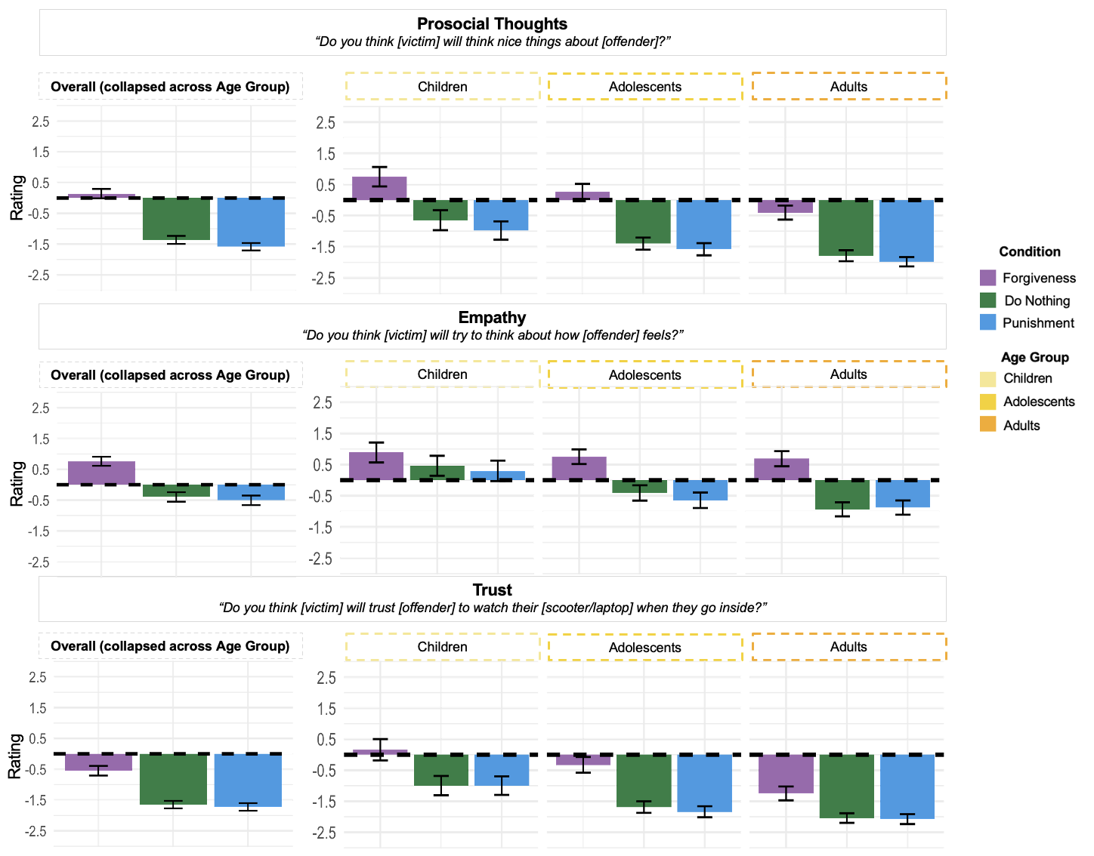

Figure S2. Participants’ ratings as a function of Condition (punishment, do nothing, forgiveness) (on the left) and as a function of Age Group (children, adolescents, adults) and Condition (punishment, do nothing, forgiveness) (on the right) for the three items included in the “Antisocial Behaviors” category. Error bars represent +/- confidence intervals.

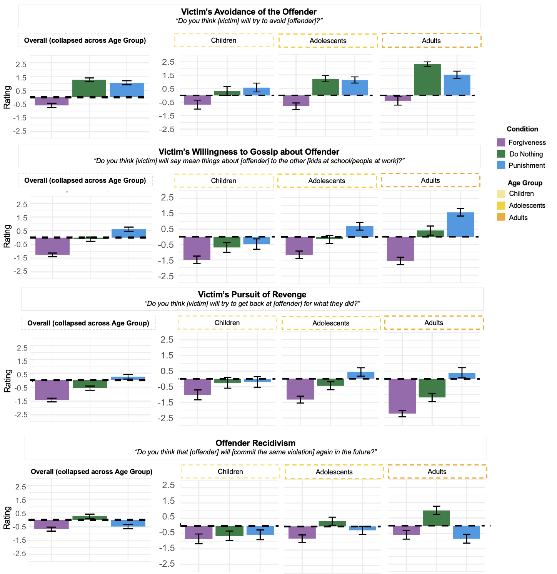

Figure S3. Participants’ ratings as a function of Condition (punishment, do nothing, forgiveness) (on the left) and as a function of Age Group (children, adolescents, adults) and Condition (punishment, do nothing, forgiveness) (on the right) for the three items included in the “Affective Change” category. Error bars represent +/- confidence intervals.

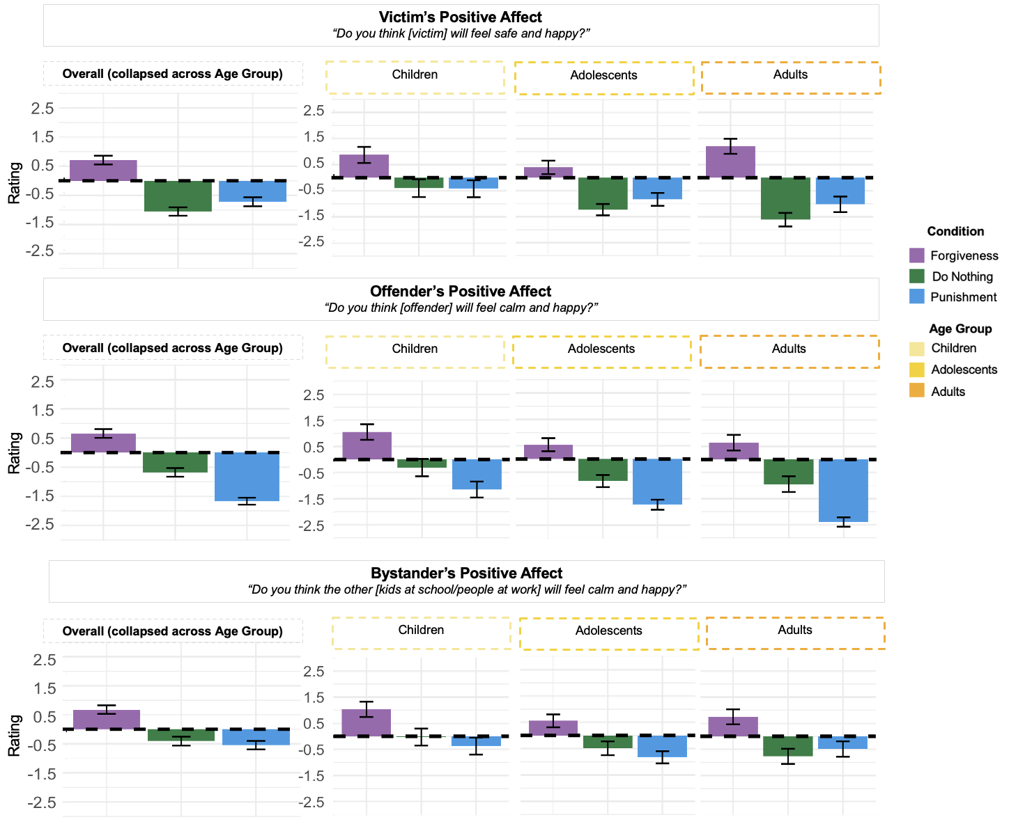

Figure S4. Participants’ ratings as a function of Condition (punishment, do nothing, forgiveness) (on the left) and as a function of Age Group (children, adolescents, adults) and Condition (punishment, do nothing, forgiveness) (on the right) for the three items included in the “Affiliative Interest” category. Error bars represent +/- confidence intervals.

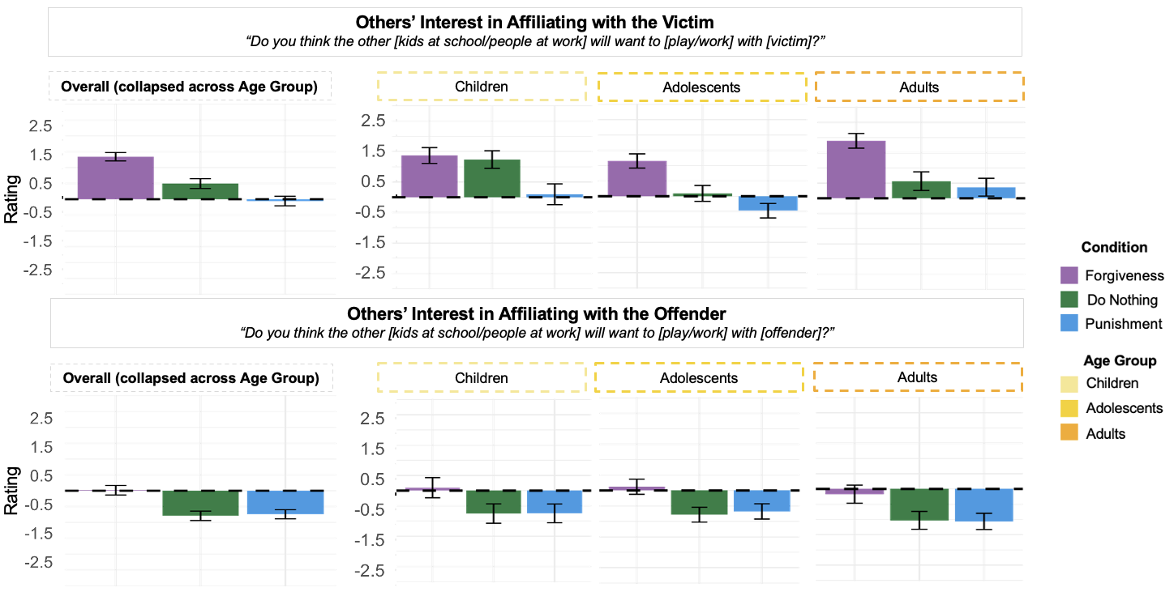

Figure S5. Participants’ ratings as a function of Condition (punishment, do nothing, forgiveness) and Vignette (Bike, Clay, Drawing) for Victim Prosocial Behavior.
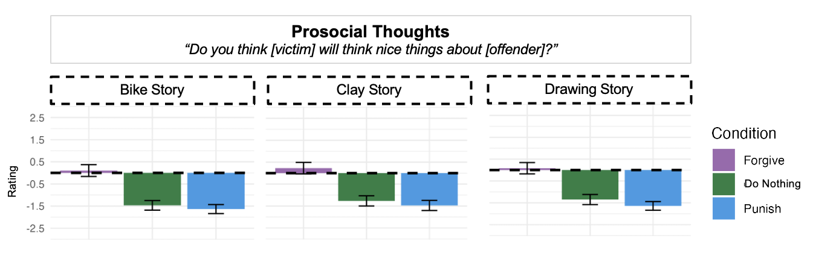

Figure S6. Participants’ ratings as a function of Condition (punishment, do nothing, forgiveness) and Vignette (Bike, Clay, Drawing) for Victim’s Empathy for the Offender.
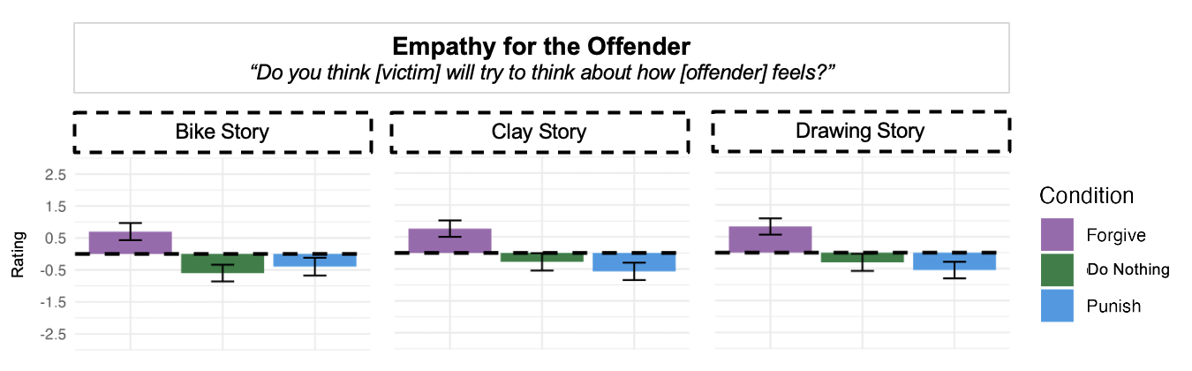

Figure S7. Participants’ ratings as a function of Condition (punishment, do nothing, forgiveness) and Vignette (Bike, Clay, Drawing) for Victim’s Trust of the Offender.
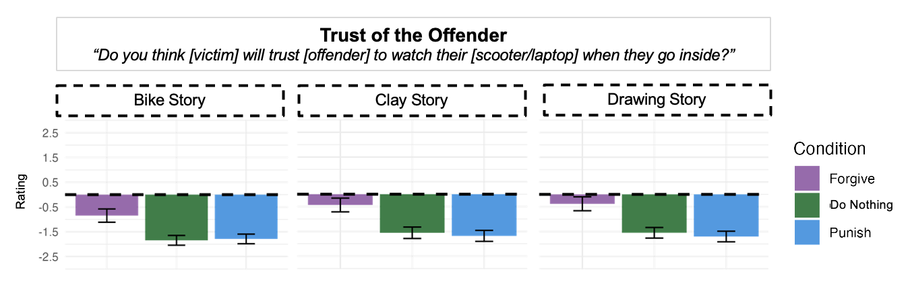

Figure S8. Participants’ ratings as a function of Condition (punishment, do nothing, forgiveness) and Vignette (Bike, Clay, Drawing) for Victim’s Avoidance of the Offender.
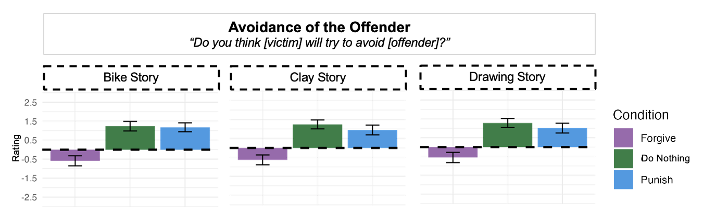

Figure S9. Participants’ ratings as a function of Condition (punishment, do nothing, forgiveness) and Vignette (Bike, Clay, Drawing) for Victim’s Willingness to Gossip About the Offender.
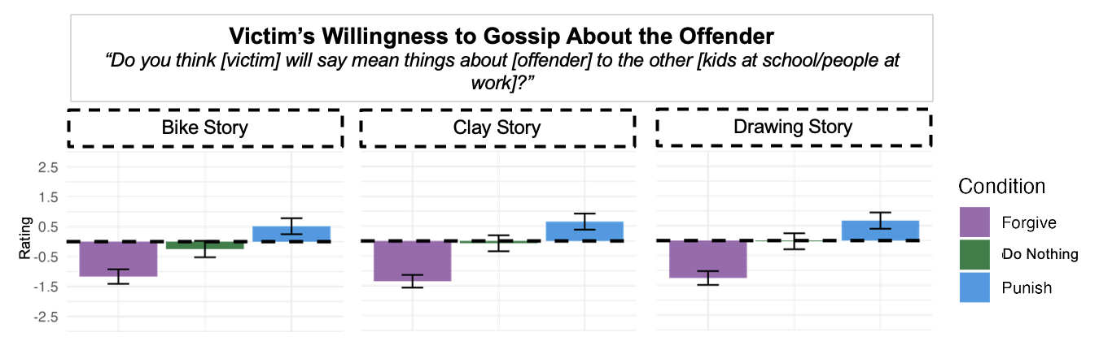

Figure S10. Participants’ ratings as a function of Condition (punishment, do nothing, forgiveness) and Vignette (Bike, Clay, Drawing) for Victim’s Pursuit of Revenge.
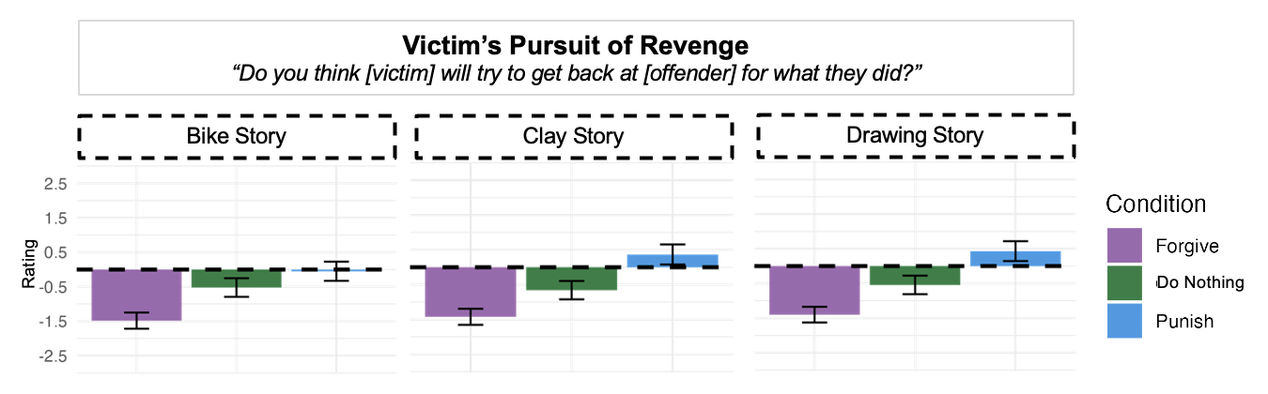

Figure S11. Participants’ ratings as a function of Condition (punishment, do nothing, forgiveness) and Vignette (Bike, Clay, Drawing) for Offender Recidivism.
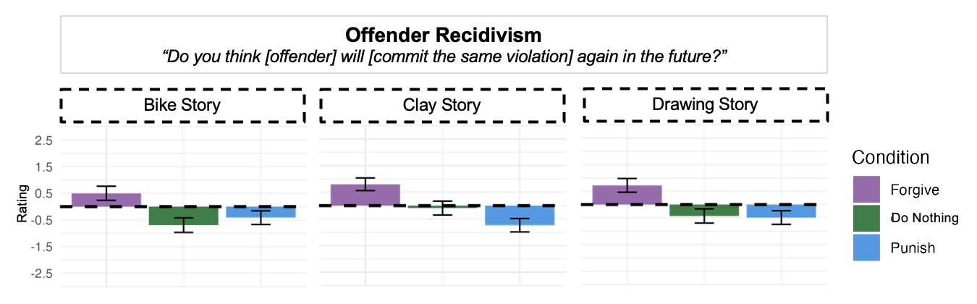

Figure S12. Participants’ ratings as a function of Condition (punishment, do nothing, forgiveness) and Vignette (Bike, Clay, Drawing) for Victim Affective Change.
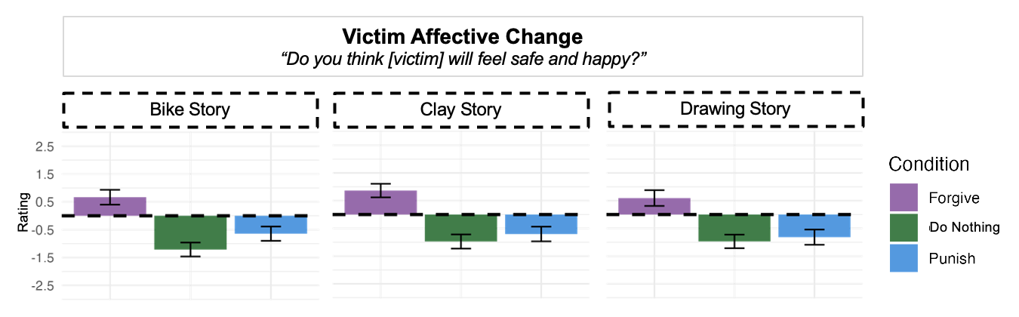

Figure S13. Participants’ ratings as a function of Condition (punishment, do nothing, forgiveness) and Vignette (Bike, Clay, Drawing) for Offender Affective Change.
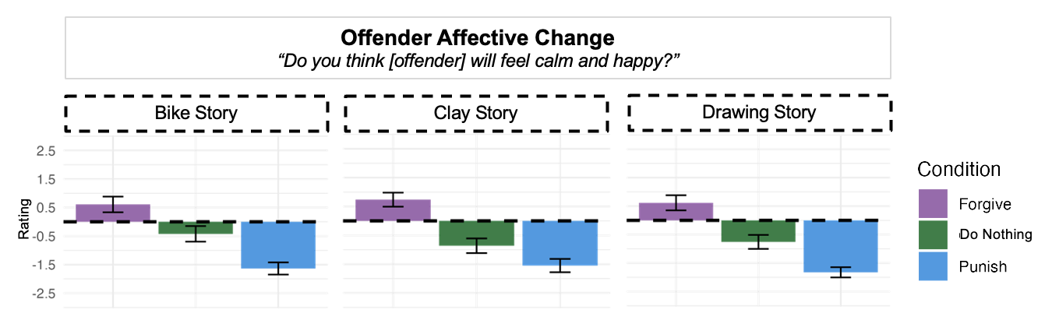

Figure S14. Participants’ ratings as a function of Condition (punishment, do nothing, forgiveness) and Vignette (Bike, Clay, Drawing) for Bystander Affective Change.
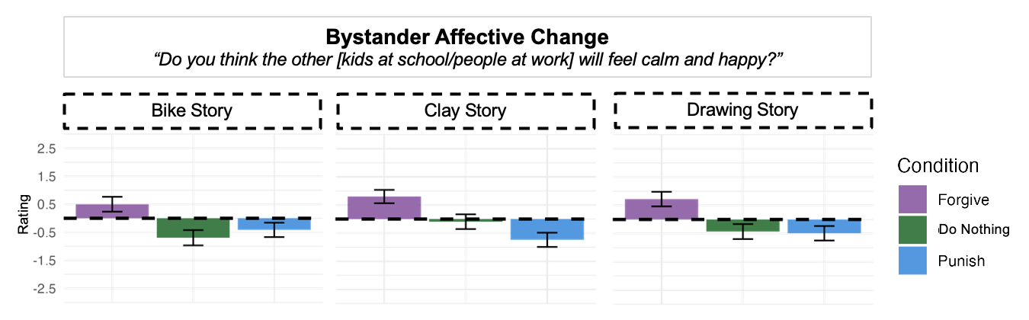

Figure S15. Participants’ ratings as a function of Condition (punishment, do nothing, forgiveness) and Vignette (Bike, Clay, Drawing) for Others’ Evaluation of the Victim.
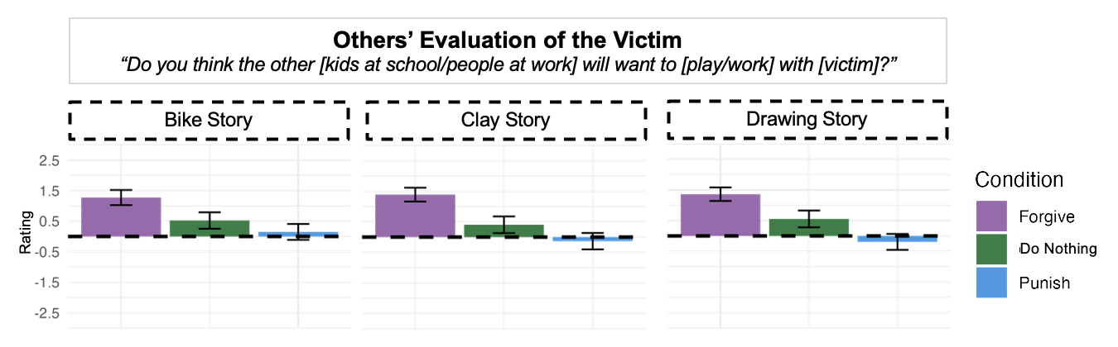

Figure S16. Participants’ ratings as a function of Condition (punishment, do nothing, forgiveness) and Vignette (Bike, Clay, Drawing) for Others’ Evaluation of the Offender.
