Supplementary Information for

Categorising content of Paris Agreement NDCs through computational linguistics

Supplementary Figures
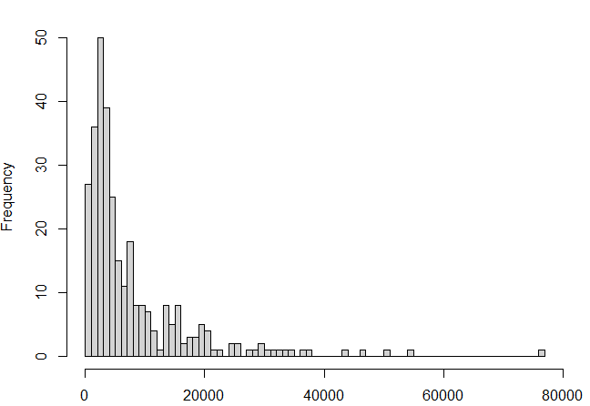
Figure S1. Distribution of NDCs by word count.
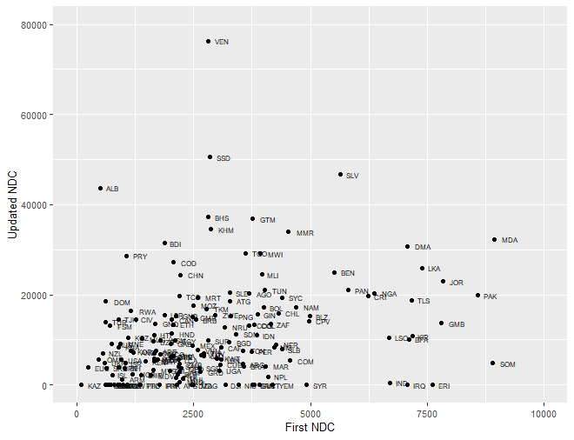
Figure S2. Comparison of first and updated NDC word counts by country.

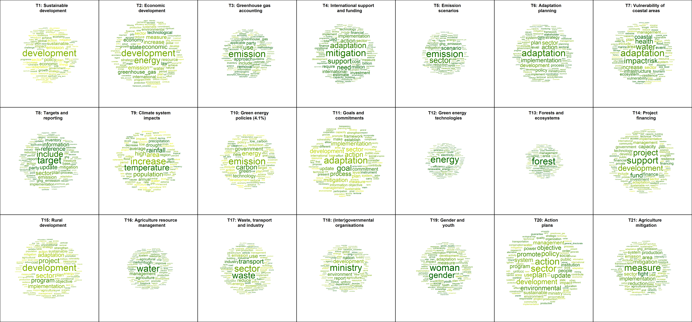
Figure S3. Word clouds of 21 topics generated based on NDC texts. Font size in a cloud reflects the probability of the appearance of the respective word given the topic, while a darker shade of colour indicates higher exclusivity of a word.

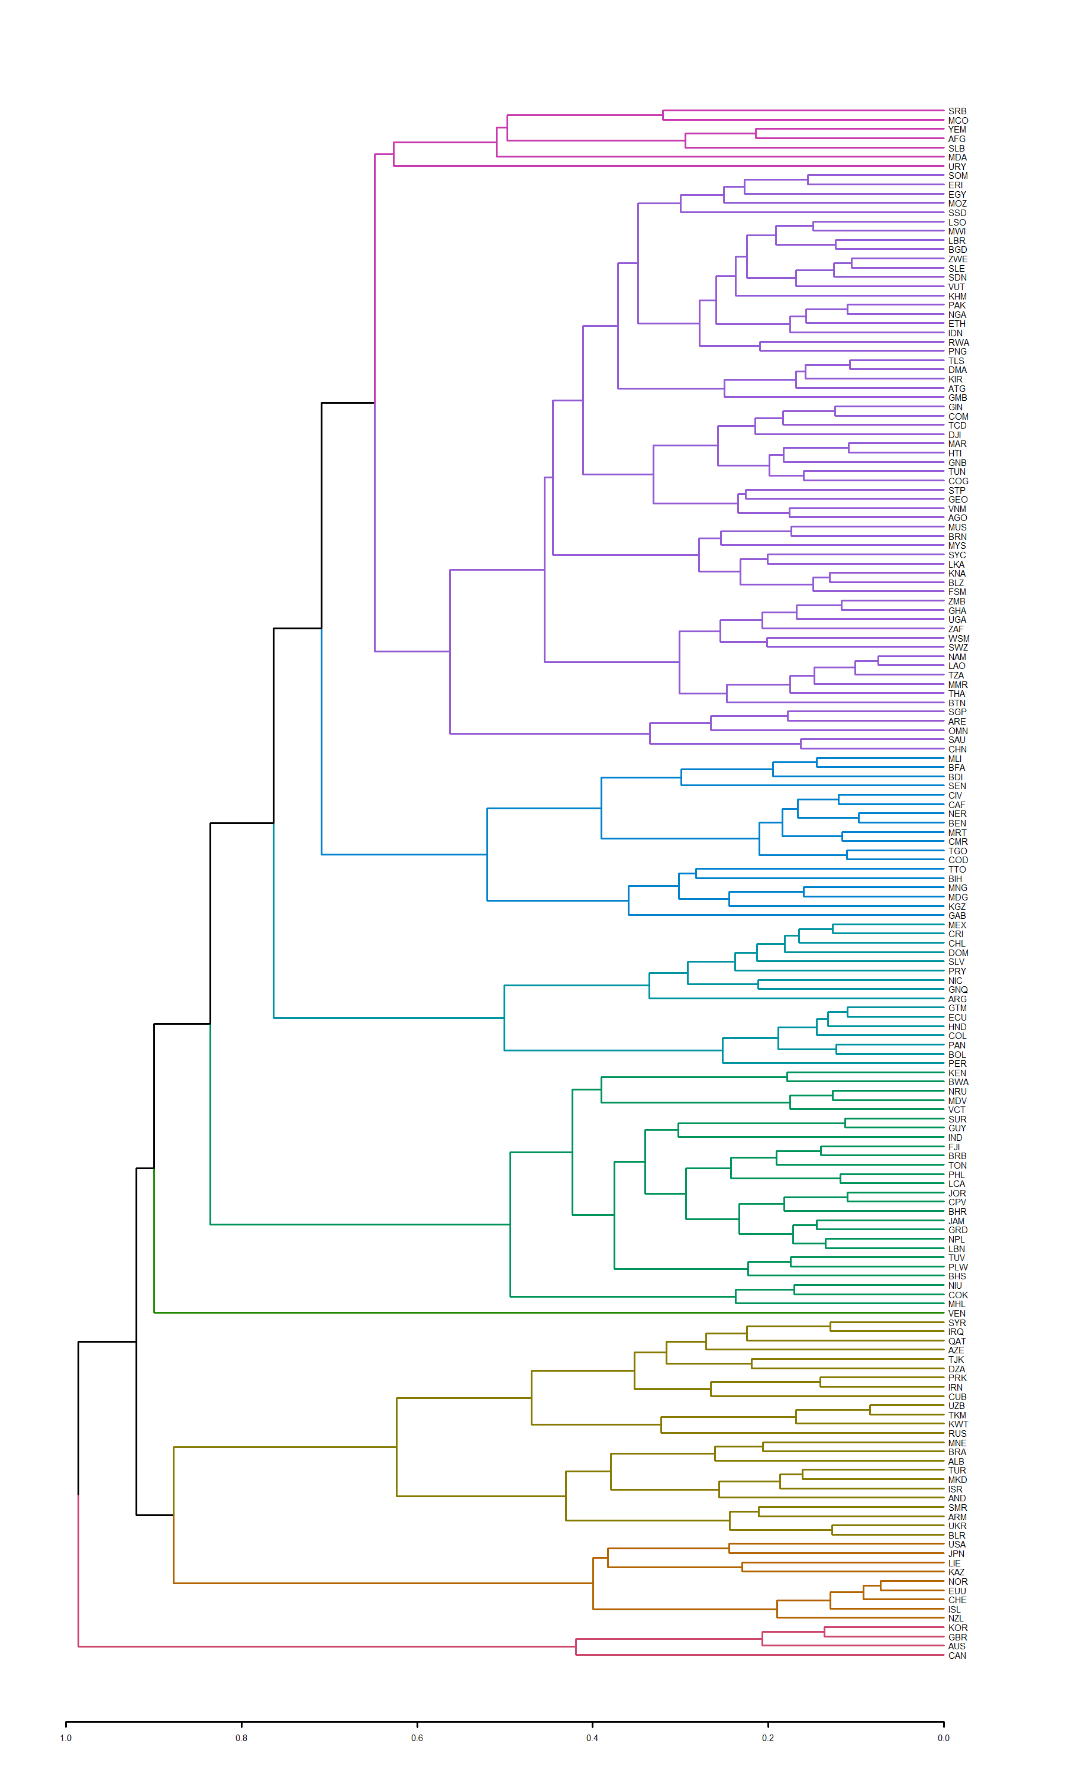
Figure S4. Dendrogram of nine clusters of parties to the Paris Agreement.

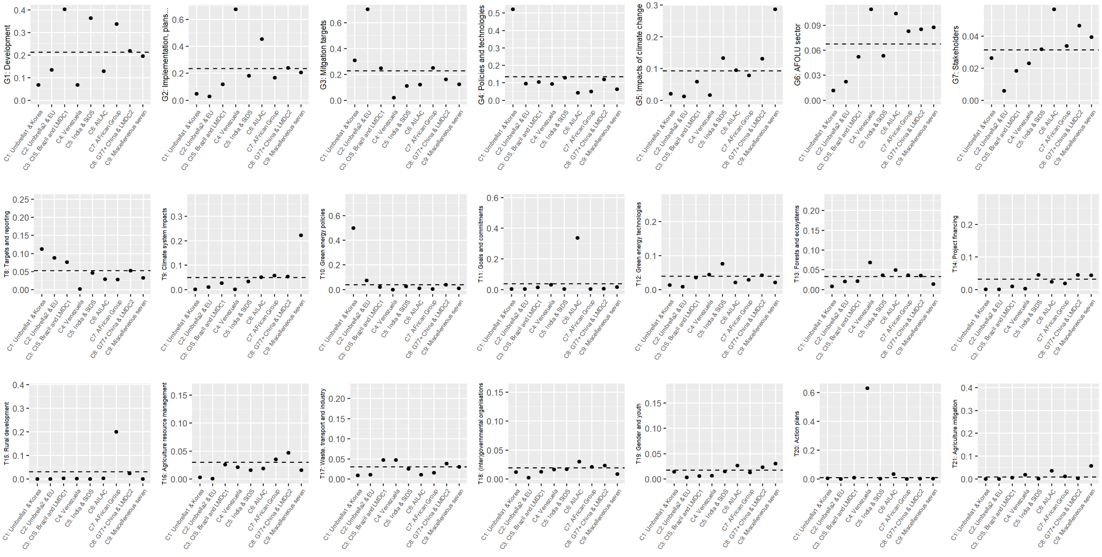
Figure S5. Average prevalence of each of the 21 topics among 9 identified clusters of parties to the Paris Agreement.
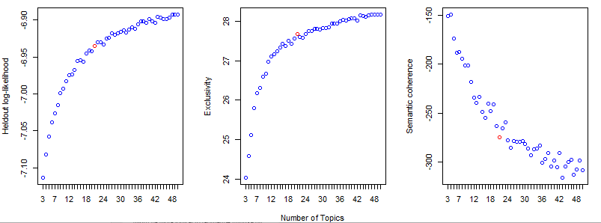
Figure S6. Criteria for selecting the number of topics in the STM model.

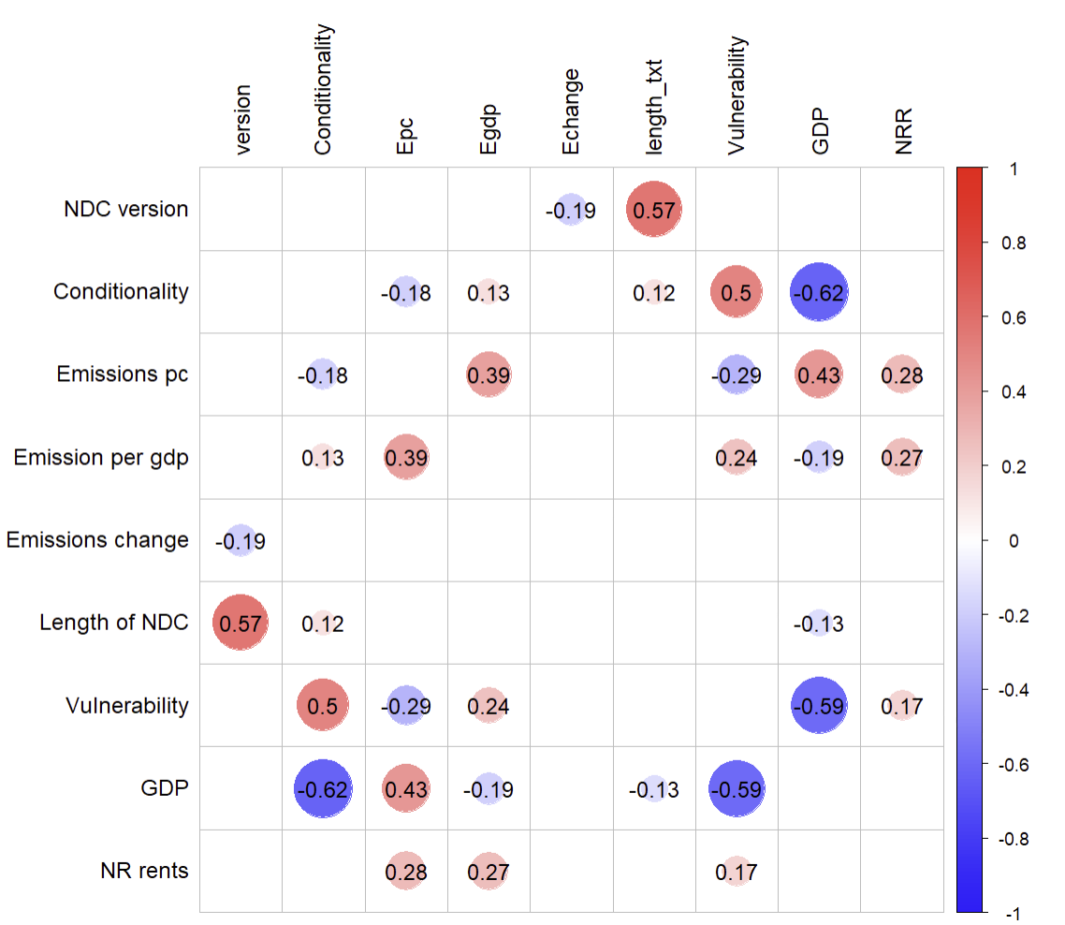
Figure S6. Correlation matrix for independent variables tested in regression models as reported in Table 1.

Supplementary Tables
Table S1. Clusters of parties to the Paris Agreement and their constituents.
Cluster | Parties
C1: Umbrella1 & EU | Australia, Canada, South Korea, United Kingdom.
C2: Umbrella2 & Korea | European Union, Kazakhstan, Iceland, Japan, Liechtenstein, New Zealand, Norway, Switzerland, United States of America.
C3: CIS, Brazil & LMDC1 | Albania, Algeria, Andorra, Armenia, Azerbaijan, Belarus, Brazil, Cuba, Iran, Iraq, Israel, Kuwait, North Macedonia, Montenegro, North Korea, Qatar, Russia, San Marino, Syria, Tajikistan, Turkey, Turkmenistan, Ukraine, Uzbekistan.
C4: Venezuela | Venezuela.
C5: India & SIDS | Bahamas, Bahrain, Barbados, Botswana, Cabo Verde, Cook Islands, Fiji, Grenada, Guyana, India, Jamaica, Jordan, Kenya, Lebanon, Maldives, Marshall Islands, Nauru, Nepal, Niue, Palau, Philippines, Saint Lucia, Saint Vincent and the Grenadines, Suriname, Tonga, Tuvalu.
C6: AILAC | Argentina, Bolivia, Chile, Colombia, Costa Rica, Dominican Republic, Ecuador, El Salvador, Equatorial Guinea, Guatemala, Honduras, Mexico, Nicaragua, Panama, Paraguay, Peru.
C7: African Group | Benin, Bosnia and Herzegovina, Burkina Faso, Burundi, Cameroon, Central African Republic, Côte d'Ivoire, Democratic Republic of the Congo, Gabon, Kyrgyzstan, Madagascar, Mali, Mauritania, Mongolia, Niger, Senegal Trinidad and Tobago.
C8: G77+China & LMDC1 | Angola, Antigua and Barbuda, Bangladesh, Belize, Bhutan, Brunei, Cambodia, Chad, China, Comoros, Dominica, Djibouti, Egypt, Eswatini, Ethiopia, Gambia, Georgia, Ghana, Guinea, Guinea-Bissau, Haiti, Indonesia, Kiribati, Lesotho, Liberia, Laos, Malaysia, Malawi, Mauritius, Micronesia, Morocco, Mozambique, Myanmar, Namibia, Nigeria, Oman, Pakistan, Papua New Guinea Republic of the Congo, Rwanda, Saint Kitts and Nevis, Samoa, São Tomé and Príncipe, Saudi Arabia, Seychelles, Sierra Leone, Singapore, Somalia, South Africa, South Sudan, Sri Lanka, Sudan, Tanzania, Timor-Leste, Thailand, Tunisia, Uganda, United Arab Emirates, Vanuatu, Vietnam, Zambia, Zimbabwe.
C9: Miscellaneous seven | Afghanistan, Moldova, Monaco, Serbia, Solomon Islands, Uruguay, Yemen.

Table S2. Results of regression analyses of prevalence for all topics.
 | T1 | T2 | T3 | T4 | T5 | T6 | T7 | T8 | T9 | T10 | T11 | T12 | T13 | T14 | T15 | T16 | T17 | T18 | T19 | T20 | T21
Intercept |  | 0.464*** | 0.288*** |  |  |  |  | 0.090*** |  |  | 0.189*** |  |  | -0.043** | -0.114*** |  |  |  |  | 0.017** | 0.039**
NDC version update | -0.051*** | -0.048*** | 0.051*** | -0.036*** |  |  |  | 0.110*** |  |  |  | -0.016*** |  |  |  |  |  |  | 0.012*** |  | -0.015***
Conditionality | 0.095*** |  | -0.114** | 0.038*** |  | 0.029** | 0.040*** |  |  | -0.099*** |  |  |  | 0.019** |  |  |  |  | 0.012**
Emissions per capita | 0.002** | 0.002** | -0.003*** |  |  | -0.001** |  |  |  | 0.001** |  | 0.001*** |  |  |  |  | 0.001**
Emissions per GDP | -0.005** |  | 0.006*** |  |  |  | -0.003*** |  |  |  |  |  |  |  | 0.004**
Ambition (% change in emissions by 2030)
Vulnerability | 0.423*** | -0.739*** | -0.285*** |  |  |  |  |  | 0.158** |  | -0.318*** | 0.102*** |  | 0.107*** | 0.307*** | 0.091*** |  |  |  | -0.040** | -0.089**
GDP per capita |  | -0.003** | 0.004*** |  |  |  |  |  |  | 0.002*** | -0.001** |  | -0.001**
Natural resources rents as % of GDP | -0.003*** | 0.005***
Length of NDC (in thousand words) | -0.004*** |  | -0.004*** | -0.002*** |  |  |  | -0.004*** |  |  | 0.001*** | 0.001*** | 0.001** | 0.001*** |  | 0.002*** | 0.001** |  | 0.002*** | 0.001** | 0.001***
R² | 0.30 | 0.34 | 0.49 | 0.28 | 0.08 | 0.15 | 0.07 | 0.43 | 0.09 | 0.34 | 0.09 | 0.10 | 0.09 | 0.12 | 0.16 | 0.24 | 0.10 | 0.07 | 0.28 | 0.07 | 0.14
N of observations | 290 | 290 | 290 | 290 | 290 | 290 | 290 | 290 | 290 | 290 | 290 | 290 | 290 | 290 | 290 | 290 | 290 | 290 | 290 | 290 | 290
Notes: Asterisks ***, **, and * denote 1%, 5%, and 10% significance, respectively. Coefficients indicate whether prevalence of respective topics is associated with the value of the covariates. Only coefficients significant at least at 5% level are shown. The number of observations in the regression models is lower than the number of NDCs in our sample due to a few missing observations for explanatory variables on vulnerability, GDP per capita and natural resources rents.

