Supplementary material

Response to clozapine in treatment resistant schizophrenia related to alterations in regional cerebral blood flow

Junyu Sun, Fernando Zelaya, Kyra-Verena Sendt, Grant McQueen, Amy L. Gillespie, John Lally, Oliver Howes, Gareth J. Barker, Philip McGuire, James H. MacCabe & Alice Egerton

Supplementary Methods 2
ASL acquisition and pre-processing 2
Grey matter volume (GMV) 3
Supplementary Tables 4
Table S1. Brain Regions with differences in Cerebral Blood Flow & Grey Matter Volume in Treatment Resistant Schizophrenia Prior to Clozapine Initiation (N=36) compared to the Healthy Volunteers (N=16) 4
Table S2. Brain Regions with differences in Cerebral Blood Flow & Grey Matter Volume in Treatment Resistant Schizophrenia at Baseline and after 12 Weeks of Clozapine Treatment (N=24) 5
Table S3. Relationships between Changes in Cerebral Blood Flow and Symptom Improvement during Clozapine Treatment (N=24) 6
Table S4. Relationships between Baseline Cerebral Blood Flow and Change in Symptom Improvement during Clozapine Treatment (N=28) 7
Table S5. Whole Brain Structural Variables in Treatment Resistant Schizophrenia Prior to Clozapine Initiation (N=36) compared to the Healthy Volunteers (N=16) 8
Table S6. Whole Brain Structural Variables within Treatment Resistant Schizophrenia at Baseline and after 12 Weeks of Clozapine Treatment (N=24) 8
Supplementary Figures 9
Figure S1. Scatterplot of Changes in ACC CBF and PANSS Scores for Negative Symptoms after controlling for the Numerical Differences in Global CBF (N=24) 9
Figure S2₁ & S2₂. Scatterplots of Changes in Thalamus CBF and PANSS Scores for Positive (left)/ Total (right) Symptoms after controlling for the Numerical Differences in Global CBF (N=24) 10
Figure S3. Scatterplot illustrating the Relationship between Striatal CBF at Baseline and the Subsequent Change in PANSS Scores for General Symptoms after controlling for Baseline Global CBF (N=28) 10
Figure S4₁ & S4₂. Scatterplots illustrating the Relationship between Hippocampus CBF at Baseline and the Subsequent Change in PANSS Scores for Total (left) / Positive (right) Symptoms after controlling for Baseline Global CBF (N=28) 11
Figure S5. Differences in Grey Matter Volume in Treatment Resistant Schizophrenia Prior to Clozapine Initiation (N=36) compared to in Healthy Volunteers (N=16) 12
Figure S6. Changes in Grey Matter Volume in Treatment Resistant Schizophrenia after 12 Weeks of Clozapine Treatment (N=24) 13
Figure S7. Differences/Changes in Cerebral Blood Flow after controlling for Grey Matter Volume. 14
References 15

Supplementary Methods

ASL acquisition and pre-processing
3D T1-weighted images were acquired in a sagittal plane (slice thickness: 1.2 mm, number of slices: 196, field of view 270 mm) using a three-dimensional T1-weighted inversion recovery spoiled gradient-echo (IR-SPGR) sequence, with parameters based on the Alzheimer’s Disease Neuroimaging Initiative (ADNI-GO, http://adni.loni.usc.edu/) (repetition time: 7.31 ms; echo time: 3.02 ms, inversion time 400 ms, flip angle 11°, acquisition matrix 256 × 256 × 196 over a field of view of 270 x 270 x 235.2mm). Whole brain cerebral perfusion images were acquired using a 3D pseudo-continuous arterial spin labelling (pCASL) sequence which uses a 3D Fast Spin Echo spiral multi-shot readout with the following parameters: label duration = 1800ms, post labelling delay = 2025ms, TE = 12ms, TR = 5500ms, ETL = 64, total acquisition time = 6min. CBF maps were computed with a voxel size of 2 x 2 x 3 mm³, in the scanner in accordance with the ASL consensus paper ¹. Spatial normalisation was achieved using the Automatic Software for ASL processing (ASAP) toolbox ² running in Statistical Parametric Mapping Software (SPM-12, Functional Imaging Laboratory (FIL), Wellcome Centre for Human Neuroimaging, Institute of Neurology, University College London (UCL), UK, http://www.fil.ion.ucl.ac.uk/spm/ software/spm12/).

We applied a three-step approach to align the CBF maps to the Montreal Neurological Institute (MNI) space to pre-process perfusion data. First, the proton density images were co-registered to the high-resolution 3D T1-weighted image after realigning the origin of both images. The transformation parameters were then saved and applied to the CBF maps. Second, the extracerebral signal from these CBF maps was eliminated via the multiplication of a binary mask generated by unified segmentation of the T1-weighted image. Third, these CBF maps, now co-registered to T1 space, were normalized to MNI space by applying the previously saved unified segmentation registration parameters (T1 to MNI). Normalized CBF maps were then smoothed using an 8-mm full width at half maximum (FWHM) Gaussian kernel. ROIs were defined using the ‘WFU PickAtlas’ in SPM-12. We extracted the mean regional CBF in each region. Mean global CBF values were calculated from a grey matter mask to investigate global differences and to account for inter-individual differences in global perfusion.

Grey matter volume (GMV)

Total and voxel-wise GMV were estimated using voxel-based Morphometry (VBM) analysis of the T1-weighted images using the Computational Anatomy Toolbox (CAT12), following the CAT12 manual, https://neuro-jena.github.io/cat//index.html ³ in SPM-12. T1-weighted images were reoriented and co-registered to the same point of origin and segmented to create grey matter (GM), white matter (WM), cerebrospinal fluid (CSF) ⁴, followed by spatial registration using the MNI standard space template as a reference ⁵. A longitudinal pipeline that considers deformations between individual images across time points was used, allowing the estimation and detection of larger changes. These GM images, modulated and normalized, were then smoothed using a Gaussian kernel of 8-mm FWHM. Automated quality control was employed to check data quality. Total intracranial volume (TIV) was calculated for each subject to account for inter-individual differences in brain size. We extracted the mean values of whole brain GM, WM, CSF, and TIV.

Supplementary Tables

Table S1. Brain Regions with differences in Cerebral Blood Flow & Grey Matter Volume in Treatment Resistant Schizophrenia Prior to Clozapine Initiation (N=36) compared to the Healthy Volunteers (N=16)

Measure | Covariate | Contrast | Region | $$P$$ | MNI Coordinates |  |  | Cluster Size
 |  |  |  |  | $$x$$ | $$y$$ | $$z$$
CBF | age & global CBF | HV > TRS | Frontal | 0.001 | -8 | 38 | 30 | 1292
CBF | age & global CBF | HV > TRS | Frontal | 0.012 | 32 | 22 | 2 | 774
CBF | age & global CBF | HV > TRS | Frontal | 0.021 | -20 | 22 | 58 | 671
CBF | age & global CBF | HV > TRS | Frontal | 0.034 | -46 | 12 | 40 | 577
CBF | age & global CBF | HV > TRS | Temporal | 0.010 | -26 | -42 | 2 | 825
CBF | age & global CBF | HV > TRS | Parietal | 0.000 | 40 | -62 | 48 | 2168
CBF | age & global CBF | HV < TRS | /
CBF | age, global CBF & GMV | HV > TRS | Frontal | 0.035 | -8 | 30 | -4 | 565
CBF | age, global CBF & GMV | HV > TRS | Frontal | 0.029 | 30 | 24 | 2 | 604
CBF | age, global CBF & GMV | HV > TRS | Temporal | 0.014 | -28 | -42 | -4 | 737
CBF | age, global CBF & GMV | HV > TRS | Parietal | 0.016 | 44 | -48 | 50 | 713
CBF | age, global CBF & GMV | HV < TRS | /
GMV | age, sex & TIV | HV > TRS | ACC | 0.000 | 26 | -24 | -18 | 2820
GMV | age, sex & TIV | HV > TRS | Thalamus | 0.000 | -20 | -34 | 6 | 2562
GMV | age, sex & TIV | HV > TRS | Hippocampus | 0.018 | 6 | 0 | 39 | 1033
GMV | age, sex & TIV | HV < TRS | /
ACC, Anterior Cingulate Cortex; CBF, Cerebral Blood Flow; GMV, Grey Matter Volume; HV, Healthy Volunteer; TIV, Total Intracranial Volume; TRS, Treatment Resistant Schizophrenia.

Table S2. Brain Regions with differences in Cerebral Blood Flow & Grey Matter Volume in Treatment Resistant Schizophrenia at Baseline and after 12 Weeks of Clozapine Treatment (N=24)

Parameter | Covariate | Contrast | Region | $$P$$ | Coordinates in MNI space |  |  | Cluster Size
 |  |  |  |  | $$x$$ | $$y$$ | $$z$$
CBF | / | BL > FP | Frontal | 0.006 | -2 | 54 | 30 | 2644
CBF | / | BL < FP | /
CBF | global CBF | BL > FP | Frontal | 0.001 | -2 | 52 | 30 | 1414
CBF | global CBF | BL < FP | Postcentral | 0.017 | -58 | -6 | 22 | 697
CBF | global CBF & GMV | BL > FP | Frontal | 0.000 | 8 | 48 | 34 | 3228
CBF | global CBF & GMV | BL > FP | Frontal | 0.036 | 42 | 20 | 38 | 550
CBF | global CBF & GMV | BL < FP | /
GMV | / | BL < FP | Postcentral | 0.017 | -58 | -6 | 22 | 697
GMV | / | BL < FP | Frontal | 0.006 | 34 | 62 | 15 | 776
GMV | / | BL < FP | Frontal | 0.031 | 51 | 50 | -3 | 544
GMV | / | BL < FP | Temporal | 0.000 | -56 | -39 | -18 | 3086
GMV | / | BL < FP | Temporal | 0.007 | 50 | -26 | -3 | 766
GMV | / | BL < FP | Temporal | 0.017 | -28 | 9 | -20 | 629
GMV | / | BL < FP | Parietal | 0.000 | 10 | -51 | 28 | 1244
GMV | / | BL < FP | Parietal | 0.003 | -8 | -33 | 33 | 914
GMV | / | BL < FP | Occipital | 0.005 | -2 | -81 | 4 | 821
GMV | / | BL < FP | Putamen | 0.000 | 21 | 0 | 4 | 2192
GMV | / | BL < FP | Putamen | 0.000 | -27 | -8 | 3 | 1590
GMV | / | BL < FP | Cerebellum | 0.034 | -34 | -58 | -33 | 533
GMV | / | BL < FP | Caudate | 0.000 | 10 | 15 | 12 | 2808
GMV | / | BL < FP | /
BL, Baseline; CBF, Cerebral Blood Flow; FP, Follow-up; GMV, Grey Matter Volume.

Table S3. Relationships between Changes in Cerebral Blood Flow and Symptom Improvement during Clozapine Treatment (N=24)

Percent change in CBF | Percent change in symptom severity scores | Test statistics
 |  | $$r$$ | $$df$$ | $$P$$
Global CBF | PANSS-Positive | -0.211 | / | 0.321
 | PANSS-Negative | 0.235 | / | 0.268
 | PANSS-General | 0.349 | / | 0.094
 | PANSS-Total | 0.247 | / | 0.245
Regional CBF |  | Controlling for percent change of global CBF
ACC | PANSS-Positive | -0.138 | 21 | 0.530
ACC | PANSS-Negative | -0.493 | 21 | 0.017
ACC | PANSS-General | -0.036 | 21 | 0.871
ACC | PANSS-Total | -0.252 | 21 | 0.246
Striatum | PANSS-Positive | -0.247 | 21 | 0.255
Striatum | PANSS-Negative | -0.021 | 21 | 0.924
Striatum | PANSS-General | -0.307 | 21 | 0.155
Striatum | PANSS-Total | -0.361 | 21 | 0.091
Thalamus | PANSS-Positive | -0.417 | 21 | 0.048
Thalamus | PANSS-Negative | -0.269 | 21 | 0.214
Thalamus | PANSS-General | -0.335 | 21 | 0.118
Thalamus | PANSS-Total | -0.494 | 21 | 0.017
Hipp | PANSS-Positive | -0.291 | 21 | 0.179
Hipp | PANSS-Negative | -0.082 | 21 | 0.709
Hipp | PANSS-General | -0.190 | 21 | 0.385
Hipp | PANSS-Total | -0.300 | 21 | 0.165
ACC, Anterior Cingulate Cortex; CBF, Cerebral Blood Flow; Hipp, Hippocampus; PANSS, Positive and Negative Syndrome Scale.

Table S4. Relationships between Baseline Cerebral Blood Flow and Change in Symptom Improvement during Clozapine Treatment (N=28)

Baseline CBF | Percent change in symptom severity scores | Test statistics
 |  | $$r$$ | $$df$$ | $$P$$
Global CBF | PANSS-Positive | -0.181 | / | 0.355
 | PANSS-Negative | -0.227 | / | 0.245
 | PANSS-General | -0.291 | / | 0.134
 | PANSS-Total | -0.350 | / | 0.068
Regional CBF |  | Controlling for baseline global CBF
ACC | PANSS-Positive | 0.126 | 25 | 0.530
ACC | PANSS-Negative | -0.015 | 25 | 0.941
ACC | PANSS-General | -0.074 | 25 | 0.713
ACC | PANSS-Total | 0.004 | 25 | 0.983
Striatum | PANSS-Positive | 0.263 | 25 | 0.185
Striatum | PANSS-Negative | -0.217 | 25 | 0.278
Striatum | PANSS-General | 0.403 | 25 | 0.037
Striatum | PANSS-Total | 0.375 | 25 | 0.054
Thalamus | PANSS-Positive | 0.273 | 25 | 0.168
Thalamus | PANSS-Negative | 0.124 | 25 | 0.538
Thalamus | PANSS-General | 0.087 | 25 | 0.668
Thalamus | PANSS-Total | 0.222 | 25 | 0.266
Hipp | PANSS-Positive | 0.403 | 25 | 0.037
Hipp | PANSS-Negative | 0.190 | 25 | 0.343
Hipp | PANSS-General | 0.337 | 25 | 0.086
Hipp | PANSS-Total | 0.496 | 25 | 0.009
ACC, Anterior Cingulate Cortex; CBF, Cerebral Blood Flow; Hipp, Hippocampus; PANSS, Positive and Negative Syndrome Scale.

Table S5. Whole Brain Structural Variables in Treatment Resistant Schizophrenia Prior to Clozapine Initiation (N=36) compared to the Healthy Volunteers (N=16)

Baseline | TRS group | HV group | Test statistics |  |  | Test statistics
 |  |  | $$t$$ | $$df$$ | $$P$$ | $$F$$ | $$df$$ | $$P$$
TIV, litres | 1.45 (0.16) | 1.49 (0.13) | -0.792 | 50 | 0.432 | / | / | /
Morphological |  |  | Before controlling for age, sex & TIV |  |  | After controlling for age, sex & TIV
GM volume, litres | 0.66 (0.07) | 0.72 (0.07) | -2.839 | 50 | 0.007 | 8.881 | 1 | 0.005
WM volume, litres | 0.50 (0.07) | 0.52 (0.06) | -0.756 | 50 | 0.453 | 0.343 | 1 | 0.561
CSF volume, litres | 0.29 (0.07) | 0.25 (0.04) | 2.464 | 47.597 | 0.017 | 2.776 | 1 | 0.102
Data shown as Mean (Standard Deviation) unless otherwise specified. CSF, Cerebrospinal Fluid; GM, Grey Matter; HV, Healthy Volunteer; TIV, Total Intracranial Volume; TRS, Treatment Resistant Schizophrenia; WM, White Matter.

Table S6. Whole Brain Structural Variables within Treatment Resistant Schizophrenia at Baseline and after 12 Weeks of Clozapine Treatment (N=24)

TRS group | Baseline | Week 12  Follow-up | Test statistics
 |  |  | $$t$$ | $$df$$ | $$P$$
TIV, litres | 1.53 (0.15) | 1.53 (0.15) | -0.153 | 23 | 0.880
Morphological
GM volume, litres | 0.66 (0.06) | 0.64 (0.07) | 4.043 | 23 | <0.001
WM volume, litres | 0.51 (0.07) | 0.51 (0.07) | -0.894 | 23 | 0.380
CSF volume, litres | 0.36 (0.05) | 0.38 (0.06) | -3.073 | 23 | 0.005
Data shown as Mean (Standard Deviation) unless otherwise specified. CSF, Cerebrospinal Fluid; GM, Grey Matter; TIV, Total Intracranial Volume; TRS, Treatment Resistant Schizophrenia; WM, White Matter.

Supplementary Figures

Figure S1. Scatterplot of Changes in ACC CBF and PANSS Scores for Negative Symptoms after controlling for the Numerical Differences in Global CBF (N=24)
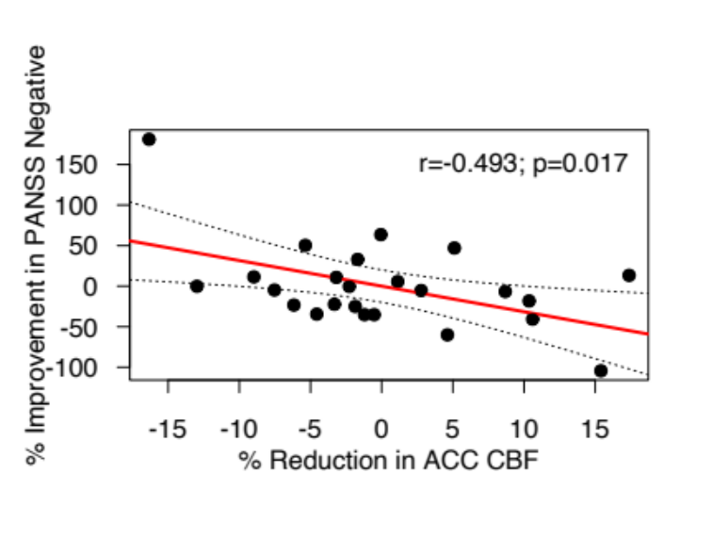
The scatter plot shows a linear regression in which percent change in PANSS scores for negative symptoms is the dependent variable and the percent change in ACC CBF is the independent variable, with regression lines and 95% CIs. ACC, Anterior Cingulate Cortex; CBF, Cerebral Blood Flow; PANSS, Positive and Negative Syndrome Scale.

Figure S2₁ & S2₂. Scatterplots of Changes in Thalamus CBF and PANSS Scores for Positive (left)/ Total (right) Symptoms after controlling for the Numerical Differences in Global CBF (N=24)
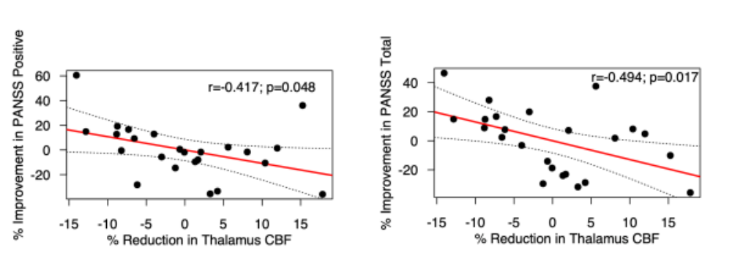
The scatter plots show linear regressions in which percent change in PANSS scores for positive/total symptoms is the dependent variable and the percent change in thalamus CBF is the independent variable, with regression lines and 95% CIs. CBF, Cerebral Blood Flow; PANSS, Positive and Negative Syndrome Scale.

Figure S3. Scatterplot illustrating the Relationship between Striatal CBF at Baseline and the Subsequent Change in PANSS Scores for General Symptoms after controlling for Baseline Global CBF (N=28)
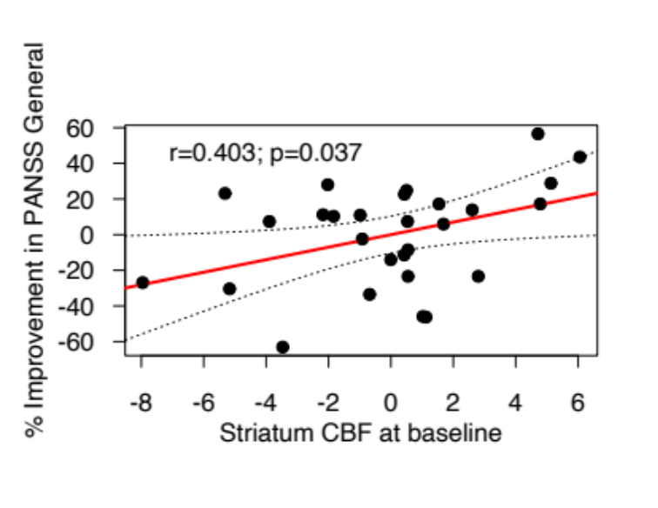
The scatter plots show a linear regression in which percent change in PANSS scores for general symptoms is the dependent variable and the baseline striatum CBF is the independent variable, with regression lines and 95% CIs. CBF, Cerebral Blood Flow; PANSS, Positive and Negative Syndrome Scale.

Figure S4₁ & S4₂. Scatterplots illustrating the Relationship between Hippocampus CBF at Baseline and the Subsequent Change in PANSS Scores for Total (left) / Positive (right) Symptoms after controlling for Baseline Global CBF (N=28)

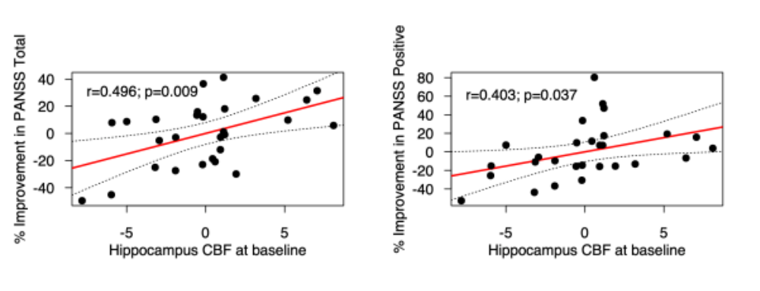
The scatter plots show linear regressions in which percent change in PANSS scores for total/positive symptoms is the dependent variable and the baseline Hippocampus CBF is the independent variable, with regression lines and 95% CIs. CBF, Cerebral Blood Flow; PANSS, Positive and Negative Syndrome Scale.

Figure S5. Differences in Grey Matter Volume in Treatment Resistant Schizophrenia Prior to Clozapine Initiation (N=36) compared to in Healthy Volunteers (N=16)
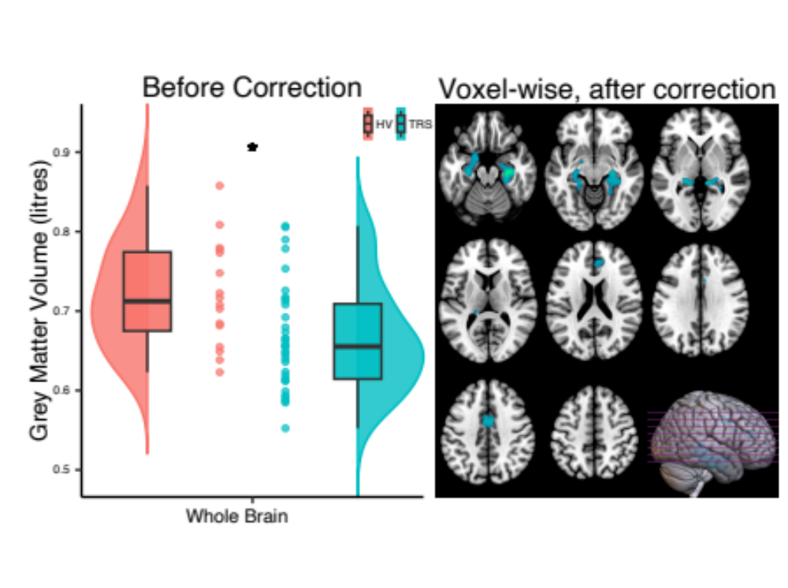
Left panel: Whole brain data showing significantly lower total grey volume in the TRS compared to HV group (* p=0.007), without controlling for age, sex or TIV. Half-violin plots depict the distribution of mean grey matter volume values within each group, boxplots show median and interquartile ranges and circles provide individual values.

Right panel: Brain sections illustrating the significant clusters (p < 0.05 family-wise error corrected) of lower grey matter volume in the TRS compared to in HV, controlling for age, sex and TIV. HV, Healthy Volunteer; TRS, Treatment Resistant Schizophrenia; TIV, Total Intracranial Volume.

Figure S6. Changes in Grey Matter Volume in Treatment Resistant Schizophrenia after 12 Weeks of Clozapine Treatment (N=24)
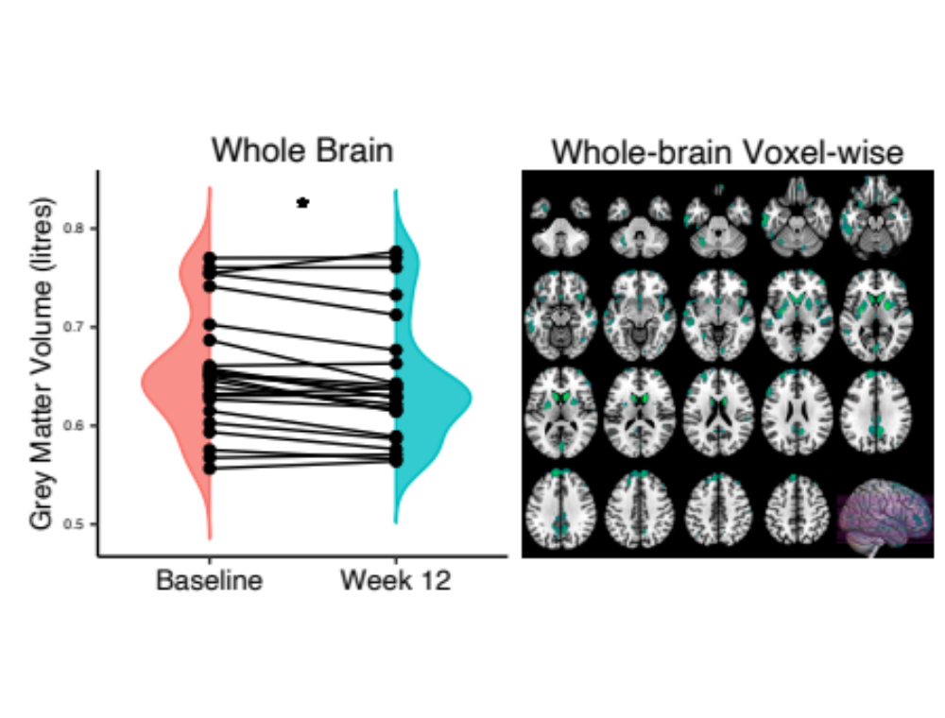
Left panel: Whole brain analysis showing decreased total grey matter volume after 12 weeks of clozapine treatment (* p<0.001). Half-violin plots depict the distribution of mean total grey matter volume at each time-point. Circles represent individual values.

Right panel: Brain sections illustrating significant clusters (p < 0.05 family-wise error corrected) in whole brain voxel wise analysis. Decreased grey matter volume following clozapine treatment was apparent in clusters across the whole brain.

Figure S7. Differences/Changes in Cerebral Blood Flow after controlling for Grey Matter Volume.
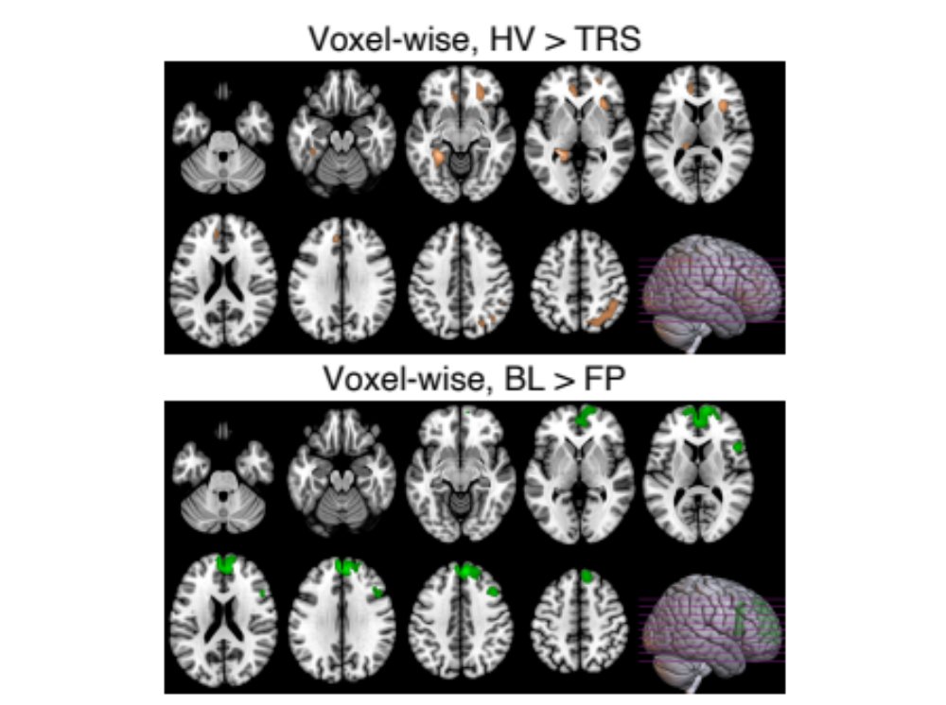

Top panel: Brain sections showing the significant clusters (p < 0.05 family-wise error corrected) of lower cerebral blood flow in TRS prior to clozapine compared to in HV, controlling for age, global cerebral blood flow & grey matter volume. HV, Healthy Volunteer; TRS, Treatment Resistant Schizophrenia.

Bottom panel: Brain sections illustrating significant clusters (p < 0.05 family-wise error corrected) in cerebral blood flow among TRS after 12 weeks of clozapine treatment. After controlling for changes in global cerebral blood flow & grey matter volume, decreased cerebral blood flow following clozapine treatment was apparent in clusters in the frontal lobe. BL, Baseline; FP, week 12 Follow-up.

References
1 Alsop, D. C. et al. Recommended implementation of arterial spin-labeled perfusion MRI for clinical applications: A consensus of the ISMRM perfusion study group and the European consortium for ASL in dementia. Magn Reson Med 73, 102-116 (2015). https://doi.org/10.1002/mrm.25197
2 Mato Abad, V., Garcia-Polo, P., O'Daly, O., Hernandez-Tamames, J. A. & Zelaya, F. ASAP (Automatic Software for ASL Processing): A toolbox for processing Arterial Spin Labeling images. Magn Reson Imaging 34, 334-344 (2016). https://doi.org/10.1016/j.mri.2015.11.002
3 Gaser, C., Dahnke, R., Thompson, P. M., Kurth, F. & Luders, E. CAT – A Computational Anatomy Toolbox for the Analysis of Structural MRI Data (2023). https://doi.org/10.1101/2022.06.11.495736
4 Ashburner, J. & Friston, K. J. Unified segmentation. Neuroimage 26, 839-851 (2005). https://doi.org/10.1016/j.neuroimage.2005.02.018
5 Ashburner, J. A fast diffeomorphic image registration algorithm. Neuroimage 38, 95-113 (2007). https://doi.org/10.1016/j.neuroimage.2007.07.007

