Identifying heterogeneity of systemic autoimmune diseases by applying joint dimension reduction and cluster analysis to immunomarkers
Chia-Wei Chang ^{a,#}, Hsin-Yao Wang ^{b,#}, Wan-Ying Lin ^{c}, Yu-Chiang Wang ^{d}, Wei-Lin Lo ^{e}, Ting-Wei Lin ^{b}, Jia-Ruei Yu ^{b}, Yi-Ju Tseng ^{a,f,*}

Supplementary Materials
Supplement Document 1
- Systemic autoimmune diseases definitions
Supplement Document 2
- Immunomarker descriptions, data pre-processing, and imputation
Supplement Document 3
- Feature selection and parameter tuning of cluster analysis
Supplement Document 4
- Statistical analysis
Supplement Document 5
- Immunological characteristics of clusters
Supplement Table 1 Typical or severe symptoms manifested by systemic lupus erythematosus, Sjögren’s syndrome, and rheumatoid arthritis
Supplement Table 2 Reference ranges for each immunomarker
Supplement Figure 1 The occurrence rates for clinical classification software (CCS) single-level diagnosis groups and common clinical manifestations across clusters
Supplement Figure 2 The proportion of results for each immunomarker stratified by the SADs
Supplement Figure 3 Diverse performance of immunomarkers in the diagnosis of the cluster number (1 to 6)

Supplement Document 1
Systemic autoimmune diseases and immunomarkers definitions
We defined systemic autoimmune diseases (SADs) based on the International Classification of Diseases, Ninth and Tenth Versions, including systemic lupus erythematosus (SLE, 710.0; M32.1x/8/9), systemic sclerosis (SSc, 710.1; M34.x), Sjögren’s syndrome (SS, 710.2; M35.0x), dermatopolymyositis (DPM, 710.3/4; M33.1x/2x/9), rheumatoid arthritis (RA, 714.0/2; M05.4/5/7/8/9; M06.0/2/3/8/9), mixed connective tissue disease (MCTD, 710.8; M35.1), undifferentiated connective tissue disease (UCTD, 710.9; M35.9), ankylosing spondylitis (720.0; M45.9), and antiphospholipid syndrome (289.81; D68.61).

Supplement Document 2
Immunomarker descriptions, data pre-processing, and imputation
At total of 33 immunomarkers were included in the clustering analysis: anti-nuclear antibody (ANA), rheumatoid factor (RF), anti-double strand DNA (anti-dsDNA), antithyroglobulin antibody (anti-Tg), antithyroid peroxidase antibody (anti-TPO), basement membrane zone antibody, complement component 3 (C3), complement component 4 (C4), cryofibrinogen, cryoglobulin, free light chain kappa, free light chain lambda, free light chain kappa/lambda, direct coombs IgG, intracellular substance antibody, AQP4 autoantibody, anti-TSH receptor antibody (TSHR), glutamic acid decarboxylase 65 antibody (GAD), CH50 complement activation enzyme (CH50-CAE), anti-Smith antibody (anti-Sm), antiribonucleoprotein antibody (anti-RNP), anti-SSA(Ro)/SSB(La) antibody, anti-Jo 1 antibody, anti-Scl-70 antibody, anticentromere antibody (anti-CENP), anti-histone antibody, anti-ribosomal P antibody (anti-RibP), anticardiolipin antibody IgG (ACAG), anticardiolipin antibody IgM (ACAM), beta2-glycoprotein 1 IgG (B2GP1G), antiphospholipid IgG, and antiphospholipid IgM.
Test results not within the reference range (Supplement Table 2) were classified as abnormal (i.e., presence of the autoantibody or out of the normal range). Those within the reference range were considered normal. Reference ranges of immunomarkers might be subject to exam method shifts or updates according to years of research findings. In response to the issue, reference range changes over time were considered when converting exam results into dichotomous forms.
We mapped the most recent data of an immunomarker based on the minimum difference in days within 90 days before and 30 days after the first diagnosis date. In addition, we mapped the earlier immunomarker data when the difference in the number of days was identical before and after the diagnosis date. We also examined each immunomarker and classified it as abnormal if any abnormal result was reported in the following 7 days (i.e., re-testing or multiple testing) to capture positive conversions.
The problem of missing values is prominent in a real-world dataset because physicians order different laboratory tests even for the same disease. Generally, we imputed missing values with “normal” results (i.e., negative and nonreactive) except for the rheumatoid factor (RF) and ANA. For diagnosing a specific SAD, laboratory tests that clinical physicians do not order are regarded as minimally valuable, and the test results are assumed to be within the reference range. By contrast, the missing value of the RF was imputed as “abnormal” for patients with RA, given the fact that RF positivity is associated with RA development [1] and is a valuable biomarker for RA diagnosis [2]. The same principle was applied to the missing values of ANA testing for patients with SLE and SS, considering the high diagnostic value of ANA testing in SLE [3] and SS [4]. The missing rates for all the immunomarkers are presented in Supplement Figure 2.

Supplement Document 3
Feature selection and parameter tuning of cluster analysis
Before cluster analysis, we applied the measure of adequacy (MSA) [5] and Bartlett’s test for sphericity to determine if our dataset is adequate to obtain PCs from the intercorrelation between variables expected to be adequately high for dimension reduction. First, we removed variables with merely a single class; that is, the results of an immunomarker from all patients were normal. Second, we computed overall MSA and individual MSA iteratively after removing the variable with the least individual MSA until the overall MSA was equal to or greater than 0.6 [6]. Finally, we tested the pruned dataset to determine the suitability for dimension reduction, where the p-value was <0.5 [7], indicating its adequacy for extracting PCs.
We fixed the parameter alpha, used to determine the importance between within-group and between-group inertia, to a default value of 0.5 of the MCA k-means algorithm [8]. We applied the grid search method for tuning parameters on the number of PCs to be utilised for clustering and the number of clusters to be divided; this tuning was performed to optimize the average silhouette width metric.

Supplement Document 4
Statistical analysis
Analysis of variance was performed to examine the distribution of differences between the means of SADs. The chi-square test or Fisher’s exact test was performed for the univariate analysis of categorical variables. Test for proportion difference of comorbidity, across all clusters and by every two clusters, were conducted by Fisher’s exact test and Barnard’s unconditional test. Adjusted odd ratios (ORs) were calculated using a multiple logistic regression model. The R package clustrd [9] was used to implement the MCA k-means algorithm. Statistical analyses were performed using R (version 4.1.0, The R Foundation for Statistical Computing). All statistical tests were two-sided, and a p-value of <0.05 was considered significant for statistical analyses.

Supplement Document 5
Immunological characteristics of clusters
In Cluster 1, 95% of the patients had RF positivity. Clusters 4 and 5 had a relatively higher proportion of patients with RF positivity (77% and 71%, respectively). In addition to RF, Clusters 4 and 5 had a higher proportion of patients with positive anti-SSA results (97% and 89%, respectively) and a moderate proportion of patients with positive ANA results (70% and 50%, respectively). However, a substantial difference in the proportion of patients with positive anti-SSB results was observed between Clusters 4 and 5 (94% and 1%, respectively).
The immunomarker pattern of Cluster 3 was similar to that of Cluster 6. Both the clusters had higher proportions of patients with ANA positivity (95% and 96%, respectively), abnormal C3 levels (97% and 95%, respectively), abnormal C4 levels (76% and 67%, respectively), and anti-dsDNA positivity (80% and 72%, respectively). However, Cluster 6 had higher proportions of patients with other emerging immunomarkers, including anti-SSA (87%), anti-SSB (59%), and anti-RNP-Sm (54%). By contrast, Cluster 2 revealed no overt difference in immunomarkers, except for ANA, which accounted for 86% of the patients.
In a maximization of sensitivity and specificity approach [10], regarding “assigning to a particular cluster” as the ground truth and immunomarker test results as tests (i.e., in sensitivity calculations, seropositive results were in agreement with ground truths, with seronegative findings being in disagreement), we identified several combinations of immunomarkers that enabled us to distinguish between the clusters (Supplement Figure 3). For example, the sum of sensitivity and specificity of C3, C4, and ds-DNA in Cluster 3 outperformed those in the others; although the performance in Cluster 6 was similar, adding other immunomarkers that were prominent in Cluster 6, namely anti-SSA, anti-SSB, and anti-RNP-Sm, would further differentiate Cluster 6 from Cluster 3.

Supplement Table 1 Typical or severe symptoms manifested by systemic lupus erythematosus, Sjögren’s syndrome, and rheumatoid arthritis
Common comorbidities | Diagnosis Codes (ICD-9-CMª / ICD-10-CM^{b}) | References
Arthritis | ICD-9-CM: 714.0, 714.2, 714,3x, 714.5, 714.89, 714.9  ICD-10-CM: M13.0, M13.1x, M13.8x | [11–13]
Myalgia | ICD-9-CM: 729.1,  ICD-10-CM: M79.1x | [11–13]
Photosensitivity | ICD-9-CM: 692.7x, 692.82,  ICD-10-CM: L58.9 | [11,12]
Alopecia | ICD-9-CM: 704.00, 704.01, 704.09  ICD-10-CM: L63.x | [11,12,14]
Oral ulcers | ICD-9-CM: 528.00, 528.09, 528.2, 528.9  ICD-10-CM: K12.0, K12.1, K12.30, K12.39, K137.0, K137.9 | [11,12]
Discoid lupus | ICD-9-CM: 695.4  ICD-10-CM: L93.x | [11,12,15,16]
Raynaud's phenomenon | ICD-9-CM: 443.0  ICD-10-CM: I730.0 | [11,12,17]
Vasculitis | ICD-9-CM: 443.81, 443.89, 443.9, 446.x, 447.6, 447.8, 447.9  ICD-10-CM: I79.x, I73.89, I73.9, M30.0, M30.1, M30.8, M31.0, M31.1, M31.2, M31.3, M31.4, M31.5, M31.6, M31.7, I77.6, I77.9, I77.89 | [11,12]
Seizures | ICD-9-CM: 345.0x, 345.1x, 345.2x, 345.3, 345.4x, 345.5x, 345.8x, 345.9x  ICD-10-CM: G40.1x, G40,2x, G40.3x, G40.4x, G40.5x, G40.8x, G40.9x | [11,12,18,19]
Serositis | ICD-9-CM: 420.0, 420.9x, 567.89, 567.9  ICD-10-CM: M32.12, K65.8, K65.9, I31.8, I31.9 | [11,12]
Renal compromise | ICD-9-CM: 583, 584, 585, 586, 996.73, 996.81  ICD-10-CM: V42.0, V45.1, N18.x, N19.x, T82.8x, Z94.0, Z99.2, Z91.15 | [11,12,20]
Digital vasculitis | ICD-9-CM: 714.2  ICD-10-CM: M05.24 | [11,12]
Skin nodulosis | ICD-9-CM: 714.0  ICD-10-CM: M06.31, M06.32, M06.33, M06.34, M06.35, M06.36, M06.37, M06.39 | [11,12]
Pulmonary nodulosis | ICD-9-CM: 793.11, 793.19  ICD-10-CM: M06.30, R91.1, R91.8 | [11,12]
Peripheral nerve involvement | ICD-9-CM: 357.1  ICD-10-CM: M05.5 | [11,12]
Pleural effusion | ICD-9-CM: 511.89, 511.9  ICD-10-CM: J90, J91.8 | [11,12]
PAH | ICD-9-CM: 416.8  ICD-10-CM: I272.1 | [11,12,21,22]
Pulmonary embolism | ICD-9-CM: 415.19  ICD-10-CM: I26.09, I26.93, I26.94, I26.99 | [11,12,23,24]
Xerophthalmia | ICD-9-CM: 264.6, 375.15  ICD-10-CM: E50.6, H04.121, H04.122, H04.123, H04.129, M35.01 | [11,12,25,26]
Xerostomia | ICD-9-CM: 527.7  ICD-10-CM: K11.7 | [11,12,16]
Lymphadenopathy | ICD-9-CM: 785.6x  ICD-10-CM: R59.x | [11,12]
Parotid enlargement | ICD-9-CM: 527.1  ICD-10-CM: K11.1 | [11,12]
Urticaria | ICD-9-CM: 708.1, 708.8, 708.9  ICD-10-CM: L50.1, L50.8, L50.9 | [11,12,27]
Dysphagia | ICD-9-CM: 787.2  ICD-10-CM: R13.x | [11,12,28]
Arthralgia | ICD-9-CM: 719.40, 719.41, 719.42, 719.43, 719.44, 719.45, 719.46, 719.47, 719.48, 719.49  ICD-10-CM: M25.50, M25.51x, M25.52x, M25.53x, M25.54x, M25.55x, M25.56x, M25.57x, M25.59 | [11–13]
ª ICD-9-CM: International Classification of Diseases, Ninth Revision, Clinical Modification
^{b} ICD-10-CM: International Classification of Diseases, Tenth Revision, Clinical Modification

Supplement Table 2 Reference ranges for each immunomarker
EXAM ENTRY | UNIT | YEAR | NEGATIVE LOWER BOUND | NEGATIVE UPPER BOUND | EQUIVOCAL LOWER BOUND | EQUIVOCAL UPPER BOUND | POSITIVE LOWER BOUND
Rheumatoid factor (RF) | - | - | - | <=6 | - | - | -
Free light chain kappa | - | - | >=3.3 | <=19.4 | - | - | -
Free light chain lambda | - | - | >=5.71 | <=26.3 | - | - | -
Free light chain kappa/lambda | - | - | >=0.26 | <=1.65 | - | - | -
Complement-3 (C3) | N/A | - | >=90 | <=180 | - | - | -
Complement-3 (C3) | mg/dL | - | >=90 | <=180 | - | - | -
Complement-3 (C3) | mg% | - | >=83 | <=180 | - | - | -
Complement-4 (C4) | N/A | - | >=10 | <=40 | - | - | -
Complement-4 (C4) | mg/dL | - | >=10 | <=40 | - | - | -
Complement-4 (C4) | mg% | - | >=18 | <=45 | - | - | -
CH50 Complement activation enzyme immunoassay (CH50-CAE) | - | - | >=63 | <=145 | - | - | -
Antinuclear antibody (ANA) | - | - | - | <80 | - | - | -
anti-Double strand DNA antibody (anti-dsDNA) | N/A | - | - | <=92.6 | >92.6 | <139 | >=139
anti-Double strand DNA antibody (anti-dsDNA) | WHOunit/mL | - | - | <=92.6 | >92.6 | <139 | >=139
anti-Double strand DNA antibody (anti-dsDNA) | IU/mL | - | - | <35 | >=35 | <=55 | >55
anti-Double strand DNA antibody (anti-dsDNA) | - | - | - | <10 | >=10 | <=15 | >15
anti-Thyroid peroxidase antibody (anti-TPO) | - | - | - | <5.6 | - | - | -
anti-Thyroglobulin antibody (anti-Tg) | - | - | - | <115 | - | - | -
AQP4 autoantibody | - | - | - | <3 | - | - | -
Glutamic acid decarboxylase 65 antibody (GAD) | - | >=2020 | - | <10 | - | - | -
Glutamic acid decarboxylase 65 antibody (GAD) | - | 2018-2019 | - | <5 | - | - | -
Glutamic acid decarboxylase 65 antibody (GAD) | - | <=2017 | - | <1 | - | - | -
anti-TSH receptor antibody (TSHR) | - | - | - | <1.75 | - | - | -
anti-ribonucleoprotein and Smith antibody (anti-RNP-Sm) | - | - | - | <5 | >=5 | <=10 | >10
anti-SSA antibody (anti-SSA) | - | - | - | <7 | >=7 | <=10 | >10
anti-SSB antibody (anti-SSB) | - | - | - | <7 | >=7 | <=10 | >10
anti-Jo-1 antibody (anti-Jo) | - | - | - | <7 | >=7 | <=10 | >10
anti-Scl antibody (anti-Scl) | - | - | - | <7 | >=7 | <=10 | >10
anti-centromere antibody (anti-CENP) | - | - | - | <7 | >=7 | <=10 | >10
anti-ribosomal P antibody (anti-RibP) | - | - | - | <7 | >=7 | <=10 | >10
anti-cardiolipin antibody IgG (ACAG) | - | - | - | <10 | >=10 | <=15 | >15
anti-cardiolipin antibody IgM (ACAM) | - | - | - | <10 | >=10 | <=15 | >15
beta2-glycoprotein 1 IgG (B2GP1G) | - | - | - | <7 | - | - | -
Rheumatoid factor IgM (RF-IgM) | - | - | - | <20 | - | - | -
Note: An exam entry might have more than one reference range (e.g., anti-Double strand DNA antibody); this stems from reference ranges that change over time. During the preprocessing or raw exam
results into dichotomous format (normal/abnormal), we adopted corresponding reference ranges to convert them correctly.

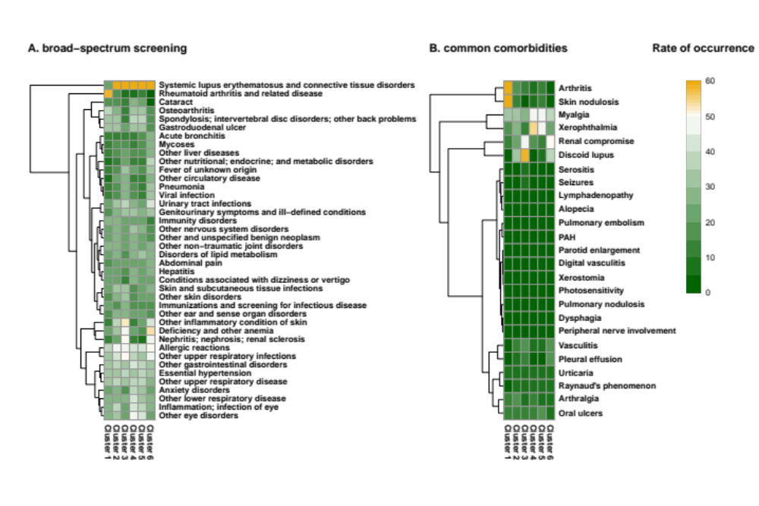
Supplement Figure 1 The occurrence rates for clinical classification software (CCS) single-level diagnosis groups and common clinical manifestations across clusters. The heatmaps illustrate the rates of occurrence for (A) clinical classification software (CCS) single-level diagnosis groups and (B) common clinical manifestations across clusters. We classified all ICD codes (not limited to SAD-related codes) into CCS single-level diagnosis groups to identify clinically meaningful manifestations.

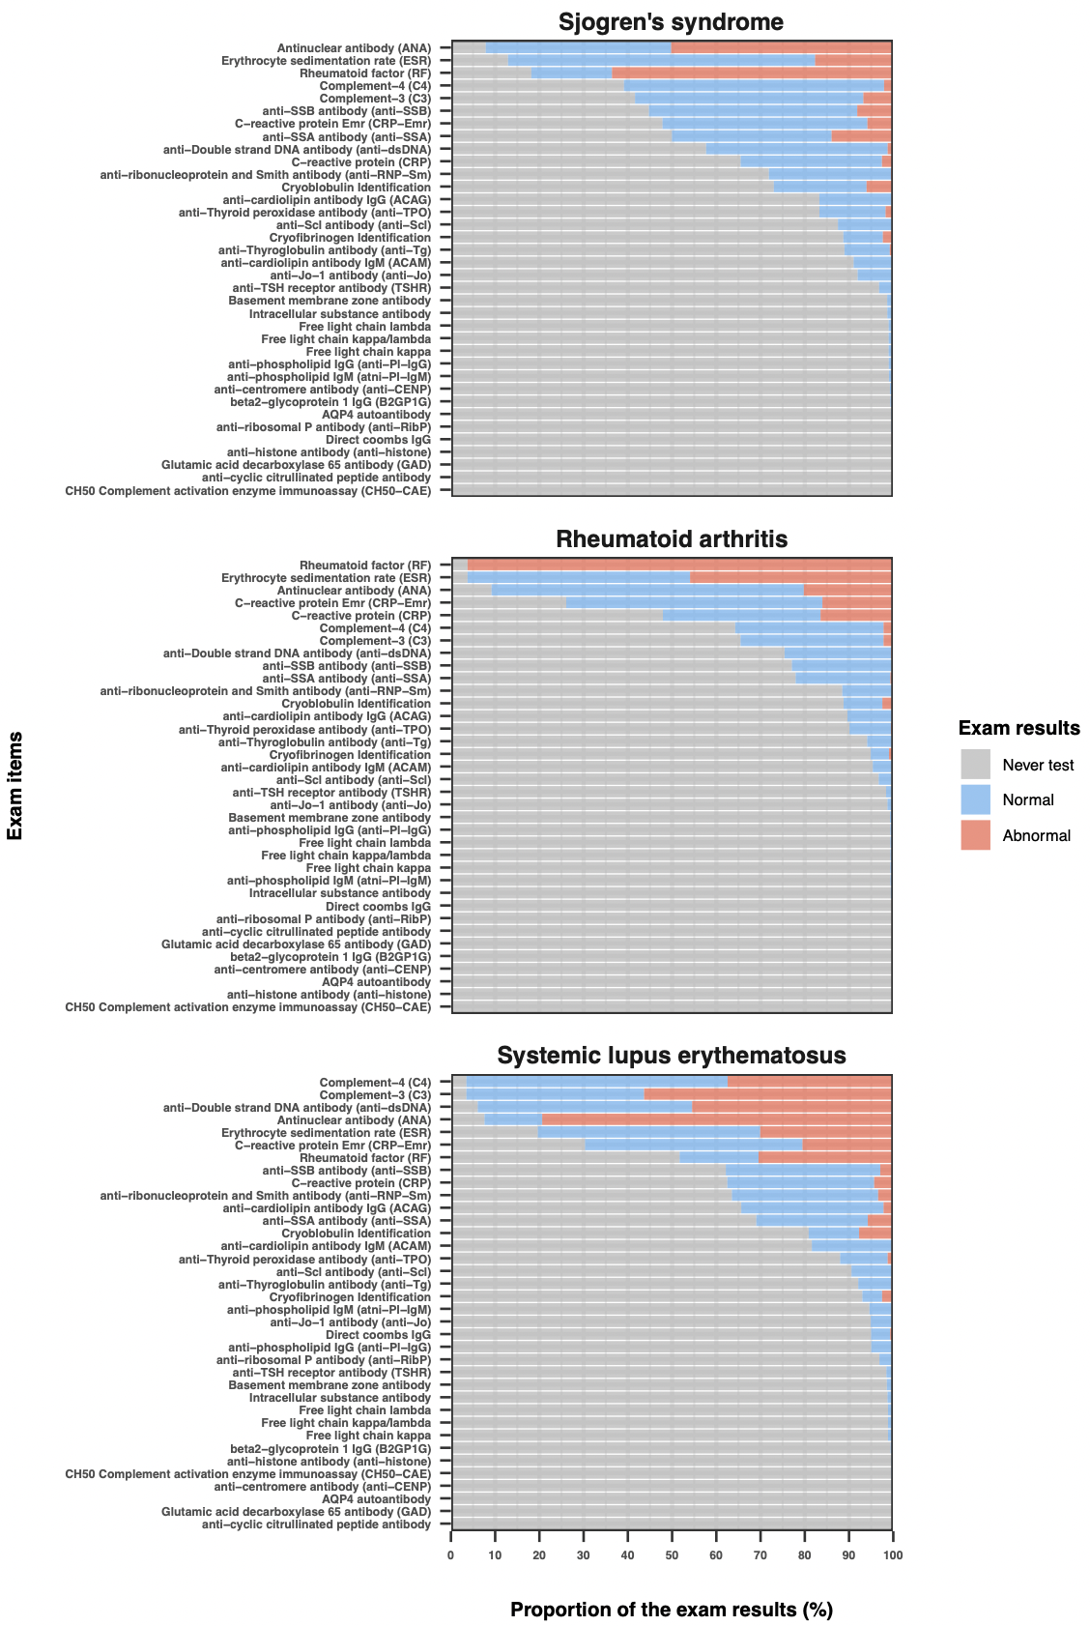
Supplement Figure 2 The proportion of results for each immunomarker stratified by the SADs. Each bar was stacked with three types of results: never tested over all observed courses (Never test; missing data) in grey, tested normal (absence of the autoantibody or within a reference range) in blue, and tested abnormal (presence of the autoantibody or out of a reference range) in red, and represented the proportions of the exam result in a specific exam item.

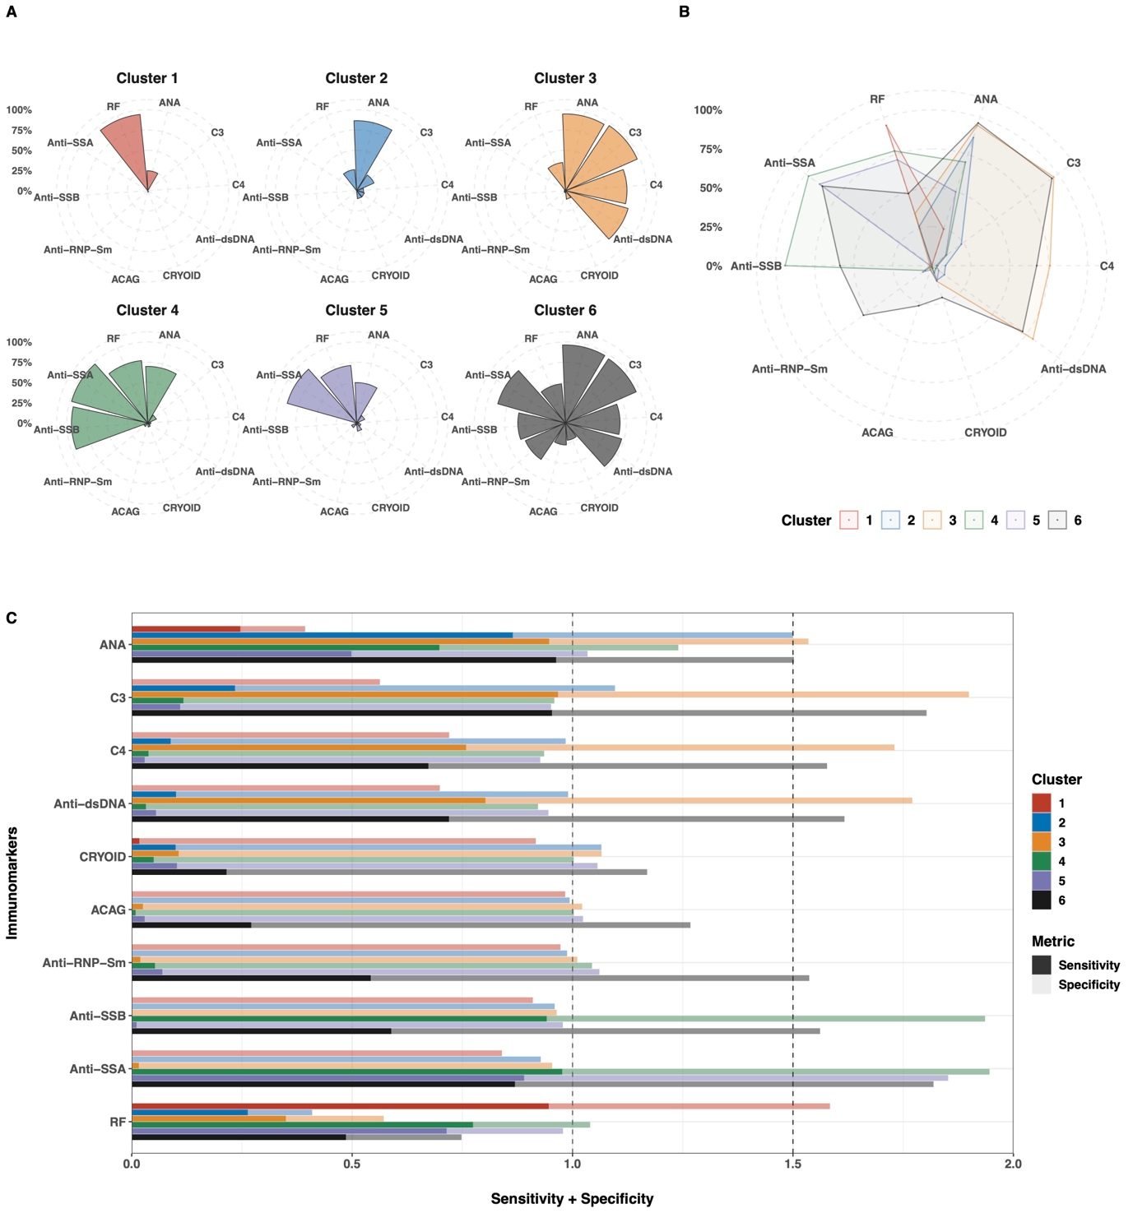
Supplement Figure 3 Diverse performance of immunomarkers in the diagnosis of the cluster number (1 to 6). Saturated colour segments represent sensitivity and the pale segment represents specificity.

References
[1] B. Kuriya, C.K. Cheng, H.M. Chen, V.P. Bykerk, Validation of a prediction rule for development of rheumatoid arthritis in patients with early undifferentiated arthritis, Ann Rheum Dis. 68 (2009) 1482. https://doi.org/10.1136/ard.2008.092676.
[2] D. Aletaha, T. Neogi, A.J. Silman, J. Funovits, D.T. Felson, C.O. Bingham, N.S. Birnbaum, G.R. Burmester, V.P. Bykerk, M.D. Cohen, B. Combe, K.H. Costenbader, M. Dougados, P. Emery, G. Ferraccioli, J.M.W. Hazes, K. Hobbs, T.W.J. Huizinga, A. Kavanaugh, J. Kay, T.K. Kvien, T. Laing, P. Mease, H.A. Ménard, L.W. Moreland, R.L. Naden, T. Pincus, J.S. Smolen, E. Stanislawska‐Biernat, D. Symmons, P.P. Tak, K.S. Upchurch, J. Vencovský, F. Wolfe, G. Hawker, 2010 Rheumatoid arthritis classification criteria: An American College of Rheumatology/European League Against Rheumatism collaborative initiative, Arthritis Rheumatism. 62 (2010) 2569–2581. https://doi.org/10.1002/art.27584.
[3] D.F. Mutasim, B.B. Adams, A practical guide for serologic evaluation of autoimmune connective tissue diseases, J Am Acad Dermatol. 42 (2000) 159–176. https://doi.org/10.1016/s0190-9622(00)90121-x.
[4] S. Veenbergen, A. Kozmar, P.L.A. van Daele, M.W.J. Schreurs, Autoantibodies in Sjögren’s syndrome and its classification criteria, J Transl Autoimmun. 5 (2022) 100138. https://doi.org/10.1016/j.jtauto.2021.100138.
[5] H.F. Kaiser, An index of factorial simplicity, Psychometrika. 39 (1974) 31–36. https://doi.org/10.1007/bf02291575.
[6] H.F. Kaiser, J. Rice, Little Jiffy, Mark Iv, Educ Psychol Meas. 34 (1974) 111–117. https://doi.org/10.1177/001316447403400115.
[7] J.F. Hair, W.C. Black, B.J. Babin, R.E. Anderson, Multivariate Data Analysis: Pearson New International Edition, ismunicz, 2013. http://books.google.com/books/content?id=oLCpBwAAQBAJ&;printsec=frontcover&img=1&zoom=1&source=gbs_api.
[8] H. Hwang, H. Montréal, W.R. Dillon, Y. Takane, An Extension of Multiple Correspondence Analysis for Identifying Heterogeneous Subgroups of Respondents, Psychometrika. 71 (2006) 161–171. https://doi.org/10.1007/s11336-004-1173-x.
[9] A. Markos, A.I. D’Enza, M. van de Velden, Beyond Tandem Analysis: Joint Dimension Reduction and Clustering in R, J Stat Softw. 91 (2019). https://doi.org/10.18637/jss.v091.i10.
[10] K. Kaivanto, Maximization of the sum of sensitivity and specificity as a diagnostic cutpoint criterion, J Clin Epidemiol. 61 (2008) 517–518. https://doi.org/10.1016/j.jclinepi.2007.10.011.
[11] C. for M. and M. Services, Centers for Medicare and Mediaid Services, Medicare, ICD-9 codes, (n.d.). https://www.cms.gov/Medicare/Coding/ICD9ProviderDiagnosticCodes/codes.
[12] C. for M. and M. Services, Centers for Medicare and Mediaid Services, Medicare, ICD-10 codes, (n.d.). https://www.cms.gov/medicare/coding/icd10.
[13] S. Anjohrin, A. Sheahan, R. Suruki, J.L. Stark, V.S. Sloan, Occurrence of Possible Rheumatologic Immune-Related Adverse Events (rh-irAEs) Associated with Immune Checkpoint Inhibitor (ICI) Therapy, Rheumatology Ther. 8 (2021) 1651–1659. https://doi.org/10.1007/s40744-021-00359-z.
[14] J. Lavian, S.J. Li, E.Y. Lee, L.A. Bordone, F.C.G. Polubriaginof, A.M. Christiano, A. Mostaghimi, Validation of Case Identification for Alopecia Areata Using International Classification of Diseases Coding, Int J Trichology. 12 (2020) 234–237. https://doi.org/10.4103/ijt.ijt_67_20.
[15] C.M. Grönhagen, C.M. Fored, F. Granath, F. Nyberg, Cutaneous lupus erythematosus and the association with systemic lupus erythematosus: a population‐based cohort of 1088 patients in Sweden, Brit J Dermatol. 164 (2011) 1335–1341. https://doi.org/10.1111/j.1365-2133.2011.10272.x.
[16] B. Hollingsworth, L. Senter, X. Zhang, G.N. Brock, W. Jarjour, R. Nagy, P. Brock, K.R. Coombes, R.T. Kloos, M.D. Ringel, J. Sipos, I. Lattimer, R. Carrau, S.M. Jhiang, Risk Factors of 131I-Induced Salivary Gland Damage in Thyroid Cancer Patients, J Clin Endocrinol Metabolism. 101 (2016) 4085–4093. https://doi.org/10.1210/jc.2016-1605.
[17] T.M. Frech, M.A. Murtaugh, M. Amuan, M.J. Pugh, The frequency of Raynaud’s phenomenon, very early diagnosis of systemic sclerosis, and systemic sclerosis in a large Veteran Health Administration database, Bmc Rheumatology. 5 (2021) 42. https://doi.org/10.1186/s41927-021-00209-z.
[18] L. Kalilani, E. Faught, H. Kim, C. Burudpakdee, A. Seetasith, S. Laranjo, D. Friesen, K. Haeffs, V. Kiri, D.J. Thurman, Assessment and effect of a gap between new-onset epilepsy diagnosis and treatment in the US, Neurology. 92 (2019) 10.1212/WNL.0000000000007448. https://doi.org/10.1212/wnl.0000000000007448.
[19] J.R. Smith, F.J.S. Jones, B.E. Fureman, J.R. Buchhalter, S.T. Herman, N. Ayub, C. McGraw, S.S. Cash, D.B. Hoch, L.M.V.R. Moura, Accuracy of ICD-10-CM claims-based definitions for epilepsy and seizure type, Epilepsy Res. 166 (2020) 106414. https://doi.org/10.1016/j.eplepsyres.2020.106414.
[20] T. Li, I. Lee, D. Jayakumar, X. Huang, Y. Xie, S. Eisen, P. Ranganathan, Development and validation of lupus nephritis case definitions using United States veterans affairs electronic health records, Lupus. 30 (2020) 518–526. https://doi.org/10.1177/0961203320973267.
[21] R. Papani, G. Sharma, A. Agarwal, S.J. Callahan, W.J. Chan, Y. Kuo, Y.M. Shim, A.D. Mihalek, A.G. Duarte, Validation of claims‐based algorithms for pulmonary arterial hypertension, Pulm Circ. 8 (2018) 1–8. https://doi.org/10.1177/2045894018759246.
[22] K.R. Gillmeyer, E.R. Nunez, S.T. Rinne, S.X. Qian, E.S. Klings, R.S. Wiener, Development and Validation of Algorithms to Identify Pulmonary Arterial Hypertension in Administrative Data, Chest. 159 (2021) 1986–1994. https://doi.org/10.1016/j.chest.2020.12.010.
[23] M.H. Gul, Z.M. Htun, J. Rigdon, B. Rivera‐Lebron, V. de J. Perez, Clinical outcomes of inferior vena cava filter in complicated pulmonary embolism, Pulm Circ. 9 (2019) 1–10. https://doi.org/10.1177/2045894019882636.
[24] S.A. Johnson, E.A. Signor, K.L. Lappe, J. Shi, S.L. Jenkins, S.W. Wikstrom, R.D. Kroencke, D. Hallowell, A.E. Jones, D.M. Witt, A comparison of natural language processing to ICD-10 codes for identification and characterization of pulmonary embolism, Thromb Res. 203 (2021) 190–195. https://doi.org/10.1016/j.thromres.2021.04.020.
[25] E.K. Akpek, A. Klimava, J.E. Thorne, D. Martin, K. Lekhanont, A. Ostrovsky, Evaluation of Patients With Dry Eye for Presence of Underlying Sjögren Syndrome, Cornea. 28 (2009) 493–497. https://doi.org/10.1097/ico.0b013e31818d3846.
[26] M.Y. Smith, M. Sabidó-Espin, A. Trochanov, M. Samuelson, S. Guedes, F.A. Corvino, F.F. Richy, Postmarketing Safety Profile of Subcutaneous Interferon Beta-1a Given 3 Times Weekly: A Retrospective Administrative Claims Analysis, J Manag Care Spec Ph. 21 (2015) 650–660. https://doi.org/10.18553/jmcp.2015.21.8.650.
[27] D. Cherepanov, K. Raimundo, E. Chang, M. Eagan, J.L. Zazzali, P.G. Solari, B. DeCotiis, I. Hussain, S.M. Rehman, N. Shahab, S.A. Tilles, M.S. Broder, Validation of an ICD-9–based claims algorithm for identifying patients with chronic idiopathic/spontaneous urticaria, Ann Allergy Asthma Immunol. 114 (2015) 393–398. https://doi.org/10.1016/j.anai.2015.02.003.
[28] M. González-Fernández, M. Gardyn, S. Wyckoff, P.K.S. Ky, J.B. Palmer, Validation of ICD-9 Code 787.2 for Identification of Individuals with Dysphagia from Administrative Databases, Dysphagia. 24 (2009) 398–402. https://doi.org/10.1007/s00455-009-9216-1.

