a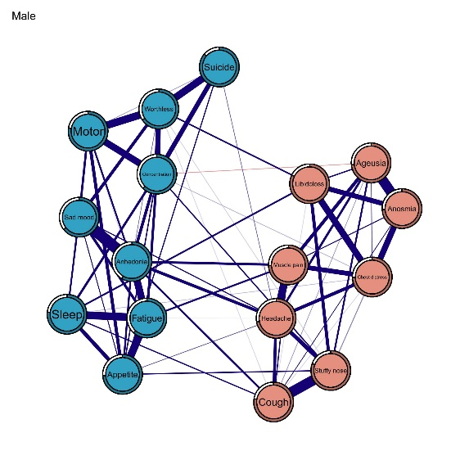b 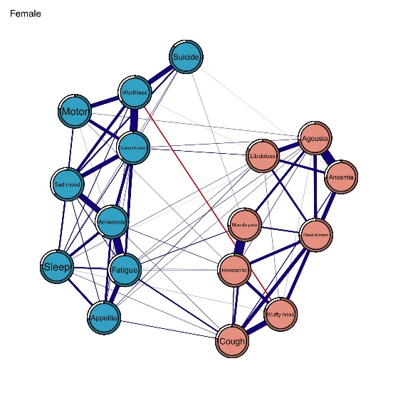
Figure 3a-b. The depression-somatic symptom network between male and female. Blue circles indicate depressive symptoms, orange circles indicate somatic symptoms, blue edges represent positive correlations, red edges represent negative correlations, the thickness of the edge reflects the magnitude of the correlation.

a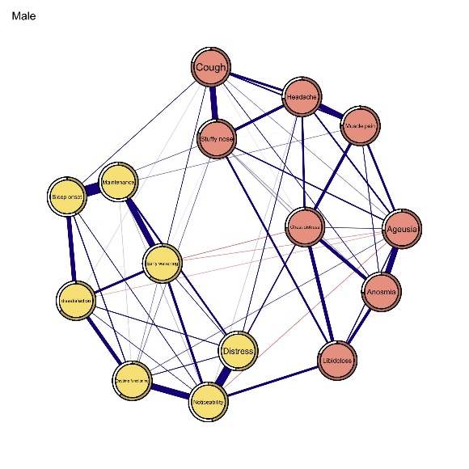b 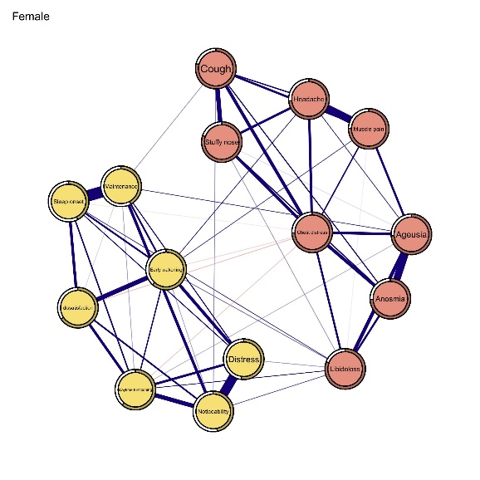
Figure 6a-b. The insomnia-somatic symptom network between male and female. Yellow circles indicate insomnia symptoms, orange circles indicate somatic symptoms, blue edges represent positive correlations, red edges represent negative correlations, the thickness of the edge reflects the magnitude of the correlation.
a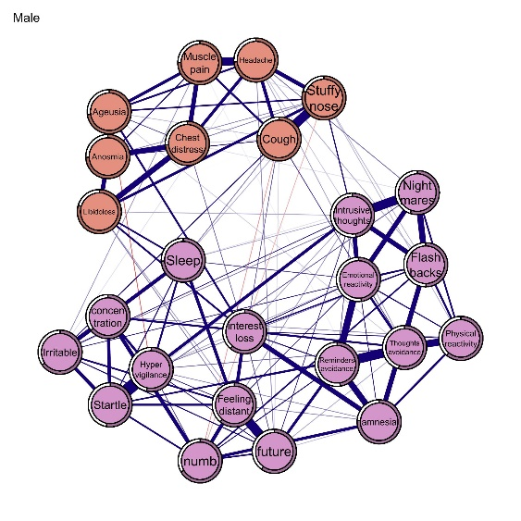 b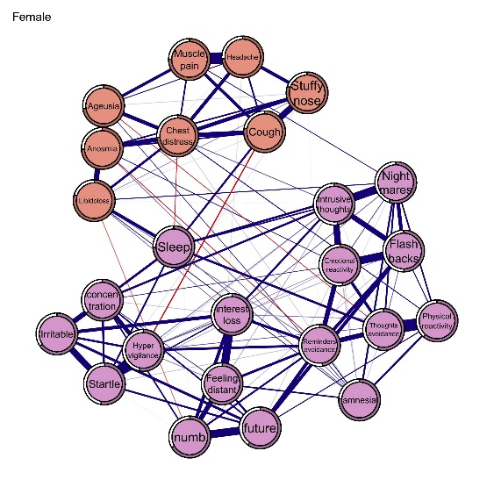
Figure 9a-b. The PTSD-somatic symptom network between male and female. Purple circles indicate PTSD symptoms, orange circles indicate somatic symptoms, blue edges represent positive correlations, red edges represent negative correlations, the thickness of the edge reflects the magnitude of the correlation.

