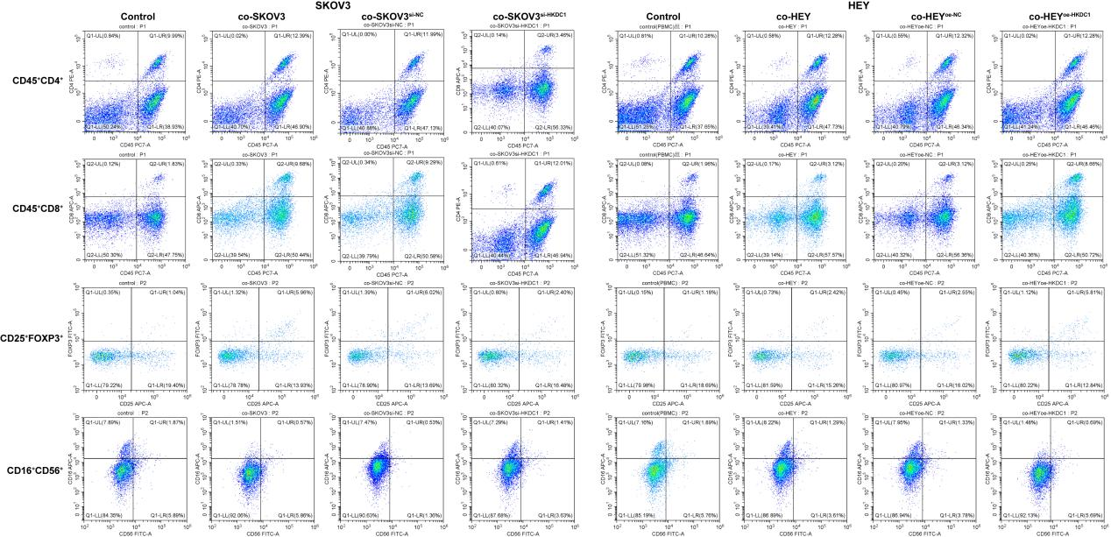
Figure S1 Representative plots of flow cytometry displaying the proportions of CD4⁺/CD8⁺ T cells (CD45⁺CD4⁺/CD8⁺), Treg cells (CD4⁺CD25⁺FOXP3⁺), and NK cells (CD3⁻CD16⁺CD56⁺).
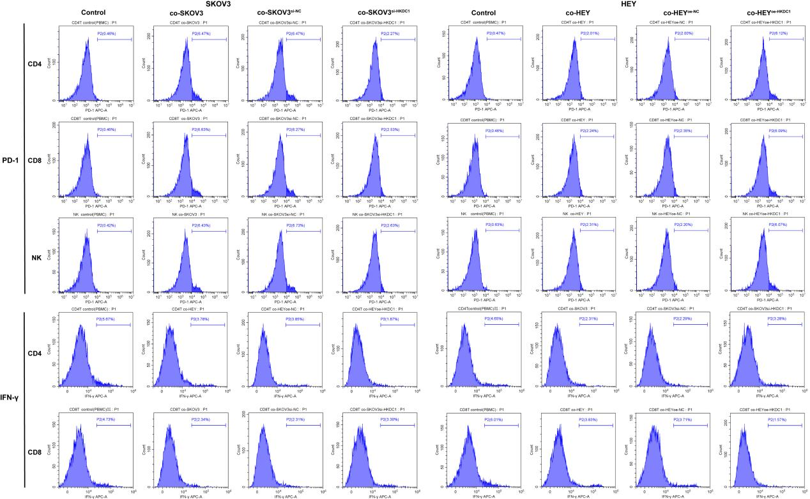
Figure S2 Representative plots of flow cytometry displaying the ratio of PD-1 and IFN-γ.
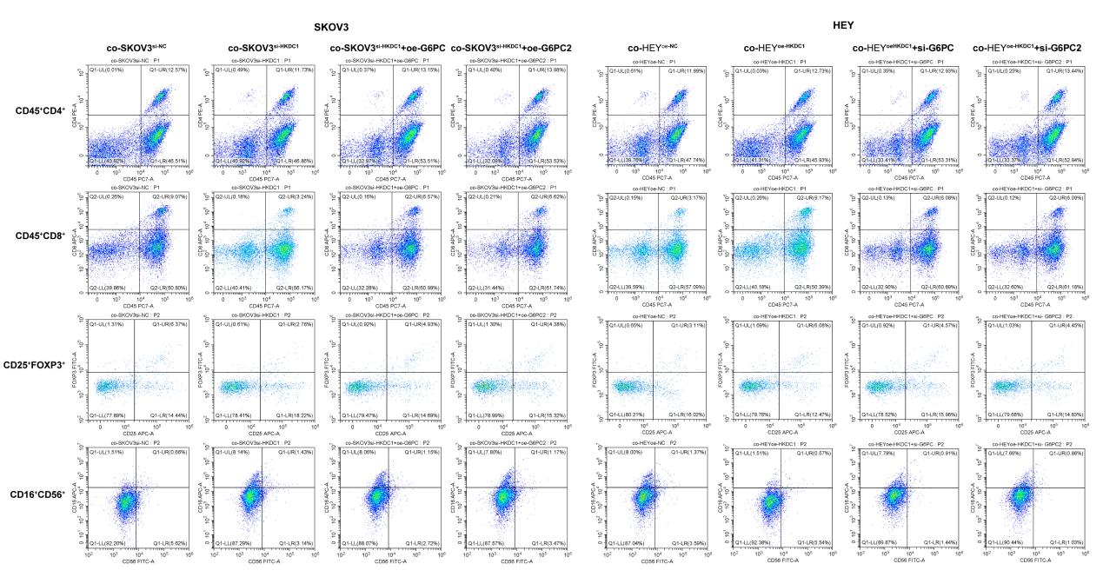
Figure S3 Representative plots of flow cytometry displaying the proportions of CD4⁺/CD8⁺ T cells (CD45⁺CD4⁺/CD8⁺), Treg cells (CD4⁺CD25⁺FOXP3⁺), and NK cells (CD3⁻CD16⁺CD56⁺).
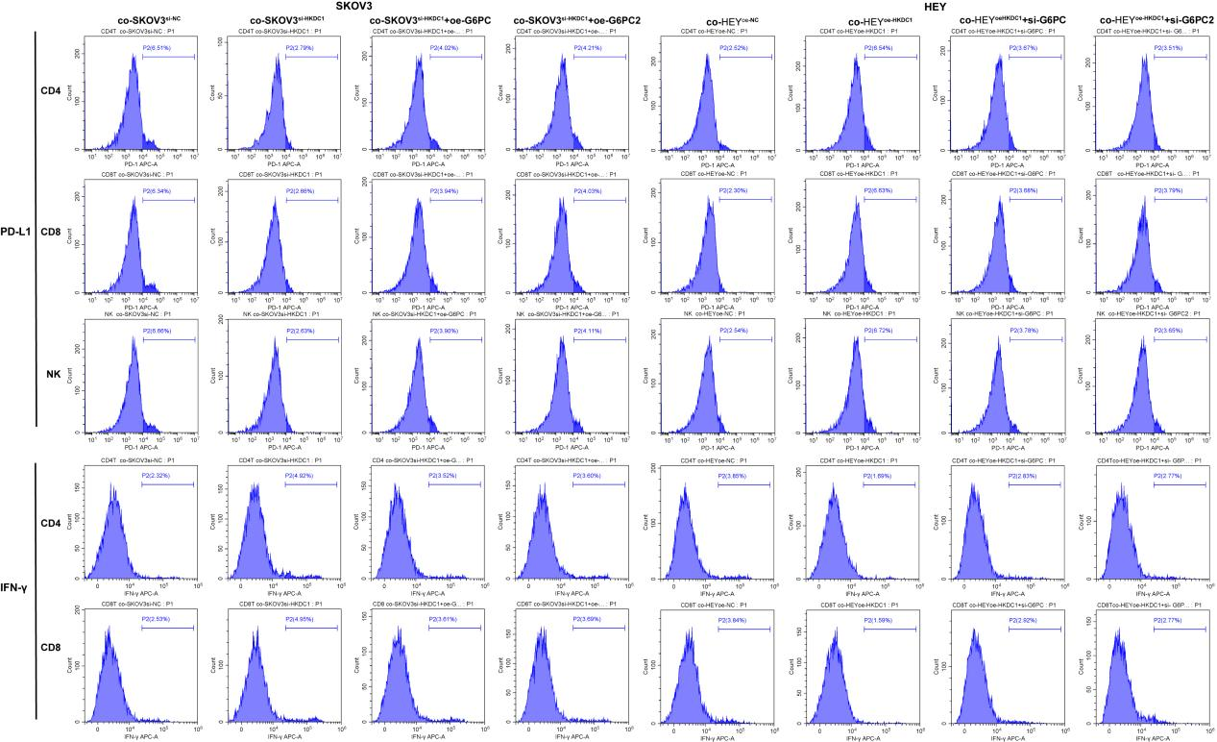
Figure S4 Representative plots of flow cytometry displaying the ratio of PD-1 and IFN-γ.
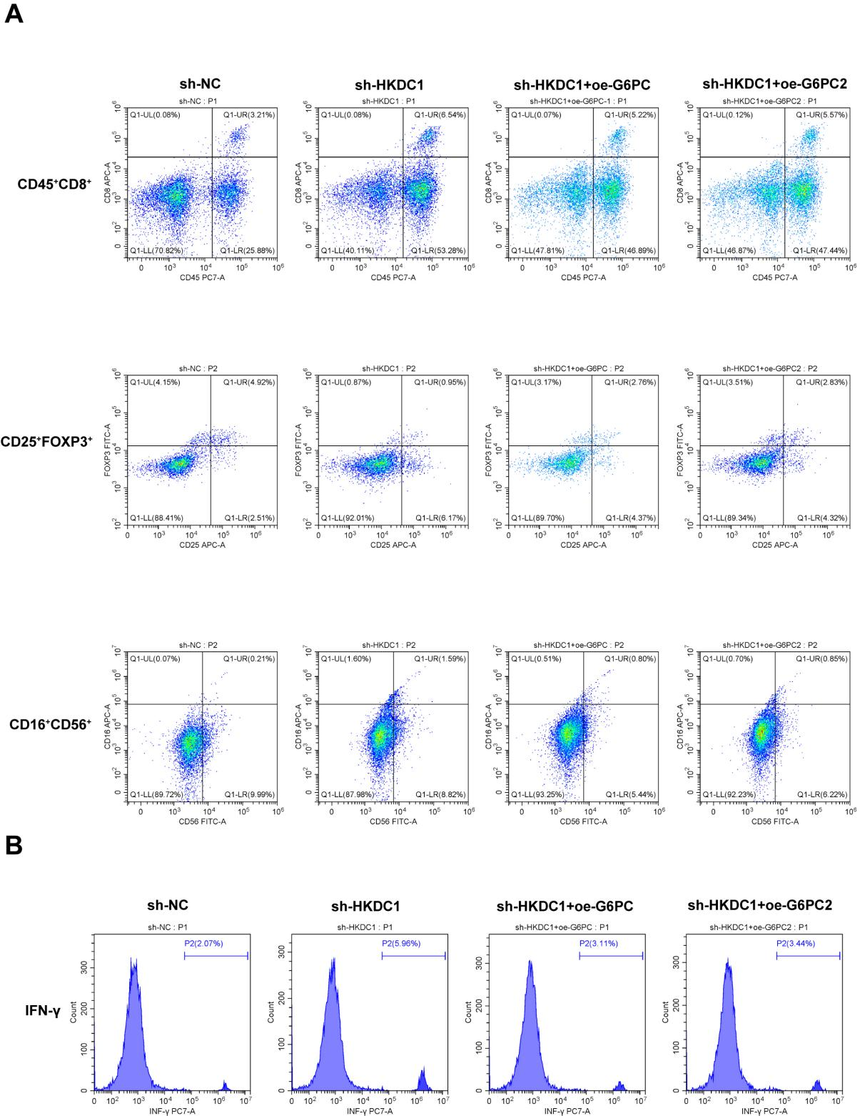
Figure S5 (A) Representative plots of flow cytometry displaying the proportions of CD4⁺/CD8⁺ T cells (CD45⁺CD4⁺/CD8⁺), Treg cells (CD4⁺CD25⁺FOXP3⁺), and NK cells (CD3⁻CD16⁺CD56⁺). (B) Representative plots of flow cytometry displaying the levels of IFN-γ.

