Molecular Structure of Flavonoids Determines the Efficacy of Glycosylation by Amylosucrase
Jong Cheoul Lee¹, Siddha Raj Upadhyaya², Samir Bahadur Thapa¹, Obed Jackson Amoah1, Niranjan Parajuli^{1,2} and Jae Kyung Sohng^{1,3, *}

¹ Institute of Biomolecule Reconstruction (iBR), Department of Life Science and Biochemical Engineering, SunMoon University, Asan 31460, Republic of Korea
² Central Department of Chemistry, Tribhuvan University, Kirtipur, 44618, Kathmandu, Nepal
³ Department of Pharmaceutical Engineering and Biotechnology, SunMoon University, Asan 31460, Republic of Korea
*Correspondance: sohng@sunmoon.ac.kr; Tel: +82(41)530-2246

DgAS
pHCE IIB-DgAS
~5861 bp
Amp^{r}
NdeI
HindIII

Figure S1. Vector map of the recombinant construct used in this study.

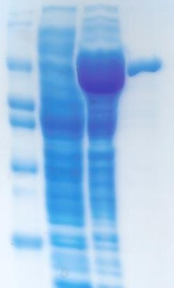
M
100 KDa
70 KDa
50 KDa
40 KDa
30 KDa
1
2
3

Figure S2. SDS-PAGE of protein DgAS. M: marker; Lane 1: Control BL-21(DE3); Lane 2: crude enzyme produced in BL-21(DE3); Lane 3: purified enzyme.
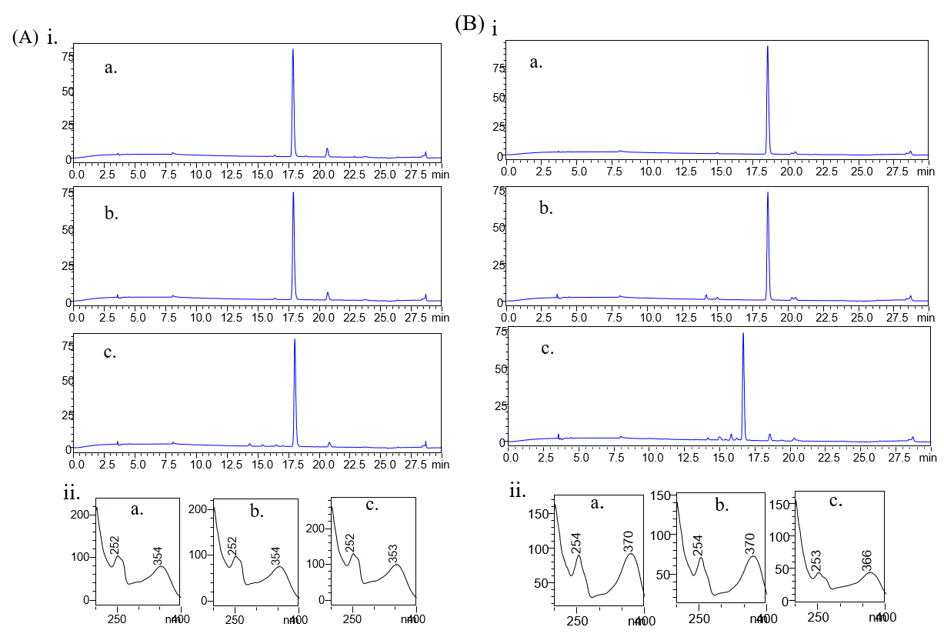
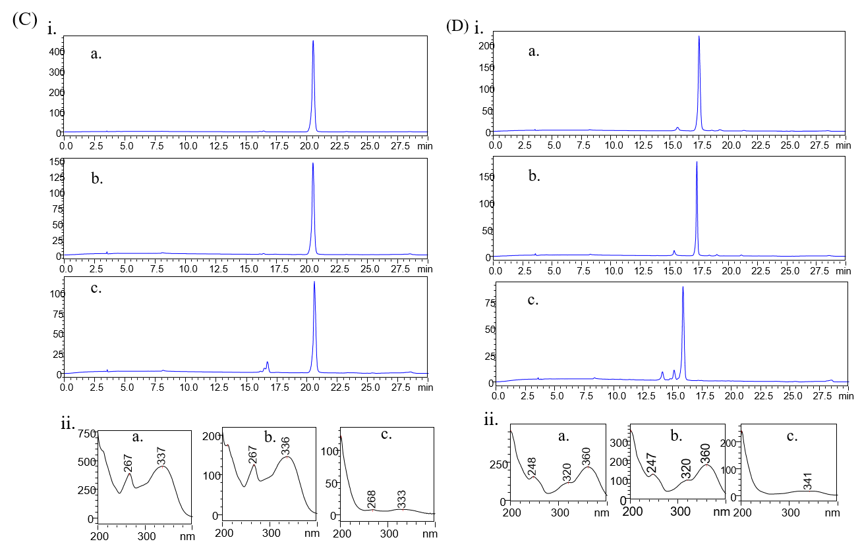
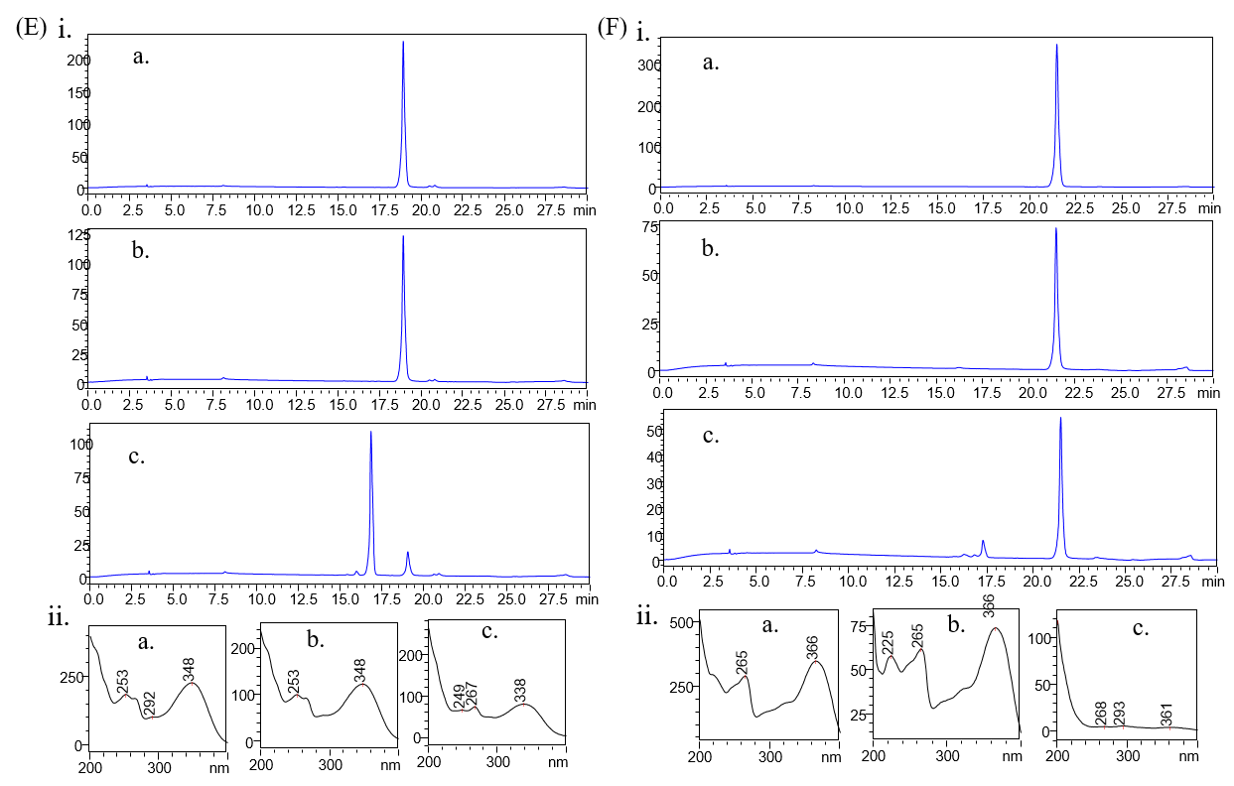
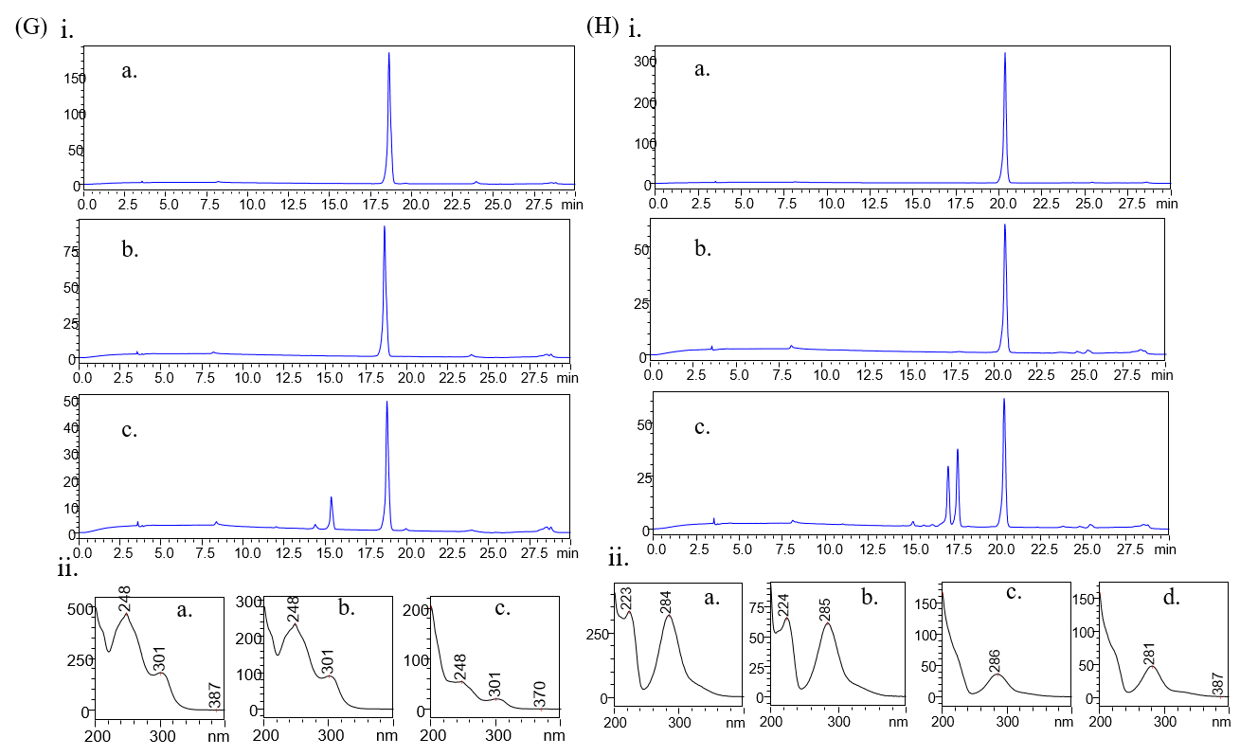

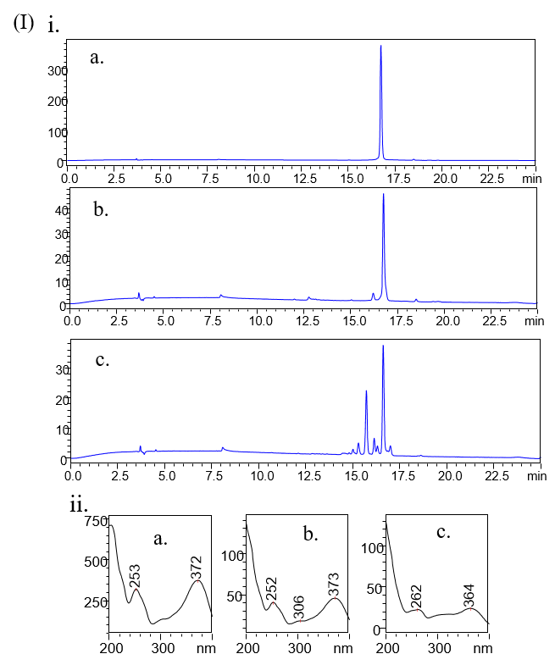
Figure S3. HPLC analysis of reaction mixture. A(i) (a) Standard Morin; (b) Control reaction; and (c) Regular glucosylation reaction. (ii) UV-VIS analysis of major each peak from HPLC (a) Standard Morin; (b) Control Peak; and (c) product peak. B(i) (a) Standard Quercetin, (b) Control reaction; and (c) Regular glucosylation reaction. (ii) UV-VIS analysis of major each peak from HPLC (a) Standard Quercetin; (b) Control Peak; and (c) product peak. C(i) (a) Standard Apigenin; (b) Control; and (c) Regular glucosylation reaction. (ii) UV-VIS analysis of major each peak from HPLC (a) Standard Morin; (b) Control Peak; and (c) product peak. D(i) (a) Standard Fisetin; (b) Control reaction; and (c) Regular glucosylation reaction. (ii) UV-VIS analysis of major each peak from HPLC (a) Standard Fisetin; (b) Control Peak; and (c) product peak. E(i) (a) Standard Luteolin; (b) Control reaction; and (c) Regular glucosylation reaction. (ii) UV-VIS analysis of major each peak from HPLC (a) Standard Luteolin; (b) Control Peak; and (c) product peak. F(i) (a) Standard Kaemferol; (b) Control; and (c) Regular glucosylation reaction. (ii) UV-VIS analysis of major each peak from HPLC (a) Standard Kaemferol; (b) Control Peak; and (c) product peak. G(i) (a) Standard Daidzein; (b) Control reaction; and (c) Regular glucosylation reaction. (ii) UV-VIS analysis of major each peak from HPLC (a) Standard Daidzein; (b) Control Peak; and (c) product peak. H(i) (a) Standard Phloretin; (b) Control reaction; and (c) Regular glucosylation reaction. (ii) UV-VIS analysis of major each peak from HPLC (a) Standard Phloretin; (b) Control Peak; and (c) product peak P; (d) product peak P2. I(i) (a) Standard Myricetin; (b) Control reaction; and (c) Regular glucosylation reaction. (ii) UV-VIS analysis of major each peak from HPLC (a) Standard Myricetin; (b) Control Peak; and (c) product peak.

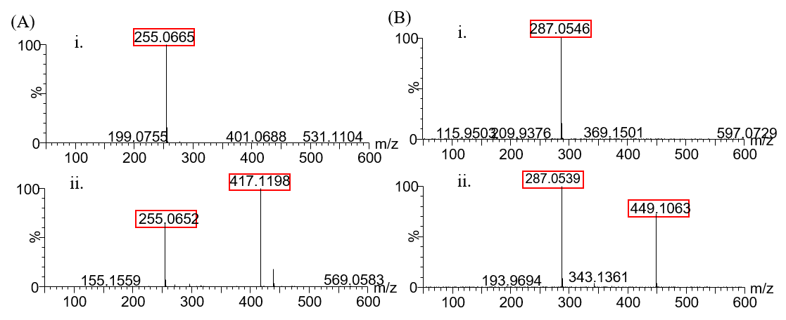
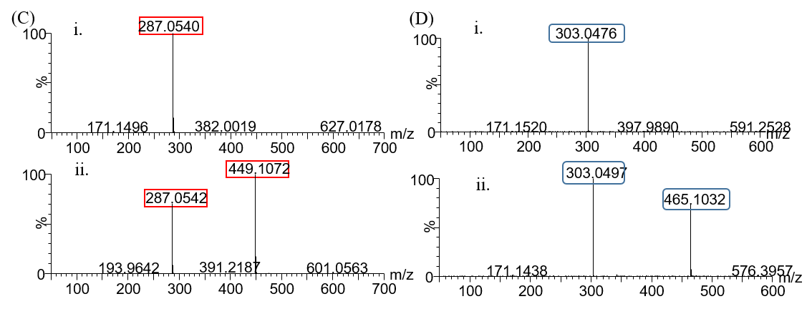
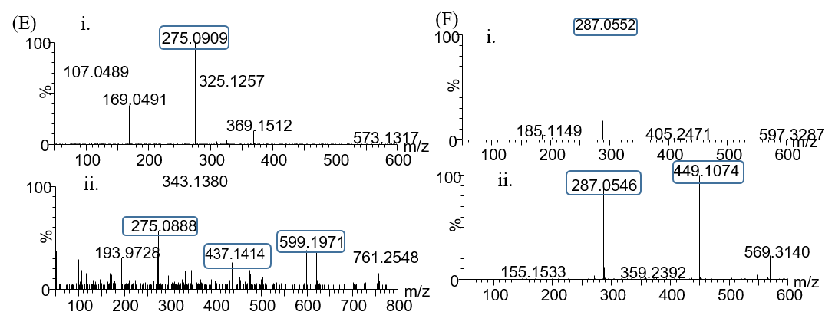
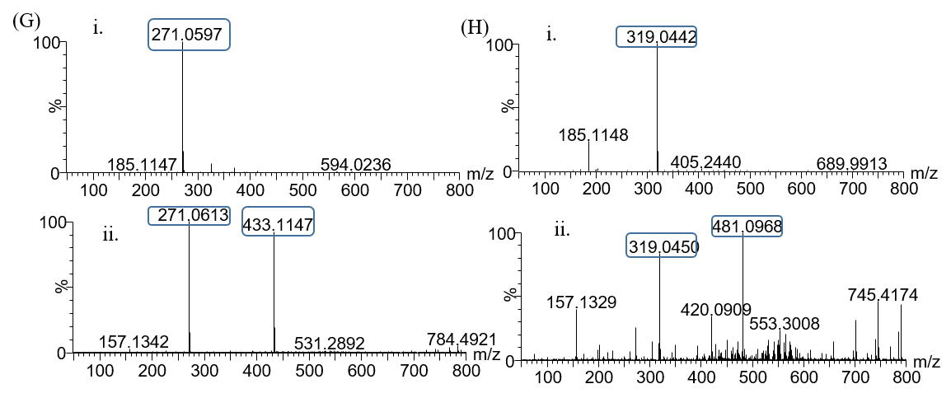
Figure S4. HR-QTOF ESI/MS analysis of A.(i) Daidzin standard and (ii) Diadzin glucoside, B.(i) Kaemferol standard and (ii) Kaemferol glucoside, C.(i) Luteolin standard and (ii) Luteolin glucoside, D.(i) Quercetin standard and (ii) Quercetin glucoside, E.(i) Phloretin standard and (ii) Phloretin monoglucoside and Phloretin diglucoside, F.(i) Fisetin standard and (ii) Fisetin glucoside, G.(i) Apigenin standard and (ii) Apigenin glucoside, H.(i) Myricetin standard and (ii) Myricetin glucoside.
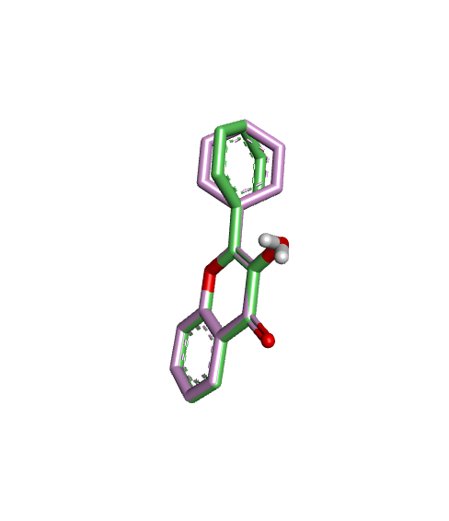
Figure S5. Validation of docking protocol with amylosucrase

