Table 2.1.: Breakdown of the Business Model Digital Transformation Adoption for Financial Capital
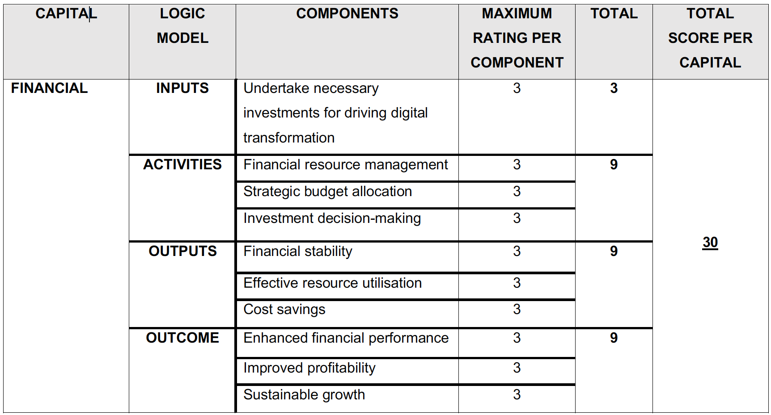
Source: Researchers compilation based on <IR> Framework

Table 2.2.: Breakdown of the Business Model Digital Transformation Adoption for Manufactured Capital
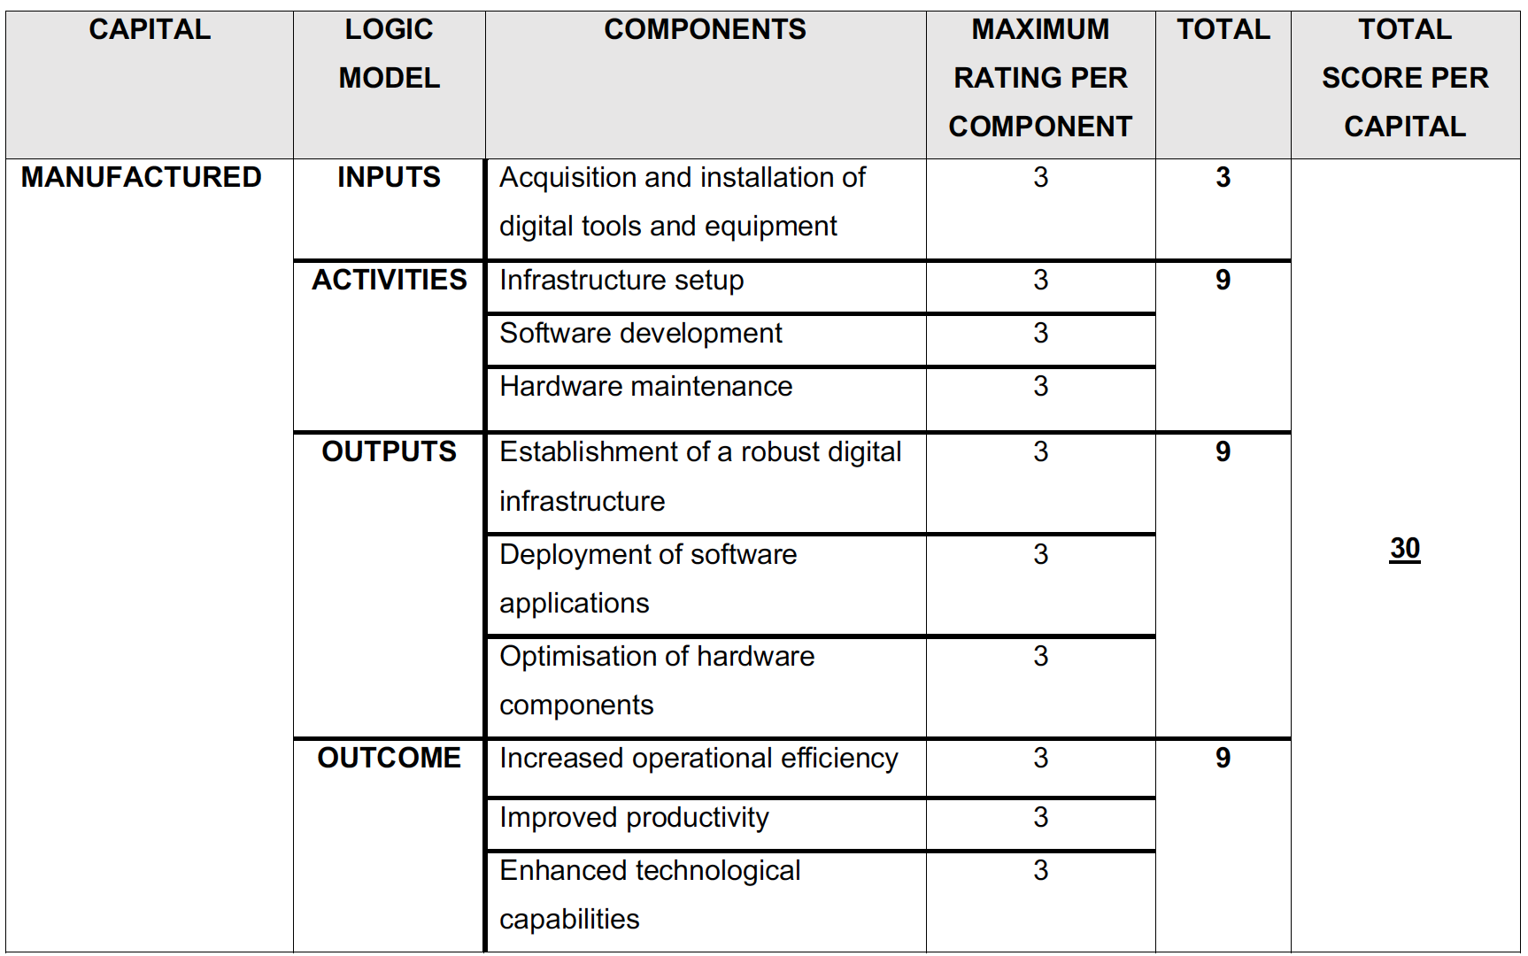
Source: Researchers compilation based on <IR> Framework

Table 2.3.: Breakdown of the Business Model Digital Transformation Adoption for Intellectual Capital
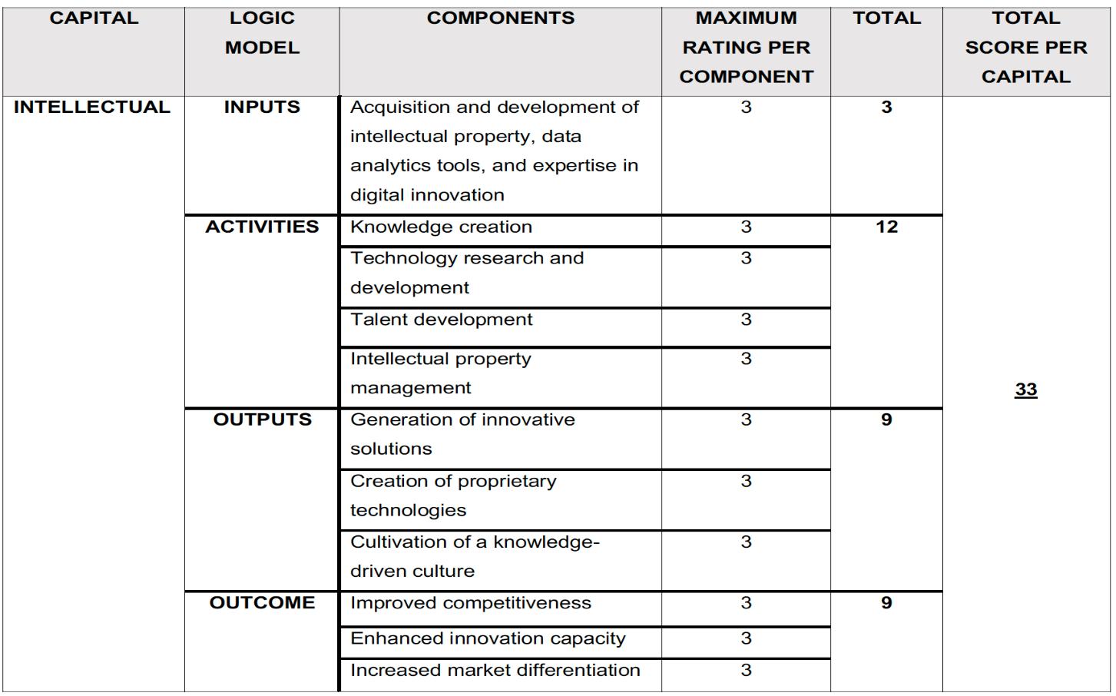
Source: Researchers compilation based on <IR> Framework

Table 2.4.: Breakdown of the Business Model Digital Transformation Adoption for Human Capital
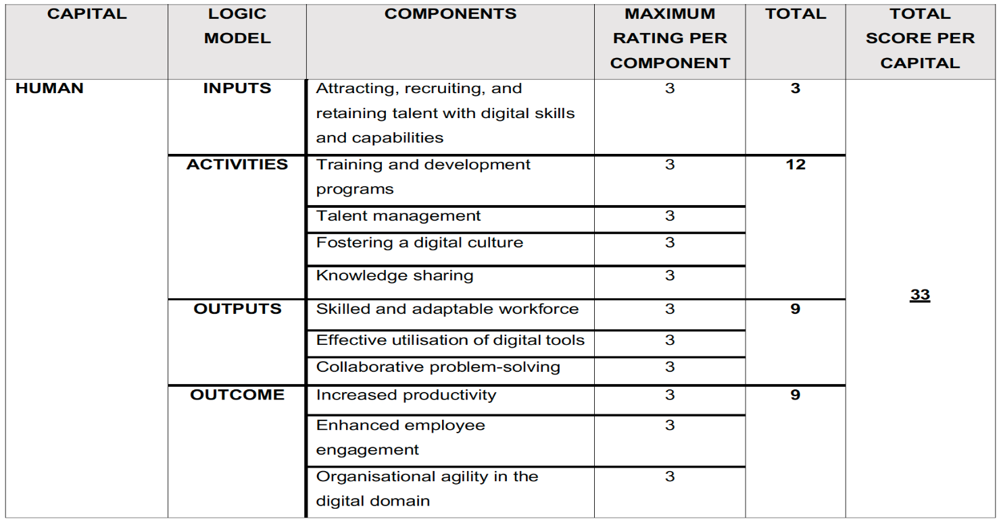
Source: Researchers compilation based on <IR> Framework

Table 2.5.: Breakdown of the Business Model Digital Transformation Adoption for Social Capital
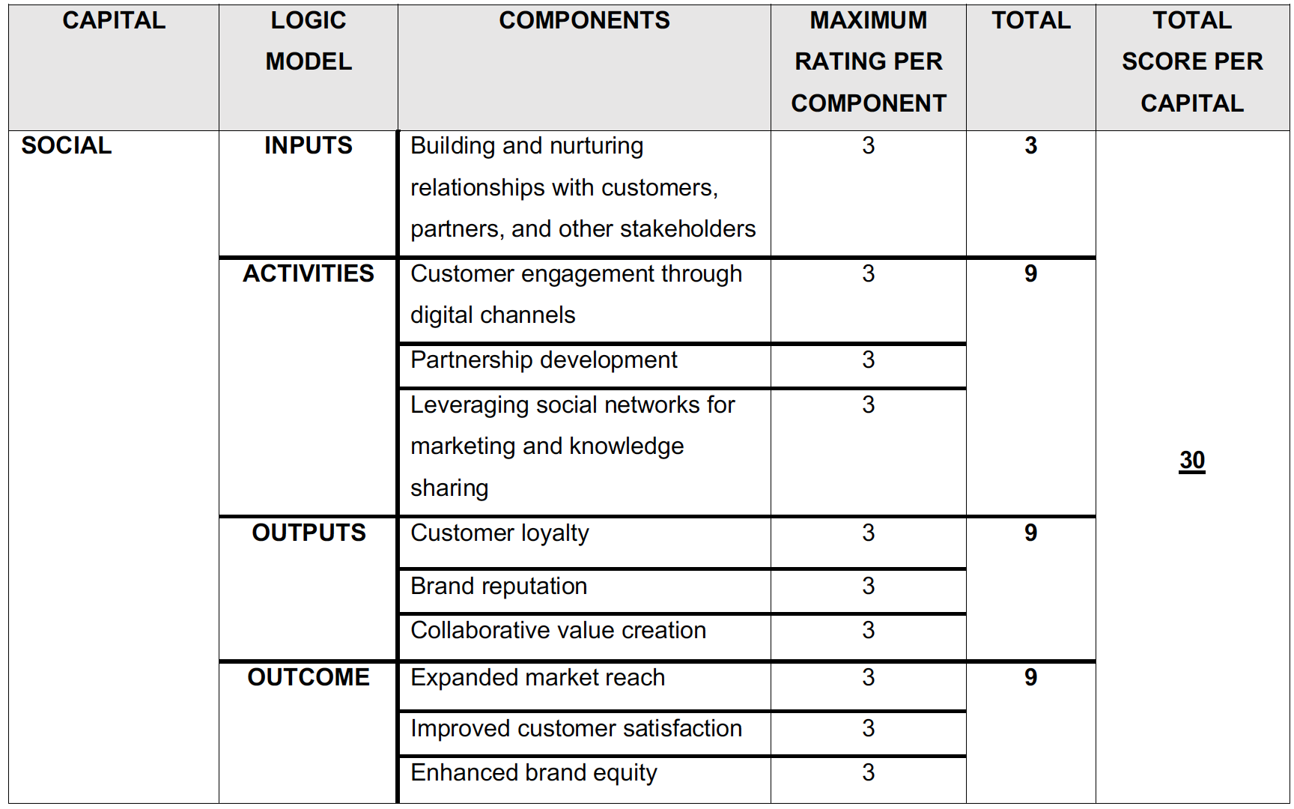
Source: Researchers compilation based on <IR> Framework

Table 2.6.: Breakdown of the Business Model Digital Transformation Adoption for Natural Capital
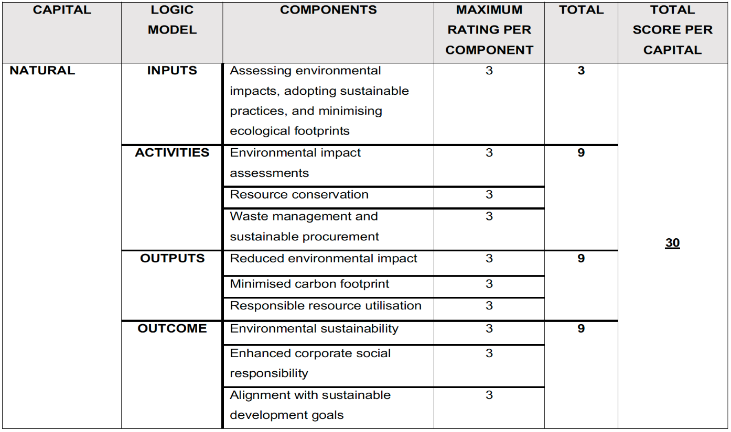
Source: Researchers compilation based on <IR> Framework

Table 2.7.: Business Model Digital Transformation Adoption Rating Interpretation
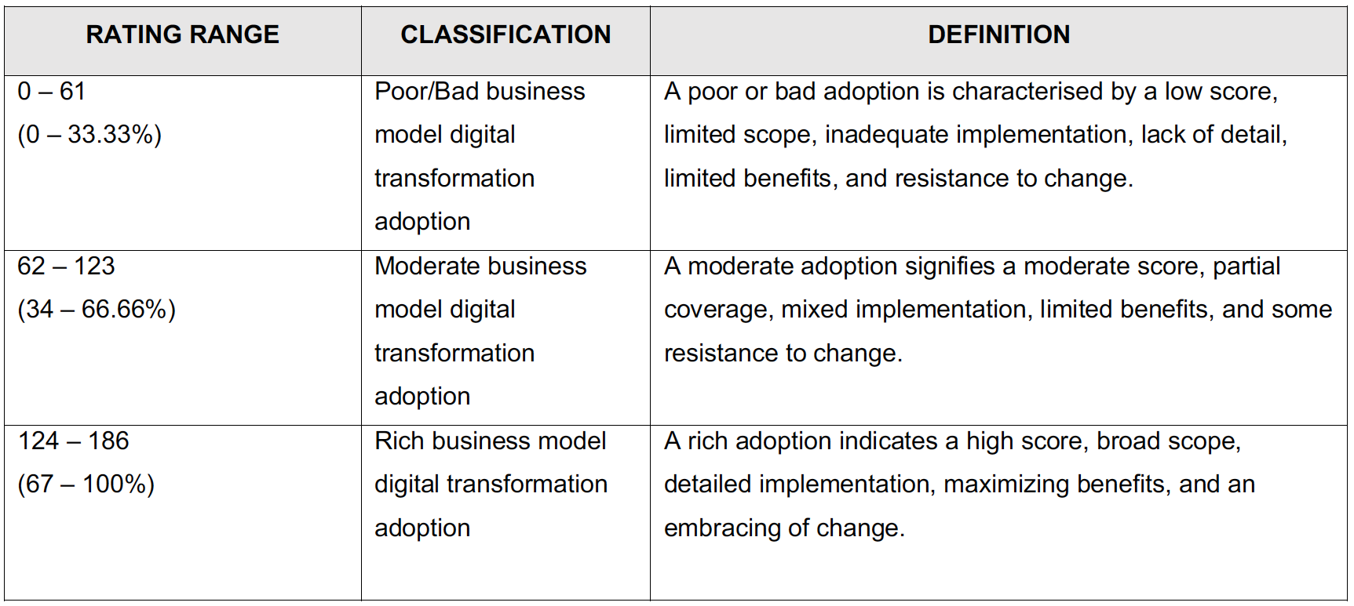
Source: Researchers' construct

Table 2.8.: Breakdown of the CAMELS Composite Rating System
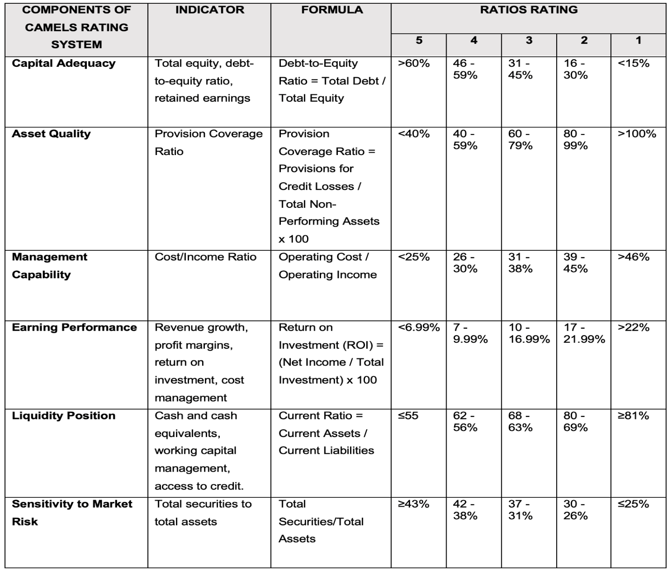
Source: Adapted from Manga (2019)

Table 2.9.: The CAMELS Composite Rating Interpretation
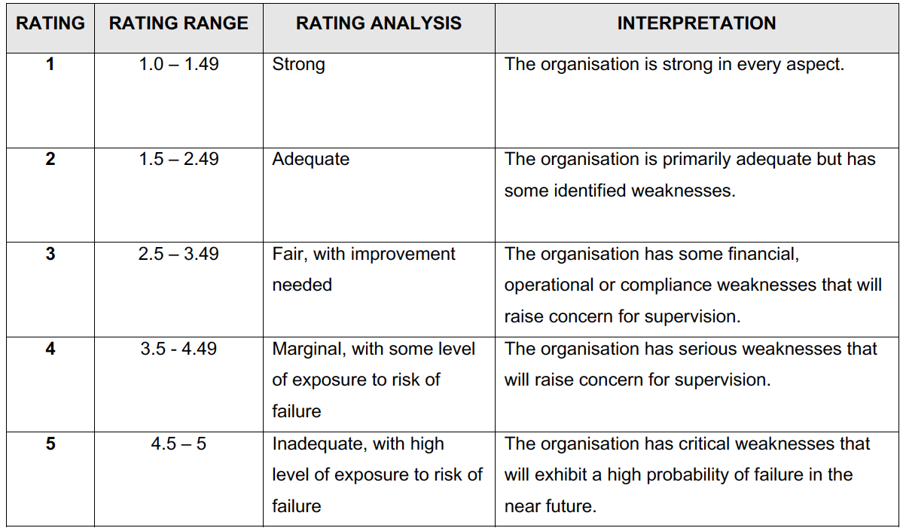
Source: Adapted from Manga (2019)

Table 3.1.: Top 100 Organisations and Their Respective Sectors

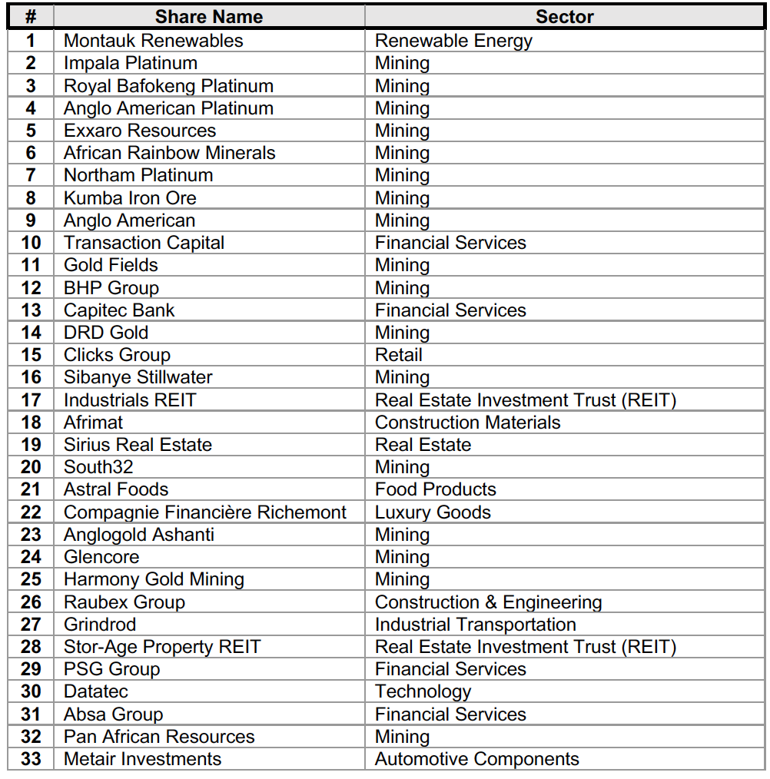
Source: Researchers' compilation

Table 3.2.: Top 100 Organisations and Their Respective Sectors (Continued)

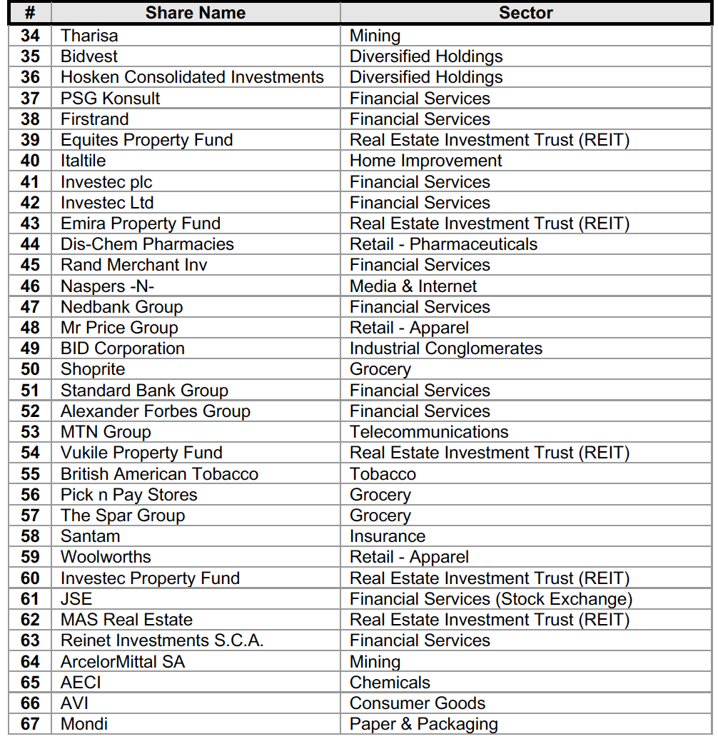
Source: Researchers' compilation

Table 3.3.: Top 100 Organisations and Their Respective Sectors (Continued)

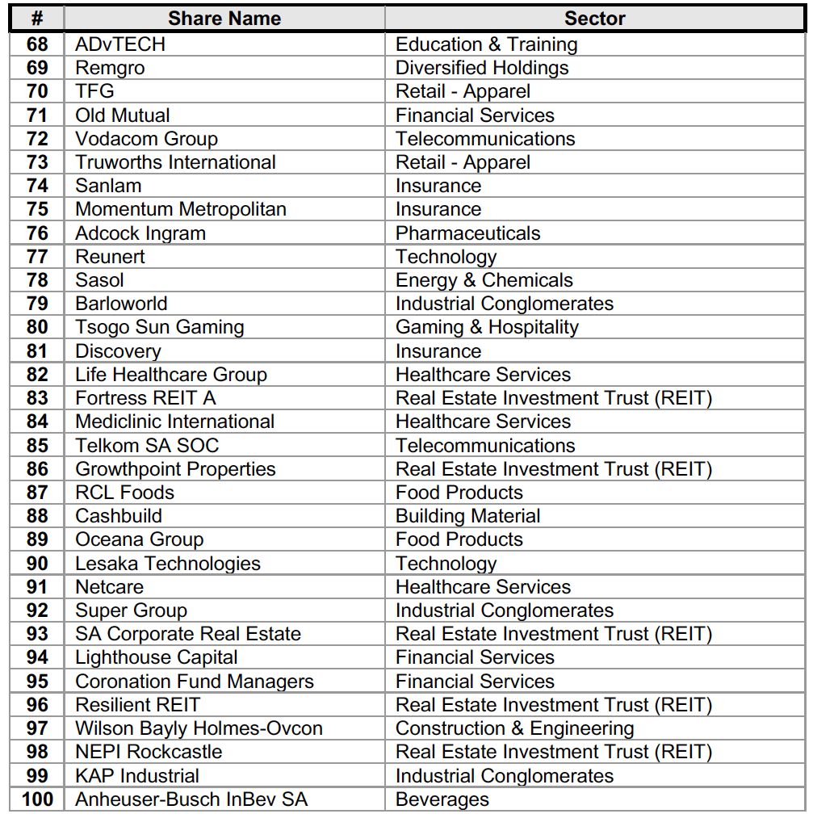
Source: Researchers' compilation

Table 3.4.: Business Models of Top 100 Organisations and their ratings per component (1 – 10)

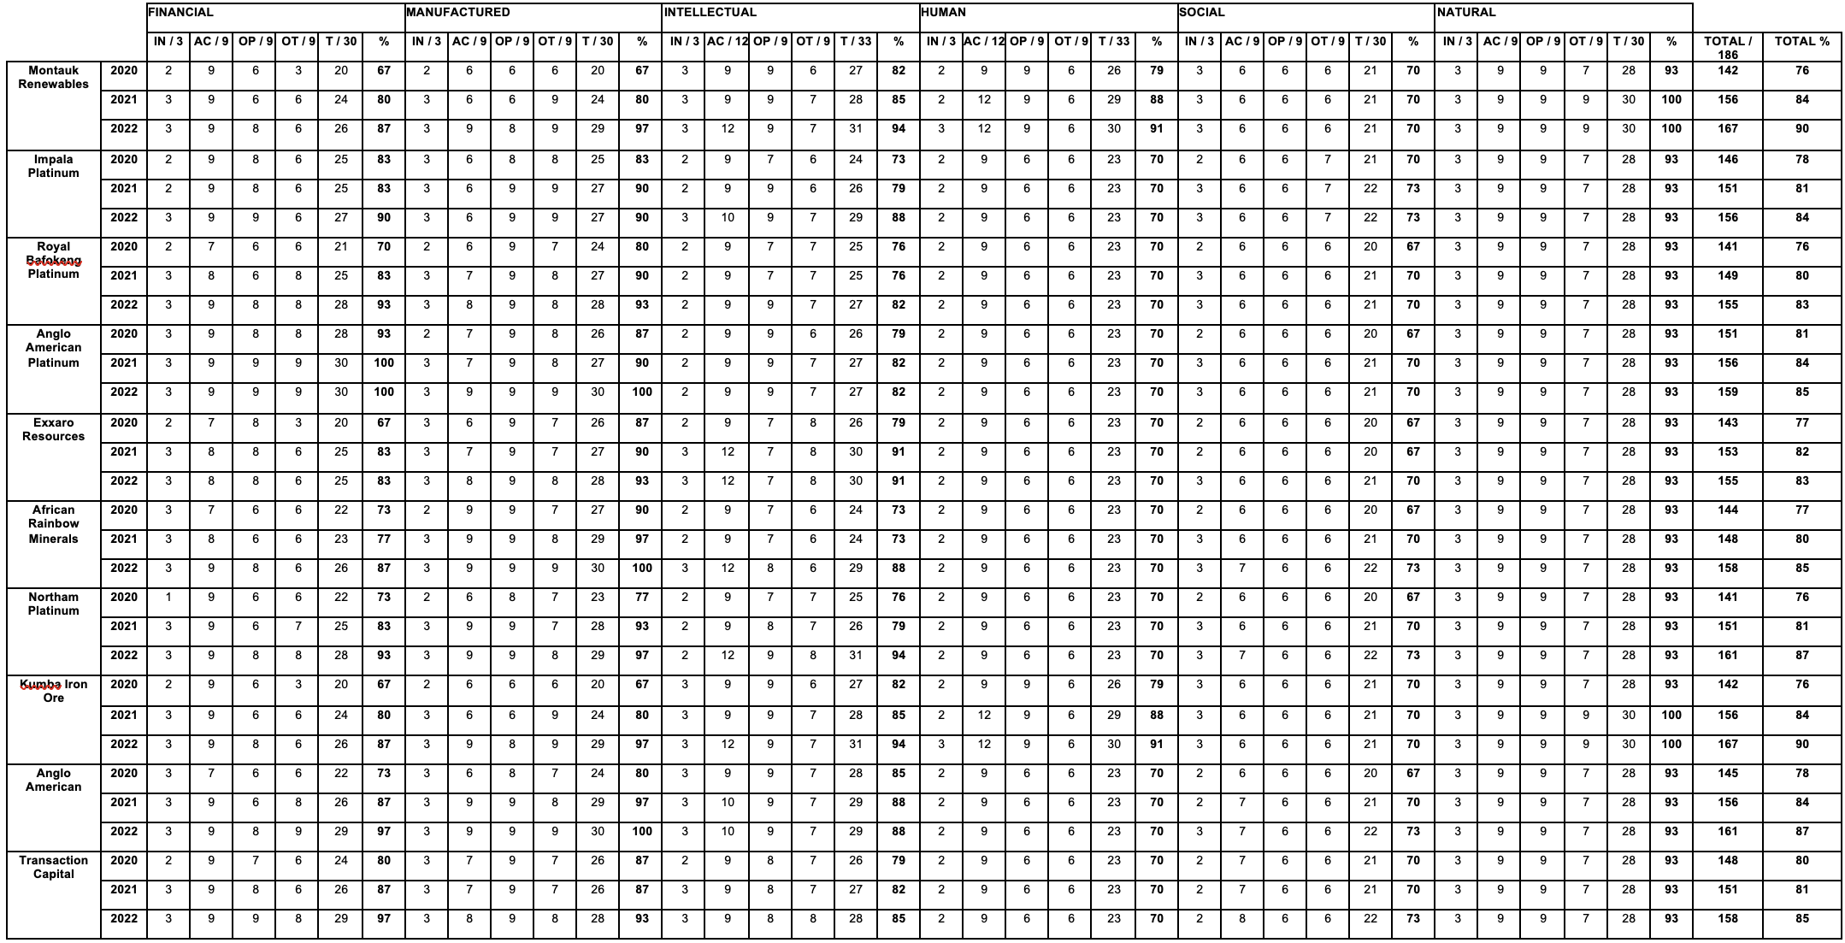

Source: Researchers compilation based on data from each organisation's Integrated Report

** Please be advised that an abbreviation key is provided at the beginning of the study for enhanced comprehension of this table.

Table 3.5.: Business Models of Top 100 Organisations and their ratings per component (11 - 20)

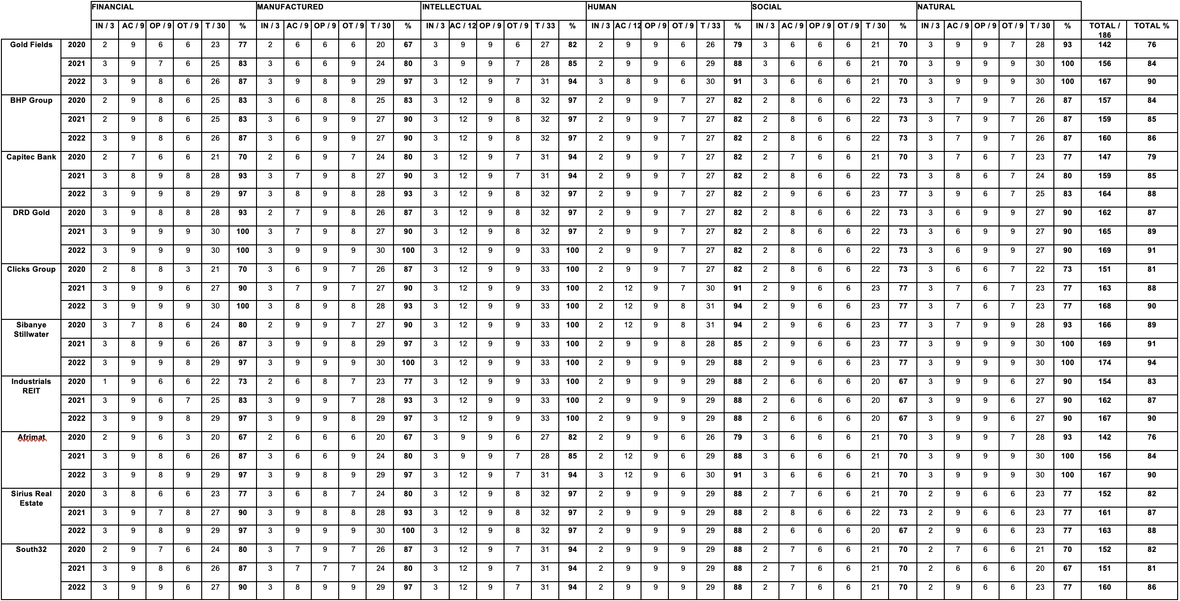

Source: Researchers compilation based on data from each organisation's Integrated Report

** Please be advised that an abbreviation key is provided at the beginning of the study for enhanced comprehension of this table.

Table 3.6.: Business Models of Top 100 Organisations and their ratings per component (21 - 30)

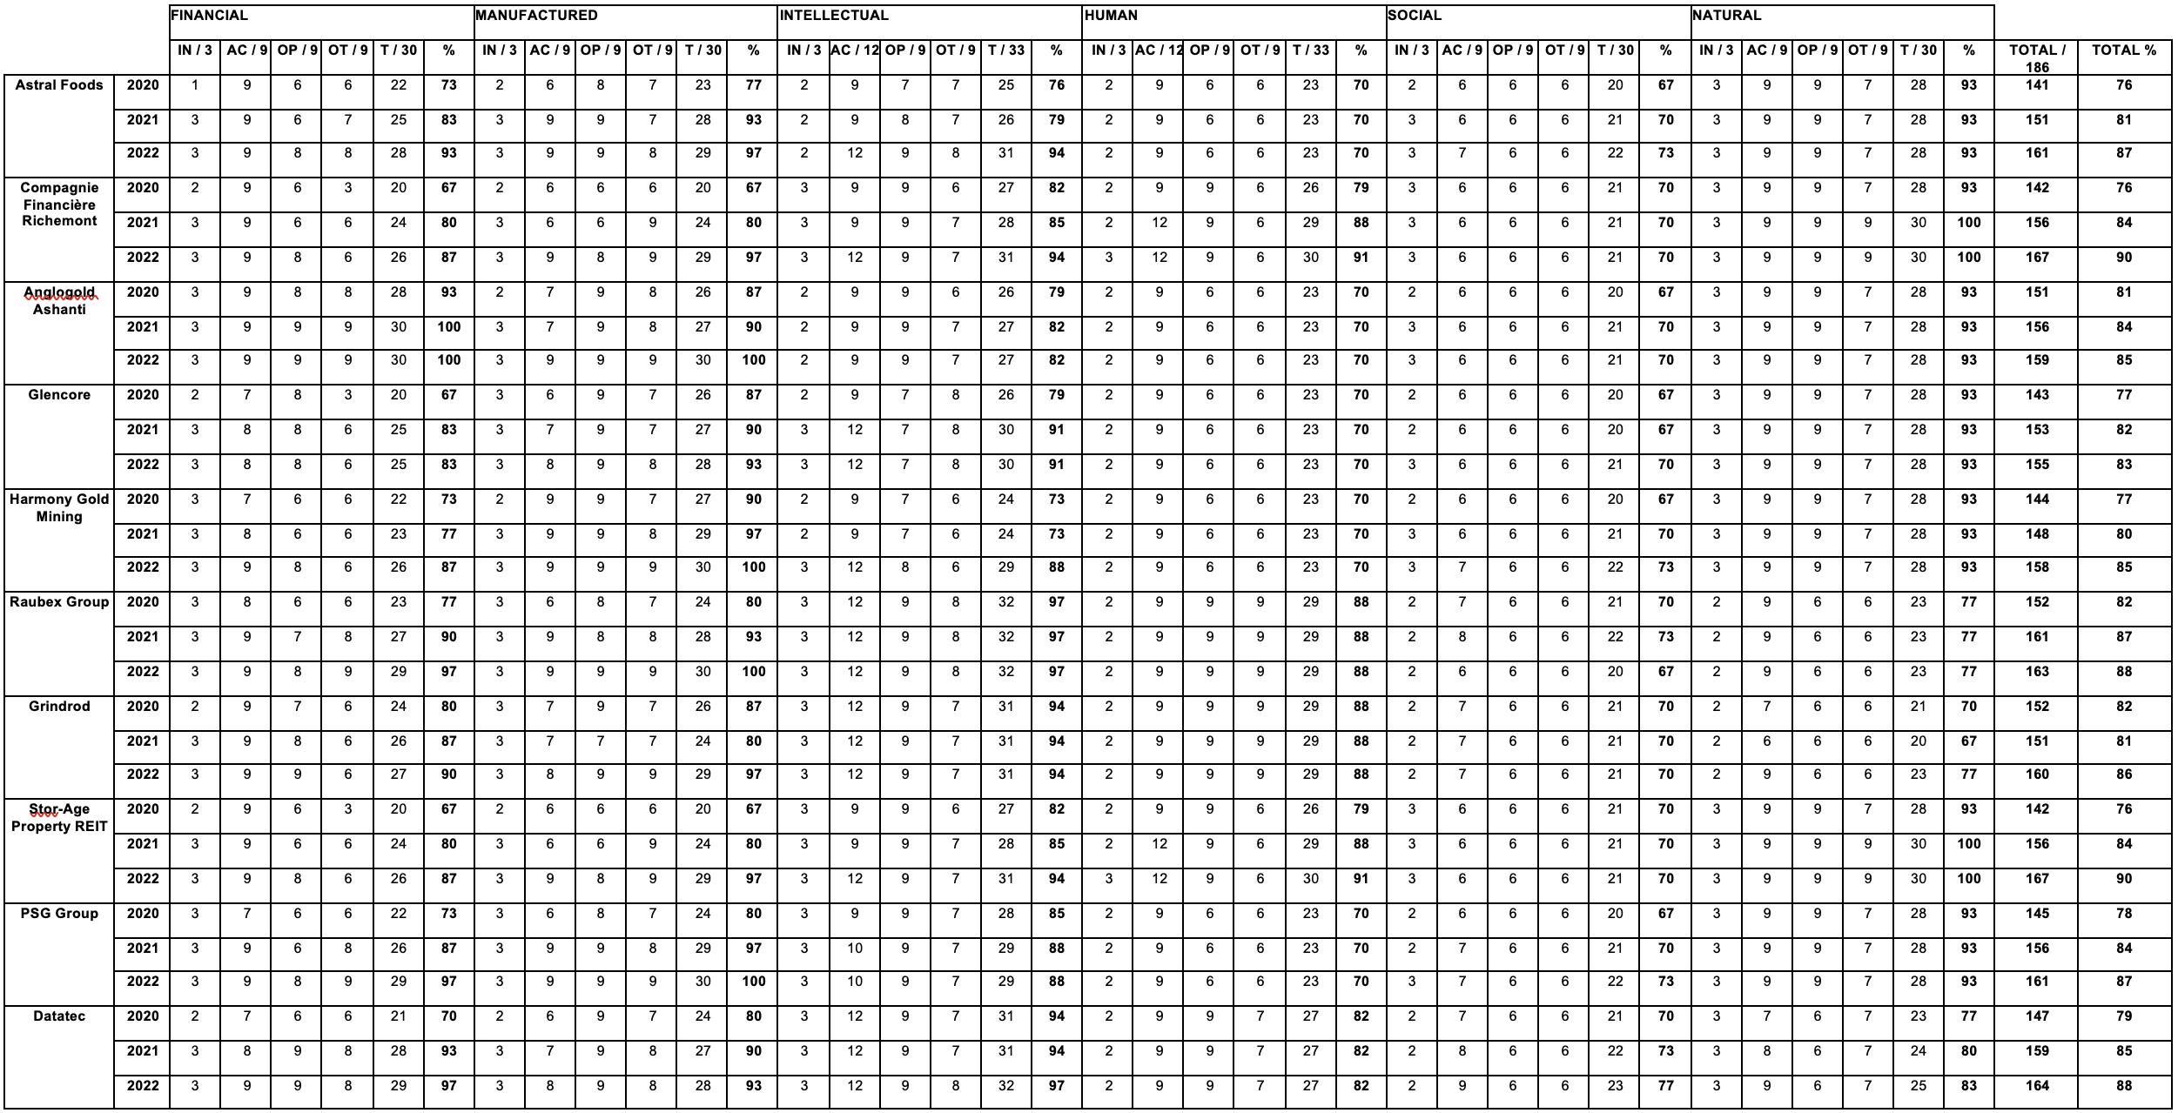

Source: Researchers compilation based on data from each organisation's Integrated Report

** Please be advised that an abbreviation key is provided at the beginning of the study for enhanced comprehension of this table.

Table 3.7.: Business Models of Top 100 Organisations and their ratings per component (31 - 40)

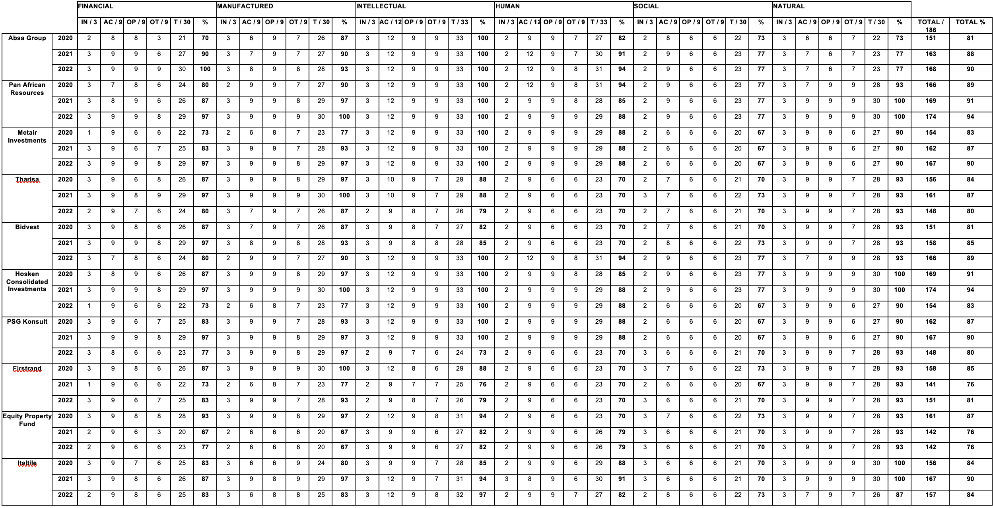

Source: Researchers compilation based on data from each organisation's Integrated Report

** Please be advised that an abbreviation key is provided at the beginning of the study for enhanced comprehension of this table.

Table 3.8.: Business Models of Top 100 Organisations and their ratings per component (41 - 50)

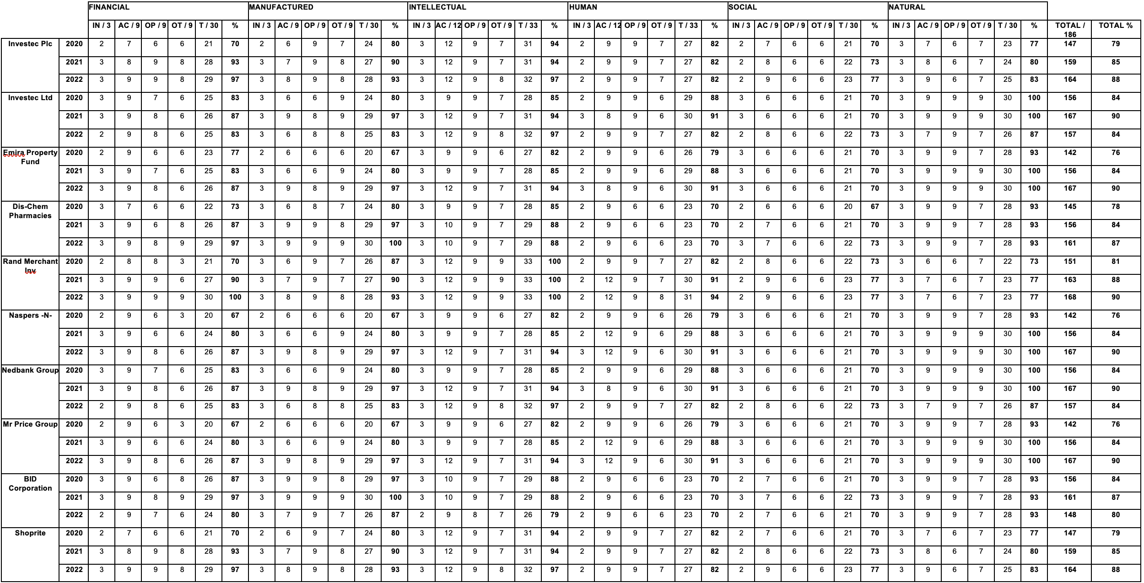

Source: Researchers compilation based on data from each organisation's Integrated Report

** Please be advised that an abbreviation key is provided at the beginning of the study for enhanced comprehension of this table.

Table 3.9.: Business Models of Top 100 Organisations and their ratings per component (51 – 60)

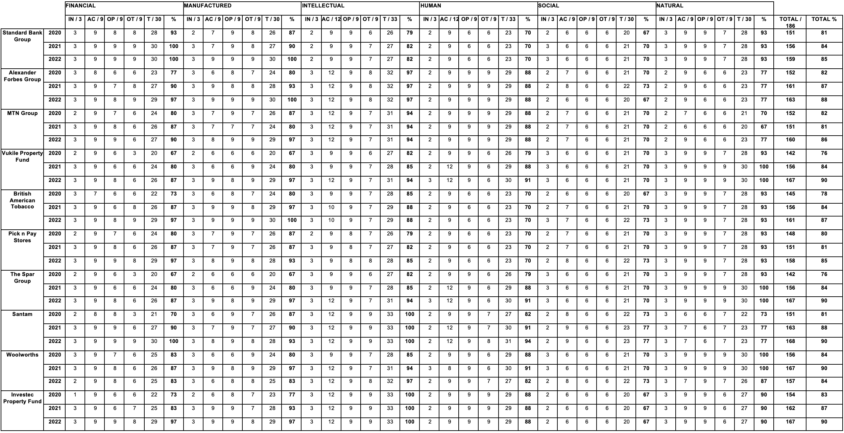

Source: Researchers compilation based on data from each organisation's Integrated Report

** Please be advised that an abbreviation key is provided at the beginning of the study for enhanced comprehension of this table.

Table 3.10.: Business Models of Top 100 Organisations and their ratings per component (61 – 70)

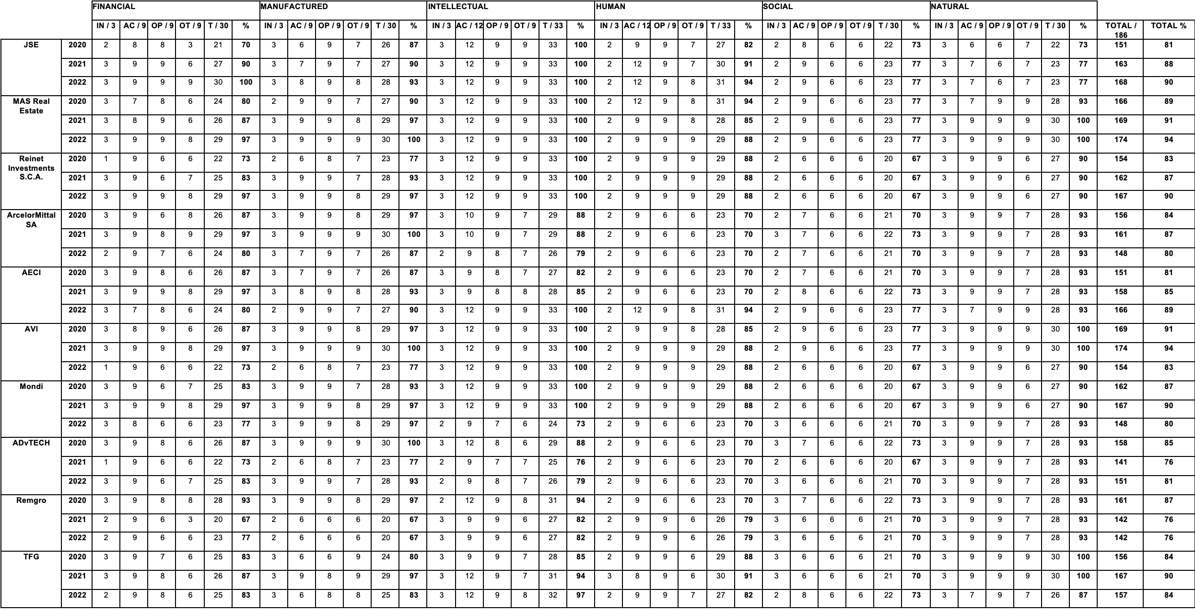

Source: Researchers compilation based on data from each organisation's Integrated Report

** Please be advised that an abbreviation key is provided at the beginning of the study for enhanced comprehension of this table.

Table 3.11.: Business Models of Top 100 Organisations and their ratings per component (71 – 80)

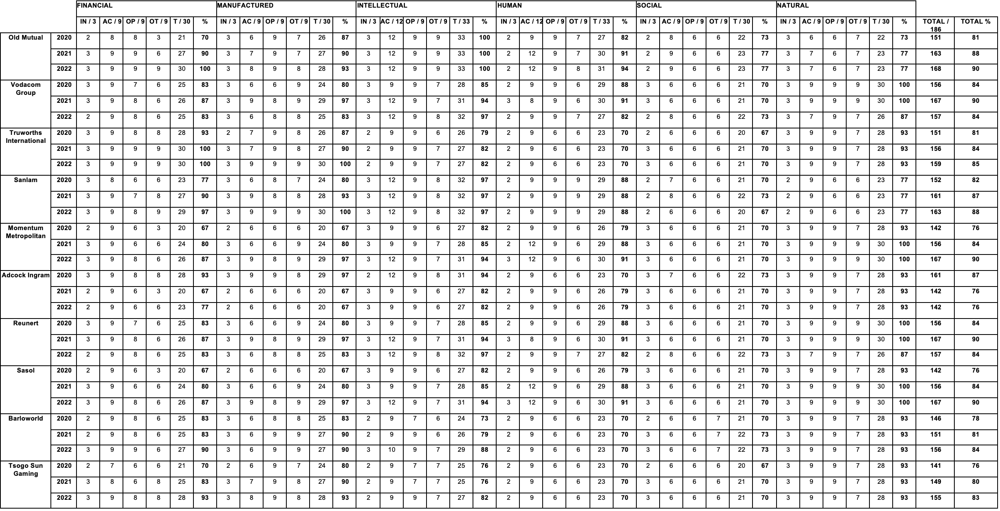

Source: Researchers compilation based on data from each organisation's Integrated Report

** Please be advised that an abbreviation key is provided at the beginning of the study for enhanced comprehension of this table.

Table 3.12.: Business Models of Top 100 Organisations and their ratings per component (81 – 90)

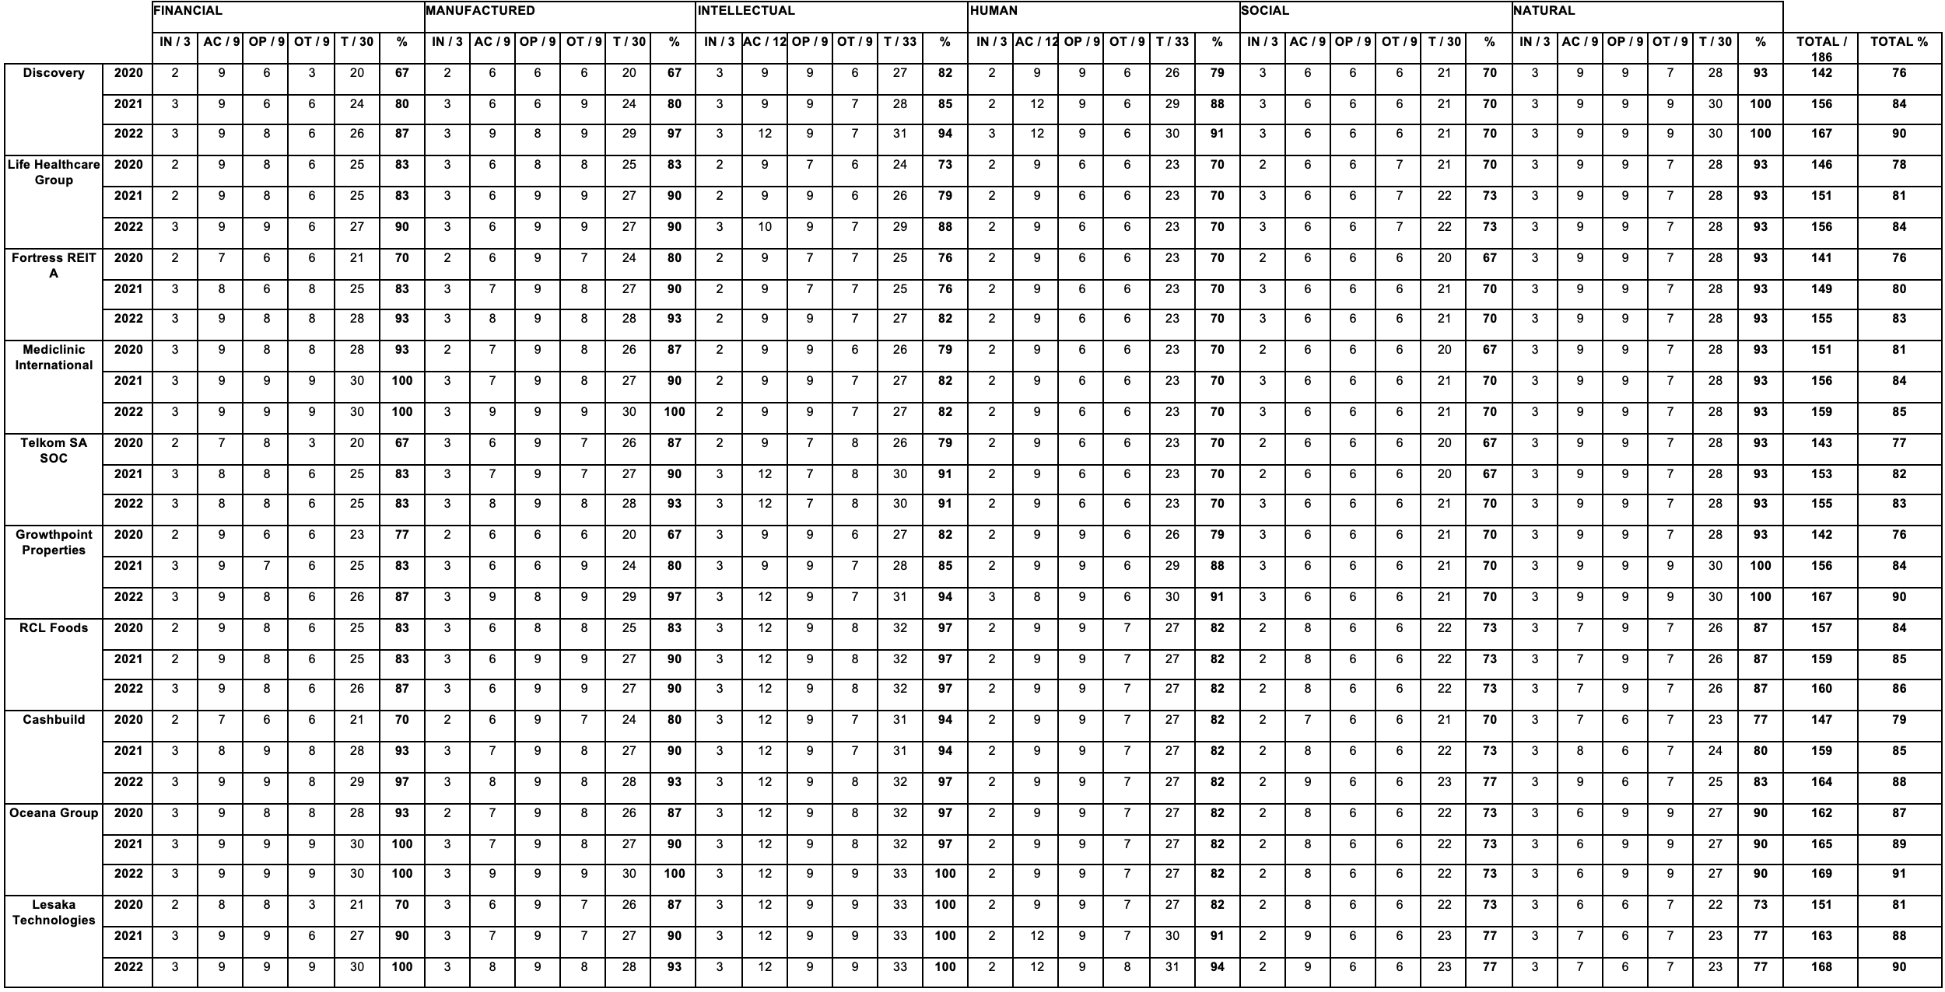

Source: Researchers compilation based on data from each organisation's Integrated Report

** Please be advised that an abbreviation key is provided at the beginning of the study for enhanced comprehension of this table.

Table 3.13.: Business Models of Top 100 Organisations and their ratings per component (91 – 100)

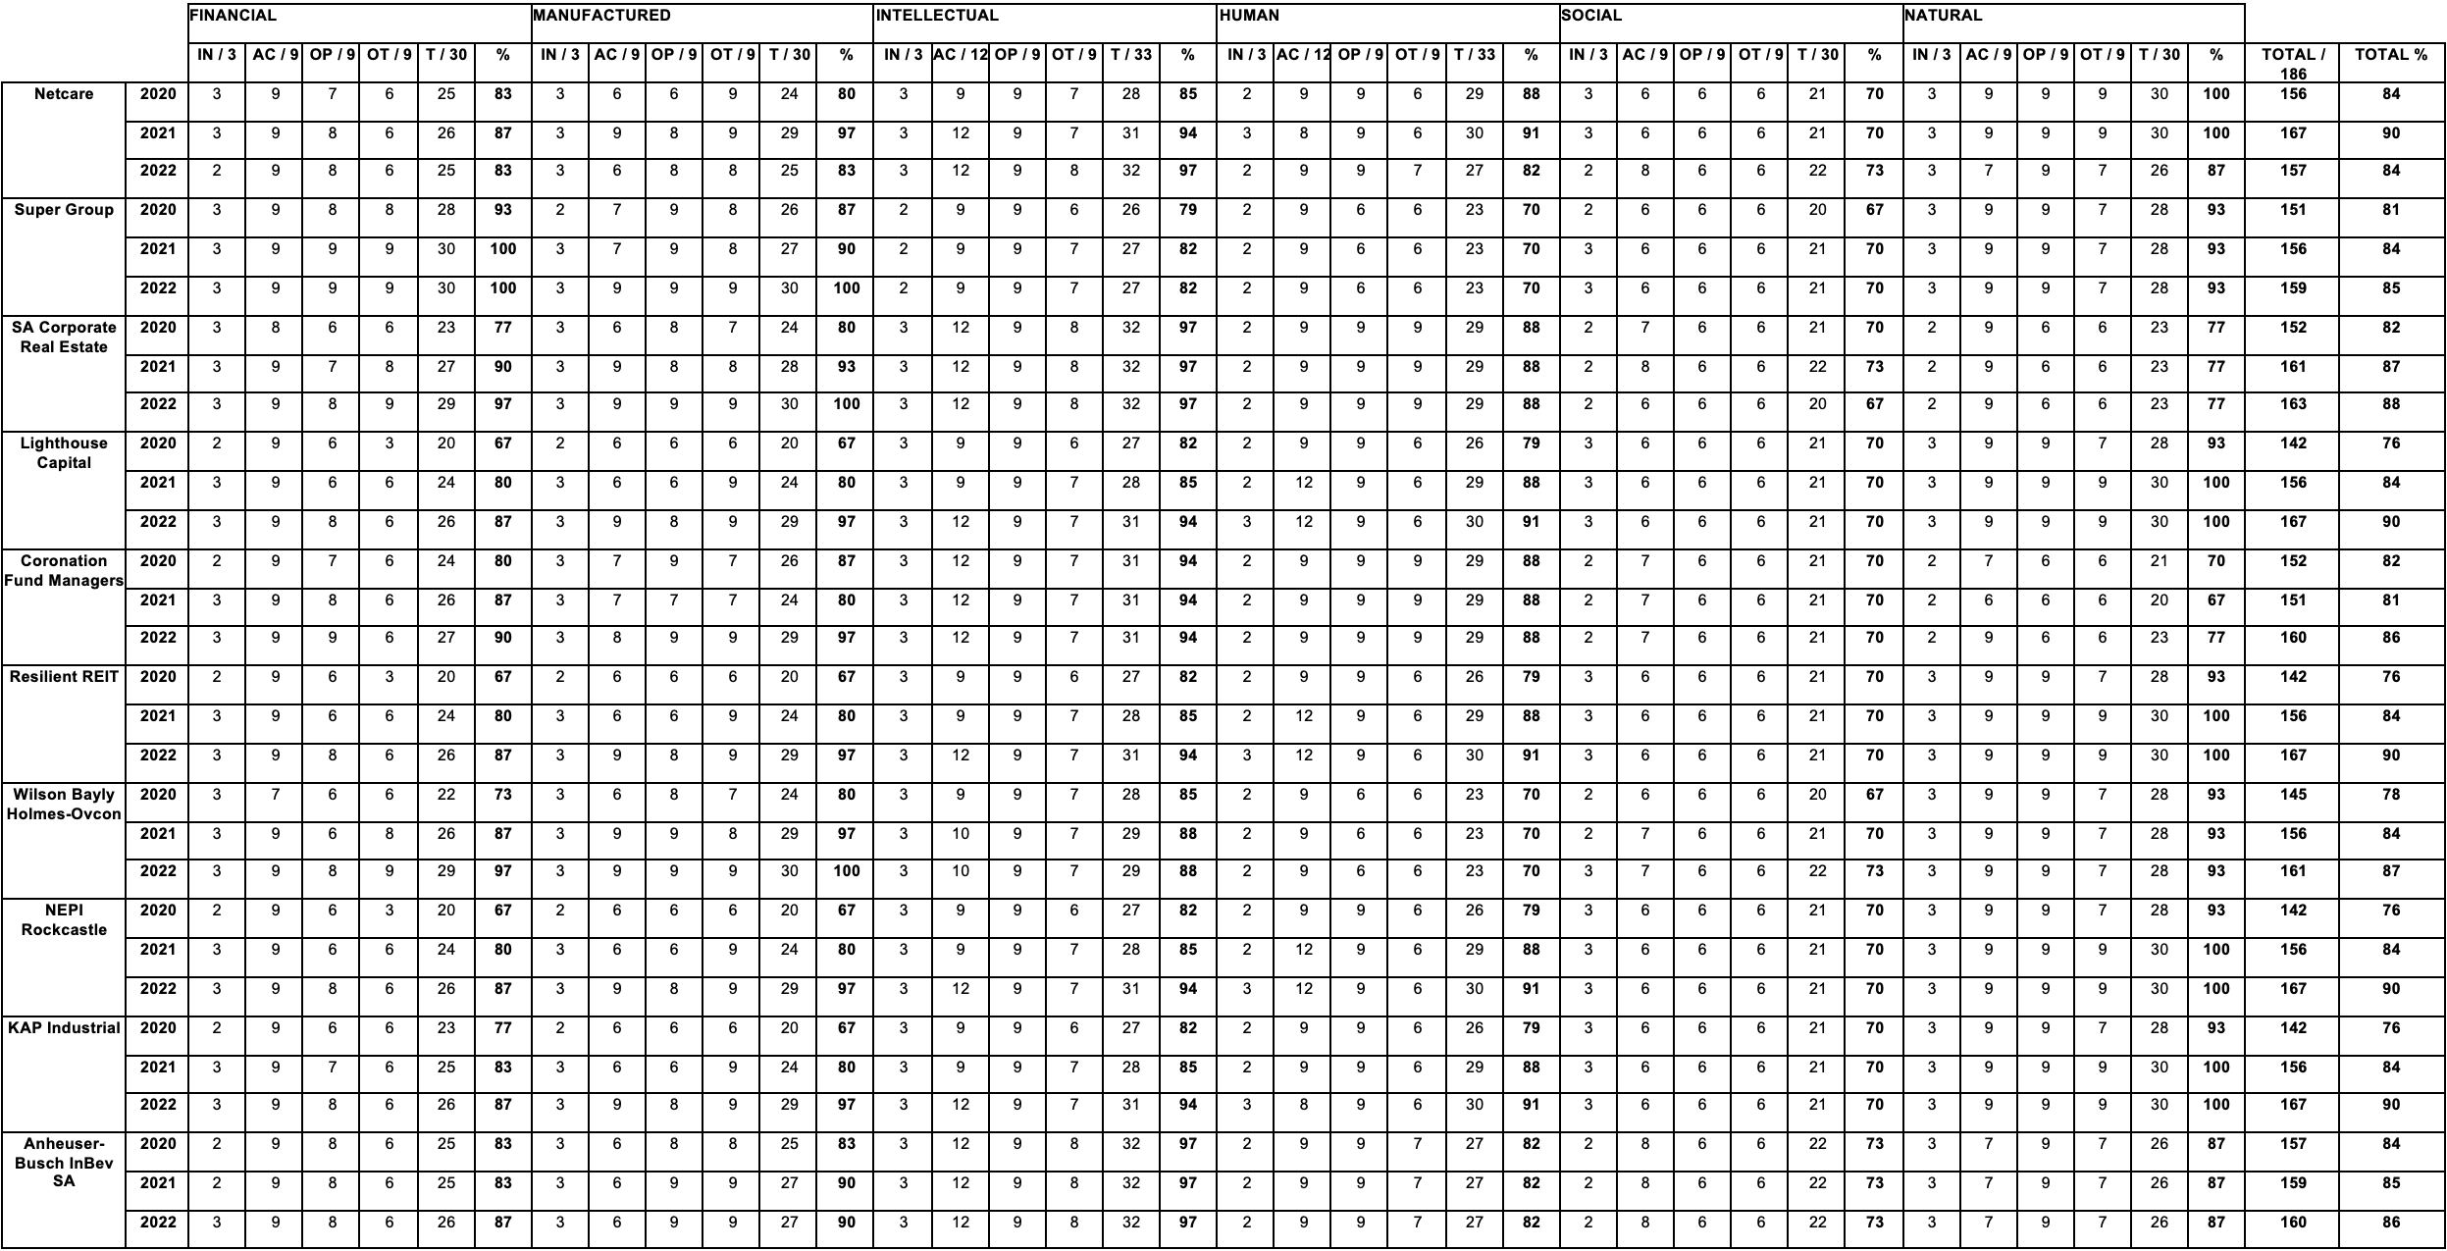

Source: Researchers compilation based on data from each organisation's Integrated Report

** Please be advised that an abbreviation key is provided at the beginning of the study for enhanced comprehension of this table.

Table 3.14.: Business Models of JSE Listed Top 100 Organisations and their Classifications (2020)
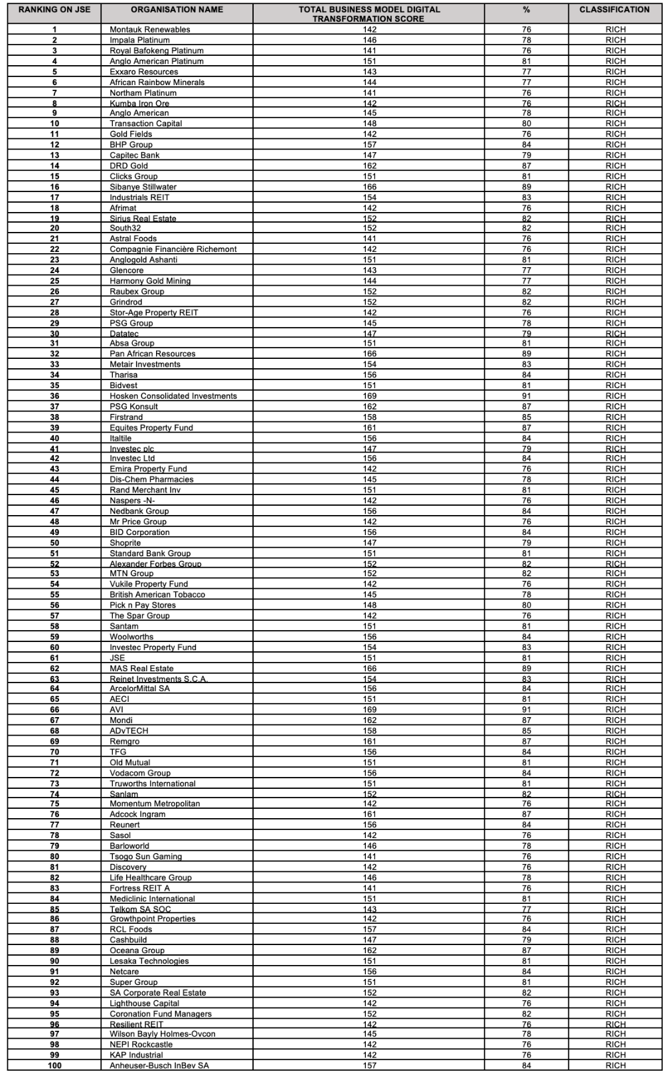
Source: Researchers interpretation

Table 3.15.: Business Models of JSE Listed Top 100 Organisations and their Classifications (2021)

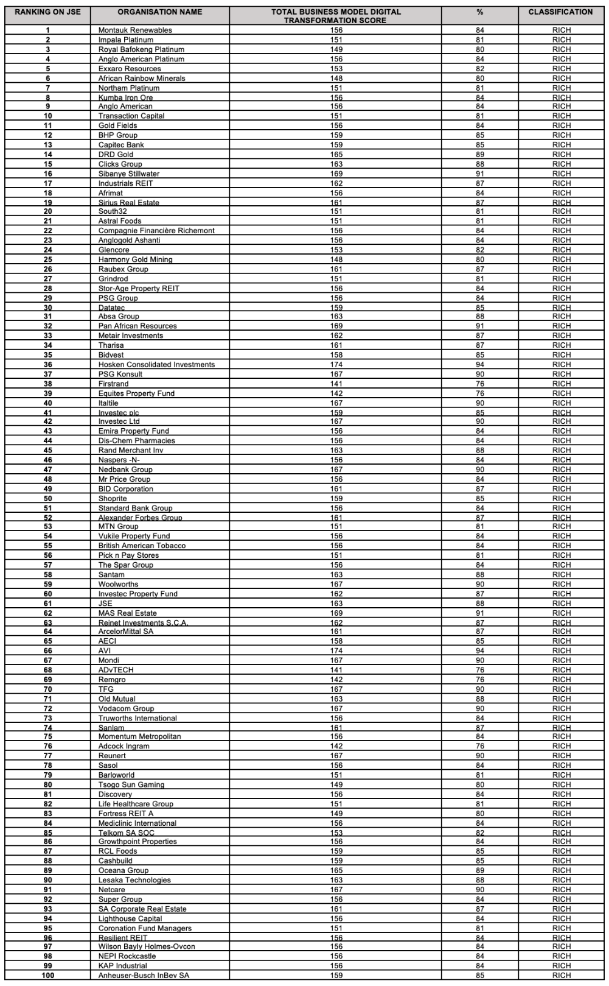
Source: Researchers interpretation

Table 3.16.: Business Models of JSE Listed Top 100 Organisations and their Classifications (2022)

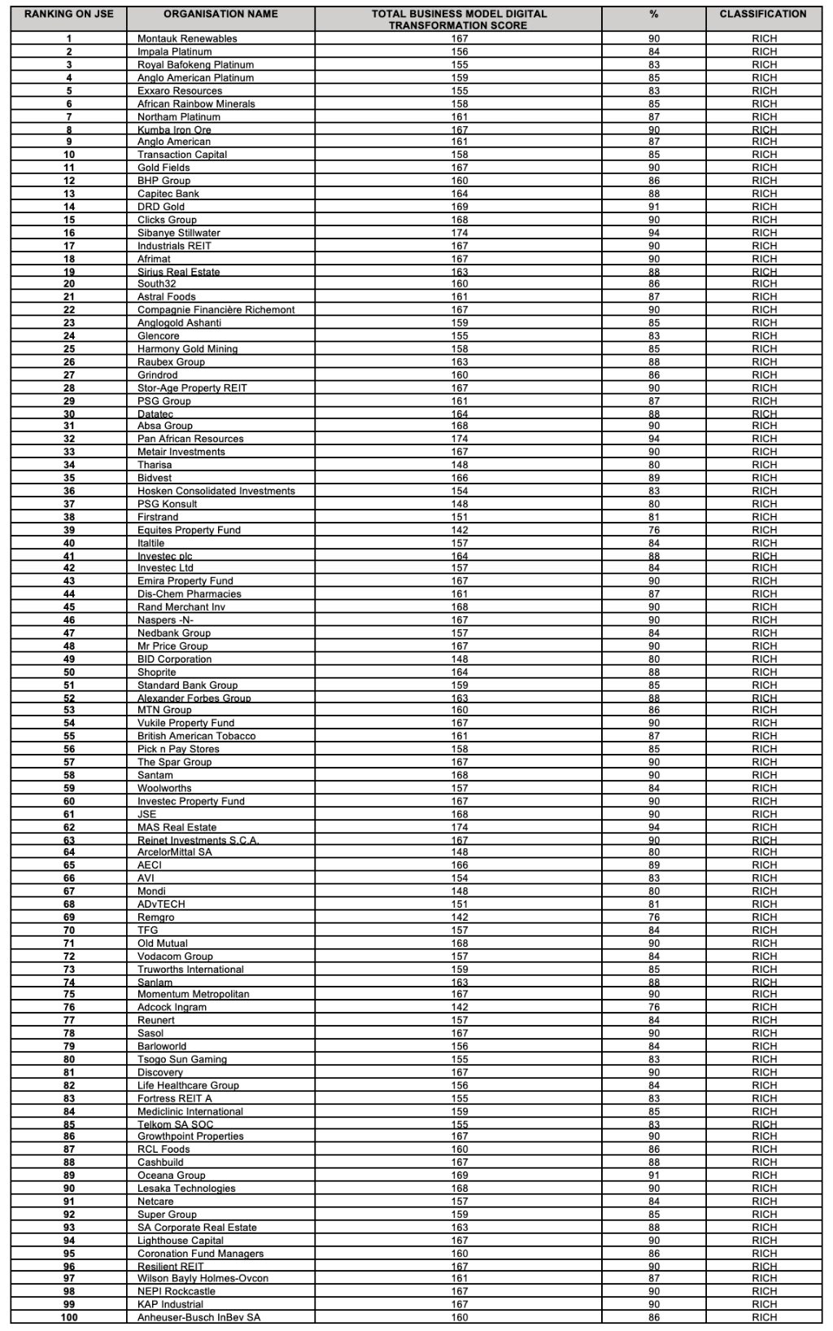
Source: Researchers interpretation

Table 3.17.: Application of CAMELS Rating System to JSE Listed Top 100 Organisations (2020)
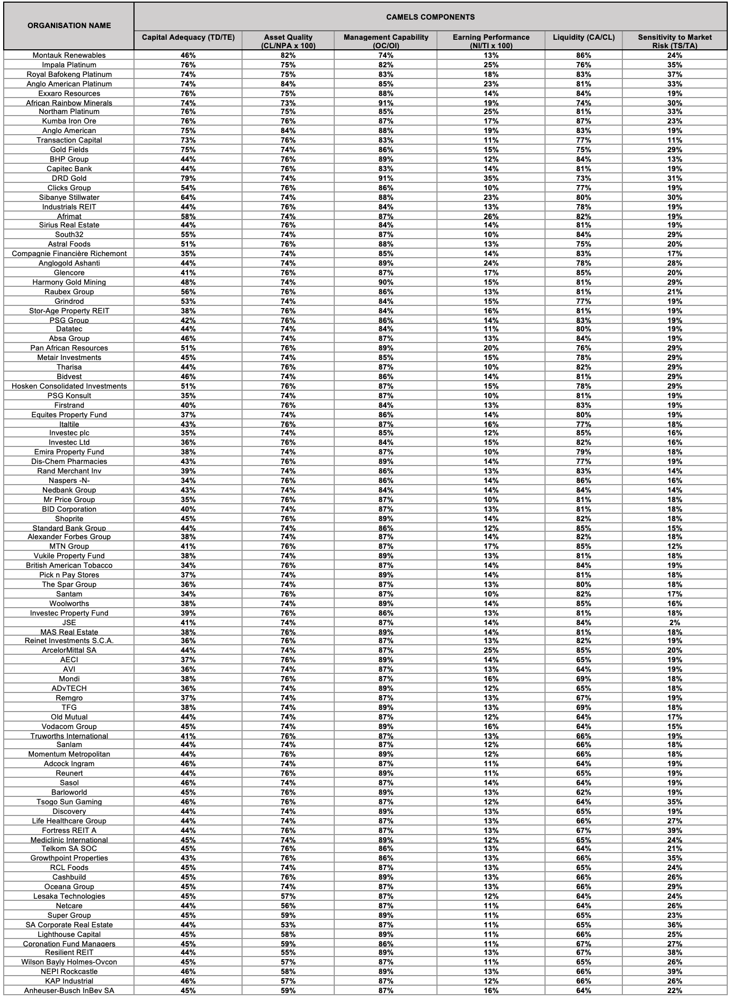
Source: Researchers compilation based on data from each organisation's Integrated Report

Table 3.18.: Application of CAMELS Rating System to JSE Listed Top 100 Organisations (2021)
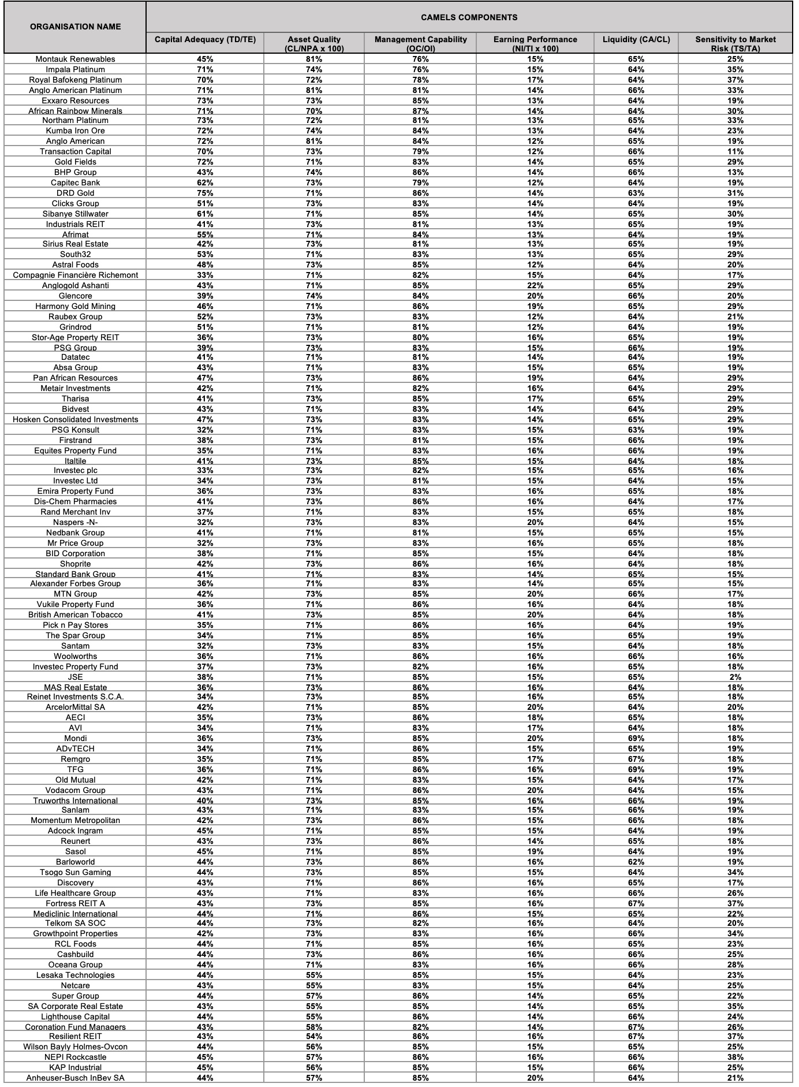
Source: Researchers compilation based on data from each organisation's Integrated Report

Table 3.19.: Application of CAMELS Rating System to JSE Listed Top 100 Organisations (2022)
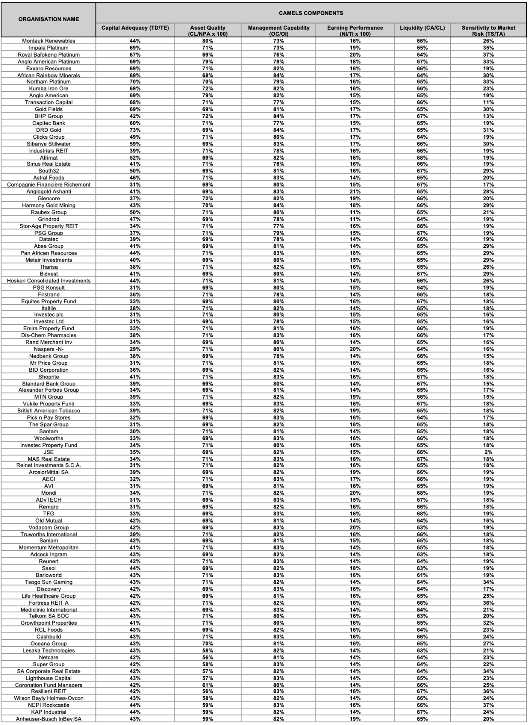
Source: Researchers compilation based on data from each organisation's Integrated Report

Table 3.20.: CAMELS Composite Ratings and Total Scores Obtained by each Organisation (2020)
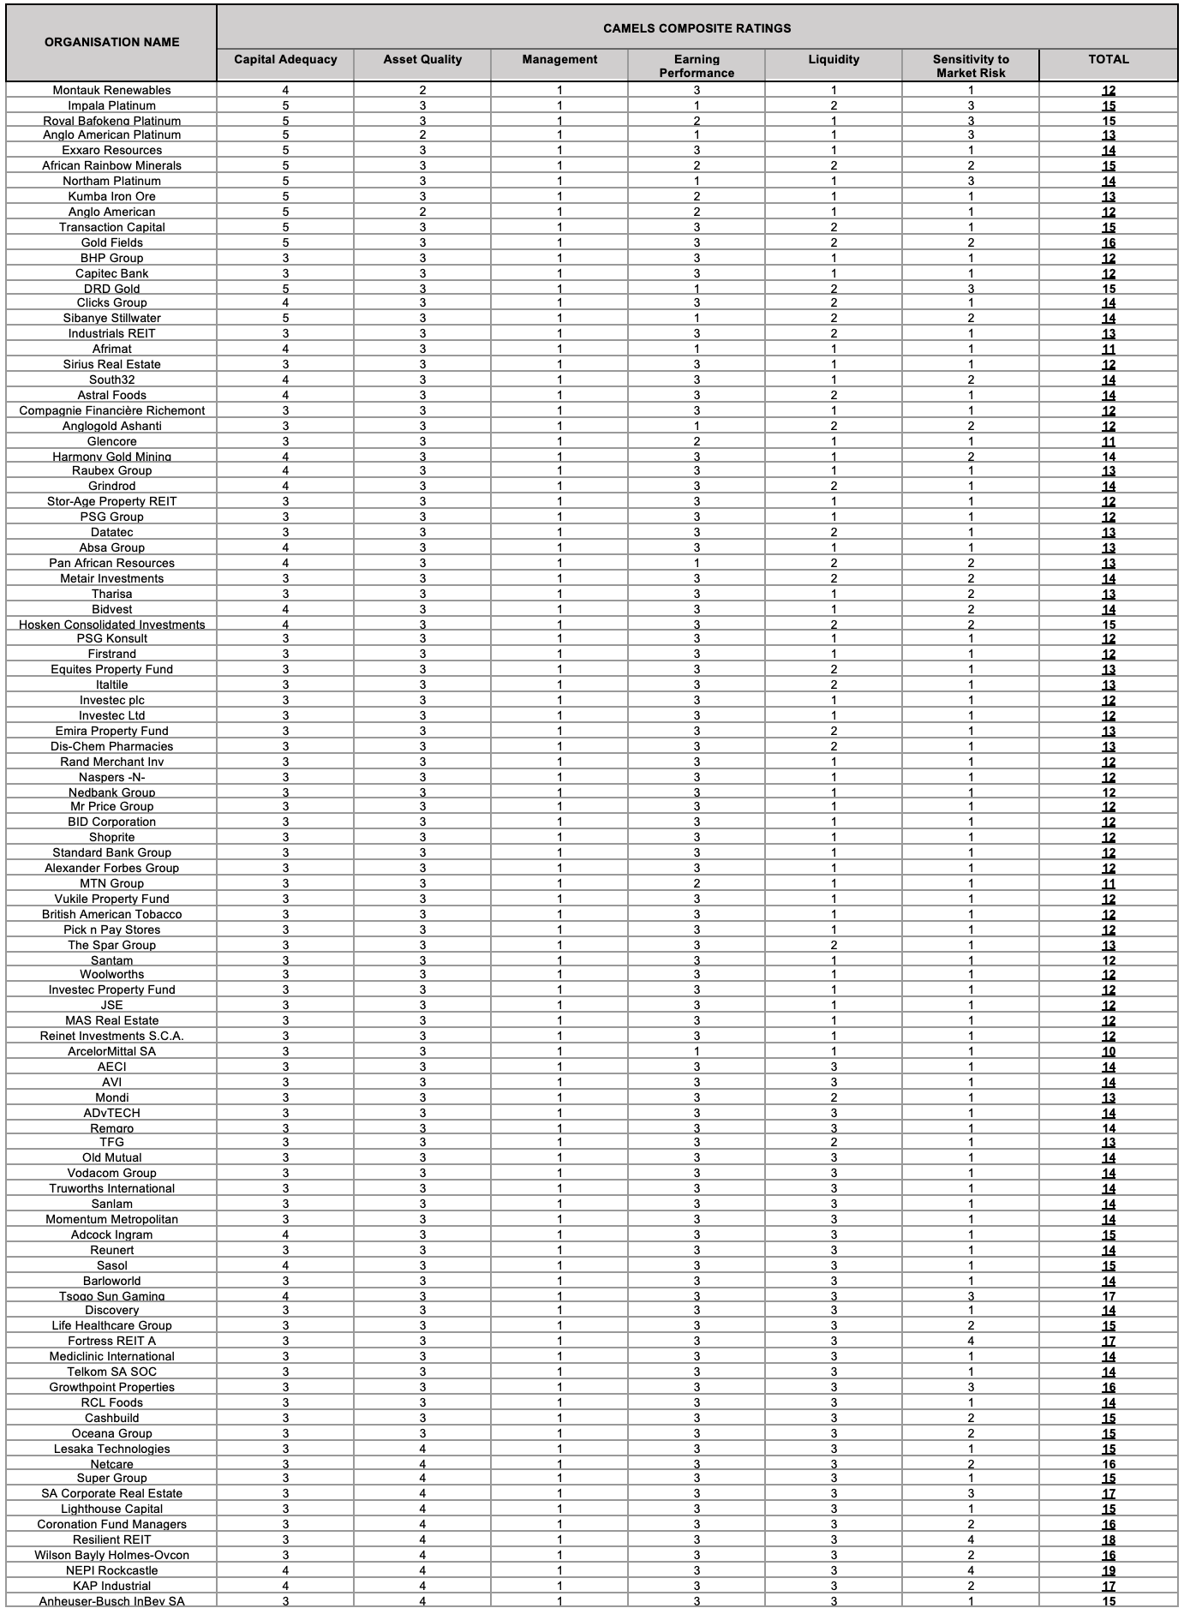
Source: Researchers construct based on the CAMELS rating system

Table 3.21.: CAMELS Composite Ratings and Total Scores Obtained by each Organisation (2021)
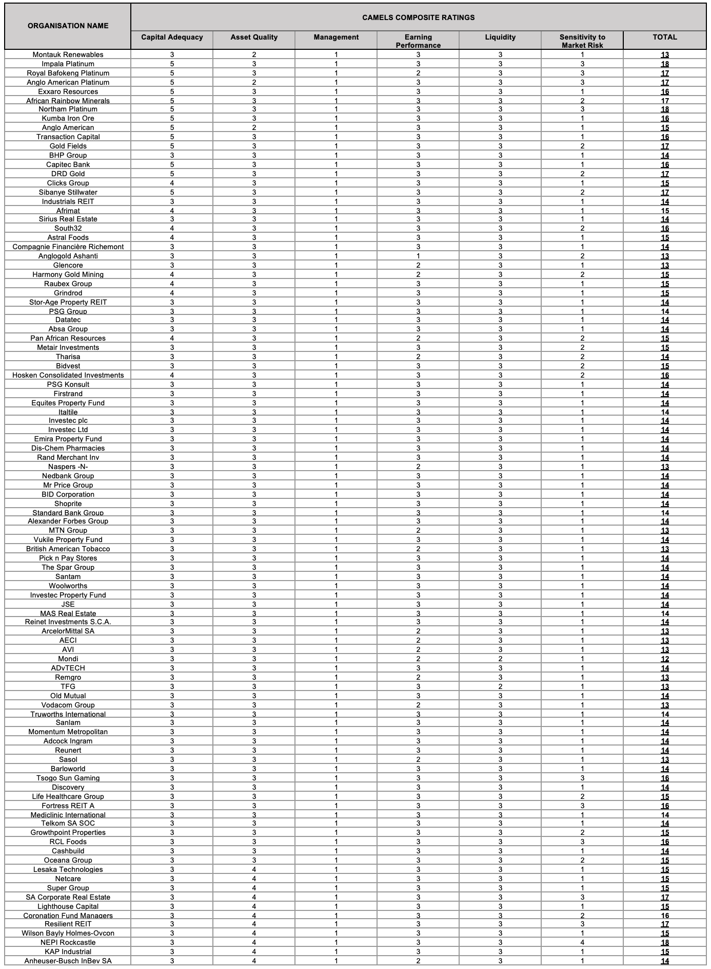
Source: Researchers construct based on the CAMELS rating system

Table 3.22.: CAMELS Composite Ratings and Total Scores Obtained by each Organisation (2022)

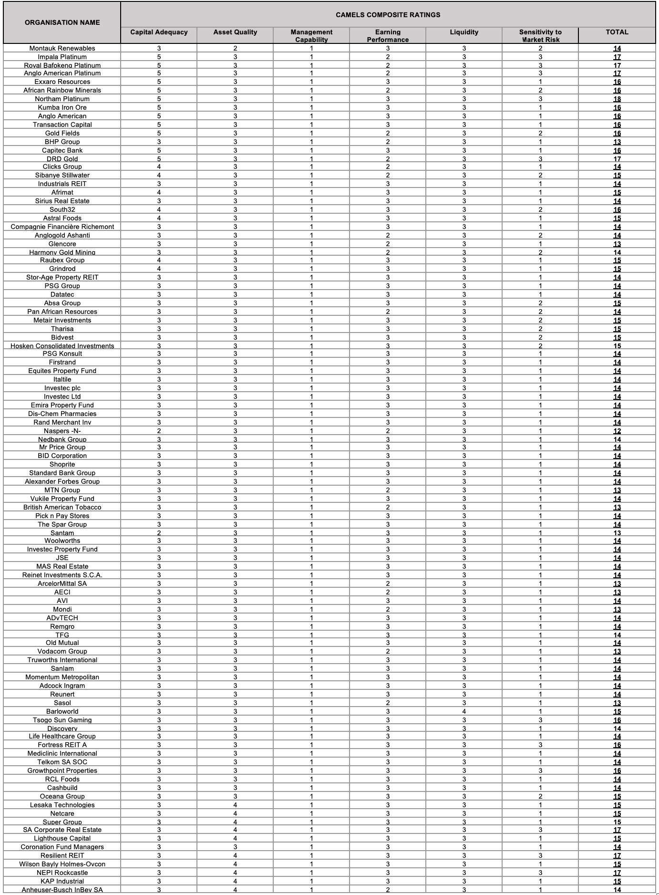
Source: Researchers construct based on the CAMELS rating system

Table 3.23.: CAMELS Composite Ratings for each Organisation (2020)
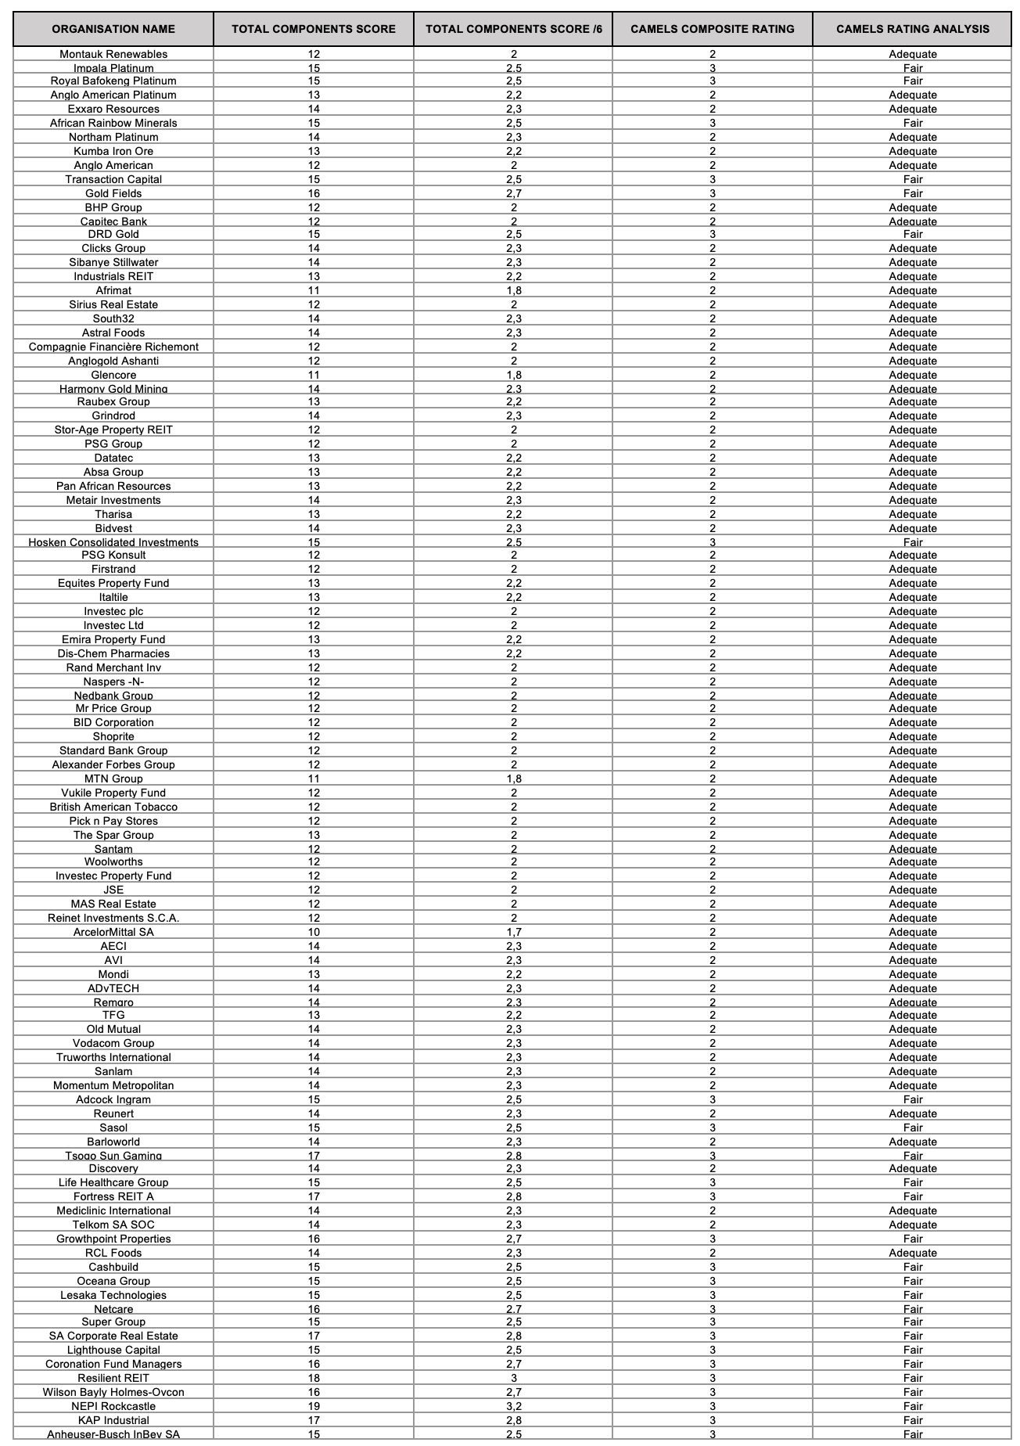
Source: Researchers interpretation

Table 3.24.: CAMELS Composite Ratings for each Organisation (2021)
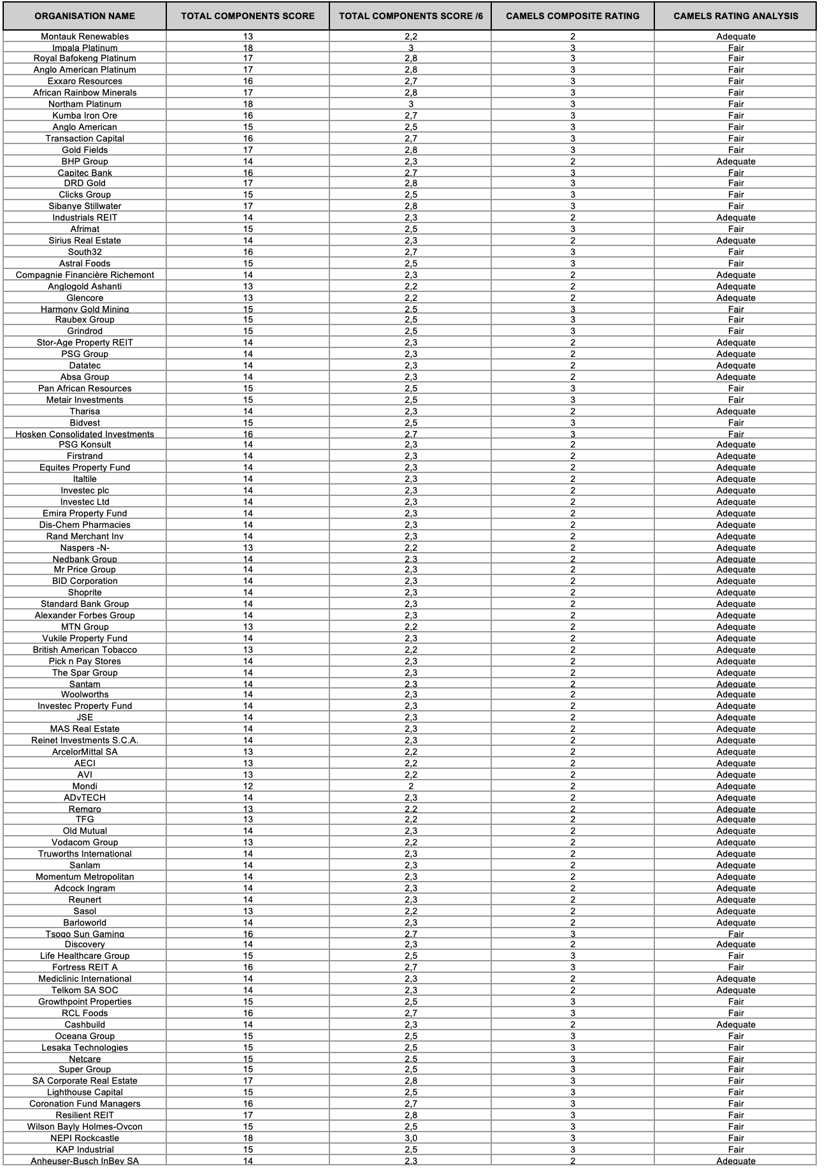
Source: Researchers interpretation

Table 3.25.: CAMELS Composite Ratings for each Organisation (2022)
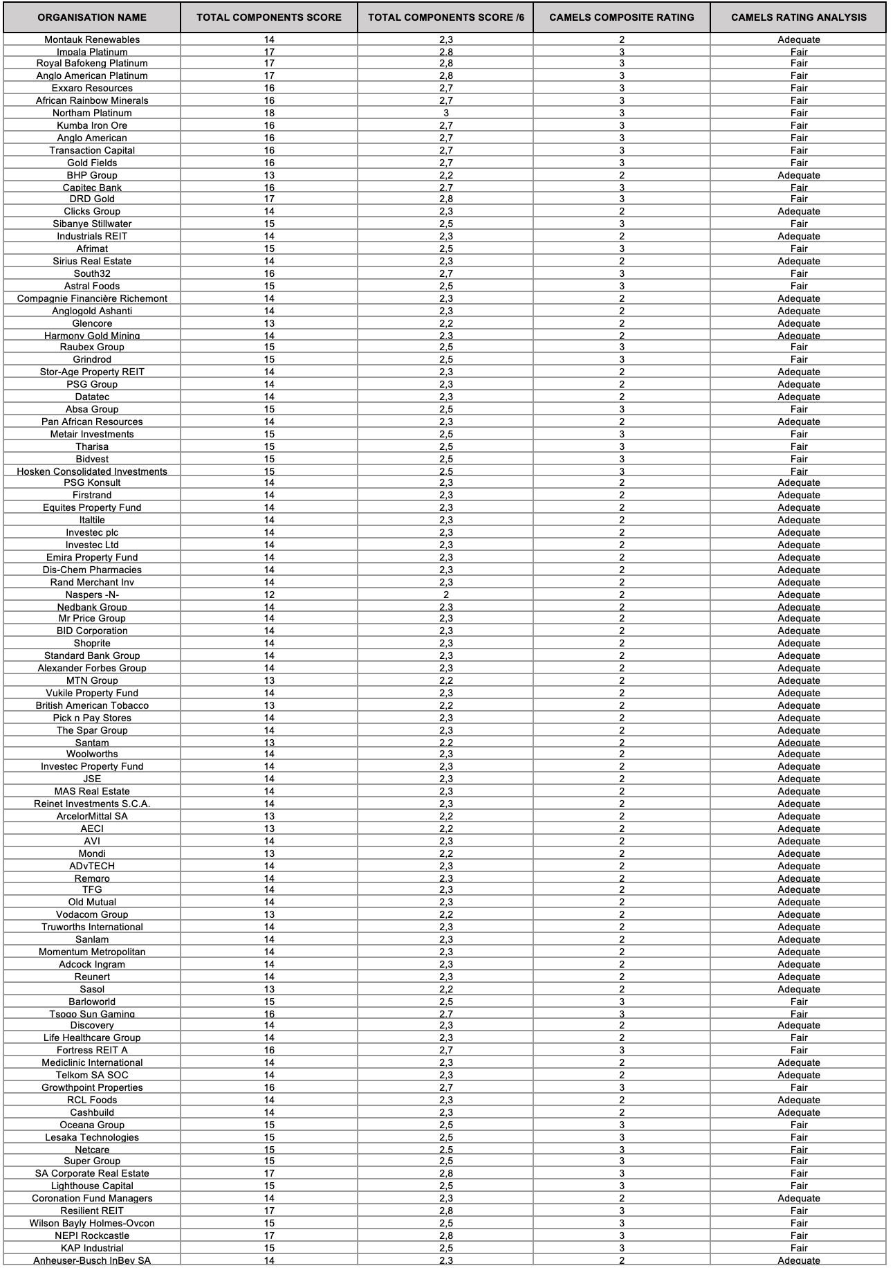
Source: Researchers interpretation

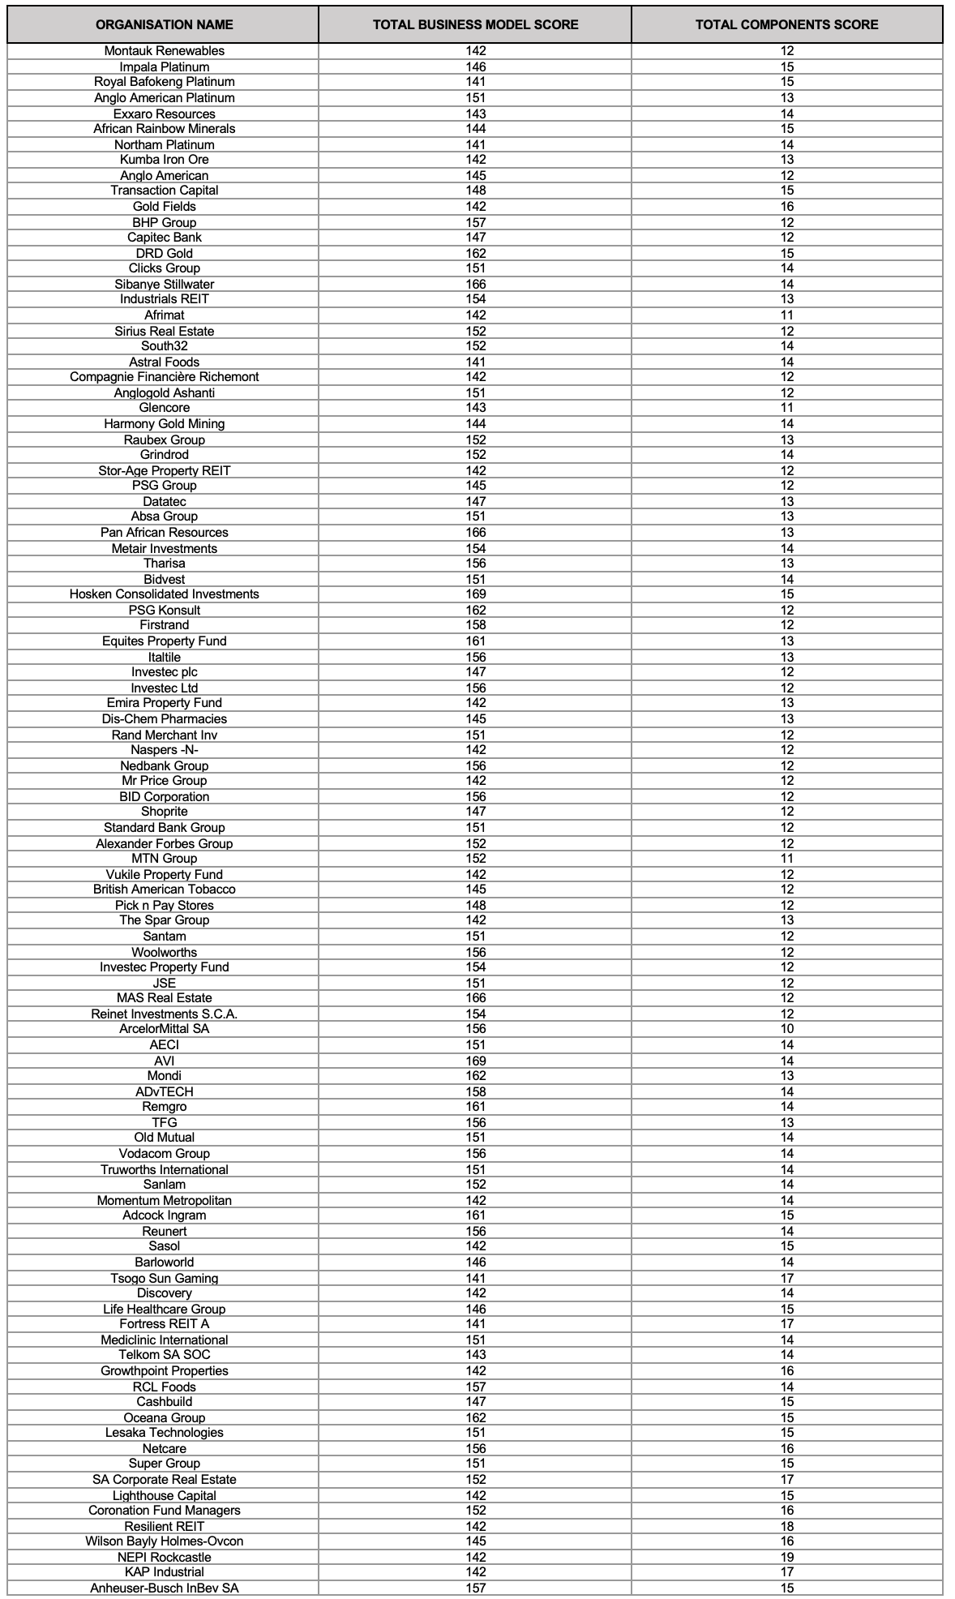
Table 3.26.: Correlation Coefficient (2020)

Results=
-0,1461853
Source: Researchers own computation using Microsoft Excel software

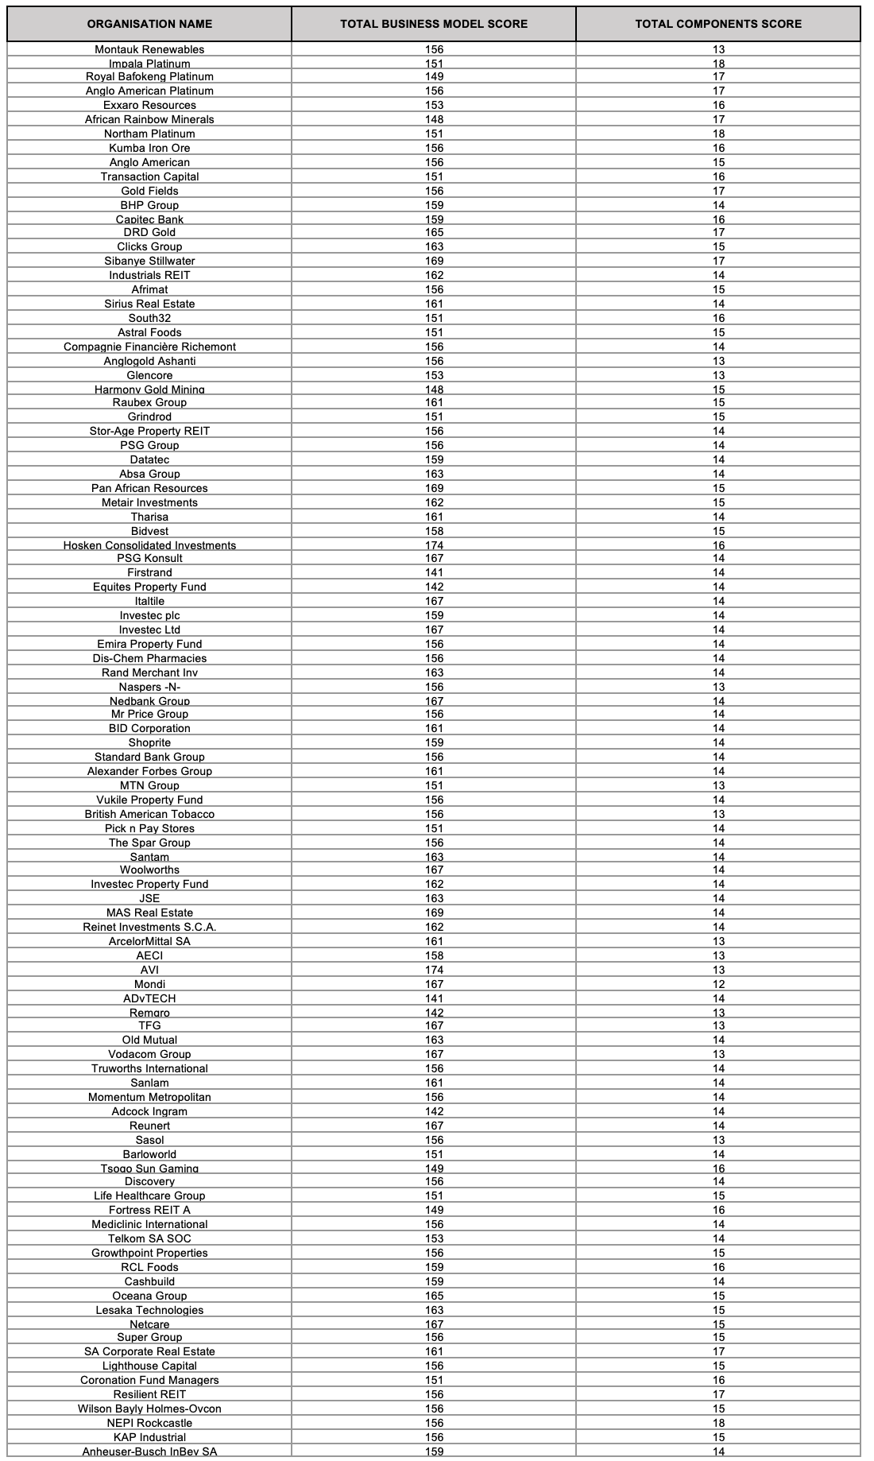
Table 3.27.: Correlation Coefficient (2021)

Results=
-0,1542847
Source: Researchers own computation using Microsoft Excel software

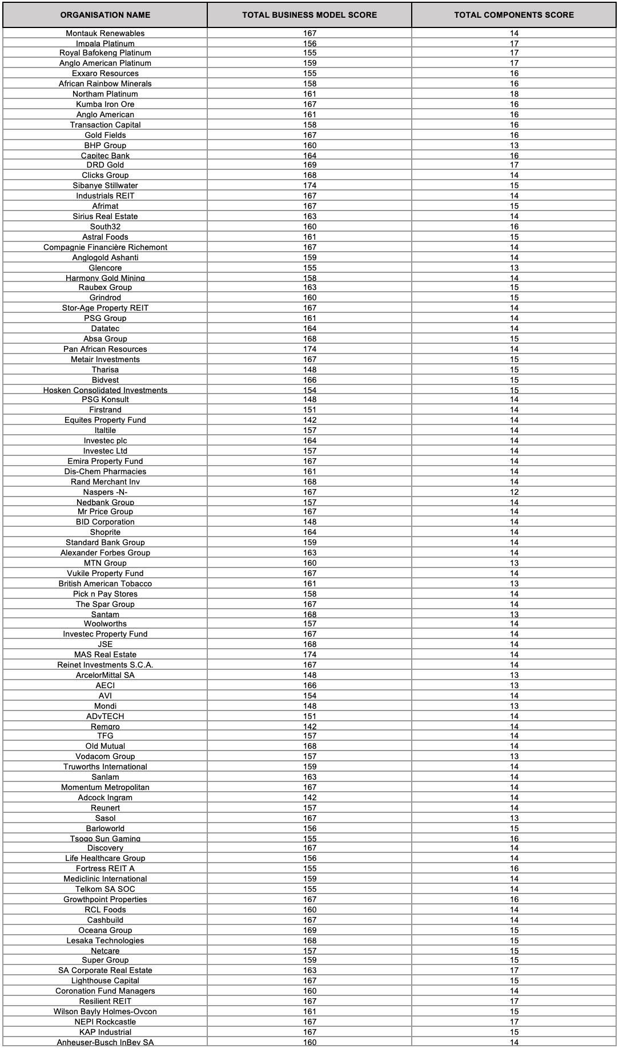
Table 3.28.: Correlation Coefficient (2022)

Results=
0.072437077
Source: Researchers own computation using Microsoft Excel software

