Supplementary Information
Supplementary Table 1 Principal components showing the eigenvalues, the proportion of variation, and principal component analysis for physiological and biochemical traits of rice in different weed control treatments under WW and DS condition
Variable | PC1 | PC2 | PC3
RWC | -0.322 | -0.348 | -0.270
MDA | 0.322 | 0.208 | -0.278
Superoxide | 0.315 | 0.296 | 0.267
Proline | 0.316 | -0.279 | -0.319
AsA | 0.313 | -0.289 | 0.563
SOD | 0.337 | -0.271 | -0.334
CAT | 0.323 | -0.225 | -0.341
POD | 0.274 | -0.488 | 0.342
PN | -0.336 | -0.246 | -0.022
Yield | -0.300 | -0.404 | 0.118
Eigenvalue | 7.2072 | 1.6064 | 0.4779
Proportion | 0.721 | 0.161 | 0.048
Cumulative | 0.721 | 0.881 | 0.929
WW: well-watered condition; DS: drought stress; RWC: relative water content; MDA: malondialdehyde content, Superoxide: superoxide ion content; Proline: proline content; AsA: ascorbic acid content; SOD: superoxide dismutase; CAT: catalase; POD: peroxidase; P_{N:} rate of photosynthesis; Yield: grain yield.

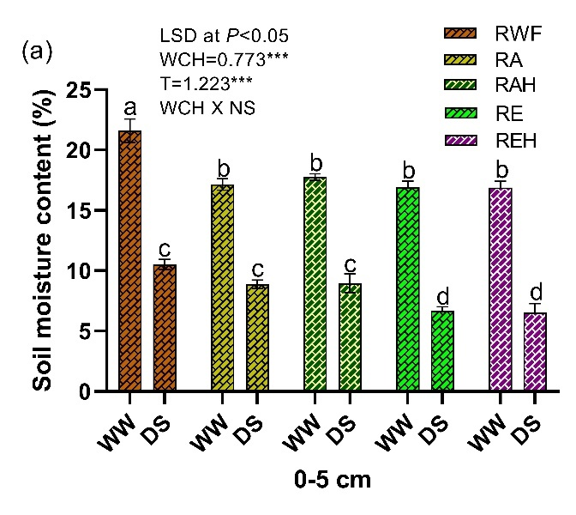 | 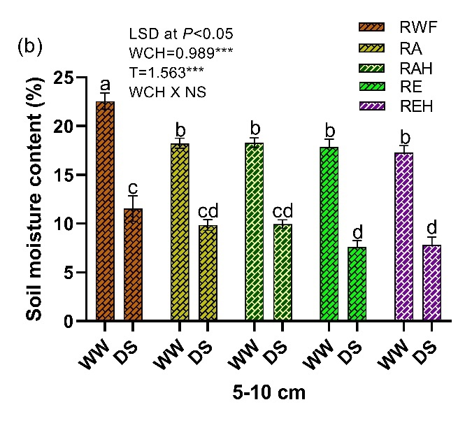
Supplementary Fig. 1. Soil moisture content variation in earthen pots with rice, A. paronychioides and E. colona under well-watered (WW) and drought stress (DS) conditions at different soil depths from top 0-5 cm (a) and below 5-10 cm (b). RWF: weed free rice; RA: rice+ A. paronychioides; RAH: rice+ A. paronychioides + herbicide; RE: rice+ E. colona; REH: rice+ E. colona+ herbicide. The data provided above represent the Mean ± SE (n = 5). Distinct lower letters in a column indicates a significant difference at P = 0.05. The significance levels of the least significant difference (LSD) are denoted by *, **, and *** for P < 0.05, 0.01, and 0.001, respectively, while "ns" indicates non-significance. WCH: refers to combinations of weeds, crop, and herbicide; T: denotes treatment; and WCH X T: represents the interaction between combinations of weeds, crop, herbicide, and treatment.

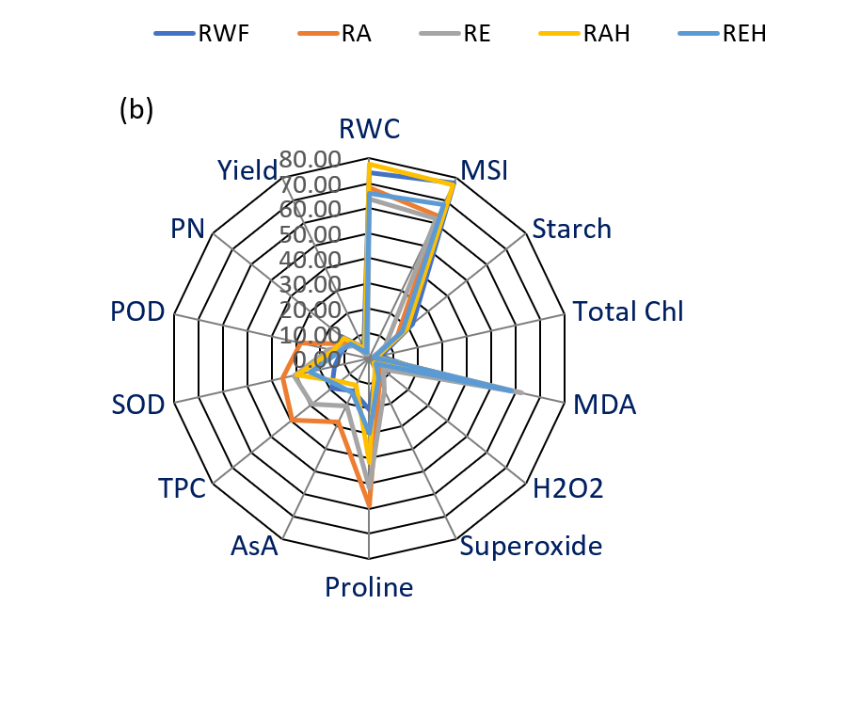
Supplementary Fig. 2. A web diagram displaying an assessment of multiple physiological and biochemical traits of rice in response to weed control treatments under both well-watered (a) and drought stress (b) conditions. RWC: relative water content; MSI: membrane stability index; Starch: starch content; Total chl: total chlorophyll content; MDA: malondialdehyde content; H₂O₂: H₂O₂ content; Superoxide: superoxide ion content; Proline: proline content; AsA: ascorbic acid content; TPC: total phenolic content; SOD: superoxide dismutase; POD: peroxidase; P_{N}: rate of photosynthesis; Yield: grain yield.

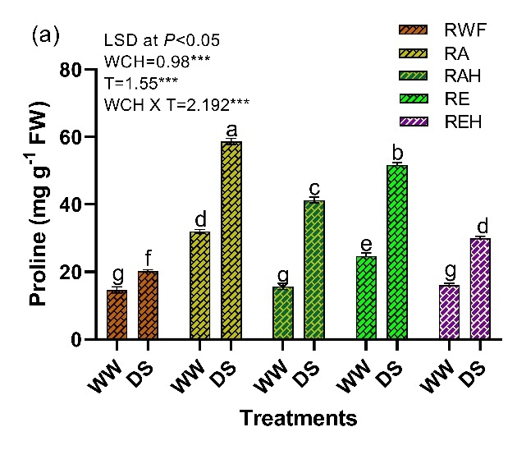 | 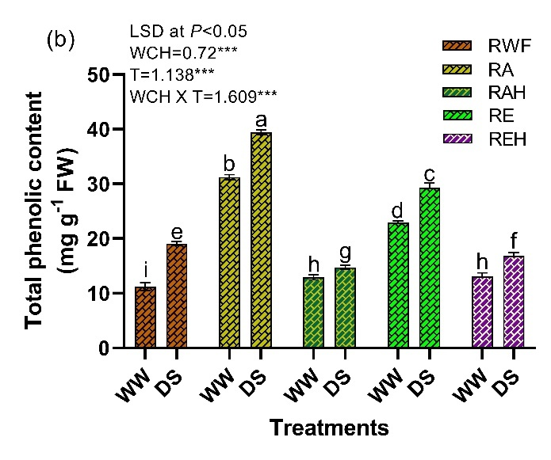
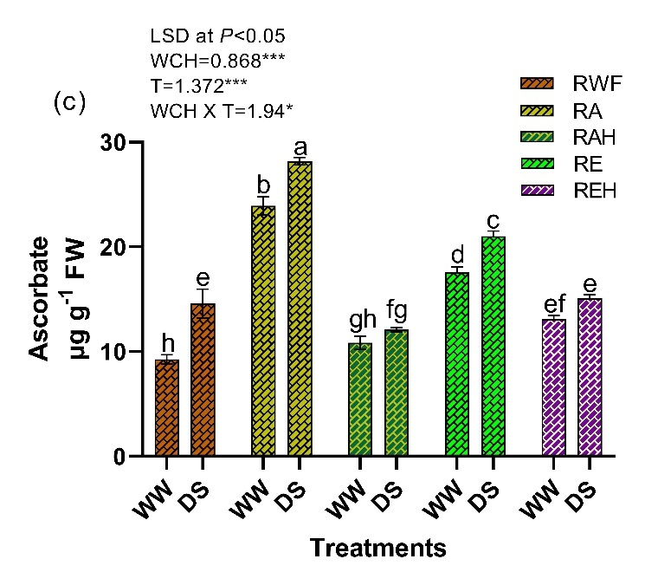 | Supplementary Fig. 3. Effect of drought stress and weed control treatments on proline content (a), total phenolic content (b) and ascorbic acid content (c) of rice under well-watered condition (WW) and drought stress (DS) conditions. RWF: weed free rice; RA: rice+ A. paronychioides; RAH: rice+ A. paronychioides + herbicide; RE: rice+ E. colona; REH: rice+ E. colona+ herbicide. The data provided above represent the Mean ± SE (n = 5). Distinct lower letters in a column indicates a significant difference at P = 0.05. The significance levels of the least significant difference (LSD) are denoted by *, **, and *** for P < 0.05, 0.01, and 0.001, respectively, while "ns" indicates non-significance. WCH: refers to combinations of weeds, crop, and herbicide; T: denotes treatment; and WCH X T: represents the interaction between combinations of weeds, crop, herbicide, and treatment.

