Supplementary materials
Impact of non optimal ambient temperature and temperature variation on the mortality of cardiovascular diseases: A research in small city of Wuhu, China
Tao Zhang^{a,b,1}, Huimin Xie^{a,b,1}, Xu Zhang^{a,b}, Jianping Ni^{a,b}, Guoqing Li^{a,b}, Hanqing Wu^{a,b}, Jiansheng Zhu^{c}, Faming Pan^{a,b*}

List of charts
S.Fig.1 The time series distribution of daily CVD deaths, DMT, DTR and RH in Wuhu, China, from 2014 to 2020
S.Fig. 2 Spearman’s correlation coefficients between meteorological factors and atmospheric pollutants in Wuhu, China, from 2014 to 2020.
S.Fig.3 (A) 3D and countour plot of association between DMT and daily CVD deaths over lag 0-21 days, with DMT(10℃) as the reference temperature. (B) 3D and countour plot of association between DTR and daily CVD deaths over lag 0-21 days, with DMT(10℃) as the reference temperature.
S.Fig 4 Extreme and moderate single-day lag effects of DMT and DTR on daily CVD deaths (reference DMT 10℃; DTR 8℃).
S.Fig 5 Extreme and moderate cumulative lag effects of DMT and DTR on daily CVD deaths (reference DMT 10℃; DTR 8℃).
S.Fig 6 Cumulative exposure-response relationship over a lag of (A) 18, (B) 25 and (C) 30 days, respectively.
S.Fig 7 Cumulative exposure-response relationship over a lag of 21 days, using (D) 6, (E) 7 and (F) 8 df per year for time, respectively.
S.Fig 8 Cumulative exposure-response relationship over a lag of 21 days, using (G) 3, (H) 4 and (I) 5 df for daily mean temperature, respectively.
S.Fig 9 Cumulative exposure-response relationship over a lag of (a) 18, (b) 25 and (c) 30 days, respectively.
S.Fig 10 Cumulative exposure-response relationship over a lag of 21 days, using (d) 6, (e) 7 and (f) 8 df per year for time, respectively.
S.Fig 11 Cumulative exposure-response relationship over a lag of 21 days, using (g) 3, (h) 4 and (i) 5 df for diurnal temperature range, respectively.
S.Table1 The overall lag-cumulative exposure-response relationship between DMT and the mortality of CVD.
S.Table2 The overall lag-cumulative exposure-response relationship between DTR and the mortality of CVD.
S.Table3 RRs and their 95% CIs of extreme and moderate effects of DMT and DTR on daily CVD deaths for different single-day lags

S.Fig.1 The time series distribution of daily CVD deaths, DMT, DTR and RH in Wuhu, China, from 2014 to 2020

S.Fig. 2 Spearman’s correlation coefficients between meteorological factors and atmospheric pollutants in Wuhu, China, from 2014 to 2020.

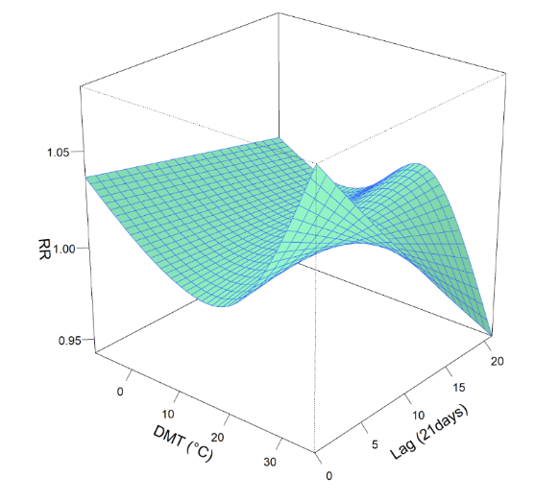
A

B
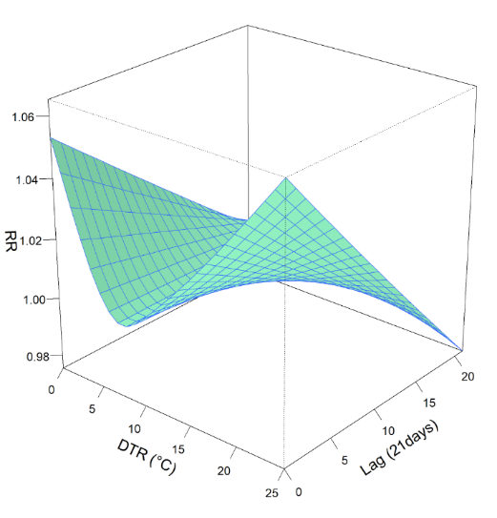

S.Fig.3 (A) 3D and countour plot of association between DMT and daily CVD deaths over lag 0-21 days, with DMT(10℃) as the reference temperature. (B) 3D and countour plot of association between DTR and daily CVD deaths over lag 0-21 days, with DMT(10℃) as the reference temperature.

S.Fig 4 Extreme and moderate single-day lag effects of DMT and DTR on daily CVD deaths (reference DMT 10℃; DTR 8℃).
Extreme and moderate cold: the 2.5th and 10th percentile of DMT; extreme and moderate heat: the 97.5th and 90th percentile of DMT
Extreme and moderate low: the 2.5th and 10th percentile of DTR; extreme and moderate HIGH: the 97.5th and 90th percentile of DTR

S.Fig 5 Extreme and moderate cumulative lag effects of DMT and DTR on daily CVD deaths (reference DMT 10℃; DTR 8℃).
Extreme and moderate cold: the 2.5th and 10th percentile of DMT; extreme and moderate heat: the 97.5th and 90th percentile of DMT
Extreme and moderate low: the 2.5th and 10th percentile of DTR; extreme and moderate HIGH: the 97.5th and 90th percentile of DTR
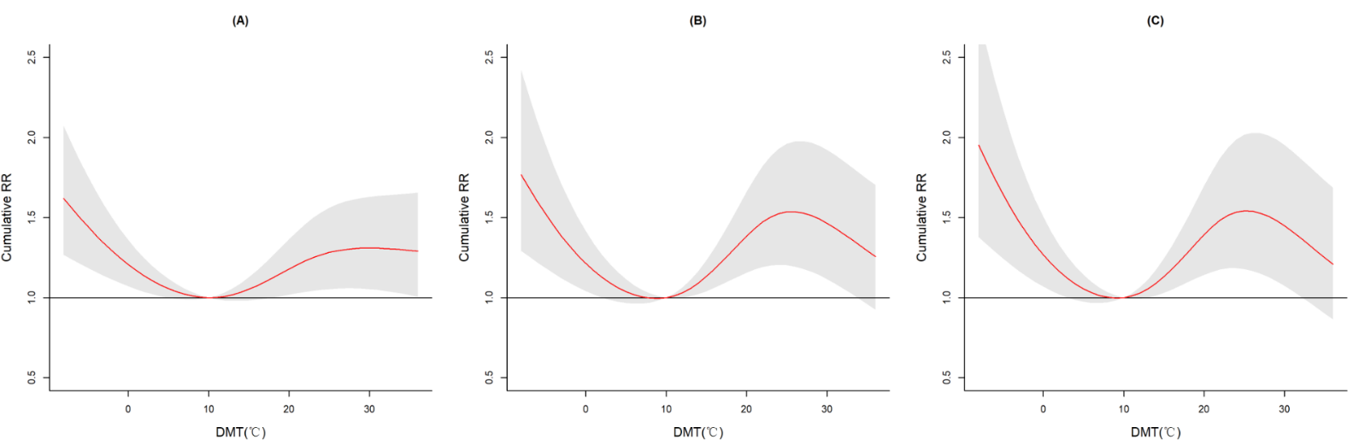

S.Fig 6 Cumulative exposure-response relationship over a lag of (A) 18, (B) 25 and (C) 30 days, respectively.
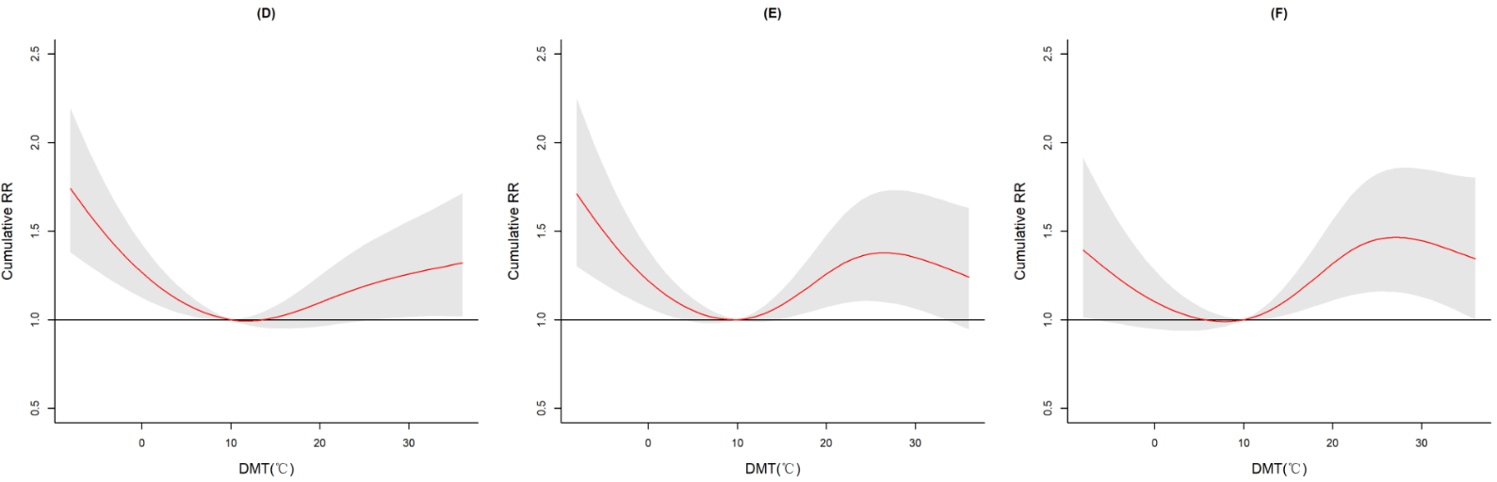

S.Fig 7 Cumulative exposure-response relationship over a lag of 21 days, using (D) 6, (E) 7 and (F) 8 df per year for time, respectively.
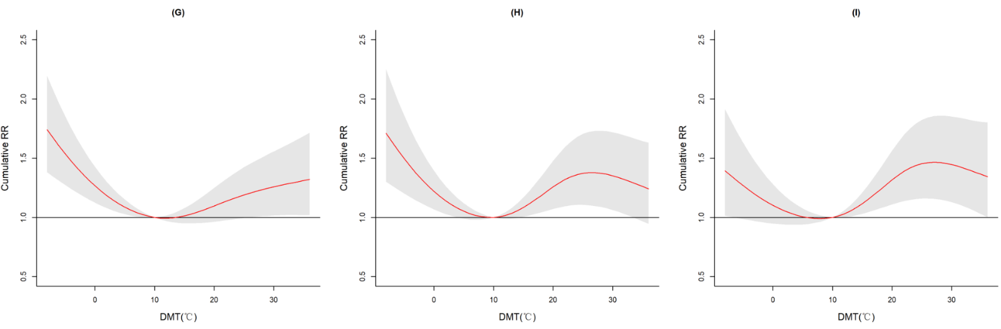

S.Fig 8 Cumulative exposure-response relationship over a lag of 21 days, using (G) 3, (H) 4 and (I) 5 df for daily mean temperature, respectively.
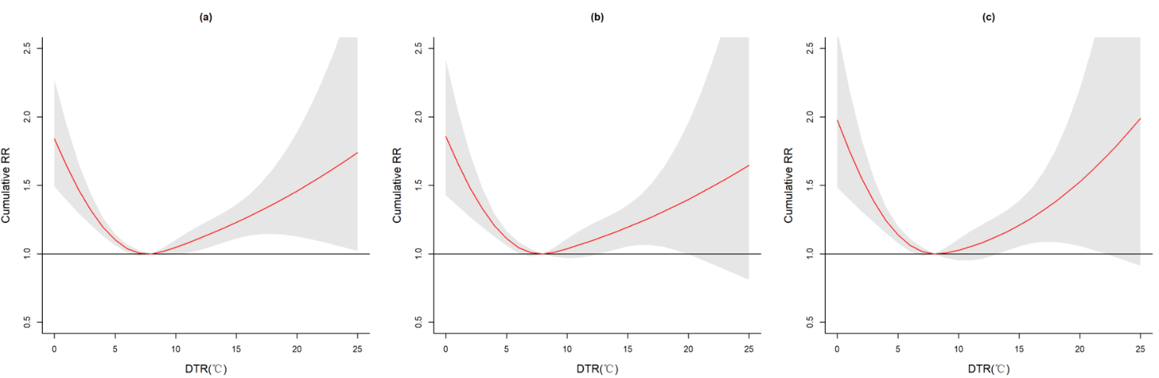

S.Fig 9 Cumulative exposure-response relationship over a lag of (a) 18, (b) 25 and (c) 30 days, respectively.
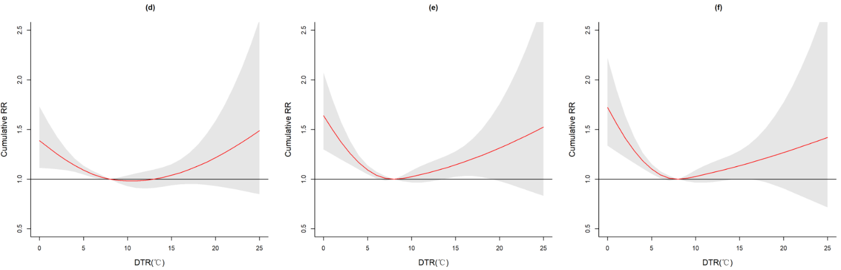

S.Fig 10 Cumulative exposure-response relationship over a lag of 21 days, using (d) 6, (e) 7 and (f) 8 df per year for time, respectively.
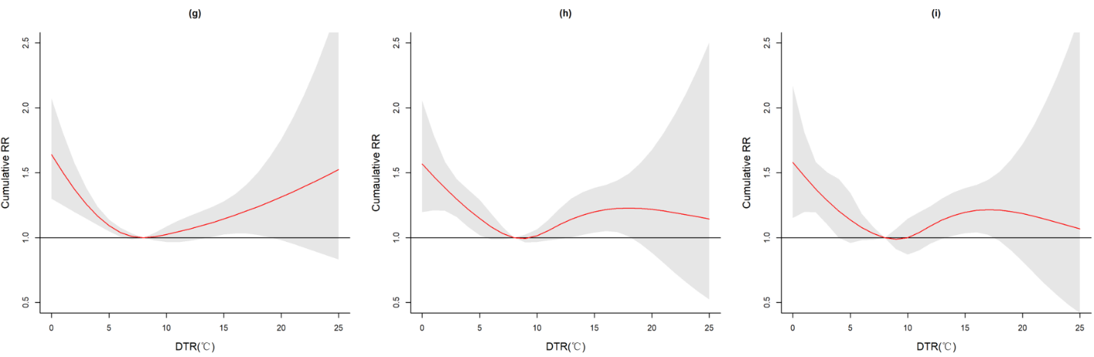

S.Fig 11 Cumulative exposure-response relationship over a lag of 21 days, using (g) 3, (h) 4 and (i) 5 df for diurnal temperature range, respectively.

S.Table1 The overall lag-cumulative exposure-response relationship between DMT and the mortality of CVD
DMT (℃) | Cumulative RR (95%CI) | DMT (℃) | Cumulative RR(95% CI)
-7 | 1.636 (1.268, 2.112)* | 15 | 1.083 (1.005, 1.167)*
-6 | 1.565 (1.235, 1.983)* | 16 | 1.114 (1.016, 1.222)*
-5 | 1.498 (1.204, 1.863)* | 17 | 1.149 (1.029, 1.282)*
-4 | 1.434 (1.173, 1.752)* | 18 | 1.185 (1.043, 1.346)*
-3 | 1.374 (1.144, 1.650)* | 19 | 1.221 (1.057, 1.411)*
-2 | 1.319 (1.117, 1.557)* | 20 | 1.257 (1.071, 1.476)*
-1 | 1.267 (1.092, 1.471)* | 21 | 1.291 (1.084, 1.538)*
0 | 1.220 (1.068, 1.394)* | 22 | 1.320 (1.094, 1.594)*
1 | 1.178 (1.047, 1.325)* | 23 | 1.344 (1.101, 1.641)*
2 | 1.140 (1.029, 1.263)* | 24 | 1.361 (1.105, 1.678)*
3 | 1.106 (1.013, 1.209)* | 25 | 1.372 (1.105, 1.704)*
4 | 1.077 (0.999, 1.161) | 26 | 1.378 (1.103, 1.721)*
5 | 1.053 (0.989, 1.120) | 27 | 1.378 (1.097, 1.730)*
6 | 1.032 (0.983, 1.085) | 28 | 1.373 (1.088, 1.732)*
7 | 1.017 (0.980, 1.055) | 29 | 1.364 (1.076, 1.728)*
8 | 1.006 (0.982, 1.031) | 30 | 1.351 (1.063, 1.719)*
9 | 1.001 (0.988, 1.013) | 31 | 1.336 (1.046, 1.706)*
10 | 1.000 (1.000, 1.000) | 32 | 1.319 (1.028, 1.692)*
11 | 1.005 (0.992, 1.018) | 33 | 1.300 (1.009, 1.676)*
12 | 1.016 (0.989, 1.044) | 34 | 1.281 (0.988, 1.660)
13 | 1.033 (0.990, 1.077) | 35 | 1.261 (0.967, 1.644)
14 | 1.056 (0.996, 1.119) | 36 | 1.241 (0.945,1.630)
DMT: daily mean temperature, CVD: cardiovascular disease, RR:realtive risk,
CI: confidence interval, *p < 0.05
S.Table2 The overall lag-cumulative exposure-response relationship between DTR and the mortality of CVD
DTR (℃) | Cumulative RR (95%CI) | DTR (℃) | Cumulative RR(95% CI)
1 | 1.500 (1.248,1.903)* | 13 | 1.090 (0.989,1.201)
2 | 1.372 (1.197,1.573)* | 14 | 1.116 (1.007,1.236)*
3 | 1.260 (1.147,1.385)* | 15 | 1.144 (1.023,1.279)*
4 | 1.167 (1.098,1.240)* | 16 | 1.174 (1.032,1.335)
5 | 1.093 (1.049,1.193)* | 17 | 1.206 (1.031,1.410)*
6 | 1.040 (1.006,1.074)* | 18 | 1.239 (1.021,1.505)*
7 | 1.009 (0.987,1.031) | 19 | 1.275 (1.003,1.621)*
8 | 1.000 (1.000,1.000) | 20 | 1.312 (0.980,1.758)
9 | 1.008 (0.978,1.038) | 21 | 1.351 (0.953,1.917)
10 | 1.024 (0.966,1.086) | 22 | 1.392 (0.923,2.099)
11 | 1.044 (0.966,1.129) | 23 | 1.435 (0.893,2.305)
12 | 1.066 (0.974,1.167) | 24 | 1.478 (0.862,2.536)
DTR: diurnal temperature range, CVD: cardiovascular disease, RR:realtive risk,
CI: confidence interval, *p < 0.05

S.Table3 RRs and their 95% CIs of extreme and moderate effects of DMT and DTR on daily CVD deaths for different single-day lags
 | Lag (days) | Extreme cold/low  RR (95%CI) | Moderate cold/low  RR (95%CI) | Moderate heat/high  RR (95%CI) | Extreme heat/high  RR (95%CI)
DMT | 0 | 1.016 (1.006, 1.025)* | 1.010 (1.003, 1.016)* | 1.029 (1.010, 1.048)* | 1.054 (1.033, 1.076)*
DMT | 3 | 1.013 (1.005, 1.023)* | 1.008 (1.003, 1.013)* | 1.025 (1.009, 1.040)* | 1.042 (1.025, 1.059)*
DMT | 7 | 1.010 (1.004, 1.017)* | 1.005 (1.002, 1.009)* | 1.019 (1.007, 1.031)* | 1.026 (1.013, 1.039)*
DMT | 10 | 1.008 (1.002, 1.014)* | 1.004 (1.000,1.007)* | 1.015 (1.004,1.026)* | 1.015 (1.003, 1.026)*
DMT | 14 | 1.005 (0.999, 1.011) | 1.001 (0.998,1.005) | 1.010 (0.998,1.022) | 0.999 (0.986, 1.012)
DMT | 18 | 1.002 (0.994, 1.009) | 0.999 (0.994, 1.004) | 1.005 (0.989, 1.020) | 0.984 (0.967, 1.001)
DMT | 21 | 0.999 (0.990, 1.009) | 0.997 (0.992, 1.003) | 1.001 (0.982, 1.020) | 0.973 (0.953, 0.994)*
DTR | 0 | 1.033 (1.022,1.044)* | 1.023 (1.015, 1.031)* | 1.019 (1.011, 1.027)* | 1.031 (1.019, 1.043)*
DTR | 3 | 1.027 (1.018,1.037)* | 1.020 (1.013, 1.026)* | 1.015 (1.009, 1.022)* | 1.024 (1.015, 1.034)*
DTR | 7 | 1.021 (1.013,1.028)* | 1.015 (1.010, 1.020)* | 1.010 (1.005, 1.015)* | 1.016 (1.008, 1.024)*
DTR | 10 | 1.015 (1.009,1.022)* | 1.011 (1.007, 1.016)* | 1.006 (1.001, 1.010)* | 1.010 (1.002, 1.017)*
DTR | 14 | 1.008 (1.002,1.015)* | 1.006 (1.002, 1.011)* | 1.000 (0.995, 1.005) | 1.001 (0.994, 1.009)
DTR | 18 | 1.002 (0.993,1.010) | 1.002 (0.996, 1.008) | 0.995 (0.989, 1.001) | 0.993 (0.984, 1.002)
DTR | 21 | 0.997 (0.986,1.007) | 0.998 (0.991, 1.006) | 0.991 (0.984, 0.999)* | 0.987 (0.976, 0.998)*

DMT: daily mean temperature, DTR: diurnal temperature range, CVD: cardiovascular disease, RR:realtive risk,
CI: confidence interval, *p < 0.05

