Supplementary Materials for

Slip Distribution of the 1946 Showa-Nankai Earthquake Estimated by Nonlinear Tsunami Inversion

Masato Kamiya, Toshiki Takeuchi, and Toshitaka Baba
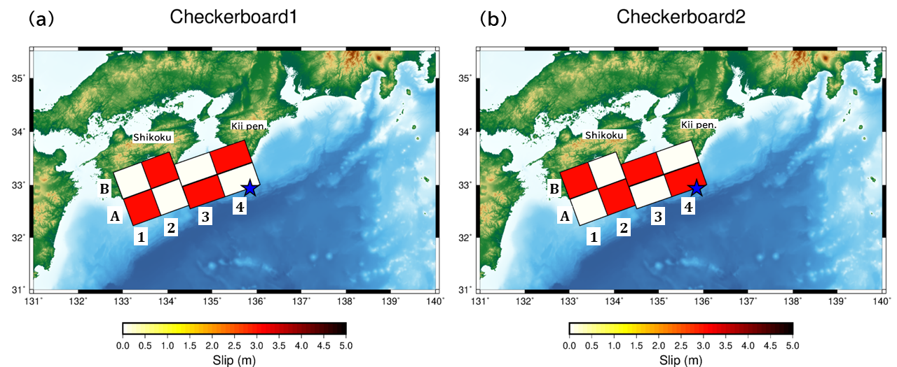

Figure S1. Assumed slip models consisting of slips of 0 and 3 m for checkerboard resolution tests. The blue star indicates the epicenter.

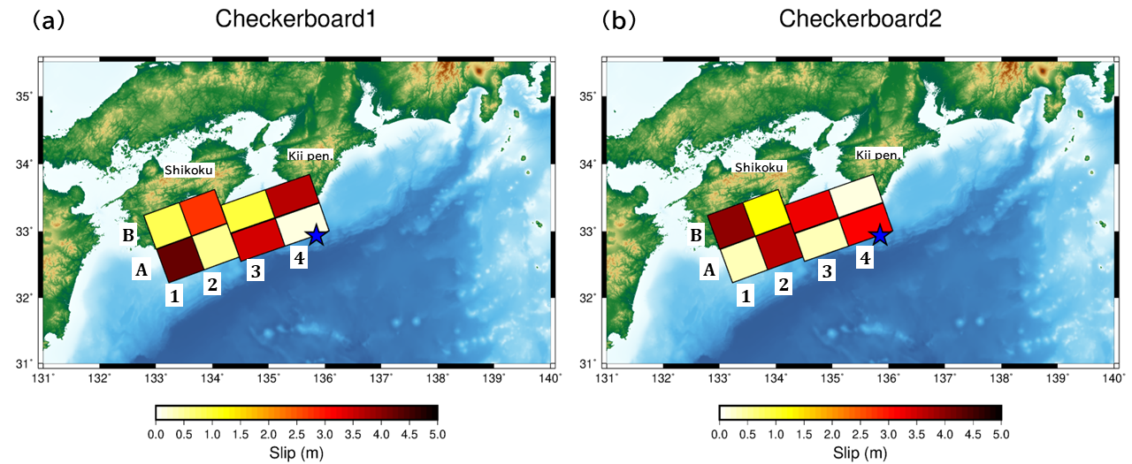
Figure S2. Results of the checkerboard resolution tests.

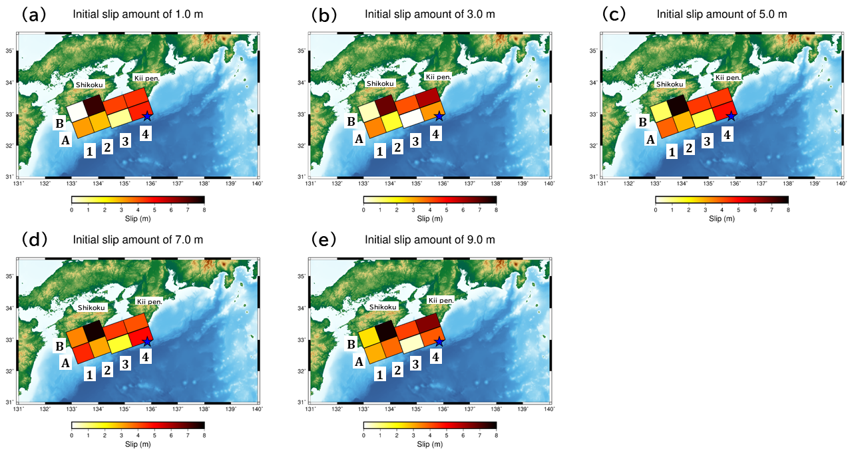

Figure S3. Estimated slip distributions derived from difference initial fault values of (a) 1.0 m, (b) 3.0 m, (c) 5.0 m, (d) 7.0 m and (e) 9.0 m. The blue star is the epicenter.

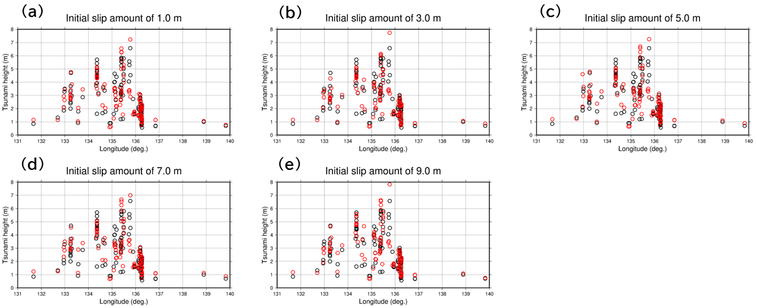

Figure S4. Comparisons of calculated (red) and observed (black) tsunami trace heights for the slip distributions shown in Figure S3.

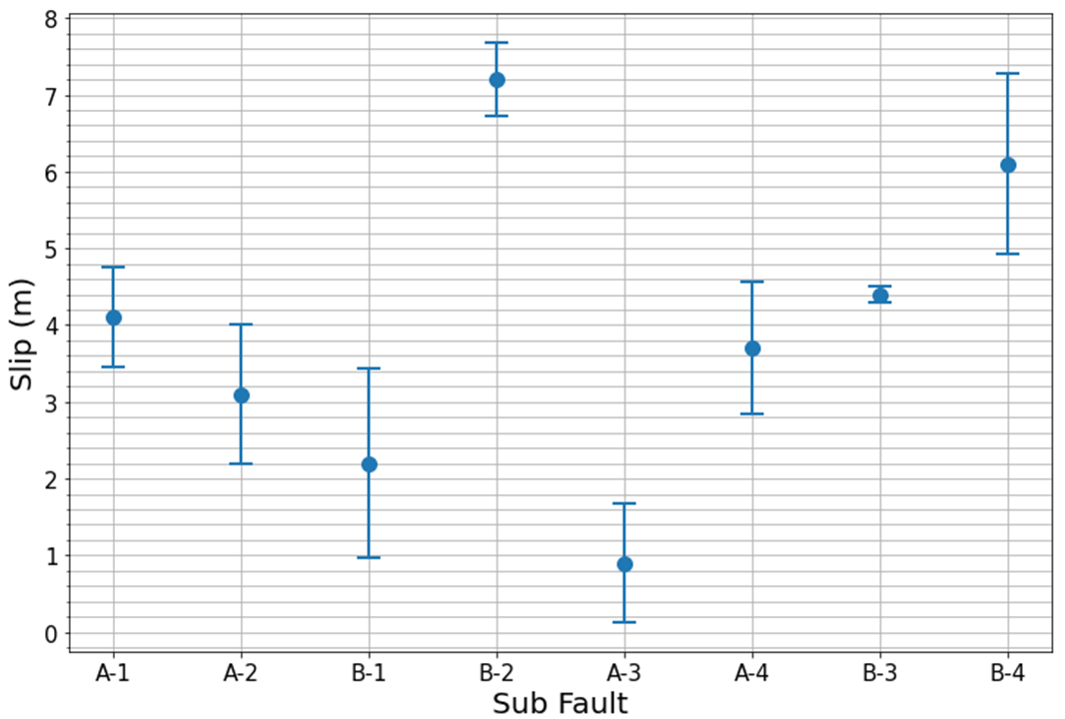

Figure S5. Variations (standard deviation) on estimated slip amounts obtained in Figure S3. Dots are the slip amounts estimated by the tsunami trace height model.

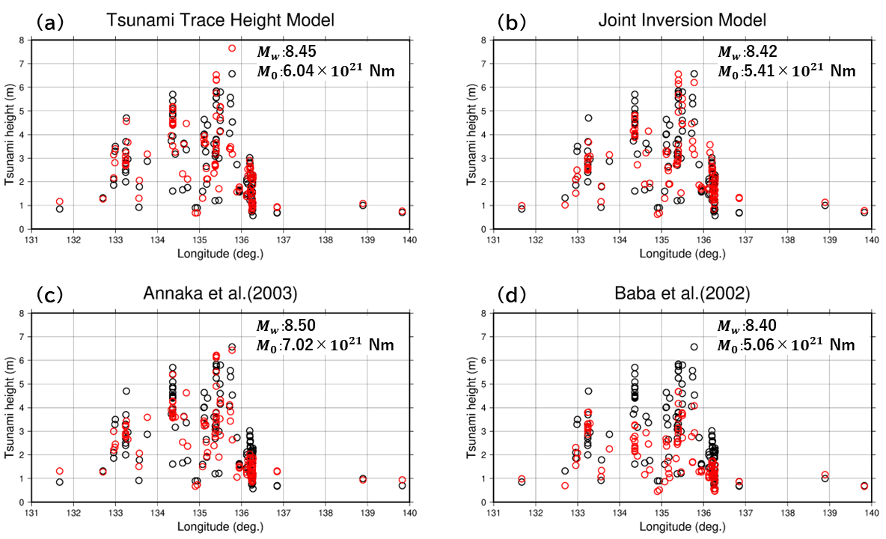

Figure S6. Comparison of calculated tsunami heights (red) and tsunami trace heights (black) between the fault models of this study and those of previous studies. (a) tsunami trace height model, (b) joint inversion model, (c) fault model of Baba et al. (2002), and (d) fault model of Annaka et al. (2003).

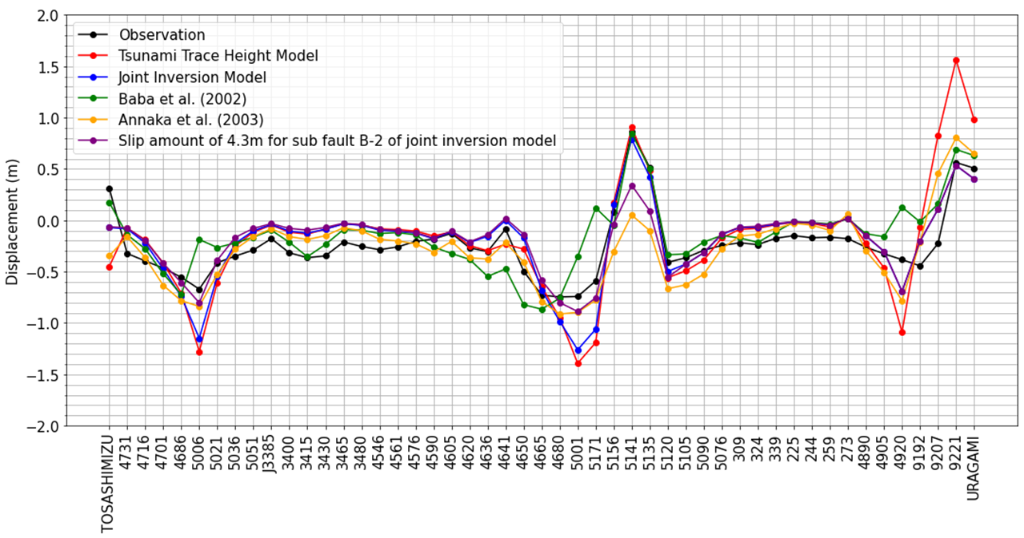
Figure S7. Comparison of observed and calculated geodetic data for the fault models in this study and faults in previous studies.

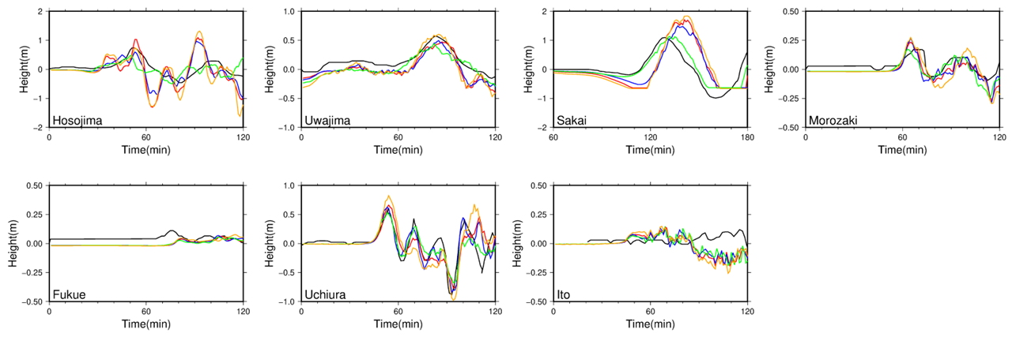

Figure S8. Comparison of observed (black) and calculated tsunami waveforms derived from the tsunami trace height (red), joint inversion (blue), Baba et al.’s (2002) (green) and Annaka et al.’s (2003) (orange) models.

