Supplement X. Protypes of interventions to increase participation in the NBCSP
Prototype description and discussion points | Visual depiction shown during interviews
Instructions to put kit in a visual place as a reminder.  Where should the message go (e.g., on the outside of kit—as it is here in orange)? What should the message say (e.g., put the kit near the toilet or on the kitchen bench)? | 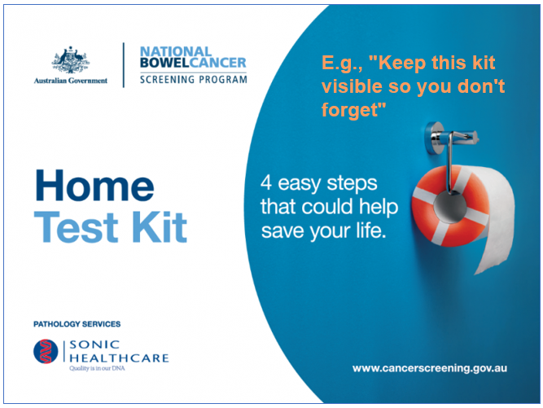
A token of sticker to use as a reminder.  Which token would be most helpful? What size? E.g., credit card size? | 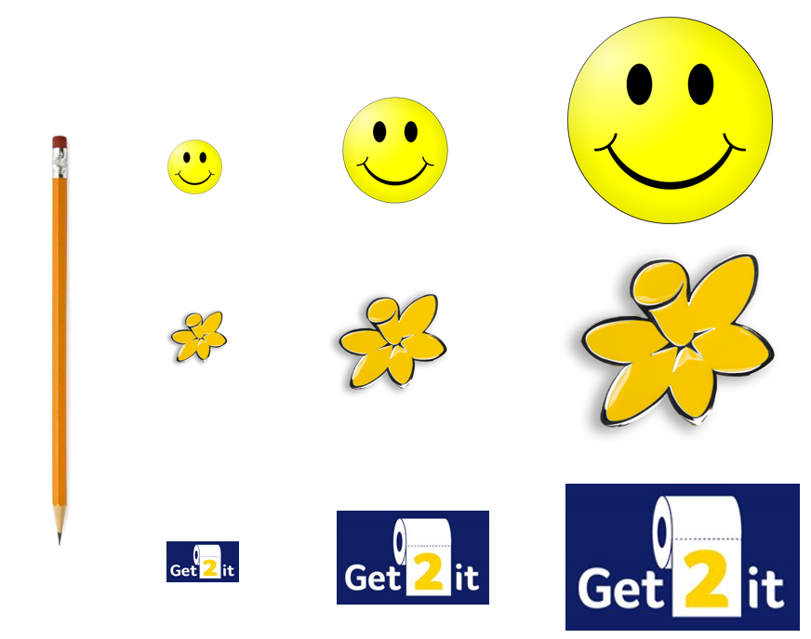
Messaging used token description.  What should the message say? E.g., “Place this token where you will be reminded” Where should it go? E.g., on the front or back of the kit? | 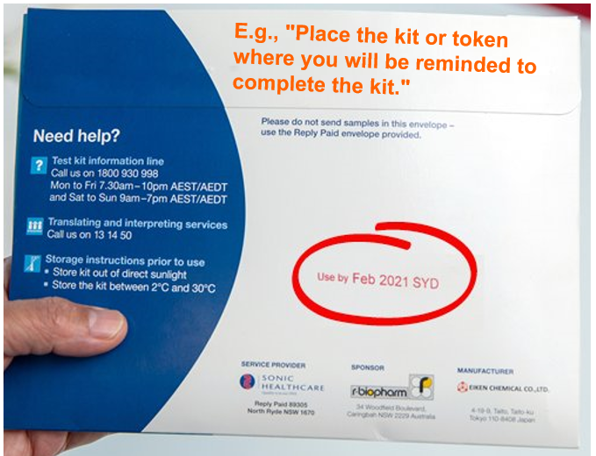
Deadline  What is the best wording for the deadline? Where should the deadline be located (e.g., outside envelope, on kit, in instructions, multiple locations). What is a reasonable timeframe for the deadline? Include a prompt to check the expiry date? How can any off-putting aspects of a deadline be minimised? | 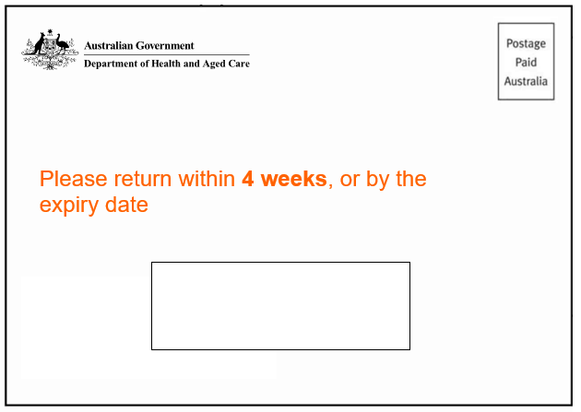
QR code to sign up for reminders  The QR code can come on a letter with options for frequency and the type of reminder (text, email, calendar import). What are your thoughts about the frequency of reminders, design of the form to collect contact details etc., and the utility of a QR code opt-in system versus extra letters or myGov notifications (which arrive automatically, with no opt-in required)? | 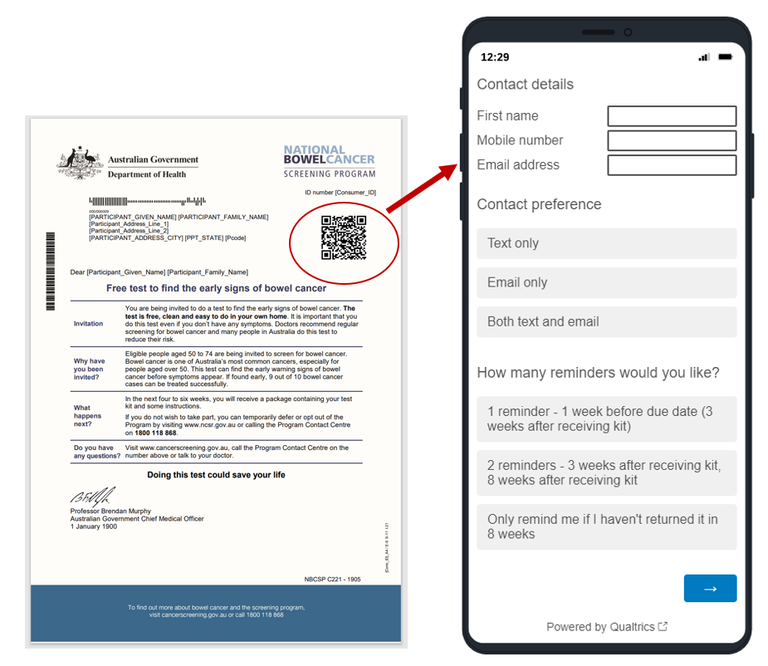  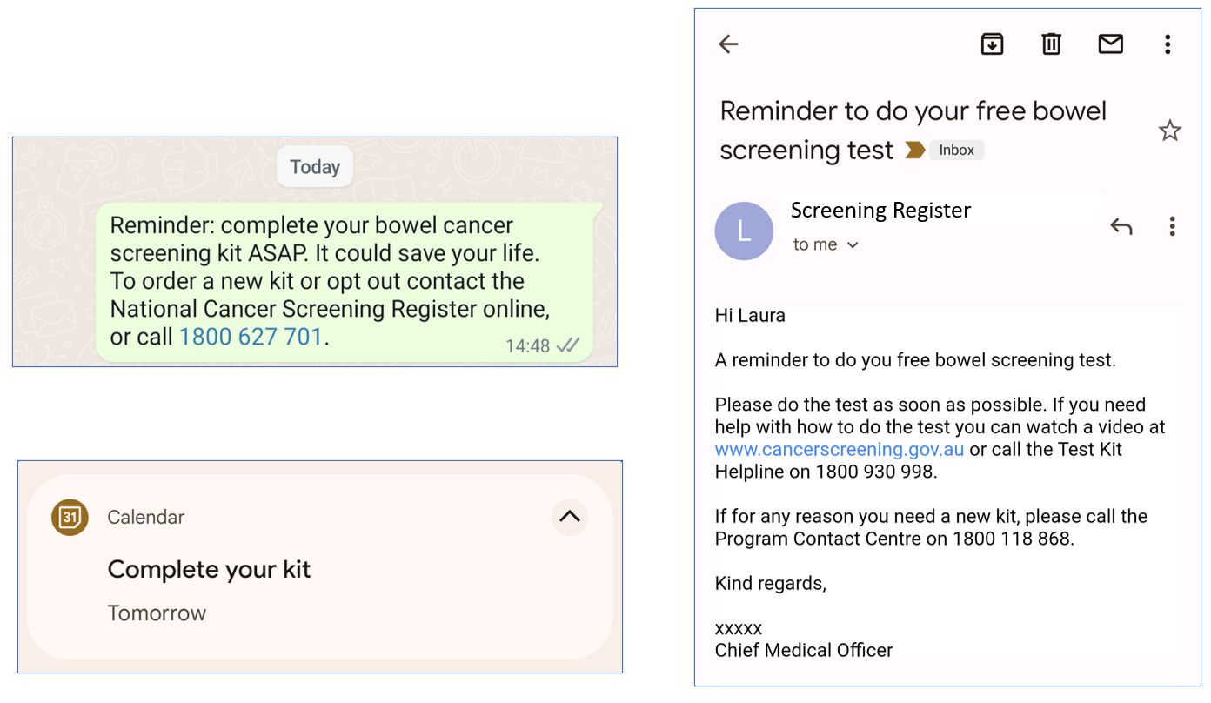
QR code to find local postal location  Is a link to the Australia post website that includes post offices/ boxes enough, or would it be preferable to have additional information specific to the NBCSP, such as box collection time, and whether it is in a hot zone. Would you like a separate QR code for this? | 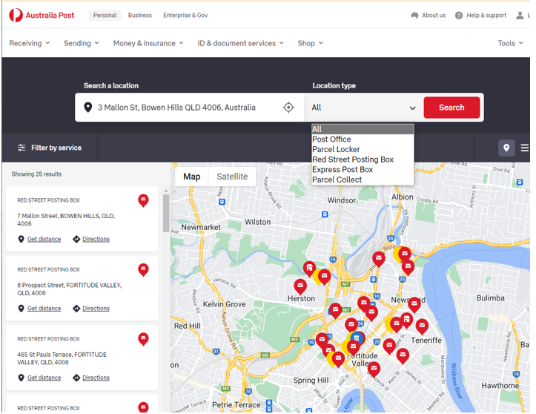
Fridge storage options  Would providing a bag with the bowel screening kit encourage you to complete the kit? What is the idea size and type of bag to store the sample – a paper bag, opaque ziplock bag, or insulated bag that would not require refrigeration? | 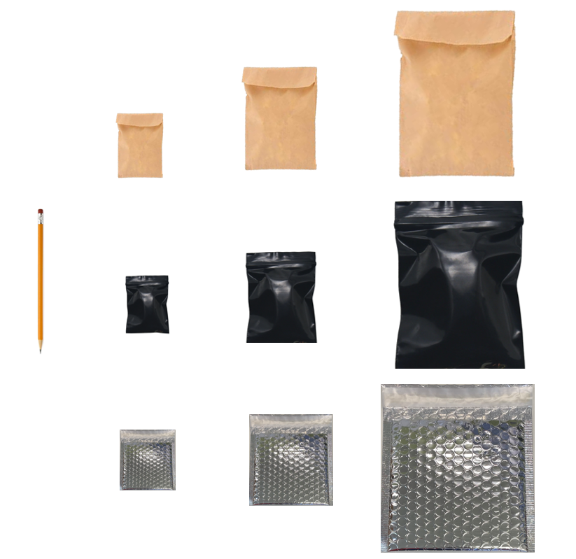
Gloves for stool sample collection  Would you like gloves included with the kit for stool sample collection? Would you prefer loose-fitting gloves or tight-fitting gloves? Would including gloves have any downsides, such as increasing hygiene concerns? | 

