Supplemental Figure

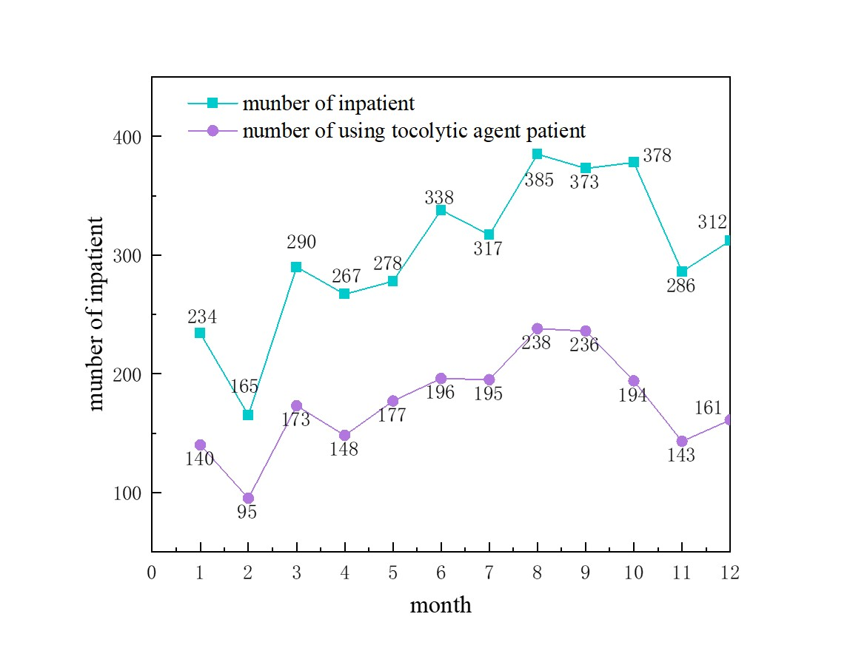
Figure. Changes in anti-preterm drugs in the OZ13 disease group from January to December 2022.

