Supplementary file
Constructing Causal Pathways for Premature Cardiovascular Disease Mortality using Directed Acyclic Graphs: Integrating Evidence Synthesis and Expert Knowledge

Appendix 1
Basic concept of Directed Acyclic Graphs (DAGs)
A Directed Acyclic Graph (DAG) is a graphical representation used to model and visualize the relationships between variables and to infer causal relationships between them. In epidemiology, DAGs are employed to depict causal relations among variables and are extensively utilized to determine which variables need to be conditioned on for controlling confounding. The terminology associated with DAGs is presented in Box 1. Box 2 providing additional key concepts in DAG involved.
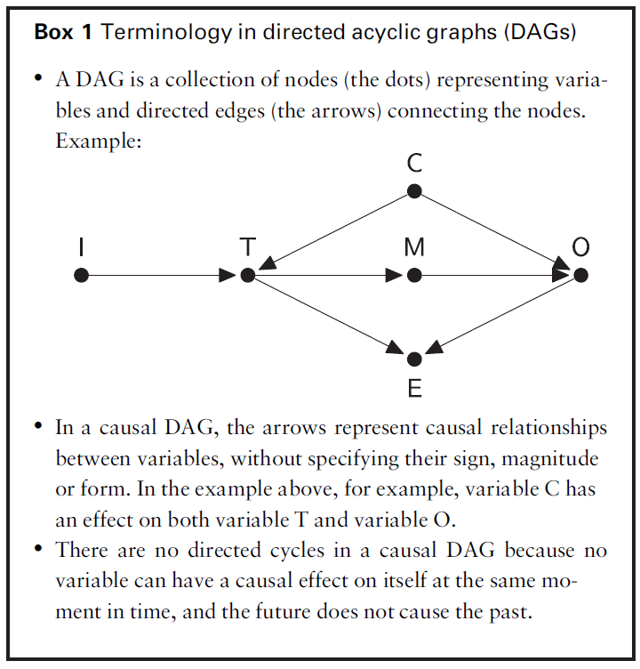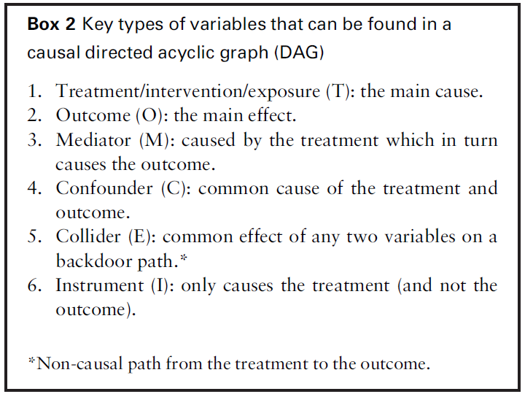(Source: Rodrigues D. et al., 2022)

When coupled with the so-called backdoor criterion, DAGs offer a rationale for the selection of confounding variables to adjust, thereby enhancing the credibility of the conditional exchangeability assumption. The backdoor criterion states that a set of variables is sufficient to control for confounding if it blocks all non-causal paths from treatment to outcome and does not include any descendants of treatment, such as mediators or colliders (see Box 2 and Box 3 for more details).

Box 3 DAG illustrating key terms and concepts.
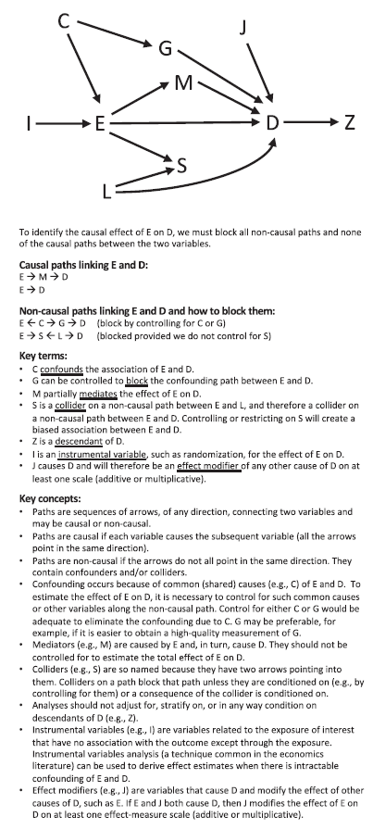
To identify the causal effect of E on D, we must block all non-causal paths and none of the causal paths between the two variables.
Causal paths linking E and D
E M D
E D
Non-causal paths linking E and D and how to block them:
E C G D (block by controlling for C or G)
E S L D (blocked provided we do not control for S)
Key terms:
- C confounds the association of E and D.
- G can be controlled to block the confounding path between E and D.
- M partially mediates the effect of E on D.
- S is collider on a non-causal path between E and L, and therefore a collider on a non-causal path between E and D. controlling or restricting on S will create a biased association between E and D.
- Z is a descendant of D.
- I is an instrumental variable, such as randomization, for the effect of E on D.
- J causes D and will therefore be an effect modifier of any other cause of D on at least one scale (additive or multiplicative).
Key concepts:
- Paths are sequences of arrows, of any direction, connecting two variables and may be causal or non-causal.
- Paths are causal if each variable cause the subsequent variable (all the arrows point in the same direction.
- Paths are non-causal if the arrows do not all point in the same direction. They contain confounder and/ or colliders.
- Confounding occurs because of common (shared) causes (e.g., C) of E and D. To estimate the effect of E on D, it is necessary to control for such common causes or other variables along the non-causal path. Control for either C or G would be adequate to eliminate the confounding due to C. G may be preferable, for example, if it is easier to obtain a high-quality measurement of G.
- Mediators (e.g., M) are cause by E and, in turn, cause D. They should not be controlled for to estimate the total effect of E on D.
- Colliders (e.g., S) are so named because they have two arrows pointing into them. Colliders on a path block that path unless they are conditioned on (e.g., by controlling for them) or a consequence of the collider is conditioned on.
- Analyses should not adjust for, stratify on, or in any way condition on descendants of D (e.g., Z).
- Instrumental variables (e.g., I) are variables related to exposure of interest that have no association with the outcome except through the exposure. Instrumental variables analysis (a technique common in the economics literature) can be used to derive effect estimates when there is intractable confounding of E and D.
- Effect modifiers (e.g., J) are variables that cause D and modify the effect of other causes of D, such as E. if E and J both cause D, then J modifies the effect of E on D on at least one effect-measure scale (additive or multiplicative).

(Source: Digitale JC. et al., 2022)

References
- Rodrigues D, Kreif N, Lawrence-Jones A, Barahona M, Mayer E. Reflection on modern methods: constructing directed acyclic graphs (DAGs) with domain experts for health services research. International Journal of Epidemiology. 2022 Aug 1;51(4):1339-48.
- Digitale JC, Martin JN, Glymour MM. Tutorial on directed acyclic graphs. Journal of Clinical Epidemiology. 2022 Feb 1;142:264-7.

Appendix 2
Questions for expert domain during the first-round interview
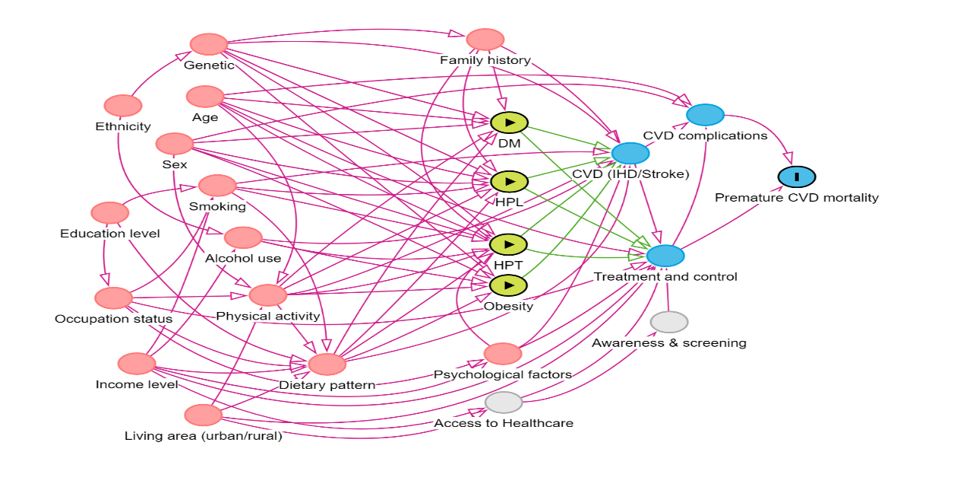
Figure 1: DAG from mapping step and translation process of ESC-DAG
- Are the suggested variables in Figure 1 considered sufficient as key factors influencing premature CVD mortality?
Yes
No
If your answer is "No," kindly suggest additional variables. Feel free to add or draw nodes in Figure 1.

- Are the directed arches as proposed in the DAG in Figure 1 correct and aligned with the three Bradford Hill criteria, considering temporality, biological plausibility, and support from posited relationships by theory?
Yes
No
If not, kindly provide comments on any directed arches that may not be correct.

- Is the combination of nodes (e.g., SES and Genetic + Family history) in Figure 2 correct based on theoretical support for the nodes? Do the conceptually related nodes have similar inputs and outputs (i.e., do they 'send to' and 'receive from' the same nodes)?
Yes
No
If not, kindly provide comments on the appropriateness of combining these nodes and whether the conceptually related nodes share similar inputs and outputs.

Appendix 3
Second-round interview online survey questionnaire.
“Consensus of DAG Model for Premature CVD Mortality Pathways by Expert Panel”. This questionnaire was administered online via Google Forms.
Introduction page
Dear experts,
Thank you for your continued involvement in the second round of the Delphi method for my thesis project on premature cardiovascular disease (CVD) mortality pathways. Your invaluable comments and suggestions during our one-to-one consultations in the first round have improved my DAG model.
In this session, I'm seeking your final consensus on the causal pathway for premature CVD mortality. This pathway, based on evidence synthesis regardless of specific data, is the model we discussed previously. As depicted in Figure 1, some causal paths have received varied suggestions, and a few paths are yet to be finalized. To achieve this, I need your input on the degree of agreement for each of the causal paths, using a Likert scale. I will employ the fuzzy Delphi method to calculate the final agreement from all experts.
I would like to inform you that this survey may require approximately 20-30 minutes of your time. Your contribution is critical to finalizing my DAG model for my final thesis/paper report.
Thank you for your time and expertise.
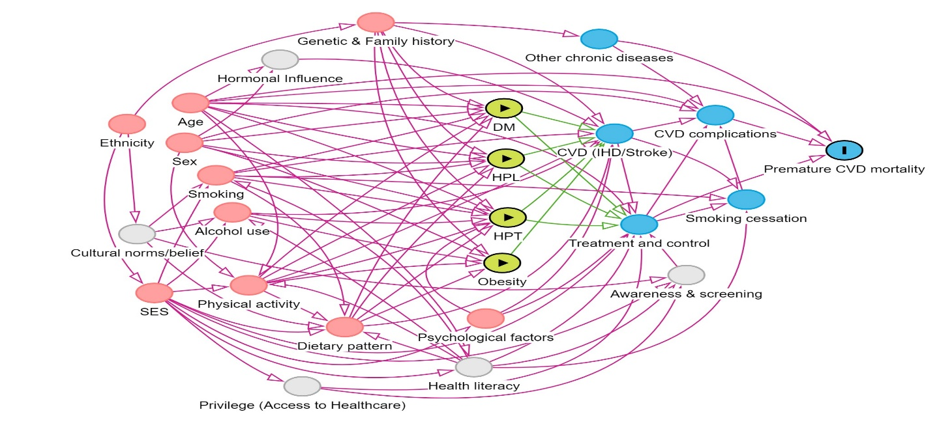
Figure 1

Next page.
Instruction to the experts
When providing the responses, kindly evaluate each causal path with a focus on determining direct cause-and-effect relationships rather than association. Consider the strength of evidence, temporal sequence, and biological plausibility. Our aim is for the final DAG model to be suitable for applications in epidemiological studies, specifically in understanding the causal pathway for CVD mortality in Malaysia. To reach a final consensus on this model, I will present a statement for each directional path and request your agreement. Please use a 7-point Likert scale (ranging from strongly disagree to strongly agree) to indicate the degree of agreement.
Expert Name (short name):
Next page.
A: Causal path from unmodifiable factors (Ethnicity)
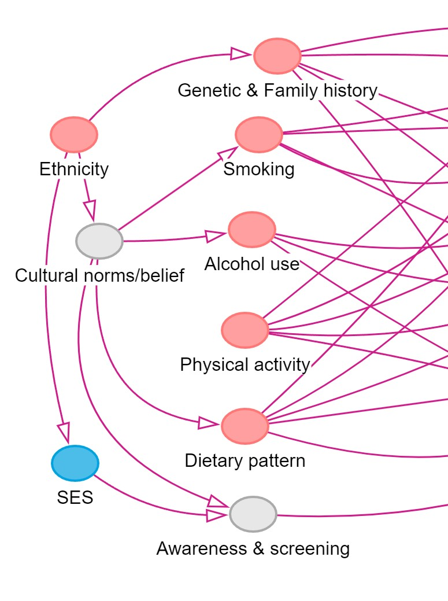
- Direction: Ethnicity -> Genetic & Family history
Do you agree that diverse ethnicities directly impact genetic variability and contribute to differences in susceptibility to cardiovascular disease?
- Direction: Ethnicity -> Cultural norms/belief/practise -> alcohol use
To what extent do you agree that ethnicity influences cultural norms/belief/practise, affecting alcohol use?
- Direction: Ethnicity -> Cultural norms/belief/practice -> Smoking
To what extent do you agree with the pathway: Ethnicity influencing Cultural norms/belief/practise, contributing to smoking behaviours?
- Direction: Ethnicity -> Cultural norms/belief/ practice -> Dietary pattern
To what extent do you agree with the causal sequence: Ethnicity influencing Cultural norms/belief/practise, which subsequently shape dietary patterns?
- Direction: Ethnicity -> Cultural norms/belief/practise -> Physical activity
Do you agree that ethnicity shapes cultural norms/belief/practise, influencing the level of physical activity, whether active or inactive?
- Direction: Ethnicity -> Cultural norms/belief/practise -> Awareness & screening
To what extent do you agree that Ethnicity shaping cultural norms/belief/practise, which subsequently impact awareness and screening for Non-Communicable Diseases (NCDs) including diabetes, hypertension, hyperlipidaemia and cardiovascular disease (IHD/stroke)?
- Direction: Ethnicity -> SES
Do you agree that variations in ethnicity result in differences in socioeconomic status?

B: Causal path from unmodifiable factors (Sex)

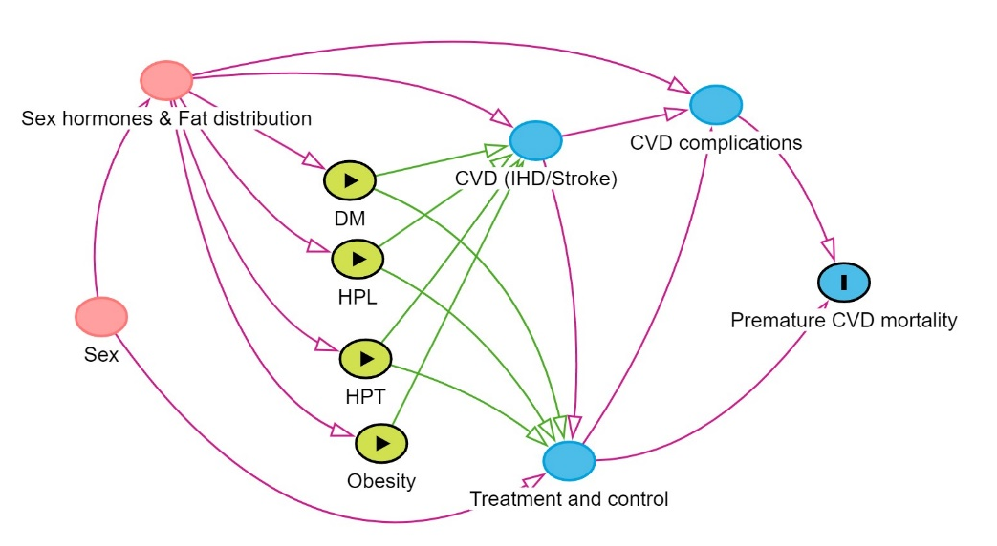
- Rename node (Hormonal influence)
Do you agree with the renaming of the node from "hormonal influence" to "Sex hormones & Fat distribution," considering that the influence of sex on NCD/CVD risk is a combined result of sex hormones (testosterone/estrogen) and variations in fat distribution patterns?
- Direction: Sex -> Sex hormones & Fat distribution -> DM
Do you agree that sex influences the development of diabetes mediated through variations in fat distribution patterns and hormone levels?
- Direction: Sex -> Sex hormones & Fat distribution -> HPT
To what extent do you agree that the causal relationship between sex and hypertension is primarily mediated by fat distribution patterns and hormone levels?
- Direction: Sex -> Sex hormones & Fat distribution -> Hyperlipidaemia (HPL)
To what extent do you agree that the causal link between sex and Hyperlipidaemia (HPL) is primarily mediated by fat distribution patterns and hormone levels?
- Direction: Sex -> Sex hormones & Fat distribution -> Obesity.
To what extent do you agree with the causal sequence: Sex influencing fat distribution patterns and hormone levels, which in turn directly impacts the development of obesity?
- Direction: Sex -> Sex hormones & Fat distribution -> CVD (IHD/Stroke).
To what extent do you agree with the causal sequence: Sex influencing CVD, specifically ischemic heart disease (IHD) and stroke, through the mediation of sex hormones and fat distribution patterns?
- Direction: Sex -> Sex hormones & Fat distribution -> CVD complications.
To what extent do you agree with the causal pathway: Sex influencing CVD complications through the mediation of sex hormones and fat distribution patterns?

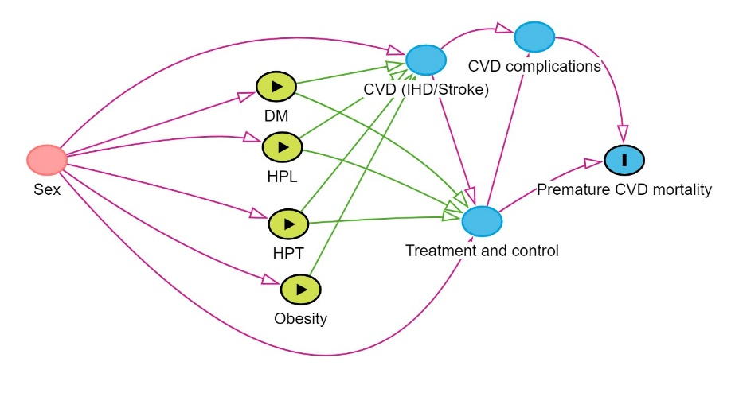

- Direction: Sex -> DM/HPT/HPL
Do you agree that an individual's biological sex directly influences the likelihood of developing Diabetes, hypertension, or Hyperlipidaemia?
- Direction: Sex -> CVD (stroke/IHD)
Do you agree that an individual's biological sex directly influences the likelihood of developing CVD, specifically IHD and stroke?
- Direction: Sex -> Obesity
How much do you agree that an individual's sex directly contributes to the development of obesity?
- Direction: Sex -> Treatment & control.
To what extent do you agree that an individual's sex directly influences the effectiveness of control measures and the body's response to treatment for cardiovascular disease?

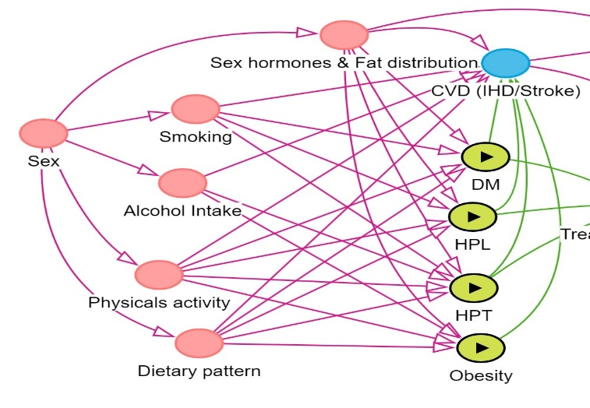
- Direction: Sex -> Smoking -> NCDs.
To what extent do you agree with the directional relationship: Sex influencing the behaviour of smoking, which in turn affects the development of NCDs?
- Direction: Sex -> Alcohol intake -> NCDs.
To what extent do you agree with the directional relationship: Sex influencing alcohol intake, which in turn affects the development of NCDs?
- Direction: Sex -> Physical activity -> NCDs.
How much do you agree with the causal link: Sex influencing the level of physical activity, subsequently impacting the development of NCDs?
- Direction: Sex -> Dietary pattern -> NCDs.
To what extent do you agree with the directional relationship: Sex influencing dietary patterns, which in turn affects the development of NCDs?

C: Causal path from unmodifiable factors (Age)
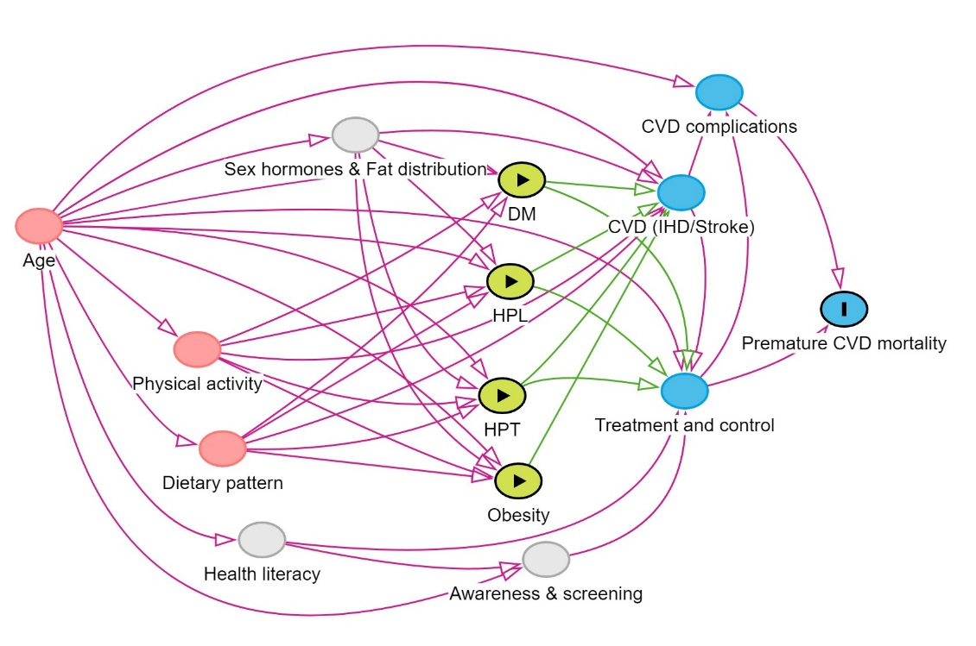
- Direction: Age -> Diabetes (DM)
To what degree do you agree that age plays a direct role in influencing the development of Diabetes?
- Direction: Age -> Hypertension (HPT)
To what extent do you agree with the directional relationship: Age influencing the development of Hypertension?
- Direction: Age -> Hyperlipidaemia (HPL)
How much do you agree with the directional relationship: Age influencing the development of Hyperlipidaemia?
- Direction: Age -> Obesity
To what extent do you agree that age plays a direct role in influencing the development of obesity?"
- Direction: Age -> CVD (IHD/Stroke)
To what degree do you agree that age directly contributes to the onset of CVD, which includes IHD and stroke?
- Direction: Age -> CVD complications
To what extent do you agree that age directly influences the severity of complications associated with CVDs
- Direction: Age -> Sex hormones & Fat distribution
To what extent do you agree with the directional relationship: Age influencing sex hormones and fat distribution patterns?
- Direction: Age -> Physical activity
How much do you agree with the directional relationship: Age influencing physical activity?
- Direction: Age -> Dietary pattern
How much do you agree with the directional relationship: Age influencing dietary patterns?
- Direction: Age -> treatment and control
To what extent do you agree that the effectiveness of treatment and control measures for CVDs/NCDs is directly influenced by age?
- Direction: Age -> Health literacy
How much do you agree with the directional relationship: Age influencing health literacy?
- Direction: Age -> Awareness & screening.
How much do you agree with the directional relationship: Age influencing awareness and screening practices for NCDs?

D: Causal path from unmodifiable factors (Genetic & family history)
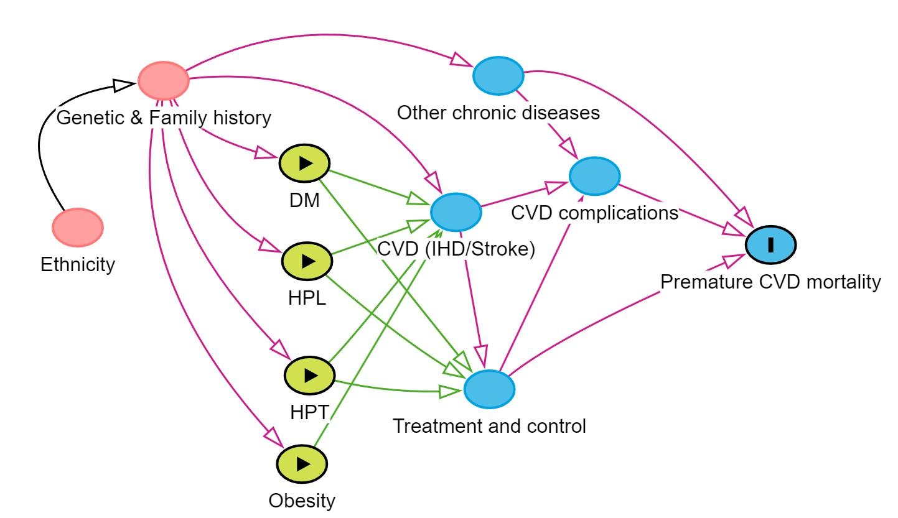
- Combine node (Genetic + Family history)
To what degree do you agree with combining Genetic and Family history into a single node in the DAG model?
- Direction: Genetic/Family history -> DM/HPT/HPL
To what extent do you agree that genetic factor/family history play a causal role in the development of diabetes, hypertension, and hyperlipidaemia?
- Direction: Genetic/Family history -> CVD (IHD/stroke)
To what extent do you agree that genetic factors/Family history play a direct role in the development of cardiovascular diseases, IHD and stroke?
- Direction: Genetic/Family history -> Obesity
To what extent do you agree that genetic factors/Family history directly influence the development of obesity?
- Direction: Genetic/Family history -> other chronic disease -> CVD complications
To what extent do you agree that a causal path exists from genetic/family history to the development of other chronic diseases, ultimately leading to complications in CVD such as IHD and stroke?
E: Causal path from Socioeconomic status (SES)
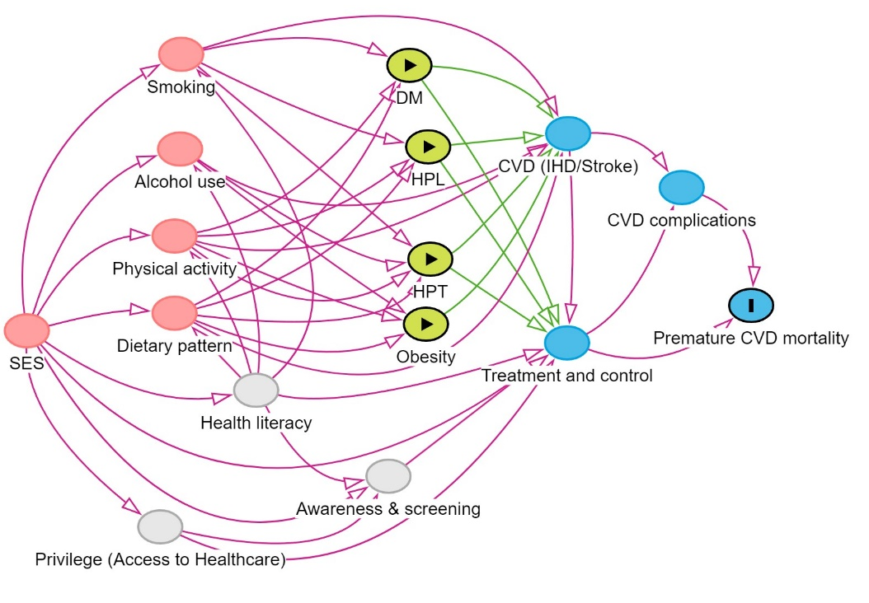
- Separate node for SES.
Do you agree that SES (Socioeconomic Status) should be represented as a separate node, distinct from education level, occupation status, income level, and living area (urban/rural) in the model?
- Combine node (education + income level as SES).
To what degree do you agree with combining education level and income level into a single node labelled SES (Socioeconomic Status) in the DAG model?
- Combine node (education + income level + occupation status + living area as SES).
To what extent do you agree with combining the nodes for occupation status, income level, education level, and living area (urban/rural) into a single node labeled SES (Socioeconomic Status) in the DAG model?
- Direction: SES -> smoking.
To what extent do you agree that an individual's socioeconomic status (SES) directly influences their likelihood of smoking?
- Direction: SES -> Alcohol intake.
To what extent do you agree that an individual's socioeconomic status (SES) directly influences their alcohol intake?
- Direction: SES -> Physical activity.
To what extent do you agree that an individual's socioeconomic status (SES) directly influences their level of physical activity?
- Direction: SES -> Dietary pattern.
To what extent do you agree that an individual's socioeconomic status (SES) directly influences their dietary patterns?
- Direction: SES -> Health literacy.
To what extent do you agree that an individual's socioeconomic status (SES) has a direct impact on their level of health literacy?
- Direction: SES -> Awareness and screening.
To what extent do you agree that an individual's socioeconomic status (SES) directly influences their awareness and participation in screening for non-communicable diseases (NCDs) or cardiovascular diseases (CVD)?
- Direction: SES -> Access to healthcare.
To what extent do you agree that individuals with higher socioeconomic status (SES) experience privileged access to healthcare, and vice versa?
- Direction: SES -> Treatment and control.
To what extent do you agree that an individual's higher socioeconomic status (SES) directly influences the treatment and control of health issues, and vice versa?

F: Causal path from behavioural risk (Dietary pattern)
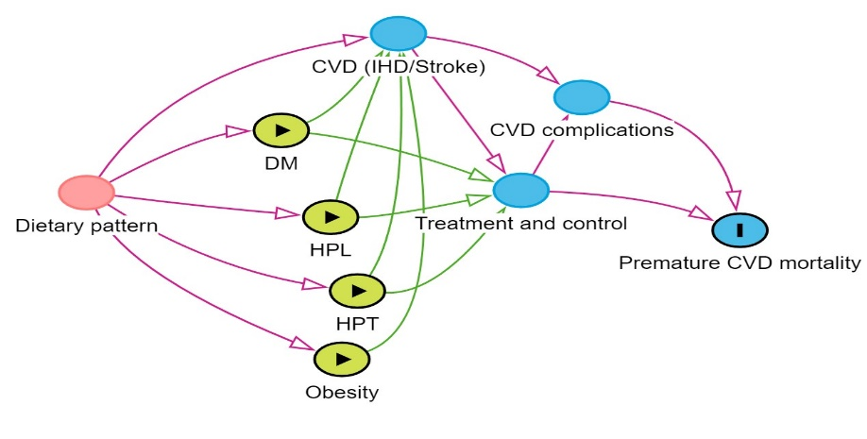
- Direction: Dietary pattern -> DM/HPT/HPL.
To what extent do you agree that an individual's dietary pattern has a direct impact on the development of diabetes, hypertension, and hyperlipidaemia?
- Direction: Dietary pattern -> obesity.
To what extent do you agree that an individual's dietary pattern has a direct impact on the development of obesity?
- Direction: Dietary pattern -> CVD (IHD/stroke).
To what extent do you agree that an individual's dietary pattern directly influences the risk of developing cardiovascular diseases, including IHD and stroke?

G: Causal path from behavioural risk (Smoking)
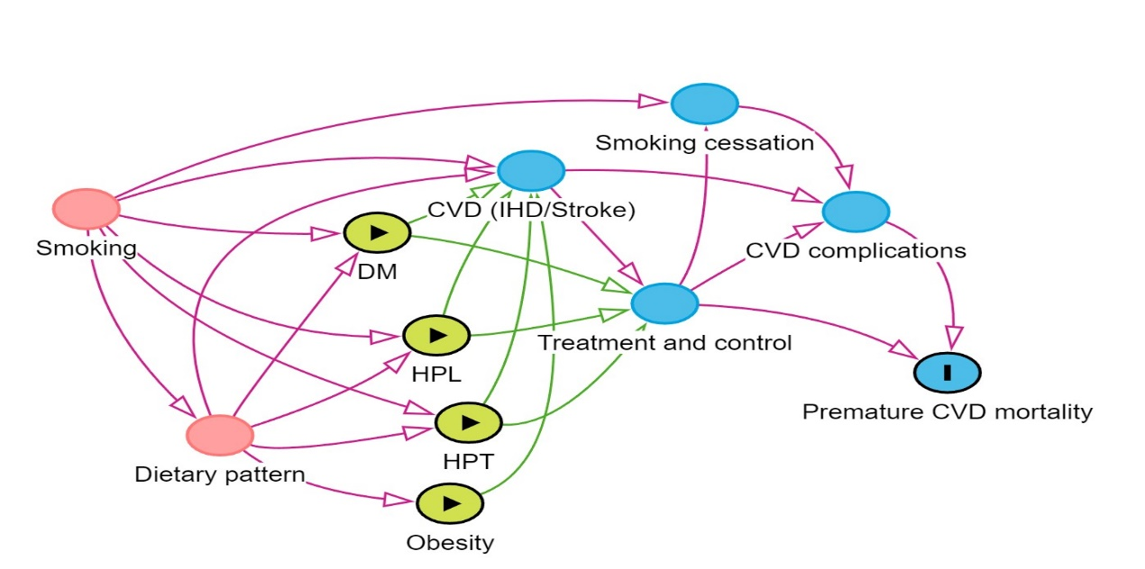
- Direction: Smoking -> CVD (IHD/Stroke).
To what extent do you agree that smoking has a direct impact on the development of CVDs, including ischemic heart disease (IHD) and stroke?
- Direction: Smoking -> DM.
To what extent do you agree that smoking has a direct impact on the development of diabetes?
- Direction: Smoking -> HPT.
To what extent do you agree that smoking has a direct impact on the development of hypertension?
- Direction: Smoking -> HPL.
To what extent do you agree that smoking has a direct impact on the development of hyperlipidaemia?
- Direction: Smoking -> Dietary pattern -> obesity.
To what extent do you agree that the observed lower likelihood of obesity among smokers is mediated by their dietary patterns?
- Direction: Smoking -> CVD/NCDs -> treatments -> smoking cessation -> CVD complications
To what extent do you agree that the causal path from CVD, including IHD, stroke or other NCDs, through the implementation of treatments, leading to smoking cessation, plays a significant role in reducing the risk of subsequent CVD complications?

H: Causal path from behavioural risk (Alcohol intake)
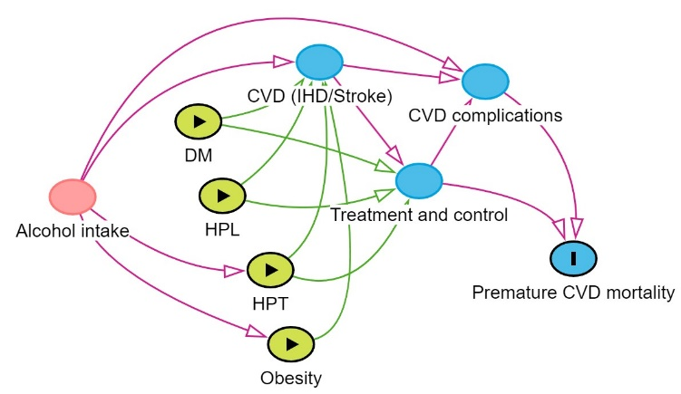
- Direction: Alcohol intake -> CVD (IHD/Stroke).
To what extent do you agree that alcohol intake has a direct impact on the development of CVDs, including IHD and stroke?
- Direction: Alcohol intake -> HPT.
To what extent do you agree that alcohol intake has a direct impact on the development of hypertension?
- Direction: Alcohol intake -> obesity.
To what extent do you agree that alcohol intake has a direct impact on the development of obesity?
- Direction: Alcohol intake -> CVD complications.
To what extent do you agree that alcohol intake is directly linked to the severity of complications in individuals with cardiovascular disease?
- To what extent do you agree that there is no direct causal link between alcohol intake and the development of diabetes?
- To what extent do you agree that there is no direct causal link between alcohol intake and the development of hyperlipidaemia?

I: Causal path from behavioural risk (Physical activity level)
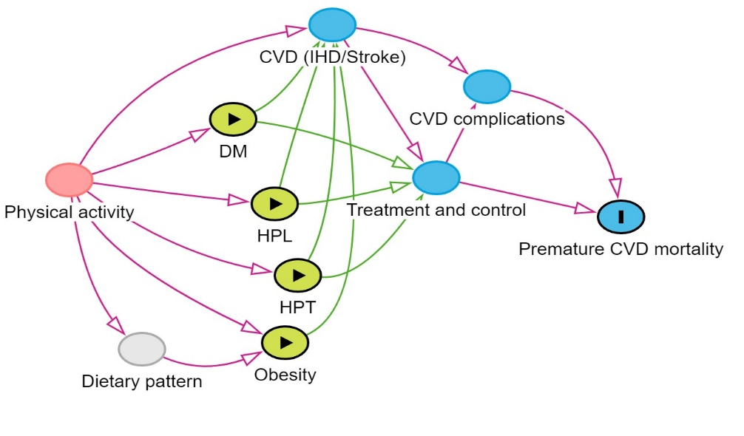
- Direction: Physical activity -> DM/HPT/HPL.
To what extent do you agree that physical activity has a direct impact on the development of diabetes, hypertension, and hyperlipidaemia?
- Direction: Physical activity -> obesity.
To what extent do you agree that physical activity has a direct impact on the development of obesity?
- Direction: Physical activity -> CVD (IHD/stroke).
To what extent do you agree physical activity directly influences the risk of developing cardiovascular diseases, including IHD and stroke?
- Direction: Physical activity -> dietary pattern.
How strongly do you agree that physical activity plays a direct role in shaping dietary patterns, as seen in examples where individuals who engage in regular physical activity tend to prefer healthier diets?

J: Causal path from other risk factors (Health literacy & access to healthcare)
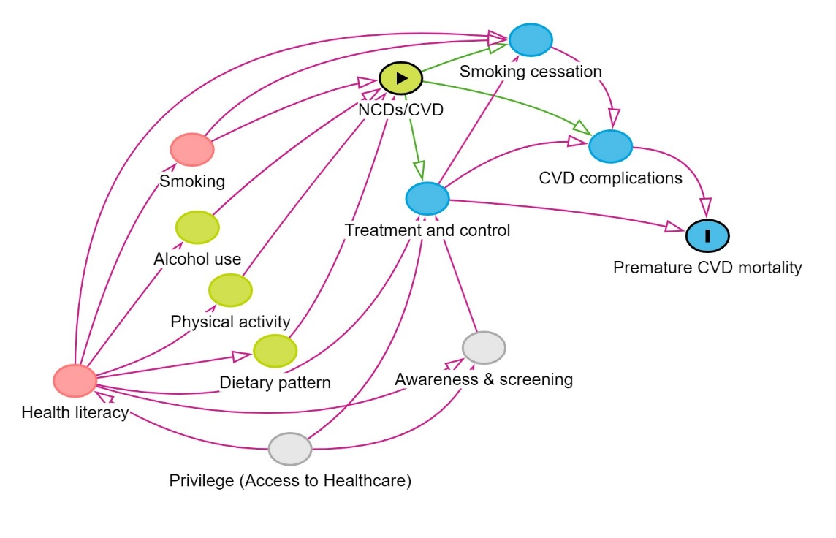
- Direction: Health literacy -> behavioural risks.
To what extent do you agree that health literacy has a direct impact on behavioural risks such as physical inactivity, smoking, alcohol consumption, and unhealthy diet?
- Direction: Health literacy -> smoking cessation.
To what extent do you agree that health literacy has a direct impact on the likelihood of successful smoking cessation?
- Direction: Health literacy -> Awareness and screening.
To what extent do you agree that health literacy directly influences awareness and screening for non-communicable diseases?
- Direction: Health literacy -> Treatment & control.
To what extent do you agree that health literacy directly influences individuals' intentions to seek treatment and their subsequent compliance with treatment and control measures for health conditions?

K: Causal path from other risk factors (Psychological & Environment factor)
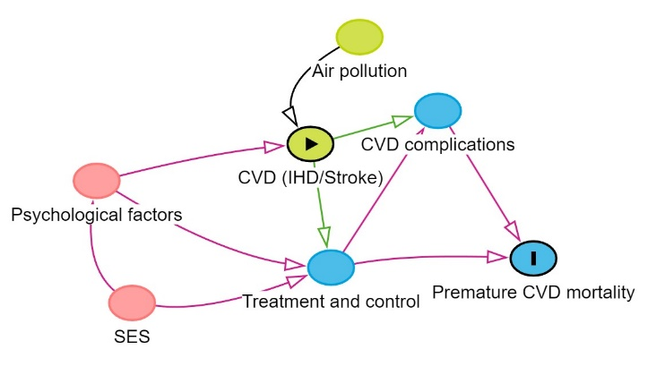
- Direction: Psychological factors -> CVD (IHD/stroke).
To what extent do you agree that specific psychological problems, such as stress, anxiety, or depression, can have a direct impact on the development of CVDs, including IHD and stroke?
- Direction: Psychological factors -> treatment/control -> CVD complications
To what extent do you agree that psychological factors play a direct role in the treatment and control (of NCDs), influencing their management and outcomes?
- Direction: SES -> Psychological factors
To what degree do you agree that socioeconomic status (SES) has a direct impact on psychological factors, subsequently affecting the risk of CVD/CVD complications?
- Direction: Environment (air pollution) -> CVD (IHD/stroke).
To what extent do you agree that environmental factors, specifically exposure to air pollution, have a direct impact on the development of CVDs, including IHD and stroke?

J: Causal path from NCDs (Diabetes, Hypertension, Hyperlipidaemia, Obesity)

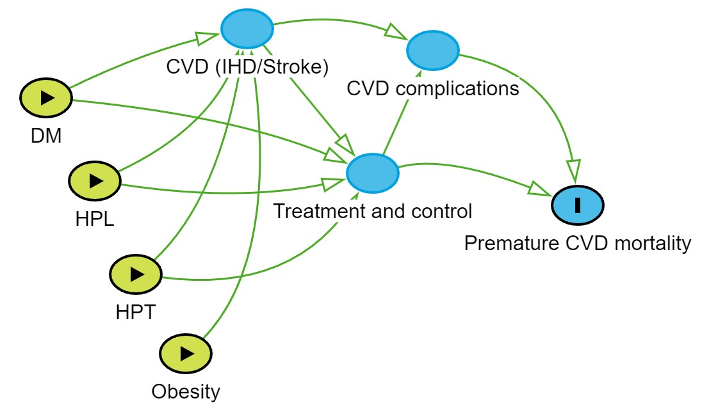
- Direction: DM/HPT/HPL -> CVD (IHD/stroke).
To what extent do you agree that conditions such as diabetes, hypertension and hyperlipidaemia have a direct impact on the development of CVDs specifically, IHD and stroke?
- Direction: Obesity -> CVD (IHD/stroke).
To what extent do you agree that obesity has a direct impact on the development of CVDs specifically, IHD and stroke?
- Direction: DM/HPT/HPL -> treatment/control -> CVD complications.
To what extent do you agree that the absence of treatment and control for diabetes, hypertension, and hyperlipidaemia directly contributes to an increased risk of CVD complications?

