SUPPLEMENTARY MATERIAL

Biomolecular interaction, antibacterial and anticancer activities of organometallic Re(I) complexes with 5-(2-butyl-5-chloro-1H-imidazol-4-yl)-1,3-diaryl-4,5-dihydro-1H-pyrazole

Reena R. Varma¹, Juhee G. Pandya², Foram U. Vaidya³, Chandramani Pathak⁴, Milan P. Dhaduk¹, Ravi A. Dabhi¹, Bhupesh S. Bhatt¹, Mohan N. Patel¹*

¹Department of Chemistry, Sardar Patel University,
Vallabh Vidyanagar–388 120, Gujarat (INDIA)
Phone number: (+912692) 226856*218
Corresponding address: jeenen@gmail.com, bhupeshbhatt31@gmail.com

²Department of Biosciences, Sardar Patel University,
Vallabh Vidyanagar, Gujarat, (INDIA)

³Department of Cell Biology, School of Biological Sciences and Biotechnology,
Indian Institute of Advanced Research, Koba Institutional Area,
Gandhinagar-382007, Gujarat (INDIA)

⁴ Amity institute of biotechnology,
Amity University Haryana,Manesar, Gurgaon-122413,(INDIA)

Supplementary data 1
Characterization data and Spectra of ligands (L1-L6) and Complexes (I-VI)
Ligand (L¹)

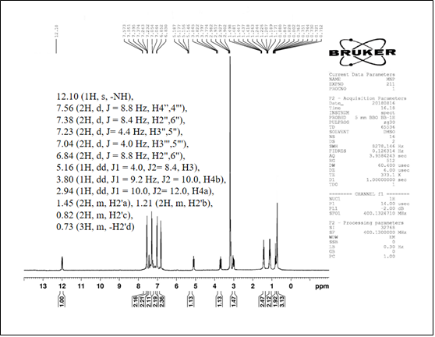

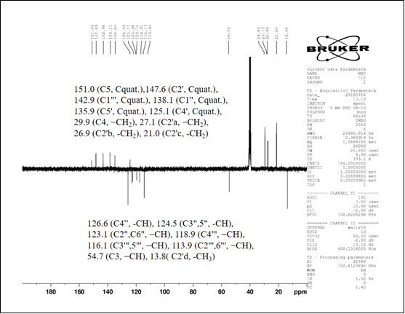

Ligand (L²)

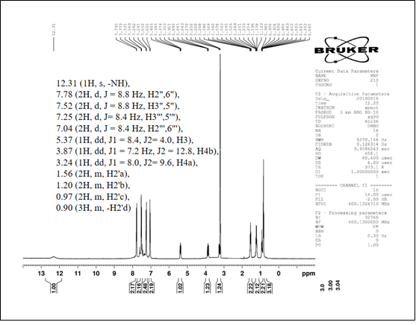

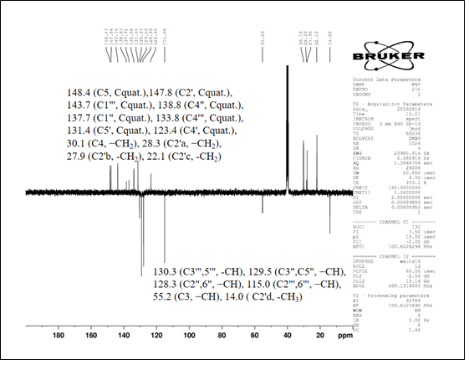

Ligand (L³)

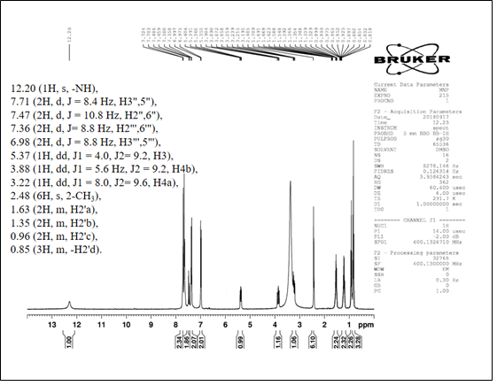

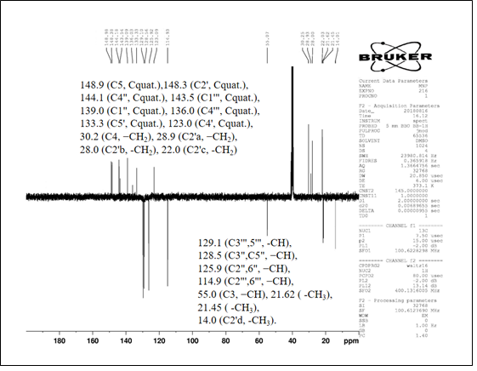

Ligand (L⁴)

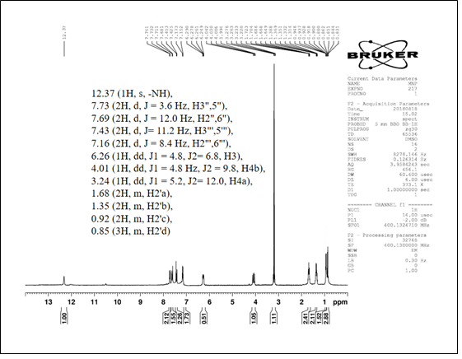

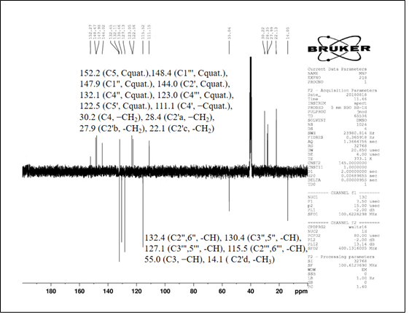

Ligand (L⁵)

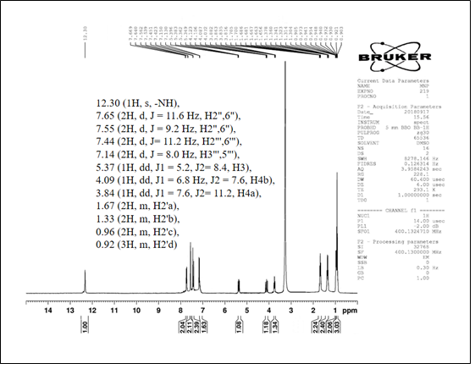

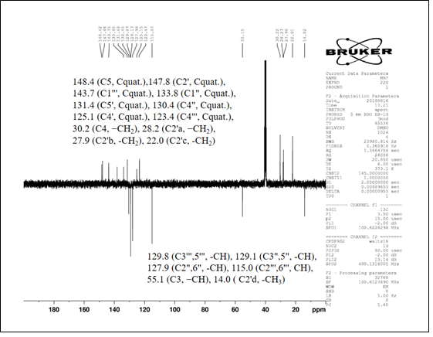

Ligand (L⁶)

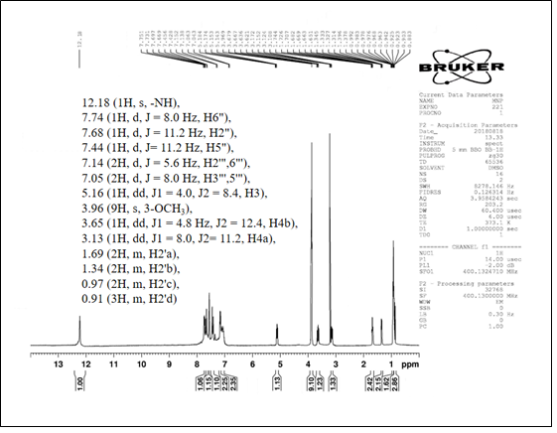

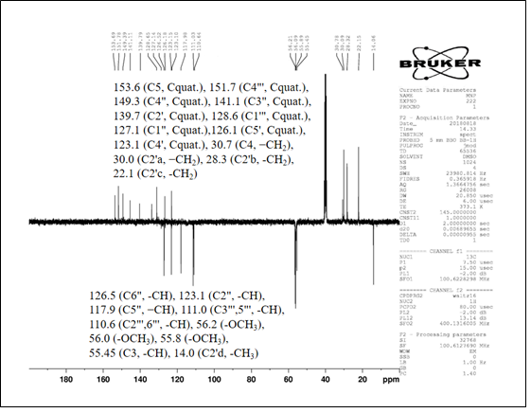

[Re(CO)₃(L¹)Cl] (I)

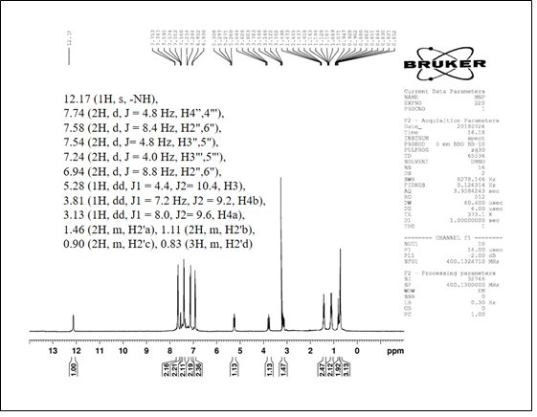

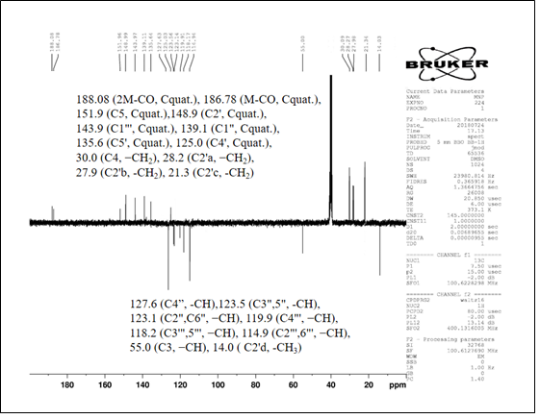

[Re(CO)₃(L²)Cl] (II)

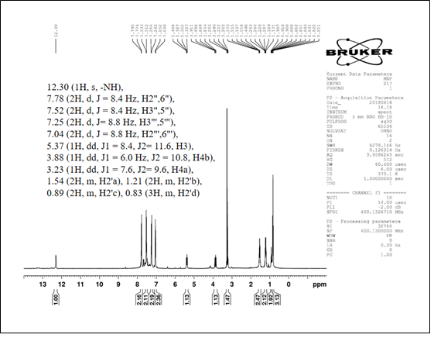

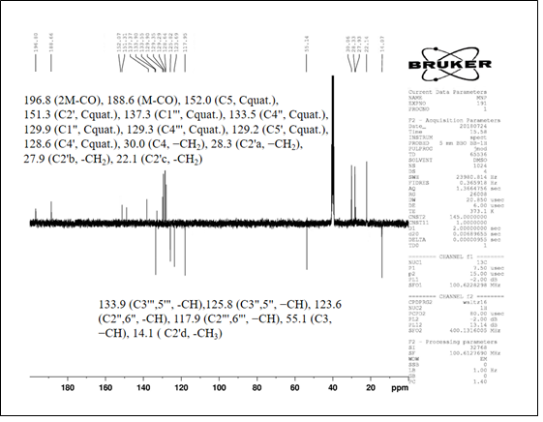

[Re(CO)₃(L³)Cl] (III)

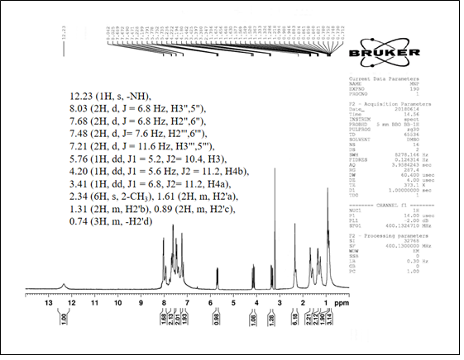

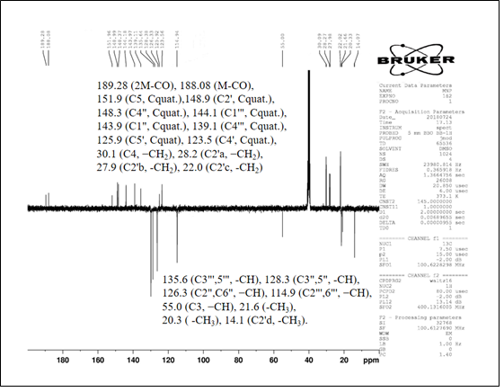

[Re(CO)₃(L⁴)Cl] (IV)

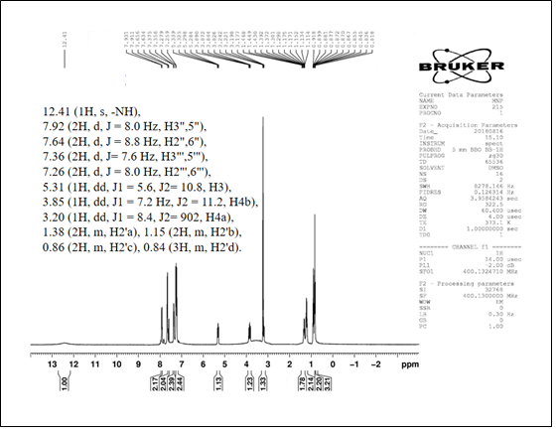

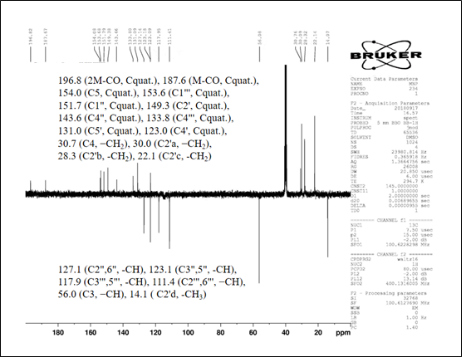

[Re(CO)₃(L⁵)Cl] (V)

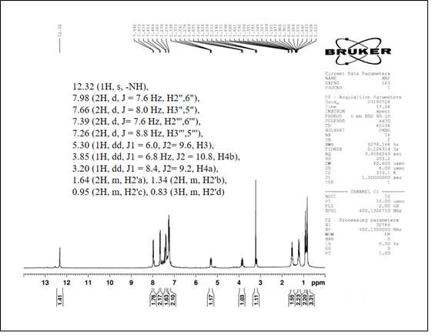
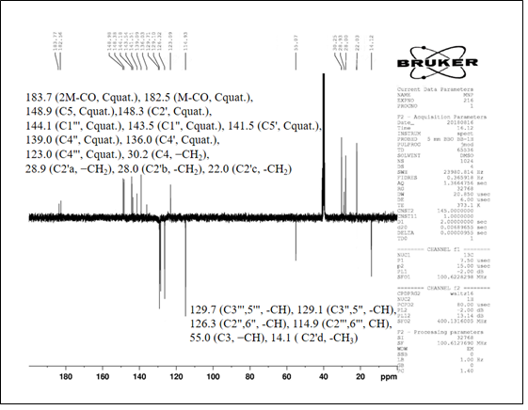

[Re(CO)₃(L⁶)Cl] (VI)

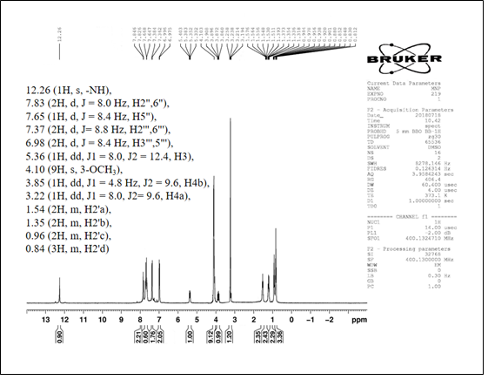

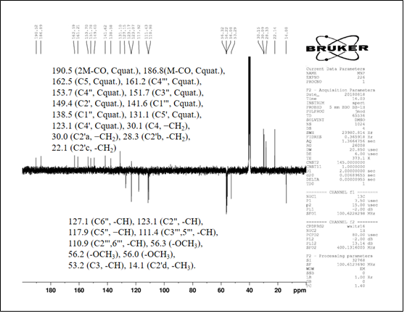

DFT data

(Table of bond length bond angle and mulical charges and images for complex I to VI )
Atom number | Bond length (Å) | Atom number | Bond length (Å)
R(1,2) | 2.4918 | R(23,26) | 1.4036
R(1,3) | 1.9081 | R(23,27) | 1.0858
R(1,5) | 1.9246 | R(24,28) | 1.408
R(1,7) | 1.8686 | R(24,55) | 1.0875
R(1,9) | 2.231 | R(26,28) | 1.4098
R(1,18) | 3.5601 | R(26,29) | 1.0875
R(3,4) | 1.1927 | R(28,54) | 1.0874
R(5,6) | 1.1826 | R(30,31) | 1.4151
R(7,8) | 1.1914 | R(30,32) | 1.412
R(9,10) | 1.3545 | R(31,33) | 1.4017
R(9,11) | 1.4259 | R(31,34) | 1.0863
R(10,20) | 1.3741 | R(32,35) | 1.4114
R(10,41) | 1.5046 | R(32,36) | 1.0847
R(11,12) | 1.381 | R(33,37) | 1.4123
R(11,17) | 1.4567 | R(33,38) | 1.0865
R(12,20) | 1.3869 | R(35,37) | 1.4045
R(12,40) | 1.7727 | R(35,39) | 1.0864
R(13,20) | 1.0113 | R(37,56) | 1.0864
R(14,15) | 1.4285 | R(41,42) | 1.5472
R(14,16) | 1.0781 | R(41,43) | 1.0956
R(14,17) | 1.3927 | R(41,44) | 1.0975
R(15,19) | 1.3606 | R(42,45) | 1.5449
R(15,21) | 1.4745 | R(42,46) | 1.1014
R(17,18) | 1.3878 | R(42,47) | 1.1031
R(18,19) | 1.3843 | R(45,48) | 1.5419
R(18,30) | 1.4293 | R(45,49) | 1.0999
R(21,22) | 1.4139 | R(45,50) | 1.0999
R(21,23) | 1.4156 | R(48,51) | 1.097
R(22,24) | 1.4055 | R(48,52) | 1.0987
R(22,25) | 1.0872 | R(48,53) | 1.0987
Re-1

Atom number | Bond angle (°) | Atom number | Bond angle (°)
A(2,1,5) | 89.9862 | A(22,24,28) | 120.2216
A(2,1,7) | 96.0782 | A(22,24,55) | 119.7522
A(2,1,9) | 86.209 | A(28,24,55) | 120.0262
A(2,1,18) | 64.5338 | A(23,26,28) | 120.347
A(3,1,5) | 91.5788 | A(23,26,29) | 119.7095
A(3,1,7) | 91.0911 | A(28,26,29) | 119.9433
A(3,1,9) | 91.4626 | A(24,28,26) | 119.491
A(3,1,18) | 108.2811 | A(24,28,54) | 120.2266
A(5,1,7) | 88.728 | A(26,28,54) | 120.2823
A(5,1,18) | 110.739 | A(18,30,31) | 120.2015
A(7,1,9) | 97.6281 | A(18,30,32) | 118.7984
A(9,1,18) | 62.1896 | A(31,30,32) | 120.536
A(1,9,10) | 125.1842 | A(30,31,33) | 119.5091
A(1,9,11) | 127.2772 | A(30,31,34) | 119.6762
A(10,9,11) | 107.4894 | A(33,31,34) | 120.7686
A(9,10,20) | 109.1165 | A(30,32,35) | 119.3068
A(9,10,41) | 128.9568 | A(30,32,36) | 119.0083
A(20,10,41) | 121.9216 | A(35,32,36) | 121.5645
A(9,11,12) | 107.2046 | A(31,33,37) | 120.3314
A(9,11,17) | 126.4194 | A(31,33,38) | 119.7124
A(12,11,17) | 126.3372 | A(37,33,38) | 119.9479
A(11,12,20) | 107.6265 | A(32,35,37) | 120.3343
A(11,12,40) | 131.6022 | A(32,35,39) | 119.3393
A(20,12,40) | 120.753 | A(37,35,39) | 120.3264
A(15,14,16) | 127.756 | A(33,37,35) | 119.9732
A(15,14,17) | 106.1935 | A(33,37,56) | 119.9151
A(16,14,17) | 125.922 | A(35,37,56) | 120.1116
A(14,15,19) | 110.4578 | A(10,41,42) | 114.3389
A(14,15,21) | 128.7524 | A(10,41,43) | 108.7944
A(19,15,21) | 120.7897 | A(10,41,44) | 109.1271
A(11,17,14) | 128.9314 | A(42,41,43) | 109.1104
A(11,17,18) | 124.6285 | A(42,41,44) | 108.9806
A(14,17,18) | 106.3604 | A(43,41,44) | 106.174
A(1,18,17) | 84.3532 | A(41,42,45) | 111.5971
A(1,18,19) | 135.1212 | A(41,42,46) | 110.0542
A(1,18,30) | 61.1995 | A(41,42,47) | 110.3658
A(17,18,19) | 111.6412 | A(45,42,46) | 108.9186
A(17,18,30) | 129.5473 | A(45,42,47) | 108.2594
A(19,18,30) | 118.7969 | A(46,42,47) | 107.5343
A(15,19,18) | 105.3293 | A(42,45,48) | 112.6425
A(10,20,12) | 108.5587 | A(42,45,49) | 109.2143
A(10,20,13) | 125.381 | A(42,45,50) | 109.0695
A(12,20,13) | 126.0603 | A(48,45,49) | 109.6216
A(15,21,22) | 120.8717 | A(48,45,50) | 109.6023
A(15,21,23) | 120.3282 | A(49,45,50) | 106.501
A(22,21,23) | 118.8001 | A(45,48,51) | 110.9995
A(21,22,24) | 120.6301 | A(45,48,52) | 111.1908
A(21,22,25) | 120.0838 | A(45,48,53) | 111.2011
A(24,22,25) | 119.2861 | A(51,48,52) | 107.7171
A(21,23,26) | 120.5102 | A(51,48,53) | 107.688
A(21,23,27) | 118.8359 | A(52,48,53) | 107.881
A(26,23,27) | 120.6537

Re2:
Atom number | Bond length (Å) | Atom number | Bond length (Å)
R(1,2) | 2.4883 | R(23,26) | 1.4034
R(1,3) | 1.9089 | R(23,27) | 1.0853
R(1,5) | 1.9253 | R(24,28) | 1.4009
R(1,7) | 1.8687 | R(24,53) | 1.0852
R(1,9) | 2.2292 | R(26,28) | 1.4028
R(1,18) | 3.5745 | R(26,29) | 1.0852
R(3,4) | 1.192 | R(28,55) | 1.8219
R(5,6) | 1.1821 | R(30,31) | 1.4147
R(7,8) | 1.1908 | R(30,32) | 1.412
R(9,10) | 1.3546 | R(31,33) | 1.4014
R(9,11) | 1.4257 | R(31,34) | 1.0858
R(10,20) | 1.3741 | R(32,35) | 1.4091
R(10,40) | 1.5042 | R(32,36) | 1.0844
R(11,12) | 1.3811 | R(33,37) | 1.4061
R(11,17) | 1.4574 | R(33,38) | 1.0847
R(12,20) | 1.3865 | R(35,37) | 1.3996
R(12,54) | 1.7722 | R(35,39) | 1.0848
R(13,20) | 1.0116 | R(37,56) | 1.812
R(14,15) | 1.428 | R(40,41) | 1.5473
R(14,16) | 1.0781 | R(40,42) | 1.0955
R(14,17) | 1.3926 | R(40,43) | 1.0977
R(15,19) | 1.3598 | R(41,44) | 1.5451
R(15,21) | 1.4734 | R(41,45) | 1.1015
R(17,18) | 1.3889 | R(41,46) | 1.103
R(18,19) | 1.3841 | R(44,47) | 1.5418
R(18,30) | 1.4281 | R(44,48) | 1.0999
R(21,22) | 1.4134 | R(44,49) | 1.0998
R(21,23) | 1.4154 | R(47,50) | 1.0969
R(22,24) | 1.4054 | R(47,51) | 1.0986
R(22,25) | 1.0865 | R(47,52) | 1.0987

Atom number | Bond angle (°) | Atom number | Bond angle (°)
A(2,1,5) | 89.9329 | A(21,22,25) | 120.3171
A(2,1,7) | 97.0111 | A(24,22,25) | 118.6807
A(2,1,9) | 86.1508 | A(21,23,26) | 120.9209
A(2,1,18) | 64.1119 | A(21,23,27) | 119.0321
A(3,1,5) | 91.8201 | A(26,23,27) | 120.047
A(3,1,7) | 90.8671 | A(22,24,28) | 118.7911
A(3,1,9) | 91.1896 | A(22,24,53) | 120.7433
A(3,1,18) | 107.9708 | A(28,24,53) | 120.4656
A(5,1,7) | 88.637 | A(23,26,28) | 118.8767
A(5,1,18) | 110.2101 | A(23,26,29) | 120.7111
A(7,1,9) | 98.2682 | A(28,26,29) | 120.4121
A(9,1,18) | 62.2288 | A(24,28,26) | 121.7139
A(1,9,10) | 125.1472 | A(24,28,55) | 119.1045
A(1,9,11) | 127.3355 | A(26,28,55) | 119.1816
A(10,9,11) | 107.4825 | A(18,30,31) | 120.4078
A(9,10,20) | 109.101 | A(18,30,32) | 118.7677
A(9,10,40) | 128.8956 | A(31,30,32) | 120.3118
A(20,10,40) | 122.0002 | A(30,31,33) | 119.908
A(9,11,12) | 107.2215 | A(30,31,34) | 119.959
A(9,11,17) | 126.5166 | A(33,31,34) | 120.0878
A(12,11,17) | 126.204 | A(30,32,35) | 119.7884
A(11,12,20) | 107.6035 | A(30,32,36) | 119.2026
A(11,12,54) | 131.5869 | A(35,32,36) | 120.9303
A(20,12,54) | 120.7943 | A(31,33,37) | 119.0831
A(15,14,16) | 127.8268 | A(31,33,38) | 120.6076
A(15,14,17) | 106.2003 | A(37,33,38) | 120.3
A(16,14,17) | 125.8495 | A(32,35,37) | 119.0548
A(14,15,19) | 110.5156 | A(32,35,39) | 120.2439
A(14,15,21) | 128.8402 | A(37,35,39) | 120.7013
A(19,15,21) | 120.6439 | A(33,37,35) | 121.8441
A(11,17,14) | 128.6551 | A(33,37,56) | 118.9053
A(11,17,18) | 124.9588 | A(35,37,56) | 119.2502
A(14,17,18) | 106.3114 | A(10,40,41) | 114.3204
A(1,18,17) | 83.8733 | A(10,40,42) | 108.682
A(1,18,19) | 135.2091 | A(10,40,43) | 109.1385
A(1,18,30) | 61.4453 | A(41,40,42) | 109.1395
A(17,18,19) | 111.6285 | A(41,40,43) | 109.078
A(17,18,30) | 129.8435 | A(42,40,43) | 106.1672
A(19,18,30) | 118.5236 | A(40,41,44) | 111.5672
A(15,19,18) | 105.322 | A(40,41,45) | 110.0505
A(10,20,12) | 108.5876 | A(40,41,46) | 110.3696
A(10,20,13) | 125.3626 | A(44,41,45) | 108.8654
A(12,20,13) | 126.0497 | A(44,41,46) | 108.3268
A(15,21,22) | 120.9963 | A(45,41,46) | 107.552
A(15,21,23) | 120.3085 | A(41,44,47) | 112.6342
A(22,21,23) | 118.6952 | A(41,44,48) | 109.2312
A(21,22,24) | 121.0022 | A(41,44,49) | 109.0168
A(47,44,48) | 109.6418 | A(44,47,52) | 111.2104
A(47,44,49) | 109.6175 | A(50,47,51) | 107.7015
A(48,44,49) | 106.5104 | A(50,47,52) | 107.6877
A(44,47,50) | 110.9817 | A(51,47,52) | 107.8944
A(44,47,51) | 111.2016

Atom number | Bond length (Å) | Atom number | Bond length (Å)
R(1,2) | 2.2682 | R(23,26) | 1.4034
R(1,3) | 2.0555 | R(23,27) | 1.0729
R(1,5) | 2.0499 | R(24,28) | 1.3927
R(1,7) | 2.0513 | R(24,29) | 1.0681
R(1,9) | 2.0033 | R(26,28) | 1.407
R(1,18) | 2.0684 | R(26,30) | 1.0714
R(3,4) | 1.2615 | R(28,56) | 1.91
R(5,6) | 1.2583 | R(31,32) | 1.4015
R(7,8) | 1.2592 | R(31,33) | 1.4013
R(9,10) | 1.2876 | R(32,34) | 1.402
R(9,11) | 1.3406 | R(32,35) | 1.0705
R(10,20) | 1.5103 | R(33,36) | 1.4008
R(10,42) | 1.5411 | R(33,37) | 1.0703
R(11,12) | 1.3279 | R(34,38) | 1.4015
R(11,17) | 1.4756 | R(34,39) | 1.0694
R(12,20) | 1.4991 | R(36,38) | 1.4015
R(12,41) | 1.7601 | R(36,40) | 1.0704
R(13,20) | 1.0039 | R(38,55) | 1.9105
R(14,15) | 1.4197 | R(42,43) | 1.5413
R(14,16) | 1.0691 | R(42,44) | 1.0652
R(14,17) | 1.4554 | R(42,45) | 1.0748
R(15,19) | 1.3116 | R(43,46) | 1.5407
R(15,21) | 1.5342 | R(43,47) | 1.0728
R(17,18) | 1.493 | R(43,48) | 1.0674
R(18,19) | 1.5255 | R(46,49) | 1.5414
R(18,31) | 1.4685 | R(46,50) | 1.0687
R(21,22) | 1.3998 | R(46,51) | 1.0713
R(21,23) | 1.4029 | R(49,52) | 1.0703
R(22,24) | 1.3938 | R(49,53) | 1.0711
R(22,25) | 1.0687 | R(49,54) | 1.0691
Re3:

Atom number | Bond angle (°) | Atom number | Bond angle (°)
A(2,1,5) | 86.7177 | A(22,21,23) | 120.2351
A(2,1,7) | 87.106 | A(21,22,24) | 120.0741
A(2,1,9) | 87.9933 | A(21,22,25) | 120.2184
A(2,1,18) | 100.4583 | A(24,22,25) | 119.7068
A(3,1,5) | 90.9478 | A(21,23,26) | 119.5562
A(3,1,7) | 87.0339 | A(21,23,27) | 120.1564
A(3,1,9) | 95.104 | A(26,23,27) | 120.2872
A(3,1,18) | 85.3676 | A(22,24,28) | 120.1062
A(5,1,7) | 93.7172 | A(22,24,29) | 120.127
A(5,1,18) | 85.8944 | A(28,24,29) | 119.7668
A(7,1,9) | 93.742 | A(23,26,28) | 119.7643
A(9,1,18) | 87.4604 | A(23,26,30) | 120.0081
A(1,9,10) | 139.537 | A(28,26,30) | 120.2276
A(1,9,11) | 109.1539 | A(24,28,26) | 120.2217
A(10,9,11) | 111.2507 | A(24,28,56) | 119.112
A(9,10,20) | 106.5829 | A(26,28,56) | 120.6663
A(9,10,42) | 126.7892 | A(18,31,32) | 120.5398
A(20,10,42) | 126.6251 | A(18,31,33) | 119.4267
A(9,11,12) | 113.0102 | A(32,31,33) | 120.0332
A(9,11,17) | 102.7126 | A(31,32,34) | 119.8467
A(12,11,17) | 144.2749 | A(31,32,35) | 120.1183
A(11,12,20) | 104.7728 | A(34,32,35) | 120.0349
A(11,12,41) | 127.2902 | A(31,33,36) | 120.0973
A(20,12,41) | 127.9311 | A(31,33,37) | 119.8945
A(15,14,16) | 132.3215 | A(36,33,37) | 120.0081
A(15,14,17) | 95.3065 | A(32,34,38) | 120.1023
A(16,14,17) | 131.9275 | A(32,34,39) | 120.0043
A(14,15,19) | 102.3526 | A(38,34,39) | 119.8934
A(14,15,21) | 128.9276 | A(33,36,38) | 119.9142
A(19,15,21) | 128.6665 | A(33,36,40) | 120.0038
A(11,17,14) | 130.3601 | A(38,36,40) | 120.0819
A(11,17,18) | 118.9423 | A(34,38,36) | 119.992
A(14,17,18) | 110.5844 | A(34,38,55) | 119.9054
A(1,18,17) | 82.1732 | A(36,38,55) | 120.1026
A(1,18,19) | 145.8646 | A(10,42,43) | 109.4846
A(1,18,31) | 86.8597 | A(10,42,44) | 109.7106
A(17,18,19) | 85.6745 | A(10,42,45) | 109.2187
A(17,18,31) | 138.6774 | A(43,42,44) | 107.6383
A(19,18,31) | 81.5048 | A(43,42,45) | 111.2658
A(15,19,18) | 120.3518 | A(44,42,45) | 109.4997
A(10,20,12) | 101.5529 | A(42,43,46) | 109.5027
A(10,20,13) | 113.55 | A(42,43,47) | 108.4928
A(12,20,13) | 112.9781 | A(42,43,48) | 110.4271
A(15,21,22) | 119.4069 | A(46,43,47) | 109.2098
A(15,21,23) | 120.3574 | A(46,43,48) | 109.697
A(47,43,48) | 109.4859 | A(46,49,52) | 109.4624
A(43,46,49) | 109.5836 | A(46,49,53) | 109.4982
A(43,46,50) | 109.3193 | A(46,49,54) | 109.4915
A(43,46,51) | 109.5485 | A(52,49,53) | 109.3969
A(49,46,50) | 109.6902 | A(52,49,54) | 109.5183
A(49,46,51) | 109.1875 | A(53,49,54) | 109.4601
A(50,46,51) | 109.4985
Re4:
Atom number | Bond length (Å) | Atom number | Bond length (Å)
R(1,2) | 2.4934 | R(24,67) | 1.4101
R(1,3) | 1.9061 | R(26,28) | 1.4057
R(1,5) | 1.9268 | R(26,29) | 1.0863
R(1,7) | 1.8692 | R(28,68) | 1.4071
R(1,9) | 2.2238 | R(30,31) | 1.4131
R(1,18) | 3.5388 | R(30,32) | 1.4167
R(3,4) | 1.1945 | R(31,33) | 1.4006
R(5,6) | 1.1818 | R(31,34) | 1.0863
R(7,8) | 1.1914 | R(32,35) | 1.4012
R(9,10) | 1.3539 | R(32,36) | 1.0844
R(9,11) | 1.4252 | R(33,37) | 1.4153
R(10,20) | 1.374 | R(33,38) | 1.0844
R(10,41) | 1.504 | R(35,37) | 1.4103
R(11,12) | 1.3814 | R(35,39) | 1.0849
R(11,17) | 1.4568 | R(37,66) | 1.3867
R(12,20) | 1.3874 | R(41,42) | 1.547
R(12,40) | 1.7728 | R(41,43) | 1.0958
R(13,20) | 1.0113 | R(41,44) | 1.0975
R(14,15) | 1.4272 | R(42,45) | 1.5449
R(14,16) | 1.078 | R(42,46) | 1.1014
R(14,17) | 1.3934 | R(42,47) | 1.1031
R(15,19) | 1.3611 | R(45,48) | 1.5419
R(15,21) | 1.4735 | R(45,49) | 1.0999
R(17,18) | 1.3877 | R(45,50) | 1.1
R(18,19) | 1.384 | R(48,51) | 1.097
R(18,30) | 1.4299 | R(48,52) | 1.0986
R(21,22) | 1.4124 | R(48,53) | 1.0987
R(21,23) | 1.4152 | R(54,55) | 1.0927
R(22,24) | 1.4013 | R(54,56) | 1.0957
R(22,25) | 1.086 | R(54,57) | 1.0984
R(23,26) | 1.4022 | R(54,68) | 1.4731
R(23,27) | 1.0852 | R(58,59) | 1.0927
R(24,28) | 1.4155 | R(58,60) | 1.096
R(58,61) | 1.0982 | R(62,64) | 1.0986
R(58,67) | 1.4736 | R(62,65) | 1.0977
R(62,63) | 1.0912 | R(62,66) | 1.4603

Atom number | Bond angle (°) | Atom number | Bond angle (°)
A(2,1,5) | 89.8936 | A(22,21,23) | 118.7138
A(2,1,7) | 95.6161 | A(21,22,24) | 120.8566
A(2,1,9) | 85.95 | A(21,22,25) | 121.5728
A(2,1,18) | 65.0343 | A(24,22,25) | 117.5668
A(3,1,5) | 91.6684 | A(21,23,26) | 120.4796
A(3,1,7) | 91.103 | A(21,23,27) | 119.0024
A(3,1,9) | 91.7509 | A(26,23,27) | 120.5165
A(3,1,18) | 108.1808 | A(22,24,28) | 120.0711
A(5,1,7) | 88.6112 | A(22,24,67) | 118.6137
A(5,1,18) | 109.8513 | A(28,24,67) | 121.2906
A(7,1,9) | 97.9441 | A(23,26,28) | 120.5769
A(9,1,18) | 62.7562 | A(23,26,29) | 121.2047
A(1,9,10) | 125.5062 | A(28,26,29) | 118.2182
A(1,9,11) | 126.8747 | A(24,28,26) | 119.2642
A(10,9,11) | 107.5741 | A(24,28,68) | 121.6657
A(9,10,20) | 109.1051 | A(26,28,68) | 119.0143
A(9,10,41) | 128.7566 | A(18,30,31) | 120.5027
A(20,10,41) | 122.1305 | A(18,30,32) | 118.9508
A(9,11,12) | 107.1511 | A(31,30,32) | 119.7066
A(9,11,17) | 126.4757 | A(30,31,33) | 120.4107
A(12,11,17) | 126.324 | A(30,31,34) | 119.6346
A(11,12,20) | 107.6355 | A(33,31,34) | 119.9287
A(11,12,40) | 131.6799 | A(30,32,35) | 119.9152
A(20,12,40) | 120.6697 | A(30,32,36) | 118.9614
A(15,14,16) | 127.7743 | A(35,32,36) | 121.063
A(15,14,17) | 106.1886 | A(31,33,37) | 119.6655
A(16,14,17) | 125.9597 | A(31,33,38) | 119.3188
A(14,15,19) | 110.4443 | A(37,33,38) | 121.0125
A(14,15,21) | 128.6768 | A(32,35,37) | 120.1757
A(19,15,21) | 120.8788 | A(32,35,39) | 121.0582
A(11,17,14) | 128.5609 | A(37,35,39) | 118.7621
A(11,17,18) | 124.9917 | A(33,37,35) | 120.0986
A(14,17,18) | 106.397 | A(33,37,66) | 124.23
A(1,18,17) | 84.5404 | A(35,37,66) | 115.6713
A(1,18,19) | 136.4206 | A(10,41,42) | 114.4818
A(1,18,30) | 60.1345 | A(10,41,43) | 108.7405
A(17,18,19) | 111.5648 | A(10,41,44) | 109.0288
A(17,18,30) | 129.7362 | A(42,41,43) | 109.1968
A(19,18,30) | 118.6878 | A(42,41,44) | 108.9428
A(15,19,18) | 105.3894 | A(43,41,44) | 106.1205
A(10,20,12) | 108.5314 | A(41,42,45) | 111.5183
A(10,20,13) | 125.4509 | A(41,42,46) | 110.0947
A(12,20,13) | 126.0176 | A(41,42,47) | 110.3519
A(15,21,22) | 120.7281 | A(41,42,47) | 110.3519
A(15,21,23) | 120.5557 | A(45,42,46) | 108.9926
A(45,42,47) | 108.2661 | A(56,54,68) | 110.6996
A(46,42,47) | 107.5082 | A(57,54,68) | 110.0202
A(42,45,48) | 112.6964 | A(59,58,60) | 110.5362
A(42,45,49) | 109.1847 | A(59,58,61) | 109.9443
A(42,45,50) | 109.0834 | A(59,58,67) | 105.6531
A(48,45,49) | 109.6173 | A(60,58,61) | 109.9361
A(48,45,50) | 109.5971 | A(60,58,67) | 110.6462
A(49,45,50) | 106.4672 | A(61,58,67) | 110.0488
A(45,48,51) | 111 | A(63,62,64) | 109.6185
A(45,48,52) | 111.1913 | A(63,62,65) | 109.8993
A(45,48,53) | 111.1982 | A(63,62,66) | 105.0763
A(51,48,52) | 107.7316 | A(64,62,65) | 110.2315
A(51,48,53) | 107.6826 | A(64,62,66) | 111.1193
A(52,48,53) | 107.874 | A(65,62,66) | 110.7743
A(55,54,56) | 110.5759 | A(37,66,62) | 119.0266
A(55,54,57) | 109.8846 | A(24,67,58) | 115.0045
A(55,54,68) | 105.5817 | A(28,68,54) | 115.6039
A(56,54,57) | 109.9966

Re-5:

Atom number | Bond length (Å) | Atom number | Bond length (Å)
R(1,2) | 2.2671 | R(24,53) | 1.0723
R(1,3) | 2.053 | R(26,28) | 1.4028
R(1,5) | 2.0465 | R(26,29) | 1.0692
R(1,7) | 2.0525 | R(28,55) | 1.54
R(1,9) | 1.9947 | R(30,31) | 1.4064
R(1,18) | 2.0717 | R(30,32) | 1.4015
R(3,4) | 1.258 | R(31,33) | 1.406
R(5,6) | 1.2579 | R(31,34) | 1.0691
R(7,8) | 1.2573 | R(32,35) | 1.4042
R(9,10) | 1.2861 | R(32,36) | 1.0683
R(9,11) | 1.342 | R(33,37) | 1.4029
R(10,20) | 1.5075 | R(33,38) | 1.0721
R(10,40) | 1.5445 | R(35,37) | 1.4035
R(11,12) | 1.3309 | R(35,39) | 1.0711
R(11,17) | 1.4854 | R(37,59) | 1.54
R(12,20) | 1.5021 | R(40,41) | 1.5413
R(12,54) | 1.76 | R(40,42) | 1.0667
R(13,20) | 1.002 | R(40,43) | 1.0742
R(14,15) | 1.4204 | R(41,44) | 1.5417
R(14,16) | 1.0672 | R(41,45) | 1.0715
R(14,17) | 1.4572 | R(41,46) | 1.0684
R(15,19) | 1.3211 | R(44,47) | 1.5413
R(15,21) | 1.5423 | R(44,48) | 1.0695
R(17,18) | 1.4939 | R(44,49) | 1.07
R(18,19) | 1.5306 | R(47,50) | 1.0702
R(18,30) | 1.4837 | R(47,51) | 1.0717
R(21,22) | 1.4041 | R(47,52) | 1.0684
R(21,23) | 1.4005 | R(55,56) | 1.07
R(22,24) | 1.4046 | R(55,57) | 1.07
R(22,25) | 1.0711 | R(55,58) | 1.07
R(23,26) | 1.4019 | R(59,60) | 1.07
R(23,27) | 1.0705 | R(59,61) | 1.07
R(24,28) | 1.4035 | R(59,62) | 1.07

Atom number | Bond angle (°) | Atom number | Bond angle (°)
A(2,1,6) | 120.9161 | A(16,17,18) | 122.1444
A(2,1,35) | 119.3918 | A(16,17,48) | 118.5221
A(6,1,35) | 119.692 | A(18,17,48) | 119.3317
A(1,2,3) | 120.8949 | A(13,18,17) | 119.6032
A(1,2,36) | 119.4012 | A(13,18,41) | 119.8267
A(3,2,36) | 119.7039 | A(17,18,41) | 120.5328
A(2,3,4) | 118.0306 | A(10,19,20) | 105.3523
A(2,3,37) | 121.3036 | A(10,19,27) | 119.1025
A(4,3,37) | 120.6658 | A(20,19,27) | 134.2951
A(3,4,5) | 121.1336 | A(19,20,21) | 133.1148
A(3,4,7) | 130.6495 | A(19,20,42) | 112.8372
A(5,4,7) | 108.2168 | A(21,20,42) | 114.0362
A(4,5,6) | 120.9136 | A(20,21,22) | 127.2704
A(4,5,9) | 109.3171 | A(20,21,26) | 114.6214
A(6,5,9) | 129.7572 | A(22,21,26) | 118.0668
A(1,6,5) | 118.1101 | A(21,22,23) | 121.0122
A(1,6,38) | 121.2345 | A(21,22,43) | 120.3088
A(5,6,38) | 120.6546 | A(23,22,43) | 118.6707
A(4,7,8) | 108.1795 | A(22,23,24) | 118.5868
A(4,7,11) | 128.9648 | A(22,23,44) | 121.3372
A(8,7,11) | 122.8543 | A(24,23,44) | 120.0759
A(7,8,9) | 108.2599 | A(23,24,25) | 122.8534
A(7,8,14) | 123.4818 | A(23,24,47) | 118.6917
A(9,8,14) | 128.2474 | A(25,24,47) | 118.4516
A(5,9,8) | 105.7506 | A(24,25,26) | 117.8455
A(5,9,10) | 121.2641 | A(24,25,45) | 120.1834
A(8,9,10) | 132.4182 | A(26,25,45) | 121.9706
A(9,10,19) | 120.7308 | A(21,26,25) | 121.6086
A(7,11,12) | 115.3696 | A(21,26,46) | 119.3332
A(11,12,13) | 122.8842 | A(25,26,46) | 119.0543
A(11,12,15) | 117.6656 | A(14,27,19) | 88.9187
A(13,12,15) | 119.4502 | A(14,27,28) | 88.7013
A(12,13,14) | 119.5729 | A(14,27,31) | 90.0676
A(12,13,18) | 118.8703 | A(14,27,33) | 90.3071
A(14,13,18) | 121.5537 | A(19,27,28) | 170.0144
A(8,14,13) | 115.478 | A(19,27,29) | 94.6593
A(8,14,27) | 114.8307 | A(19,27,31) | 88.8628
A(13,14,27) | 129.2129 | A(19,27,33) | 98.8724
A(12,15,16) | 120.7931 | A(28,27,29) | 87.4568
A(12,15,39) | 117.5532 | A(28,27,31) | 81.4439
A(16,15,39) | 121.6498 | A(28,27,33) | 90.837
A(15,16,17) | 119.1198 | A(29,27,31) | 88.1425
A(15,16,40) | 120.7048 | A(29,27,33) | 90.9814
A(17,16,40) | 120.1752

Atom number | Bond length (Å) | Atom number | Bond length (Å)
R(1,2) | 2.4693 | R(24,28) | 1.4056
R(1,3) | 1.9084 | R(24,29) | 1.084
R(1,5) | 1.9275 | R(26,28) | 1.4074
R(1,7) | 1.8667 | R(26,30) | 1.0841
R(1,9) | 2.2237 | R(28,31) | 1.4732
R(1,18) | 3.6731 | R(31,32) | 1.2803
R(3,4) | 1.1909 | R(31,33) | 1.2809
R(5,6) | 1.1805 | R(34,35) | 1.4126
R(7,8) | 1.1911 | R(34,36) | 1.4119
R(9,10) | 1.3537 | R(35,37) | 1.3993
R(9,11) | 1.4263 | R(35,38) | 1.0849
R(10,20) | 1.3745 | R(36,39) | 1.4017
R(10,48) | 1.5032 | R(36,40) | 1.0841
R(11,12) | 1.3802 | R(37,41) | 1.4054
R(11,17) | 1.4613 | R(37,42) | 1.0837
R(12,20) | 1.3865 | R(39,41) | 1.4049
R(12,47) | 1.7707 | R(39,43) | 1.0841
R(13,20) | 1.0119 | R(41,44) | 1.4772
R(14,15) | 1.4293 | R(44,45) | 1.2782
R(14,16) | 1.0781 | R(44,46) | 1.2788
R(14,17) | 1.3894 | R(48,49) | 1.5469
R(15,19) | 1.3584 | R(48,50) | 1.0966
R(15,21) | 1.4714 | R(48,51) | 1.0975
R(17,18) | 1.3958 | R(49,52) | 1.5453
R(18,19) | 1.3829 | R(49,53) | 1.1015
R(18,34) | 1.4263 | R(49,54) | 1.1029
R(21,22) | 1.4154 | R(52,55) | 1.5417
R(21,23) | 1.4173 | R(52,56) | 1.0999
R(22,24) | 1.4 | R(52,57) | 1.0999
R(22,25) | 1.0857 | R(55,58) | 1.0968
R(23,26) | 1.3986 | R(55,59) | 1.0985
R(23,27) | 1.0848 | R(55,60) | 1.0987
Re-6:

Atom number | Bond angle (°) | Atom number | Bond angle (°)
A(2,1,5) | 89.3066 | A(15,21,23) | 120.1903
A(2,1,7) | 103.5065 | A(22,21,23) | 119.0686
A(2,1,9) | 85.7508 | A(21,22,24) | 120.8583
A(2,1,18) | 66.0892 | A(21,22,25) | 120.178
A(3,1,5) | 91.9207 | A(24,22,25) | 118.9635
A(3,1,7) | 89.5713 | A(21,23,26) | 120.7593
A(3,1,9) | 90.8551 | A(21,23,27) | 118.9196
A(3,1,18) | 101.1808 | A(26,23,27) | 120.3211
A(5,1,7) | 88.6587 | A(22,24,28) | 118.6996
A(5,1,18) | 107.7936 | A(22,24,29) | 121.6972
A(7,1,9) | 101.3895 | A(28,24,29) | 119.6031
A(9,1,18) | 61.8179 | A(23,26,28) | 118.7785
A(1,9,10) | 125.5545 | A(23,26,30) | 121.6313
A(1,9,11) | 126.9699 | A(28,26,30) | 119.5902
A(10,9,11) | 107.4729 | A(24,28,26) | 121.8353
A(9,10,20) | 109.097 | A(24,28,31) | 119.0194
A(9,10,48) | 128.4919 | A(26,28,31) | 119.1453
A(20,10,48) | 122.4075 | A(28,31,32) | 118.1959
A(9,11,12) | 107.2401 | A(28,31,33) | 118.2019
A(9,11,17) | 126.5297 | A(32,31,33) | 123.6022
A(12,11,17) | 126.1436 | A(18,34,35) | 120.3887
A(11,12,20) | 107.5963 | A(18,34,36) | 118.7398
A(11,12,47) | 131.268 | A(35,34,36) | 120.7389
A(20,12,47) | 121.1218 | A(34,35,37) | 119.7658
A(15,14,16) | 127.947 | A(34,35,38) | 120.134
A(15,14,17) | 106.2908 | A(37,35,38) | 120.0609
A(16,14,17) | 125.6293 | A(34,36,39) | 119.68
A(14,15,19) | 110.5494 | A(34,36,40) | 119.2157
A(14,15,21) | 128.896 | A(39,36,40) | 121.0913
A(19,15,21) | 120.5545 | A(35,37,41) | 118.8315
A(11,17,14) | 128.2176 | A(35,37,42) | 121.5934
A(11,17,18) | 125.4295 | A(41,37,42) | 119.5694
A(14,17,18) | 106.2335 | A(36,39,41) | 118.8345
A(1,18,17) | 79.4782 | A(36,39,43) | 121.3458
A(1,18,19) | 131.1189 | A(41,39,43) | 119.8197
A(1,18,34) | 70.2352 | A(37,41,39) | 122.1477
A(17,18,19) | 111.4862 | A(37,41,44) | 118.7473
A(17,18,34) | 130.1062 | A(39,41,44) | 119.1024
A(19,18,34) | 118.3478 | A(41,44,45) | 118.0168
A(15,19,18) | 105.4169 | A(41,44,46) | 117.9678
A(10,20,12) | 108.5893 | A(45,44,46) | 124.0148
A(10,20,13) | 125.3331 | A(10,48,49) | 114.5104
A(12,20,13) | 126.0777 | A(10,48,50) | 108.5677
A(15,21,22) | 120.741 | A(10,48,51) | 108.9624
A(49,48,50) | 109.3045 | A(49,52,57) | 109.0929
A(49,48,51) | 109.0152 | A(55,52,56) | 109.6384
A(50,48,51) | 106.1507 | A(55,52,57) | 109.5966
A(48,49,52) | 111.5103 | A(56,52,57) | 106.5004
A(48,49,53) | 110.122 | A(52,55,58) | 110.9446
A(48,49,54) | 110.2738 | A(52,55,59) | 111.2173
A(52,49,53) | 108.8845 | A(52,55,60) | 111.2209
A(52,49,54) | 108.3378 | A(58,55,59) | 107.6947
A(53,49,54) | 107.6073 | A(58,55,60) | 107.6848
A(49,52,55) | 112.6233 | A(59,55,60) | 107.9154
A(49,52,56) | 109.2006

MULLICAN CHARGES:
Re1:
 | Atom | Charge |  | Atom | Charge
1 | Re | 0.070646 | 21 | C | 0.390197
2 | Cl | -0.11362 | 22 | C | -0.12302
3 | C | 0.086198 | 23 | C | -0.11649
4 | O | -0.22582 | 24 | C | -0.0119
5 | C | 0.129583 | 26 | C | 0.003194
6 | O | -0.16586 | 28 | C | 0.005021
7 | C | 0.128465 | 30 | C | 0.32585
8 | O | -0.22596 | 31 | C | -0.10595
9 | N | -0.30893 | 32 | C | 0.076645
10 | C | 0.11529 | 33 | C | 0.024635
11 | C | 0.724659 | 35 | C | 0.150481
12 | C | -0.41226 | 37 | C | -0.03725
14 | C | -0.11333 | 40 | Cl | 0.029694
15 | C | 0.102386 | 41 | C | 0.113831
17 | C | -0.04574 | 42 | C | 0.026619
18 | N | -0.2879 | 45 | C | 0.06377
19 | N | -0.15923 | 48 | C | -0.04361
20 | N | -0.07029

Re2:
 | Atom | Charge |  | Atom | Charge
1 | Re | 0.073956 | 22 | C | -0.11113
2 | Cl | -0.1092 | 23 | C | -0.10724
3 | C | 0.086635 | 24 | C | 0.040291
4 | O | -0.22134 | 26 | C | 0.051366
5 | C | 0.134672 | 28 | C | -0.11983
6 | O | -0.16544 | 30 | C | 0.334657
7 | C | 0.131936 | 31 | C | -0.10147
8 | O | -0.22043 | 32 | C | 0.089632
9 | N | -0.30994 | 33 | C | 0.080569
10 | C | 0.116221 | 35 | C | 0.189557
11 | C | 0.7252 | 37 | C | -0.17072
12 | C | -0.41065 | 40 | C | 0.114105
14 | C | -0.11144 | 41 | C | 0.02769
15 | C | 0.095139 | 44 | C | 0.064182
17 | C | -0.04153 | 47 | C | -0.04169
18 | N | -0.28387 | 54 | Cl | 0.032161
19 | N | -0.15802 | 55 | Cl | -0.03754
20 | N | -0.06734 | 56 | Cl | -0.02275
21 | C | 0.423596

Re3:
 | Atom | Charge |  | Atom | Charge
1 | Re | 0.073546 | 22 | C | -0.10607
2 | Cl | -0.10985 | 23 | C | -0.10667
3 | C | 0.093423 | 24 | C | 0.103092
4 | O | -0.22439 | 26 | C | 0.087307
5 | C | 0.132666 | 28 | C | -0.24569
6 | O | -0.15262 | 31 | C | 0.325843
7 | C | 0.125347 | 32 | C | -0.09736
8 | O | -0.22417 | 33 | C | 0.101548
9 | N | -0.2992 | 34 | C | 0.133161
10 | C | 0.110402 | 36 | C | 0.217741
11 | C | 0.720572 | 38 | C | -0.3039
12 | C | -0.41114 | 41 | Cl | 0.032632
14 | C | -0.11411 | 42 | C | 0.115393
15 | C | 0.100699 | 43 | C | 0.027196
17 | C | -0.04105 | 46 | C | 0.064469
18 | N | -0.27704 | 49 | C | -0.04281
19 | N | -0.15875 | 55 | Br | 0.013615
20 | N | -0.06666 | 56 | Br | -0.00788
21 | C | 0.410703

Re4:
 | Atom | Charge |  | Atom | Charge
1 | Re | 0.064014 | 24 | C | 0.216152
2 | Cl | -0.10945 | 26 | C | -0.08083
3 | C | 0.095183 | 28 | C | 0.206776
4 | O | -0.22949 | 30 | C | 0.346866
5 | C | 0.133952 | 31 | C | -0.13526
6 | O | -0.1602 | 32 | C | 0.095116
7 | C | 0.120946 | 33 | C | -0.1032
8 | O | -0.23143 | 35 | C | 0.035919
9 | N | -0.30221 | 37 | C | 0.339673
10 | C | 0.110836 | 40 | Cl | 0.031048
11 | C | 0.720233 | 41 | C | 0.116186
12 | C | -0.4126 | 42 | C | 0.025644
14 | C | -0.10672 | 45 | C | 0.0643
15 | C | 0.08435 | 48 | C | -0.0444
17 | C | -0.04433 | 54 | C | 0.194624
18 | N | -0.27561 | 58 | C | 0.198956
19 | N | -0.15779 | 62 | C | 0.185887
20 | N | -0.06896 | 66 | O | -0.33165
21 | C | 0.471634 | 67 | O | -0.3351
22 | C | -0.22237 | 68 | O | -0.36279
23 | C | -0.14392

Re5
 | Atom | Charge |  | Atom | Charge
1 | Re | 0.068558 | 22 | C | -0.12102
2 | Cl | -0.1163 | 23 | C | -0.12057
3 | C | 0.084186 | 24 | C | -0.1824
4 | O | -0.22918 | 26 | C | -0.14825
5 | C | 0.121135 | 28 | C | 0.425643
6 | O | -0.18046 | 30 | C | 0.328268
7 | C | 0.12628 | 31 | C | -0.10961
8 | O | -0.22931 | 32 | C | 0.074343
9 | N | -0.30706 | 33 | C | -0.11705
10 | C | 0.113418 | 35 | C | -0.03779
11 | C | 0.722708 | 37 | C | 0.425584
12 | C | -0.41337 | 40 | C | 0.113766
14 | C | -0.11799 | 41 | C | 0.025926
15 | C | 0.092222 | 44 | C | 0.063518
17 | C | -0.0448 | 47 | C | -0.04471
18 | N | -0.28465 | 54 | Cl | 0.027184
19 | N | -0.1592 | 55 | C | -0.08936
20 | N | -0.07214 | 59 | C | -0.09148
21 | C | 0.403959

Re6
 | Atom | Charge |  | Atom | Charge
1 | Re | 0.074666 | 24 | C | -0.07575
2 | Cl | -0.08977 | 26 | C | -0.06423
3 | C | 0.100583 | 28 | C | 0.352179
4 | O | -0.2086 | 31 | N | 0.077535
5 | C | 0.139035 | 32 | O | -0.21854
6 | O | -0.15285 | 33 | O | -0.22133
7 | C | 0.134604 | 34 | C | 0.334441
8 | O | -0.20874 | 35 | C | -0.08026
9 | N | -0.30306 | 36 | C | 0.126891
10 | C | 0.114728 | 37 | C | -0.0916
11 | C | 0.716165 | 39 | C | 0.018354
12 | C | -0.40394 | 41 | C | 0.380044
14 | C | -0.10643 | 44 | N | 0.079239
15 | C | 0.097093 | 45 | O | -0.24909
17 | C | -0.0333 | 46 | O | -0.24483
18 | N | -0.2642 | 47 | Cl | 0.040883
19 | N | -0.15338 | 48 | C | 0.116699
20 | N | -0.05673 | 49 | C | 0.033308
21 | C | 0.446585 | 52 | C | 0.064571
22 | C | -0.09245 | 55 | C | -0.0364
23 | C | -0.09214

II IIIIIIII

I I

IV VI

III

IV I

V

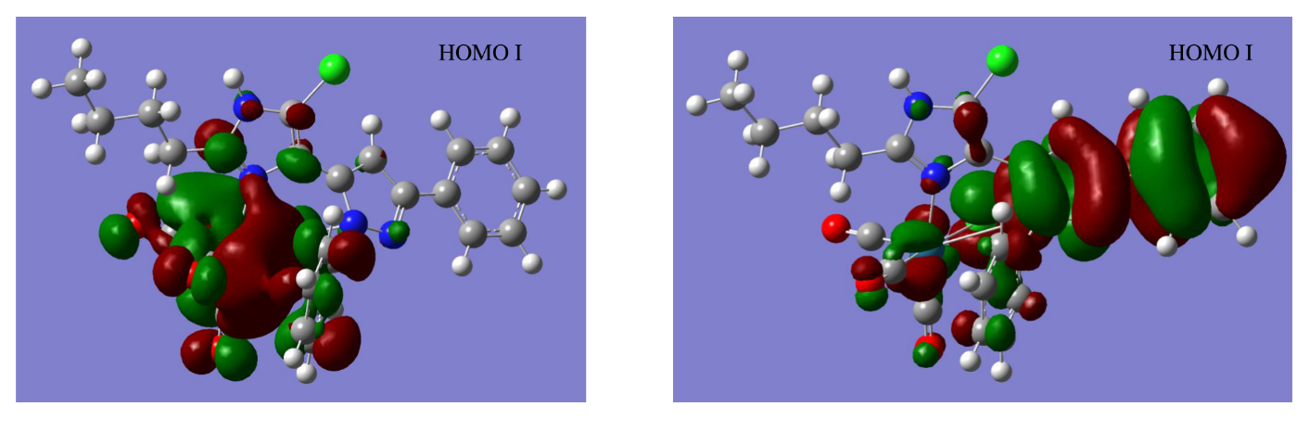
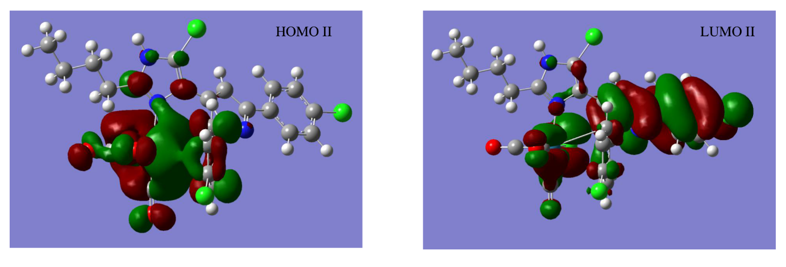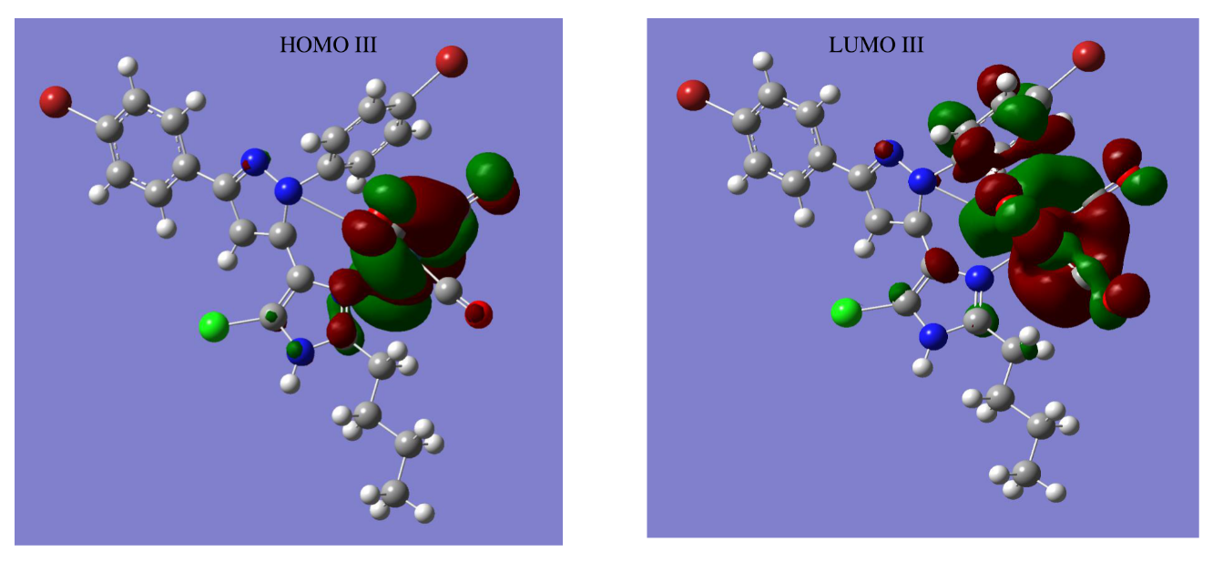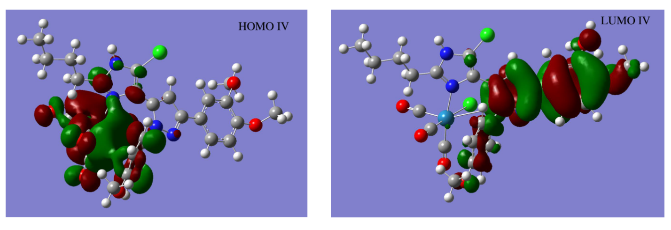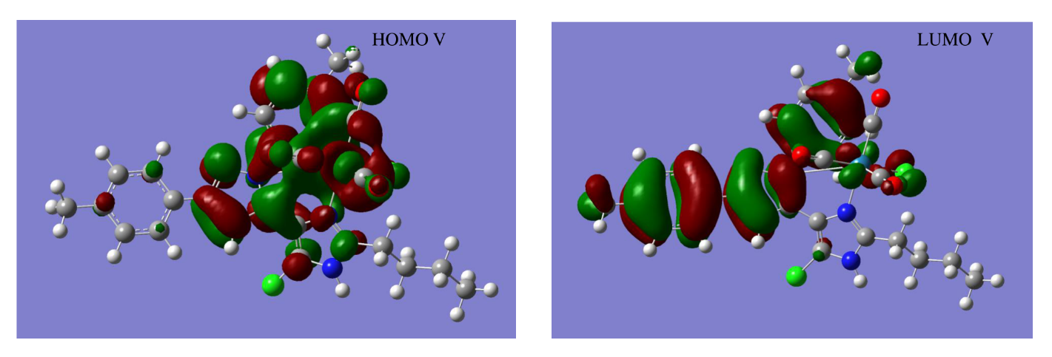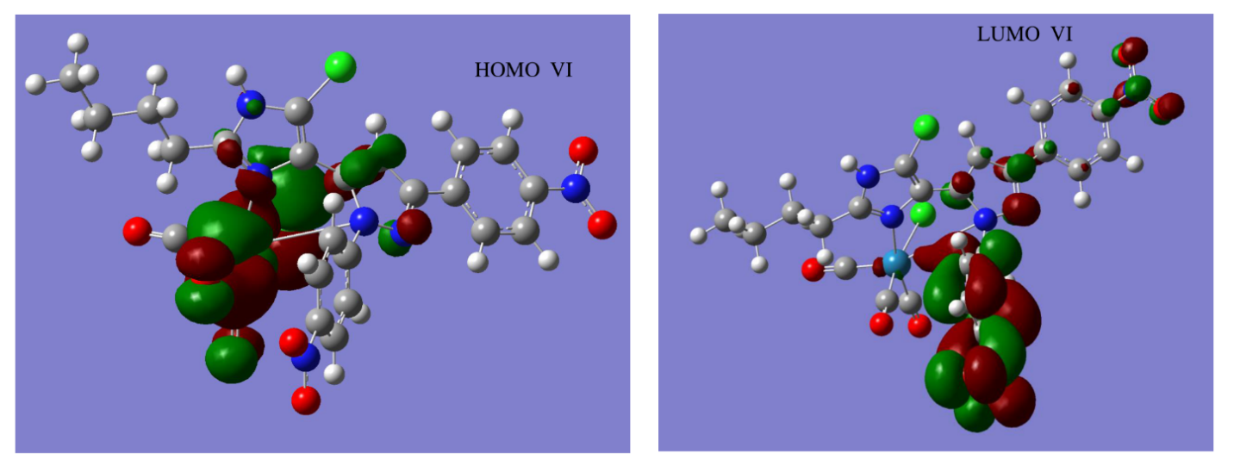

Supplementary data 2
Molecular docking data and images of ligands (L1-L6) and Complexes (I-VI)

