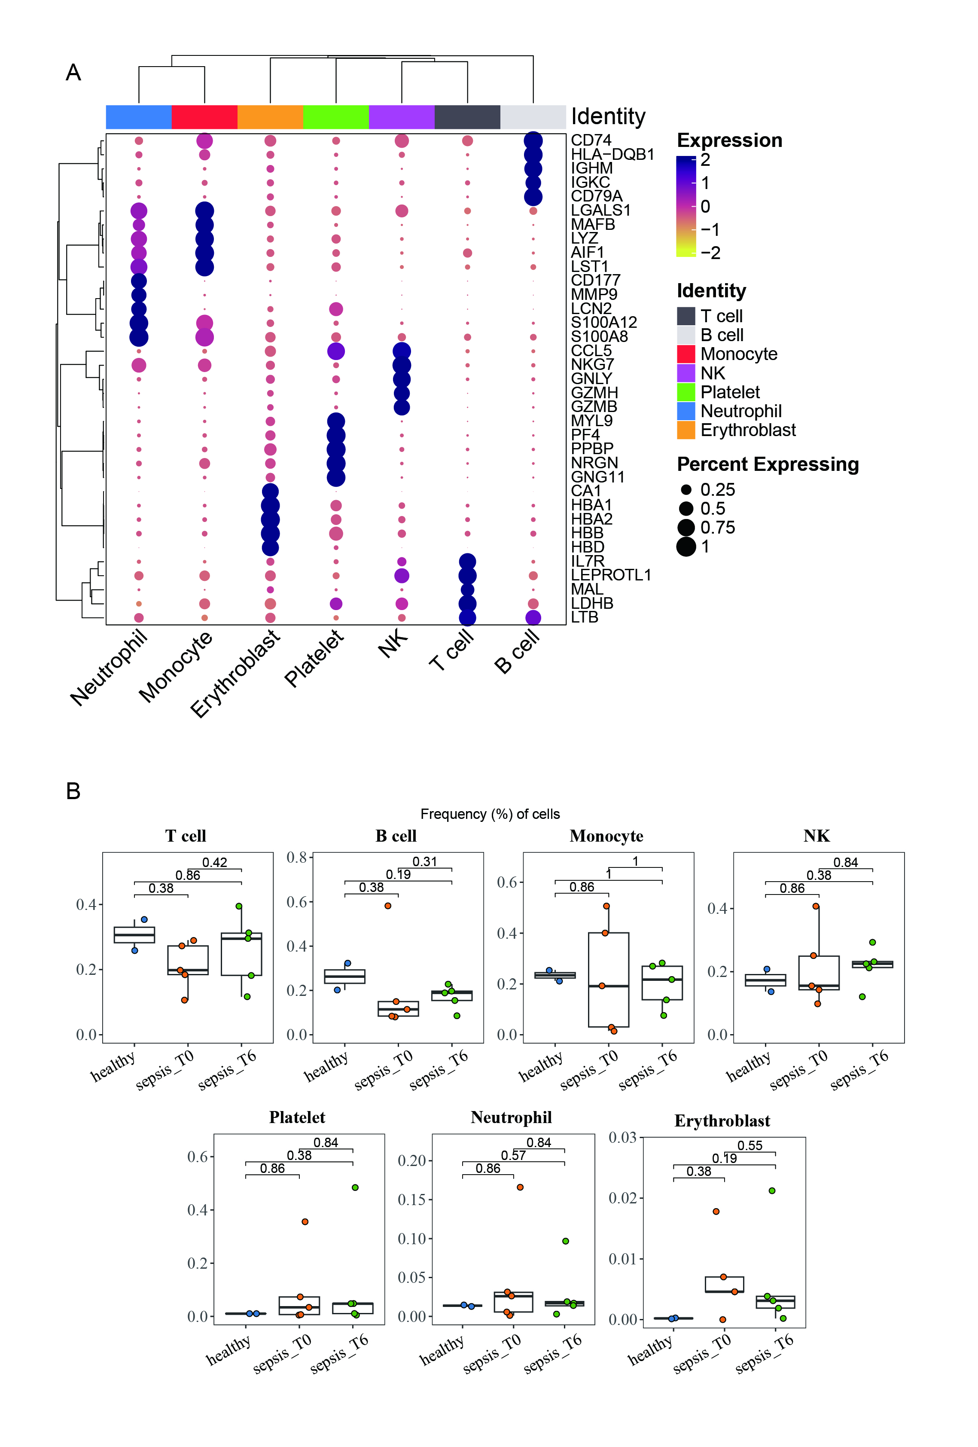Supplement1. Cell annotations and cell ratios
- Identification of markers used for grouping;
- Cell proportions between groups and p values were calculated using one-sided unpaired wilcoxon test. The center line indicates the median value, and the upper and lower hinge lines indicate the 75th and 25th percentiles, respectively.
Supplement2：Changes in the average activity of each module of transcription factors.
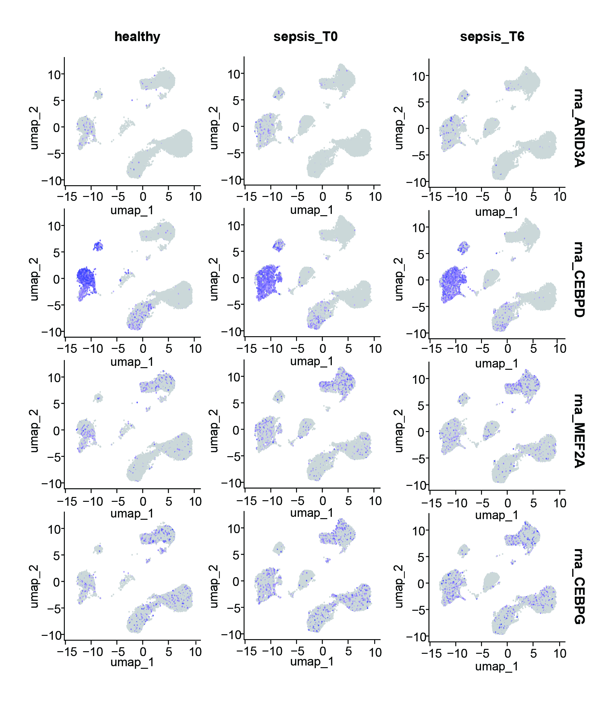
Supplement3: Expression of upstream key transcription factors of NLRC4 in each sample type;

