Supplementary Information

Intratumoral administration of astatine-211-labeled gold nanoparticle for alpha therapy

Hiroki Kato^{1*}, Xuhao Huang², Yuichiro Kadonaga³, Daisuke Katayama¹, Kazuhiro Ooe¹, Atsushi Shimoyama², Kazuya Kabayama², Atsushi Toyoshima³, Atsushi Shinohara^{2,3}, Jun Hatazawa⁴, Koichi Fukase^{2,3}

1. Department of Nuclear Medicine and Tracer Kinetics, Osaka University Graduate School of Medicine
2. Department of Chemistry, Graduate School of Science, Osaka University
3. Division of Science, Institute for Radiation Sciences, Osaka University
4. Research Center for Nuclear Physics, Osaka University
* Corresponding author: Hiroki Kato, kato-h@umin.org
Department of Nuclear Medicine and Tracer Kinetics, Osaka University Graduate School of Medicine, 2-2 Yamadaoka Suita, Osaka 565-0871 Japan,
TEL: +81-6-6879-3461, FAX: +81-6-6879-3469
Compound syntheses
Production and separation of ²¹¹At
²¹¹At was supplied from RIKEN via Supply Platform of Short-lived Radioisotopes. ²¹¹At was produced in the ²⁰⁹Bi(α, 2n)²¹¹At nuclear reaction using the AVF Cyclotron. The metallic Bi target was prepared by a vacuum evaporation method onto an Al plate. The separation of ²¹¹At from the irradiated Bi target was conducted by a dry distillation method. The irradiated Bi target was placed in a quartz column and heated up to 850°C using an electric tubular furnace. The evaporated ²¹¹At was transported from the quartz column by a carrier gas (mixed nitrogen and oxygen gas) into a Teflon trap tube which was cooled by ice water. The trapped ²¹¹At was then washed out by 100 μL of distilled water from the trap tube and received by a Teflon sample tube. The radioactivity of ²¹¹At dissolved in distilled water was determined by measurement of X-ray from a daughter nuclide, ²¹¹Po, using a high-purity germanium (HPGe) detector (BE-2020; Mirion Technologies (Canberra), Inc., Connecticut, USA).

Synthesis of AuNP
5 nm gold nanoparticles were purchased from Sigma-Aldrich, Co., LLC (St. Louis, USA), and 13 nm, 30 nm, and 120 nm gold nanoparticles were synthesized using the seeded growth synthesis method (Fig. S1A).¹
Tetrachloroauric (III) acid tetrahydrate was purchased from Kishida Chemical Co., Ltd. (Osaka, Japan) and used as a raw material for gold nanoparticles synthesis.
The following aqueous solutions (A-D) were prepared: A) 8 mL of water was added to 2 mL of tetrachloroauric (III) acid (0.17% w/v) aqueous solution for adjustment; B) 0.5 mL of ascorbic acid (1% w/v) aqueous solution and 0.25 mL of sodium citrate (0.88% w/v) aqueous solution were mixed, and 9.25 mL of water was added for adjustment; C) 2 mL of water was added to 8 mL of tetrachloroauric (III) acid (0.17% w/v) aqueous solution for adjustment; and D) 2 mL of ascorbic acid (1% w/v) aqueous solution and 1 mL of sodium citrate (0.88% w/v) aqueous solution were mixed, and 7 mL of water was added for adjustment.
Next, 47.5 mL of water was added to 2.5 mL of a tetrachloroauric (III) acid (0.17% w/v) aqueous solution. After the addition was completed, the temperature was raised to 100 °C or higher with stirring. After heating, 2 mL of an aqueous solution of sodium citrate (0.88% w/v) and citric acid (0.05% w/v) were add to the aqueous solution and the solution was stirred for 5 minutes at the same temperature. After stirring, the temperature was returned to room temperature to obtain 13 nm gold nanoparticles (AuNP).
Next, 15 mL of water was added to 5 mL of 13 nm AuNP solution for adjustment. While stirring this solution, aqueous solutions A and B were simultaneously added from separate syringes at a flow rate of 0.25 mL/min. After the addition was completed, the temperature was raised to 100 °C or higher with stirring, and the mixture was further stirred for 30 minutes at the same temperature. After stirring, the temperature was returned to room temperature to obtain 30 nm AuNP.
Finally, 15 mL of water was added to 5 mL of 30 nm AuNP solution for adjustment. While stirring the prepared aqueous solution, aqueous solutions A and B were simultaneously added from separate syringes at a flow rate of 0.25 mL/min. After the addition was completed, the temperature was raised to 100 °C or higher with stirring, and the mixture was further stirred for 30 minutes at the same temperature. After stirring, the temperature was returned to room temperature to obtain 60 nm AuNP. While stirring 20 mL of the 60 nm AuNP solution, aqueous solutions C and D were simultaneously added from different syringes at a flow rate of 0.25 mL/min. After the addition was completed, the temperature was raised to 100 °C or higher with stirring, and the mixture was further stirred for 30 minutes at the same temperature. After stirring, the temperature was returned to room temperature to obtain 120 nm AuNP.

Modification of AuNP with mPEG
All sizes of AuNPs were modified with methoxy poly(ethylene glycol) thiol (Fig. S1A). To modify the AuNP, poly (ethylene glycol) (PEG) methyl ether (mPEG) thiol (Mn 6,000) purchased from Sigma-Aldrich, Co., LLC (St. Louis, USA) was used. mPEG thiol (Mn 6,000) was added to the aqueous solutions containing the 5 nm, 13 nm, 30 nm, and 120 nm AuNP so that the final concentration of mPEG thiol was 0.1 mg/mL. The reaction mixtures were stirred at room temperature for 2 hours. After that, the mPEG-modified AuNP (5 nm) was centrifuged by using amicon ultra-0.5 centrifugal filter devices (50K) at 10000 G for 10 minutes. After centrifugation, distilled water was added to the devices. This operation was performed 3 times to obtain 5 nm AuNP-S-mPEG. The mPEG-modified AuNP (13 nm, 30 nm, 120 nm) was precipitated by centrifugation (10000 G, 1 hour). After removing the supernatant liquid by decantation, the same amount of distilled water as the removed solution was added to the precipitate. This operation was performed twice to obtain 13, 30, and 120 nm AuNP-S-mPEG. The quality of the synthesized AuNP-S-mPEGs were confirmed using transmission electron microscopy (TEM) (JEM-2100; JEOL Ltd., Tokyo, Japan). The sizes of the nanoparticles were measured from the TEM images using the software ImageJ (https://imagej.nih.gov/ij/).

²¹¹At labeling on AuNP-S-mPEG
²¹¹At aqueous solution was added to AuNP-S-mPEG aqueous solution and the resulting mixture was shaken at room temperature for 15 minutes. After shaking, an ²¹¹At-AuNP-S-mPEG aqueous solution (about 40 MBq/mL) was obtained (Fig. S1A). The ²¹¹At-AuNP-S-mPEG aqueous solution was diluted with physiological saline before administration to rats. The radioactivity of ²¹¹At-AuNP-S-mPEG was measured using a germanium semiconductor detector. The yield was evaluated using the centrifugal filter separation method. Briefly, the reaction solution was added to the amicon ultra-0.5 centrifugal filter devices, then centrifuged to separate the ²¹¹At-AuNP-S-mPEG and free ²¹¹At. After the first centrifugation, water was added to the filter device then second and third centrifugation were performed to obtain the filtrates. The radioactivity of the filtrates and the ²¹¹At-AuNP-S-mPEG solution in the filter devices were measured to evaluate the reaction yield.

Compound characterizations
The mean core diameters of the 5 nm, 13 nm, 30 nm and 120 nm AuNP-S-mPEG were measured using transmission electron microscopy (TEM) and were found to be 5.1 ± 1.1 nm, 13.1 ± 1.4 nm, 30.8 ± 2.7 nm and 120.7 ± 13.3 nm, respectively (Table S1,S2). Using the TEM images, the size distributions were measured using ImageJ, and the AuNP-S-mPEG were found to be approximately spherical and reasonably monodispersed (Fig. S1B-I). The mass concentrations of Au in the 5 nm, 13 nm, 30 nm, and 120 nm AuNP-S-mPEG solutions were measured using ICP-OES (Optima 8300; Perkin Elmer Inc., Waltham, USA) and were found to be 63.6 mg/L, 42.1 mg/L, 43.3 mg/L, and 168 mg/L, respectively.
The mass concentrations of AuNP-S-mPEG for the cell toxicity study and the intratumoral administration are shown in the table S1 and S2 respectively. The particle concentrations, which were not directly measured but were calculated from the mass concentration, and the radiation dose administered to each tumor are shown in the table S2.

References

1. Ziegler C, Eychmüller A. Seeded Growth Synthesis of Uniform Gold Nanoparticles with Diameters of 15−300 nm. The Journal of Physical Chemistry C. 2011;115:4502-4506.

Supplemental table
Table S1.
Gold nanoparticles administered to cultured cells for the cell toxicity study
Particles | Diameter (nm) | Mass concentration (mg/L)
Particles | Diameter (nm) | 0 MBq/mL group | 0.01 MBq/mL group | 0.1 MBq/mL group | 1 MBq/mL group
5 nm | 5.1(1.1) | 11.2 | 0.011 | 0.112 | 11.2
13 nm | 13.1 (1.4) | 6.07 | 0.061 | 0.607 | 6.07
30 nm | 30.8 (2.7) | 7.62 | 0.076 | 0.762 | 7.62
120 nm | 120.7 (13.3) | 29.7 | 0.297 | 2.97 | 29.7
Mass concentration: The mass concentration of Au of the particles in the solvent.
The standard deviations are shown in parentheses.

Table S2.
Gold nanoparticles administered to each tumor
Animal model | Particles | Diameter (nm) | Particle concentration (/L) | Mass concentration (mg/L) | Dose (MBq)
C6 | 5 nm | 5.1(1.1) | 9.46 × 10¹⁵ (1.65 × 10¹⁵) | 12.7 (2.21) | 1.39 (0.04)
C6 | 13 nm | 13.1 (1.4) | 2.46 × 10¹⁴ (4.92 × 10¹³) | 5.59 (1.12) | 1.46 (0.07)
C6 | 30 nm | 30.8 (2.7) | 2.95× 10¹³ (2.76 × 10¹³) | 8.74 (8.18) | 1.29 (0.50)
C6 | 120 nm | 120.7 (13.3) | 2.38 × 10¹² (2.53 × 10¹²) | 42.4 (45.0) | 1.51 (0.57)
C6 | Unlabeled 30 nm | 30.8 (2.7) | 6.49 × 10¹³ | 19.2 | 0
PANC-1 | 13 nm | 13.1 (1.4) | 1.15 × 10¹⁵ (1.94 × 10¹⁴) | 26.2 (4.40) | 1.17 (0.07)
PANC-1 | Unlabeled 13 nm | 13.1 (1.4) | 1.23 × 10¹⁵ (2.13 × 10¹⁴) | 27.8 (4.83) | 0
Mass concentration: The mass concentration of Au of the particles in the solvent.
The standard deviations are shown in parentheses.

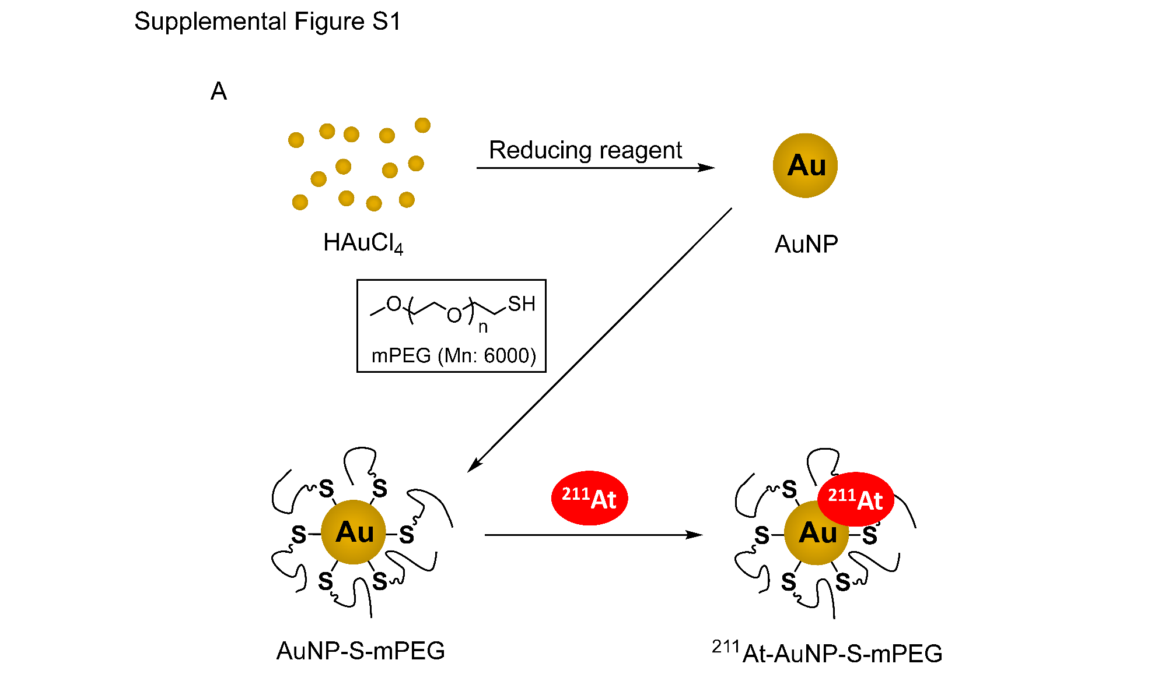
Supplemental Figure
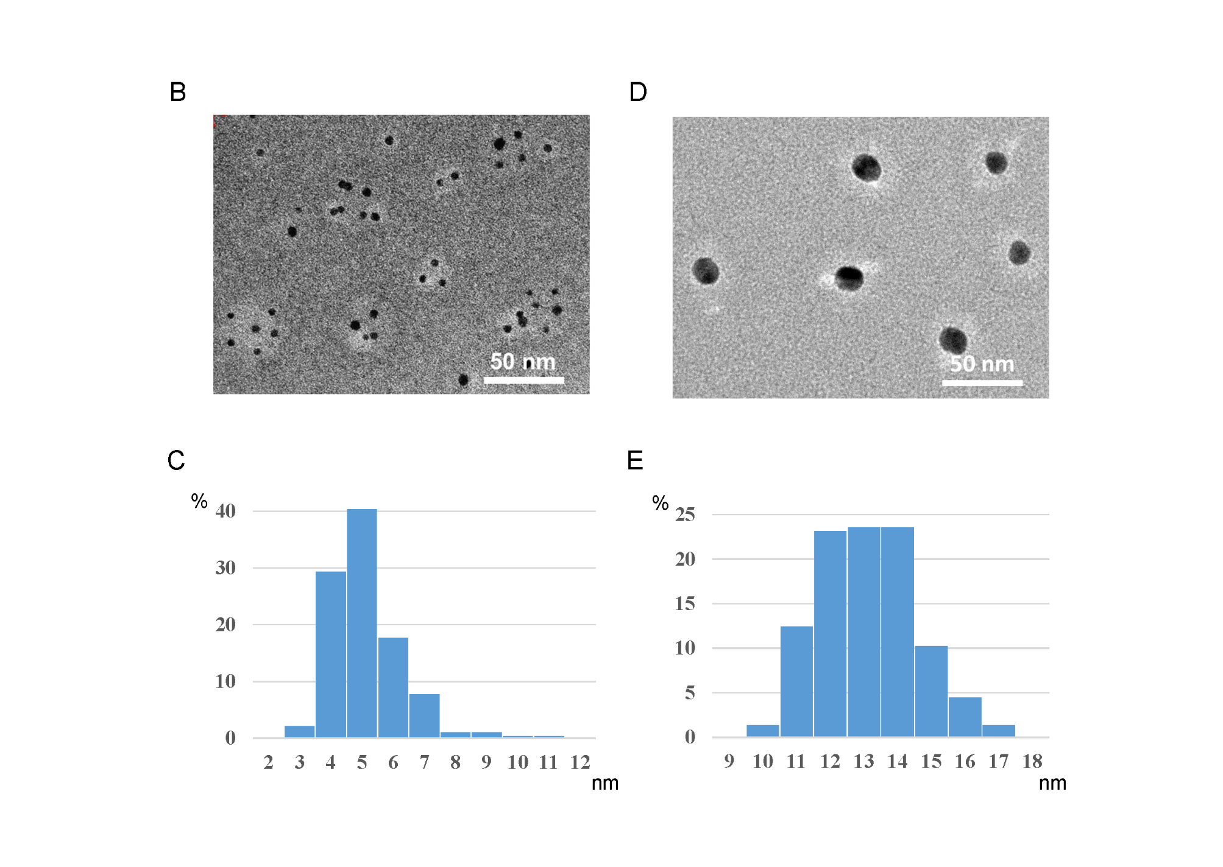
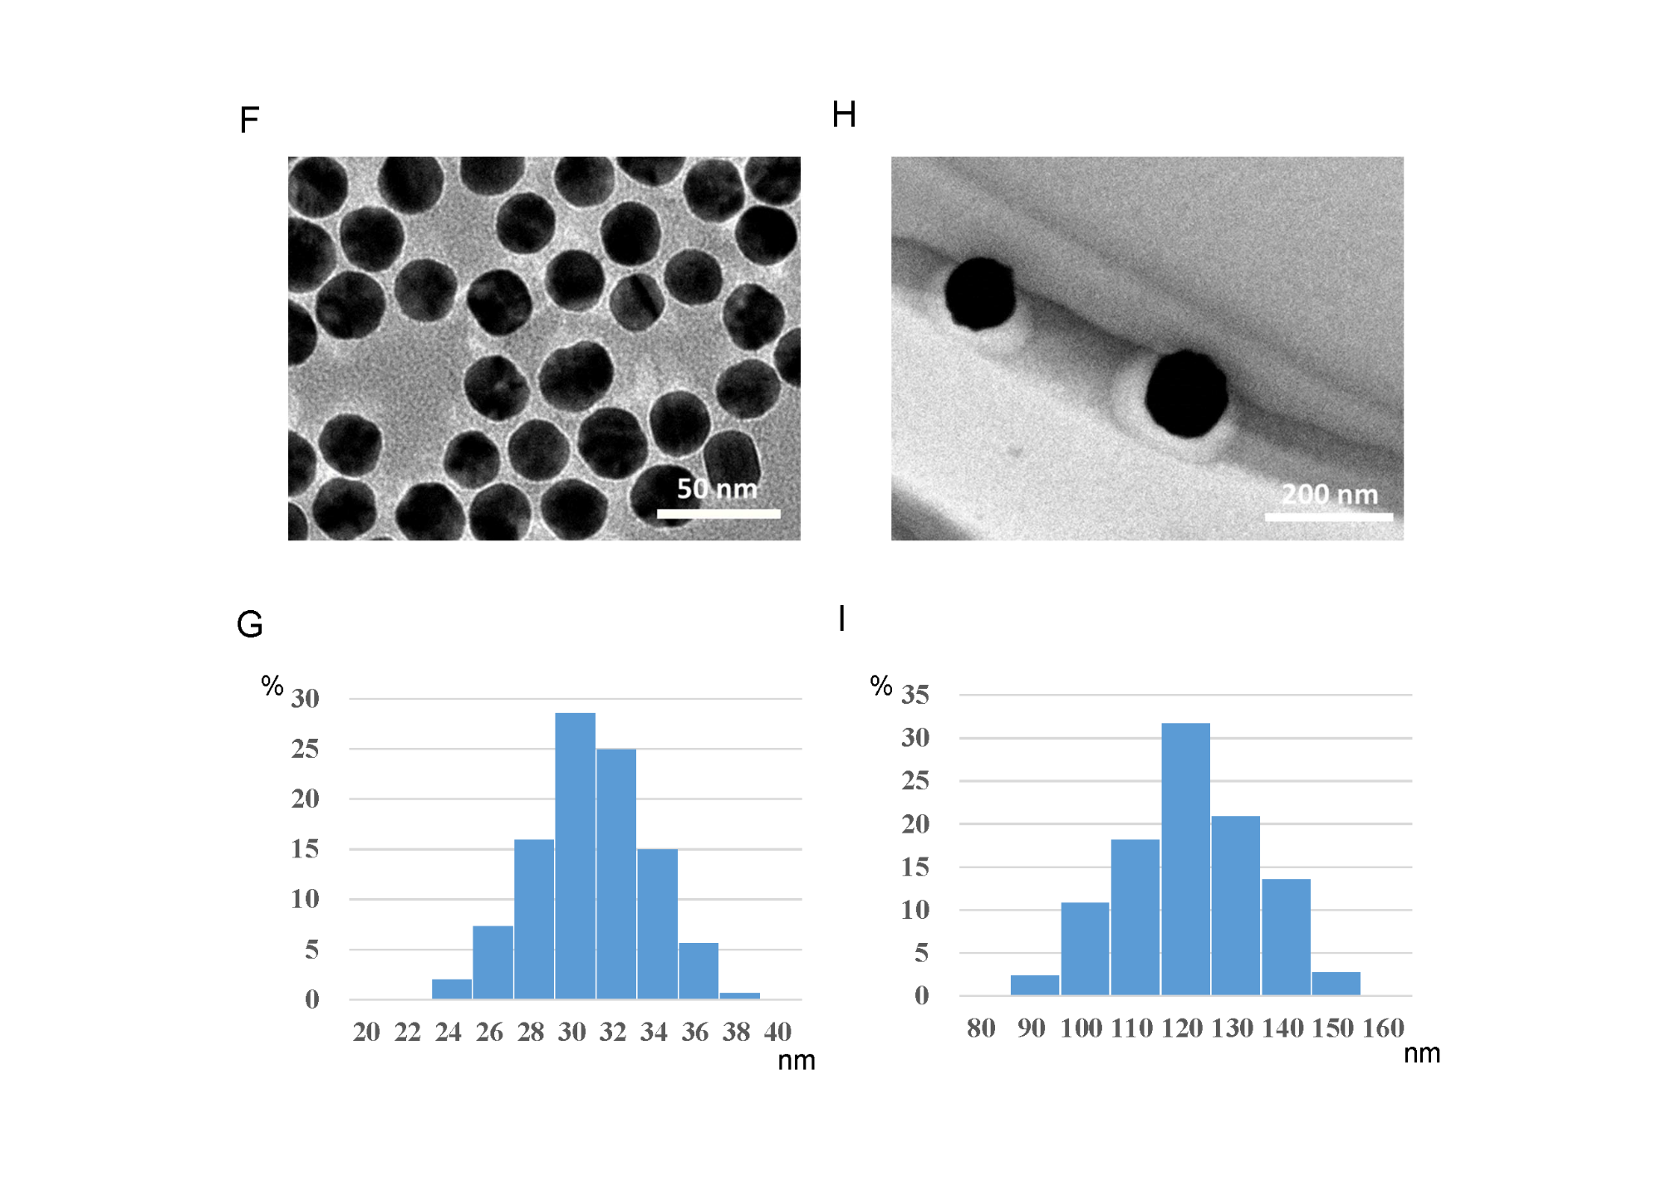

Supplemental Fig. S1.
(A) AuNP nanoparticles of the desired size were produced from tetrachloroauric (III) acid; mPEG thiol was added, and the mixture was stirred to produce AuNP-S-mPEG. ²¹¹At-AuNP-S-mPEG was then produced by adding ²¹¹At aqueous solution to the AuNP-S-mPEG aqueous solution and shaking. (B, D, F, H) Negatively stained TEM images showing mPEG-coated gold nanoparticles with diameters of 5 nm (B), 13 nm (D), 30 nm (F), and 120 nm (H). (C, E, G, I) Size distributions of 5 nm (C), 13 nm (E), 30 nm (G), and 120 nm (I) mPEG-coated gold nanoparticle cores. The sizes of the nanoparticle were measured using TEM images and ImageJ.

